
Robinson & Garton, 2007)

Level 4
Module code: LCBB4003

Introducing the Modern Workplace

Assignment: 1

Sony

MODULE LECTURER´S NAME: John-Paul Okeke

STUDENT NAME: Meri Tahu

STUDENT IDENTITY NUMBER: 1911661

CONTENTS

Introduction

This essay is to discuss the organisation and structure & culture in the Sony Corporation.

Sony, or SONY is a Japanese company that was founded on 7th May 1946 by Akio Morita and Masaru Ibuka.
The name is derived from the word sonus, which is Latin for sound, and Sony is now the leading manufacturer and producer of music production in the world. It is also a major figure globally in the gaming industry – both consoles and software. Along with this it has become one of the largest film & TV production companies, a major producer of IT products, and electronics for the consumer & professional markets. Along with all this, Sony also has a financial services branch of the corporation. (www.sony.net)

Structure and organisation are very important within the Sony Corporation.
Its organisational culture has buyer satisfaction at its heart. This also affects its employees, as well as the sub-contractors in the music, gaming, film and electronics industries. (Meyer, 21 Feb 2017)

MAIN BODY

Organisation

The definition of an organisation can be said to be a group (of people) collectively working towards or trying to further the aims of the group. The group should preferably be structured to get the best performance towards a common purpose.
Within business, organisation is used to define a business operating in a marketplace. (Erasmus, Strydom and Rudansky-Kloppers, 2016).
A modern company must be run efficiently to be able to stay competitive in the world of business.

Structure and Culture
Organisational structure is how activities and constituent parts within an organisation are subsequently organized and their means of communication. The organisations created the structures to coordinate the activities of work factors and control the member performance. (Ahmady, Mehrpour and Nikooravesh, 12 September 2016)

Organisational structures
Here, structure is the relationship between the various parts of an organisation. (Ahmady, Mehrpour and Nikooravesh, 12 September 2016)
There are various types of organisational structures. Organisation theorists state the two fundamental types of structures are physical and social structures. Within operating parts of business, the main types of structures come from social structures and include functional structure, divisional, flat structure and matrix structure.
A flat, or simple structure simply has the head of affairs at the top and everybody else below. It will have very few levels.
Functional structure allows for greater complexity with more degrees of separation and breakdowns into different needs such as by department or function.
Divisional or multidivisional has developed organisational paths. Definitions and roles of departments or divisions become more defined and specialised as companies grow and expand.
Matrix structure is a combination of functional and multidivisional structures. This is to enable the efficiency of functional structure combined with the flexibility and sensitivity of multidivisional structure. This can be based on product, market or geographical region, but with the functional logic in multidivisional structure. Specialised workers are in each department or branch. This delegation of activities to employees is done by project managers.
There is also network structure. These have come about due to rapid changes of technology. limited life spans of product along with dedicated markets have forced organisations to adapt quickly to changes. A network doesn’t necessarily have a hard-defined structure or organisation and distribution may be uneven or possibly ad hoc.

Organisational cultures
In 1999 Charles Handy defined four types of organisational cultures; power culture, role culture, task culture and person culture.
Handy shows power culture to be like a spider’s web with a control coming from the centre and spreading out or networking from there throughout the organisation. The closer to the centre the more influence. The smaller they are the quicker they can react to situations, but success depends upon the ability of the person at the centre of such a culture.

Seen as very hierarchical, the structure of role culture is like the front of a Greek temple with columns supporting a beamed roof. Each column has a well-defined specific role in this organisation structure.
The strength of the organisation is defined by how well the columns can support the beams with different departments in different columns. All interaction is controlled from above.
Influence may come from a position rather than knowledge. A rigid structure, it is not suited for adaptability and change can be a long drawn out process.
Task Culture is seen to project oriented and centres around getting the job done. Based on team work it is represented by a net where strength comes from where the lattices intersect or individuals combine. Expertise and experience are required and the right team work can respond quickly and well making it a very flexible means of approach to a task.
A Person Culture is individually derived and driven. People do what they are good at or are specialised at. This makes it quite an unusual culture as these individuals then have to be assisted or tolerated. The role of a specialised consultant can be seen to operate in the person culture.
(Cacciattolo, 2014)

ORGANISATIONAL STRUCTURE OF SONY CORPORATION

Within Sony the group of people brought together are the company employees and sub-contractors. Their aims are to develop and produce innovative quality goods and products that Sony can sell successfully around the world.

The organisational structure of Sony Corporation between the departments and branches as seen by Sony is shown in this diagram: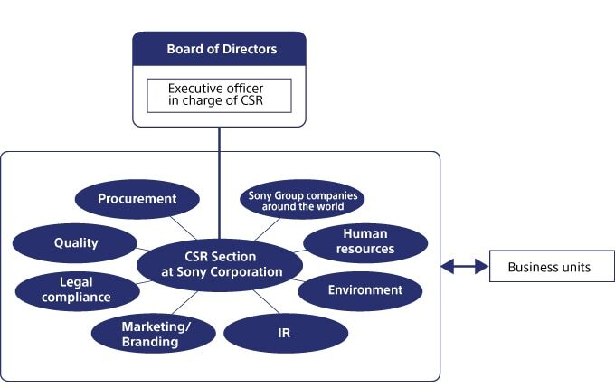
Organisational Structure of Sony Corporation
(sony.net)
Corporate Structure of Sony Corporation

A newer organizational structure was first employed in October 2005 by Sir Howard Stringer when he became chairman of the Sony Global Corporation.
This was a multi-divisional structure. This organizational structure then subsequently changed and evolved.
Also known as a product structure, a multi-divisional structure is when a company’s organizational function is structured into divisions. Each division becomes a distinct entity within the company. Each divisional structure is self-contained, possessing all its own required resources and necessities internally. It may have its own production, sales and marketing departments. (Johnson, G., Scholes, K. and Whittington, R. 2008) However, in Sony’s case, all marketing is finally overseen by the Sony marketing department.

Sony has used multi-divisional structure to its benefit.
Within the Electronics group Sony the Electronics CEO now makes all the centralized decision-making. This led to coordination and the separate businesses having their own targets and attention. But with structured and planned horizontal coordination, there is still coordinated actions across the different sectors and products.
Each section can concentrate on its own market such as electronics, gaming or entertainment.
Then depending on situation in whichever market Sony Corporation manage resources accordingly allowing flexibility. Core businesses can have maximised investment. (Meyer P., 2018)

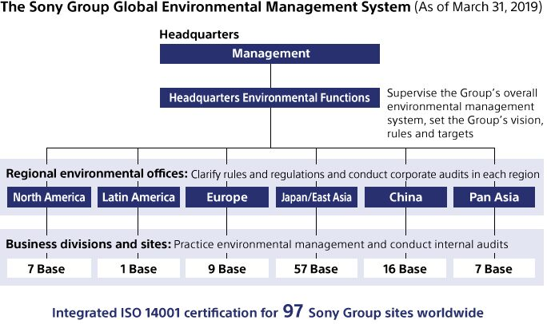
(sony.net)

Stringer streamlined Sony, closing such things as Sony’s chain of restaurants, and gave each main product within the divisions its very own strategy.
Each multi divisional structure was able to operate independently, enabling joint ventures such as Sony Ericsson and Sony BMG. These have generally been bought out or merged fully so now every division has become a company in its own right.
These include:
Sony Electronics Inc., which was merged into Sony Electronics Corporation, effective 1st April 2020, also incorporating Electronics Products & Solutions (“EP&S”) segment (Imaging Products & Solutions, Home Entertainment & Sound, and Mobile Communications) including all departments. This aims to improve its organizational structure further. (sony.net)
Sony Pictures Entertainment Inc. based in Culver City, California, USA
and Sony Computer Entertainment Inc. which was originally founded earlier in 1993 but became Sony Interactive Entertainment in 2016 to handle all aspects for the PlayStation gaming system. (www.sie.com)

The different operating companies that Sony Corporation holds globally all report to Sony’s corporate social responsibility section which oversees all of Sony Corporation’s operations. These operating companies are defined by Sony and shown below, broken down into their various structures.

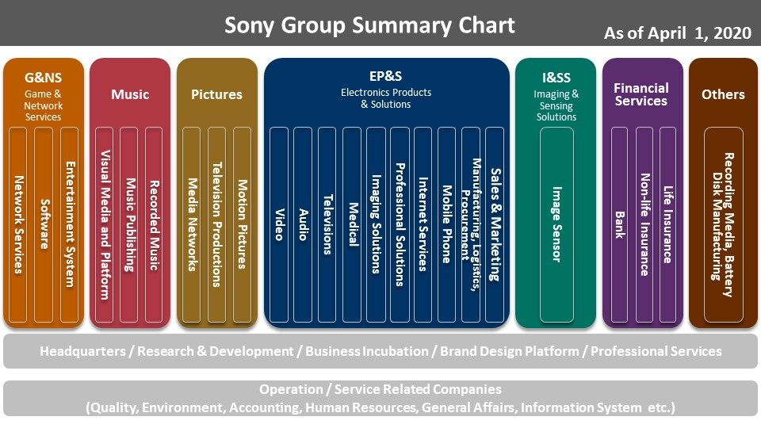
(sony.net)

Structural culture of Japan

Only 15% of the landmass of Japan can support farming and agriculture, the larger part of the land giving way to mountains. So being able to live efficiently is central to Japanese culture. This has traditionally meant centralising focus on the collective and placed importance on conformity.
This cultural belief is also operated at business level. Market share is more important than profit, which is looked at as a future goal.
A place in society and the wellbeing of employees is rooted in Japanese culture. Prioritising or maximising shareholder profit is seen as a Western value.

A notable absence not shown in the diagram Organisational Structure of Sony Corporation is research and development. This is structured into one department rather than being spread amongst the different operating companies that belong to Sony Corporation. (Meyer, 8 Sep 2018)

A reason for having a centralised research and development department is Sony’s commitment to innovation and maximising efficiency. This comes from its Japanese origins and mixing modern concepts with traditional ideas & philosophies. From its start Sony has focussed on improving technology and providing customers with a level of high-quality products, a strategy that was able to initially help Sony Corporation stand out from its competitors. (Das B., 24 Dec 2013)

Human resource (People)

Sony understands the value of communication within the companies and between employees. It values its employees and what they think. It has done this since its beginnings it has fostered this to promote an open-minded approach towards its development. This is both within workplaces, but also runs throughout and across the whole organisational structure of the different companies within Sony Corporation.
Not only this but it is also looking at new ways to develop and further communication between employees. It is developing communities to allow accolades to be given and shared that also allow for exchanges of information and ideas. (sony.net Aug 2019)
This is a form of network structuring, enabled and made necessary by faster changes in technology.

CONCLUSION

Possibly greater than the sum of its component parts, Sony is well placed and established within various different markets. Any positive or especially outstanding achievement within one of its divisions reflects across all of Sony’s operations, whereas any negativity is kept within the division.
Each division is a major business within all markets it operates holding strong assets within every company. It is seen as a very dynamic company that is also safe.
Because of its break down into divisions or separate individual companies it is very flexible and is a specialist in each of the defined markets it operates in.

References

Ahmady G.A., Mehrpour M. and Nikooravesh A. (12 September 2016) Procedia - Social and Behavioral Sciences Pages (455-462 Organizational Structure) Elsevier

Cacciattolo, K., (2014). Understanding Organisational Cultures. European Scientific Journal. 2. pp1-2.

Das B., (24 December 2013) Sony and the Japanese Culture. Available at SSRN: https://ssrn.com/abstract=2370964 or http://dx.doi.org/10.2139/ssrn.2370964

Erasmus B., Strydom J.W. and Rudansky-Kloppers S. eds., (2016) Introduction to business management. Oxford University Press Southern Africa.

Johnson, G., Scholes, K. and Whittington, R. (2008) Exploring Corporate Strategy: Text and Cases. 8th Edition, Prentice Hall, Harlow.

Meyer P., (updated 8 September 2018) Sony Corporation’s Organizational Structure Pros & Cons http://panmore.com/sony-corporation-organizational-structure-pros-cons

Meyer P., (21 February 2017) Sony’s Organizational Culture for Customer Satisfaction http://panmore.com/sony-organizational-culture-customer-satisfaction

https://www.sie.com/en/corporate.html (retrieved 13 August 2020)

https://www.sony.net/SonyInfo/CorporateInfo/ (retrieved 8 August 2020)

https://www.sony.net/SonyInfo/csr_report/about/organization.html (retrieved 8 August 2020)

https://www.sony.net/SonyInfo/csr_report/environment/management/structure.html (retrieved 8 August 2020)

https://www.sony.net/SonyInfo/csr_report/employees/engagement/culture_communication.html (29 August 2019)

https://www.sony.net/SonyInfo/IR/news/20200326_01E.pdf (retrieved 13 August 2020)

