Lead
Student Number 2225279

3rd January 2024

LEADERSHIP aND THE INDIVIDUAL (BMpO7008D)
Programme: MSc (Operational and Strategic Leadership)
Trudi Meyrick

Word Count 5484 (excluding titles and citations)

Table of Contents
Table of Contents 1
Introduction 2
Experiences 3
Early years in policing 5
Gibbs Reflective Model 12
Description 12
Feelings 13
Evaluation 17
What was good 18
What was bad 19
Analysis 22
Conclusion 24
Action plan 26
Summary 27
Appendix A 30
Appendix B 31
Appendix C 32
Appendix D 33
Appendix E 34
References 35

Introduction
The concept of leadership has historical roots dating back to the era of one of the most important Greek philosopher’s Plato. It is not viewed as a straightforward concept but rather a multifaceted one with numerous interconnected aspects with ethics playing a crucial role in this complexity (Scott & Freeman, 2021). This is taken to mean that leadership is not a simple or singular concept but rather a complex one with many inter-related components, emphasising the significance of ethics in this intricate structure.
As an everyday word used in organisations, police leadership is facing a major crisis in terms of maintaining legitimacy and must do more to reform as it faces its biggest challenge to date (The Police Foundation, 2022; Strategic Review of Policing in England and Wales, 2022). Public trust and confidence remain shattered and at its lowest ebb following international injustices which include the killing of George Floyd in Minneapolis, to high profile cases involving serving Metropolitan police officers which include the murder of Sarah Everard and the multiple horrific sexual offending of David Carrick (Daily Express 2022; Casey 2023).
Furthermore, the ability to continue to police by consent, a fundamental principle of law enforcement remains debated as officers and staff navigate through the complexities of policing including racial bias (Torrible, 2022). These challenges require robust leadership to address systemic issues, promote accountability, building trust internally and externally within communities.
This paper aims to analysis and interrogate the leadership challenges I have encountered in my early career and explore strategies to overcome these challenges in police leadership.

Experiences
Since my early years, I have shown leadership potential, passing my sergeant legislation exam early in my service. Subsequently I undertook leadership programmes internally and externally, signing up for master classes to further refine my leadership style through training, education and mentorship.
Over the years, as I progressed in various roles, I used reflective practices setting out a personal strategy for individual learning in professional practice (Jasper, 2003). Reflection has assisted in my personal development and growth from an organisational and personal perspective learning from past experiences.

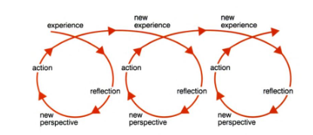
Figure 1 Reflective Cycle - (Jasper, 2003)

Evaluating my leadership approach, the way I lead people has been shaped from the early years of my childhood experiences, which laid the foundation from my humble beginnings. Such experiences have continuously developed as I have grown, matured and gained new perspectives. My values of trust, honesty and integrity are deep routed which align to my qualities of fairness and integrity. Leaving education at 16 years of age and becoming a mother at 18 years, I was stereotyped and placed into a societal box of negative and stigmatising comments. This made me stronger and more resilient to succeed demonstrating that how you start out in life does not define who you become.
During my time with South Wales Police, I have encountered diverse leadership approaches and observed a multitude of leadership challenges, all of which have contributed to my personal and professional growth. Through these experiences, my understanding of leadership has been significantly broadened and enriched through self-reflection. This has allowed me to gain a deeper insight into my identity and align further with my core values.
Hereafter, I apply the GIBBS reflective model to underpin my leadership experience and reflections.
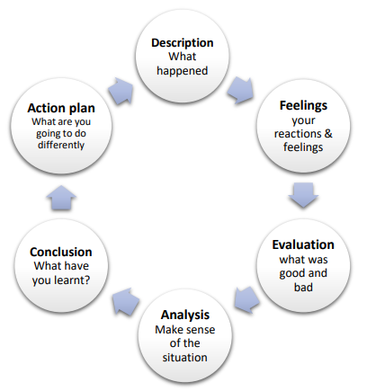
Figure 2 – (Gibbs, 1988)
Use of the cyclican model in this reflective report is underpinned with academic theory and sources. It demonstrates how I have gained a deeper understanding of situations, using theories of learning, motivation and models of reflection which has assisted in the devleopment of my personal leadership style.

Early years in policing
I joined South Wales Police in 1999, at the age of 27, older than many of the newly recruited colleagues and was considered by my peers as mature. I demonstrated life experience as a mother and leadership qualities from previous employment as an events manager, a middle management leadership position.
Following police training school, I joined a team of experienced officers who displayed team ethos and supported me in my new role. However, the shift inspector clearly undermined me in every role I performed. He belittled me, questioning my effort. This I found extremely upsetting as his behaviour was for no apparent reason, commencing from the first day I joined the shift.
Whilst the team and my tutor were highly supportive towards me, it was clear they were fearful of the inspectors behaviour. The inspector exhibited an ambient demeanour, with a combination of demanding and controlling behaviour (Chiang, et al., 2021). Whilst there are various leadership styles, he predominantly used an authoritarian leadership style where he held all the power and the ability to influence others (Lunenburg, 2012). Afraid of his rank and status the shift conformed to his behaviour. As a consequence he was able to exert his influence to attain desired results and outcomes (Krishnan, 2003).

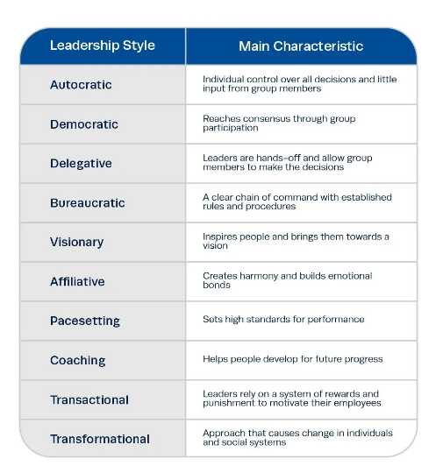
Figure 3 - Leadership Styles (Institute Project Management, 2023)

In the context of policing, a hierarchial strucutre is employed wherein power is commenly utilised as an inherent mechanism. This system relies on legitimate power derived from rank and structure to effectively uphold order and discipline. However, the inspector used coercive power to influence behaviour by creating threat and fear. He would often dismiss my work, misinforming my tutor which was accepted and tolerated by all despite its negative impact. The unplesant environment impacted my emotional and physhological needs and I questioned my role and purpose in policing. Supressing ideas and creativity, an evident limitation associated with the utilisation of his authoritarian leadership style, the inspector set the emotional tone influencing how the team felt and thought (Chiang, et al., 2021).

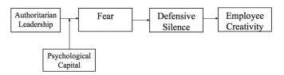
Figure 4 - How authoritatian leaders can influence employee creativity based on transactional theory of stress (Guo, et al., 2018).

At work I felt judged, inadequate, and questioned my competence, I started to consider if I had made the right career choice and if policing was the right role for me? I did not want to come into work, I felt restricted, fearing that I would be condemned and criticised by the inspector who used his position of authority and coercive power to influence my behaviour. Whilst this authoritarian leadership style is known to maintain discipline and allows inexperienced officers to know what to do and when to it, Argyris (as cited by Mullins, 2019, p. 24) describes how “this form of organisational behaviour restricts individual growth and self-fulfilment”. This resonated with my emotional state as I generally perceive myself as psychologically well adjusted. However, during this time I experienced feelings of inadequacy and discontentment.
Whilst my moral started to decline my commitment to the role and to the public remained high, as I had worked hard and made sacrifices to fulfil my policing ambition. I had to dig deep and drew upon my intrinsic motivators, internal desire and personal satisfaction to overcome the inspectors negativity to drive my personal motivation. According to Pink (2009) motivation is primarily determined by internal factors rather than external factors such as financial rewards. I agree with this viewpoint, as I personally expereinced that the influence of money as an external factor on my motivation was minimal during this challenging phase in my career.
On conclusion of my tutorship and on commencement of independent patrol, the inspector completely changed his approach. He became reassuring, supportive providing recognition and praise. He encouraged me to apply for roles that would further stretch my learning and he supported me to apply for my sergeants promotion exam. The inspector behaved differently, he changed from utilising coercive power to reward power in an attempt to empower and motivate me. (Lunenburg, 2012) states that ‘through legitimate and referent power, true leaders are able to influence others to modify behaviour’.
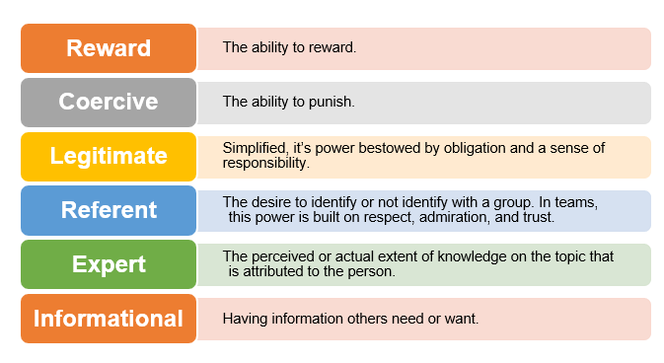 Figure 5 - Six bases of social power and influence defined (Wilson & Associates, 2021)

Conversley analysing the inspectors leadership style and the legitimate power he held which came from his rank and role, he used it ineffectively. There was never true follower acceptance where he could positively influence all. In contrast his leadership and power, whilst accepted, alienated his shift creating frustration and fear instread of conformity and true motivation.
All of this fell short of its potential as when individuals are confronted with stressors or threats, they refrain from sharing relevant ideas or opinions as a protective measure, finding it safer to keep quiet, also known as defensive silence (Guo, et al., 2018). At this time all were afraid to professionally challenge the inspectors behaviour or speek freely.
Motivation is one of the most important factors affecting human behaviour and performance, a dynamic process that originates from a persons needs, influences goal selection and guides behaviour towards the goals and objectives (Global Institute for Research and Education, 2013; Bong, et al., 2023). Reflecting upon the inspectors leadership and management style, I felt frustrated as he did not fully engage his staff or consider their needs, desires or incentives.
“Behind every managerial decision or action are assumptions about human nature and human behaviours” (McGregor, 1960, p. 43). Upon reflection of the inspectors early assumption and belief of my ability as a student officer, it was that I required tight control and direction. The inspector formed McGregor theroy X assumptions about my ability and competance in line with his view of all student officers and did not consider my past expereinces as a previous supervisor or a special constable. Using an authoritarian syle of leadership, the inspector micromanaged my work, bypassing my tutor and front line sergeant attempting to control decisions (Appendix A).
In contrast, once I commenced independent patrol and had proven myself, he formed theory Y assumptions, adopting a participative management style, allowng me to take ownership of my work, offering trust over my decisions and encouraged wider development.
Based on contextual theories, such as ‘Maslow’s hierarchy of needs (PHILO-notes, 2021) and the findings of Pichere (2015), I concluded that my psychological needs relating to interpersonal relationships, sense of connection and group affiliation both within the organisational context and on a personal level were adversely affected. (Appendix B).
In accordance with Maslows theory of needs and Alderfer’s ERG theory, which offer a dynamic and flexible perspective on human motivation categorising needs into three groups, it is acknowledged that invividuals have multiple needs that require fulfilment simutaneoulsy (Arnolds & Boshoff, 2011; Robbins & Judge 2009). However, Ikwukananne & Udechukwu (2009) argue that Maslows theory is inadequate as it solely focuses on the levels of needs and fails to consider the specific types of needs. Later is 1959, Hazberg introduced the two-factor theory of motivation and hygiene, which introduced a distinct set of factors to assess workplace motivation (Appendix C).
I contemplated the impact of the inspectors behaviour on my motivation during my time in the role. This reflection led me to question my own worthiness for the role as I experienced a sense of division and unhappiness both within the work environment and in my personal life. I became moody and miserable feeling undervalued and not worthy of the role, battling self esteem issues and worried about the future, I considered leaving policing. I now recognise that my satisfaction was dependent on motivators, while dissatisfaction was the result of hygiene factors (Global Institute for Research and Education, 2013). At this point in my career I had job-dissatisfaction as a result of supervision and interpersonal relatonships, however when motivators were applied by the inspector through empowerment and responsibility following independent patrol status, it did not fully motivate me and it remained clear that his earlier authoritarian leadership style had constrained my initial growth and confidence. Critically reviewing Herzbergs two factor theory and considering my own personal experieces, feelings and professional relationship with my inspector, I concluded, that improving hygiene factors can prevent dissatisfaction but it doesn’t necessarily lead to satisfaction (Appendix D).
Over the following months, I saw the inspector repeat the same behaviour and leadership traits when a new student officer was appointed to the shift. When I reflect back on my early negative expereince, I shamefully conformed. I should have challenged and taken action, however being very young in the role I adapted to his leadership style, fearful of repercussions. I now humbly recognise and accept that I should have confronted the situation. This has seen me reflect, mature, adapt and grow over the years in terms of my adaptability and willingness to learn. The realisation has motivated me to continuously evolve and adopt a more inclusive leadership approach and to avoid repeating the leadership style that I encountered very early in my career.

Gibbs Reflective Model

Description
One of my toughest leadership challenges within my profession was upon promotion from a shift sergeant to the rank of inspector, a middle management role that is highly influential holding legitimate and positional power.
Upon being promoted I found myself in the role of a detective inspector within the Public Protection Department. This promotion was unusual as I had limited experience or knowledge of this specialism. Furthermore, it is usual to promote officers into a familiar role where they can demonstrate competency as they grow into the new rank with close mentorship and support of their Senior Management Team (SMT). The new SMT were unknown to me and therefore as I transitioned into my new role, I had to build fresh relationships with senior managers quickly demonstrating competence and confidence.
According to McClelland’s theory of needs, every person has one of three main driving motivators, which are developed through culture and life experiences (Gregg, 2023). I thrive when entrusted with the responsibilities of leading and developing individuals which enhances my motivation. (Appendix E). Supported by Rybnicek, et al (2017, p. 473) “personality-based rewards are more rewarding, and thus are presumed to impact on motivation to a greater extent”.
The significance of the promotion was amplified when I met my predecessor, who informed me that the department was undergoing a period of substantial change and two geographical Public Protection Departments were joining to form one unit, to meet cost saving challenges. As an individual who is motivated through recognition and constructive feedback potraying a strong desire to achieve, complete and accomplish work and tasks, I assumed the responsibility for leading the change despite having limited time and opportunities to develop the necessary skills. Aligning with Smith’s (2019) assertion ‘even the most competent police leaders, cannot just ‘do change’. Time and opportunity to build a new skill set to lead change effectively is required.

Feelings
To motivate, reward systems should align with intrinsic factors (Pardee, 1990). I felt consciously incompetent and inadequately prepared for the role, lacking the requisite skills and knowledge. I experienced a sense of fear regarding the potential for failure and my self-doubt was prominent at that time. As part of the change officers and staff were under pressure as they were required to adjust to new roles, different responsibilities, changes in work practises and relocation. All of this was under my leadership placing additional stressful factors on me as a newly promoted inexperienced inspector. According to Owen (2020) in every career there exist critcal junctures or crisis where individuals either excel or falter. It is within these pivotal instances that one’s capacity for resilience in the face of adversity becomes relevant.
I had to find balance and I drew upon every part of my leadership experiences to assist in what I knew was going to be a challenging time. In line with the organisation expectations of me as a middle manager, I knew I had to step up, take control, and seize the moment with confidence, ”leadership is not given to you, you have to take it” (Owen, 2020, p. 121). Demonstrating all the traits of good leadership, I ensured I fully committed to the role, undertaking a period of rapid learning which could deliver instant change in performance (Dowrick, 2012). In order to facilitate the tranistion, I put a 100 day plan in place, setting priorities and goals, building relationships, communication and aligning expectations.
Learning from previous leadership experiences, my focus remained clear. Important was getting to know the team collectively and as individuals, to help me understand and ascertain their abilities, experience and strengths. Based upon the teams capabilities, skills, areas of development and motivation, I was able to identify which leadership style best suited each situation and effectively match different activities against the individual and team’s needs. Utilising McClelland needs theory a comprehensive comparision of indidividual characteristices, such as values and the need for achievement, affiliation and power could be obtained. This played a siginificant role in positively influencing behavioural motivation (Rybnicek, et al., 2017). Additional studies suggest that performance may suffer if individuals are assigned tasks that are irrelevant to their skills, Yuki & Gardner (2019). Therefore, in order to effecitvely organise the team and optimise performance, I aligned activities with individual skill sets and needs.

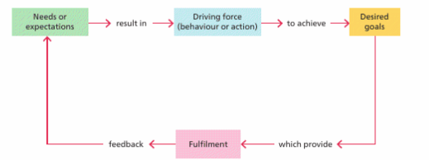
Figure 6 – Basic motivation model (Mullins, 2019)

Finding common values and purpose is essential to build trust (Owen, 2020). To establish trust and build rapport with my peers I was humble in my approach, a valuable trait that has grown from my childhood. I approached my role with a learning mindset, speaking openly and honestly about my past expereinces in policing, outlining the unfamiliar territory. Important at this time was that I built a strong team, creating synergy (Lussier & Achua, 2015). I recognised I didn’t have have all the answers or all of the solutions and that I was open to learning from the team, seeking input from them all. In my role as the inspector, I embraced a servant leadership style by adopting a humple demeanour and openly expressed my dedication to consistently support and develop the team.
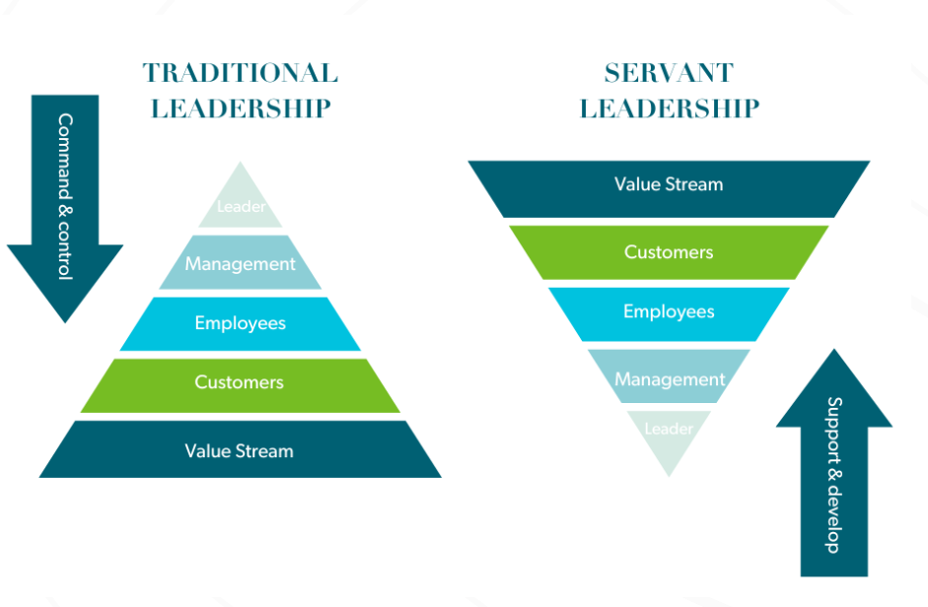
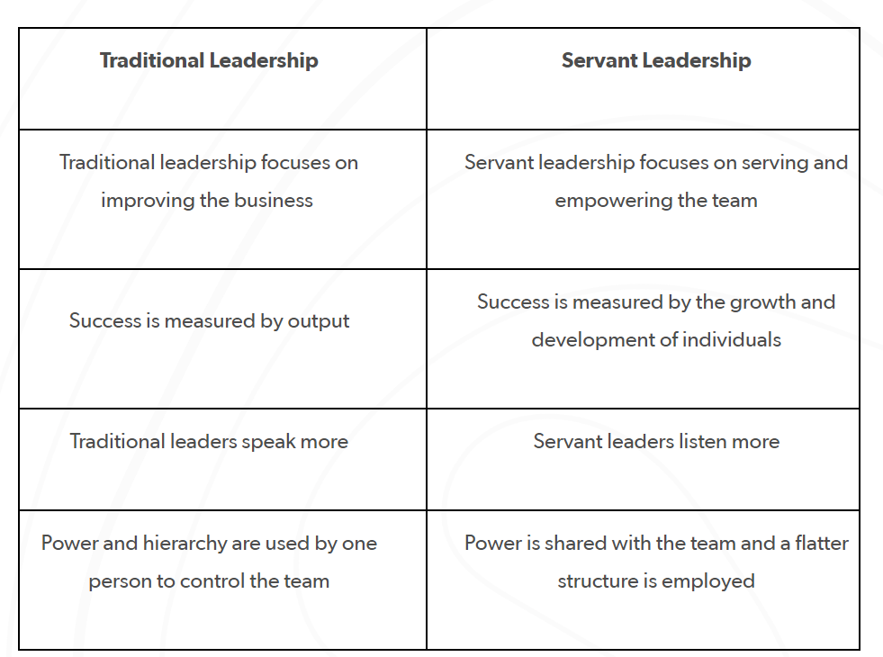
Figure 7 – The role of servant leadership in agility (Dancheva, 2023)

I prioritised the needs of the team above my own, remaining flexible and adaptable in my leadership approach. By utilising referent power and embodying servant leadership principles, I effectively facilitated the achievement of tasks and goals within the team and department.
I encouraged effetive communication and speaking truth to power in a respectful way. I listened attentively, asked questions to understand and sought input from all members. This quickly delivered improvements as team members and individuals felt empowered and stepped forward with ideas to see through some of the change manangment challenges. According to Owen (2020) as the leader entails assuming accountability, it is highly advantageous for the leader to allow team members to generate intelligent ideas.
It was clear the team were working hard. Whilst I held responsibility to deliver the overarching objectives, I was clear not to prioritise the task at the expense of the team as this is when productivity can decline and teams can become demotivated. This is supported by Arbinger Institute (2002) who emphasis the importance of leaders recognising individual autonomy and fulfiling both individual and teams need for effective leadership.

Evaluation
I took the lead in initiating and driving change by forming a guiding coalition consisting of individuals within my sphere of influence including the internal SMT, peers and external partners. I gave clarity of purpose and direction drawing upon two parts of servant leadership namely the visonary/direction role and the servant aspect namely operational and implementation (Blanchard, et al., 2005). I spent valuable time getting to know the team. I met them on an individual basis, displaying a genuine interest in their role and listened attentively, empathising to understand the impact the change had on them. Wallace & Gravells (2009) concur that social awareness, which involves recognising the emotions and needs of others is crucial. Additional research corroborates that individuals willingness to contribute to their fullest potential is influenced by how they are treated.
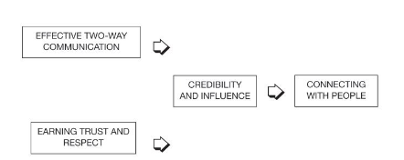
Figure 8 - Connecting with people (Wallace & Gravells, 2009)

What was good
Servant leadership ultimately assisted in positively influencing and implementing the change, positively leading the team, building strong relationships and gaining great results. According to Mughal & Shahid (2019) the behaviour of servant leaders indicate a deliberate persuation and solid position. This is taken to mean that servant leaders not only carry out their tasks and responsibilities but also actively seek to persuade and influence others.

Fostering the development of each member and holding the belief that individuals possess inherent worth that goes beyond their measurable contibution, the effectivness of my approach helped the team to achieve their goals. Academic evidence suggests that setting specific goals has a positive impact and teams are more likely to achieve challenging goals and higher level of performance compared to easier goals (Robbins & Judge, 2009). As a result, the team displayed overwhelming support towards me, wanting me to be successful and achieve my goals, which was to confidently embed in the rank and drive forward the department. Walt Disney started his theme parks with a clear purpose (Blanchard, et al., 2005), I ensured that I did the same. I presenting a clear purpose, which was to implement the change, connect the teams with strengthened relationships and to positively deliver the business.

I treated people as a family, a core aspect of servant leadership and utilsing moral power based on my personal values, I inspired action based on a strongly held set of values and beliefs as I pursued the vision. I knew how important it was to be true to myself and I started to gain greater knowledge which was shared with the team. Drawing on Law, et al (2017), organisations and their members demonstrate higher level of productivity when knowledge is effectively shared and subsequently utilised. As a consequence of this approach, the daily nervous feeling held in the pit of my stomach, which I had experienced since starting my role started to fade away as the team and I were able able to apply the knowledge, performing roles and tasks efficently.

What was bad
Aware of the downside I also recognised that whilst I held a positive and professional relationship with the team, I was mindful of normative behaviourists, where a team act and do to achieve a result or task, rather than fully understanding or knowing what they think. Accoring to (Miller, 2023) this can be problematic as some physical behaviours can tell you very little about an individual and the behaviour is further intepretated by thought. To motivate, I encouraged open and honest dialogue championing truth in the face of authority. To assist in this approach I further drew upon Albert Bandura’s theory (also known as social cognative theory).

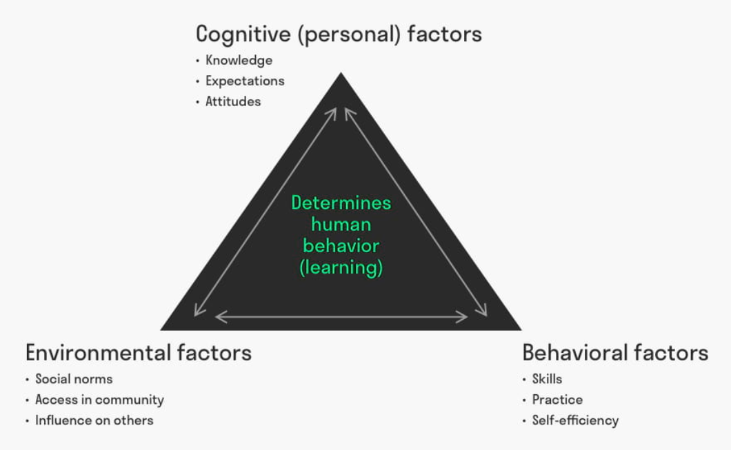
Figure 9 - Albert Bandura Social Learning Theory (Bandura, 1977)

I took the best learning from sensorial experiences and observing peers, subodinates and the the SMT. This provided me with opportunities to take contol of the work and I clearly saw that I had potential to acquire the necessary abilities to bring about meaningful change (Taylor, 2013). This approach improved my self-efficacy, I was in a postive psycholgical state, I started to believe in my own ability in the role and rank which further enhanced my motivation, persistance and personal resillience.Through observing and social learning, I further employed the principle of positive reinforcement, reward and recognition, recognised as communication and motivation devices (Ng & Tung, 2018) I ensured work was recognised, which proved to be a successful motivator for the team and helped to monitor shifts in behaviour. This served as a valuable opportunity for self reflection and personal growth.

Following rellocation of the department, I observed a particular officer who seemed disengaged and detached. I had not witnessed this demeanour from her before. Of concern was the negative impact it was starting to have on the team dynamics and the ability to accomplish tasks effectively. In response I took the initative and held additional one to one meetings with her sergeant. I adjusted my leadership style becoming more directive as I believed that by taking a more proactive and direct approach my leadership would prevent increased negativity in the work environment. This involved reducing some of the autonomy the sergeant held in leading her team.

Although I recognised the sergeants high level of competence, I perceived a lack of commiment to effectively address and influence the situation. Supported by Strang (2005) effective leaders utilise their influence and active presence to bring about change in the behaviour of their staff. However, I was concerned that if the disengagment persisted, the impact would be detrimental to the teams performance and morale and team members may look at alternative roles in the organisation

Consequently the sergeant disclosed to me that she was attempting to deal with a highly sensitive matter involving the officer, who had underlying and deep rooted issues. She stated that it was draining and taking a lot of her energy to resolve, impacting on her welfare and performance, which in turn was detrimental to her team’s moral and overall performance. She further disclosed that she had not advised me as she recognised the pressure that I had been put under by the organisation upon promotion and felt disloyal to her colleague by disclosing the issue. She stated that she felt incompetent as she could not deal with the issue herself as an experienced sergeant. Upon reflecting of the situation I clearly assumed early assumptions based upon (McGregor, 1960) theory X concept.

Analysis
Looking inwardly I identified my leadership style was ineffective. Looking back, I was manovouring from a servant leadership style displaying traits of an authoritarian leader, retaining authority to overcome the situation. Reflecting on my motivations which can be taken for granted in psychology (Bong, et al., 2023), I have now come to realise that on occasion they have been overlooked. My motivation has always been a driving force behind my actions, yet at this point in my career it was not utilised positvely in making good choices or achieving goals. Revisiting my early days in policing there was some resemblances to my first inspector which upset me as my intention was to always prevent others from experiencing the same emotional turmoil I experienced.

“People will forget what you said, people will forget what you did, but people will never forget how you made them feel” (Angelou, 1984).

I changed my approach, displaying higher levels of emotional intelligence. Whilst some acadamic acrticles have demonstrated a positve relationship between emotional intelligence and transformational leadership, conversely other studies have reported non significant results (Walter, et al., 2011). I stongly advocate for the importance of emotional intelligence and firmly believe it plays a crucial role in enhancing individual and organisational effectivness. I thoughtfully considered my approach, I made time to outline the position with the sergeant and talked openly and honestly about the situation. This provided the opportunity to proivde constructive and reassuring feedback. I discussed the sensitivies of the issue, advising I had managed a similar situation previously. Collectively we agreed a way forward in which I could mentor her through the situation increasing her confidence as well as protecting the reputation of the organisation maintaing critical oversight. Together we devised a supportive SMART action-plan which provided clarity of goals and direction (Herrity, 2023).
Rather than continuing to respond to the situation in an authoritarian style, I employed a participative leadership style by involving the sergeant in the decision making process and valuing her input. I stepped back so, there was less survillance, and I gave her back control over her team and wider decision making with greater and more meaningul support. This acted as a powerful source of motivation as she felt valued and recognised.

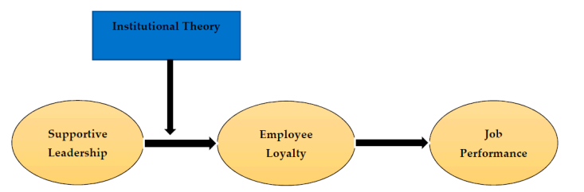

Figure 10 - The Effect of Participative Leadership Style on Employees’ Performance: The Contingent Role of Institutional Theory (Khassawneh & Elrehail, 2022)

Conclusion
As I have navigated my way through my policing career, I am more aware of the impact that my leadership style has on others. Reflecting on my early years, my inspectors behaviour clearly had a negative and long lasting effect on me. Whilst my leadership has matured over the years with experience, knowledge, command and leadership training, the way I dealt with the aforementioned situation had a negative impact on the sergeant. However, I was quick to recognise the impact and quick to make a change. According to Roe (2017), the conduct of a leader can exert a profound and significant impact on individuals and it is important for leaders to acknowledge the implications of their actions, influence and effect.

Upon wider reflection of my leadership style and review of two Myers Briggs Personality Tests taken seven years apart, my personality preference of Extraversion, Sensing, Thinking, Judgement (ESTJ) determines as an individual I am always driven and resolute to get the job done properly. I have a prominent leadership style seeking leadership directly and take charge quickly focusing on efficency and prodcuctivity (Myers, 1962).
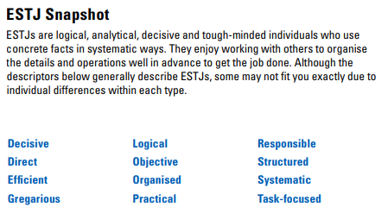

Figure 11 – Myers Brigg Type Interapretive Report Trudi Meyrick (MBTI, 2015)

Reflecting on both set of results my dominant motivator is the need for achievement, setting goals, making decisions and getting things done. I have a preference for motivated and hard working people and will monitor to determine that the job is done correctly, but can become frustrated and controlling if expectations are not met.
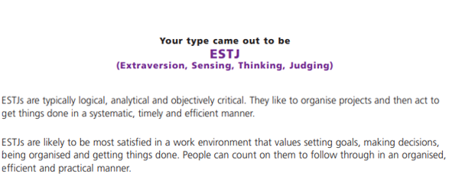
Figure 12 – Myers Brigg Type Interapretive Report Trudi Meyrick (MBTI, 2022)

Whilst I acknowledge the impact and influence my leadership style has on others, particularly in the way I initially led the sergeant, I quickly recognised my appraoch was ineffective and adapted by leadership style. However, people can rely on me to follow through tasks in an orgnaised efficent and practical manner. What is evident from both set of results is that I have a clear and preferred style of leadership. However I am mindful that I can on occasion make assumptions based on my management style, past expereinces and beliefs, shaping my thinking, the choices I make and influencing human behaviour (Boos & Jacquemart, 2000).
Whilst my personality tests demonstrate a level of assertivenss, we all have blindspots regardless of self awarness. On occasion I can feel insecure and I recognise the importance of feedback and the positive impact it has on me building personal confidence and reassurance.

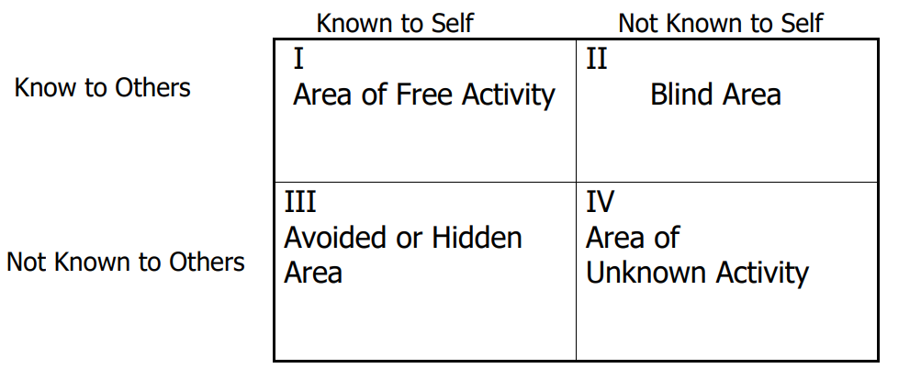
Figure13 – Johari’s Wndow - A Graphic Model of Awareness in Interpersonal Relations (Luft & Ingham, 1961)

Action plan
Reflecting on my experiences and how they have shaped my personal and professional development over the years, it has been supported by a development plan and SWOT analysis whereby I regulary critique my own work, evaluating and reflecting on my approach, identifying areas of strength and improvement, making adjustments as needed to enhance my personal leadership effectiveness and self awarness (Raeburn, 2023).
Reflecting on this situation, I earned respect of the sergeant and peers through the effective use of referent powers based on my personal characteristics of trust and admiration. This was earned through my personal qualities, emphasing communality by placing importance on shared values and role modelling (Raven, 2008). Maximising the use of emotional intelligence, displaying humility and acknowledging that I had assumed the wrong leadership style, the strong bond I built with the team, drew me professionally closer, building a solid relationship and positive connection. Together a shared sense of purpose developed through effective leadership rather than over exerting rank or power.
“Transformational leadership profoundly changes and enhances the motivations, values and objectives by imparting essential leadership principles, thus enabling leader and the team to work together cohesively in pursuit of organisational goals, elevating the team to higher moral standards”. (Krishnan, 2003, pp. 345-351)

Contemplating the implications of my actions, in the future, I will strive to adopt a more cautious approach and refrain from jumping to conclusions ensuring I give due dilligence to situations before formalising assumptions.

Summary

In my reflective analysis of my early career in policing I contemplate the enduring effect the inability to speak freely had on my personal growth and development. Policing remains a heirarchial rank structured organisation where power and rank can be a barrier for raising issues exacerbated by a perceived lack of psychological safety and fear of negative consequencs (Kish-Gephart, et al., 2009). However, I have come to a profound realisation that the hierarchical structure within the police system should not impede the ability to express thoughts and concerns to anyone in a position of authority.
In considering the situation and the authoritarian style of leadership I initially assumed as a newly promoted inspector, whilst it was inappropriate in the situation, it is a style of leadership that I still utilise in various situations. As a Public Order and Public Safety Commander, and a Firearms Gold Commander it can be the most appropriate style of leadership to achieve a desired result. Whilst I recognise this style leaves low autonomy and hinders participation and motivation as total decision making power sits in this leadership style, it is necessary in setting gold strategies to achieve strategic objectives. This leadership style is clearly advantageous in such circumstances where incidents are fast paced, high risk and task orientated, where goals are clearly defined and require strict adherence to procedures. This requires me to assume a highly directive-low supportive style of leadership that is authoritative and transactional (Bass & Riggio, 2006). In contrast as a force crisis negotatior an affiliative leadership style is used to build relationships, valuing open communication and empathy in an attempt to create trust and harmony and negotate the person out of the crisis situation.
Therefore in my role, movement between different styles of leadership dependant on the task, organisational needs, demonstrating adaptability is essential to effectively navigate diverse situations, engage team members, develop skills and foster personal growth.
To encourage participation and opinion, I have come to embrace a transformational or democratic leadership style, which emphasises the importance of actively involving others in decision making processes and encourages participation and expression of opinions regardless of role or rank. This approach fosters a collaborative and inclusive environment where everyone’s contributions are valued and respected.
Examining different approaches, in my academic self-reflection, over the years, I have developed a sense of maturity and confidence that enables me to prioritise the sharing of responsibilities, skills, knowledge and expereince with individuals who possess greater expertise. This approach now ensures that I am well-informed and equipped to make informed decisions, continuously displaying inclusive leadership.

Appendices

Appendix A
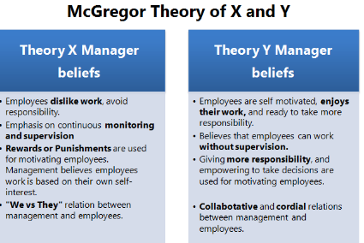

Trudi Meyrick - Impacting motivation and role satisfaction at this point in career was the application of the inspectors Theory X manager beliefs.

Appendix B
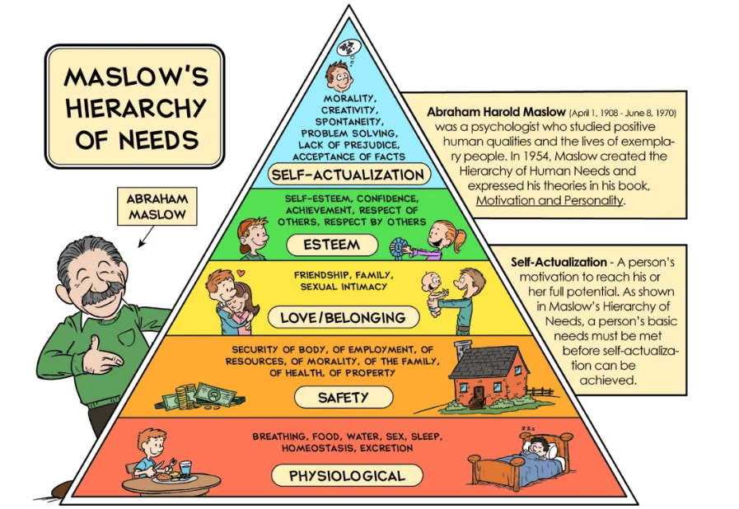

Trudi Meyrick psychological needs affected namely:
Love / Belonging

Organisational Impact Personal Impact
Feeling of team spirit missing Undervalued
Shallow relationships Not worthy
Lack of teamwork Alone

Appendix C
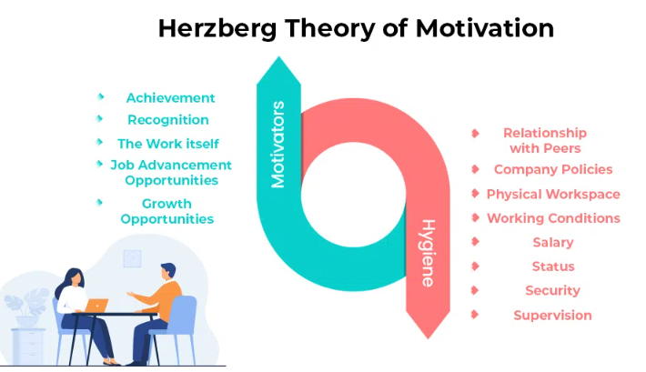

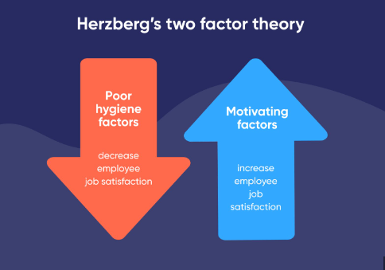

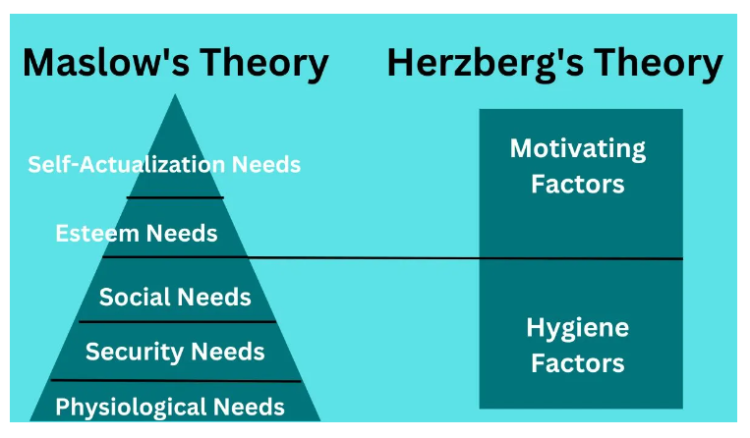
Appendix D


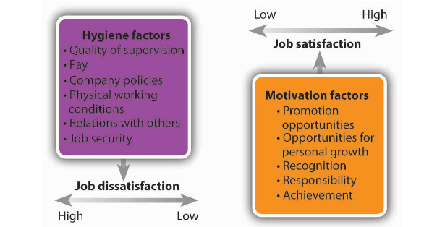

Trudi Meyrick – Motivation at this point in career
Addressing hygiene factors, lowered job dissatisfaction however did not lead to job satisfaction when motivators applied.

Appendix E

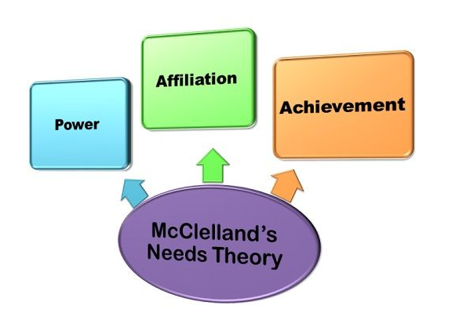
TRUDI MEYRICK - WORK/MOTIVATION

POWER - Ability to positively influence the behaviour of others and get things done. Does not like uncertainty if not in control.

AFFILIATION - Maintenance of good, pleasant and social relationships. Careful to maintain professional boundaries.

ACHIEVEMENT- seek feedback, motivated to succeed and complete the task to the best of ability with the highest of standards. Failure is not accepted, will seek alternative outcomes.

References
Angelou, M., 1984. I Know Why The Caged Bird Sings. New York: Randon House.
Arbinger Institute, 2002. Leadership and self-deception : getting out of the box. San Francisco: Berrett-Koehler.
Arnolds, C. A. & Boshoff, C., 2011. Compensation, esteem valence and job performance: an empirical assessment of Alderfer’s ERG theory. The Inernational Journal of Human Resource, 13(4), pp. 697-719.
Bandura, A., 1977. Self-Efficacy: Toward a Unifying Theory of Behavioural Change. 84(2), pp. 191-215.
Bass, B. M. & Riggio, R. E., 2006. Transformational Leadership. 2nd ed. New Jersey: Psychology Press.
Blanchard, K., Broadwell, R. & Maxwell, J. C., 2005. Servant Leadership in Action. 1 ed. Oakland: Berrett-Koehler Publishers Incorporated.
Bong, M., Reeve, J. & Kim, S.-i., 2023. Motivation Science: Controversies and Insights. Oxford: Oxford University Press.
Boos, L. & Jacquemart, C., 2000. A Primer on Decision Making: How Decisions Happen. Schmalenbach Business Review, 52(1), pp. 92-94.
Casey, L., 2023. An independent review into the standards of behaviour and internal culture of the Metropolitan Police Service, London: Metropolitan Police.
Chiang, J. T.-J. et al., 2021. We have emotions but can't show them! Authoritarian leadership, emotion suppression climate and team performance. Human Relations, 74(7), pp. 931-1119.
Daily Express, 2022. Policing is in crisis and it's the chief constables who are the problem. [Online]
Available at: ttps://www.express.co.uk/comment/expresscomment/1694884/police-crisis-chief-constables-failure-suella-braverman-criticism
[Accessed 21st December 2023].
Dancheva, R., 2023. Leadership in Agility. [Online]
Available at: https://www.agilesherpas.com/blog/agile-servant-leadership
[Accessed 20th December 2023].
Dowrick, P. W., 2012. Self modeling: Exanding the theories of learning. Psychology in the Schools, 49(1), pp. 30-41.
Gibbs, G., 1988. Learning by Doing. 1st ed. Oxford: FEU.
Global Institute for Research and Education, 2013. Herzberg's Two Factors Theory on Work Motivation: Does it Work for Todays Environment?. Global Journal of Commerce & Management Perspective, 2(5), pp. 18-22.
Gregg, 2023. McClelland's Theory of Needs. [Online]
Available at: https://www.google.com/gasearch?q=mcclelland%20needs%20theory&tbm=&shem=rime&source=sh/x/gs/m2/5#fpstate=ive&vld=cid:dac78b39,vid:kxUfU-Vsq9o,st:0 <https://gbr01.safelinks.protection.outlook.com/?url=https%3A%2F%2Fwww.google.com%2Fgasearch%3Fq%3Dmcclellan
[Accessed 17th December 2023].
Guo, L. et al., 2018. Authoritarian leadership and employee creativity: The moderating role of psychological capital and the mediating role of fear and defensive silence. Journal of Business Research, Volume 92, pp. 219-230.
Herrity, J., 2023. How To Write SMART Goals in 5 Steps (With Examples). [Online]
Available at: https://www.indeed.com/career-advice/career-development/how-to-write-smart-goals
[Accessed 2nd January 2024].
Ikwukananne, I. & Udechukwu, D., 2009. Correctional Officer Turnover:of Maslow's Needs Hierarchy and Herzberg's Motivation Theory. Public Personal Management, 38(2), pp. 74-79.
Institute Project Management, 2023. 10 Leadership Styles and How to Identify Your Own. [Online]
Available at: https://www.projectmanagement.ie/blog/leadership-styles/
[Accessed 3rd January 2024].
Jasper, M., 2003. Beginning Refective Practise. Cheltenham: Nelson Thorne Ltd.
Khassawneh, O. & Elrehail, H., 2022. The Effect of Participative Leadership Style on Employees’ The Contingent Role of Institutional Theory. Administrative Sciences, 12(4), pp. 1-13.
Kish-Gephart, J., Detert, J. R., Trevino, L. K. & Edmondson, A. C., 2009. Silenced by Fear:: The Nature, Sources, and Consequences of Fear at Work. Research in Organisational Behaviour, Volume 29, pp. 163-193.
Krishnan, V. R., 2003. Power and Moral Leadership: Role of Self-Other Agreement. Leadership & Organizational Development, 24(5/6), pp. 345-351.
Law, K., Chan, A. & Muammer, O., 2017. Towards an integrated framework of intrinsic motivators, extrinsic motivators and knowledge sharing. Journal of Knowledge Management, 21(6), pp. 1486-1502.
Luft, J. & Ingham, H., 1961. The Johari Window - A Graphic Model of Awareness in Interpersonal Relations. Human Relations Training News, 5(1), pp. 6-7.
Lunenburg, F. C., 2012. Power and Leadership: An Influence Process. International Journal of Management, Business and Administration, 15(1), p. 1.
Lussier, R. N. & Achua, C. F., 2015. Leadership: Theory, Application & Skill Development. 6th ed. Boston: Cengage Learning.
MBTI, 2015. Myers-Briggs Type Interpretive Report for Organisations. Report prepared for Trudi Meyrick, Swansea: MBTI.
MBTI, 2022. Myers- Briggs Type Indicator; Interpretive Report. Report prepared for Trudi Meyrick, 2022: MBTI.
McGregor, D., 1960. The Human Side of Enterprise. New York: McGraw-Hill.
Miller, D., 2023. Why Normative Behaviour Fails. Sage Journal, 21(3), pp. 441-446.
Mughal, Y. H. & Shahid, K., 2019. Servant Leadership Styles and Strategic Decision Making. USA: IGI Global.
Mullins, L. J., 2019. Organisational Behaviour in the Workplace with Jacqueline McLean. 12th ed. Harlow: Pearson Education Limited.
Myers, I. B., 1962. The Myers-Briggs Type Indicator: Manual. Princeton, New Jersey: Educational Testing Service .
Ng, P. K. & Tung, B., 2018. The importance of reward and recognition system in the leadership of virtual project teams: a qualitative. Journal of Transnational Management, 23(4), pp. 198-214.
Owen, J., 2020. The Leadership Skills Handbook : 100 Essential Skills You Need to Be a Leader. 5th ed. London: Kogan Page Limited.
Pardee, R. L., 1990. Motivation Theories of Maslow, Herxberg, McGregor & McClelland. [Online]
Available at: https://gbr01.safelinks.protection.outlook.com/?url=https%3A%2F%2Ffiles.eric.ed.gov%2Ffulltext%2FED316767.pdf&data=05%7C02%7CTrudi.Meyrick%40south-wales.police.uk%7Cae058d68210b4e31690e08dbff4b46a4%7C270c2f4dfd0c4f0892a9e5bdd8a87e09%7C0%7C0%7C638384471140
[Accessed 17th December 2023].
PHILO-notes, 2021. Abraham Maslows's Hierarchy of Needs Explained. [Online]
Available at: https://www.bing.com/videos/riverview/relatedvideo?q=maslow%27s+hierarchy+of+needs&mid=0EDFCA8CFD4EA93BBA680EDFCA8CFD4EA93BBA68&FORM=VIRE
[Accessed 31st 12 2023].
Pichere, P., 2015. Maslows Hierarchy of Needs. Belgium: Primento Publishing.
Pink, D. H., 2009. Drive: The Surprising Truth about what Motivates us. New York: Riverhead.
Raeburn, A., 2023. SWOT analysis: Examples and templates. [Online]
Available at: https://asana.com/resources/swot-analysis
[Accessed 31st December 2023].
Raven, B. H., 2008. The Bases of Power and the Power/Interaction. Analyses of Social Issues and Public Policy, 8(1), pp. 1-22.
Robbins, S. & Judge, T., 2009. Organizational Behavior. 17th ed. Harlow: Pearsons Education Limited.
Roe, K., 2017. Leadership; Practice and Perspectives. 2nd ed. Oxford: Oxford University Print.
Rybnicek, R., Bergner, S. & Gutschelhofer, A., 2017. How individual needs influence motivation effects:a neuroscientific study on McClelland’s need theory. Springer, 13(2), pp. 443-482.
Scott, D. & Freeman, E. R., 2021. Models of Leadership in Plato and Beyon. Oxford: Oxford University Press.
Smith , R., 2019. The ‘Police Change Manager’: Exploring a new leadership paradigm for policing. International Journal of Police Science and Management, 21(3), pp. 156-167.
Strang, K. D., 2005. Examining effective and ineffective transformational project leadership. Team Performance Management, 11(3/4), pp. 68-103.
Strategic Review of Policing in England and Wales, 2022. New landmark report into future of policing proposes most fundamental reform for a generation. [Online]
Available at: ttps://www.policingreview.org.uk/new-landmark-report-into-future-of-policing-proposes-most-fundamental-reform-for-a-generation/
[Accessed 21st December 2023].
Taylor, R., 2013. Confidence at Work. London: Kogan Page Ltd.
The Police Foundation, 2022. Only fundamental reform can reverse the crisis of confidence in policing” says Chair of Strategic Review of Policing. [Online]
Available at: https://www.police-foundation.org.uk/news/only-fundamental-reform-can-reverse-the-crisis-of-confidence-in-policing-says-chair-of-strategic-review-of-policing/
[Accessed 21st December 2023].
Torrible, C., 2022. Trust in the police and policing by consent in turbulent times. Safer Communities, 21(3), pp. 171-183.
Wallace, S. & Gravells, J., 2009. Leadership and leading teams. Exeter: Learning Matters.
Walter, F., Cole, M. S. & Humphrey, R. H., 2011. Emotional Intelligence: Sine Qua Non of Leadership or Folderol?. Academic of Management Perspectives, 25(1), pp. 45-59.
Wilson & Associates, 2021. Social Power and Influence within a Team. [Online]
Available at: https://www.wilsonpublishing.com/social-power-and-influence-within-a-team/
[Accessed 3rd January 2024].
Yuki, G. & Gardner, W. L., 2019. Leadership in Organizations. 9th ed. Harlow: Pearson.

