Student Name: Masum Chowdhury
Student ID: 2533886

Complete the TEEL tasks below. Please note that the use of AI is not permitted for this task.
- Read the paragraph below.
Identify the TEEL structure in the paragraph.
Write the correct part of TEEL next to each sentence in the square brackets.
- T: [Topic Sentence]
- EXP: [Explanation]
- E: [Evidence / Example]
- L: [Link Sentence]

Paragraph
[T] Using data to make business decisions improves efficiency and reduces risk. Many businesses now analyse data to guide pricing, stock levels, and planning. [EXP] Research from McKinsey Global Institute (2017) found that data-driven organizations are significantly more likely to acquire customers and be profitable than those that rely on intuition. [E] This shows that using data can directly improve business performance. [EXP] It is not just about collecting information. [L] Additionally, businesses must also use the data to make informed decisions. [ EXP] For example, data can highlight which products are selling well and which are not. [E] This allows managers to adjust quickly and reduce waste. [L]Over time, these small decisions can lead to higher profits and better use of resources. [L] Overall, using data supports more accurate and effective business decision-making.
- Find the cohesive devices in the above paragraph and highlight or underline them. Then fill in the answers for each below.

A, Device: Additionally, - Extending the idea by adding further supporting details.
B, Device: For Example, - Purpose: introduces a specific illustration which clarifies the point bei
C, Device: Overall - Purpose: concludes the paragraph by bringing the ideas together and reinforcing the main argument.
- Choose the strongest topic sentence from the options below.

- Time management is important.
- Time management is important because it helps people organise their work.
C) Time management is important because it helps employees prioritise tasks, meet deadlines, and reduce workplace stress, leading to higher productivity.

- Choose the strongest explanation sentence
Topic Sentence:
Good teamwork is important in the workplace because it helps employees achieve shared goals efficiently.
Which is the best explanation?
A) Teamwork happens in many workplaces.
B) When employees collaborate effectively, they can share ideas, solve problems faster, and support each other’s strengths.
C) Some people prefer to work alone.
- Choose the strongest evidence/example
Topic Sentence:
Workplace training is essential because it helps employees improve their skills and performance.
Explanation:
When employees receive proper training, they become more confident and capable in their roles.
Which is the best evidence/example?
a) Training is something companies often provide.
b) A study by LinkedIn (2023) found that 94% of employees said they would stay longer at a company that invests in their learning.
c) Employees go to work every day.

- Choose the best linking sentence
Topic Sentence:
Flexible working hours can improve employee satisfaction and productivity.
Explanation + Evidence:
When employees can manage their own schedules, they are better able to balance work and personal responsibilities. For example, many companies report increased performance after introducing flexible working policies.
Which is the best linking sentence?
A) Flexible working is becoming more common.
B) Employees like flexibility.
C) Overall, flexible working hours contribute to a more productive and satisfying workforce.
Write the final draft of your TEEL paragraph on your chosen topic here. This is the final draft of the paragraph you started in class!
Teel Final Draft
Communication is important in the workplace because it helps employees collaborate effectively and achieve shared goals. This is especially prevalent within the food industry, especially in the restaurant business. When employees receive clear instructions, constructive feedback, and open channel discussion, they are more likely to feel confident, supported, and able to perform their tasks successfully. There are multiple examples of this where this is used in the restaurant business, for example kitchen staff as well as the ‘front of house where the waiters are serving the customers and to ensure customer satisfaction is always met. For example, McKinsey (2023) explains that organisations with effective communication systems experience faster problem-solving and stronger teamwork because employees can share openly. Delite (2022) also notes that transparent communication builds trust, which encourages employees to participate more actively in decision-making. The purpose of this allows business to thrive in terms of profit and customer satisfaction and if any members of staff are in need to help they are able to use teamwork to help guide them through processes that they may not be sure of. This shows that communication is not only about exchanging information but also about creating a positive environment where employees feel valued and included in decisions and therefore able to collaborate with other team members. It can also be argued that communication is that foundation of business thriving as it can promote teamwork and other beneficial factors to help businesses to grow successfully. Overall, when organisations invest in strong communication practices, they build a more connected, productive, and high-performing workforce (Harvard Business Review, 2021).

References:
Business communication. (n.d.). [online] hbr.org. Available at: https://hbr.org/topic/subject/business-communication [Accessed 1 Aug. 2026].
Capabilities | McKinsey & Company. (n.d.). [online] www.mckinsey.com. Available at: https://www.mckinsey.com/capabilities [Accessed 1 Aug. 2026].
Deloitte Insights. (2026). Talent. [online] Available at: https://www.deloitte.com/us/en/insights/topics/talent.html%20 [Accessed 1 Aug. 2026].

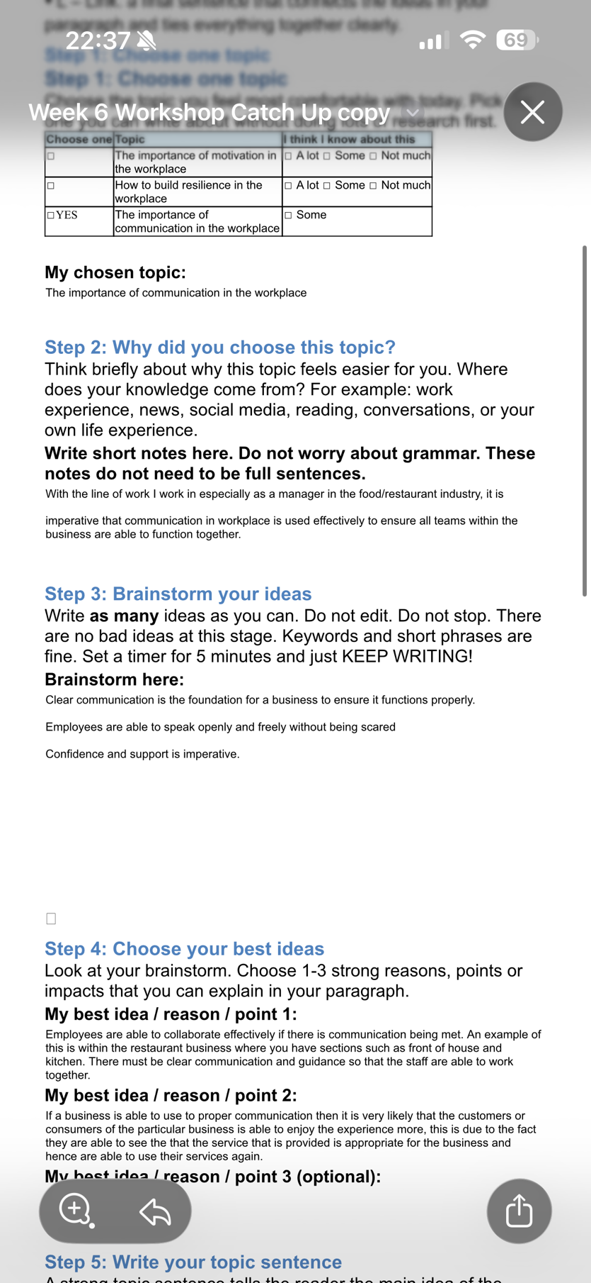
WEEK 6 EVIDENCE PHOTOGRAPH OF DRAFT- please note that I was not able to access where I could upload the evidence hence I have screenshotted the necessary week 6 task for the draft and therefore have completed what I was meant to do for the AS2 .


