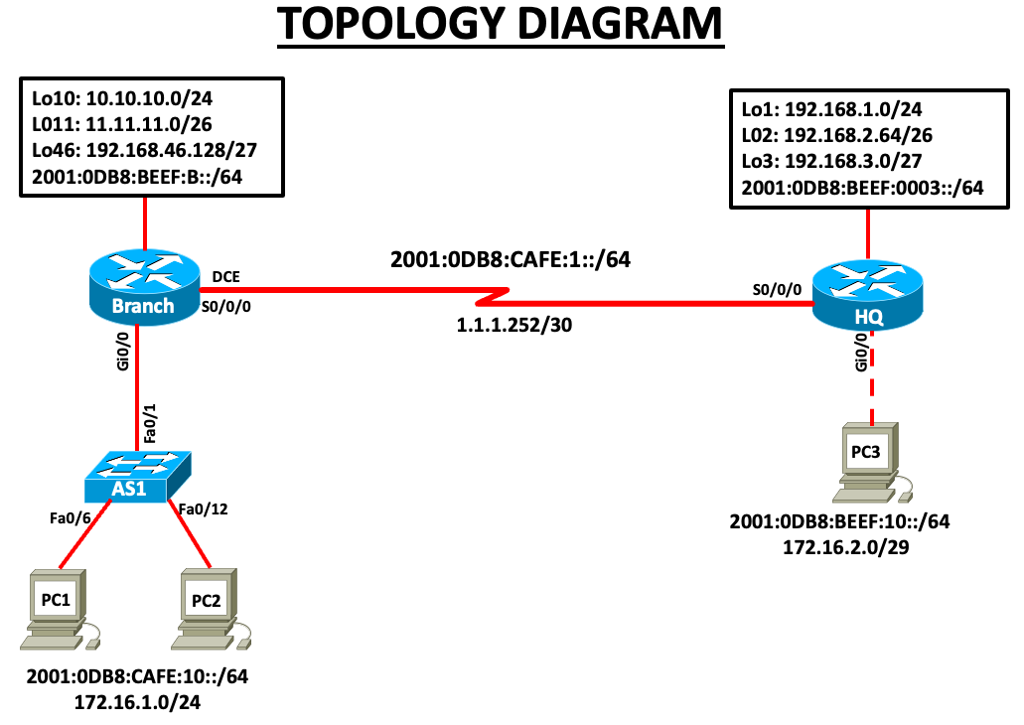
The lab is to be conducted on real devices in pairs. It is open, so you may research on the internet; the idea is to be able to complete the task.
NB : LAB interfaces may not match actual device interfaces. Run a “show ip interface brief “ on routers and switches before starting. Router interfaces may vary (e.g., Gi0/0 & Gi0/1 or Gi0/0/0 & Gi0/0/1), and switch interfaces can also differ based on the model.
- From the topology diagram, create and complete your own IP addressing table. For LAN and IPv4 addresses, assign the first usable address to the router interface, the second usable address to the switch, and last usable addresses to the PCs. For IPv6, use the first, second, third, and fourth addresses to meet your addressing requirements.(40 marks)
- Cable and configure the topology, then conduct the tests below.
- Configure IPV6 Static Routing
- Configure OSPV2
3..Network connectivity for both IPV4 and IPV6 (60 marks)
Using ping command, verify end-to-end connectivity for both IPv4 and v6 networks:
  - From PC1, ping PC2. Is it successful? ________
  - From PC1, ping the any Loopback on Branch router . Is it successful? ________
From PC2, ping any Loopback on HQ Router. Is it successful? ________
From PC2 , ping PC3 . Is it successful-----------------?

