LEARNING IN THE DIGITAL ERA
ASSIGNMENT 1: E-PORTFOLIO
CyberShield Learning Portfolio
Building the Human Capabilities of a Future Cybersecurity Incident Analyst
LEARN | COLLABORATE | EVIDENCE

Student name | CORNEL RUSALIM
Student ID | 2539927
Programme | CertHE Computing Skill for Workplace
Module code | ACCA4025
Module | Learning in the Digital Era
Assessment | Assignment 1: E-Portfolio
Submission deadline | 24 July 2026, 2.00 pm

Table of Contents
E-Portfolio: Link and Homepage Evidence 3
Task 1 - IEEE Referencing and Essential Academic and Employment Skills 4
1a. Essential skills for study and employment 4
1b. Turnitin similarity and self-assessment reflection 5
Task 2 - Collaborative Teamwork and Professional Academic Poster 7
2a. Team activity record 7
Team reflection prompts 9
TASK 2: POSTER 10
Task 3 - Automatic Referencing Tool 12
3a. Structured communication in virtual cybersecurity teams 12
3b. Practical evidence of RefWorks use 13
References 16
Task 4 - E-Portfolio Creation and Review 17
4a. Build specification 17
4b. Illustrative Review of the Completed E-Portfolio 17
Required screenshot evidence 18
References 22
Appendix 1 – AI Research Output for Task 1 22

E-Portfolio: Link and Homepage Evidence
https://sites.google.com/view/cornel-rusalim/cybershield-learning-portfolio

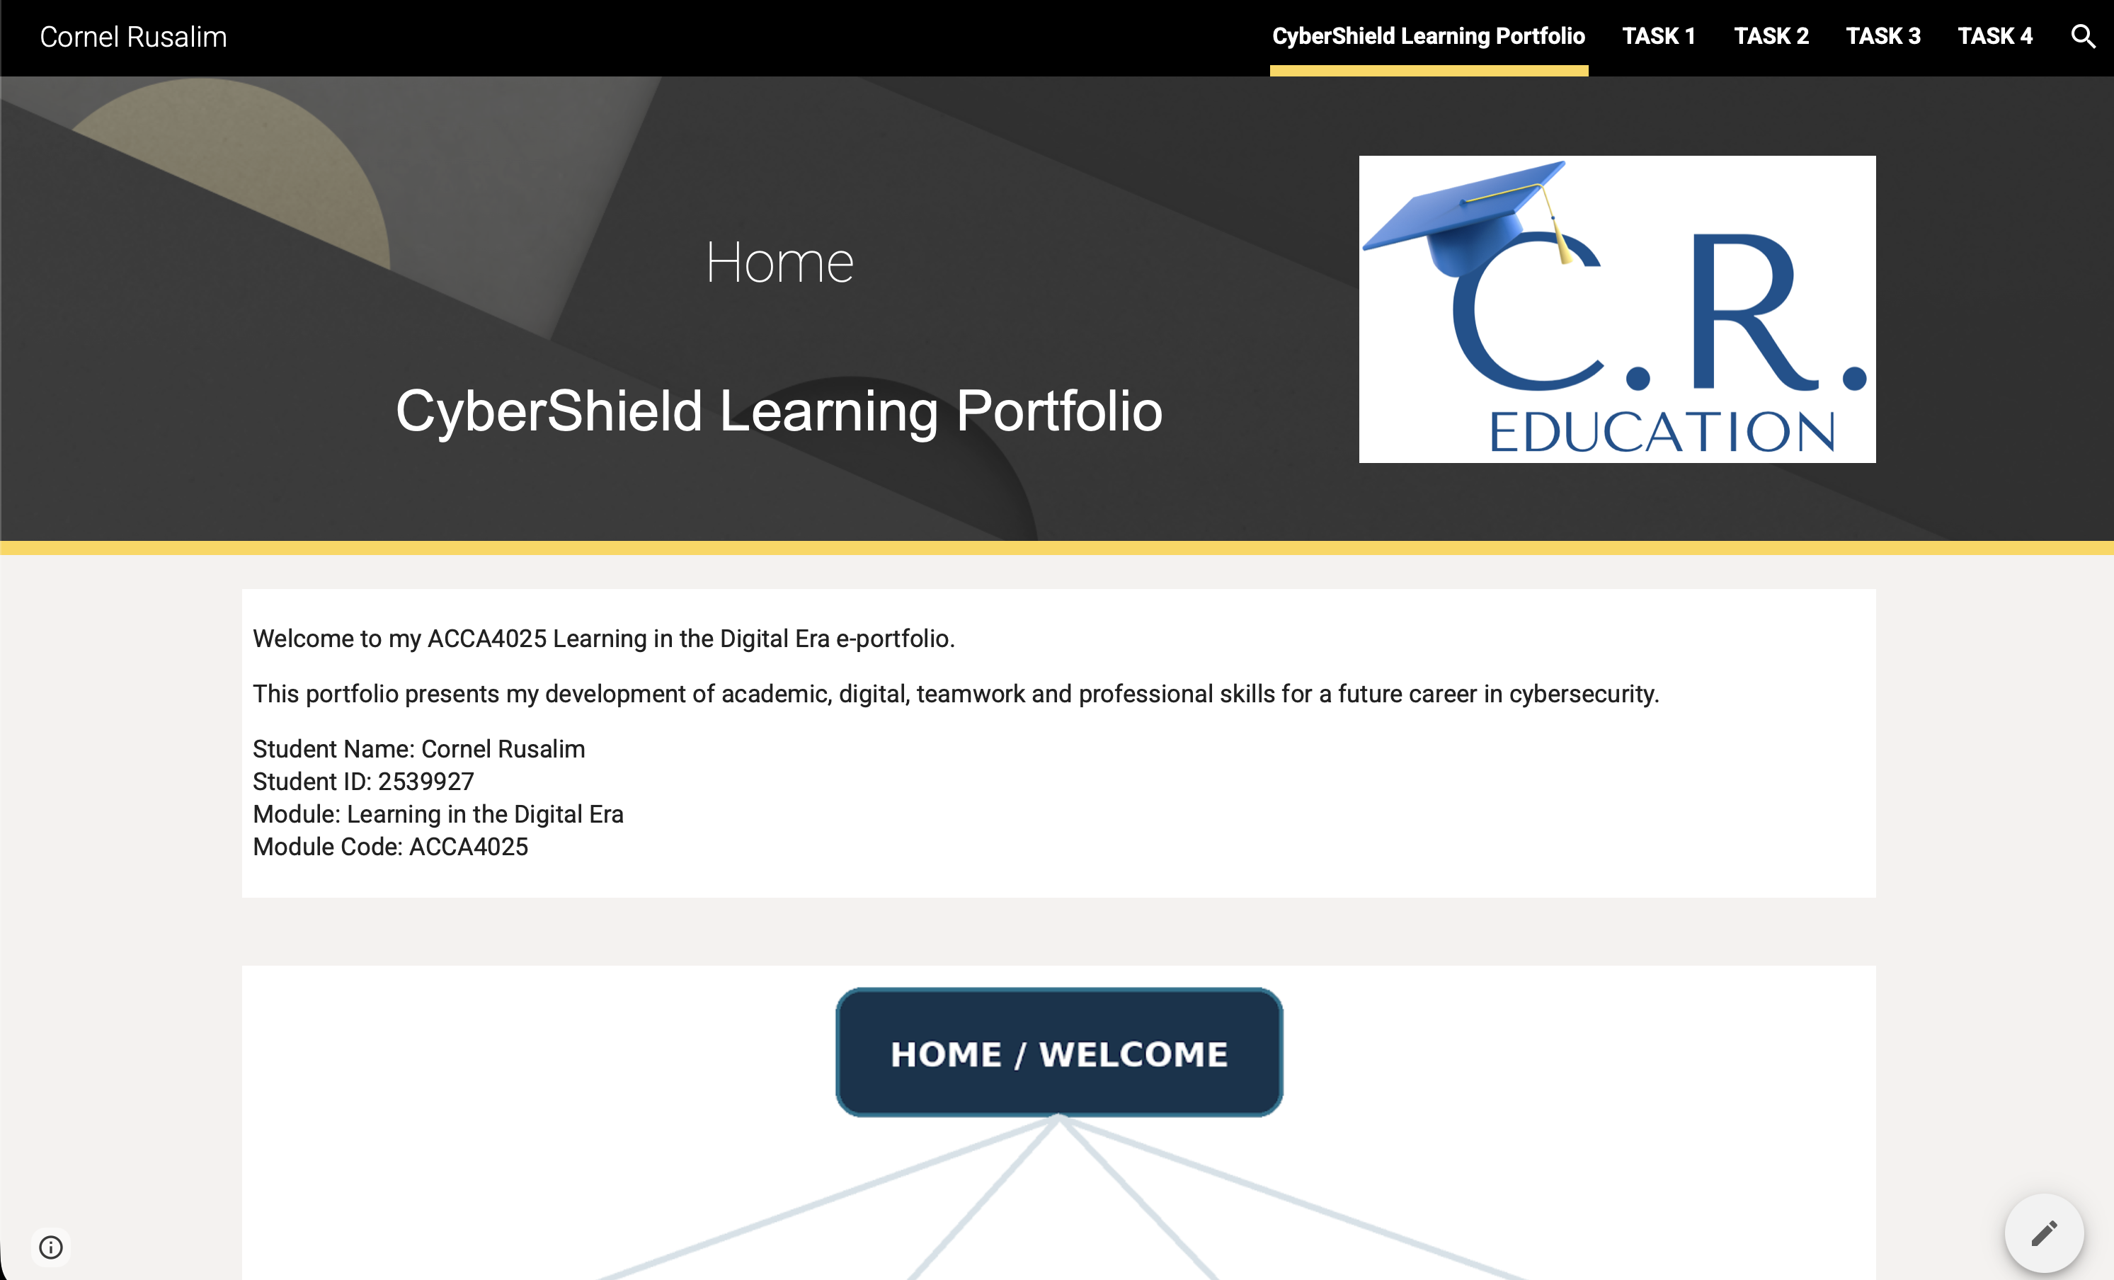

Welcome to my CyberShield Learning Portfolio The following portfolio chronicles the academic, digital and professional skills I am developing for a role in cybersecurity incident analysis. It provides examples of information literacy, collaboration in teams, virtual collaboration, referencing and reflection. Every page connects research with practice and demonstrates how I am starting to investigate data, communicate choices and polish my work through feedback.

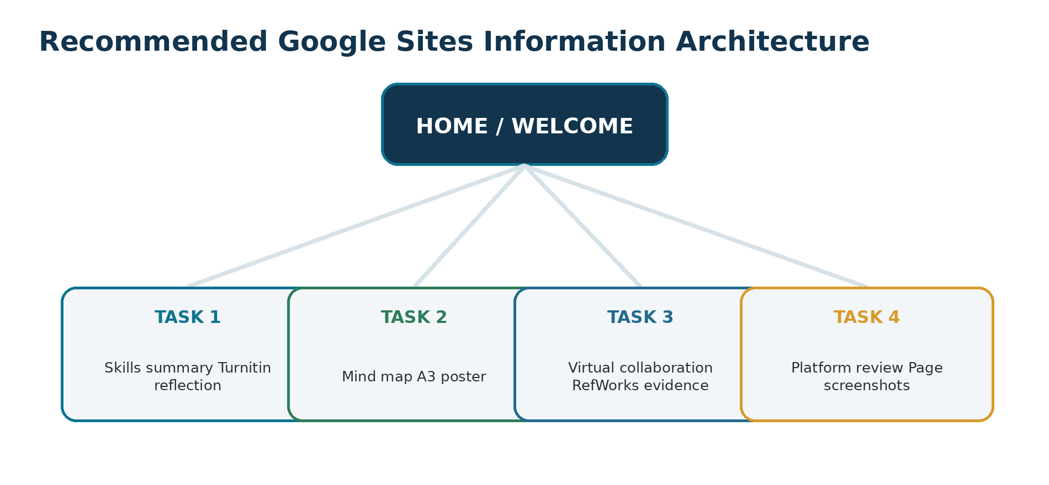
Figure 1. Recommended e-portfolio information architecture (original planning visual).

Task 1 - IEEE Referencing and Essential Academic and Employment Skills

1a. Essential skills for study and employment
Cybersecurity incident analysis combines technical judgement, clear communication and disciplined learning. Cybersecurity work is described in the NICE Framework using tasks, knowledge and skills demonstrating that employability depends on practical capability rather than simple familiarity with software tools [2]. The first major skill in your studies will be information literacy locating reliable evidence, assessing source quality and correctly referencing sources using IEEE. This facilitates accurate threat intelligence and mitigates speculative decision-making [1].
Analytical problem-solving is equally important. An incident analyst must make sense of partial logs, test rival hypotheses and separate relevant signals from noise. The European Cybersecurity Skills Framework building operational roles with risk analysis, incident management and high confidence reporting [3]. Technical fluency in networks, operating systems, cloud services, scripting and security tools allows for gathering and validation of evidence by the analyst. Career guidance also emphasizes practice, networking and writing [4].
Technical ability alone is insufficient. The top non-technical need for development in the workforce would be communication from ISC2’s research [5]. An analysis of 17,929 cybersecurity job advertisements identified similar demand for knowledge management, data analysis, teamwork and diversity [6]. Given that threats, controls and organisational priorities are constantly shifting resilience, ethical judgement and continuous learning are key. According to the World Economic Forum [7], networks and cybersecurity, technological literacy, analytical thinking and resilience are among skills gaining importance.
This profile will be developed through labs, reflective logs, peer feedback and an evidence-based e-portfolio. It demonstrates not only what I know, but also how I research, communicate, evaluate evidence and improve my work. The summary was informed by generative-AI research notes [1], which were checked and verified against current professional and academic sources [2] – [7].

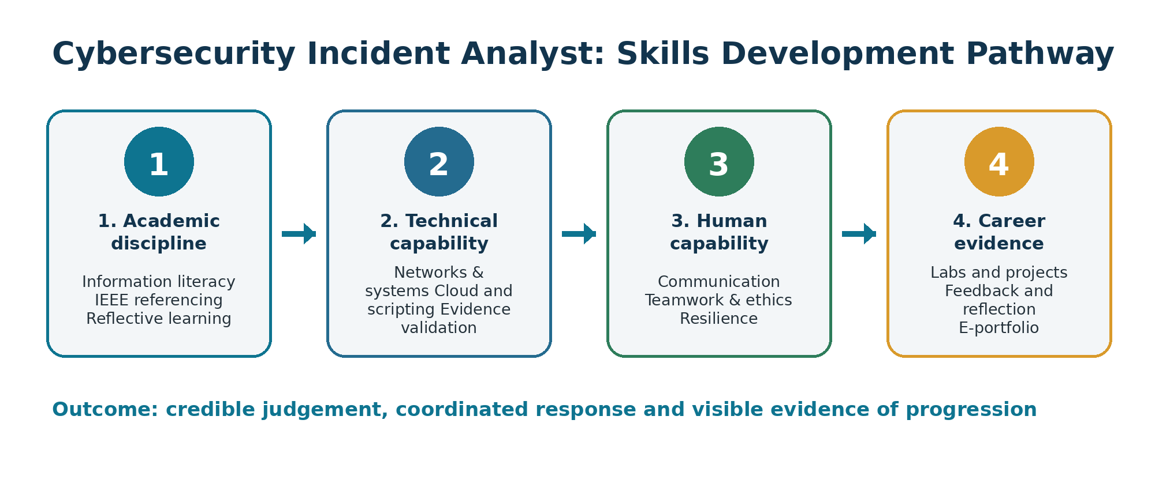
Figure 2. Skills development pathway for a future cybersecurity incident analyst (original visual).

1b. Turnitin similarity and self-assessment reflection
TURNITIN EVIDENCE
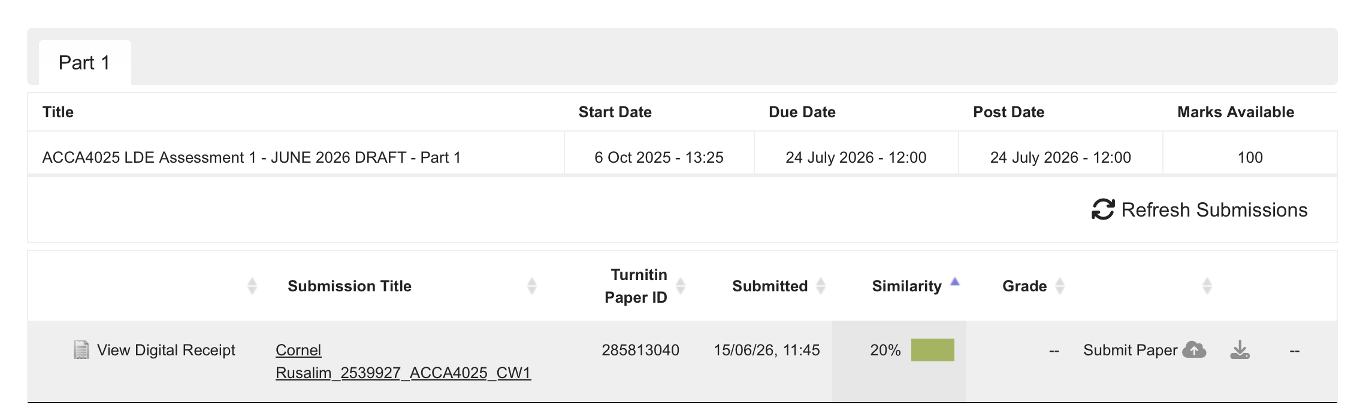

Turnitin Similarity Reflection
My Turnitin similarity score is 20% This means that a large part of the submission was written in my own words, but a few matches can be expected by checking sources correctly, use slip-ups, key phrasing and the reference list. The only difference between my next submissions and this one is: I would painstakingly check each highlighted match; rephrase source material much more precisely and quote verbatim only where absolutely needed. Generic Assessment Criteria Score: 74% It shows relevant research, correct IEEE referencing, practical implementation and a professional format. To gain a better mark at distinction level, more comparative critical engagement between sources and a closer reflection of my learning processes would have also been needed.

References
[1] OpenAI’s ChatGPT, private communication, Jun. 27, 2026.
[2] R. Petersen, D. Santos, K. Wetzel, M. Smith and G. Witte, "Workforce Framework for Cybersecurity (NICE Framework)," NIST Special Publication 800-181 Rev. 1, Nov. 2020, doi: 10.6028/NIST.SP.800-181r1.
[3] European Union Agency for Cybersecurity, "European Cybersecurity Skills Framework Role Profiles," Sep. 2022. [Online]. Available: https://www.enisa.europa.eu/publications/european-cybersecurity-skills-framework-role-profiles. [Accessed: Jun. 27, 2026].
[4] G. Auger, J. Scott, J. Helmus and K. Nguyen, Cybersecurity Career Master Plan. Birmingham, UK: Packt Publishing, 2021.
[5] ISC2, "2024 ISC2 Cybersecurity Workforce Study," Oct. 2024. [Online]. Available: https://www.isc2.org/Insights/2024/10/ISC2-2024-Cybersecurity-Workforce-Study. [Accessed: Jun. 27, 2026].
[6] C. M. Graham and Y. Lu, "Skills expectations in cybersecurity: Semantic network analysis of job advertisements," Journal of Computer Information Systems, vol. 63, no. 4, pp. 937-949, 2023, doi: 10.1080/08874417.2022.2115954.
[7] World Economic Forum, The Future of Jobs Report 2025. Geneva, Switzerland: World Economic Forum, 2025.

Task 2 - Collaborative Teamwork and Professional Academic Poster

2a. Team activity record
Evidence item | Details | Verification
My Contribution | Cornel Rusalim | Here, I researched on the five collaboration themes; the drafted content for cybersecurity section; organized the branches in Coggle and checked through finished presentation.
Collaboration tools | Zoom & Classroom  With Eugen Iorgu | Collaboration through Zoom, classroom discussions and Coggle.
Mind-map tool | Coggle | https://coggle.it/diagram/aj_efYVaifWNtPIo/t/-/AlTdfPfRiBsUGh--47jqaod-KASxdlPsAbvBMcAvOR0

Final Team Mind Map: Effective Teamwork in Cybersecurity Incident Response
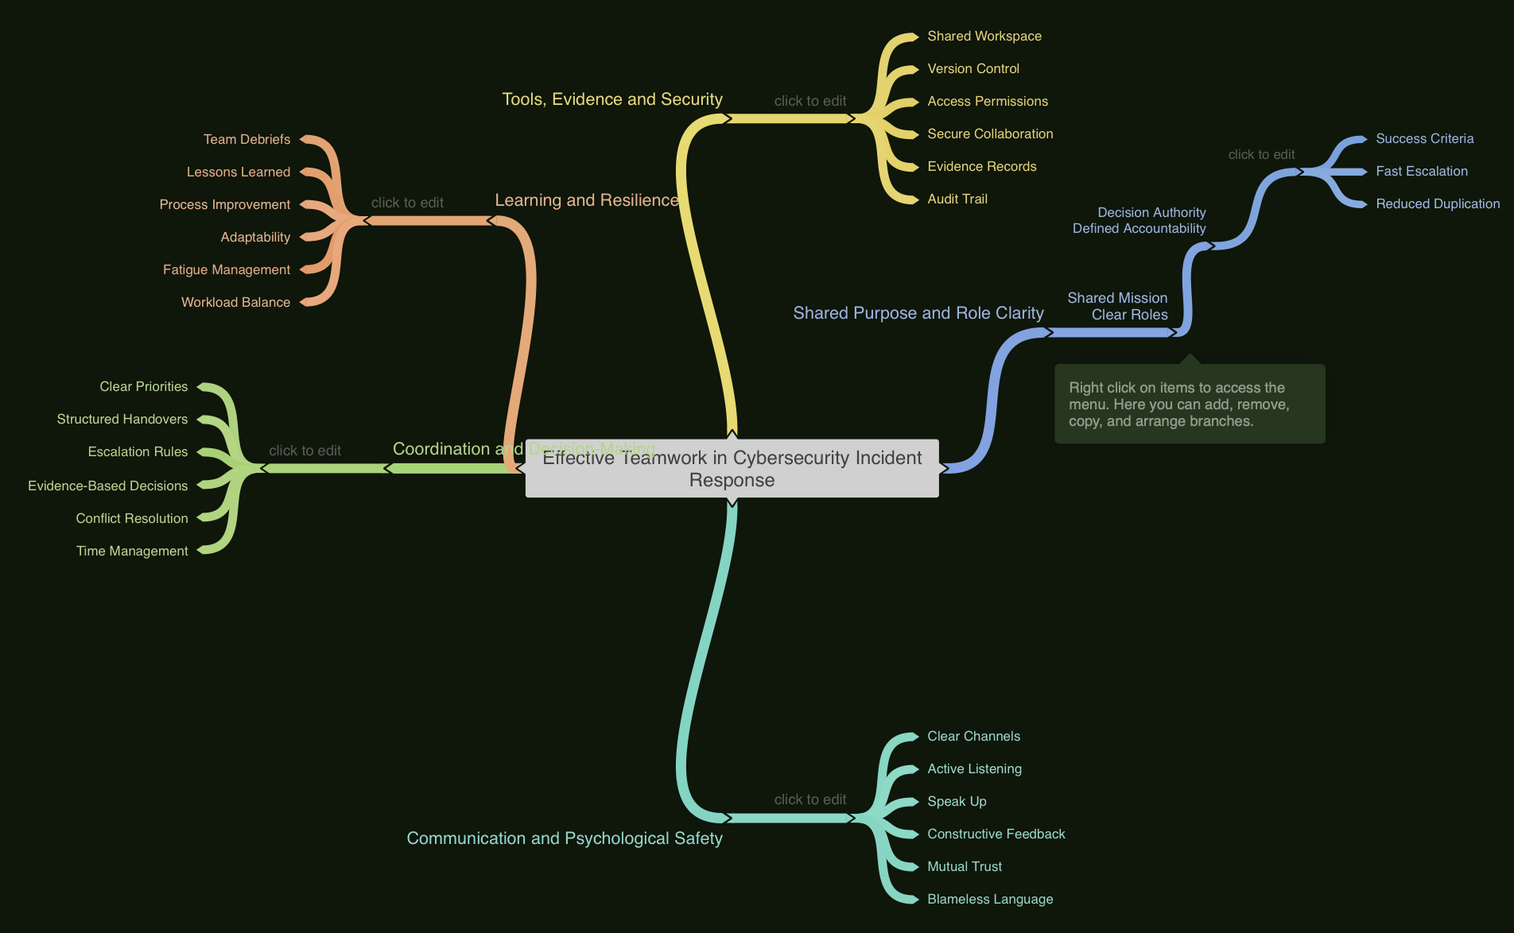
Figure 3. Final collaborative mind map showing the key considerations for effective teamwork in cybersecurity incident response.

Link Coggle Map
https://coggle.it/diagram/aj_efYVaifWNtPIo/t/-/AlTdfPfRiBsUGh--47jqaod-KASxdlPsAbvBMcAvOR0

Shared Purpose and Role Clarity
Effective cybersecurity teamwork begins with a shared mission: protecting systems, data and users while restoring services safely. Successful incident classification, response, report generation and minimum business impact need to be key objectives. It is essential to define the roles, authority and reporting lines required for a particular incident scenario ahead of time so that every member knows who investigates, communicates, authorizes and escalates decisions. It reduces delay, pitfalls and prevents duplicated effort by allocating high-risk tasks only to individuals within your team who are authorised to take that action [1], [4].
Communication and Psychological Safety
Teams should agree in advance which communication channels will be used during an incident, how often teams should reach out for updates along with common terminology and escalation routes. Updating short and succinct, based on evidence, along with active listening reduces miscommunication and constructive feedback increases the common information status. Psychological safety is just as critical: here, it is also important that members can challenge assumptions, report errors and raise concerns without fear of humiliation or retaliation. Research indicates that psychological safety shared among team members is associated with better overall team performance and trust promotes knowledge sharing in virtual teams. Thus, leaders must encourage diverse perspectives and use language that is respectful, non-blaming and geared toward learning or improving the system [2], [3].
Coordination and Decision-Making
Coordination becomes easier when it is informed by agreed priorities, structured handovers and controlled decision-making. The team should identify what needs immediate attention in terms of systems, users and risks then assign the tasks according to competence, authority and availability. This means serious issues get routed outside the IT help desk in a timely manner, directly to senior decision-makers as per the predefined escalation criteria. Disagreement should be resolved through evidence, agreed procedures and professional discussion rather than personal authority. Short briefings, action logs, deadlines and progress checks create more efficient time management and help keep participants focused for the entire incident response [1], [4].
Tools, Evidence and Security
Secure digital tools support accountability and operational continuity. What a shared workspace does is it just logs task ownership, timelines of incidents and decisions made evidence and approved communications. While version control minimizes confusion over which document is the current one, access permissions follow least-privilege principles. Sensitive information must be secured at rest, in transit and in conversation. Accurate records support review, regulatory compliance and future learning without unneeded exposure of sensitive or proprietary information [4], [5].
Learning and Resilience
Structured debriefs are part of the process for high-performing teams to assess what went right, what failed and what needs to change. Reflections in lessons learned should turn into a playbook, but also training and communication plans of action. Over the course of an extended incident, it is also important to pay attention to fatigue and workload as they can directly impact resilience. Also rotating demanding duties, planning for rest and supporting colleagues minimise preventable errors and helps the team sustain accurate decision-making in stressful conditions [1], [3].

Team reflection prompts
Roles and Deadlines
Through an initial discussion, the team agreed on responsibilities, where members chose tasks according to their competencies and availability. We established deadlines for research, content development, review and final submission. We verified the accuracy of the information and checked for spelling errors and whether the mind map was clear and logically organised. By the time the final version was approved, progress had been shown.
Challenge and Uncertainty
Team members were expected to answer the question What is in the best interest of my team? and respectfully challenge ideas, supporting their views with data. Where there were disagreements about how to structure the mind map and what content belonged on it, we examined the options against one another and settled upon whichever fit the assignment best. Disagreement was dealt with directly through respectful communication, listening and being a team (we all wanted to make the outcome better not tear each other apart).
Personal Contribution
I researched and drafted the parts on shared purpose, communication, coordination, secure tools and team resilience. I played a role in putting together the mind map and reviewing how clear it was and how it was presented. I'm therefore adding some evidence of my contribution: messages, edits and the map contents at the end. In hindsight, I will agree on deadlines sooner and schedule more frequent updates on progress.

TASK 2: POSTER
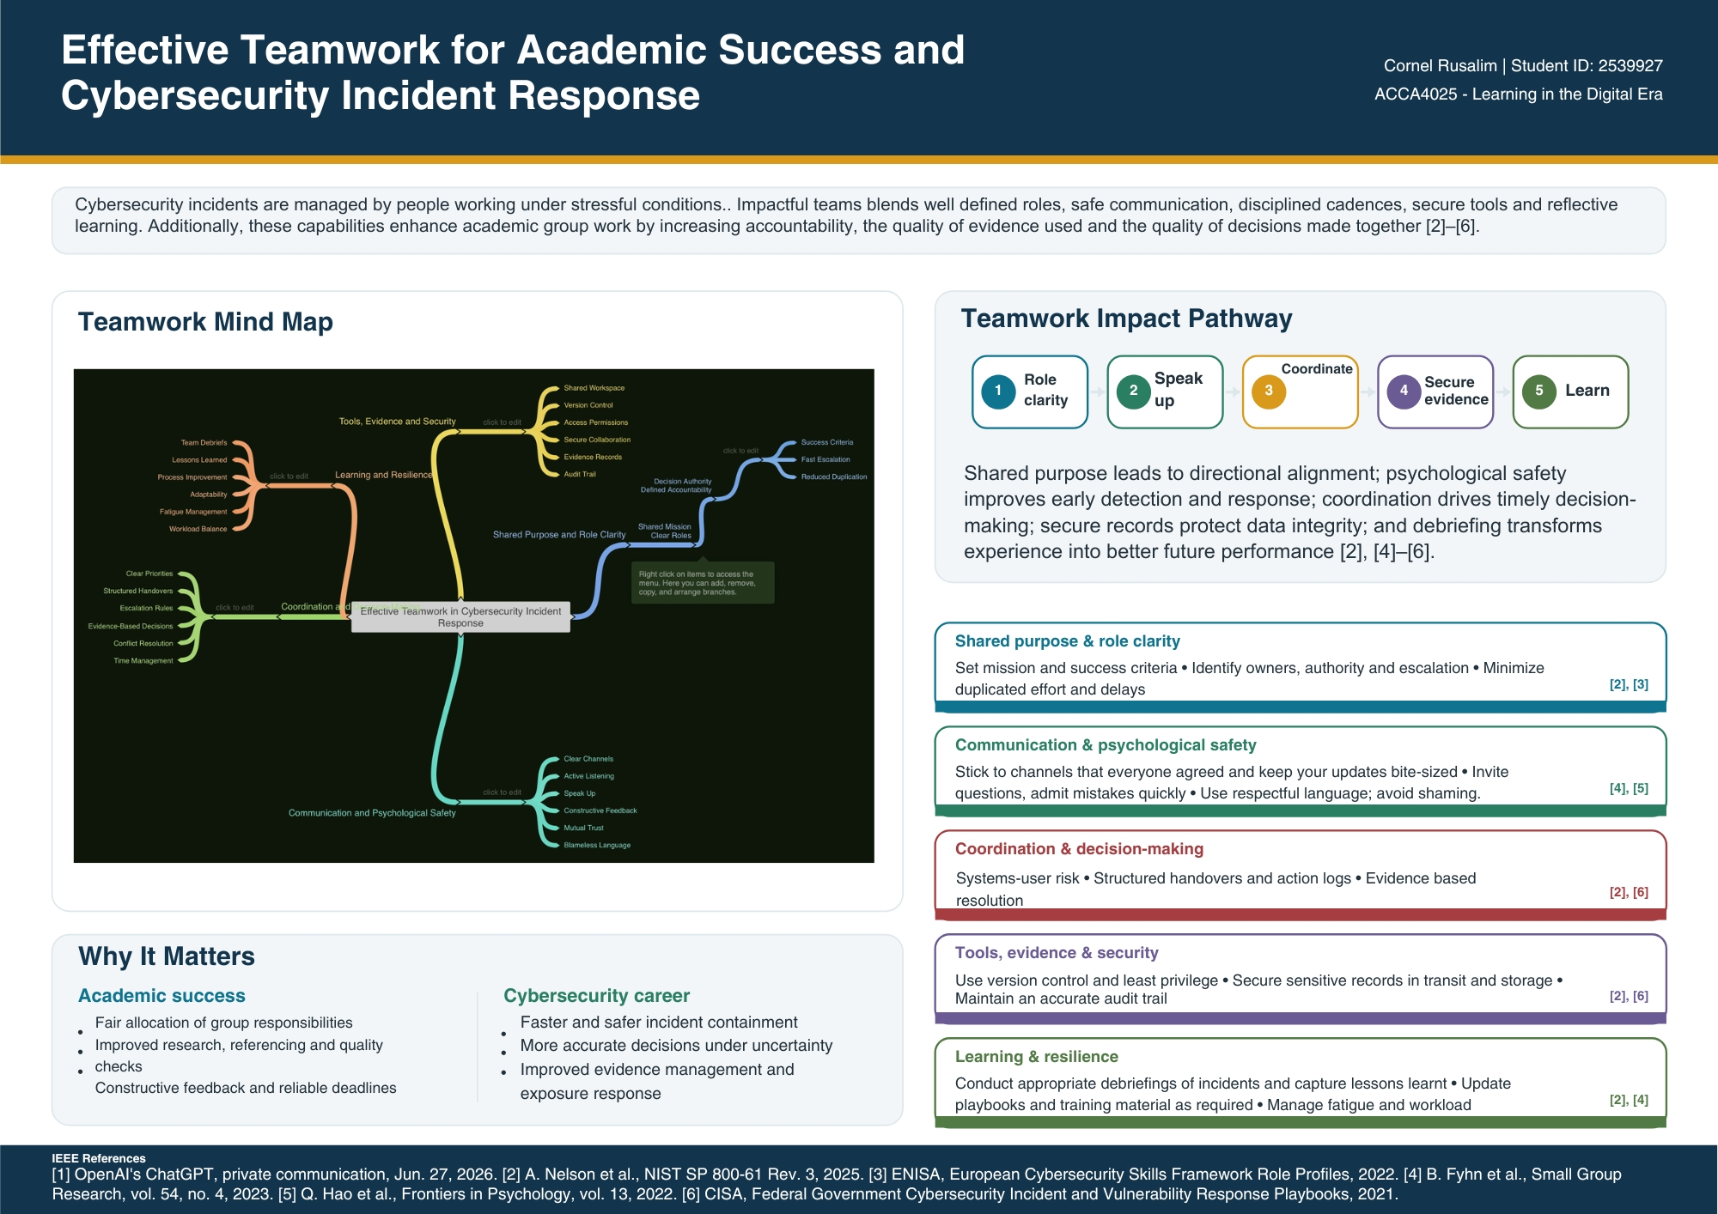

LINK POSTER:
https://drive.google.com/file/d/1-SXIEk0K9Hl1cxDF9zH0241OiQ7AjSui/view?usp=sharing

Poster rationale
The poster demonstrates how effective teamwork supports both academic achievement and cybersecurity incident response. The layout provides a transparent visual hierarchy of the mind-map, making it clear that the team mind map is the principal collaborative artefact and communicating how role clarity, communication, coordination, secure evidence handling and reflective learning contribute to stronger team performance. That is why pretty much everything was portrayed in very small sections and through colour coded themes, all while retaining an academic structure for easy scan ability. In essence, the poster connects teamwork principles with practical benefits for cybersecurity work, including improved accountability, expedited decision making, reliable handover and promotion of safety. IEEE citations were employed in support of some of the key claims and to indicate engagement with currently available academic and professional sources.

References
[1] S. Tannenbaum and E. Salas, Teams That Work: The Seven Drivers of Team Effectiveness. New York, NY, USA: Oxford University Press, 2020.
[2] B. Marder, P. Ferguson, M. Brennan, C. Marchant, M. Rossi, C. Hedler, S. Black and R. Doig, "'Going agile': Exploring the use of project management tools in fostering psychological safety in group work within management discipline courses," The International Journal of Management Education, vol. 19, no. 3, 100519, 2021, doi: 10.1016/j.ijme.2021.100519.
[3] A. Alami, M. Zahedi and O. Krancher, "Antecedents of psychological safety in agile software development teams," Information and Software Technology, vol. 162, 107267, 2023, doi: 10.1016/j.infsof.2023.107267.
[4] A. Nelson, S. Rekhi, K. Scarfone and M. Souppaya, "Incident Response Recommendations and Considerations for Cybersecurity Risk Management: A CSF 2.0 Community Profile," NIST Special Publication 800-61 Rev. 3, Apr. 2025, doi: 10.6028/NIST.SP.800-61r3.
[5] National Institute of Standards and Technology, "NICE Framework Competency Areas: Preparing a Job-Ready Cybersecurity Workforce," NISTIR 8355, Jun. 2023, doi: 10.6028/NIST.IR.8355.

Task 3 - Automatic Referencing Tool

3a. Structured communication in virtual cybersecurity teams
Endpoint detection and response (EDR): Virtual partnership enables cybersecurity teams to investigate incidents across locations, time zones and organizational limits. It is less about the number of digital tools and more about people, process and technology being aligned. As a starting point and corroboration of what comes out in recent evidence [1]-[2].
Information is surfaced early or not, depends on people factors. Studies of remote-work find problematic communications, loneliness, low efficient workload and work-home interference to be commonly recurring challenges while social support, autonomy and self-discipline enhance the outcomes [1]. In incident response, where junior analysts report errors and quest for help, they need to have psychological safety. In a study about remote software teams, it was shown that decreased spontaneous interaction can increase the barrier for speaking up [2]. With inclusive turn-taking, explicitly invite challenge, use short one-to-one check-ins and blameless reviews instead.
Process provides coordination. There is large-scale workplace evidence that shows that remote working can be associated with less dynamic and cross-boundary collaboration networks, and a more prominent use of asynchronous media for communication [3]. This should be countered through a channel matrix, called an incident lead, role allocation, severity criteria, escalation path, decision log and scheduled handovers for virtual incident team. A synchronous meeting is for ambiguity only, urgent coordination and relationship work; an asynchronous update is evidence, decisions, owners and deadlines. That helps alleviate excess meetings and retain a single source of truth.
These practices must be supported, not undermined, by technology. The choice between secure messaging for low-priority items, video meetings for lower data-sensitive urgent needs but not available because of travel impediments, dashboards etc., should be determined by the urgency of the task and necessity or sensitivity of information shared documents that are version controlled and outcome governed on an as a service basis must take precedence. But in the case of an incident affecting normal systems, redundant communication routes become a must. Virtual communication can also limit creative idea generation [4], so complex hypothesis-building advantages from: Deliberative brain-storming Individual-preparation prior to meetings and co-located sessions, where possible.
As such the best model for a cybersecurity incident analyst is one of intentional hybridisation with focused protected time, mins at short operational huddles, evidence documented and social capital built through rounded relationship building over time. The current incident-response guidance from NIST focuses on preparation, coordinating response and learning from incidents as part of an organizations risk-management activity [5]. As an example of the academic aspect, it is possible to use RefWorks for storing metadata from verified sources and citations in IEEE format, but automatically imported records still require manual validation [6].
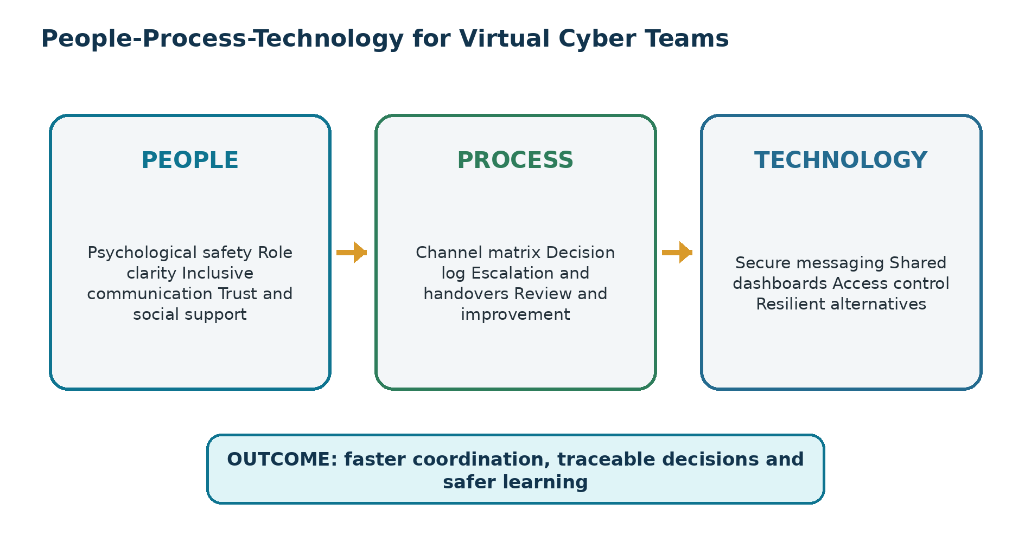
Figure 4. People-process-technology model for virtual cybersecurity collaboration (original visual).

3b. Practical evidence of RefWorks use
Using RefWorks I created a new ACCA4025 project and imported records in batches using DOI, URL and database export. I then systematically checked each author, title, year, journal, volume, issue, page range and DOI against the publisher record before choosing IEEE output formatting. I used RefWorks Citation Manager to insert citations and bibliography generation within Word [7]. The screenshots below provide practical evidence of source import, metadata validation, IEEE style selection, in-text citation insertion and bibliography generation.

IMPORTING A SOURCE
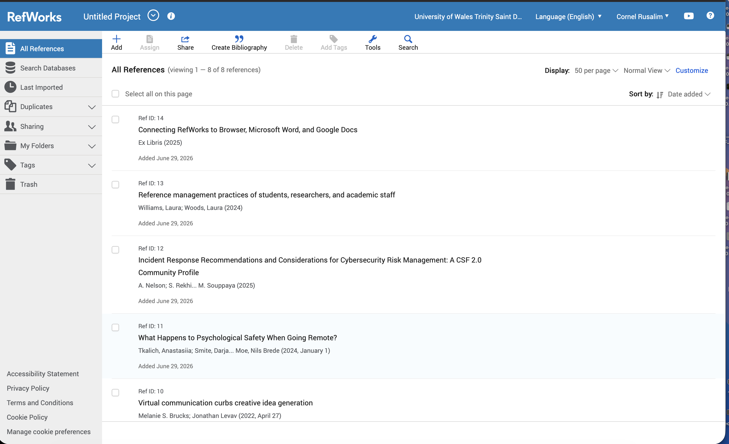

CHECKING METADATA
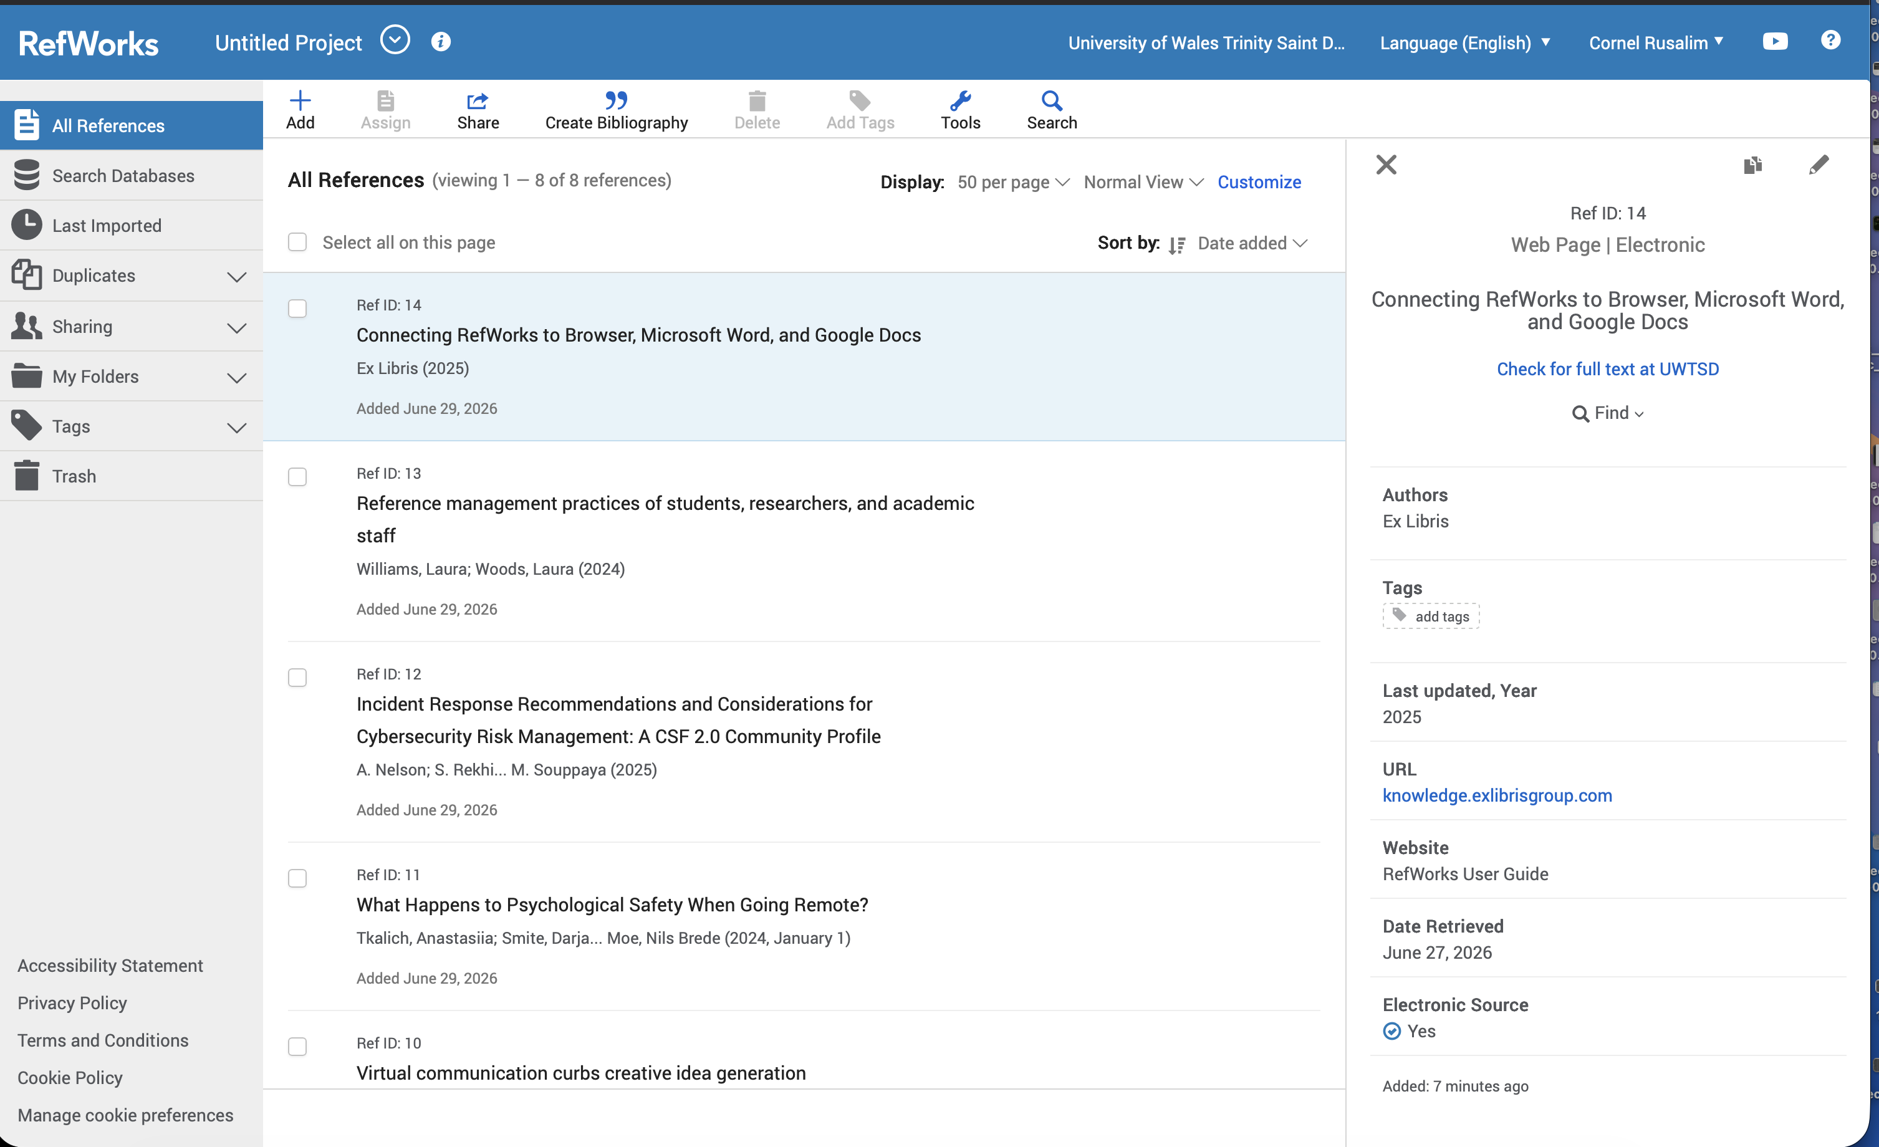

SELECTING IEEE
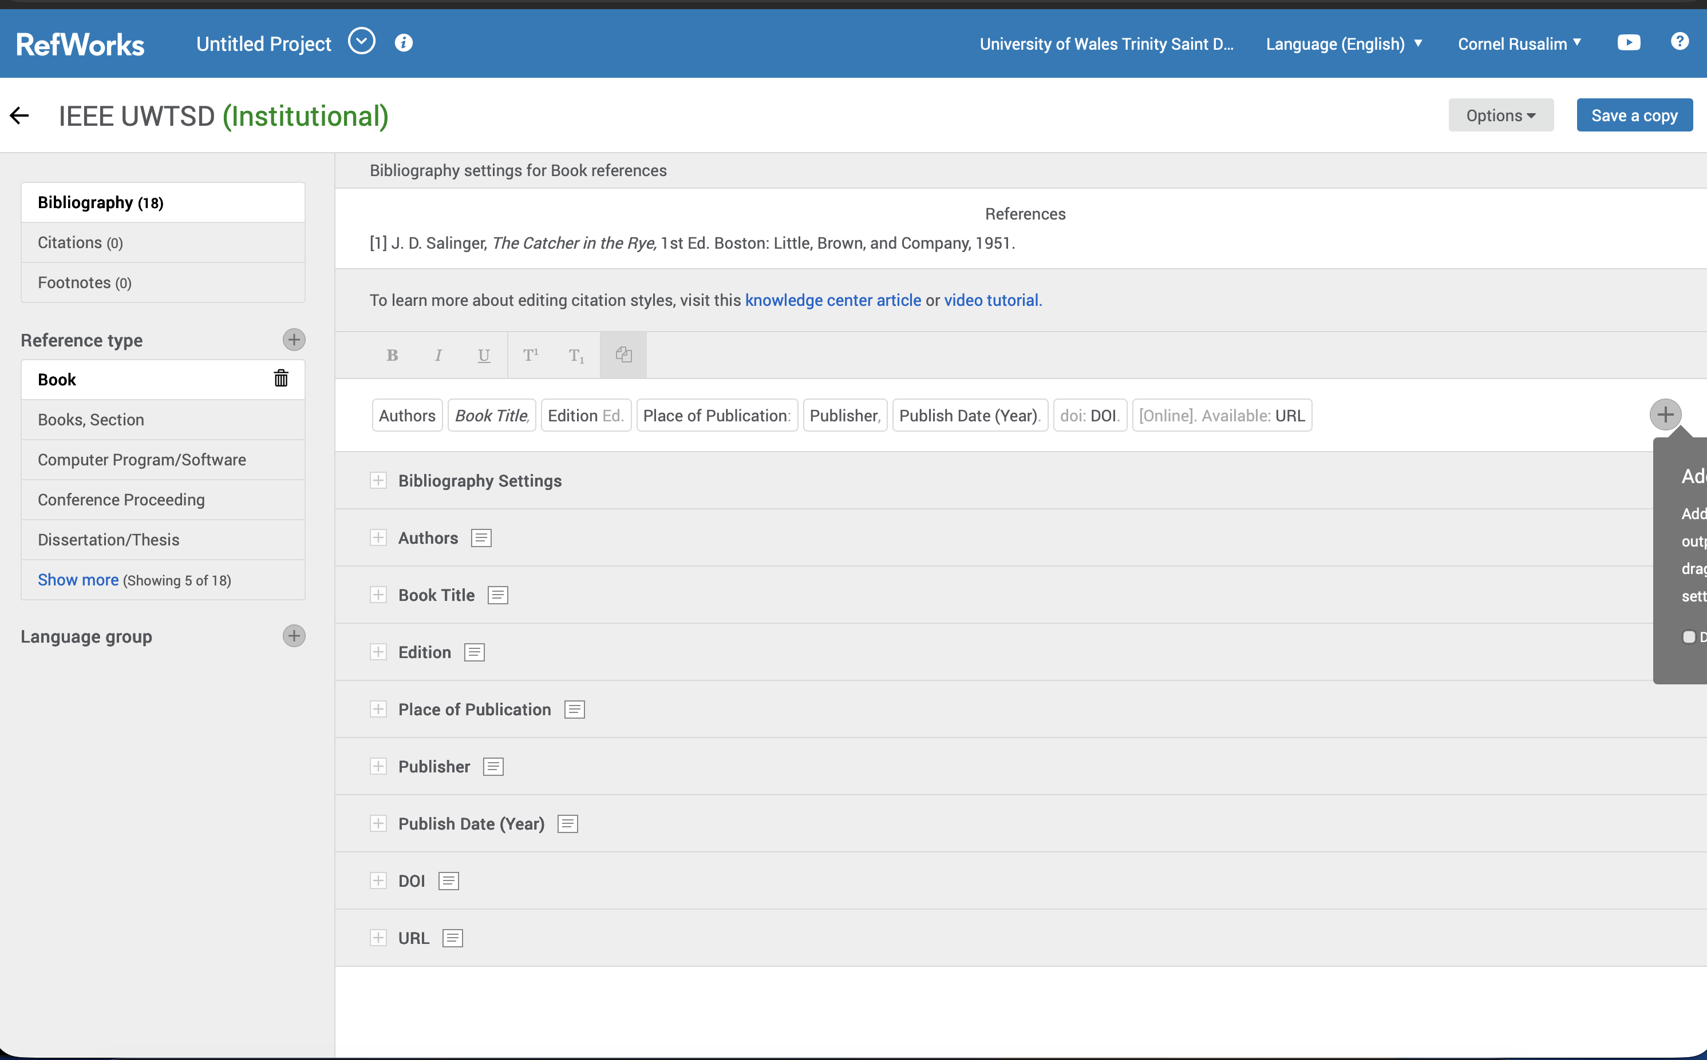

INSERTING A CITATION
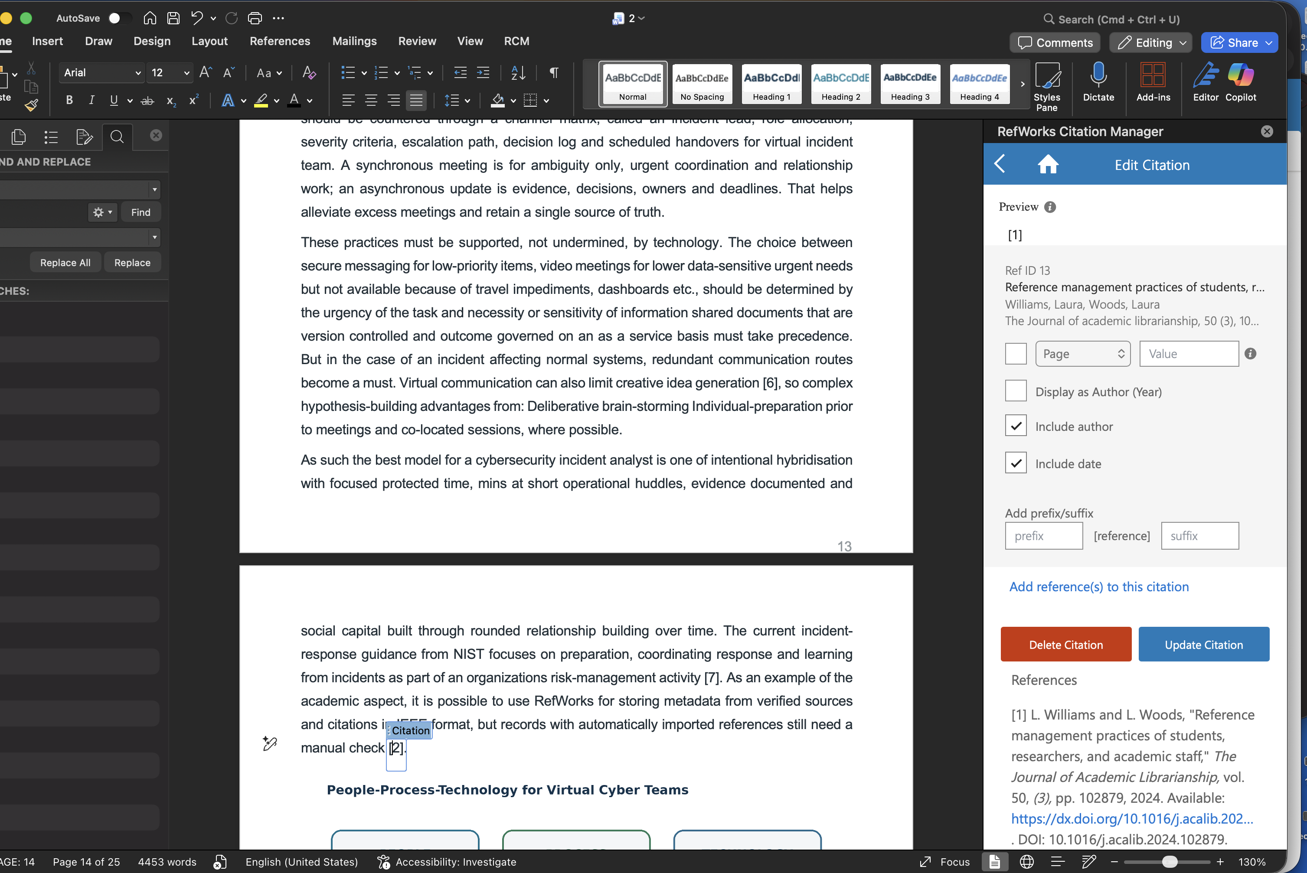

GENERATING THE BIBLIOGRAPHY
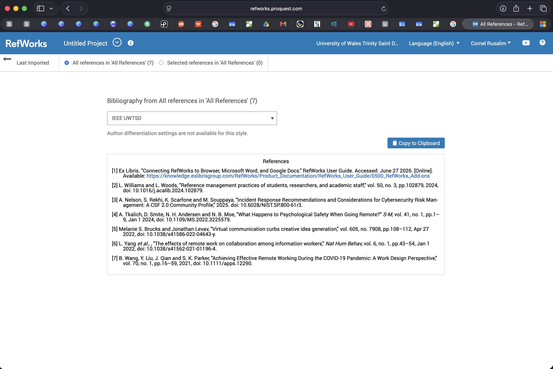

References
[1] B. Wang, Y. Liu, J. Qian and S. K. Parker, “Achieving effective remote working during the COVID-19 pandemic: A work design perspective,” Applied Psychology, vol. 70, no. 1, pp. 16–59, 2021, doi: 10.1111/apps.12290.
[2] A. Tkalich, D. Smite, N. H. Andersen and N. B. Moe, “What happens to psychological safety when going remote?” IEEE Software, vol. 41, no. 1, pp. 113–122, 2024, doi: 10.1109/MS.2022.3225579.
[3] L. Yang et al., “The effects of remote work on collaboration among information workers,” Nature Human Behaviour, vol. 6, pp. 43–54, 2022, doi: 10.1038/s41562-021-01196-4.
[4] M. S. Brucks and J. Levav, “Virtual communication curbs creative idea generation,” Nature, vol. 605, pp. 108–112, 2022, doi: 10.1038/s41586-022-04643-y.
[5] A. Nelson, S. Rekhi, K. Scarfone and M. Souppaya, “Incident Response Recommendations and Considerations for Cybersecurity Risk Management: A CSF 2.0 Community Profile,” NIST Special Publication 800-61 Rev. 3, Apr. 2025, doi: 10.6028/NIST.SP.800-61r3.
[6] L. Williams and L. Woods, “Reference management practices of students, researchers, and academic staff,” The Journal of Academic Librarianship, vol. 50, no. 3, Art. no. 102879, 2024, doi: 10.1016/j.acalib.2024.102879.
[7] Ex Libris, “Connecting RefWorks to Browser, Microsoft Word, and Google Docs,” RefWorks User Guide, 2025. [Online]. Available: https://knowledge.exlibrisgroup.com/RefWorks [Accessed: Jun. 27, 2026].

Task 4 - E-Portfolio Creation and Review

4a. Build specification
Page | Required content
Home | Portfolio purpose, career theme, concise navigation and professional welcome.
Task 1 | Skills summary, original visual, Turnitin evidence, reflection and Task 1 references.
Task 2 | Team details, genuine mind map, final A3 poster, working links and Task 2 references.
Task 3 | Virtual-collaboration summary, RefWorks screenshots and Task 3 references.
Task 4 | Platform review, screenshot evidence, accessibility and link-testing statement.

4b. Illustrative Review of the Completed E-Portfolio
I selected Google Sites because it provided a straightforward method for creating a browser-based portfolio with consistent navigation, embedded files and controlled sharing. According to Google’s guidance, a site owner can publish his or her work along with the ability to control access to the published version; institutional accounts may restrict public exposure. The critical practical test was therefore not whether the site appeared correctly while I was logged in, but whether the tutor could access every page and embedded artefact while I was signed out [1].
The completed website contains five pages which are: Home, Task 1, Task 2, Task 3 and Task 4. This structure reduces navigation depth and reflects the order of assessment tasks. Each task page starts with a precise title, displays the primary written or visual artefact in a size that is readable and ends with its IEEE citation list. According to the literature, selected artefacts in an e-portfolio can showcase employability skills and aid in the construction of a professional identity [1]. Activities designed for reflection and the visibility of emerging work can help to promote self-regulated and collaborative learning [2].
Great care was taken to ensure material accessibility in black and white (high contrast), heading descriptions, short paragraphs, appropriate link labels, as well as text alternatives for visual materials. Colour was not the only thing in which important information remained uncommunicated. E-portfolios, however, require time to develop and maintain; students also must be technically confident, students need current files to keep the e-portfolio up-to-date and although it seems likely that students appreciate the value of an e-portfolio in employability terms this may not translate into positive behaviours regarding career planning [3]. Consequently, I opened all links in an incognito browser window and ensured embedded files had been shared correctly; I compressed any images that were too large and included screenshots of them in my Word submission document.

Required screenshot evidence
HOMEPAGE
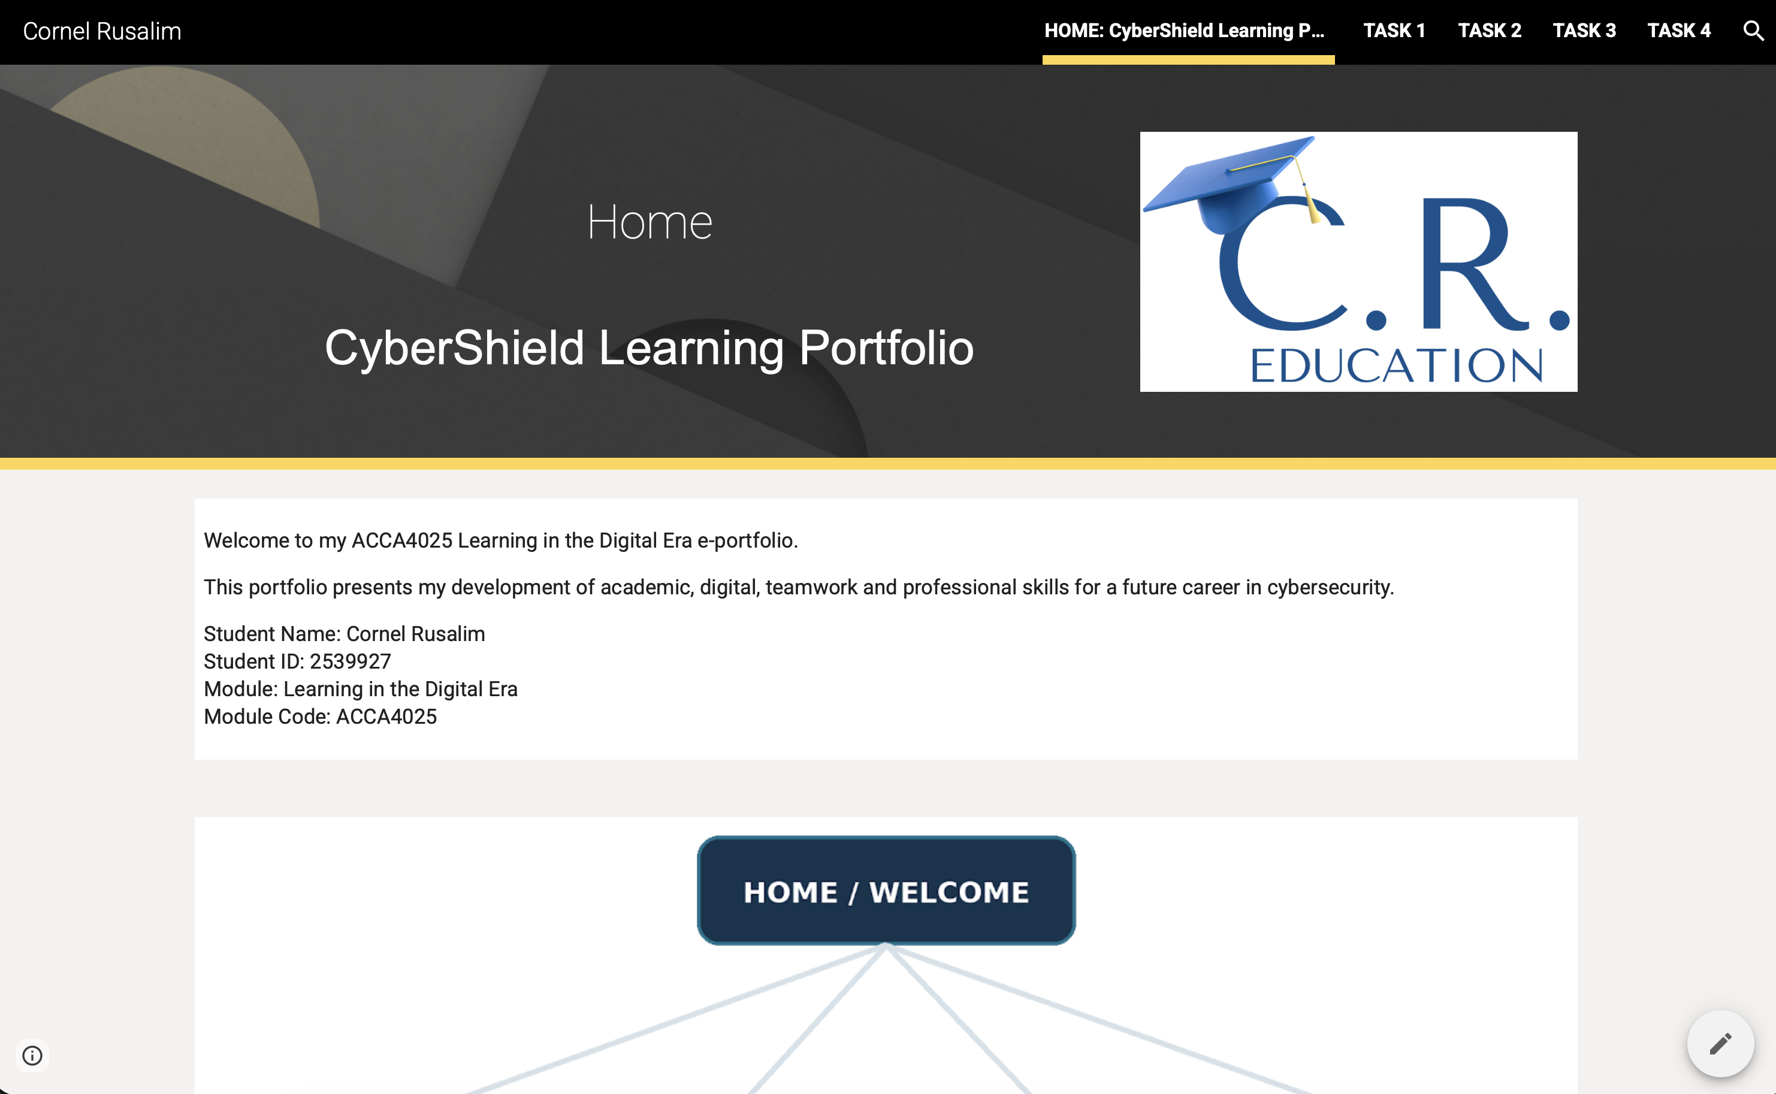

TASK 1
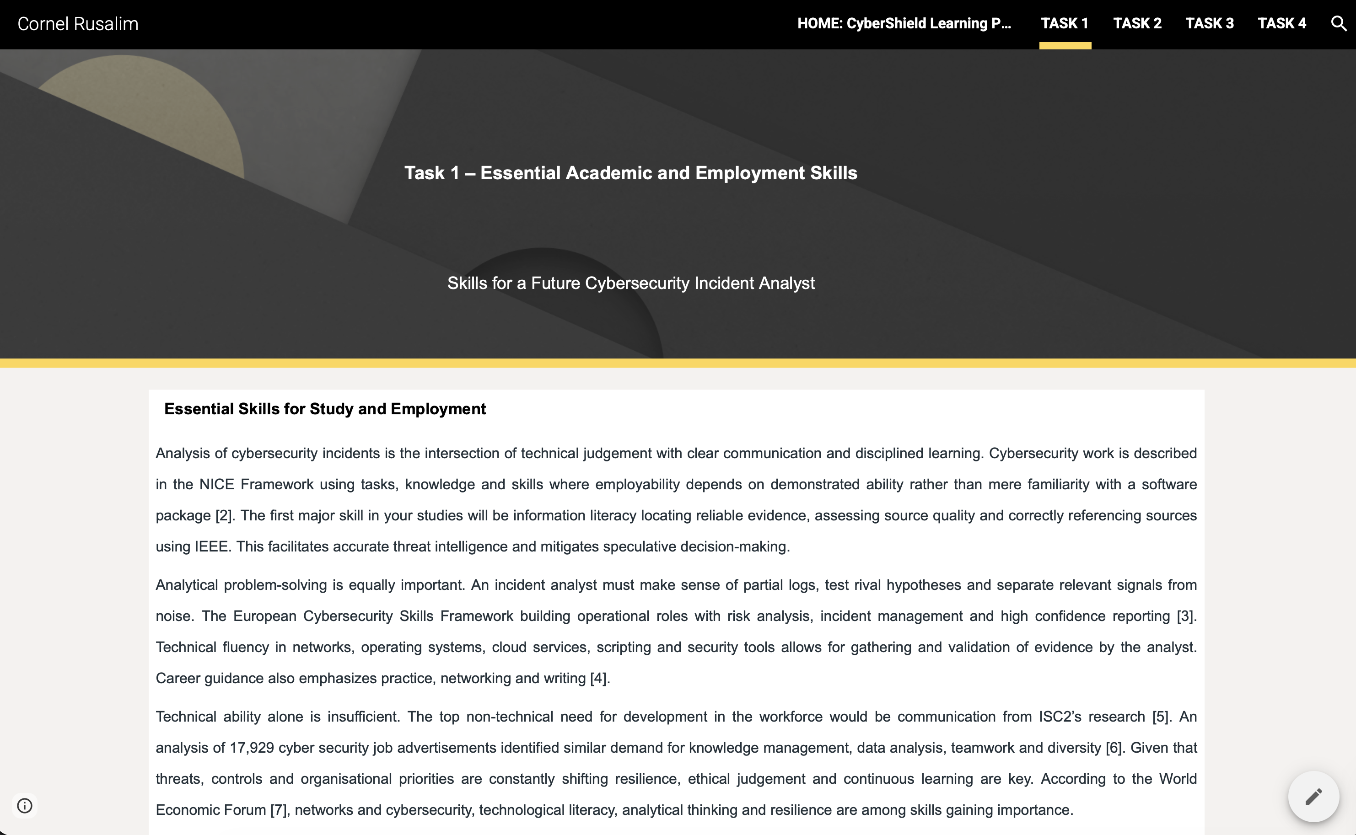

TASK 2
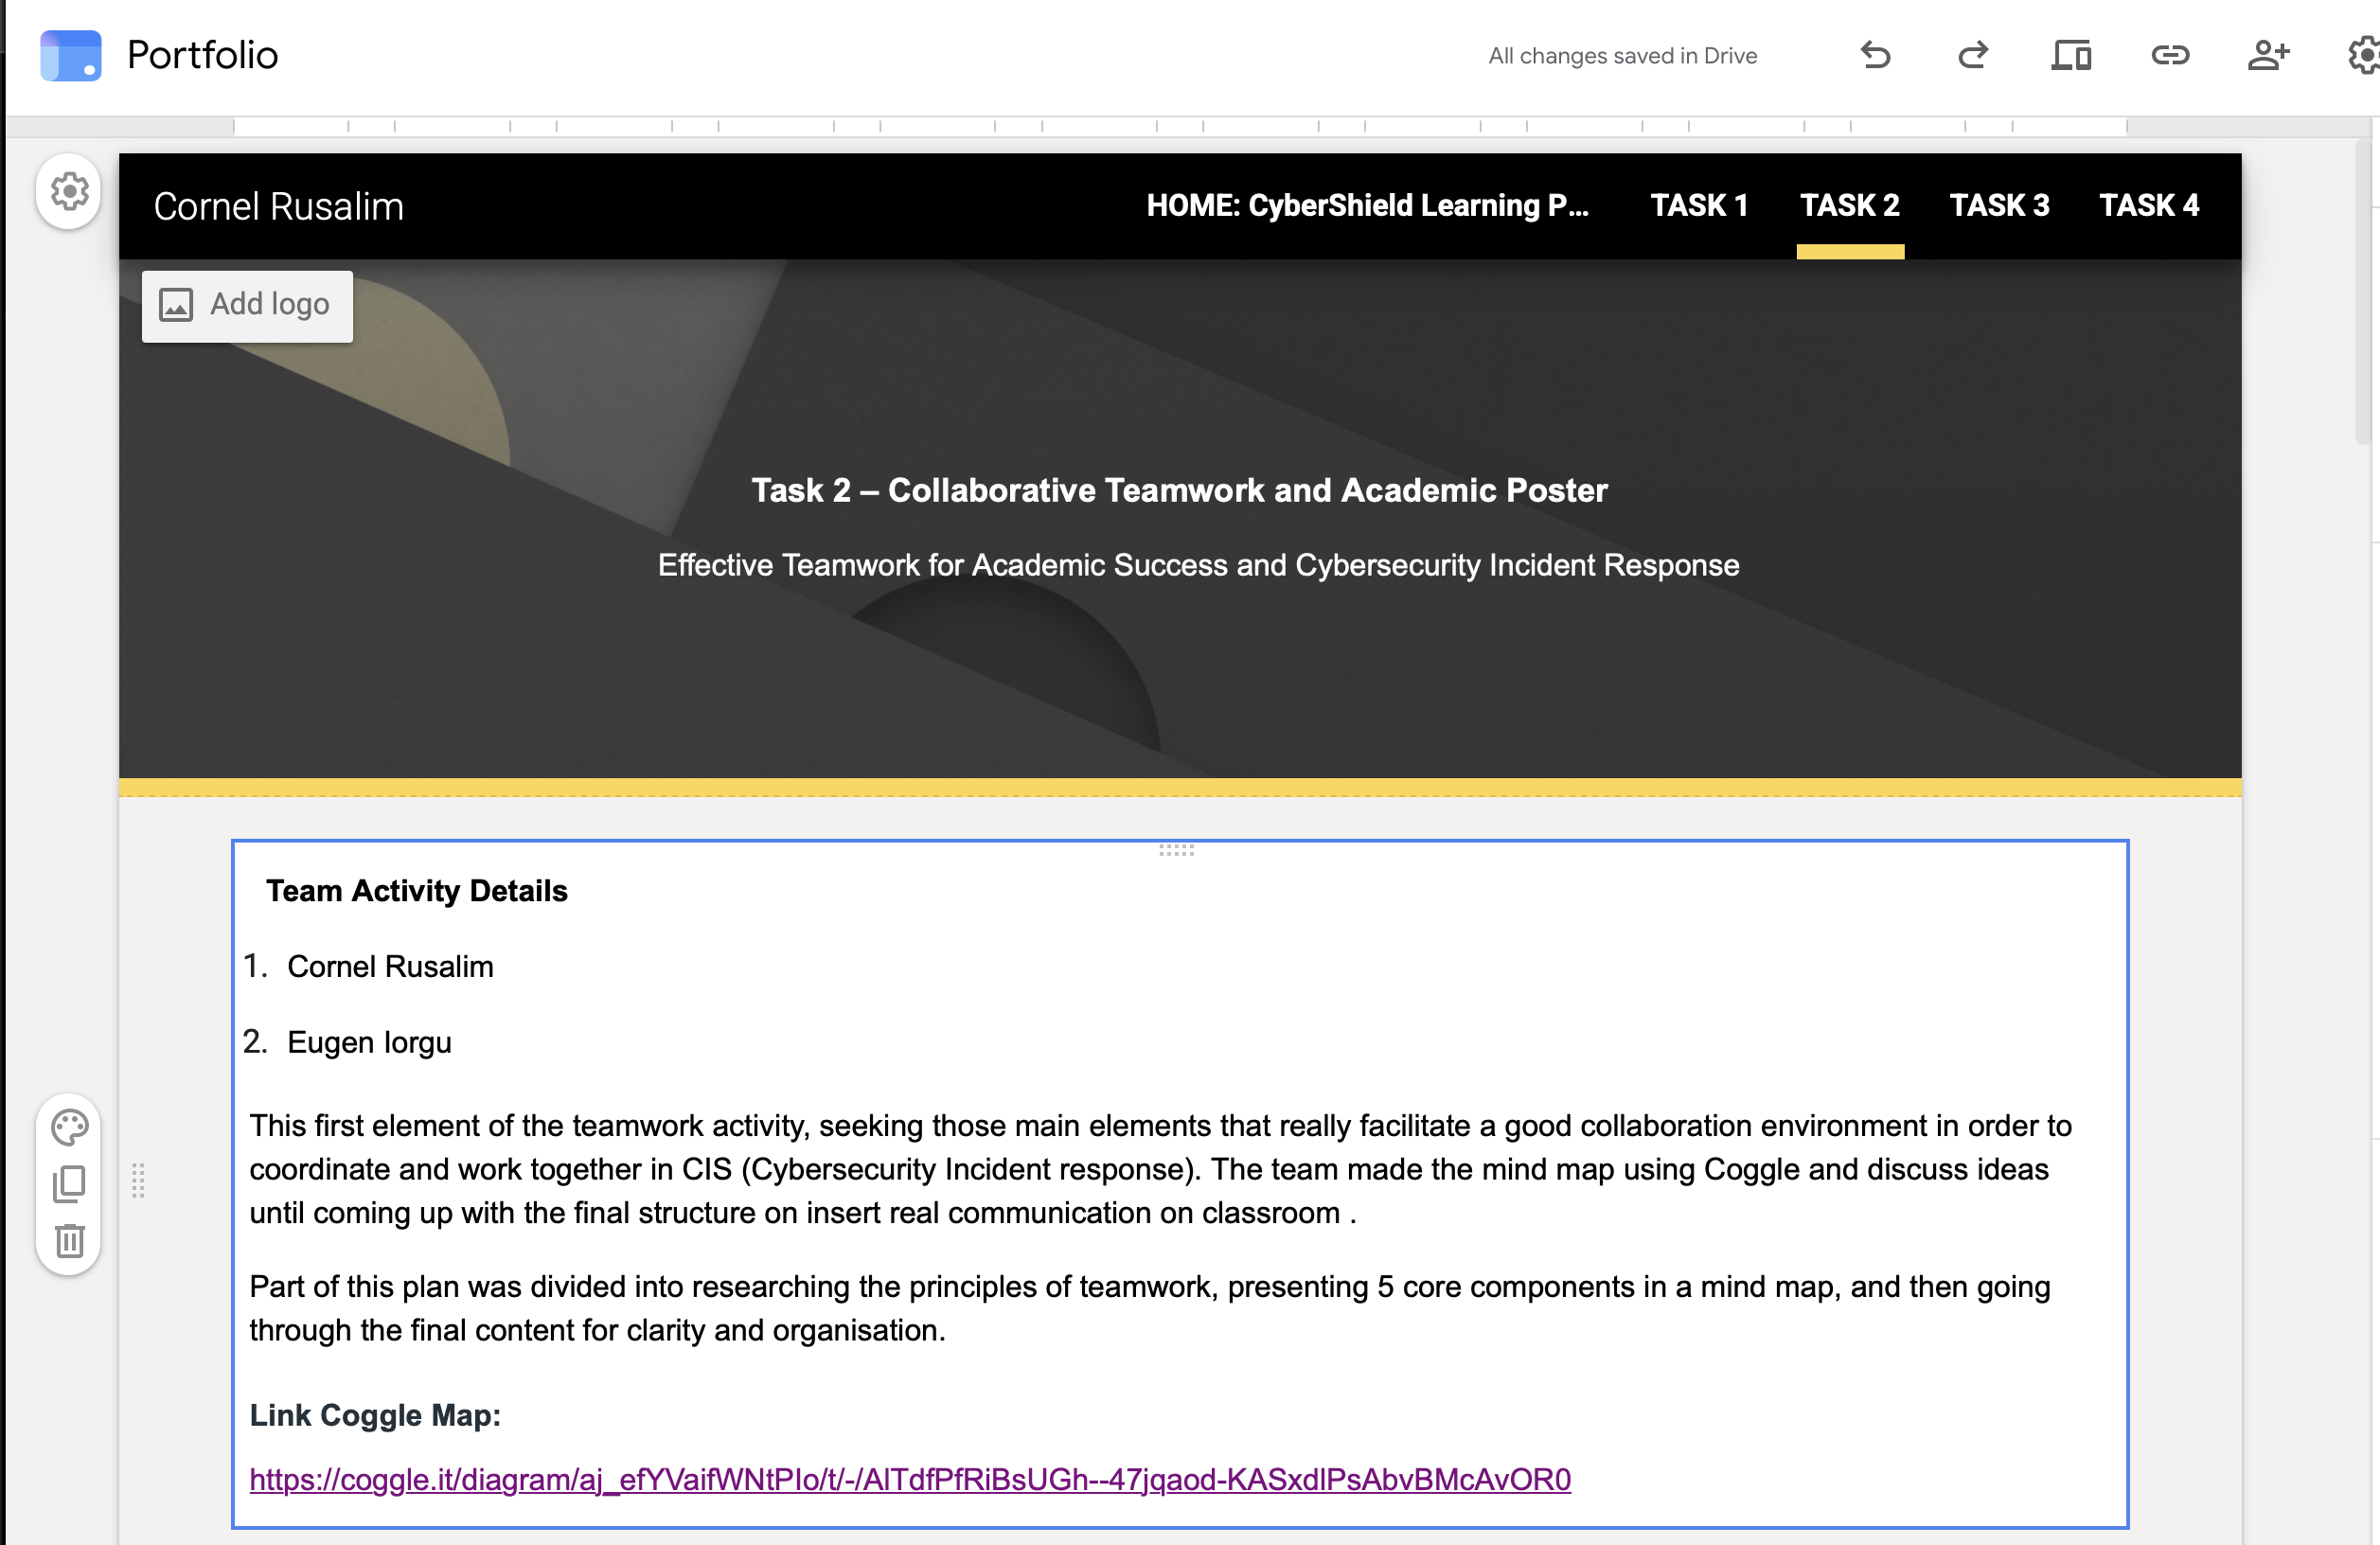

TASK 3 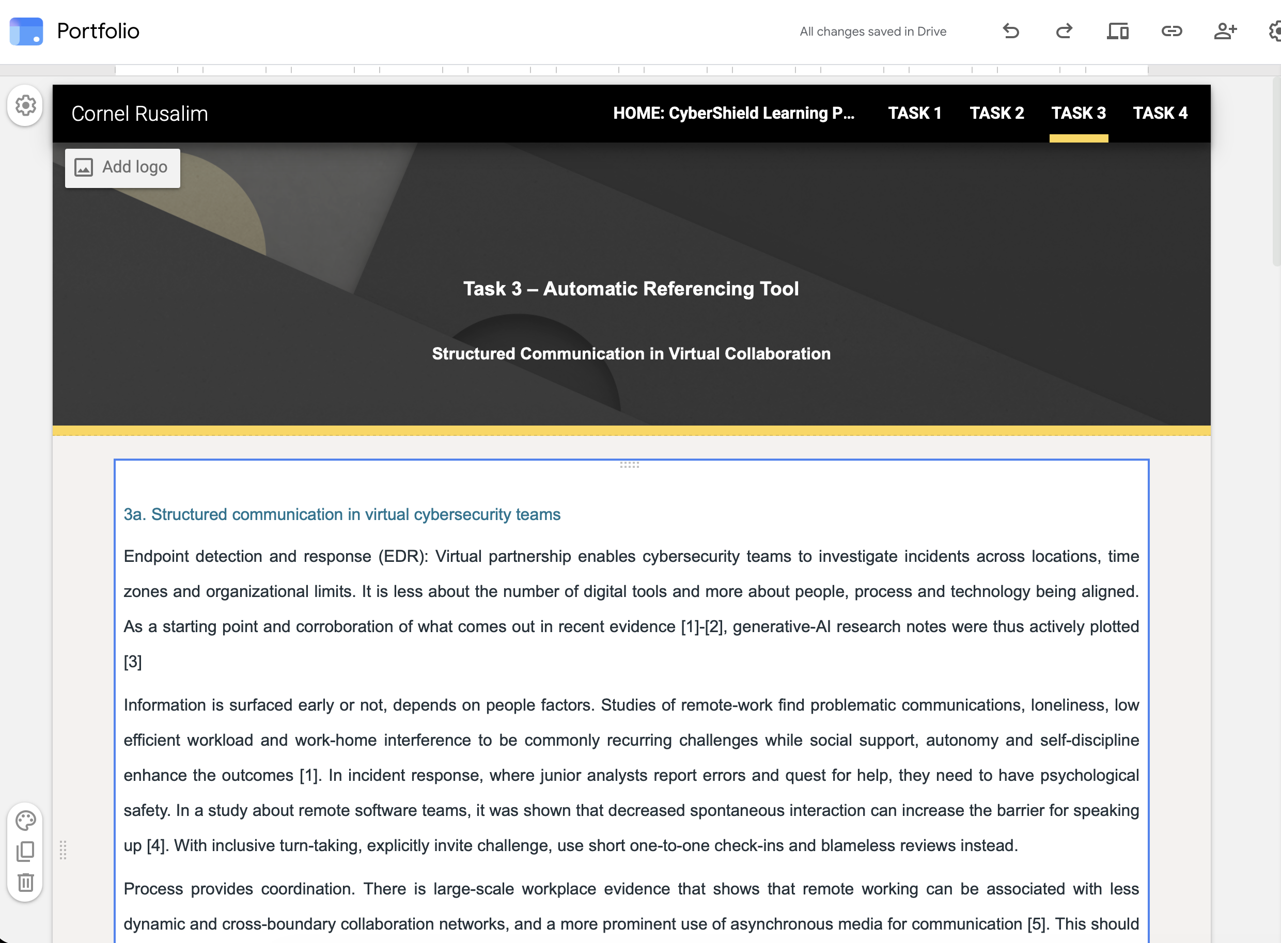

TASK 4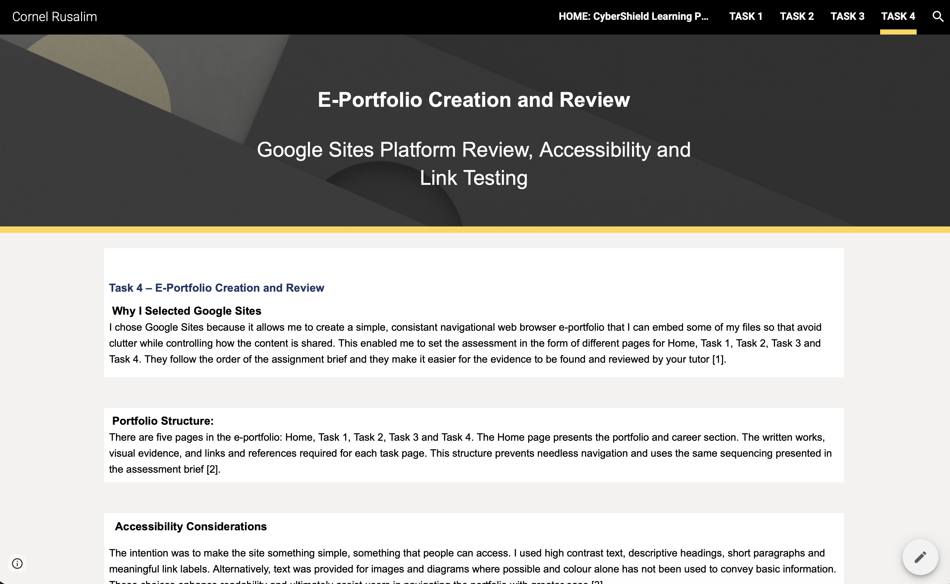
.

SIGNED-OUT ACCESS TEST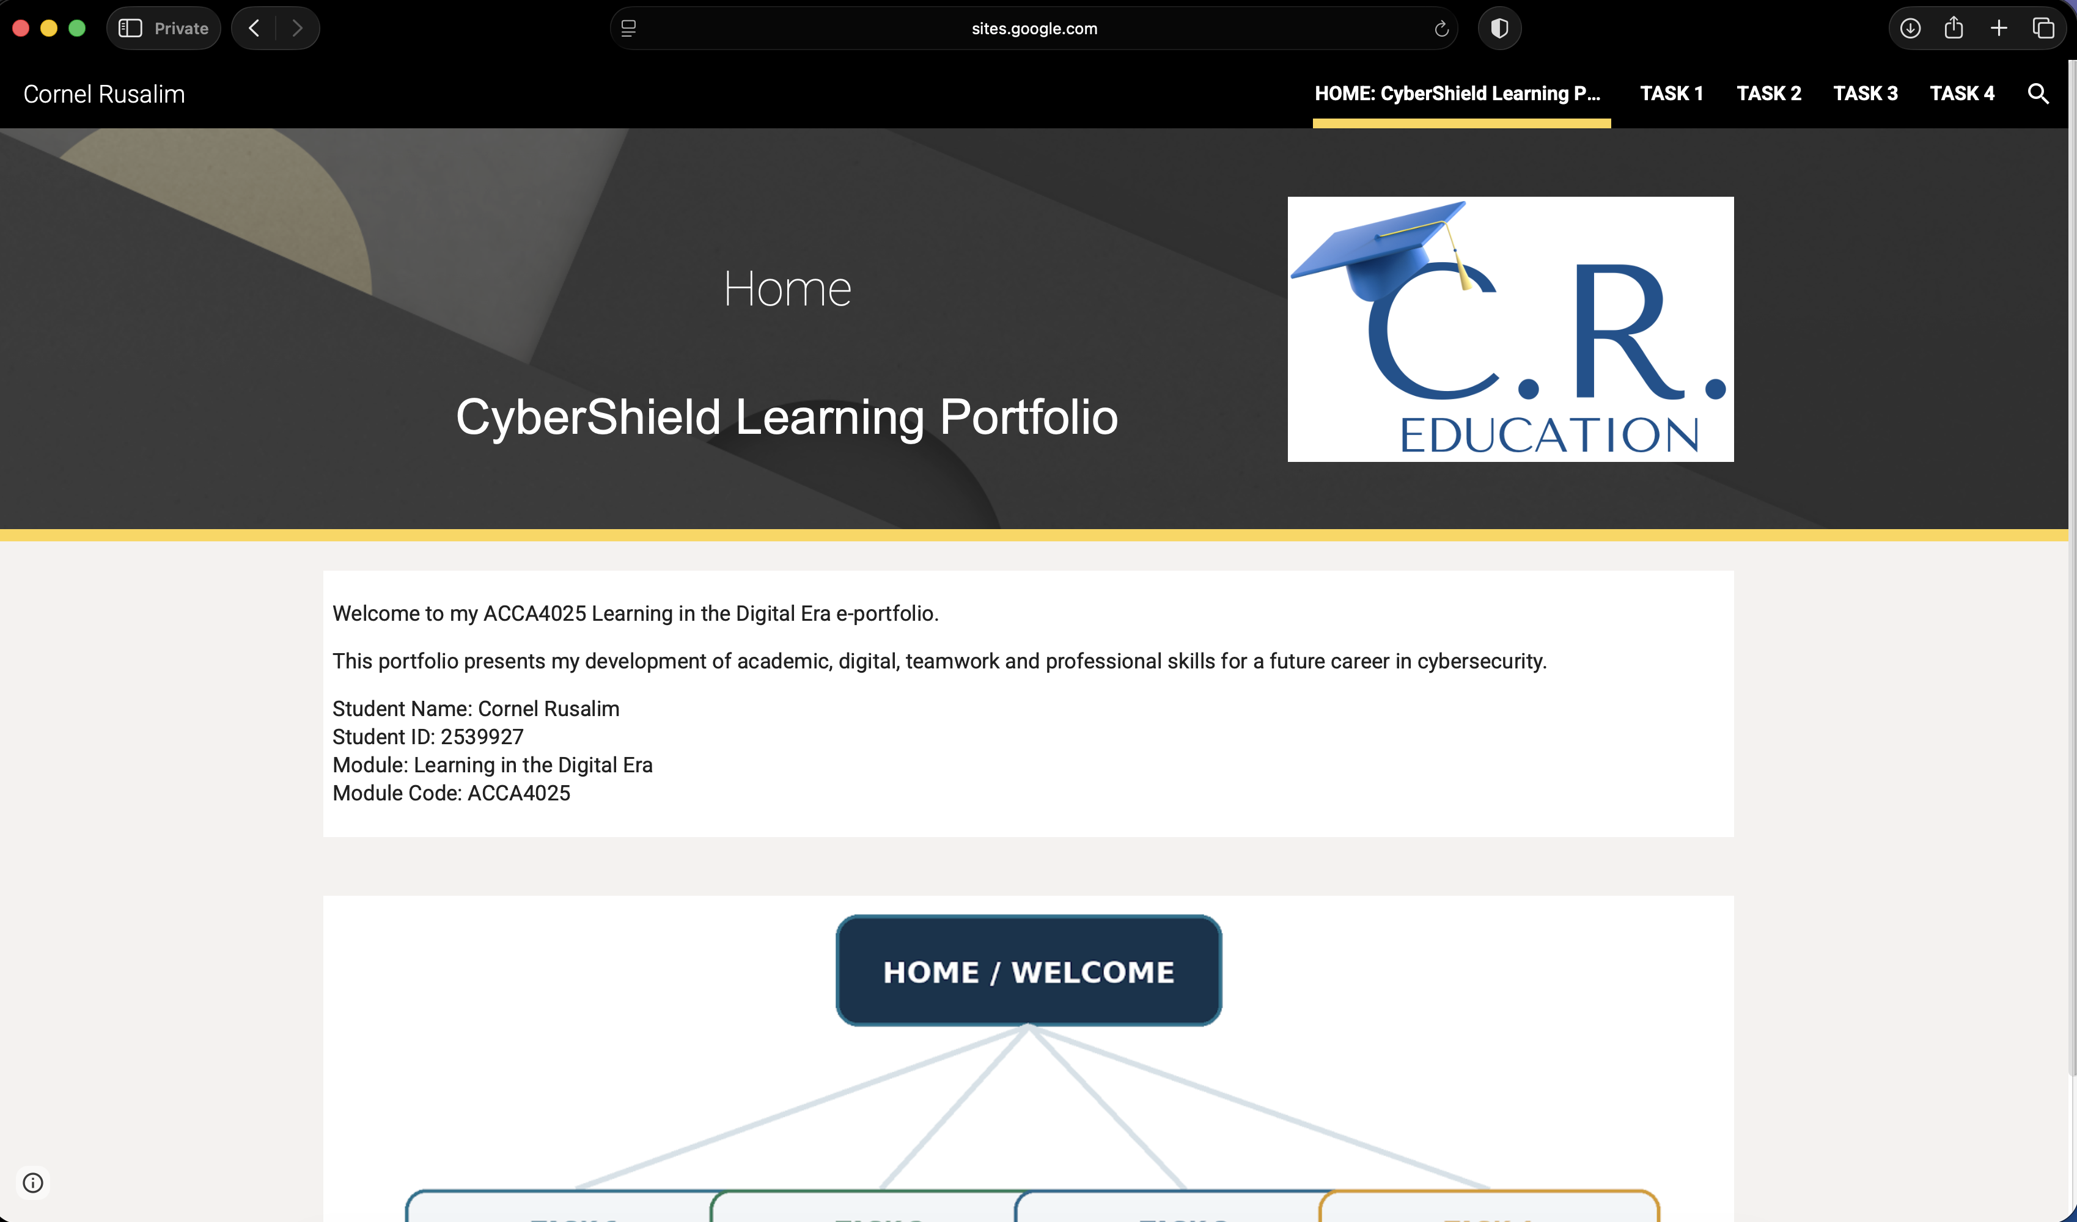

References
[1] Google, "Publish and share your site," Google Sites Help, 2026. [Online]. Available: https://support.google.com/sites/answer/6372880. [Accessed: Jun. 27, 2026].
[2] S. Carter, "ePortfolios as a platform for evidencing employability and building professional identity: A literature review," International Journal of Work-Integrated Learning, vol. 22, no. 4, pp. 463-474, 2021.
[3] R. Lam, "E-Portfolios for self-regulated and co-regulated learning: A review," Frontiers in Psychology, vol. 13, 1079385, 2022, doi: 10.3389/fpsyg.2022.1079385.
[4] E. Gutierrez-Santiuste, S. Garcia-Segura, M. A. Olivares-Garcia and E. Gonzalez-Alfaya, "Higher education students' perception of the e-portfolio as a tool for improving their employability: Weaknesses and strengths," Education Sciences, vol. 12, no. 5, 321, 2022, doi: 10.3390/educsci12050321.

Appendix 1 – AI Research Output for Task 1
Prompt Used
Identify critical academic, digital, analytical, communication and employability skills needed to become a Cybersecurity Incident Analyst in the future. Discuss how these skills underpin university study, investigations into incidents, evidence-based decisions and your career development in the long term. This response is to be used for basic research notetaking only and should always be cross verified with primary academic or professional sources.

AI Research Notes
Based on AI-generated research notes, key capabilities for a Cybersecurity Incident Analyst include information literacy, analytical problem-solving, technical competence, communication, teamwork, ethical judgement and resilience and continuous learning. The notes from each meeting indicate that academic skills such as source evaluation, IEEE citation and reflective learning underpinned effective professional development and decision-making. They further noted that technical knowledge ought to be paired with communication and collaboration, since incident response necessitates that analysts read evidence, communicate findings, represent a range of perspectives in anomalous situations, and do so under pressure.

Verification and Use Statement
The AI output itself is derived as a point of reference only and is certainly not quoted exactly into the final submission in Task 1. Using data sources such as the NICE Framework, the European Cybersecurity Skills Framework, the ISC2 Cybersecurity Workforce Study and academic research into cybersecurity job advertisements and skills requirements we reviewed check large existing bodies of professional uses. The last portion of the text was rewritten, paraphrased and synthesized into an academic format.

AI Reference
[1] OpenAI’s ChatGPT, private communication, Jun. 27, 2026.

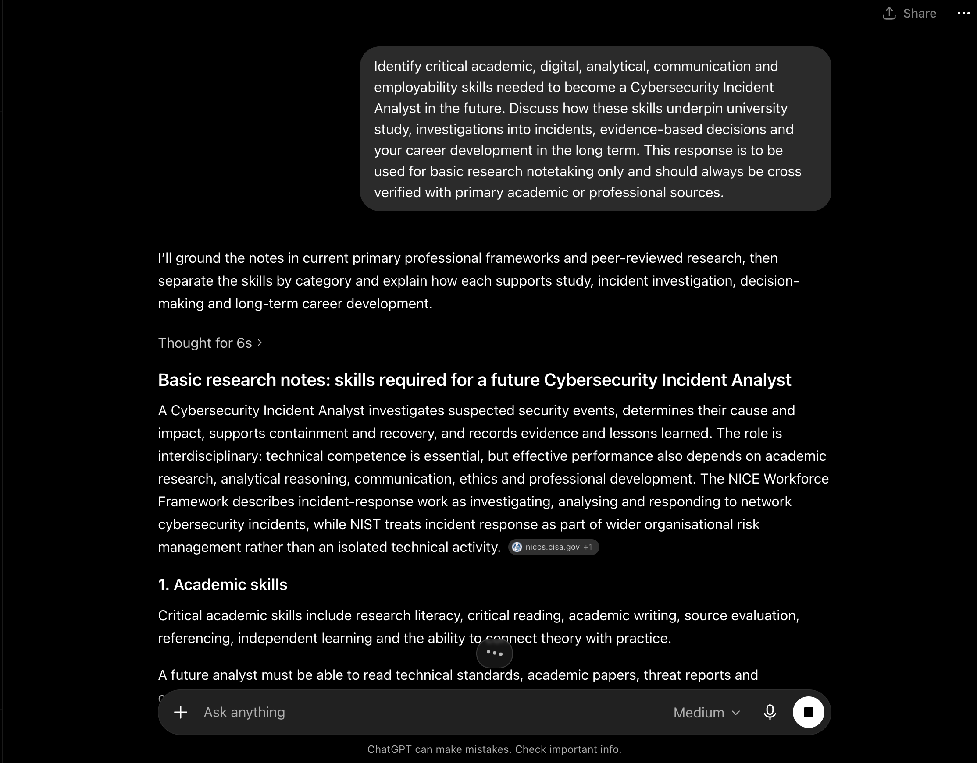Figure A1. Generative AI prompt and research output used as initial research notes for Task 1.

