Digital Skills and Research Methods
Module code: BMSW4003
Lecturer’s name: Rula Alousi
Student name: George Cosmin Nita
Student id: 1919044

Table of Contents
1.0 Introduction 3
2.0 Background 3
2.1 Analysing VLE and Moodle 3
2.2 Analysing the Positive Impacts of VLE 4
2.3 Analysing the Negative Impacts of VLE 5
3.0 Aims and Objectives 6
3.1 Research Aims 6
3.2 Research Objectives 6
4.0 Method 6
4.1 Data Collection and Analysis 6
4.2 Geographical Overview 7
4.3 Sampling 7
4.4 Nature of the Questions Asked 7
5.0 Results 8
5.1 Questionnaire 8
6.0 Discussion 10
8.0 References 13
Appendix 15

1.0 Introduction
A virtual learning experience refers to a device that provides technologically based solutions for educators intended to build immersive, active learning environments. VLEs will help teachers develop, store, and disseminate information, arrange courses and classes, and promote student-teacher contact (in the form of e-mails and discussions), often in real-time (Stiles, 2020). Digital learning environments are also part of the broader learning management framework of a higher education institution (LMS). It has been found that this specific method or style of learning has certain impacts on the overall learning experience of students, which would be identified and explored in this research.
In this research-based report the key subject of focus would be exploring the various impacts and implications of a virtual learning environment on the overall learning experience of the students in a specific university. A research-based approach would be adopted for this report and has been structured accordingly. It would consist of detailed background information, the aims and objectives, the research methodology, the findings, and the final discussion to explain the findings and other aspects of the research.

2.0 Background

2.1 Analysing VLE and Moodle
A virtual learning environment or VLE is one of the most significantly rising aspects of learning and gaining knowledge in recent times to improve and enhance the overall learning experience of modern students. As opined by Lee et al. (2014) a virtual learning environment can be simply described as an online forum which can be used by educational institutions for educational purposes. He further stated in his study that it encapsulates all the online experiences that accompany the course, whether they be online classes, reading tools, stand-alone skill tests or other types of simulated learning and knowledge pages. Based on this description in his study it can be assumed that he had an overall positive image and reputation for the concepts and impacts caused by the virtual learning environment. This description clearly highlighted the various areas and functionalities, which VLE offers to the educational institutions across the world.
In the world of VLE, however Moodle has been a rising star as most of the educational institutions situated in the UK are looking to make use of the various functionalities this service has to offer. As opined by Schepers (2018), Moodle is an open-source and free learning management system which is also considered as a virtual learning environment. This service is widely used in universities, workplaces, and schools for educational learning and training purposes. It helps the institutions and organisations to virtualise their learning and training operations and improve their performance monitoring systems across the board (Dougiamas, 2014).

2.2 Analysing the Positive Impacts of VLE
One of the biggest reasons for the popularity of virtual learning environments or VLE has been the benefits it has to offer for institutions and organisations looking to make use of it. As opined by Podgorelec (2015), one of the biggest areas of impact by VLE resides in the benefits it brings for both sides including the organisations and institutions as well as the learning individuals entitled to study under the virtual learning frameworks. After reviewing this opinion, it can be stated that it is quite valid, however in his study he missed out identifying the negative impacts of virtual learning environments. According to the opinions of Kuhar (2015), one of the biggest advantages, which have a positive impact on the students, is that it allows the students access to their coursework materials from anywhere and anytime in the world. This provides the students some much needed freedom by allowing them to access their academic materials and details from anywhere, it basically serves the purpose of mitigating the physical barriers caused by physical learning environments. Similarly, as opined by Gadreet al. (2016) virtual learning environments and frameworks like Moodle, provides the institutions and organisations some combinations of freedom and professional academic structure. Thus, it can be observed that the opinions of Kuhar (2015), and Gadre et al. (2016) are quite similar and they both highlighted similar themed positive impacts, which are associated with virtual learning environments.
However according to the opinions of Evans and Fan (2012), one of the other most significant positive impacts which is associated with virtual learning environments is that it helps students to develop significantly to develop time management skills. The virtual learning environments are based on strict schedules and allocated times for specific works and ensures that all students adhere to it without any failures or excuses. Further it has also been found that virtual learning environments saves tons of time for students and allows the students to choose the best possible time for certain scenarios.

2.3 Analysing the Negative Impacts of VLE
Although virtual learning environments and similar services are mostly known and acknowledged for the various benefits, however it also has certain negative impacts on the lives of students and certain education organisations. According to the opinions of Dung (2020), one of the biggest disadvantages of VLE, which has a considerably negative impact on the students, happens to be the dwindling attention spans. VLE’s often require students to open multiple browser windows which can be difficult for certain students to maintain track of the work and lose focus. Similarly, according to the opinions of Arkorful and Abaidoo (2015), not all individuals and students are well accustomed with the usage of modern technology. For the ones who do not have the knowledge to make use of the virtual learning environment frameworks it can have a seriously negative impact on the motivation and overall morale of the students, which would adversely affect their learning.

3.0 Aims and Objectives

3.1 Research Aims
The key aim of this research is to identify and analyse the impacts and implications of ‘Virtual Learning Environment - Moodle’ on the students studying in University of Wales Trinity Saint David.

3.2 Research Objectives
The key objectives of this research are as follows:
- To explore the concept of virtual learning environment.
- To explore the positive impact of VLE on the students belonging to University of Wales Trinity Saint David.
- To explore the negative impacts of VLE on the students belonging to University of Wales Trinity Saint David.

4.0 Method

4.1 Data Collection and Analysis
For this research the primary data collection method has been used which involved collecting data using the quantitative data collection method. This method allowed the researcher to collect much more recent and practical data and feedback from the students directly, compared to the secondary form of research. Further, in this research the specific instrument of the questionnaire would be used to collect feedback and data from the students and analyse them using the frequency analysis methods.

4.2 Geographical Overview
This research would be conducted in the geographic location involving the United Kingdom. However, the University of Wales Trinity Saint David based in the city of London would be the specific geographic coverage for the data in this research.

4.3 Sampling
A sample size of 16 students has been selected for the data collection using questionnaire on survey monkey. For selecting the sample for this research, the probability sampling method has been used as it provided a random and unbiased selection approach.
In addition to the analysis system available on survey monkey, for the purpose of this research Microsoft Excel was also used to display the data in charts and tables.

4.4 Nature of the Questions Asked
In order to address the aim and achieve the objectives set for this research, the nature of the questions needed to be set appropriately. Thus, for this research interrogative and open-ended questions were used. As the name suggests in these types of questions more freedom has been provided to the respondents, however the questions are also multiple choice in nature.

5.0 Results

5.1 Questionnaire
Question1. Are you a student of UWTSD?

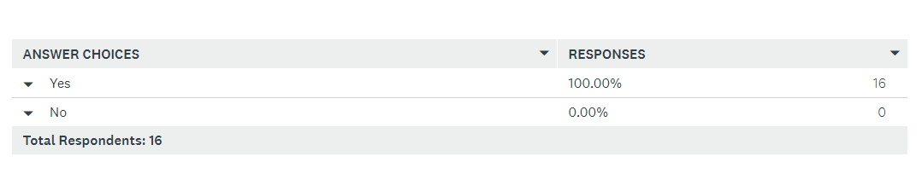
Table 1
(Source: Created by SurveyMonkey)
Question 2: Did you use Moodle platform before?
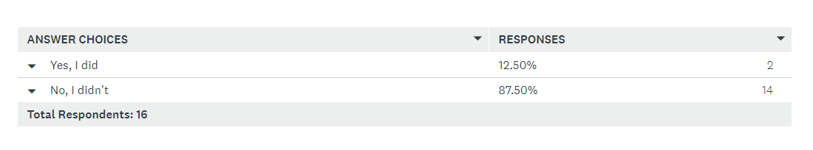
Table 2
(Source: Created by SurveyMonkey)
Question 3: Do you consider Moodle platform easy to use?
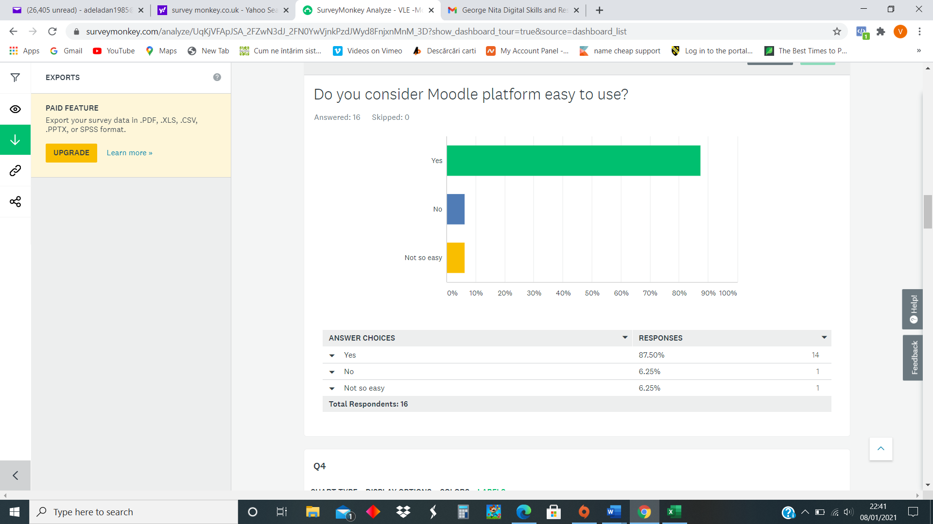
Table 3
(Source: Created by SurveyMonkey)

Question 4: How often do you use the Moodle platform?
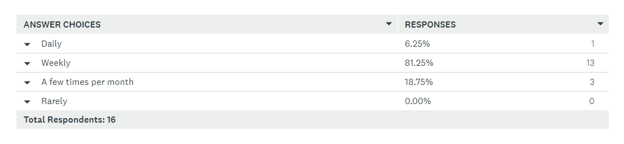
Table 4
(Source: Created by SurveyMonkey)
Question 5: What are the positive impacts of Moodle and virtual learning environment from your point of view?
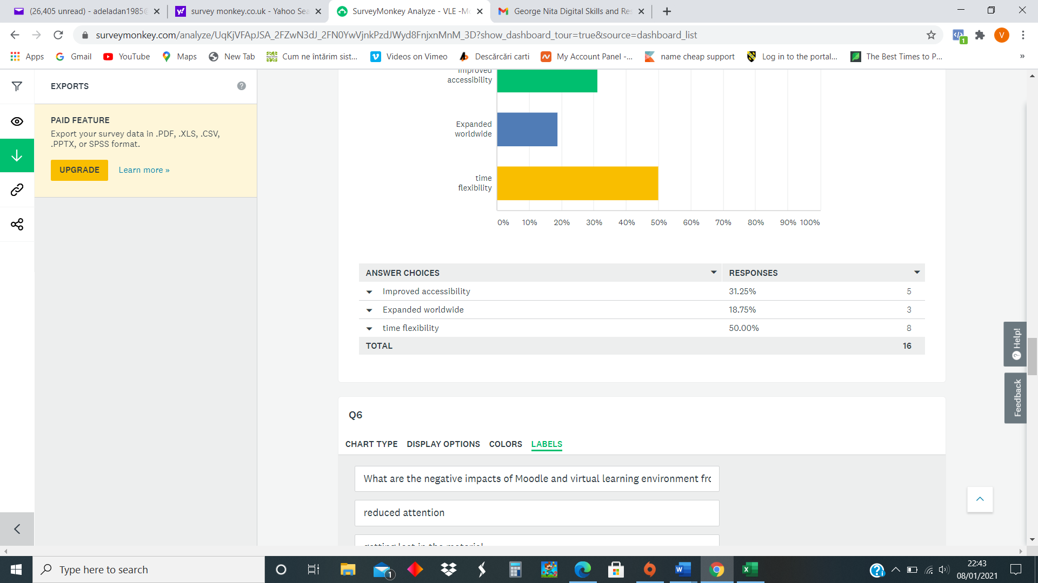
Table 5
(Source: Created by SurveyMonkey)
Question 6: What are the negative impacts of Moodle and virtual learning environment from your point of view?
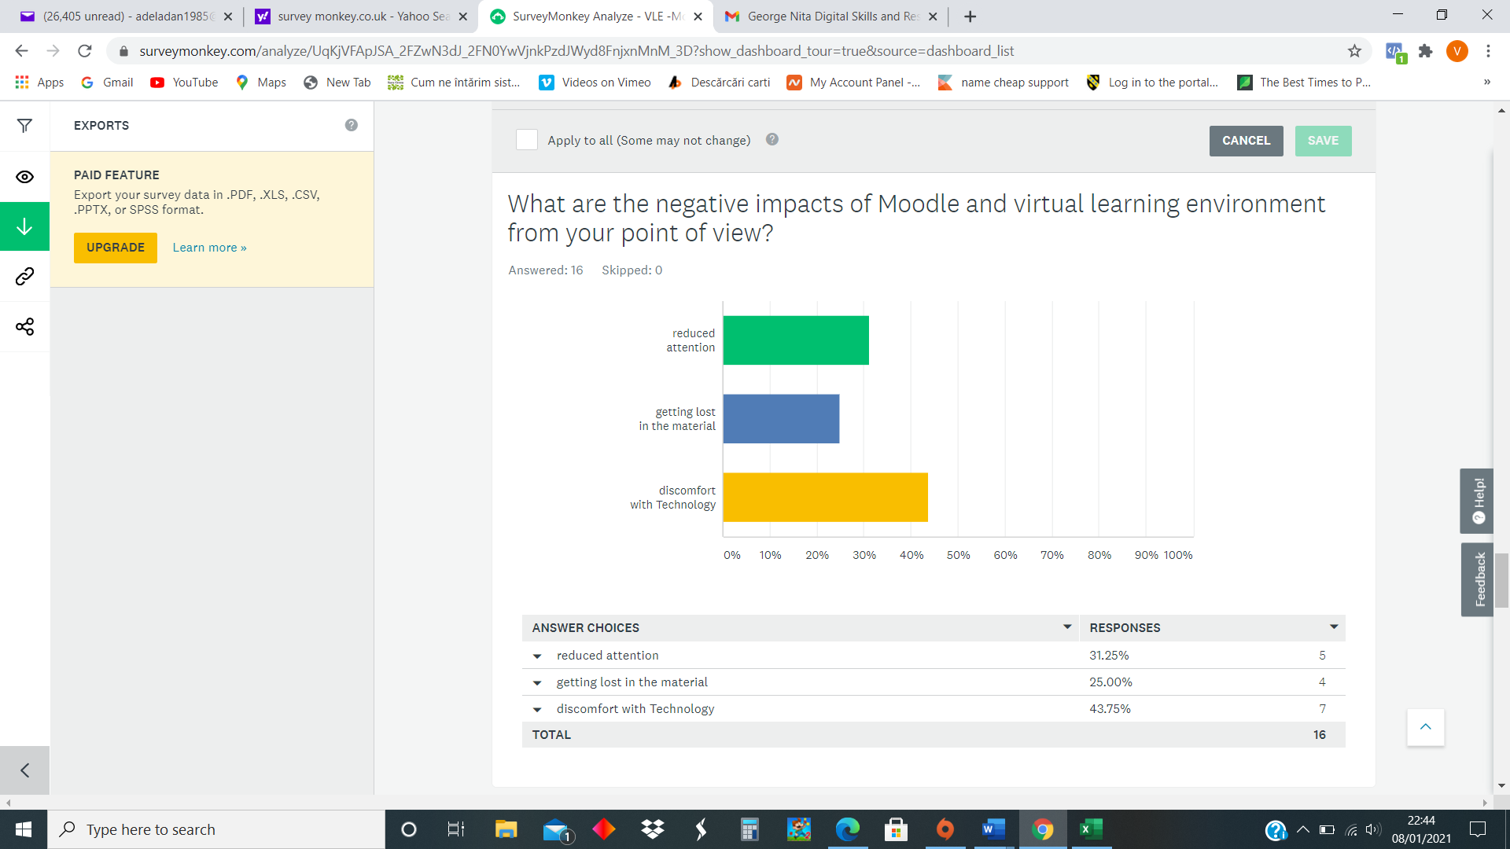
Table 6
(Source: Created by SurveyMonkey)
Question 7: Do you think Moodle and virtual learning environment is the future of education? 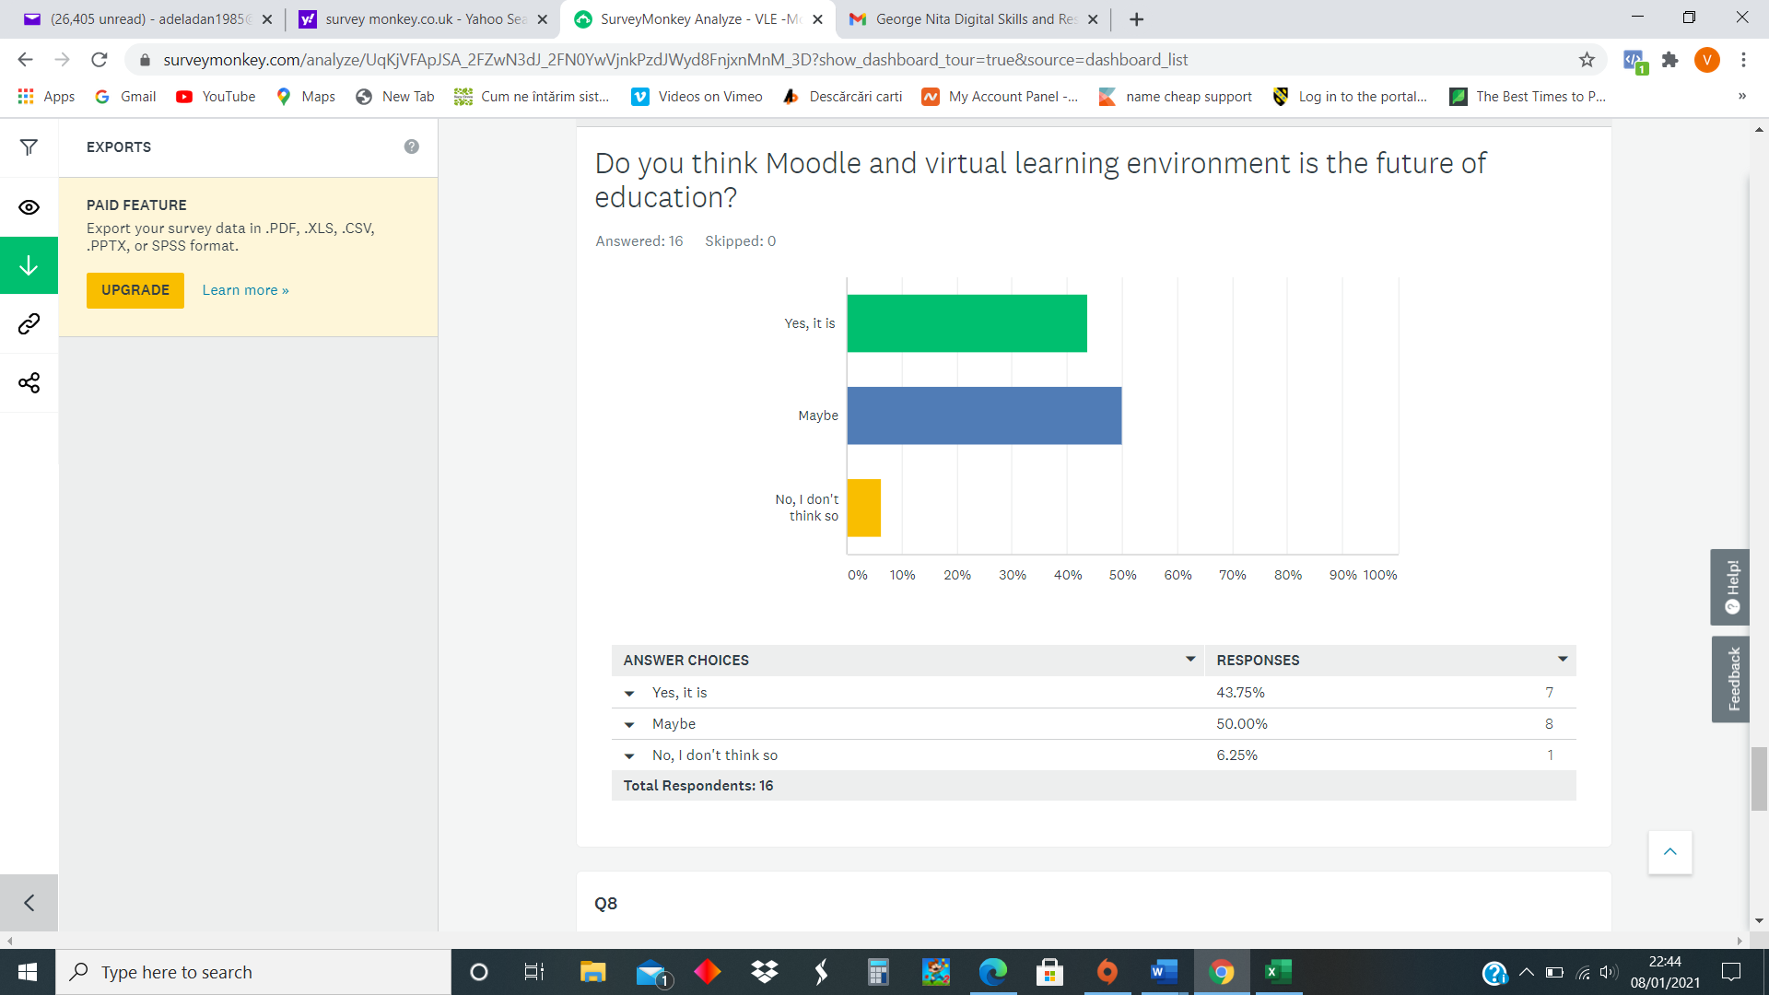Table 7
(Source: Created by SurveyMonkey)
Question 8: Do you think something can be improved on Moodle?
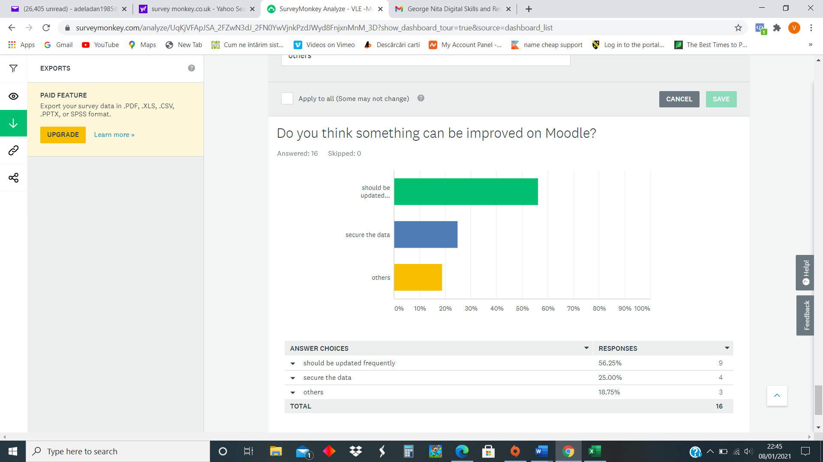Table 8
(Source: Created by SurveyMonkey)

6.0 Discussion
After conducting a brief literature review of the subject of virtual learning environment along with primary research. A lot of valuable data and information was revealed which served the overall purpose of this research and identified the various positive and negative impacts associated with the virtual learning environment - moodle in University of Wales Trinity Saint David. In the literature review which can also be termed as the secondary research for it was found that many authors have explored this specific concept, some of them highlighted the positive aspects of virtual learning environments, whereas some highlighted the certain negative aspects associated with virtual learning environments. For instance, one of the authors highlighted that one of the biggest positive impacts of a virtual learning environment is that it allows the students and educational organisations with some much-needed breathing space and freedom. It enables the learner to learn in their specific way, by allowing them access to the learning materials anywhere and anytime. This aspect of VLE and Moodle mitigated the barriers and limitations imposed by the traditional physical learning environments. If the findings of the survey are explored, it can be found that a similar notion was observed among the students living in University of Wales Trinity Saint David. Table 1 shows that out of 16 participants, all people gave their responses. Table 2 shows that 87.50% of the total respondents use Moodle platform whereas the remaining 12.50% of the total respondents never used Moodle platform. Table 3 shows that 87.50% of the total respondents find using Moodle to be extremely easy, whereas, 6.25% considered the same to be so and so. The remaining 6.25% of the total respondents considered using Moodle to be difficult.
Table 4 shows 6.25% of the total respondents use Moodle daily, whereas 81.25% use weekly and the remaining 18.75% use Moodle sometimes and 0% use rarely. Table 5 shows that 31.25% of the responses indicated improved accessibility to be a positive impact of using Moodle and VLE. Whereas, 50% indicated time flexibility and 18.75% indicated worldwide expandability to be the positive impacts of using VLE and Moodle. Table 6 shows that 25% considered getting lost in the material to be a major negative impact of using VLE and Moodle. 31.25% of the total respondents indicated reduced attention and 43.75% indicated discomfort with technology to be the negative impacts of using Moodle and VLE. Table 7 shows that 16 responses, where 43.75% of the total respondents consider Moodle and VLE to be the future of education, whereas, 6.25% disagreed with the statement. The remaining 50% were not sure with their answers. Table 8 shows that 56.25% of the total respondents recommended updating Moodle frequently for better experience, whereas, 25% of the total respondents suggested using all the https for ensuring data security. The remaining 18.75% suggested other options.
7.0 Conclusion
After conducting a brief research about virtual learning and its impacts on the students studying in University of Wales Trinity Saint David London Campus. It was found that it has many positive as well as negative impacts on their learning experience. On further discussion and comparing the literature discussed in this research with that of the findings of the primary research it was found that they are quite similar.

8.0 References
Arkorful, V. and Abaidoo, N., 2015. The role of e-learning, advantages and disadvantages of its adoption in higher education. International Journal of Instructional Technology and Distance Learning, 12(1), pp.29-42.

Dougiamas, M., 2014. Moodle: A virtual learning environment for the rest of us. TESL-EJ, 8(2), pp.1-8.

Dung, D.T., 2020. The advantages and disadvantages of virtual learning. IOSR Journal of Research & Method in Education, 10(3), pp.45-48.

Evans, C. and Fan, J.P., 2012. Lifelong learning through the virtual university. Campus-Wide Information Systems.

Gadre, A., Cudney, E. and Corns, S., 2016. Model development of a virtual learning environment to enhance lean education. Procedia Computer Science, 6, pp.100-105.

Lee, J., Hong, N.L. and Ling, N.L., 2014. An analysis of students' preparation for the virtual learning environment. The internet and higher education, 4(3-4), pp.231-242.

Podgorelec, V. and Kuhar, S., 2015. Taking advantage of education data: Advanced data analysis and reporting in virtual learning environments. ElektronikairElektrotechnika, 114(8), pp.111-116.

Stiles, M.J., 2020. Effective learning and the virtual learning environment. In Proceedings: EUNIS 2000–Towards Virtual Universities, InstytutInformatykiPolitechnikiPoznanskiej.

Van Raaij, E.M. and Schepers, J.J., 2018. The acceptance and use of a virtual learning environment in China. Computers & Education, 50(3), pp.838-852.

Appendix
Questionnaire



