
LEVEL 4
SEMESTER 2

MODULE CODE: SHSS4086
INTRODUCTION TO SPORT AND EXERCISE PSYCHOLOGY
ASSESSMENT TYPE: REPORT
ASSESSMENT/COMPONENT: 2

COMPONENT WEIGHTING: 50%
WORD COUNT: 1500 WORDS
MODULE TUTOR: ALISON CONNAUGHTON

SUBMISSION DETAILS:
Assignments should be submitted via Turnitin (Moodle) by 3pm on Friday 26th of April, 2019.

TASK:
Write a report on the following topic:
As a group, you will gather data using the measure provided for at least 20 team sport participants and 20 individual sport participants from the student population at UWTSD.
Motivation to take part in Team vs. Individual SportAim: To undertake a comparison of the motives for taking part in team and individual sports. Participants will be gathered from the School of Sport, Health and Outdoor Education.

Assessment Feedback Sheet

Student No./Name: Megan Davies
Module: Introduction to Sport and Exercise Psychology
Module Code: SHSS4086

Personal Evaluation – to support your academic progress please complete the section below BEFORE submitting your work.
What do you consider to be the best aspects of this work? |  |  | Introduction
Which aspects do you consider could have been improved in this piece of work? |  |  | Discussion could’ve been improved
What have you found most satisfying whilst undertaking this submission? |  |  | Introduction
ASSESSMENT CRITERIA | Learning  Outcomes |  | GRADE
ASSESSMENT CRITERIA |  |  | Poor  < 20% | Weak  20-29% | Unsatisfactory  30-39% |  | Satisfactory  40 – 49% | Good  50 – 59% | Very Good  60 – 69% | Excellent  70 – 84% |  | Exceptional  85– 100% | %
1. Introduction:  Review of relevant literature relating to motives for taking part in team and individual sports.  (approx. 500 words) | 1,2 |  |  |  |  |  |  |  |  |  |  |  | 30%
2. Method:  Outline the participants, procedures and design of the study (approx. 200 words) | 1,2 |  |  |  |  |  |  |  |  |  |  |  | 15%
2. Results:  Descriptive statistics, use of tables, figures and associated narrative (approx. 250 words) | 1,2 |  |  |  |  |  |  |  |  |  |  |  | 25%
3. Discussion:  Discussion of your findings in light of previous research & Practical implications.  Use of appropriate resources (approx. 550 words) | 1,2 |  |  |  |  |  |  |  |  |  |  |  | 30%
It is expected that students will present work that is proof read, correctly referenced and adheres to the Assessment Checklist. Therefore a range of 0 – 10 marks will be deducted for non-completion of any of the points on the checklist below.
TUTOR COMMENTS:

Submission date: 26/4/19  via Turnitin |  | Return date:  (at least within 4 weeks) |  |  |  | Tutor: Alison Connaughton |  |  |  |  | Mark:

- Please complete the Personal Evaluation section of the Assessment Feedback sheet, add your name and details, and paste the whole of this assignment document into the front of your assignment

- Submission is a single word file, clearly labelled with your name and module code
- Font style - Times New Roman, size -12 for text and 14 for headings
- Ink colour – black only
- Line spacing – 1.5 line spacing and 2cm- 2.5cm page margins
- Quotations more than three lines to be indented 1 line spacing
- One line space between paragraphs, paragraphs must be left aligned
- Pagination (your assignment should have page numbers)
- All tables and figures are internally referenced and have a title
- Word count checked and written at end of text (before references and any appendix)
- Assignment is within 10% of the word limit (excluding references and any appendices)
- All references in the text are included in the reference list
- Correct referencing following the Harvard style, as described in the UWTSD referencing guide.
- Correct spelling using UK English
- Correct use of punctuation
- Grammar and syntax correct- double check anything that has a green line under it
- I have read my assignment out loud to myself and it makes sense and is easy to read
- Somebody else has read my work and it makes sense to him or her!
- I have checked and I have not plagiarised
Failure to follow these guidelines will cost you marks!

Introduction
Motivation is defined as a ‘hypothetical construct used to describe the internal and/or external forces that produce the initiation, direction, intensity and persistence of behaviour’ (Vallerand & Thill 1993). Intrinsic motivation is identified as being ‘the pleasure, interest and enjoyment of an individual’ (Deci 1971). Increasing your level of intrinsic motivation means you will be prepared better to ‘focus in the present’ (Cohn, 2019). This means an individual will maintain a ‘consistent level of motivation’ throughout the season. Intrinsic motivation is described by the Michigan State University of as a ‘energizing behaviour’ who is remotely interested in the activity. (Michigan State University, 2019) Intrinsic motivation may give recognition, or a feeling of accomplishment, enjoyment and satisfaction in participating in the sport and many more positive factors. Less pressure, achieving goals and high levels of motivation are usually established through intrinsic motivation.
Whereas, extrinsic motivation is known to an individual as ‘the rewards and prizes from an activity’(Deci,1971). These are known as the comparison which is used for classifying motivation that is based on two different distinctive forms of motivation (Wann,2001). In some cases, extrinsic motivation can come across a positive factor or a negative factor. Athletes who may feel effects from certain pressures that the particular sport can bring. Extrinsic motivation brings competitive pressures and anxiety, your sport feeling like work instead of a game (Cohn,2019). In some athlete’s perspective, this pressure could be a positive, but in others this could come across a negative.
From an athlete’s perspective, there may be many different justifications why they participate in sport. Whether it is for a team or participating in an individual sport. An athlete’s intrinsic, extrinsic, and potentially a feeling of amotivation can have an effect on their personal performance levels through enhancing motivation to accomplish activities, experience stimulation, and to understand a new task (Academy, 2019). Participating in sporting teams like Rugby or Netball is frequently known as individuals wanting social context of sport is salient to participants’ motivation. Social reasons are for engaging in physical activities including affiliation, being part of a team, and social status (McCullagh et al,1993). Another article which indicates the reasoning for socialising and the involvement in sport shows such as wanting to be part of a team or to be with friends, and social sources of positive and negative affect such as social recognition and parental pressure’ (Allen,2003). Previous research shows that individuals with a strong connection to a team do not dissociate themselves when the team plays poorly (Wann,1993)
A few individuals choose to participate in individual sports. Research suggests that individuals who desire to enhance their self-esteem through an association within a team feel proud when the team plays well and engage in ‘basking in reflected glory’ (Cialdini et al,1976). Having family, friends and supporters which help to encourage an individual to help with the development of the players motivation levels.
Method
In order to assemble the below results, we asked 12 sporting teams and 12 sporting individuals of a mixture of different sporting backgrounds to participate in the investigation. We used the questionnaire which measures motivation which is known as the SMS-6 questionnaire (Pelletier et al., 1995). This questionnaire is known as the Sports Motivation Scale. Each participant was given a copy of the questionnaire. Before participating in a game or training session, the individuals were instructed to answer each question which measured how they were feeling before a game or the activity.
The SMS-6 questionnaire is a known questionnaire which measures the scale of motivation for an individual. This scale is the revised six-factor scale which measures factors from amotivation, external regulation, introjected regulation, identified regulation, integrated regulation and intrinsic motivation. It takes a measurement of intrinsic motivation, extrinsic motivation and amotivation inside any sport and this scale was used to test an athlete’s motivation towards sport participation.
The intention of this study was to find a group of questionnaires to a number of different sporting teams and individuals to undercover the different motives within the School of Sport, Health and Outdoor Education. This study establishes the different motivates these individuals have to participate within their chosen sports team or sport. There are many different motives to why people participate within individual sports and sporting teams. A main cause of measuring an individual’s motivation is to establish a theoretical construct on the persons behaviour. This represents an individual needs and actions.
Results
The below results indicate the measurement of motivation results from each population which was chosen to participate in this questionnaire. The two tables below indicate the results broken down into the mean and standard deviation of the results from both the individual participants who participate within an individual sport. Figure 1 shows each result for the team participants and figure 2 shows the results for the individual participants
Figure 1
Figure 1 shows both the mean and standard deviation from the participants within the sporting teams. This shows all the data from how each individual was feeling before, after or during activity.
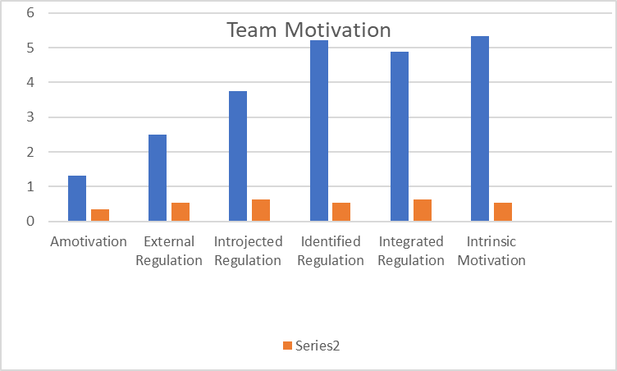
 | Amotivation | External Regulation | Introjected Regulation | Identified Regulation | Integrated Regulation | Intrinsic Motivation | Age
Mean | 1.31 | 2.50 | 3.75 | 5.21 | 4.88 | 5.33 | 20.25
Standard Deviation | 0.34 | 0.53 | 0.64 | 0.54 | 0.64 | 0.53 | 1.71

Mean 2. Standard Deviation

Figure 2
 | Amotivation | External Regulation | Introjected Regulation | Identified Regulation | Integrated Regulation | Intrinsic Motivation | Age
Mean | 1.07 | 1.86 | 4.43 | 5.20 | 5.23 | 6.02 | 22.27
Standard Deviation | 0.16 | 1.44 | 0.82 | 1.06 | 0.93 | 0.68 | 4.31
Figure 2 which is below this text is showing the mean and standard deviation from the individual participants. This figure also indicates how an induvial is feeling before after or during the sporting activity.
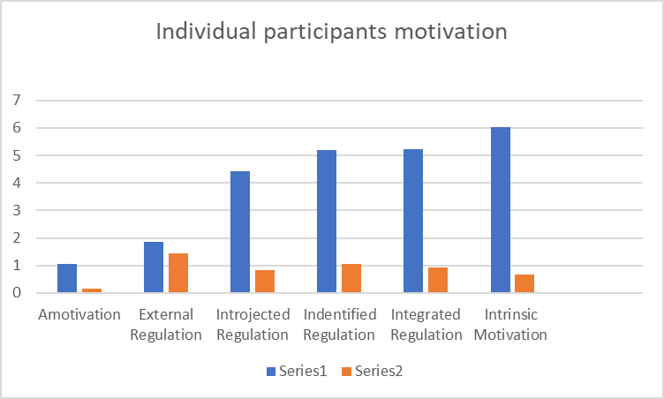

Mean Standard Deviation
Looking at each set of data in figure 1 and 2 and between the graphs produced, it shows that Intrinsic motivation and Identified regulation and identified regulation were the highest scoring of each component within each the team participants and individual participants.
Discussion
The data which is gathered above is used to be analysed to determine the effectiveness of each motivation scale involved. Intrinsic motivation showed high levels in each the individual participant and team participant.
Studying a relationship between a fan with a strong psychological connection with the team they support from a potential view of being a reason why an individual or team feels motivated, and sports team established that they were expected to be more to develop an extrinsic motivation attitude towards the team. It is believed that there is an increased importance which is placed on a team which means the success may lead highly identified fans to adopt an extrinsic motivational pattern which will reflects the desire to gain something from the performance. (Wann,2001). An online article suggests that an ‘individual who needs external motivation may be able to achieve goals set by others, to follow instructions, and to succeed with significant amount of outside structure’ (Monica et al,2010). So, if the participant does not have a small level of intrinsic motivation, they may be unable to ‘set and achieve personal goals’ (Monica et al,2010).
According to Hardy et al, elite athletes must have high levels of intrinsic motivation in order to sustain effort through dips in form and confidence ( Hardy et al, (1993) Having high levels of intrinsic motivation will establish that the individual or sports team enjoy more instead of participating in the chosen sport as if it is work. Intrinsic motivation is likely to lead to ‘persistent behaviour’ toward an individual or teams’ goal. (US Academy,2019) As know, the motivation will need to be based upon the circumstances of the participant. Developing intrinsic motivation with initiating internal rewards to external motivators. A sporting example of this would be scoring your first try in rugby. Using an external motivator will help to develop the internal reward for when that opportunity occurs. Focusing on how you feel once you’ve scored the try and how you physically feel. Giving credit and continuing to implement this routine and striving to develop that adrenaline to score again will make an induvial feel better as a player.
Developing intrinsic behaviour through being specific with positive feedback which can give confidence or self-esteem will play a positive factor in a player’s performance. Many people who need extrinsic motivation tend to be very negative in providing themselves with feedback (Monica et al,2010). Intrinsic motivation will give recognition, or the feeling of accomplishment, enjoyment and satisfaction in participating in the sport and many more positive factors as mentioned previously through this report with less pressure, achieving goals and high levels of motivation are usually established through intrinsic motivation.

The research carried out using the SMS-6 questionnaire showed that certain motivational types had a positive effect on an induvial and sports team. This was conducted on a group of students who were the age of 18+.

Word count 1,462

References
Academy, U. (2019). intrinsic motivation – The Sport Journal. [online] Thesportjournal.org. Available at: http://thesportjournal.org/article/tag/intrinsic_motivation/ [Accessed 23 Apr. 2019].

Allen, J. (2003). Social Motivation in Youth Sport. Journal of Sport and Exercise Psychology, 25(4), pp.551-567

Cohn, P. (2019). What Motivates Athletes? | Sports Psychology Articles. [online] Peaksports.com. Available at: https://www.peaksports.com/sports-psychology-blog/whats-the-best-motivation-for-athletes/ [Accessed 18 Apr. 2019].

Consumer, C.S., 2004. Motivations across multiple sports. Sport Marketing Quarterly, 13(1), pp.17-25

Deci, E.L. (1972). Intrinsic motivation, extrinsic reinforcement and inequity. Journal of Personality and Social Psychology, 22, pp.113-120.

McCullagh, P., Matzkanin, K., Shaw, S. and Maldonado, M. (1993). Motivation for Participation in Physical Activity: A Comparison of Parent–Child Perceived Competencies and Participation Motives. Paediatric Exercise Science, 5(3), pp.224-233.

A, M. (2010). Motivation: Intrinsic vs. Extrinsic by Monica A. Frank, Ph.D.. [online] Excel At Life. Available at: https://excelatlife.com/articles/intrinsic_motivation.htm [Accessed 9 Apr. 2019].

Msu.edu. (2019). Intrinsic Motivation. [online] Available at: https://msu.edu/~dwong/StudentWorkArchive/CEP900F01-RIP/Webber-IntrinsicMotivation.htm [Accessed 19 Apr. 2019].

Academy, U. (2019). The Structure of a Team: The Influence of Goal Setting Type on Intrinsic Motivation, Group Cohesion, and Goal Achievement Orientation of Division III Female Athletes. [online] The Sport Journal. Available at: http://thesportjournal.org/article/the-structure-of-a-team-the-influence-of-goal-setting-type-on-intrinsic-motivation-group-cohesion-and-goal-achievement-orientation-of-division-iii-female-athletes/ [Accessed 16 Apr. 2019].

Wann, D. (2001). Intrinsic and Extrinsic motives for originally following a sport team and team identification. Perceptual and Motor Skills, 93(6), p.451.

Pelletier, L., Fortier, M., Vallerand, R., Tuson, K., Briere, N., & Blais, M. (1995). Toward a new measure of intrinsic motivation, extrinsic motivation, and amotivation in sports: The sports motivation scale (SMS). Journal of Sport & Exercise Psychology, 17(1), 35-53.

