Title: Safety and Crisis Management in Hospitality Sector

Student Name: Hani Rosteenmehr
Student ID: 2118863

Module Title: Contemporary Themesin the Hotel and Hospitality Sector (BMIH6001)

Lecturer Name: Dr Ernest Balutie Wavei

Contents
Abstract 3
Introduction 4
Literature Review 4
Application to Hotel and Hospitality Sector 6
Political Factors 6
Economic Factors 7
Social Factors 7
Technological Factors 8
Environmental Factors 8
Strengths and Limitations 9
Evaluation Future Policy and Management 10
Conclusion 11
References 12
Appendix A: Safety and Security in Hotel Industry 14
Appendix B: Disaster Management Process for Hotels 15

Abstract
This conference paper will explore surging improvements about safety and crisis management in the hospitality sector, analysing the impact of PESTLE framework. This will also evaluate the institutional response, highlighting strengths and weaknesses of crisis management. Moreover, future policy recommendations will be provided to boost partnerships between the hospitality sector and local authorities. These recommendations aim to harness sustainable resilience and readiness against risks posed for the hospitality industry.
Keyword: Hospitality, PESTLE, Sustainability, and Technology.

Introduction
Safety and crisis management are seen as social aspects when it comes to the smooth running of operations in the hotel sector. The need for crisis management has increased with the surge of new challenges worldwide (Arvian, 2022). This ranges from natural disasters to pandemics; the hotel industry is facing a lot of risk. All these risks need well-crafted plans and strategies to respond. Hotels must be held responsible to make sure that their guests are safe when they are living. This calls for a thorough strategy for crisis management that incorporates successful recovery techniques together with prevention measures.
In this backdrop, disaster management plays a pivotal role in minimizing the impacts of unforeseen events. This includes fires and earthquakes. This hotel must integrate well-crafted protocols to evacuate guests on short notice and resume operations as soon as possible (Barbe et al., 2020). Moreover, the hospitality sector also needs to prepare their systems for other crises like cybercrime and public health emergencies (Brotherton , 2015). Therefore, risk management is needed to not only predict but also reduce the possibility of terrorists happening. This conference paper will explore these challenges in more depth, using case studies to show how the hospitality sector can come with a robust risk management framework.

Literature Review
Atasoy et al. (2022) have conducted research studies on crisis management and natural disasters that can affect the hospitality sector. As per this study, global events like the pandemic have exposed the lack of protocols in hospitals, leading to financial and human losses as well. When it comes to readiness from hotels to make any big crisis happen, hotels need to devise multi-layer strategies for crisis management. This may include technology, work for upskilling of employees, and proactive risk assessment. A large chunk of revenue comes up from international tourism when it comes to the hotel industry; this highlighted the need for a comprehensive communication framework to address possible threats (Barbe et al., 2020).
Most hotels worldwide are struggling to design effective disaster management strategies. The infrastructure of hotels is also lacking managerial response and design, which can help in effective management for Ciris. Kwok et al. (2022) also recommended that hotels that are small in size are more exposed to vulnerability due to a lack of proper planning and financial resources as well. Based on the report, building resilience requires collaboration with disaster response and municipalities, as well as insurance coverage for business interruptions brought on by natural catastrophes.
There are a number of challenges highlighted by Liu-Lastres (2022) and the required need for highly sophisticated risk management practices in hospitable institutions. As per this research study, a large number of hotels are only using basic assessment protocols. These protocols are not enough to manage possible risks like cybersecurity. Therefore, it exposed this to hackers or cyberattacks to attack hotel reservation systems and guests (Atasoy et al., 2022). This called for hotels to allot an appropriate amount to take robust security measures. The findings of his study also highlighted that changes toward online booking and digital services have exposed the hotel industry to cyber risk, posing a serious threat to financial stability and customer trust (Upadhyay et al., 2023). Thus, hotels need to have complete risk management plans, with cybersecurity being a crucial component of crisis readiness.
Pandemic and public health emergencies have played a crucial role in revamping crisis management in the healthcare sector (Leta and Chan, 2021). This report has quoted World Health Organization (WHO) reports, which show that pandemic has led to unprecedented global disruption in hotel industries. This has forced hotels to integrate safety protocols. As per the study of Kwok et al. (2022), a number of hotels were not ready to cater to crises like the pandemic, lacking on many fronts such as procedures and equipment to ensure guests well-being. This crisis has compelled industrial leaders to revisit health policies, increasing focus on devising strategies for pandemics. This helps in catering to health issues but also long-term problems with operations like lower occupancy rates and shifting consumer habits.
Ritchie and Jiang (2021) have highlighted the critical role of critical communication. This helps organizations manage disasters in their full spirit. The study also showed the key role of clear and timely responses to guests and employees. On the other hand, poor communication can lead to persistent complaints, negative reviews from customers, and damage brand image as well. Therefore, effective communication should be supported by digital technology, helping hotels to maintain confidence in customers and stick to safety procedures (Leta and Chan, 2021). This method necessitates a well-planned communication plan with frequent updates, unambiguous directions, and assurances of the hotel's crisis management procedures.
There is a need to incorporate technology in the hospitality sector to increase the capabilities of crisis management (Clegg et al., 2020). Therefore, many hotels have employed sophisticated technology like automated emergency systems, digital check-ins and check-outs, and other technologies that help reduce physical interaction. This helps hotels swiftly respond to crises. As per the research study, Upadhyay et al. (2023) have shown that hotels that have sophisticated technology are more capable of handling emergencies, reducing risks, and recovering in less time as compared to hotels that are operating on manual procedures. With the use of these technologies, hotels can monitor visitor movements, spot any risks, and start automatic safety procedures, all while lowering the need for human interaction.
Sustainably and crisis management have been highlighted by the different studies. As per the research study of Leta and Chan (2021), hotels are facing effects of climate change in the shape of frequent heatwaves and floods, damaging their infrastructure and operations as well. In order to cater to these issues, studies have highlighted the integration of sustainable environmental practices that can help reduce climate-related disasters. For this hotel, infrastructure should be designed with resilient infrastructure (Ritchie and Jiang, 2021). This helps hotels implement energy efficiency systems and recovery plans to make their surrounding environment more secure. Incorporating sustainability into disaster recovery frameworks not only makes hotels more robust, but it also gives them a competitive advantage in drawing in eco-aware tourists.

Application to Hotel and Hospitality Sector
In order to design the PESTEL framework, it can provide a comparative analysis of different factors that are responsible for the influence hotel and hospitality industry.

Political Factors
In order to create crisis management technology, government regulators and political stability play a key role. When it comes to rules and regulations, health and safety protocols, and disaster management, they can influence hotel operations. For instance, during the pandemic, different governments strictly implemented lockdowns, creating disasters for the global hospitality sector (Tuan, 2021). Therefore, hotels must abide by government rules about the implementation of hygiene measures and capacity limits. This has significantly changed the operations of hotels. Different studies have shown that countries where hotels are implementing were better equipped to withstand the crisis thanks to the incentives and unambiguous government assistance (Gowreesunkar et al., 2021).
In most case studies, political instability can create hurdles to effectively manage crises. Therefore, warning torn and politically unstable areas are making it difficult for hotels to make sure guests are getting quality services.

Economic Factors
Economic meltdown and decreasing purchase power of customers also impact the hospitality industry, making it difficult to manage crises. During recessions or economic crises, hotels cannot extend peak hours or days during season days, challenging the financial resilience of hotels (Kaschner, 2017). Due to the financial crisis of 2008 and the pandemic, the hotels had faced severe economic losses.
There are a number of hotels that have used cost-cutting measures. This includes layoffs, offering discounts to lure customers, and deferring capital expenditures. For this, various strategies will be used by hotels to service (Arvian, 2022). Moreover, layoffs also weaken the industry’s capability to offer quality service and cater to emergencies. Therefore, hotels are forced by economic constraints to strike a compromise between cost-effectiveness and keeping a strong crisis management system.

Social Factors
Health and safety trends also play a key role in managing crises in the hospitality sector. After the pandemic, this has highlighted awareness about hygiene, compelling hotels to implement health protocols to protect guests (Haavisto and Linge, 2022). A number of hotels have swiftly adopted new social expectations to implement boost-up clearing protocols, social seclusion tactics, and frictionless check-ins, which increased consumer trust and increased the likelihood of keeping customers.
On the other hand, social factors have also shown the vulnerabilities of crisis management. For this, corporate social responsibility (CSR) is used by hotels to focus on their role in community support programs (Kaschner, 2017). A number of hotels have successfully implemented these initiatives, offering shelters during natural disasters and healthcare facilities during pandemics as well.

Technological Factors
When it comes to the implementation of sophisticated technology in crisis management in the hotel and hospitality industries. Moreover, advanced technologies like AI-backed systems and big data analytics will transform hotels. In this way, hotels can predict and reduce this crisis. Therefore, hotels can implement sophisticated tactics that are better equipped to cater to emergencies like cyber threats (Donbak et al., 2022). AI systems, for instance, may keep an eye on visitor behavior to spot any safety concerns, and Internet of Things (IoT) devices can streamline emergency reactions, such as closing gas valves in the event of a fire.
On the other hand, vulnerabilities of technology reliance in crisis management must be considered. Therefore, cybersecurity has become a rising concern as more and more hotels are implementing digital technology (Santos and Silva, 2019). This suggested a high number of cyberattacks on hotel databases to steal private information of guests like account numbers, personal names, and other credentials.

Environmental Factors
As the frequency of national disasters is increasing due to changing environmental conditions worldwide, posing a serious challenge for hospital industry. Hotels that are located in hilly, coastal, and riverside areas are more vulnerable to tsunamis and flooding (Arvian, 2022). This has compelled organizations to come up with new crisis management strategies against environmental risks (Donbak et al., 2022). Therefore, hotels need to integrate eco-friendly infrastructure with energy-efficient systems and sustainable operations to minimize impact. On the other hand, plenty of hotels are lacking the money for making investments in green infrastructure, especially the smaller, independently run establishments.
Legal Factors
In order to implement crisis management strategies in its full scope, the hotel industry needs to comply with legal regulation. For this law, labor and health-related regulations are needed for hotels to maintain operational integrity. For instance, the pandemic showed that hotels have faced several lawsuits due to their inability to uphold safety measures and breach contracts with guests as well. As legal frameworks bound hotels to protect the rights of guests as employees and guide them in possible challenges and crises like pandemic.
Other legal issues have emerged in the shape of data breaches, as many hotels have failed to implement robust data protection mechanisms. This includes the full-scale impulsion of the General Data Protection Regulation (GDPR). The Marriot Hotel breach is a stark case study that showed the potential legal repercussions of cybersecurity incidents, highlighting how crucial it is to incorporate legal concerns into crisis management strategies.

Strengths and Limitations
As there are a number of advantages linked with crisis management for the hospitality sector, there are a number limitation that must be considered. One of the key strengths is embedded in its ability and capability to swiftly implement operational changes during crises. For instance, many hotels have swiftly implemented health protocols during COVID-19, minimized the risk of spreading the pandemic, and strictly implemented social distancing measures (Wut et al., 2021). All these actions have led hotels to continuously operate under the strict government regulations without exposing themselves to vulnerabilities.
On the other hand, there are a number of challenges where hotels were inclined to implement short-term solutions without using long-term crisis management. In some cases, this was due to management’s decision to save capital (Ivanov and Webster, 2019). Successful case studies have shown hotels that implement cleaning programs are more likely to generate more revenue than hotels that are implementing short-term programs. Moreover, smaller hotels with fewer resources found it difficult to put these strategies into practice, underscoring the differences in the industry's crisis resilience.

Evaluation Future Policy and Management
In order to increase the resilience level of the hospitality sector, future policy should be made up of various factors like technology, sustainability, and comprehensive risk management mechanisms (Leta and Chan, 2021). Therefore, the hospital sector must be built on the latest experience after the pandemic or other natural disaster. For this, hotels must employ sustainable strategies that not only address issues swiftly but also increase the capabilities for future disasters. There are a number of recommendations that must be employed in hotels providing services in the hospitality industry:
- Development of sustainable policies that are not only aligned with environmentally friendly practices. Therefore, hotels should invest in environment-friendly infrastructure to help reduce environmental-related issues (Barbe et al., 2020).
- Governments should introduce green initiatives or plans to give incentives to hotels that are practicing sustainable practices and have robust crisis management strategies (Atasoy et al., 2022).
- Use of sophisticated technology can also help in preparing hotels against any possible crisis. This includes using historic data and AI to forecast the possibility of a crisis (Barbe et al., 2020).
- AI-backed systems should be used to monitor guest activity without infringing their basic rights to privacy. This technology must be used for safety risks only (Costa and Costa, 2022).
- The Internet of Things should be used for swift energy responses.
- In order to guarantee that hotels address crises not just reactively but also deliberately, potential laws have to support investments in these capabilities (Ford and Sturman, 2019).
- Establishment of cordial relationships between local governments and hotels, which can be done by public authorities to improve hotel’s capabilities to respond to big crises (Barbe et al., 2020).
- A crisis management framework should be designed, including a transparent communication channel in which all local authorities should be on board.
For future management strategies should be made to increase the skillset of employees and make them prepare for crises. There are a number of hotels that could not handle the pandemic due to untrained employees to manage crises. Hotels should invest their resources to upskill their employees to cater to emergencies effectively (Barbe et al., 2020). This includes providing them knowledge about safety protocols and evacuation procedures during crises. To guarantee that hotels are constantly ready for new threats, training must be continuous rather than only a one-time reaction to a particular emergency.

Conclusion
To sum up this report, crisis management and safety are crucial for hotel and hospitality industries to cater to global crises on short notice. In this PESTLE analysis is used to dig deep into strengths and problems that arise during crisis response and highlight the need for integration of sustainable technology and crisis communication. Subsequent policies have to concentrate on augmenting technical innovation, sustainable practices, employee education, and cooperation with government agencies. By taking these steps, the industry will be able to strengthen its resilience and more skilfully handle any future crises.

References
Atasoy, B., Türkay, O. and Şengül, S., 2022. Strategic responses of chain hotels to COVID-19 from a situational crisis communication theory perspective. Journal of Hospitality and Tourism Insights, 5(5), pp.1118-1136.
ARVIAN, M.A., 2022. Management Of Global Crisis In Tourism Business: Examining The Marketing Communication Strategies Amidst Pandemic Times For Tours And Travel Agencies In Indonesia.
Barbe, D. and Pennington-Gray, L., 2020. Social media and crisis communication in tourism and hospitality. Handbook of e-Tourism, pp.1-27.
Brotherton. B., 2015 Researching Hospitality & Tourism 2nd Edn. Sage. London
Clegg, S.R., Skyttermoen, T. and Vaagaasar, A.L., 2020. Project management: a value creation approach. Sage.
Costa, V. and Costa, C., 2022. Challenges in Times of Crisis and Pandemics in the Hospitality Industry: A Systematic Literature Review. Sustainability and Competitiveness in the Hospitality Industry, pp.1-22.
Cooper, C. and Hall, M. (2019) Contemporary Tourism: An International Approach, 4th Edn. Goodfellows, Oxford.
Donbak, E.R., Kirpik, G. and Valeri, M., 2022. An overview of crisis management in hospitality enterprises: the case of operating at an international level hotel in Adiyaman. Tourism Risk, pp.81-102.
Ford, R.C. and Sturman, M.C., 2019. Managing hospitality organizations: Achieving excellence in the guest experience. SAGE Publications.
Gowreesunkar, V.G., Maingi, S.W., Roy, H. and Micera, R. eds., 2021. Tourism destination management in a post-pandemic context: Global issues and destination management solutions. Emerald Publishing Limited.
Haavisto, V.E. and Linge, T.T., 2022. Internal crisis communication and Nordic leadership: the importance of transparent and participative communication in times of crisis. Scandinavian Journal of Hospitality and Tourism, 22(4-5), pp.331-356.
Ivanov, S., & Webster, C. (Eds.). (2019). Robots, artificial intelligence, and service automation in travel, tourism and hospitality (1st ed.). Emerald Publishing
Kwok, L., Lee, J. and Han, S.H., 2022. Crisis communication on social media: what types of COVID-19 messages get the attention?. Cornell Hospitality Quarterly, 63(4), pp.528-543.
Kaschner, H., 2017. Effective crisis decision-making. Journal of Business Continuity & Emergency Planning, 11(1), pp.27-36.
Liu-Lastres, B., 2022. Beyond simple messaging: a review of crisis communication research in hospitality and tourism. International Journal of Contemporary Hospitality Management, 34(5), pp.1959-1983.
Leta, S.D. and Chan, I.C.C., 2021. Learn from the past and prepare for the future: A critical assessment of crisis management research in hospitality. International Journal of Hospitality Management, 95, p.102915.
Ritchie, B.W. and Jiang, Y., 2021. Risk, crisis and disaster management in hospitality and tourism: a comparative review. International Journal of Contemporary Hospitality Management, 33(10), pp.3465-3493.
Santos, J.D. and Silva, Ó.L., 2019 Digital Marketing Strategies for Tourism, Hospitality, and Airline Industries. 1st edn. Hershey: IGI Global.
Tuan, L.T., 2021. Employer event communication and hospitality workers’ resilience during the COVID-19 crisis: the role of core beliefs examination and family support. International Journal of Contemporary Hospitality Management, 33(5), pp.1593-1619.
Upadhyay, S., Chaskar, A. and Sigala, M., 2023. Breaking waves: A bibliometric odyssey on crisis communication in tourism and hospitality (1980–2022) and paving the path for future research. Journal of Contingencies and Crisis Management, 31(4), pp.941-953.
Wut, T.M., Xu, J.B. and Wong, S.M., 2021. Crisis management research (1985–2020) in the hospitality and tourism industry: A review and research agenda. Tourism Management, 85, p.104307.

Appendix A: Safety and Security in Hotel Industry
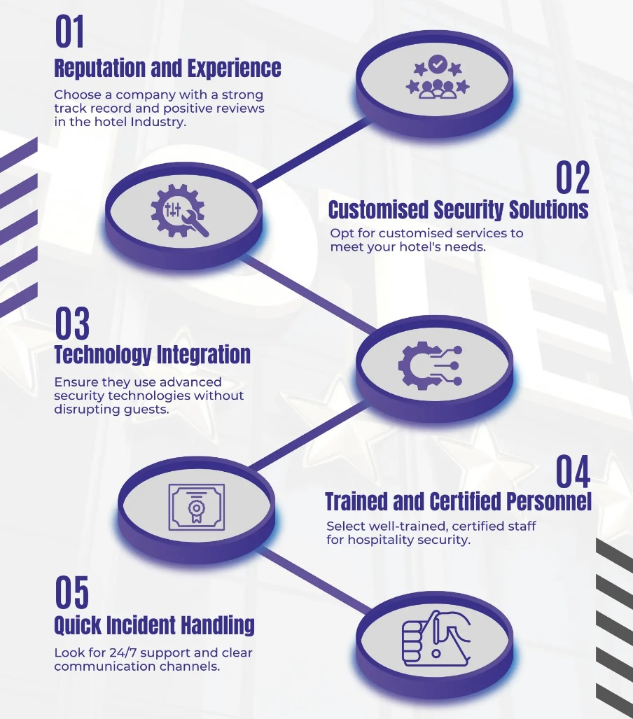
Source (Donbak et al., 2022)

Appendix B: Disaster Management Process for Hotels
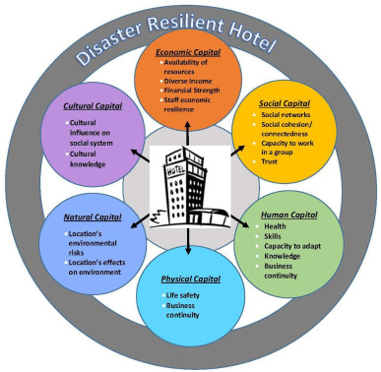
Source (Arvian, 2022)

