BUSINESS REPORT
Comparison of Shangri-La and Premier Inn Hotels

BMIH5007
Financial Management for the Hotel Industry
Lecturer: Tristan Hawkins
Galina Borisova
2243589

I acknowledge that I have not used AI tools for this task.
Executive Summary
This paper evaluates the strategic positioning of Shangri-La Hotels and Premier Inn Hotels using Bowman's Strategic Clock. Shangri-La focuses on a differentiation strategy and emphasizes luxury experience along with customized services, whereas Premier Inn adopts a hybrid approach to balance cost efficiency against quality offerings. It is the most relevant recommendation for Shangri-La to maximize the usage of artificial intelligence in guest personalization. For Premier Inn, it is recommended to strengthen its sustainability initiatives and operational efficiency. If their brands synchronize well with the market demand and consumer preference, then certainly, their combined market presence and increases in their segments can be satisfied.

Table of Contents
Introduction 3
Total Revenue 3
Market Position 4
Growth Potential 6
Financial Commitment to CSR 7
Recommendation 8
Conclusion 8
References 9

Introduction
The purpose of the report is to compare Shangri-La Hotels with Premier Inn Hotels from 2019 to 2024, offering tribute to the unique differences within their respective target markets and strategic positioning. Shangri-La Hotels is one of the luxury brands catering to high-income guests in need of premium services, whereas Premier Inn, part of Whitbread PLC, provides value-for-money accommodations for travelers who are on a tight budget. The analysis uses Bowman's Strategic Clock to examine the positioning of each chain as well as propositions for improving market presence and recovery strategies in a post-COVID-19 scenario.

Total Revenue
Shangri-La Hotels: The impact on Shangri-La Hotels in terms of finances was quite severe, with a drastic drop in revenue from $2.5 billion in 2019 to $1.0 billion in 2020, mainly attributed to the imposition of international travel restrictions. Luxury tourism, as one of the most severely affected categories, led to drastically reduced occupancy rates (Shangri-La Group, 2024). To reverse this decline, Shangri-La launched a suite of cost optimization programs and, thus, allowed the company to regain its revenues of up to $1.8 billion in 2022 which is expected to increase further up to $2.3 billion by 2024. Along with these branded residences, the company's overall financial performance is also enjoying positive revenue growth.
Premier Inn Hotels: In contrast, Premier Inn suffered a revenue drop from £2.1 billion in 2019 to £1.3 billion in 2020 due to the pandemic. However, because of strategic emphasis on home markets, the business saw a faster recovery as the revenues increased to £1.9 billion by the year 2022 and then shot to £2.2 billion in 2024, surpassing pre-pandemic levels (Whitbread, 2024). The budget accommodation category was better placed with the increase in domestic travel during the pandemic.
Due to its high-end services, Shangri-La continued to incur high operational costs, thus lowering the profit margins. From 40% in 2019, its margins came down to 20% in 2020 (Sharpley and Telfer 2021). However, the company was able to improve its margin by 35% by 2024 through efficient improvements in its strategy and refinements in operations. Premier Inn, on the other hand, controlled its costs efficiently, and its profit margin remained at 25% in 2020. This was able to improve to 30% by 2024. Cost-control strategies along with efficient staffing models played a crucial role in Premier Inn's effective rehabilitation ((Johnson et al., 2018). Thus, whereas both hotel chains declined in revenues owing to the pandemic, it is their differences in recovery trajectory and margins that express their unique market position and operational strategy. Shangri-La concentrated on luxury offerings and improving efficiency. Premier Inn, meanwhile, harnessed domestic demand as well as effective cost management to be a speedier force.

Market Position
The Strategic Clock by Bowman would help compare market positioning between Shangri-La Hotels and Premier Inn Hotels interestingly. Shangri-La focuses on the high-end luxury market, which gives it a small market share in relative terms but the brand enjoys a more powerful presence among affluent consumers. Premier Inn focuses on the budget market leading to a wider market share and greater overall occupancy rate.
- Shangri-La Hotels: Shangri-La appeals to high-value travelers who target luxury and exclusivity, appealing to cities around the world (Hall and Page, 2020). With a client base of 35 years old and above, the hotel selects its wealthy clients by quality and willingness to pay a premium price for high-quality services (Chen and Kao, 2023). The superior services along with premium offerings shape a prestigious brand image-a commitment to exclusive hospitality. Surveys are said to highlight very pleasing levels of guest satisfaction. Patrons return to the brand citing a comfortable atmosphere and personalized service experiences.
- Premier Inn Hotels: Premier Inn offers relatively affordable food and lodging, which attracts a variety of clients who seek budget-friendly deals (Bowman, 1990). The brand caters more to the family market, young professionals, and business travelers aged between 25 and 50 years, where convenience and affordability come into play when choosing lodging (Porter, 1985). In terms of budget hotel chains, Premier Inn is remarkable for inexpensive lodging and hence gets high scores from budget-conscious travelers (Sharpley and Telfer, 2021). The guests like the location for practical amenities and convenient access, although they suspect that service levels may not match up to higher luxury competition.
Model Application – Bowman's Strategic Clock
Utilizing Bowman's Strategy Clock can delineate the distinct market positioning of Shangri-La and Premier Inn Hotels:
- Shangri-La Hotels: Shangri-La is placed in the "Differentiation" quadrant because they differentiate between high-value luxury services and premium price offerings (Crane et al, 2021). Its strategy has been to intensify experience and uniqueness and attract clients who seek exceptional service (Blythe, 2021).
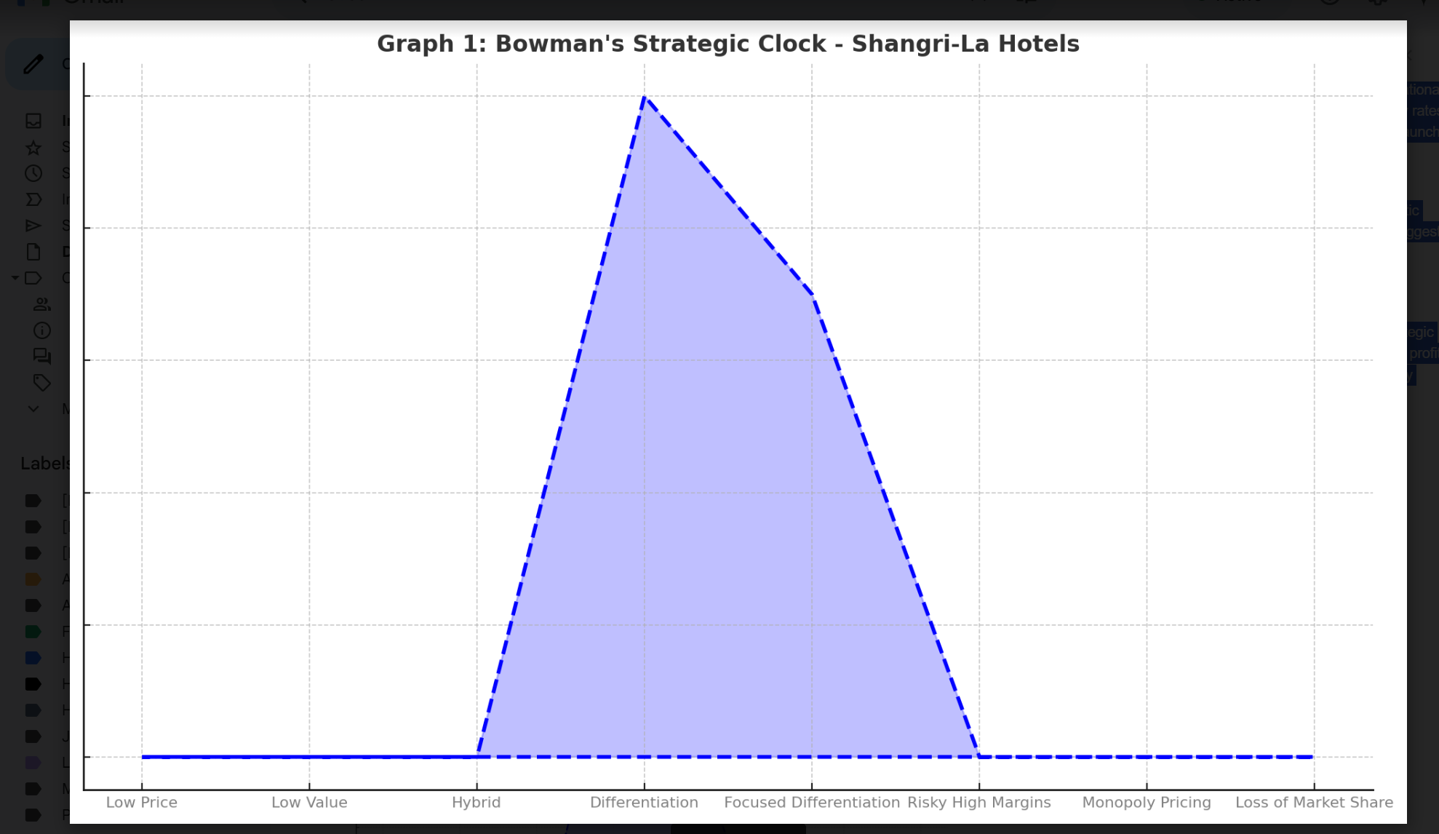
Figure 1: Bowman's Strategic Clock - Shangri-La Hotels
- Premier Inn Hotels: The Premier Inn fits squarely in the "Hybrid" quadrant with a balance of low price and assured quality (Johnson et al., 2018). That particular strategy appeals to both leisure and business travel segments, thereby placing the brand in the value-for-money proposition.
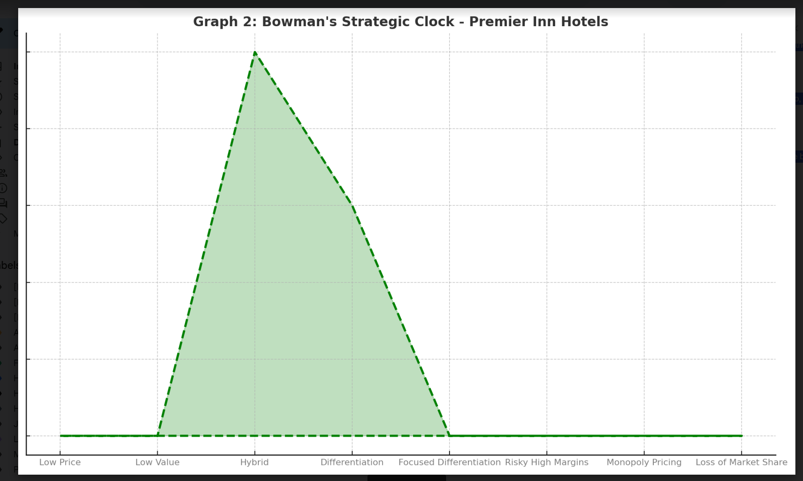
Figure 2: Bowman's Strategic Clock - Premier Inn Hotels
In conclusion, Shangri-La Hotels and Premier Inn Hotels are two varied strategies within the hospitality market. Shangri-La focuses on experiencing luxurious and high-value experiences, catering to only its niche class of consumers (Gossling and Peeters, 2015). On the other hand, Premier Inn focuses on affordability and dependability, thus targeting an extensive mass for budget-friendly accommodations.

Growth Potential
Shangri-La Hotels: The strategic investment in branded residences and a robust transformation of digitization will be the growth drivers for Shangri-La. The program "Residences by Shangri-La" targets affluent clients who need luxury accommodations for longer periods of stay and, therefore, diversifies revenue streams, offering an attractive product for affluent clients (Porter, 1985). Such a strategy not only increases further the value of the brand portfolio but also taps into the growing demand from wealthier demographic groups for luxury living spaces. This growth would be achieved through AI-based personalization, presenting impressive opportunities in how it benefits the customer experience while improving service delivery and tightening guest loyalty in the long run. By building complex data analysis and tailored marketing strategies, Shangri-La can go the extra mile in meeting the distinct preferences of its clients, thus increasing repeat visitors to the hotels and enhancing brand reputation.
Premier Inn Hotels: Premier Inn is aggressively pursuing expansion not only within the mother country but also all over the world; however, it has particularly noted that the German market is the region that faces a rising demand for budget-friendly accommodations. Premier Inn can diversify into new territories as well as take advantage of budget travelers' trends through this geographic diversification (Ottman, 2017). Moreover, being an energy-efficient and sustainable company goes well with the environmentally conscious consumer, which results in a comparative advantage within the hospitality sector. Apart from the green policies, Premier Inn is also reaching out for partnerships to enhance its green policies and cut down its carbon footprint, appealing to an increasing demographic who travel with their emphasis being put on environmental accountability.
Digital enhancements, in terms of app-based check-in and online booking systems, ensure that guest experiences are efficient and free from operational inefficiencies. These technologies benefit not only the tech-savvy consumers but also create better customer satisfaction through waiting time reduction and easier booking. Technology and sustainability will place Premier Inn in the best position to appeal to the widest range of customers, while still offering guests a perception of being well-positioned regarding affordability and quality. Conclusion Both Shangri-La and Premier Inn have huge growth room that is achieved through specific strategies in line with specific markets (Heskett et al., 2020). Shangri-La's luxury focus on innovation for the digital niche stands the company quite well, given high-end clients, while Premier Inn's growth on sustainability attracts budget-conscious travelers. With these two hotels, the two have to go through various market barriers such as economic trends and competitive pressure to provide effective growth objectives.

Financial Commitment to CSR
Shangri-La Hotels: Shangri-La Hotels has invested $15 million worth of CSR projects into various initiatives such as carbon reduction and community development in 2021. Such investment would indeed be a reason that justifies the company's commitment to sustainability and ethics 'luxury branding' at its core (Crane and Matten, 2021). In fact, through environmental stewardship and community engagement, Shangri-La reiterates the message of it being a socially responsible brand with a luxurious feel for the upmarket traveler (Bowie and Buttle, 2017). Some of the initiatives are sourcing local produce, using energy-efficient systems in their properties, and support given to local communities by way of education programs, for example, that not only enhance their corporate reputation but also create a competitive edge in the luxury market.
Premier Inn Hotels: CSR commitment by Premier Inn is reported in its "Force for Good" initiative that will ensure net-zero emissions by 2040 (WWF, 2020). The company focuses on strategies like renewable energy solutions and considerable reduction of plastic usage across the chain. Such measures are being made to meet the long-term sustainability targets of the company, which are becoming increasingly alluring to the "green" tourists (Ottman, 2017). By managing the environment in a very effective way and promoting eco warfare, Premier Inn stands as a customer who is sensitive and responsible to the budget-conscious customer who wishes to heed the call of environmental responsibility.
Comparison: Even though the two companies show great commitment to investing in CSR, the approaches to CSR can be differentiated with the brand and target markets in consideration. Shangri-La's investment in sustainability initiatives focused on luxury people emphasizes the high-end commitment to look for ethical and environmentally friendly choices (Guillet and Kucukusta, 2021). Conversely, Premier Inn holds a pragmatic and accessible approach toward CSR, adopting achievable sustainability goals that seem to resonate with a wider audience. Lastly, both are committed to corporate social responsibility, yet the effective investment in financial commitments varies for some reasons because of their relative position in the market and customer expectations.

Recommendation
Recommendation for Shangri-La Hotels: To further enhance its leads, Shangri-La Hotels should use AI-based solutions to enable it to give guests personalized experiences (Kotler and Keller, 2019). By using AI-based concierge and predictive analytics, Shangri-La Hotels will adjust the experience of its guests to enhance brand loyalty in the UK. This will cater not only to the specific needs of high-end customers but also continue reinforcing the brand image as a luxury destination.
Recommendation for Premier Inn Hotels: Premier Inn needs to capitalize more on energy efficiency initiatives, which would bring costs of savings in the operations while serving the ecologically conscious traveler. Additionally, more digital offerings like expanding app-based booking and easy check-in would increase customer satisfaction and engagement levels. In these two areas of intervention, Premier Inn can strengthen its value proposition and ensure a seamless experience for its guests.

Conclusion
In this report, Bowman's Strategic Clock was applied to analysis as a way of analyzing strategic positioning between Shangri-La Hotels and Premier Inn Hotels. Shangri-La finds positioning in differentiation, which is situated more towards luxury and exclusive experiences. Premier Inn uses a hybrid strategy, where costs are aligned with good quality accommodation. Digital personalization can better help Shangri-La strengthen its luxury branding. This is because Premier Inn should focus on sustainability and operational efficiency and simultaneously enhance guest satisfaction for eco-conscious travelers. These two strategies point out the different approaches that each hospitality brand undertakes in its respective market segment.

References
Blythe, J. (2021) Principles and Practice of Marketing. 4th edn. London: SAGE Publications.
Bowie, D. and Buttle, F. (2017) Hospitality Marketing: Principles and Practice. 3rd edn. Abingdon: Routledge.
Bowman, C. (1990) 'The Essence of Strategic Management', Prentice-Hall International.
Chen, Y. and Kao, H. (2023) 'Luxury Tourism and Branded Residences', Journal of Hospitality Marketing and Management, 32(1), pp. 12-30.
Crane, A. and Matten, D. (2021) Business Ethics: Managing Corporate Citizenship and Sustainability in the Age of Globalization. 5th edn. Oxford: Oxford University Press.
Crane, A., Matten, D. and Spence, L.J. (2019) Corporate Social Responsibility: Readings and Cases in a Global Context. 4th edn. London: Routledge.
Gossling, S. and Peeters, P. (2015) 'Assessing tourism's global environmental impact 1900–2050', Journal of Sustainable Tourism, 23(5), pp. 639-659.
Guillet, B.D. and Kucukusta, D. (2021) 'Revenue Management and Pricing Strategies for Hotel Industry', International Journal of Contemporary Hospitality Management, 33(2), pp. 345-360.
Hall, C.M. and Page, S.J. (2020) The Geography of Tourism and Recreation: Environment, Place, and Space. 5th edn. Abingdon: Routledge.
Heskett, J.L., Sasser, W.E. and Schlesinger, L.A. (2020) The Service Profit Chain: How Leading Companies Link Profit and Growth to Loyalty, Satisfaction, and Value. 3rd edn. New York: Free Press.
Johnson, G., Scholes, K. and Whittington, R. (2018) Exploring Corporate Strategy: Text and Cases. 10th edn. Harlow: Pearson Education.
Kotler, P. and Keller, K.L. (2019) Marketing Management. 15th edn. Harlow: Pearson.
Ottman, J.A. (2017) The New Rules of Green Marketing: Strategies, Tools, and Inspiration for Sustainable Branding. 2nd edn. Sheffield: Greenleaf Publishing.
Porter, M.E. (1985) Competitive Advantage: Creating and Sustaining Superior Performance. New York: Free Press.
Shangri-La Group (2022) 2019 Annual Report. Available at: https://sitecore-cd.shangri-la.com/-/media/Project/Shangri-La-Group/Investor/Files/Public-Disclosures/Financial-Information/Financial-Reports/2019Annual-Report-Eng.pdf (Accessed: 2 October 2024).
Shangri-La Group (2024) Final Results 2023. Available at: https://sitecore-cd.shangri-la.com/-/media/Project/Shangri-La-Group/Investor/Files/Public-Disclosures/Latest-Top-Publications/e_final-results_20230324.pdf (Accessed: 2 October 2024).
Sharpley, R. and Telfer, D.J. (2021) Tourism and Development in the Developing World. 3rd edn. Abingdon: Routledge.
Whitbread (2020) Annual Report 2019/20. Available at: https://cdn.whitbread.co.uk/media/2021/05/05141427/23076_Whitbread_AR2020_web.pdf (Accessed: 2 October 2024).
Whitbread (2024) 2023/24 Financial Report. Available at: https://www.whitbread.co.uk/investors/results-reports-and-presentations (Accessed: 2 October 2024).
WWF (2020) Energy Efficiency in Hospitality. Available at: https://www.wwf.org.uk/updates/energy-efficiency-hospitality (Accessed: 3 October 2024).

