Natalie Tully 2025743
Sujeewa Herath
Problem solving and decision
making, BMSW40O4.
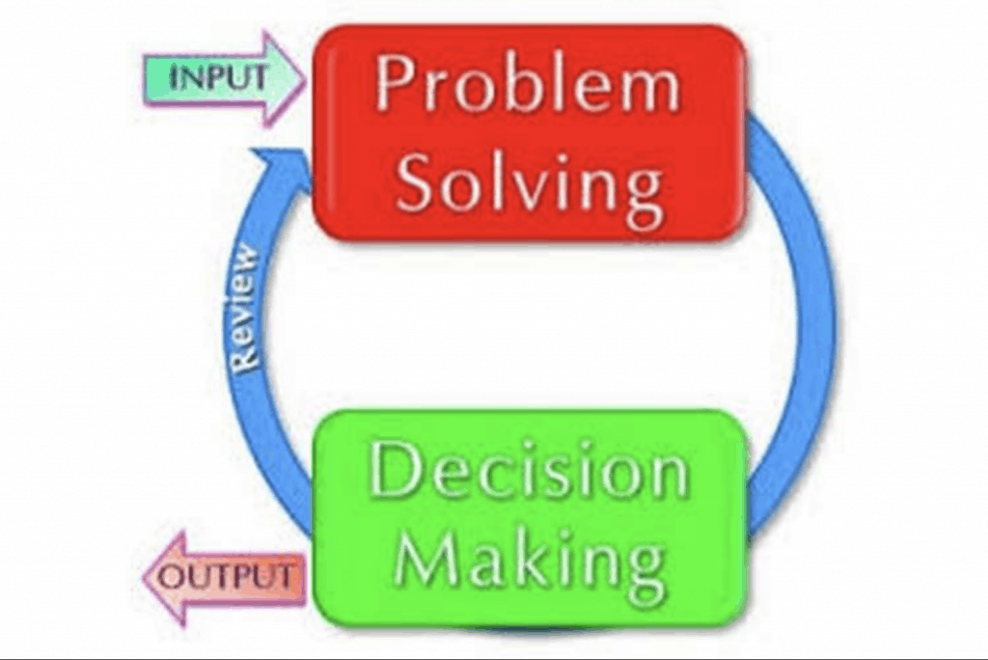

TABLE OF CONTENTS
Page 3 Introduction.

Page 4 What is work-related stress?

Pages 5 and 6 Cause and effect analysis of the complex problem.

Pages 6, 7, and 8 Factors contributing to the complex problem, pestle analysis.

Pages 9 and 10 Alternative solutions to reduce work-related stress by decisions making solutions, (decision making by PMI and grid analysis)

Page 11 conclusion

Page 12 Action plan

Page 13 references

Introduction
After reviewing the case study, it is apparent that work-related stress is the leading cause of health problems in the UK, costing the health sector billions of pounds. It also has an impact on employees and businesses. Each year, over 11 million working days are missed due to work-related stress, and stress can exacerbate diseases like anxiety and depression. In addition, approximately half a million people in the UK suffer from work-related stress that causes them to get unwell. This report will consider this case study to acquire a better understanding of the complicated issue of work-related stress on workers and organisations. Cartwright, S. and Cooper, C.L., (1997.)
The four main areas that will be reviewed are as follows:
The nature and impact of the complex problem on employees and their organisations.
within this section will explore what is work-related stress? What's impact stress has on the employees and the organisations?
Cause and effect analysis of the complex problem.
Looking into the problem in more depth and the potential causes and effects of the identified problem (work-related stress). Using swot and fishbone diagram.
Factors contributing to the complex problem, pestle analysis.
This section will explore the political, economic, social, technical, and environmental components of the six PESTLE factors and how these can impact work-related stress on organisations and employees.
Alternative solutions to reduce work-related stress by decisions making solutions, (decision making by PMI and grid analysis) This section will look at how the decision-making process may aid in issue solving by reviewing several options and selecting the best path to pursue using various decisions methods PMI and grid analysis.

What is work-related stress?
There are many definitions of work-related stress here is a definition states that "The adverse reaction people have to excessive pressures or other types of demand placed on them at work." (HSE, 2017) Work-related stress is a growing problem around the world that affects not only the health and well-being of employees but also the productivity of organisations. (Iskamto, 2021) Work-related stress arises where work demands of various types and combinations exceed the person’s capacity and capability to cope. Work-related stress can affect many factors in a person’s life including mental health physical and psychology. The most common signs of physical and psychology are 1. Exhaustion 2. Muscle tense 3. Aches and pains 4. Palpitations of the heart 5. Sleep problems, such as insomnia 6. GI problems, such as diarrhoea or constipation Dermatological problems are number seven. Among the psychological symptoms is 1. Anxiety 2. Nervousness 3. Despair. Work stress can also cause work overload and underload. (Nixon et al., 2011) Stress has a consequence on decision-making and organisational skills., it can have a negative impact on workplace behaviour and culture. It can result in increased injury rates, workplace conflict, an increase in conflicts, and a deterioration in employee relations. All these factors can have a critical impact on a business work-related stress impacts the employees as well the employer’s here are some of the common issues and concerns around work-related stress are as followed.

Employers
- Poor timekeeping
- Increased Incidents reports
- Increased of employees complains
- Poor performance
- Low-profit intake
Employees
- Mental health issues
- Low income
- Job lost
- Health conditions

Cause and effect analysis of the complex problem.
To analysis the cause and effects one needs to first find out the root problem of work-related stress by using fishbone and SWOT. These are the most powerful and successful methods for recognising and solving problems. If the root of the problem is removed, the problem will not repeat in the future. (SWOT) Strength, weakness, opportunities, and threats. Using this method can help link between positives and negative factors, turn weaknesses into strengths, and investigate internal and outside threats Using Fishbone Diagrams for problem-solving, you will quickly determine several potential causes and factors that can cause the effect of the complex problem. Singling out the main causes of the problem. As you can see from the diagrams below, the different categories can help determine how to look at the problem in a clearer way for the root problem.

.

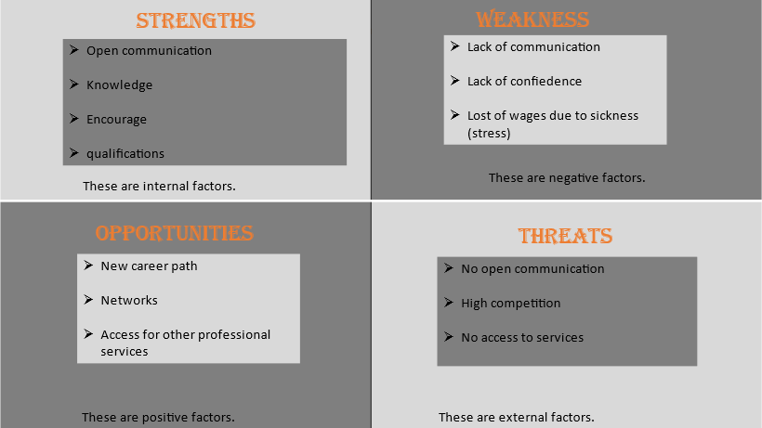
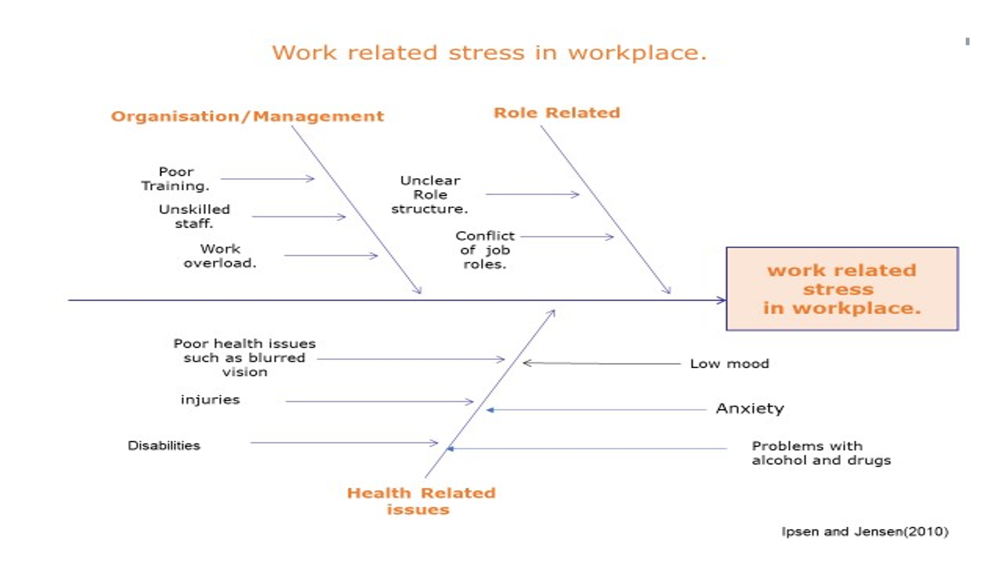

In the 1960s Kaoru Ishikawa was the man behind the fishbone diagram and wished to alter people's perceptions about working. He encouraged managers not to be satisfied with simply enhancing the quality of a product, believing that quality can always be improved further. (Skymark.com, 2019)
Factors contributing to the complex problem, pestle analysis.
PEST analysis is a macro-environmental framework that is used in the environmental scanning component of strategic analysis or research to provide an overview of the many macro-environmental aspects to be investigated. It's a strategic tool for understanding market growth or decrease, as well as the company's position, potential, and operational direction. PEST stands for Political, Economic, Social, Technological, Legal, Environmental. (B2U - Business-to-you.com, 2016)
Political
When considering political factors, you should consider how government policies and actions may impact the economy as well as the industry in which the company works. Such as:
- Pensions
- Brexit
- Government policy
- Income tax
- trade restrictions

Economic
Economic Factors consider the numerous areas of the economy and how the situation in each area may affect your company. Such as:
- Disposable income (net pay low)
- Exchange rate, sending money home, travel
- Unemployment rates
- Higher tax (pay more for people unemployed)
Social
Social factors relating to societal cultural and demographic trends Consumerist conduct in culture is heavily influenced by social norms and influences. Such as:
- Age distribution, (the hourly rate of pay min)
- Population growth rate, (a job at risk)
- Cultural barriers- praying, (short of staff).
- Lifestyle attitudes- smoking, family work-life balance.

Technological
Technological factors are connected to industry-specific development as well as broad economic growth. Being unaware of the most recent developments in a certain business may be immensely detrimental to operations. Such as:
- Technological awareness.
- Wi-Fi
- Older generation, access wages slip I.T issues.
- Online course –training

Legal
Legal factor is important as law is always changing and can have an impact on a company, for example, employees' safety to property rights laws. so is vital to pay close attention to any new laws or regulations that might affect the business, as well as to analyse existing laws for any adjustments. Legislation is used by the government to create and enforce rules, laws, and requirements.
- Copyright and patent law
- Consumer protection law
- Health and safety law
- Policy and produces
- Labour law
Environmental
Environmental hazards could cause problems such as pollution and weather, which, for example, might be detrimental to your business. Although you have little control over these circumstances, you may prepare ahead to limit their damage. Adverse weather is becoming more common. best to create disaster recovery preparations in case of a natural disaster. Such as:
- Clear air zones
- Weather climate
- Environmental policies

Alternative solutions to reduce work-related stress by decisions making solutions, (decision making by PMI and grid analysis)
By understanding decision-making PMI, which stands for plus, minus, and interesting. Which is Brainstorming decision making and critical thinking tool. PMI was developed by Dr. Edward de Bono.
PMI technique can assist you in:
* Brainstorming ideas
* Making rapid judgments by analysing and balancing the benefits and drawbacks
* After the fact, reflect on or analyse a product or process
* Identify your strengths and shortcomings to order to improve in the future. (Virtual ​Library, 2018)
The table below is used to assist the decision-making process as given by using the method of positive, negative, and points of interest. Plus column is where list all of the positive aspects of the decisions, minus is a list of negative and interesting are in the middle points of interest column. Rating each decision out of one to five eva plus or minus totaling each column to get a better understanding of your preferred decision.
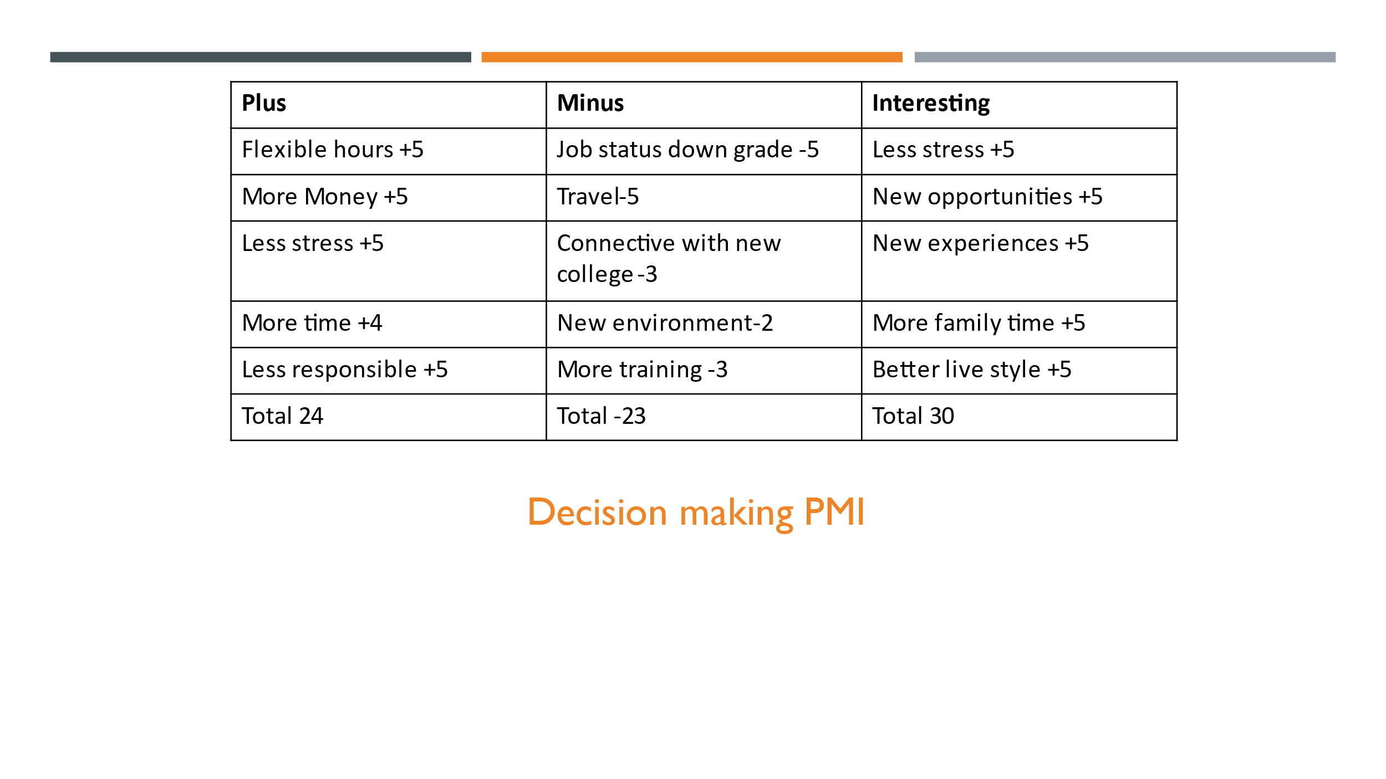

Grid Analysis
Grid Analysis, also known as Decision Matrix Analysis, Pugh Matrix Analysis, or MAUT, which stands for Multi-Attribute Utility Theory, is a type of analysis that uses matrices to solve problems. (Professional Skills Blog Magnusson Training & Consulting LLC, 2009). It can be used to determine the most effective way to quickly decide between several options for solutions, but if you are unsure which one is the best way to solve a problem, by using the tablet below, you can rank your alternatives against the deciding factors. On a 1–10 scale, 1 being the least important, 10 being the most important. We used grid analysis to reduce work-related stress by following simple steps. 1. Make a list of the different options. We consider this the most important deciding factor that needs to be considered. Factors included are working fewer hours, sharing workloads, break time, PPA time, and thinking of anything else we determine to be valuable in our decision-making process. After evaluating the factors and using different decision-making tools, the three main factors whereas followed in the table below where we decided that the most frequent alternatives factors are 1. Work fewer hours, 2. Change job 3. Change departments. After analysing all data, it concludes that to reduce work-related stress, the change department is the best solution to the problem.
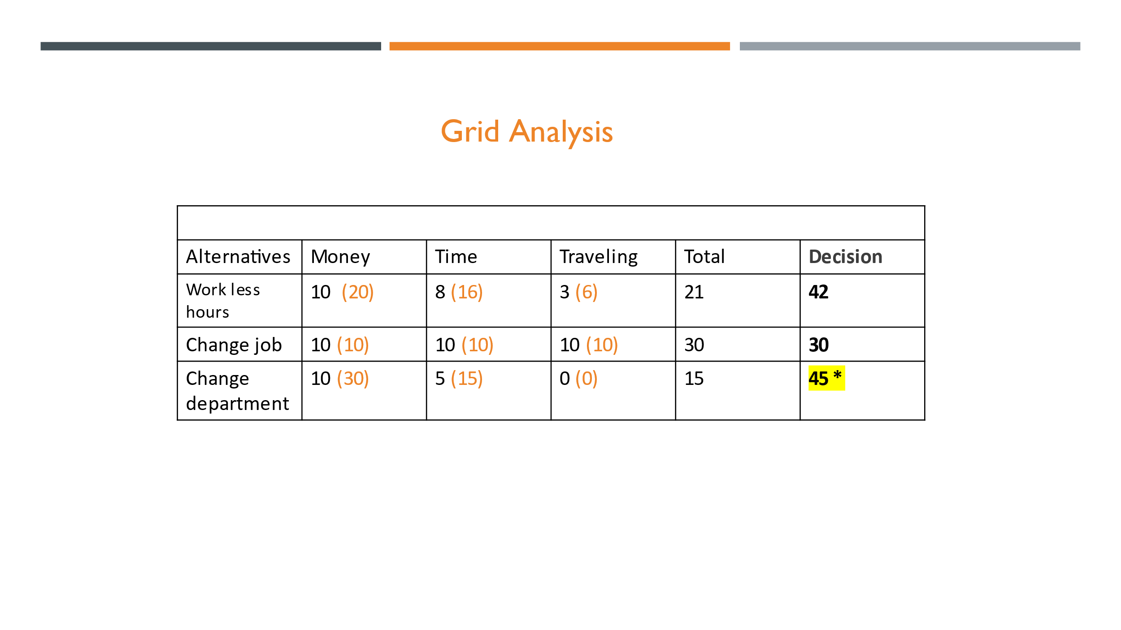

Conclusion
In conclusion to this report, based on the case study and using information from my PowerPoint, I was able to gather more in-depth knowledge and a greater understanding of what work-related stress is. I now understand that it’s not just how it may affect the employees, employers, and companies, but a much bigger picture than I first thought. It interacts with a lot more people throughout the world, costing billions of pounds to deal with the health effects of stress. Where there’s already a strain on the health industry, it ends up going full circle, putting more strain on the health staff, which results in more stress-related health issues. Dealing with stress in the workplace is very important for everyone involved as the impact is a greater need for companies to run smoothly to deliver a better service to their customers or clients. Having a better understanding allows you to move forward as an employee or employer to deal with the problem at hand and find a solution to the cause and effect of the problem. This is where I realised the importance of using the tools that I have learned to deal with any stress issues I may have within my workplace to reduce my stress or concerns before they affect my health or my performance at work, not just at work but affecting all areas of my life. After doing my research on how to reduce and solve my problem with work-related stress, I found that finding my solution to the cause and effect of the problem by using PMI, alternative solutions, and grid analysis was a good way to determine the best way to move forward to reduce my stress levels.

Problem.
- Work-related stress
Chosen Solution:
- Change department.
Action plan
Actions | Description | Time frame | Staff responsible
Apply for a transfer of departments | Speak with the departmental managers or human resources department and complete a written request for a transfer. | 8th December 2021 –  13th December 2021 | Employee  Manger
Identify Training needed for change of department | Speak with the departmental manager to identify if any more mandatory training is needed for the changing role.  Record the training needs | 13th December 2021 –  17th December 2021 | Employee  Manger
Identify workload to be complete and finished before changing department. | Finalise workload with the team to be complete.  Team meeting to be arranged to discuss future arrangements. | 17th December 2021-  Waiting date | Employee’s Team  Manger
Enquire for an update on the process and date for the moving departments. | Record, plan future communications from the manager and human resources department to chase updates. | 20th December 2021 – 2nd January | Employee

References

B2U - Business-to-you.com. (2016). PESTEL Analysis (PEST Analysis)

Cartwright, S. and Cooper, C.L., 1997. Managing workplace stress (Vol. 1). Sage.

HSE (2017). Stress at work - Causes HSE. [online] Hse.gov.uk. Available at: https://www.hse.gov.uk/stress/causes.htm.
‌
Iskamto, D., 2021. Stress and Its Impact on Employee Performance. International Journal of Social and Management Studies, 2(3), pp.142-148.

Nixon, A.E., Mazzola, J.J., Bauer, J., Krueger, J.R. and Spector, P.E. (2011). Can work make you sick? A meta-analysis of the relationships between job stressors and physical symptoms. Work & Stress, 25(1), pp.1–22.
‌
Professional Skills Blog Magnusson Training & Consulting LLC. (2009). Decision Making Tool: The Grid-Analysis. [online] Available at: https://magnussonllc.wordpress.com/2009/08/19/decision-making-tool-the. [Accessed 7 Dec. 2021].

Skymark.com. (2019). Kaoru Ishikawa: The man behind the fishbone diagram.

Virtual ​Library. (2018). PMI Plus, Minus, Interesting Strategy.

‌

‌
‌

‌

