Elysia Williams (1702842)
University of Wales Trinity Saint David
Strategic Travel and Tourism management

Table of Contents
Executive summary 1
Introduction 1
Stakeholder 2
Benchmarking 2
Porter’s Five Forces 3
Pest & Swot analyse 4
Recommendations 5

Executive summary
This report discusses the different competitors of the heart of Wales line and what they provide and offer. The two benchmarks I looked at and compared to the line and to see what they do as an organisation to the rail line, to see if they can apply similar ideas to the Wales line to help make improvement to the heart of Wales. The two lines investigated in the report are The Devon & Cornwall rail line and the second The Scotland west highland line.
Then in the report it looks at the stakeholders with partnerships to the line and they provide and offer with and long the line to their different consumers. This report then goes into Porter’s 5 forces and how they apply to the rail line and what the rail line investigates when looking at things with the forces.
The report then goes into a Pest and Swot analyse of the Heart of Wales rail line. With the Report then finishing off with recommendations of how the line can improve, how people can become more aware of it and what the rail line can do when working with the different villages along the way to promote the line and the things along it.

Introduction
The heart of Wales line opened in 1868 and is now 150 years on and still going. The line is a rural railway between Swansea and Shrewsbury, The Heart of Wales Development Company (2018). Along this line there are 11 stops these are calling at Swansea, Llanelli, Ammanford, Llandeilo, Llandovery, Llanwrtyd Wells, Llandrindod, Knighton, Craven Arms, Church Stretton and Shrewsbury. There are currently 4 trains a day going up and down the line calling at the stops and requested stops can be available.
After transport for Wales taking over the different Arriva trains and now taking charge of the different lines like the heart of Wales they are planning on expenders for example there will be 5 trains a day instead of 4, which will be new modern trains with higher capacity. This means that they need filling, by either doing something for the train or the different stop locations along the rail line.

Stakeholder
Heart of Wales Development Company play as partnership to the Heart of Wales railway line, Visit Carmarthenshire (2019). The Development Company focus on developing and promoting the line regarding attracting local residents, visitors and also the business. According to Welsh Government (2019) Network rail own the infrastructure of the line and the company provide ‘management support activities’ designed to support the line in the local area. As a company, they have begun to offer the local community short stays and holidays that they hope will create revenue acting as a stakeholder for the line. There is ongoing work towards the upcoming ‘franchise bid’ to try and ensure the service on the line meets the needs of the locals.

According to Visit Carmarthenshire (2019), a lot of the stations are looked after by the local groups and they focus on planters and gardens to help make the stations inviting and enjoyable places to wait. A stakeholder that gives a lot of support to the lines revenue digits is Llandovery Station Cafe which is highly loved by customers and is run by local volunteers. There is also a local run ticket office at the station of Llandrindod wells and the Black Mountain Food Hub run a local produce distribution network in Llandeilo station.

Benchmarking
Devon and Cornwall Rail line
The Devon and Cornwall rail line has a main route with many smaller routes leading off of it. There are seven different route lines leading off the main line. Since 2001 the passenger numbers of the rail line have more than doubled. The highest increase seen on the Line was the Maritime Line, from the graph below (1.1) you can see that 268% growth meant that the number of journeys made per year increased drastically from the year 2008 onwards jumping from about 300,000 journeys per year to nearly 600,000 journeys in 2010. This shows that when working with the partnership’s help it really made a different introducing the new ideas to the line and everyone has benefitted.
(1.1)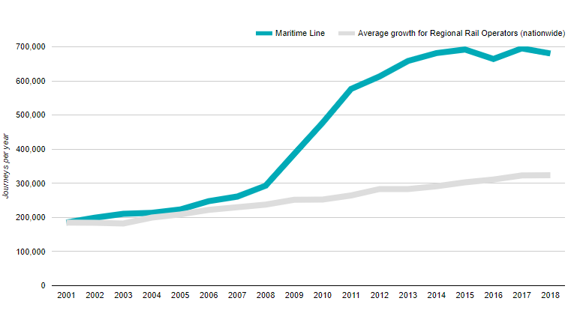
According to the dcrp.org.uk website ‘The Devon & Cornwall Rail Partnership develops the line by:
- Running the Line Forum
- Supporting friends of the station groups
- Promoting the line for visitors
- Encouraging the greater use by local residents
- Working towards improvements’
All of these things that was taken place by the line and the partnerships are what helped the line becoming the success that it is today.
Some of the Projects that was taken place to help reach the goals of the development of the line was the Looe Valley Line heritage project, The Munchtime express, Carbon Reduction Challenge and more.
One of the projects that was done by the Devon and Cornwall that I think could be applied or something similar created on the heart of Wales line is ‘The Munchtime Express’. This project consisted of a different restaurant each week on a Tuesday lunchtime, to serve taster lunch to each rail passengers. This was publicity and got interest for the train and the different restaurants along the trainline and in the train stations stops. Something like this could be called Brunch Bites which is morning to lunch time snacks of local foods from local restaurants being handed out on the heart of wales line.
Scotland rail line
The West highland line is a line from Glasgow to Oban or Fort Williams and Mallaig. According Scotland’s railway website the ScotRail this line is ‘considered by many to be the most scenic rail journey in the world’ as you leave the Glasgow city life behind to go into the west coast.
Also, West highland rail line offers the Combined tickets and Rovers. This pass gives their customers the advantage of ‘unlimited travel on a set number of days and are valid across Trains, coaches, ferries and buses.’ Traveller only must know how long they would like to travel for e.g 3-5 days and how much of Scotland they would like to see.
The heart of Wales line could take inspiration from this idea and offer their own type of combination ticket which allows their passengers to travel nationwide using all different kinds of transport to explore hidden beauties in Wales and giving back to the local community.

Porter’s Five Forces
The five forces tool was created but the Harvard business school professor Michael Porter, he created this to help businesses analyse the ‘attractiveness of an industry in terms of Five competitive forces’, Davies (2019).

(1.2) 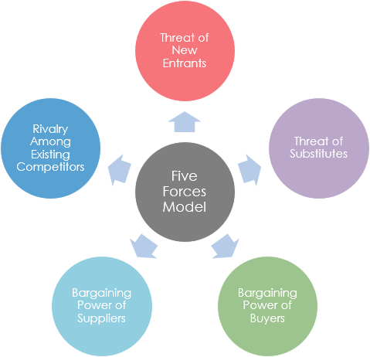
Rivalry between existing competitors, this is business or organisations with a similar product and service to offer with the same aim in the customer groups and market. For example the competitors for the heart of wales is the West highland rail line and the Devon Cornwall train line, these would be considered competitors as they offer both transport with a view and a more eco-friendly way of travelling. Along with the rail line, the locations along the line are in competition with other places around Wales and the different places like along the West highland line for example as people will travel and want to explore the lines depending what’s along them e.g manmade views, restaurants and more.
The threat of substitutes, a substitute that’s similar to the rail line is choosing to travel by car. The car isn’t as environmentally friendly but it can be chosen over by travelling but train as the travel can be more direct, you can stop and start on travels when needed and the car means no waiting around, this means as the trains only travel on the heart of wales line 4 times a day if your ready before the train is due you have to wait around for the train as when someone travels by car they can go when they want to.
The bargaining power of buyers, with the buyers of organisations being the immediate customers they have the power to demand what they want e.g cheaper prices. So, by the heart of wales wanting to get more passengers on board and to impress the travellers they already have now they offer different deals, one of them being pensioners travel free in winter months.
The bargaining power of suppliers, the supplier of the rail line is transport for Wales they offer the rail service and what happens to it. To keep the line going and the product of the line up and in demand the line is trying to offer more by adding another train on every day and also by using new trains to increase the capacity on the train so more travellers can ride the line.

Pest & Swot analyse
This is a pest analyse I created looking at the heart of Wales line and the facts effect it.
P  Political | E  Economic | S  Sociological | T  Technological
Even though Transport for Wales are adding an extra train to run daily with modernised trains, the government are cautious of train capacity as for example, according to BBC (2019), Tory economy spokesman ‘Russel George accuses the minister of not taking appropriate action’ regarding the capacity on welsh trains. | With the heart of rail line being more aimed for the working class and pensioners they have more disposable income to spend on the train travel and in the areas along the line. With people spending their money in the different rural areas along the line it is creating a positive multiplier effect for the communities and local economy. | From when experiencing the heart of Wales line first-hand, it was clear that majority if the passenger were pensioners, this means they have the money to spend on the rail line however they are not the future consumers. | The rail line has been taken over by transport for wales with the mission of having ‘97% of journeys will be made on brand new trains’ this means there is improvement being made with the lines technology, Davies (2019).

The SWOT entails what is the positives and negatives of the line and what can be done and effect the development and running of the line.
S  Strengths | W  Weaknesses | O  Opportunities | T  Threats
- The heart of wales line strength is offering a way of transport through the heart of wales which is more sustainable.  - Offers good deals e.g free travel on the line for travellers over the age of 65 in the winter months. | - Unless travelling to somewhere direct on the line not many people will use it for travel.  - The Rail Line isn’t very publicised and not many people are made aware of it. | - No many competitors apart from different modes of transport.  - They can offer something more on the line than just travel they could offer an experience. | - People can take alternative train routes which come more often  - People use different transport modes such as cars to travel at their own times and can cost less than the train.

Recommendations
One of the first recommendations that I suggest that can create more publicity for the trainline and for the villages/towns of the stops along the way, is seasonal trains special events. Through out the year different holidays like Christmas, Halloween, Easter and more can have special trains. For an example a Christmas train can be one of the older steam train which could look like the very famous Christmas train ‘The Polar Express’ (1.3).
By using an old train for special events will get locals or families interested. However, to make it even more special more can be done than changing the train, we can add the golden ticket effects like the polar express. By having this golden ticket can make every child feel like a winner creating a special long-lasting memory. Christmas food and beverages can also be provided by local suppliers from along the line.
The train can come from both directions along the line, one starts from Shrewsbury and another from Swansea. Both the lines can intertwine with the walking trail and meet in the near middle of the line at Llandovery. The train starting from Swansea station, walking trail can be from trail 13-12, Walk path of Llandeilo to Llangadog. Then from Shrewsbury station trail can be 9-10 Walk path of Llanwrtyd wells – Cynghordy. Paths shown in image 1.4. On these walk trails as families, couples or friends can take part in Santa’s mission with help from elves to find the lost reindeers. then get back on and travel to meet Santa and visit Christmas markets where local businesses can be advertised.
(1.4)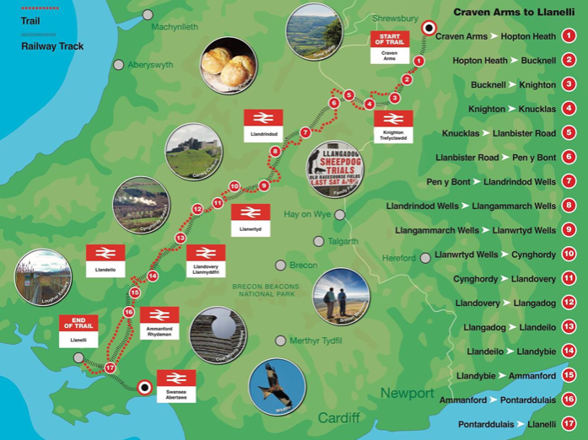

Like the Devon & Cornwall train, the heart of Wales line can introduce different projects on their train line for example like a historical projects looking back 150 years ago when the heart of wales line first opened, it can be a look back for people who had families involved in the creation of the line and for people who has worked on, with, around or for the line along the many of years it has been in use. They can also add the project like the Devon line of ‘The Munchtime Express’ but like I have said previously put their own twist on it as Brunchtime Bits where local business make tradition welsh food along with signature dishes of their own as little tasters for the train travellers.
When looking at the West Highland train line they came up with the option of a multi ticket option when their passengers can buy a multi ticket and it covers the cost of their train and their other forms of transport while on their travel. This will be a good idea to introduce travel of long distance and into nearby areas.
Another thing I recommend that can be done the rail line is linking with local B&B, campsite and hotel businesses and providing discounted stays for any guests who have travelled via the heart of wales line to get to them.
With cycling becoming such a popular sport introducing cycling routes along the walking trials or connecting to pre-existing cycle it will open the line to new customers and it will have more of an aim for the active families.
To conclude, The Heart of Wales line are trying to improve, and they can look at the different benchmarks in this report for inspiration and opening their customer market and work on revenue. It is clear to see through the information regarding stakeholders, people of the community want to get involved and improve the tourism within their community.

Bib
(1.1)
Picture: https://www.dcrp.org.uk/lines/maritime-line/
Devon and Cornwall railway partnership (N/A). Maritime Line. [Online]. Available at: https://www.dcrp.org.uk/lines/maritime-line/. [Accessed:27 /11/2019].
(1.2) Picture: https://www.google.com/search?q=porters+5+forces&rlz=1C1GCEB_enGB877GB877&source=lnms&tbm=isch&sa=X&ved=2ahUKEwi71-LcxI3mAhWKN8AKHcQsC4YQ_AUoAXoECBIQAw&biw=977&bih=932#imgrc=9DWuTqGNxs48OM:
(1.3)
Picture: https://www.google.com/search?client=firefox-b-d&tbm=isch&sxsrf=ACYBGNR7MxFM0E4_xHRIzy2TgxyT65SPDg:1575291958459&q=the+polar+express+movie&chips=q:the+polar+express+movie,g_1:train:5cgN2khKTT8%3D&usg=AI4_-kQSt5fEavJXonH-CfelyPzoLfvkSw&sa=X&ved=0ahUKEwiFxefsg5fmAhWRkhQKHWOoAC0Q4lYIKSgA&biw=1366&bih=654&dpr=1#imgrc=DvVZqiXKr2zc-M:
(1.4)
Picture:
[Davies,2019] Rail in Wales; Heart of Wales line.
https://moodle.uwtsd.ac.uk/pluginfile.php/314709/mod_resource/content/1/TfW%20and%20Heart%20of%20Wales%20Line%20presentation.pdf
Visit Carmarthenshire (2019). Heart of Wales Line Development Company. [Online]. Available at:https://www.visitcarmarthenshire.co.uk/view/146-heart-of-wales-line-development-company. [Accessed: 27/11/2019].
Welsh Government (2019). The Heart of Wales line Development Company Limited [Online]. Available at:https://businesswales.gov.wales/business-directory/list-businesses/heart-wales-line-development-company-limited. [Accessed: 27/11/2019].
BBC NEWS (2019).Trains in Wales: Distribution fear if old engines removed from service. [Online]. Available at: bbc.co.uk/news/uk-wales-politics-50495899 . [Accessed: 25/11/20.19].
The Heart of Wales Line Development company (2018). The Heart of Wales Line: 150 Years on. Book. [Accessed: 27/11/2019].

