Some students have indicated that they have been unable to access the record of the Live Chat that we held yesterday on Moodle.
If you follow the steps below, you should be able to see the chat that we had.
- Find the ‘Cultural Norms –Live Chat activity and click on it.
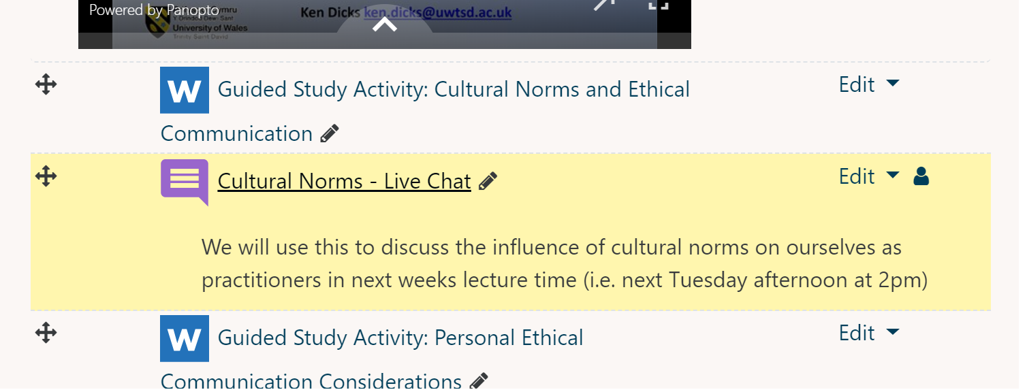

- Click on ‘View past chat sessions’
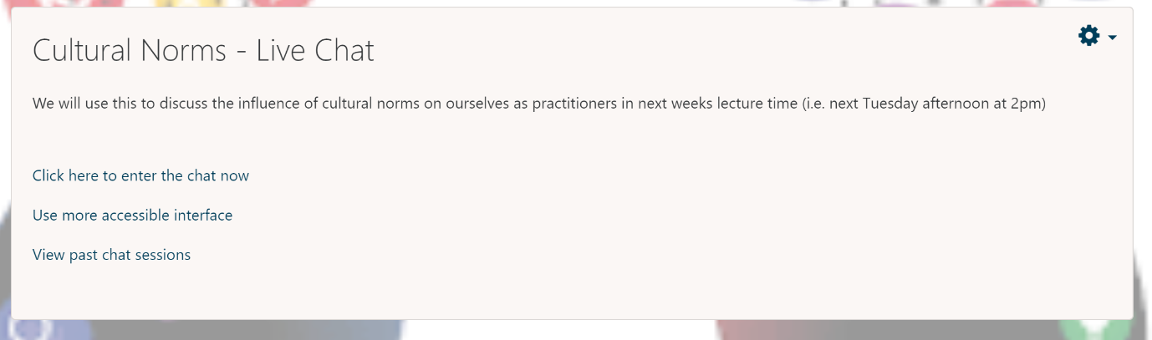
- Click on ‘See this session’
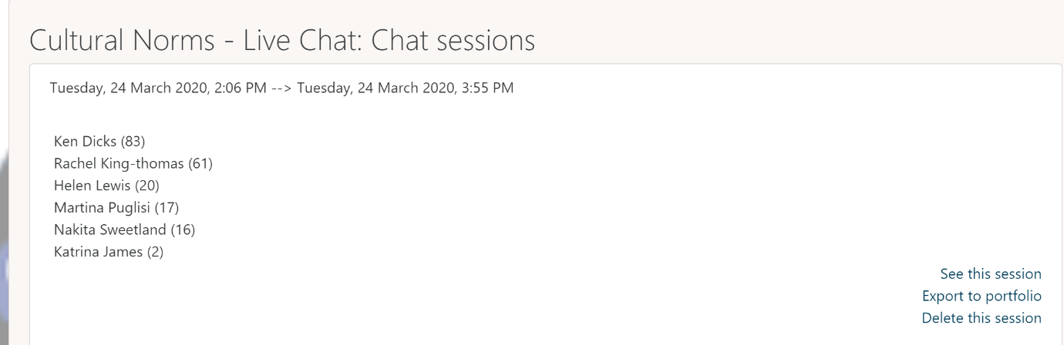

Hope this helps. Ken

