Student name: Vera McKendrick
Student ID number: 2014436
Programme: Contextual Practices
Module: Ways of Perceiving
Module code: ADAD4019
Assignment Title: Imagined display Space (Exhibition, festival, performance etc.)

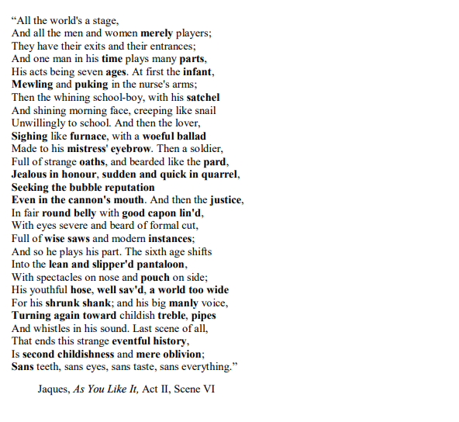
Figure 1. All The World’s a Stage – William Shakespeare (Learning English, BBC. (2007).

The Mind of the Artist -The Swansea Jacket by Vera-louise
I have chosen to use immersive art as my exhibition style as it takes static art and turns it into performance art; it is a way of presenting art as an experience by which the audience no longer just view art but experience it too from within the world of the artist. As an artist I find inspiration all around me - in my own life's journey. I have therefore chosen to do an exhibition on a piece called "The Swansea Jacket" which I, Vera-louise designed in 2021.
My piece does not deconstruct art histories in a technical sense, where discussions of embroidery and weaving are at the forefront of fashion, stories of historical fashion can be found in museums.

"The Swansea Jacket" is a political and philosophical piece that envelopes the figurative journey of life and death within fashion, the consequences of overconsumption and mass production and correlation to the death of individual creativity and the life given to saturated fashion. I intend to discuss further the theme and inspiration of the exhibit, the piece, and the artist. I will also detail the research and analysis that I have carried out since beginning my art project and the journey to the piece’s final composition, of which the exhibits narrative is based on.

One of the deepest longings of the human soul is the longing to be seen (O'Donohue, 1998).

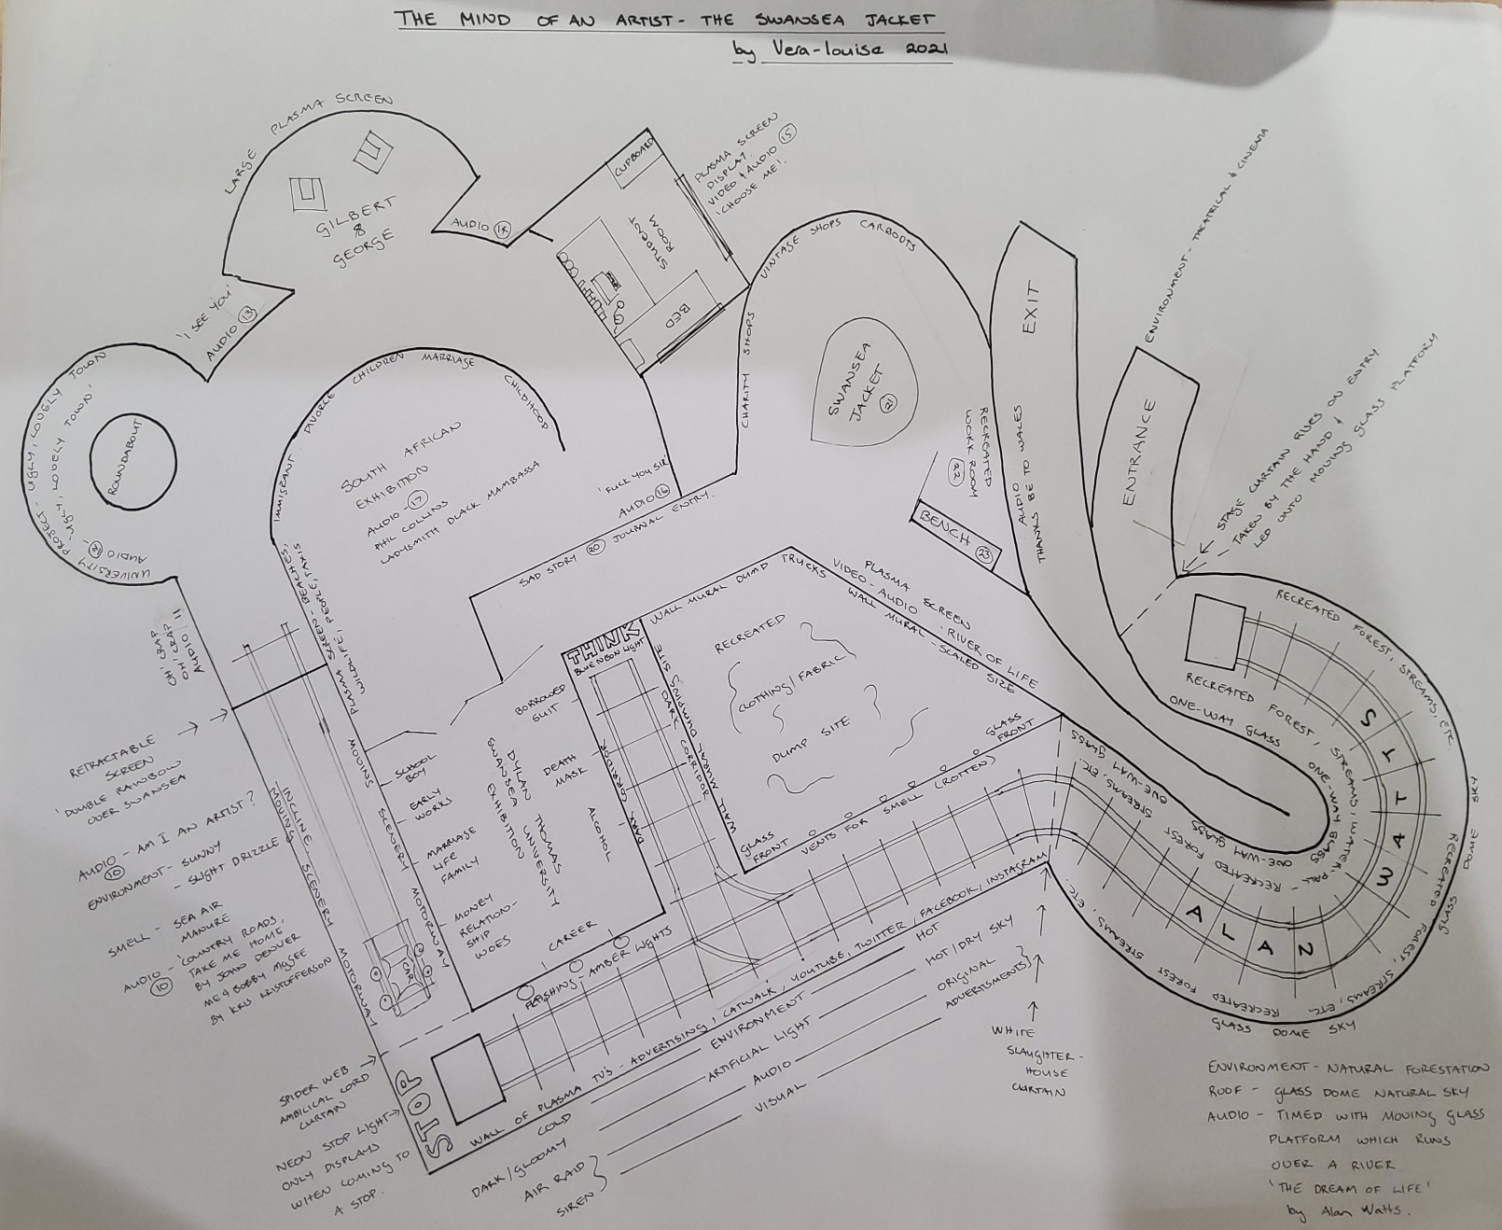
Figure 2. Floor Plan for The Mind of An Artist- ”The Swansea Jacket” by Vera-louise.

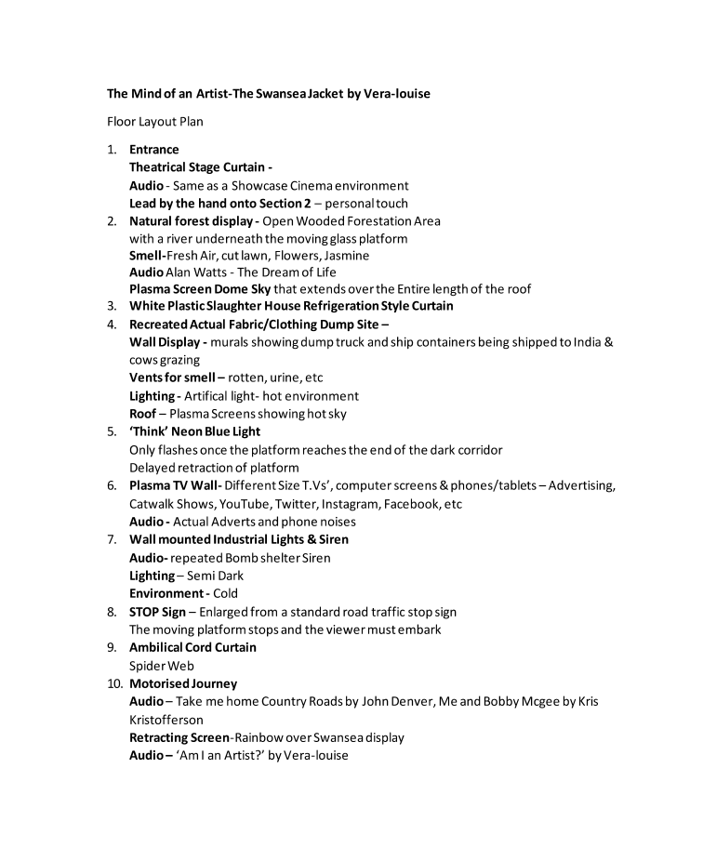
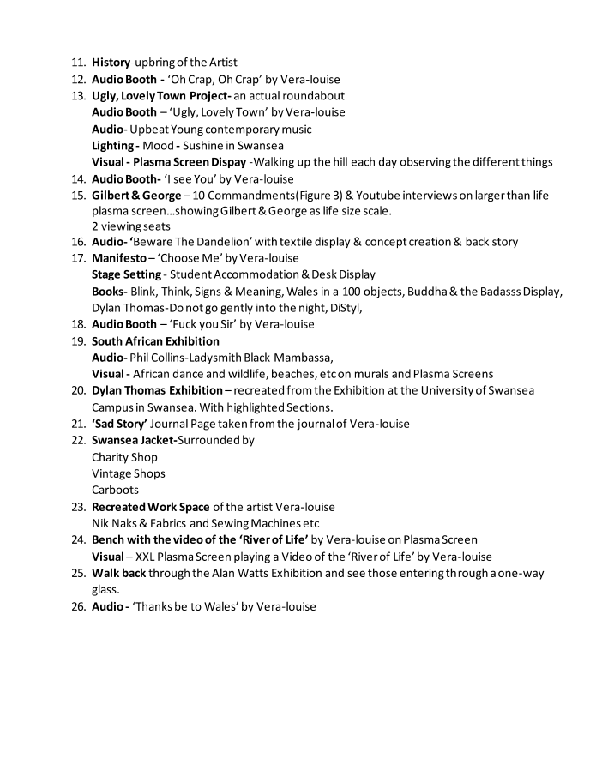

Figure 3 & 4. Floor Plan Description for The Mind of An Artist-”The Swansea Jacket” by Vera-louise.

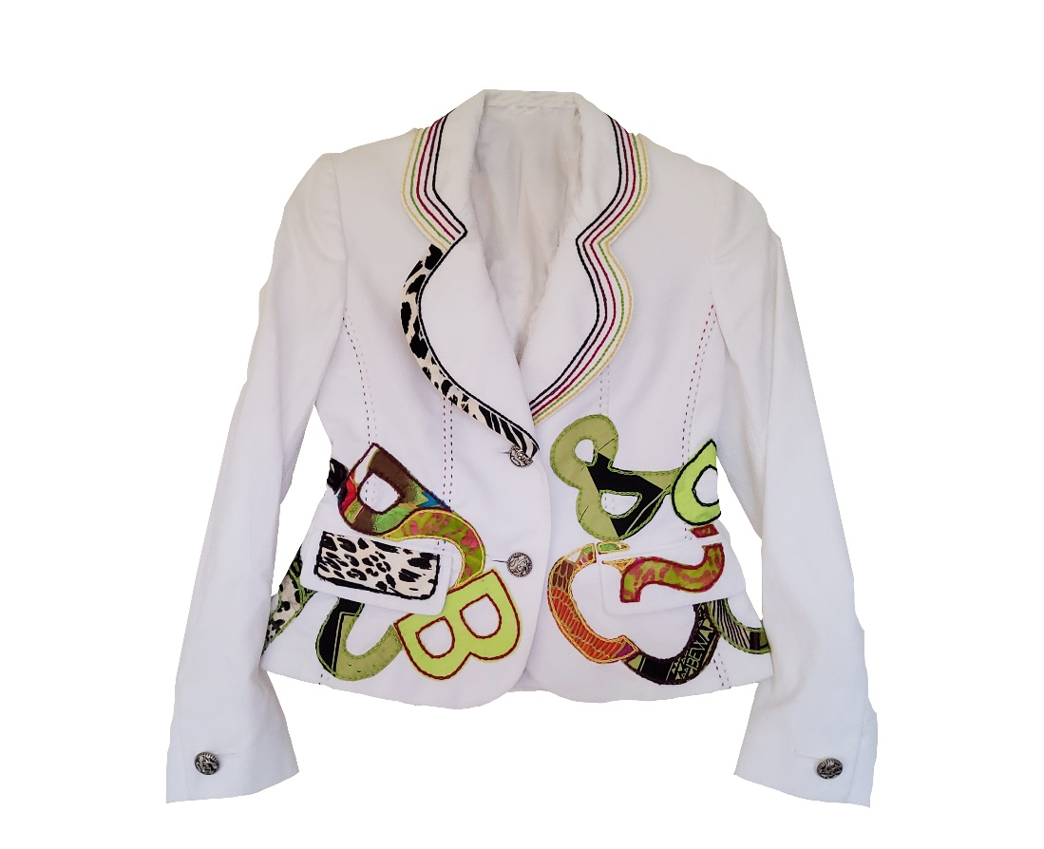
Figure 5. Front view image of “The Swansea Jacket” designed by Vera-louise.
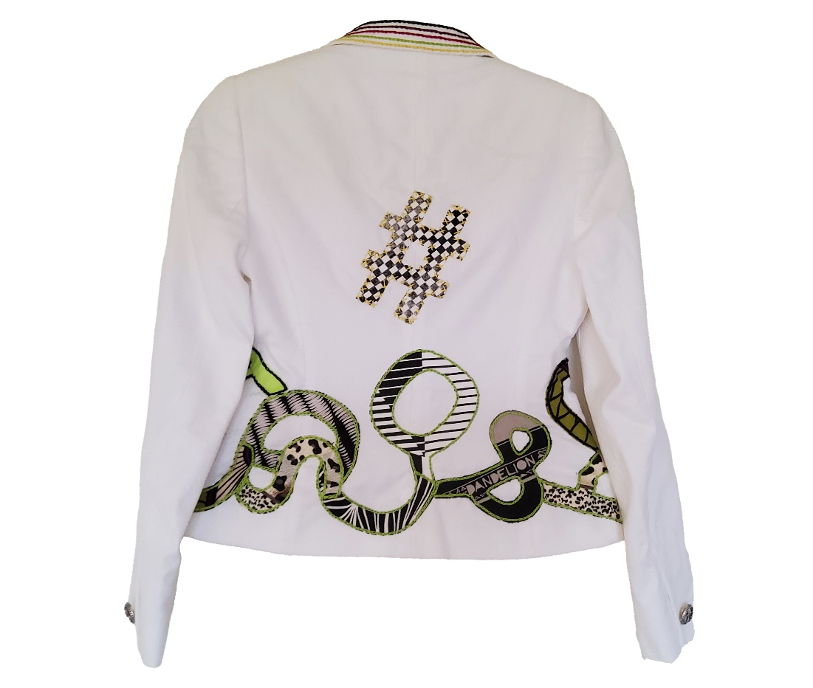
Figure 6. Back view image of “The Swansea Jacket” designed by Vera-louise.

I have created an exhibition that is based on “The Swansea Jacket”. The journey takes participants on an immersive journey through the artists mind as you explore the various factors and experiences that lead to the creation of the final piece.
The floorplan is symbolic in the same way its structure reflects the circle of life, albeit this journey is that of a smaller scale. In life we cannot predict what is ahead of us, yet once we have completed this section of our journey, we have the capability and fondness of being able to look back. Coming to the end of the circle is like finding yourself back at the beginning, not necessarily as starting again but as being able to see where you began. The labyrinth’s journey finally ends in the same way; the participant is now able to see the start of the journey through one-way glass.
The use of visual imagery, colour, lighting, temperature, smell, and audio is high on the agenda and is designed to showcase how environment and life in general impacts our psychology.
The major design element embroidered onto the jacket is the roundabout which is a symbolic metaphor of the many turns, u turns, and full circles that we take in life and is inspired from the many roundabouts in Swansea.

Other factors which influenced the pieces at the time were deconstruction, reconstruction and sustainability; The use of colour as symbolism i.e., black implies death and colour implies life; The hashtag is the symbol for ‘interwovenness’ of life and death, it was a symbol that the artist had previously used in a poster design called ‘Life and Death’; while colours such as that of a rainbow are prominent in the design of this piece as the many rainbows over the coastline near Swansea are testament to it.

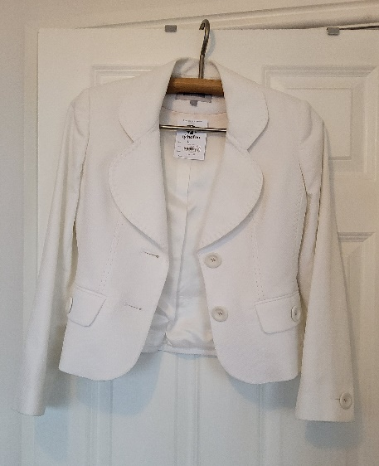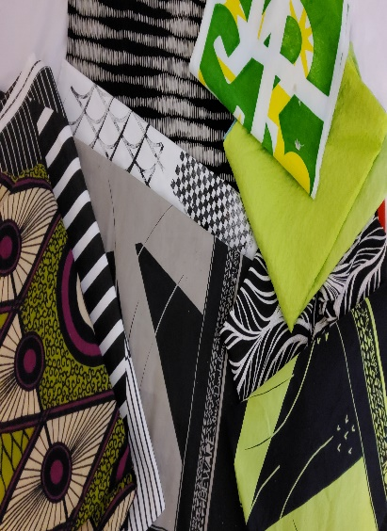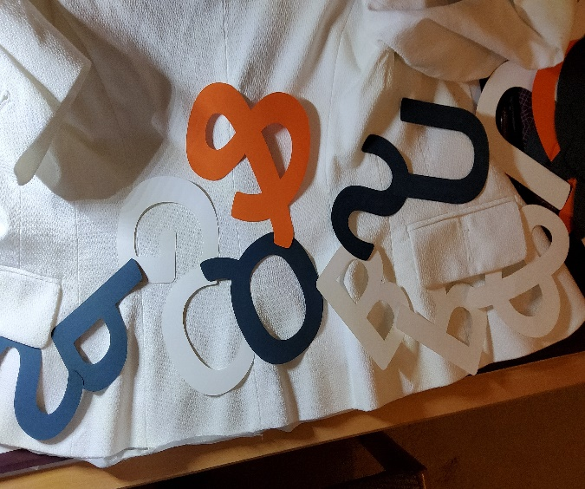
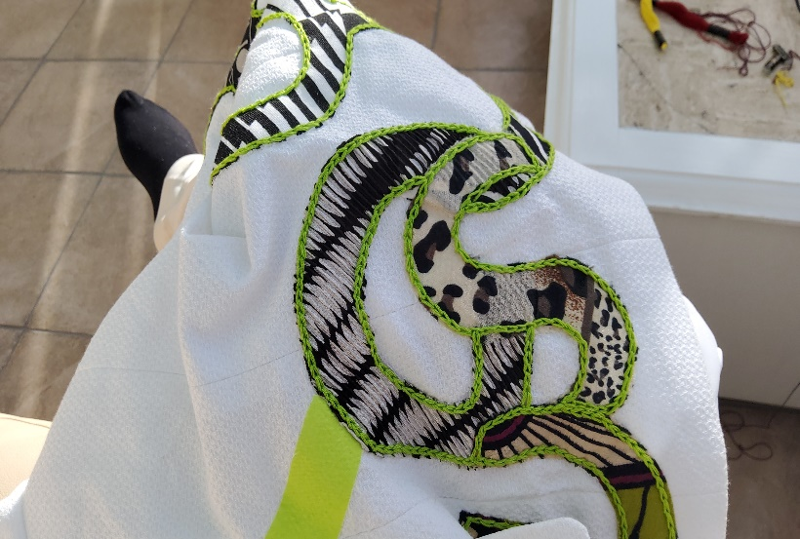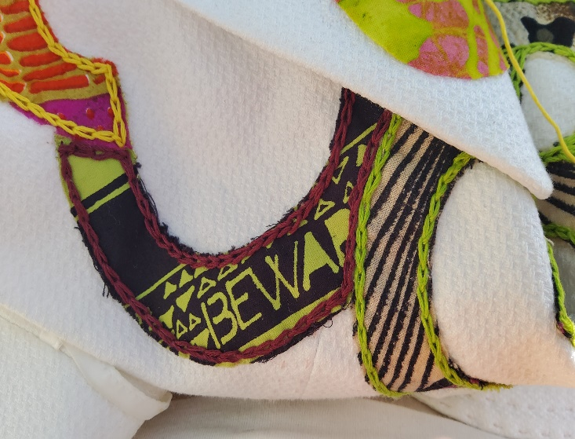

Figure 7,8,9,10 & 11. Construction images of “The Swansea Jacket”.

“The Swansea Jacket” is a new concept that I had created by combining and collaging artwork from my previous projects and influences such as, however, are not just limited to the following; a previous university project on ‘The Ugly Lovely Town’(Swansea) and the impact of The Dylan Thomas Exhibition at Swansea University and the impact of the two pieces namely his death mask, and the borrowed suit which he was wearing at the time of his death and the poem ‘Do Not Go Gently Into That Good Night by Dylan Thomas; The use of colour imagery in relation to The Ugly, Lovely Town e.g. how Ugly and Lovely can be equated to Death and Life and portrayed in Black and White/Colour; Another university project on the creation of a personal manifesto and the research into the artists known as Gilbert & George, the YouTube videos: namely, the interview with Mark Lawson (www.youtube.com, n.d.) and Gilbert and George: No Surrender (BBC Imagine)(www.youtube.com, n.d.), and their manifesto known as the 10 commandments(design manifestos .org, 2020); The psychologist Dr. Jordan Pietersen’s ‘how to write a manifesto’ and a selection of his talks on YouTube; Alan Watts and his YouTube Video on The Dream of Life (T&H – Inspiration & Motivation, 2013); Still I Rise by Maya Angelou (Literature Today UK, 2014); Numerous books e.g. The Buddha and the Badass by Vishen Lakhani, Blink by Malcolm Gladwell, Think by Michael R. LeGault, Deconstruction by Andreas Papadakis, Catherine Cooke and Andrew Benjamin, De Stijl by Paul Overy (Overy, 2000); the artists’ numerous poems written during the time of the jacket's creation, and the artists’ personal background and enthusiasm for sewing and upcycling.

Floor Layout Plan no. 13 ‘Ugly, Lovely Town’
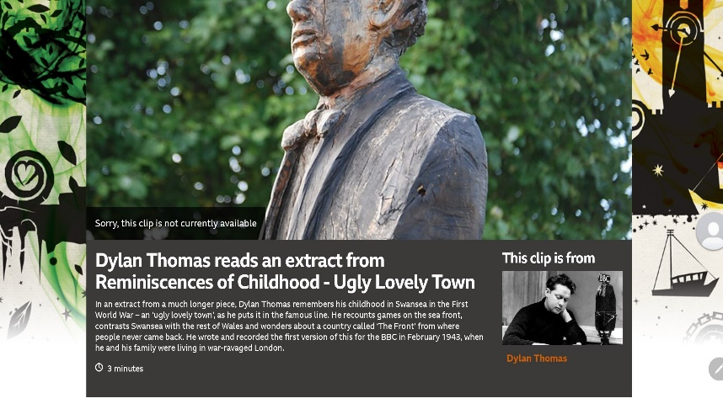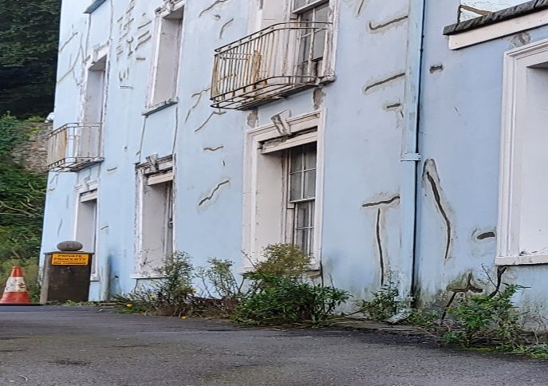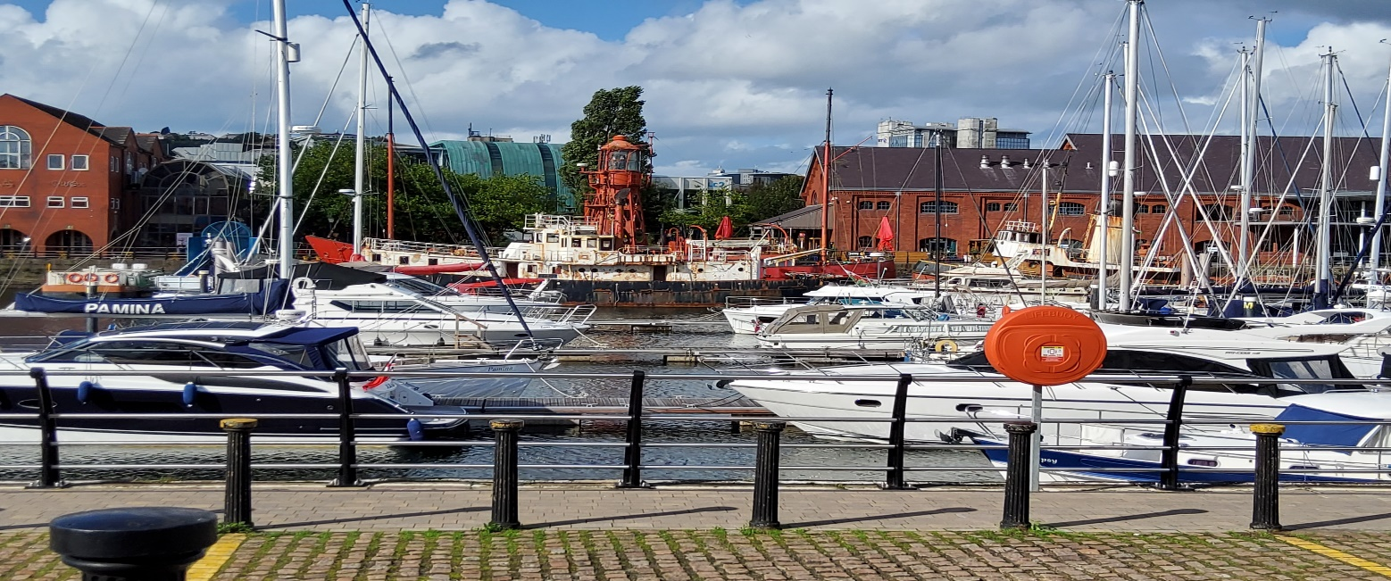
Figure 12. Dylan Thomas Exhibition (BBC One - Dylan Thomas, Dylan Thomas reads an extract from Reminiscences of Childhood - Ugly Lovely Town, 2022).
Figure 13. Image of a building in Swansea.
Figure 14. Image of the Marina at Swansea Harbour.

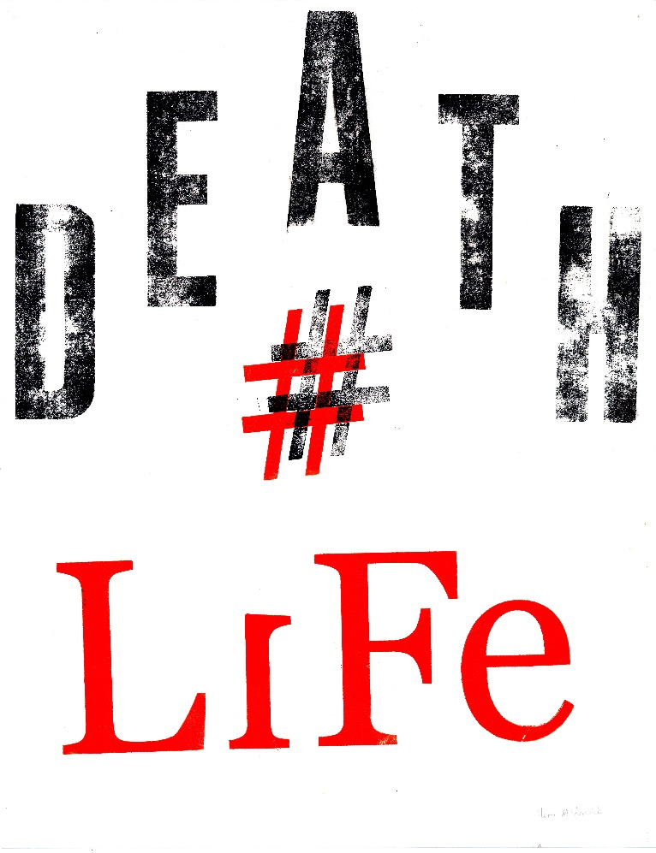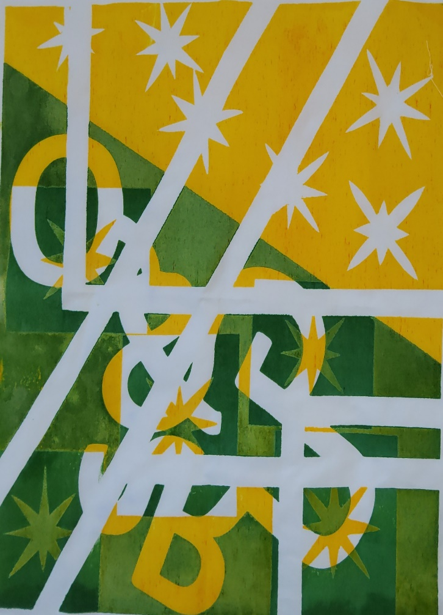
Figure 15. Death Life Poster by Vera-louise (Hashtag). Figure 16. “Swansea” Screen print by Vera-louise.

Floor Layout Plan 15.
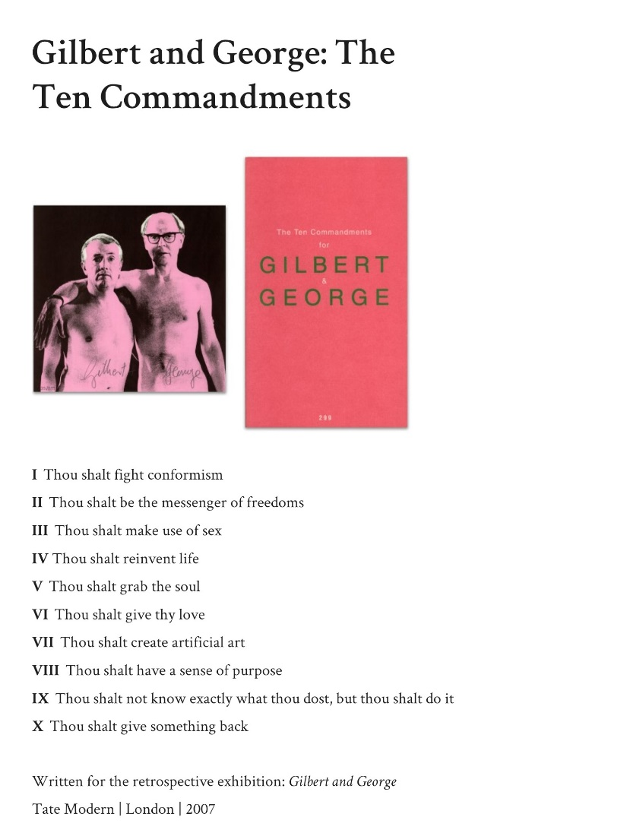

Figure 17. Gilbert and George: The Ten Commandments, 2022(designmanifestos.org).

Floor Layout Plan no. 17

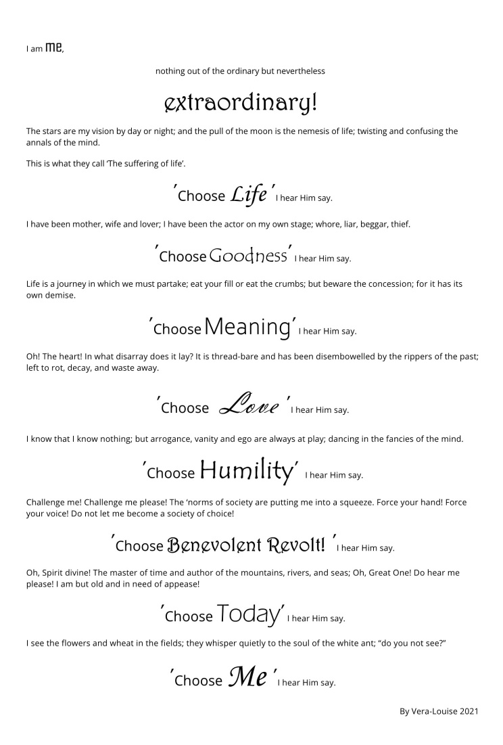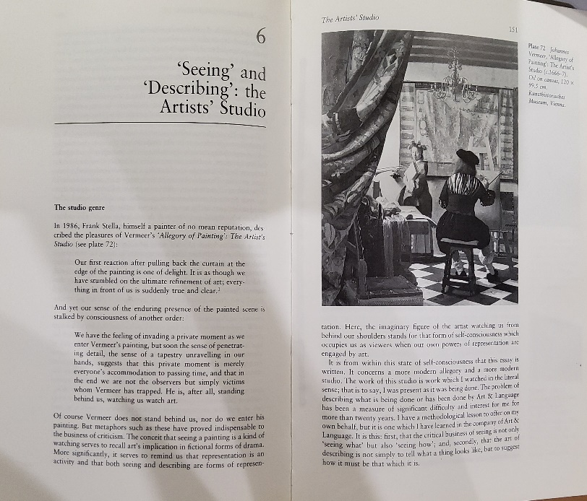
Figure 18. ‘Choose Me’ by Vera-louise(Vera-louise,2022). Figure 19. ‘Seeing’ and ‘Describing’; The Artist's Studio (Harrison, 1991).
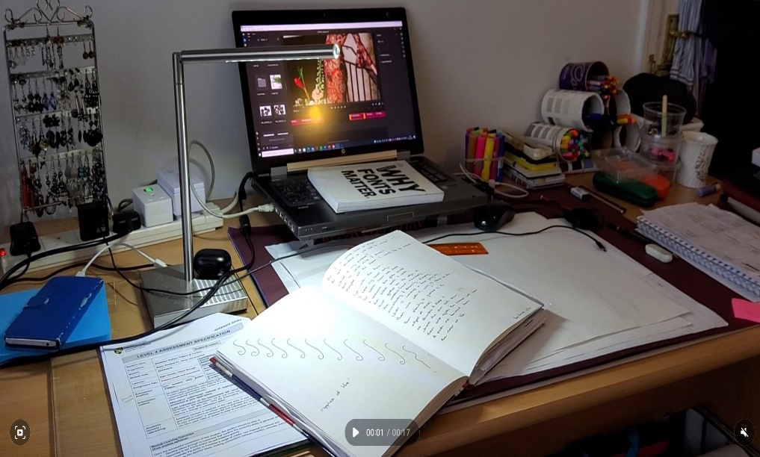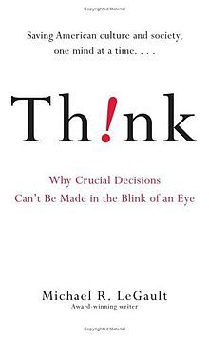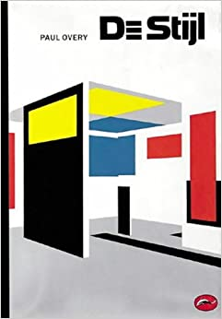

Figure 20. The Desk of Artist Vera-louise.
Figure 21. The Book Think by Michael R. LeGault (LeGault, 2014).
Figure 22. The Book De Stijl by Paul Overy (Overy, 2000).

Floor Layout Plan. 20 ‘The Dylan Thomas Exhibition’
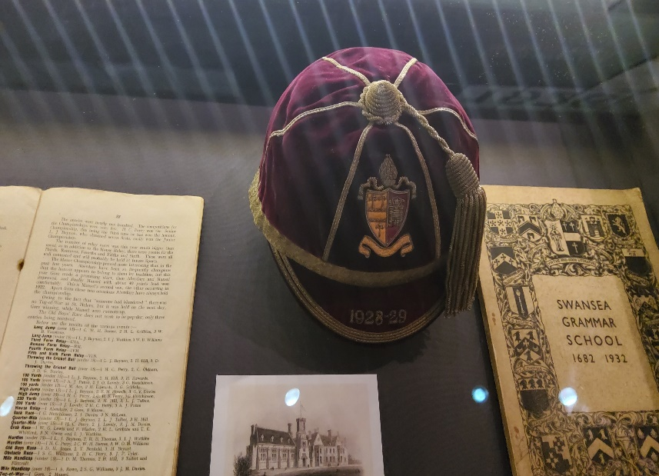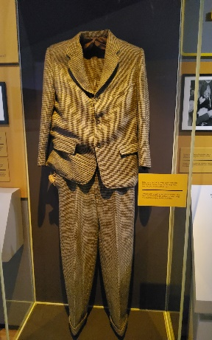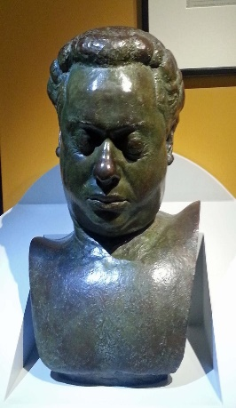
Figure 23. The Schoolboy Collection - Image taken from The Dylan Thomas Exhibition.
Figure 24. The Borrowed Suit – Image taken from The Dylan Thomas Exhibition.
Figure 25. The Death Mask of Dylan Thomas – Image taken from The Dylan Thomas Exhibition.

While thrifting and upcycling has recently been on the rise, big brands such as Tommy Hilfiger (recycled denim), Calvin Klein (sustainable fabric), Ralph Lauren (recycled plastic), and many others have been making their own contributions to a better world by having a greener footprint in the fashion industry. There is no greater more current issue than that of sustainable fashion; an industry that is the second largest consumer of water and responsible for between 4-10% of global emissions (World Economic Forum, 2022)
The production cycle for creating new fabric contributes greatly to global emissions, from extraction of raw material to finished product assembly. Logistically the best solution to meet global growth and be sustainable is by repurposing, reusing and recycling material that is heading to landfill. Companies like Patagonia have adopted an innovative program called Worn Wear where old and worn clothes can be returned, repaired and resold. PurFi, is a US based company that has developed a new way to close the loop on textile waste by the using a chemical to recycle textile waste back to its virgin quality fibre, meaning it can be repurposed elsewhere. The process uses less water, less energy and emits fewer greenhouse gases than the manufacturing and processing of new material. Rebecca Smithers, a correspondent for The Guardian wrote a newspaper article in April 2017 it estimated that as much as 235million items of unwanted clothing would end up in landfill that spring (Smithers, 2022). Imagine for just a second that these items were repurposed or recycled and the impact that this would make on both combating climate change and in creating a circular fashion model where fabrics could have a longer life cycle in today’s “fast fashion” culture. “The Swansea Jacket” is an item that addresses these issues, the Jacket is a statement aesthetically however the exhibition highlights the underlying symbolism in its design, its relation to the life and death of fashion and the beauty that can be found in the marrying of creativity and innovation. The profoundly great aspect of repurposing something is that you have the capability to take something that has been discarded and create something completely new, much in the same way as how foundry art takes different art forms and collages them together in a way that creates something truly unique (Putting It Together: The Art of Assembling — Foundry Art Centre, 2022).
“Ideas alone can be works of art; they are in a chain of development that may eventually find some form.... Since no form is intrinsically superior to another, the artist may use any form, from expression of words (written or spoken) to physical reality, equally.” (LeWitt, 1969)
“The Swansea Jacket” is equally an expressive form of art, as well as a statement piece which currently mirrors all that is wrong with the fashion industry while trying to “aid in the comprehension of the Worlds ideas”- Georg Wilhelm Hegel (Macdonald, S., 1970), but yet encourages a way forward.

List of Figure

- (Learning English, BBC. (2007). BBC Learning English Talk about English Shakespeare ‘All the world’s a stage…’. [online] BBC Learning English.com. Available at: http://downloads.bbc.co.uk/worldservice/learningenglish/webcast/scripts/tae_wc_shakespeare_speech.pdf [Accessed 10 Apr. 2022].
- ‘The Mind of the Artist - ”The Swansea Jacket” by Vera-louise' Exhibition Floorplan Map.
- ‘The Mind of the Artist - ”The Swansea Jacket” by Vera-louise' Exhibition Floorplan Description. Pg.1
- ‘The Mind of the Artist- ”The Swansea Jacket” by Vera-louise' Exhibition Floorplan Description. Pg.2
- Front view image of “The Swansea Jacket” designed by Vera-louise
- Back view image of “The Swansea Jacket” designed by Vera-louise
- Construction images of “The Swansea Jacket” -Thrift Shop Jacket
- Construction images of “The Swansea Jacket” -Fabrics used in the construction of “The Swansea Jacket”
- Construction images of “The Swansea Jacket” -Roundabout design used in the construction of “The Swansea Jacket”
- Construction images of “The Swansea Jacket” -Project in Progress
- Construction images of “The Swansea Jacket” -Project in Progress
- Dylan Thomas Exhibition (BBC One - Dylan Thomas, Dylan Thomas reads an extract from Reminiscences of Childhood - Ugly Lovely Town, 2022)
- Image of a building in Swansea
- Image of the Marina at Swansea Harbour
- ‘Death Life’ Poster by Vera-louise
- ‘Swansea’ Screen print by Vera-louise
- design manifestos .org. 2022. Gilbert and George: The Ten Commandments. [online] Available at: <https://designmanifestos.org/gilbert-and-george-the-ten-commandments/> [Accessed 25 April 2022].
- ‘Choose Me’ by Vera-louise (A Simple Blessing. 2022. [online] Available at: <http://(2022)> [Accessed 25 April 2022].)
- Harrison, C., 1991. Essays on Art & language. 1st ed. Oxford [England]: Basil Blackwell Ltd, pp.150,151.
- Image of the study desk of the Artist Vera-louise
- The Book Think by Michael R. LeGault (LeGault, M., 2014. Think!. 1st ed. New York: Threshold Editions).
- The Book De Stijl by Paul Overy (Overy, P., 2000. De Stijl. London: Thames & Hudson).
- The Schoolboy Collection - Image taken from The Dylan Thomas Exhibition at The University of Swansea Building in Swansea.
- The Borrowed Suit – Image taken from The Dylan Thomas Exhibition at The University of Swansea Building in Swansea.
- The Death Mask of Dylan Thomas – Image taken from The Dylan Thomas Exhibition at The University of Swansea Building in Swansea.

Bibliography
design manifestos .org. (2020). Gilbert and George: The Ten Commandments. [online] Available at: https://designmanifestos.org/gilbert-and-george-the-ten-commandments/ [Accessed 24 Apr. 2022].
Foundry Art Centre. 2022. Putting It Together: The Art of Assembling — Foundry Art Centre. [online] Available at: <http://foundryartcentre.org/putting-it-together/#:~:text=Assemblage%20and%20collage%20involve%20the%20thoughtful%20combination%20of,to%20synthesize%20materials%20to%20produce%20a%20cohesive%20result.> [Accessed 24 April 2022].
LeWitt, S., 1969. Art-Language. Sentences on Conceptual Art,.
Literature Today UK (2014). Still I Rise by Maya Angelou. YouTube. Available at: https://www.youtube.com/watch?v=qviM_GnJbOM Accessed 24 Apr. 2022].
Macdonald, S., 1970. The History and Philosophy of Art Education. 1st ed. University of London Press Ltd.
O'Donohue, J., 1998. Anam cara. Great Britain: Bantam Press, p.112.
Smithers, R., 2022. Britons expected to send 235m items of clothing to landfill this spring. [online] the Guardian. Available at: <https://www.theguardian.com/environment/2017/apr/06/britons-expected-to-send-235m-items-of-clothing-to-landfill-this-spring> [Accessed 24 April 2022].
‌T&H - Inspiration & Motivation (2013). The Dream of Life - Alan Watts. YouTube. Available at: https://www.youtube.com/watch?v=wU0PYcCsL6o [Accessed 24 Apr. 2022].
World Economic Forum. 2022. Is Fashion bad for the environment. [online] Available at: <(https://www.weforum.org/agenda/2020/01/fashion-industry-carbon-unsustainable-environment-pollution/)> [Accessed 25 April 2022].
www.youtube.com, n.d. Mark Lawson Talks To Gilbert and George. [online]
[online] Available at: https://www.youtube.com/watch?v=YL86-gH3dg0 [Accessed 24 Apr. 2022].

www.youtube.com, n.d. Gilbert and George: No Surrender (BBC Imagine). [online] Available at: https://www.youtube.com/watch?v=NUxVkYKStMI [Accessed 24 Apr. 2022].
‌‌

‌

