
Creating Rubrics in Moodle
Simplified

Step 5: To add extra rows of criteria or columns of scale click on the “+” icon
Left click the Zero marks to add scores or percentage values, press Return/Enter to confirm. One of these must be a zero score.

Step 4: left click an icon to select Rubric type.
Left to right: Standard rubric - allows you to enter scale values and criteria percentages. Custom rubric - allows you to enter any value directly into the rubric cells. Qualitative rubric - allows you to create a rubric that has no numeric scoring
Step 6: When all the criterion, scales, and cells have been edited click on Save to save the rubric.

See http://tinyurl.com/zcb3goj for further instruction.
Step 1: When building a new Turnitin assignment, in Grademark options select Launch Rubric Manager on the far right
Step 3: Type a name for the Rubric
To edit the name, description, or percentage value click directly on the title, description or percentage value to open the text box field. Make your edit then press Return/Enter
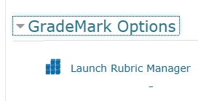
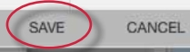
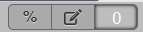
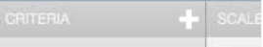
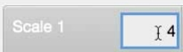
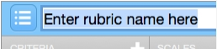
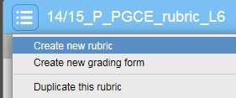
Step 2: Left click the Create new rubric text in the drop down menu on the top left of the manager screen window.

