OS Install and setup
ACCA4021

Daniel Leone (2317483)
2317483@student.uwtsd.ac.uk

Contents
1. Introduction 2
2. Background information 2
3. Creating a Virtual Machine 2
3.1 Setting Parameters 3
3.2 Further settings 7
4. Installing an Operating System 10
4.1 Windows 7 Installation 10
4.2 Finalising the installation 15
5. Ensuring the OS installation is fully operational 20
5.1 Checking Drivers 20
6. Using a Virtual Machine 28
6.1 Partitioning drives 28
6.2 Installing Software 37
6.2.1 Installing Google Chrome 37
6.2.2 Installing OpenOffice 39
7. References 44
8. Appendix 44
8.1 Further Background information 44
8.2 Further parameter config. information 45
8.3 Further VM Networking information 45
9. Bibliography 45

Introduction
The aim of this report is to document the process of setting up a Virtual Machine (VM), using Oracle VirtualBox. The first objective will be to demonstrate making an informed decision when setting parameters for the VM. As part of the set up and configuration stage, further settings will be demonstrated such as those required to enable networking within the Virtual Machine. Next, the Windows 7 operating system (OS) installation process will be documented. Once the VM is up and running, Checks will then be performed, ensuring the installation is working as intended. Finally, the author of this report will demonstrate configuration changes and tasks that can be performed within the virtual machine environment itself.

Background information
As described on a webpage from Lenovo [1], VirtualBox is an open-source virtualization software which allows a user to run multiple OS’s on their computer simultaneously. The virtualization software creates a “guest” OS environment within the “host” computers’ OS. These guest OS environment(s) are known as virtual machine(s).

Creating a Virtual Machine
As a pre-requisite, in this demonstration, the host machine already has Oracle VirtualBox installed, and has an .ISO file of Windows 7 ready to be installed onto the virtual machine.

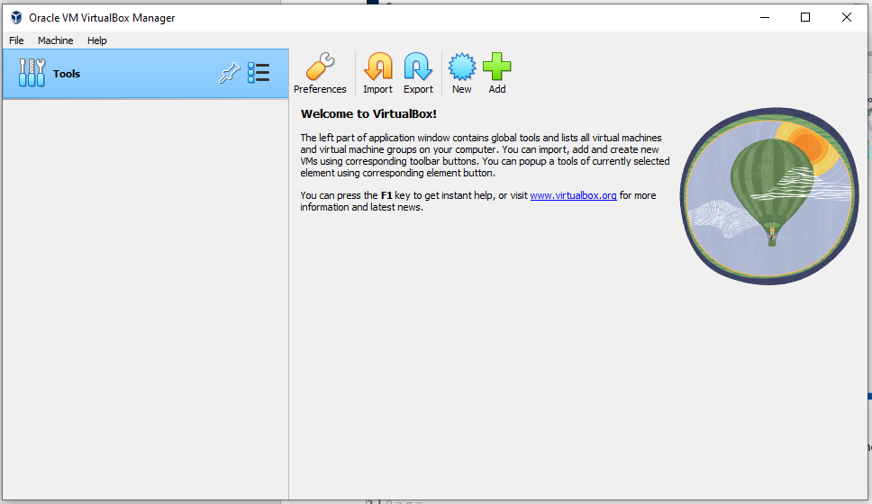
Setting Parameters


The first step is to click ‘New’; This will begin the process of setting up a new virtual machine. This can be used every time a new VM is required.

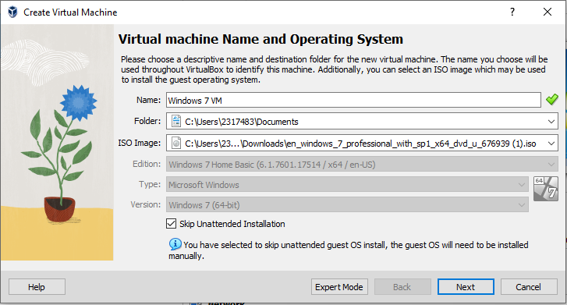The user will be prompted to provide the following information for the new VM.
- Name – An identifier for this particular Virtual Machine, e.g. “Windows 7 VM”
- Folder – This is the directory on the host machine, in which the VM will be stored e.g. C:\Users\UserName\Documents
- ISO image – This is the directory location of the operating system to be installed e.g.
C:\Users\UserName\Downloads\OperatingSystem.iso
In this example, “Skip Unattended Installation” has been checked – Which is means that some steps within the Windows 7 installation process will need to be completed manually.
Once the above fields are complete, click next.

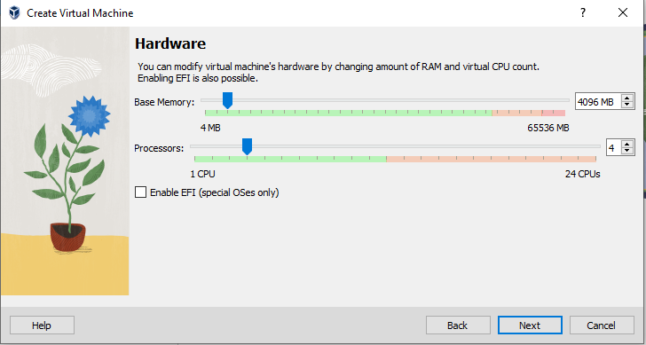The user will now be prompted to allocate an amount of the host machines’ Memory and CPU to the VM. As is noted in “Figure 1.9” of the VirtualBox Manual [2], Care should be taken when deciding on how much of the host machines resources are to be allocated to a VM. Allocated memory will not be available to the host, whilst the VM is running. In this example 4GB has been allocated out of the host’s 64GB. It is also advised that no more than half of the hosts CPU cores/threads are allocated to a VM. In this example only 4 cores/threads have been allocated out of the available 24.

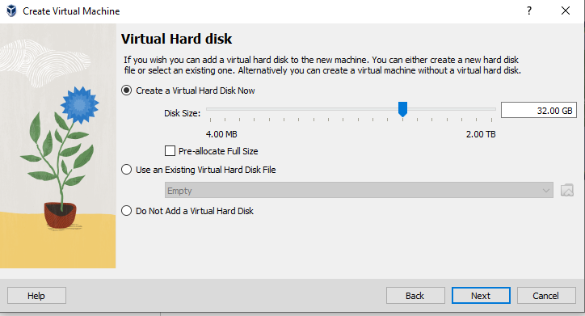Next the user will be prompted to allocate storage for a ‘Virtual hard Disk’. “Figure 1.10” of the VirtualBox manual [2] states that this allocation is Dynamic*. Alternatively, the user can check “Pre-allocate Full Size” if preferred. 32GB has been allocated dynamically in this example.
Once storage has been allocated, click next.

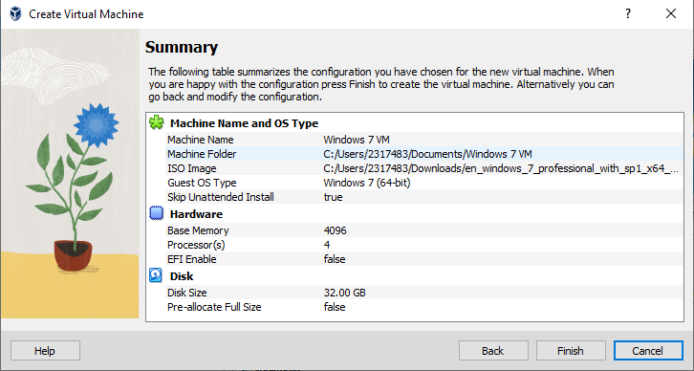
The user is then presented with a summary of the VM’s configuration.

3.2 Further settings
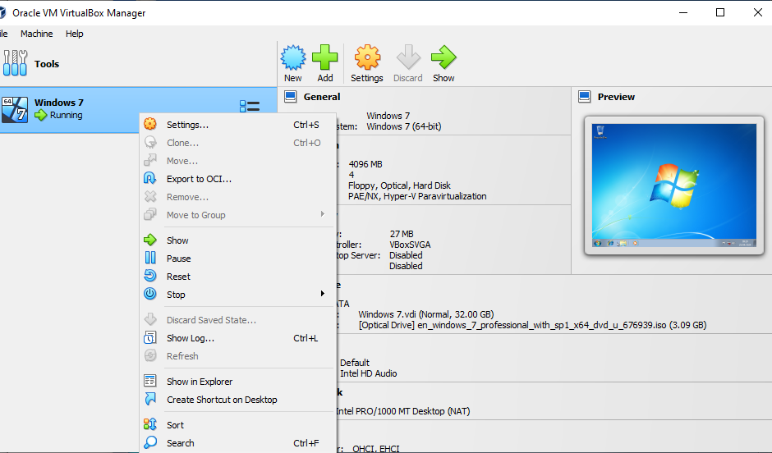

The next steps are required to allow the VM access to the network through the hosts physical hardware.
Right click the VM and click Settings, Navigate to the Network section.

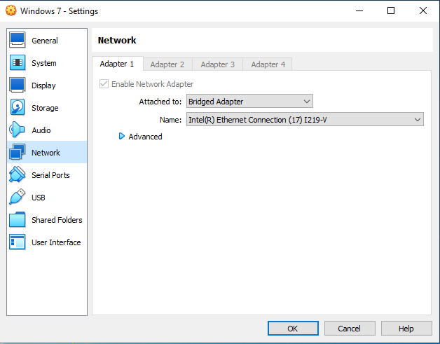
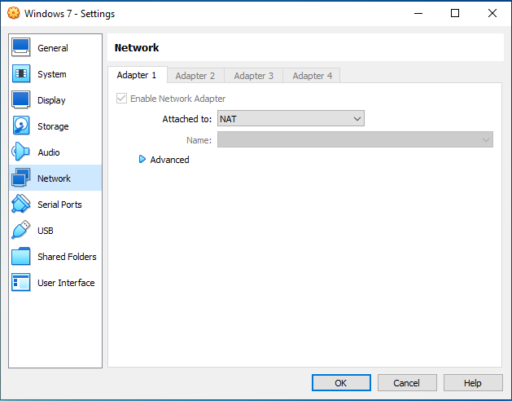
Once an ‘attached to’ option has been selected, Click OK.
In this example, the default NAT option has been used.

4. Installing an Operating System

4.1 Windows 7 Installation
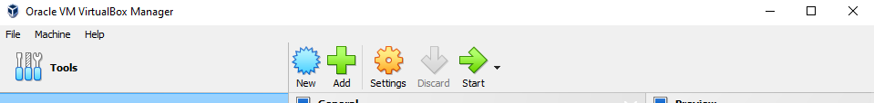Click ‘Start’ to start the Virtual Machine.
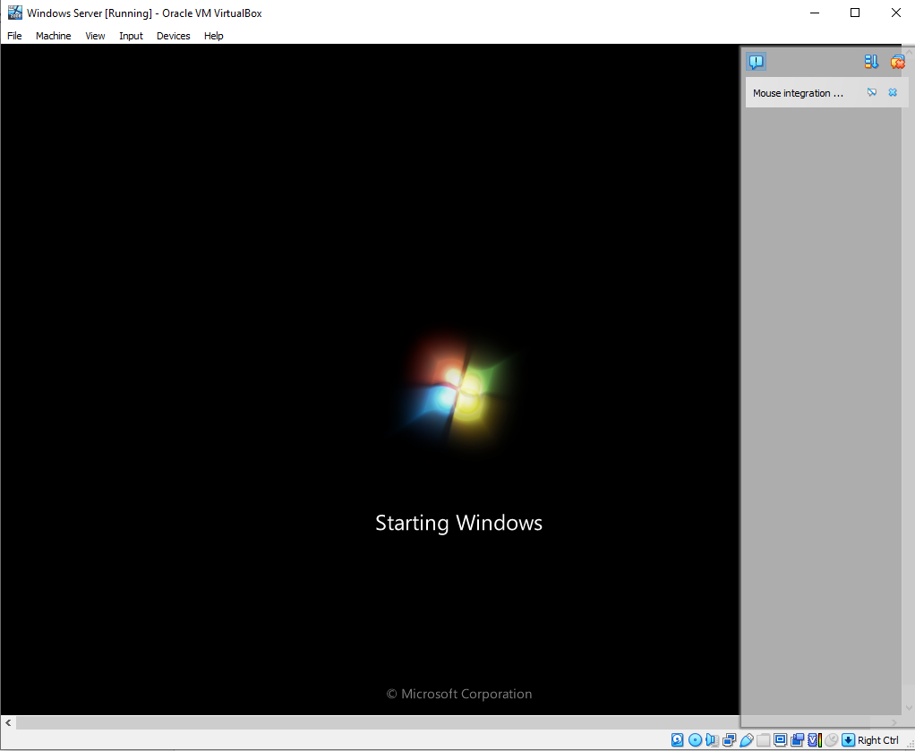The Windows installation will begin.

Follow the setup to install Windows to the VM.
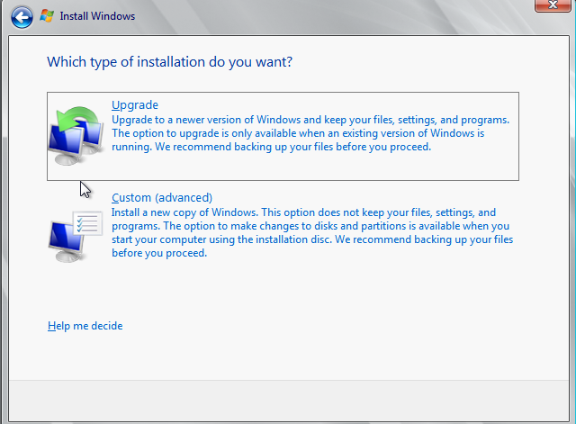
Click Custom (advanced).
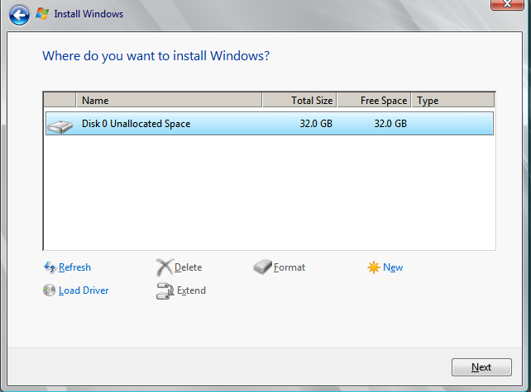


Highlight Disk 0 Unallocated Space, then click ‘New’.

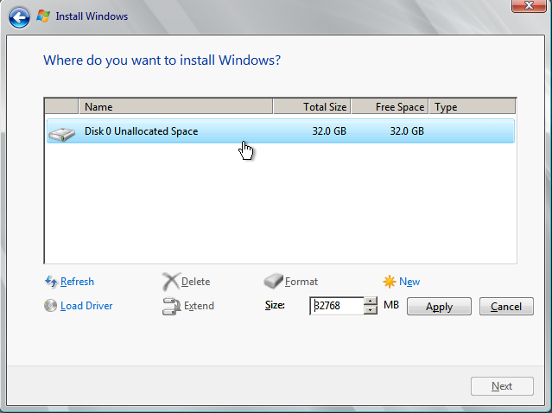
Click ‘Apply’.

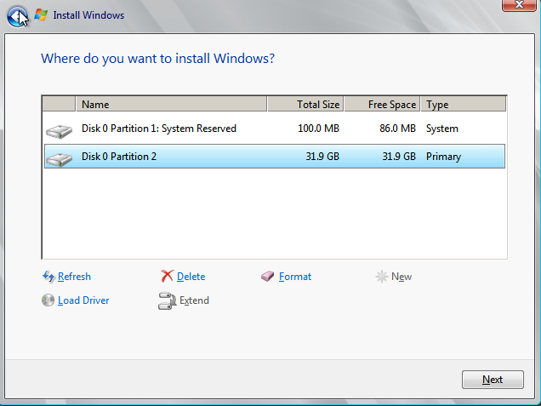
There will now be 2 partitions, Partition 1: System reserved, and Partition 2
Select Partition 2 and click next – this is where the main Windows installation will take place.
Wait for the install to complete. It may take some time, depending on the speed of the host machines’ physical storage drive.

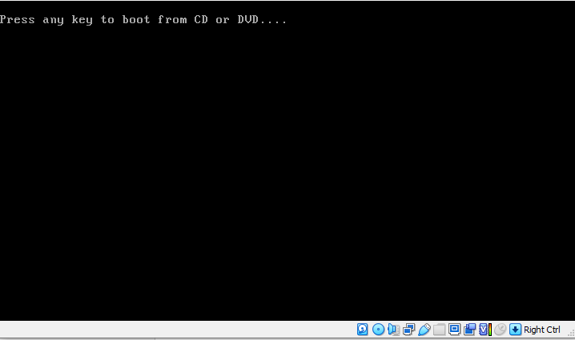
The installation will ‘reboot’ the virtual machine. The installation will continue without any user input. (The installer will need to boot from the Virtual hard disk at this stage, rather than the disk image ISO).

4.2 Finalising the installation
Once the installation is complete, the user will be prompted to input user details to finalise the setup of the operating system.
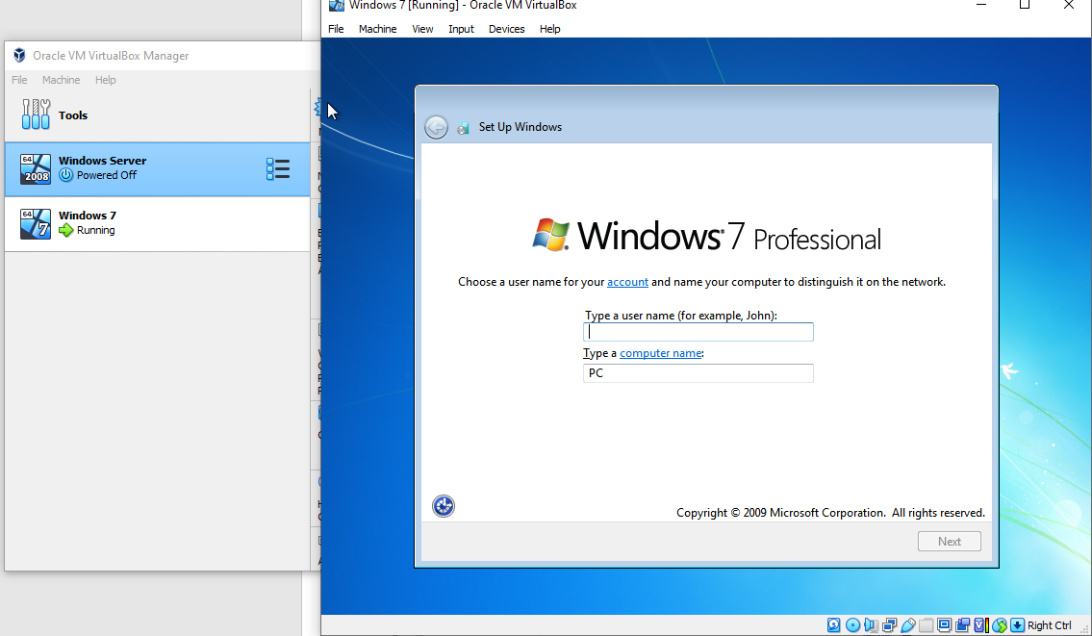
Input a Username, and computer name. Then, click Next.

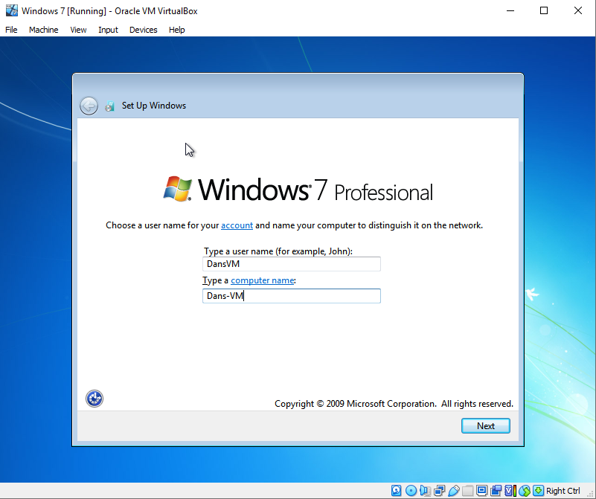
In this example, the Username has been set as ‘DansVM’ and the Computer Name is ‘Dans-VM’.

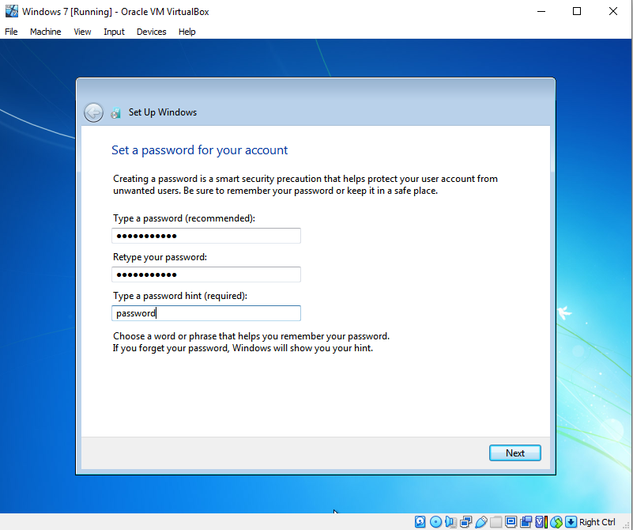Next, Create a password and a password hint.
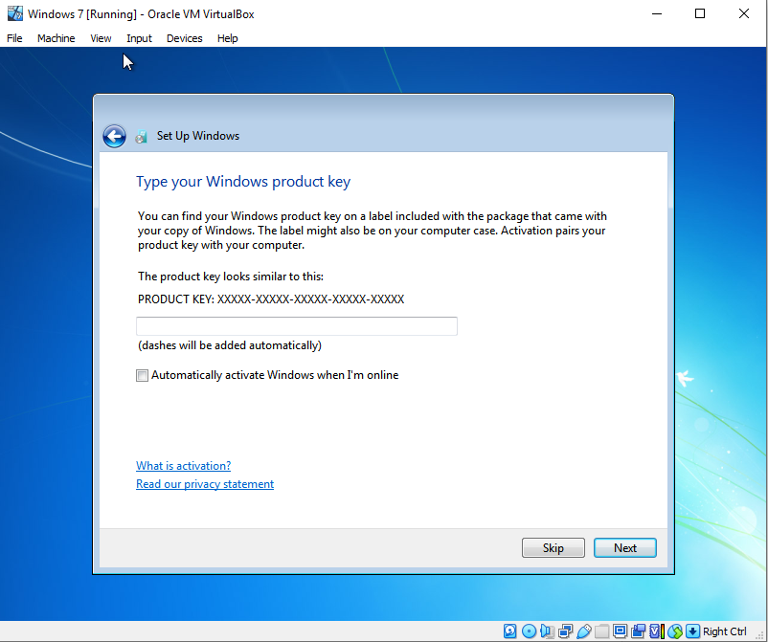
Enter product key, or skip.
Continue to follow installation settings including date & time, network.
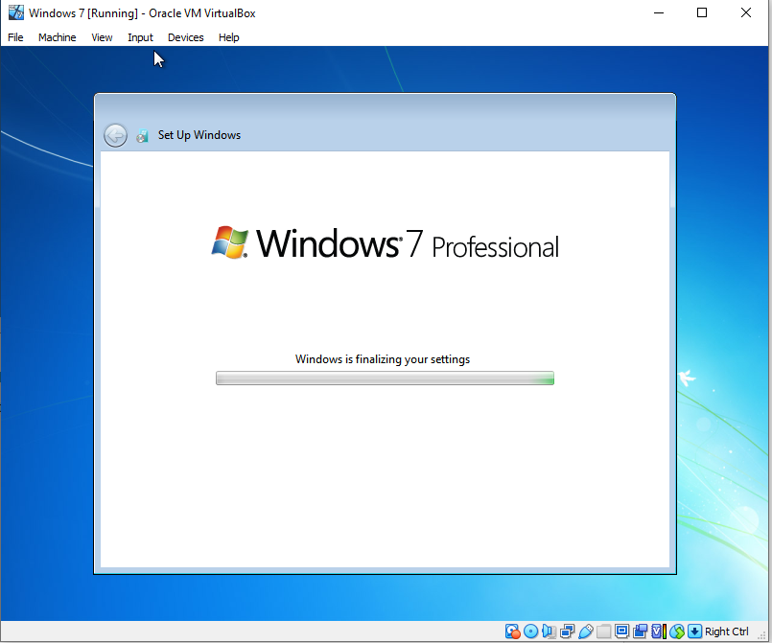The set up will now finalize the settings.
The installation process and initial set up are now complete.

5. Ensuring the OS installation is fully operational

5.1 Checking Drivers

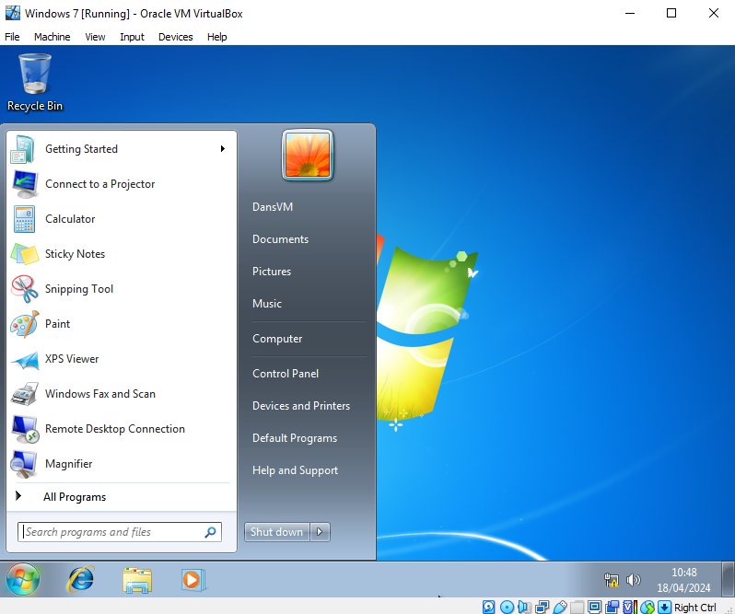
Go to the start menu, click control panel.
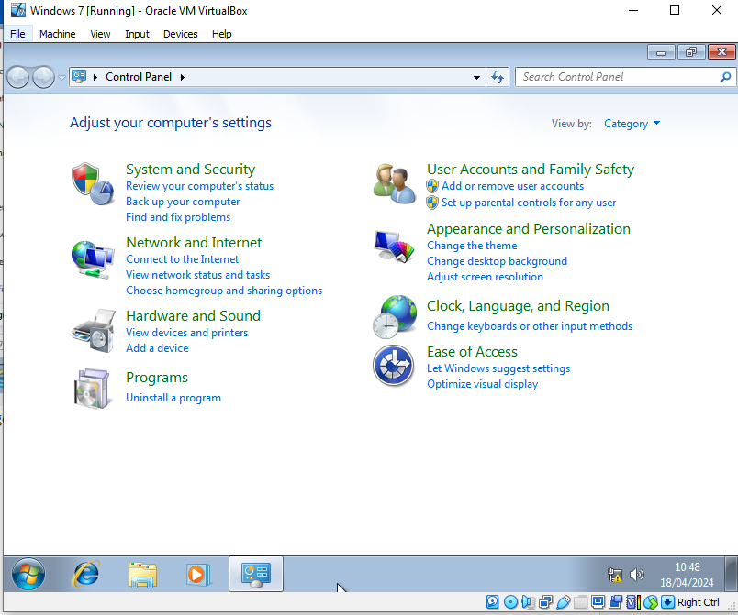Click ‘System and Security’.
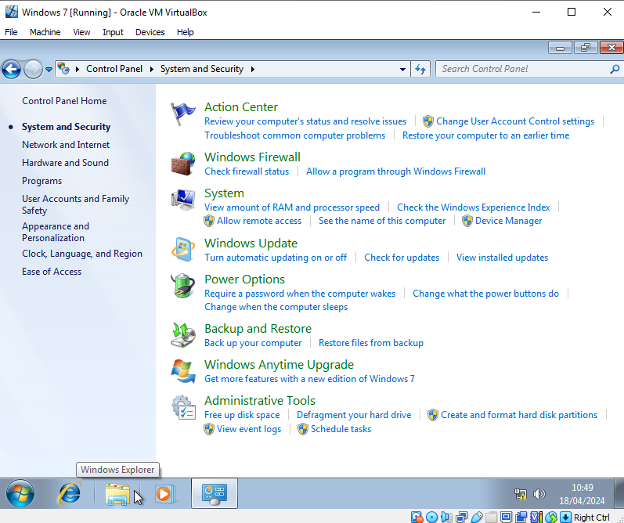Click ‘System’.
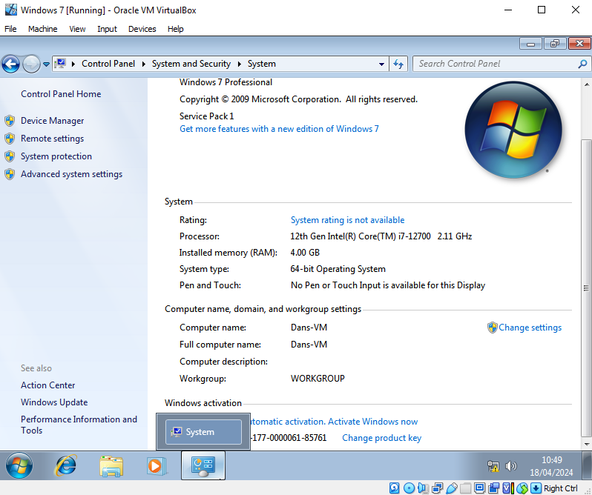Some of the configured hardware parameters can be viewed here, such as the 4GB of RAM which was allocated.
Next, click ‘Device Manager’, located top left.
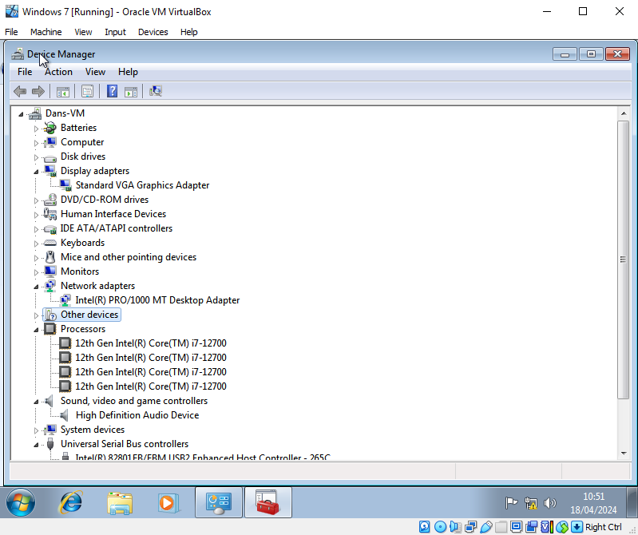Here, further details of the Virtual machine’s virtual hardware can be reviewed. Four CPU cores were successfully allocated.
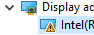
We can also see that the devices are working correctly. There doesn’t appear to be any driver issues, which would typically be indicated by a yellow exclamation sign next to the device.
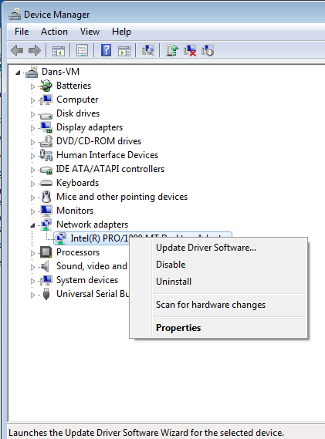
If required, drivers can be installed through the device manager. Right click the device, and click ‘Update Driver Software…’.

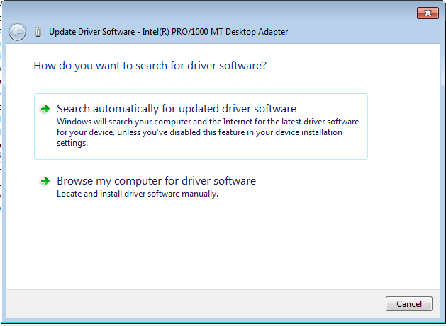
Next, choose to either search automatically (online), or select the driver software manually. In this example, the search automatically option has been selected.

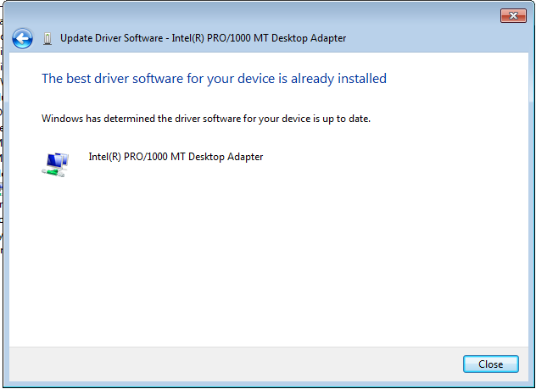

In some circumstances, Specialized software may be required for devices such as Graphics Cards. An example of this is Nvidia’s ‘GeForce Experience’ Software. On a webpage by Nvidia [3], It is said that GeForce Experience “keeps your drivers up to date” and “automatically optimizes your game settings”. Such software will need to be installed manually and will typically be readily available through the device manufacturer’s website.

6. Using a Virtual Machine

6.1 Partitioning drives
Navigate to Disk Management,
It can be seen that the virtual machine has one disk, and there are 2 partitions.
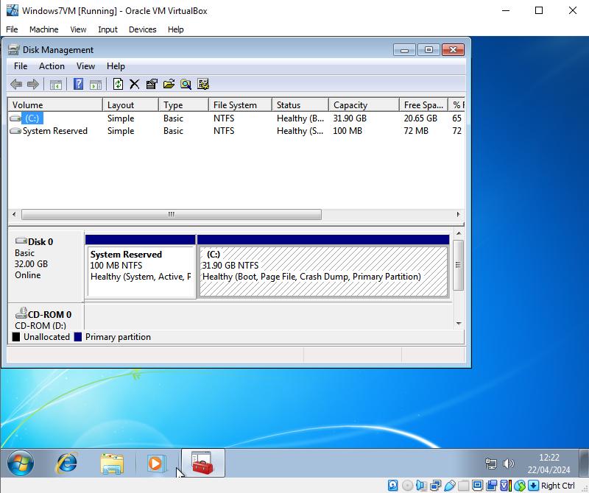
Right click (C:), click shrink
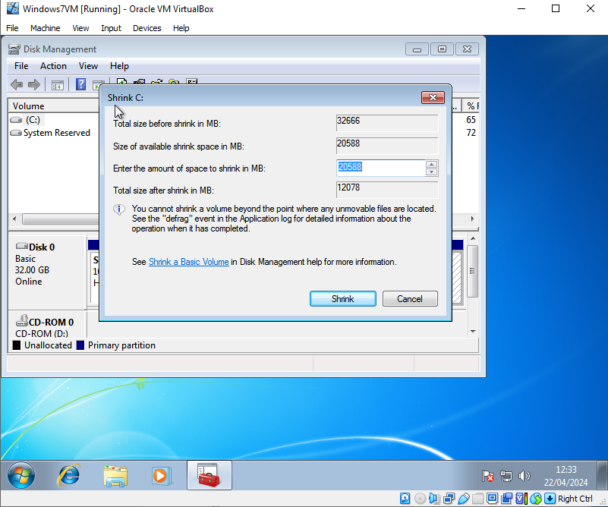
Input the amount of space to shrink the (C:) volume.
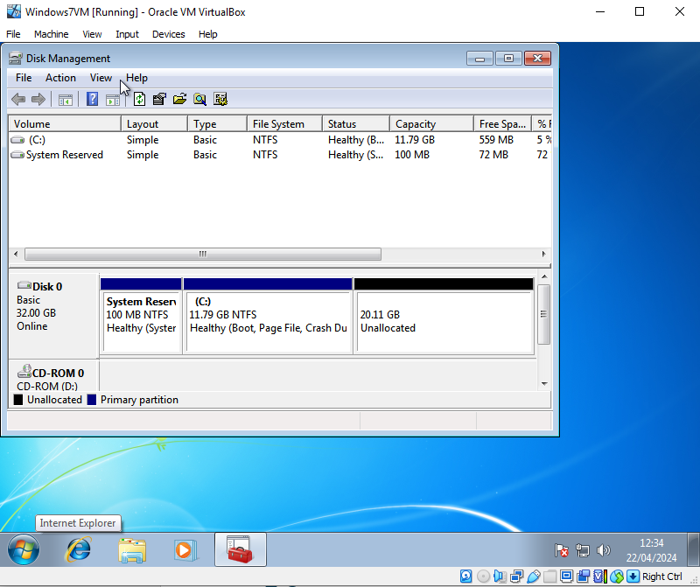
The (C:) Volume has been shrunk; we now have 20GB of space which is unallocated (marked in black).
Format the partition:
Right click the unallocated space, click ‘new simple volume’.
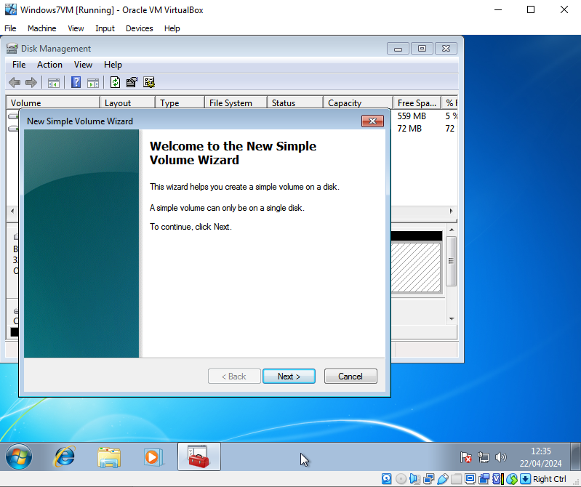
Follow the volume wizard.
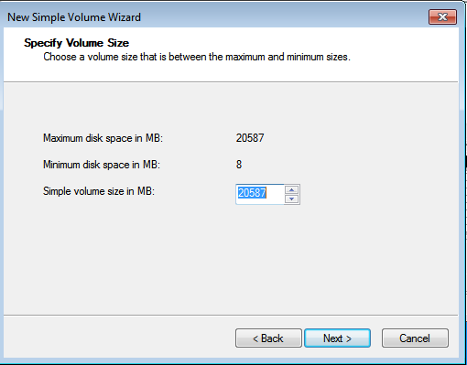
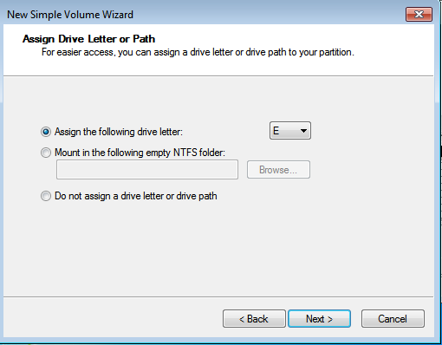
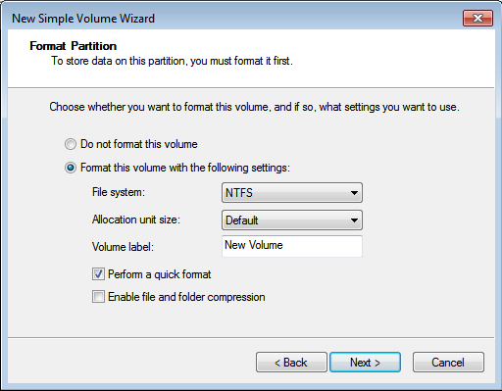
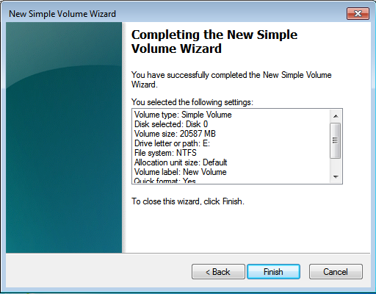
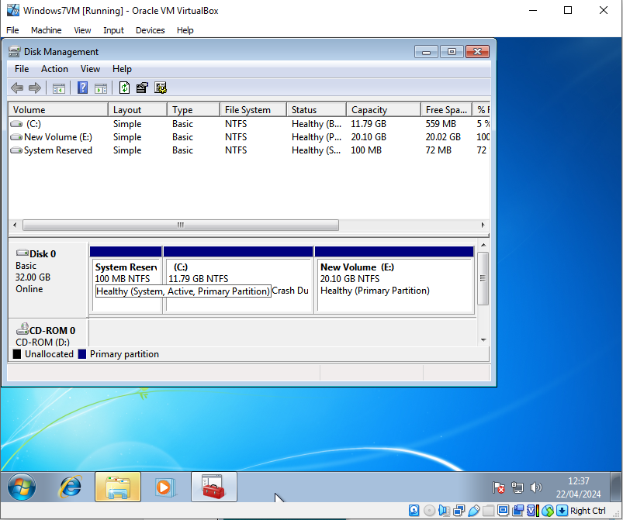
Our new volume has now been assigned the Volume letter (E:), and will be usable, as if it were a newly connected drive.
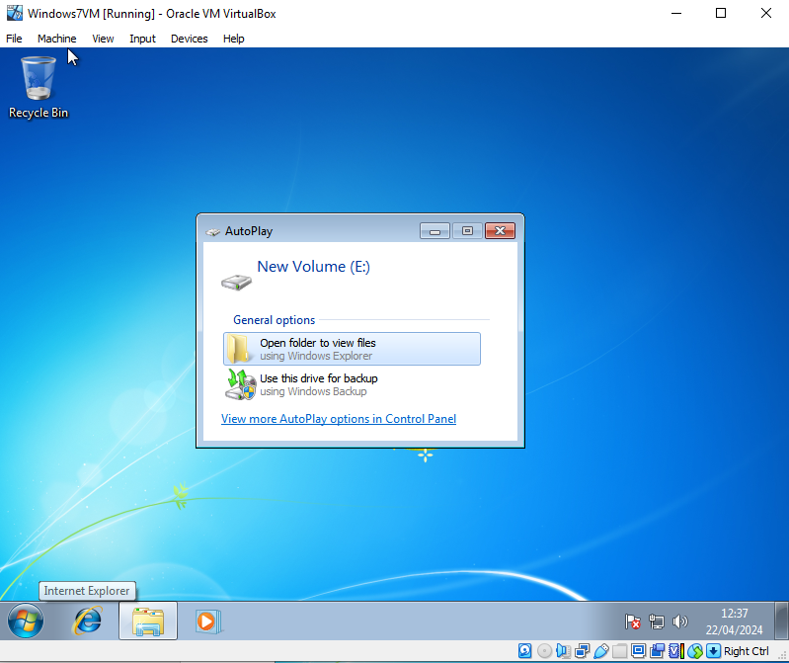
Windows explorer has recognised the new volume.

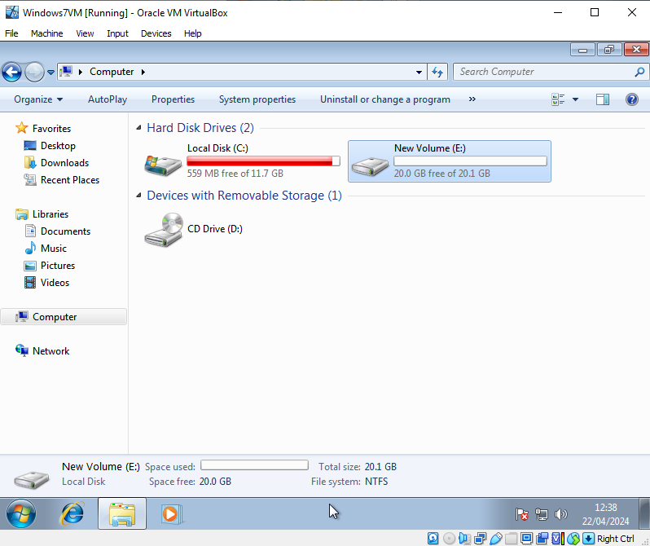

6.2 Installing Software

6.2.1 Installing Google Chrome
The following images demonstrate a successful installation of the Google Chrome web browser within the VM:
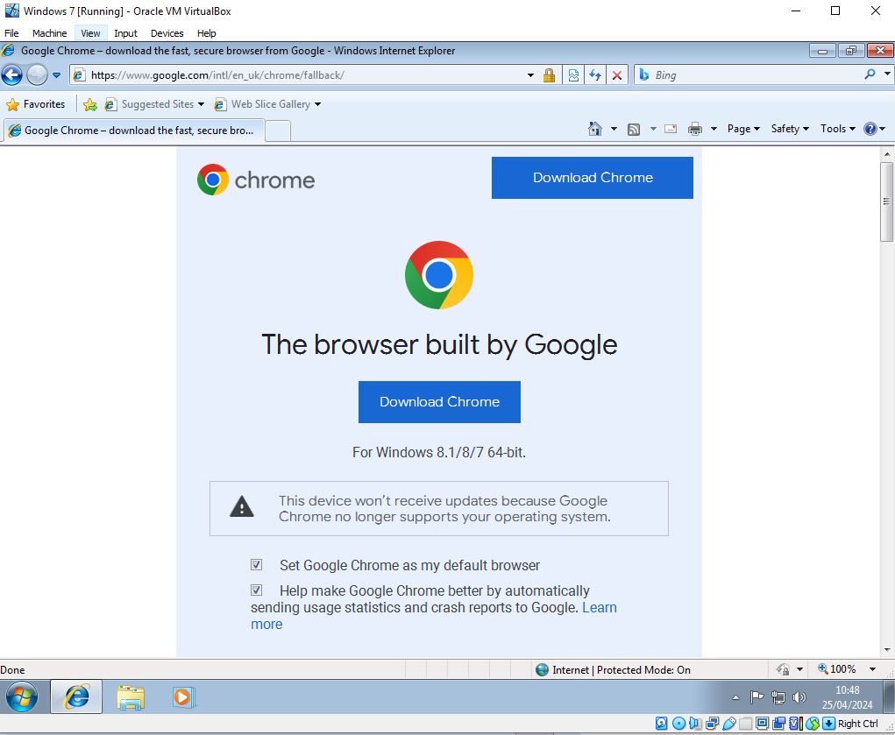
Click Download Chrome, Open installer, follow installation.

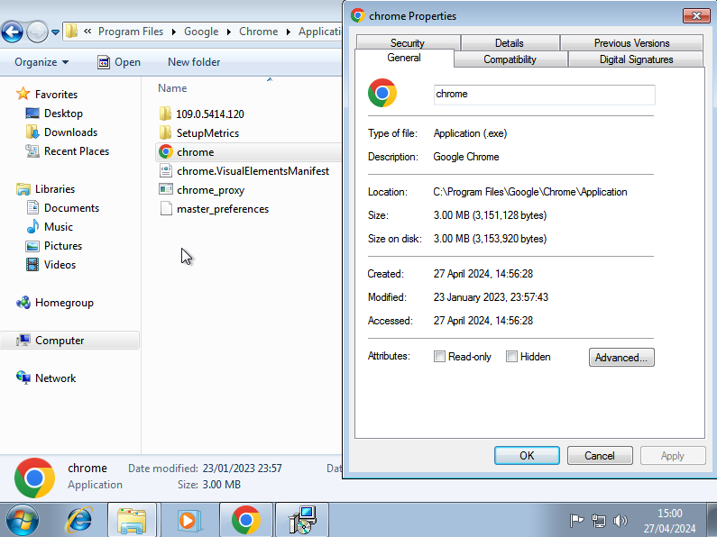
The Installation directory can be seen in the screenshot above.

6.2.2 Installing OpenOffice
The following images demonstrate a successful installation of the OpenOffice within the VM:
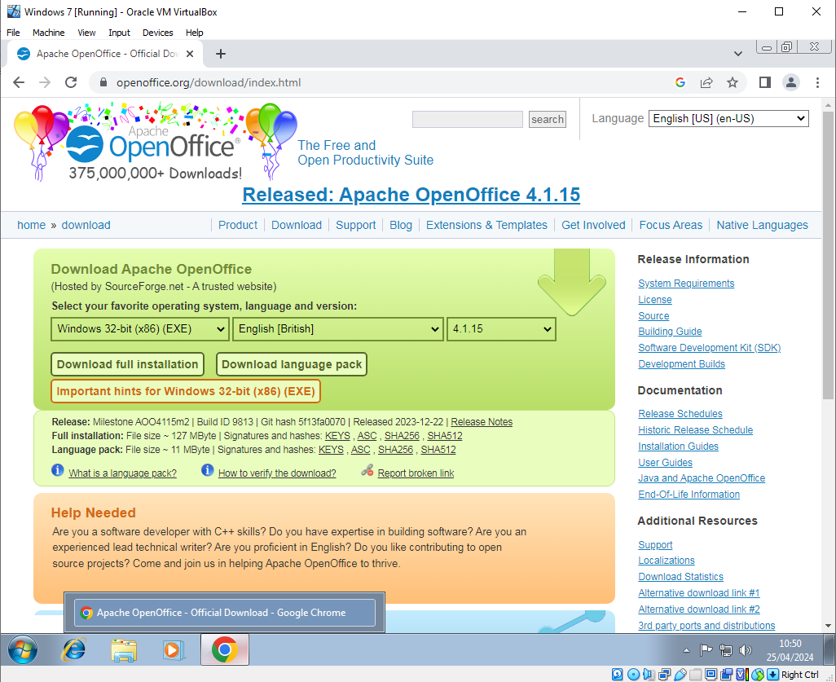
Click “Download full installation”, Open installer, follow installation.

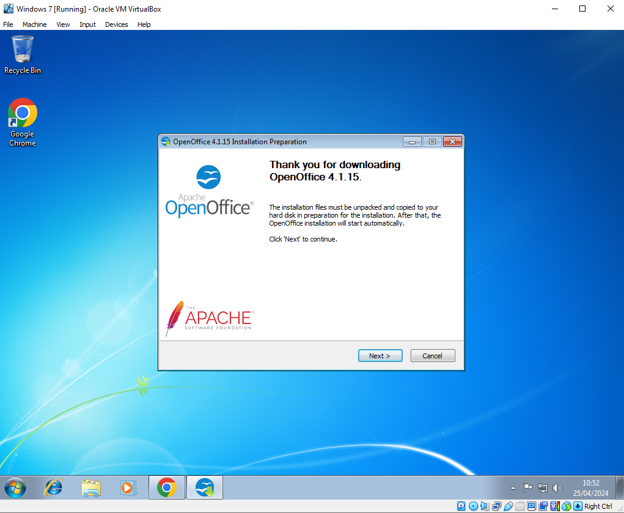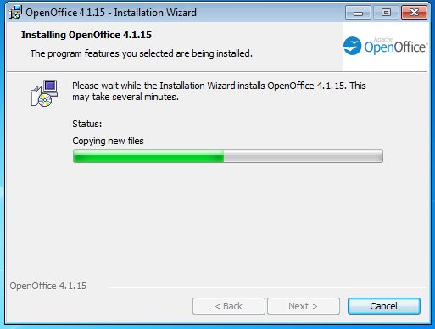
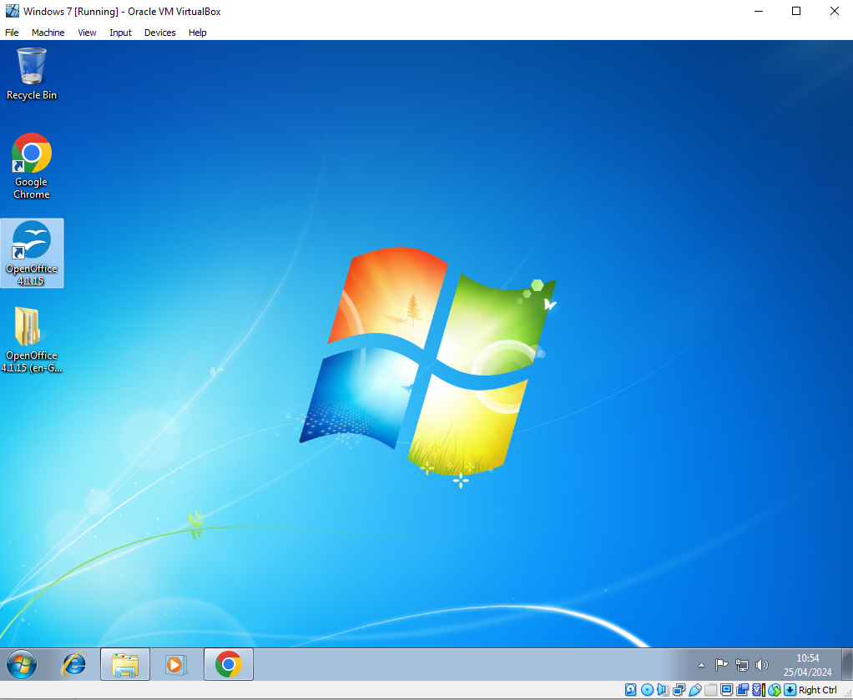
A shortcut has been added to the desktop, for convenience.
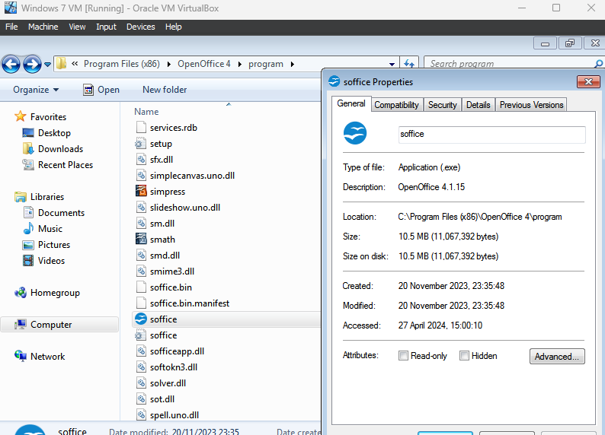
The Installation directory can be seen in the screenshot above.

7. References

[1] | Lenovo, "What is VirtualBox?," [Online]. Available: https://www.lenovo.com/us/en/glossary/virtual-box/#:~:text=It%20allows%20users%20to%20create,isolating%20environments%20for%20increased%20security.. [Accessed 25 04 2024].
[2] | VirtualBox, "Manual," [Online]. Available: https://www.virtualbox.org/manual/ch01.html#create-vm-wizard. [Accessed 25 04 2024].
[3] | Nvidia, "GeForce Experience FAQs," [Online]. Available: https://www.nvidia.com/en-gb/geforce/geforce-experience/faq/. [Accessed 25 04 2024].

8. Appendix

8.1 Further Background information
A virtual machine can be used for a vast number of reasons, but are particularly useful for the following:
- A user may have a computer running a Windows OS, and want to perform a specific task, or, run a piece of software which requires Linux OS. This example can be reversed, Likewise, a Linux user may want to run a piece of software which is only compatible within a Windows environment.
- The virtual environments are isolated. This allows for experimentation, testing and configuration without any risk to the host OS.
- Convenience - removes the need for separate physical machines, and/or, the need for multi-booting on a singular machine.

8.2 Further parameter config. information
*When allocating Hard disk space to a VM, A dynamic allocation defines a maximum limit of storage available to the VM. Unlike with Memory and CPU allocation, this hard disk allocation is not automatically reserved wholly for the VM, instead the VM will only use this resource from the host as is necessary, e.g., when downloading files, or, installing software. This means that space will not be deprived from the host machine unnecessarily.

8.3 Further VM Networking information
In simple terms:
”Bridged Adapter” Will present the VM to the network as its own unique machine. Thus, it will have its own unique IP address, this may be suitable for a home network environment where a DHCP server is set up in such a way to automatically provide new IP addresses to newly connected clients.
”NAT” will mask the VM, as such, any network activity will appear to be happening from the host machine itself. This option can be suitable for a work or university environment, where security measures are in place to prevent IP addresses being allocated to unknown clients.

9. Bibliography

https://www.virtualbox.org/manual/ch01.html#virt-why-useful
https://www.lenovo.com/us/en/glossary/what-is-dual-boot/
https://www.youtube.com/watch?v=Fhdxk4bmJCs
https://superuser.com/questions/227505/what-is-the-difference-between-nat-bridged-host-only-networking
https://www.linkedin.com/advice/0/how-do-you-choose-between-nat-bridge-mode-your

