

Postgraduate/Distance Learning
Assignment coversheet & feedback form
TO BE USED FOR ALL ESSAY SUBMISSIONS FROM APRIL 2026
THIS COVER SHEET REPLACES ALL PREVIOUS VERSIONS.
YOU MUST SIGN THE AI DECLARATION BEFORE YOU SUBMIT THE ESSAY.

THIS SHEET MUST BE THE FIRST PAGE OF THE ASSIGNMENT YOU ARE SUBMITTING (DO NOT SEND AS A SEPARATE FILE)
For completion by the student:
Student Name: Gemma Cook

Student University Email: 2517984@student.uwtsd.ac.uk
Module code: HPCA7028  Module title: Sacred Skies | Student ID number:  2517984 |  |  | Educational support needs:  Yes/ No
Assignment title: A Critical Examination of the Sky in Relation to Material Culture

Assignment due date: 30th April 2026
This assignment is for the 1st 2nd 3rd 4th 5th 6th module of the degree
Plagiarism declaration
I confirm that this is my original work and that I have adhered to the University policy on plagiarism.

Artificial Intelligence (AI) declaration

I confirm that I have not used any AI tools in the research and creation of this assignment. I confirm that I have not presented any AI generated materials as my own work. I confirm I have copies of my drafts, notes, and other resources I used, which I may be asked to provide in evidence.

Signed: Gemma Cook
Date: 28/4/2026

Assignment Mark
1st Marker’s Provisional mark
2nd Marker’s/Moderator’s provisional mark
External Examiner’s mark (if relevant)
Final Mark

NB. All marks are provisional until confirmed by the Final Examination Board.

For completion by Marker 1:
Comments:

Marker’s signature: |  |  | Date:
For completion by Marker 2/Moderator:

Comments:

Marker’s Signature: |  | Date:
External Examiner’s comments (if relevant)

External Examiner’s Signature: |  | Date:
A Critical Examination of the Sky in Relation to Material Culture

Introduction
This essay will critically examine the sky in relation to material culture through the following two examples of two-dimensional images: A photograph of a ‘Sunset Across the Fields taken my myself (1986- ) on the 24th Feb 2026 (Fig. 1) and Joseph Mallord William Turner’s (1775–1851) painting ‘The Fighting Temeraire tugged to her last berth to be broken up, 1838,’ (Fig. 2) I will be critically examining both two dimensional images of the sky through the themes of Composition and Transformation.
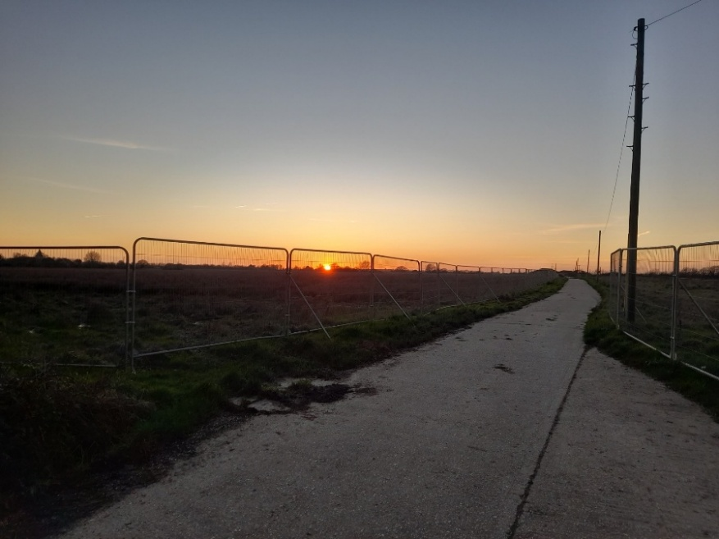
Figure 1. Sunset Across the Fields, Tuesday 24th Feb 5.35pm 2026, Photograph on smartphone: Gemma Cook
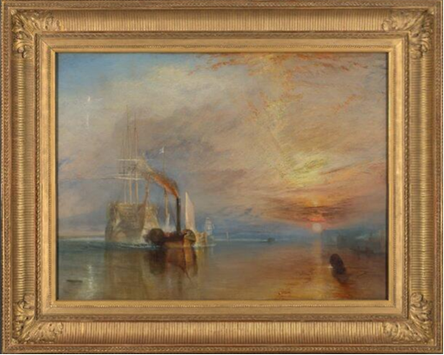
Figure 2. Joseph Mallord William Turner (1775-1851) The Fighting Temeraire, tugged to her last Berth to be broken up, 1838, (1839) Oil on canvas, 90.7 x 121.6cm. Image: The National Gallery, London, England.
I captured Figure 1 on my smartphone, whilst standing on the driveway/ public footpath route leading to Church Barton House on the edge of Pagham Village, near Bognor Regis in West Sussex, UK. The Church Barton footpath takes you from the edge of Pagham village and traverses Pagham Harbour (Fig. 3), which is protected and recognised as a Site of Special Scientific Interest, and is a local nature reserve. Pagham village has been identified as having some form of residential living for over three and a half thousand years as evidenced by the excavations of Bronze age artefacts. Post-war years, the village of Pagham began a period of rapid expansion, and this has continued to the present day, with currently over 6000 residents.
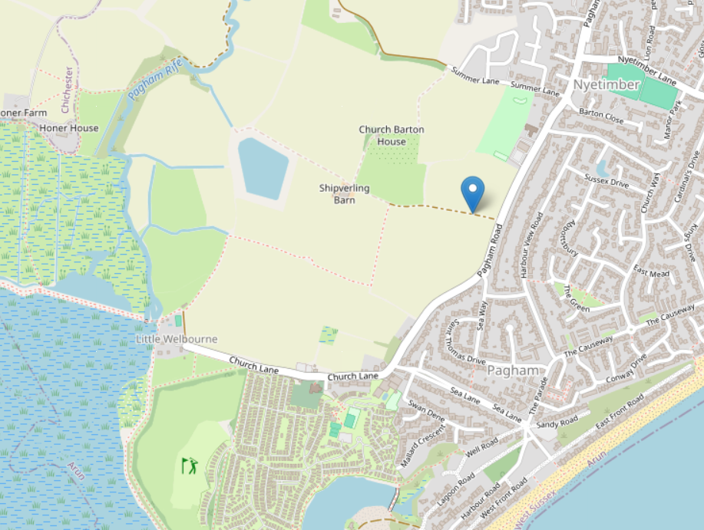
Figure 3. OpenStreetMap, Church Barton Footpath aerial view, [adapted] 2026, Image: Footpathmap.com
Figure 2 is an oil painting on canvas, painted by Joseph Mallord William Turner (hereafter referred to as Turner) in 1838, and was part of five paintings displayed in the British Royal Academy of Arts exhibition held in the National Gallery, in the spring of 1839. Figure 2 depicts the final journey of the HMS Temeraire. HMS Temeraire was a 98‐gun, three‐decker, second rate warship of the British Royal Navy, known for its participation in the Battle of Trafalgar in 1805. From 1812 until 1838 it served as a prison ship in Plymouth Harbour and as a victualling and receiving ship for seamen waiting to take up active duties off Sheerness in Kent. After decommissioning by the Royal Navy, on the 6th September 1838 it travelled fifty five miles up the River Thames from Sheerness in Kent to Rotherhithe in South East London in order to be broken up for timber by the timber merchant, John Beatson.
Composition
Turner was an artist of the Romanticism movement that occurred in Western civilization over a period from the late 18th to the mid-19th century. Romanticism was a term used to describe art and literature distinguished by a new interest in human psychology, expression of personal feelings and interest in the natural world. Turner represented ‘The Fighting Temeraire’ on a landscape 90.7 × 121.6 cm canvas, maximizing the view across the horizon. Interestingly, for this landscape Turner shunned one of the major principles of compositional design of his time, being that of symmetry. When painting sunsets, other Romantic Movement artists, such as Casper David Freidrich (1774-1840), chose to place the central figure, the sunset, directly in the centre of the canvas, such as in ‘Dreamer (Ruins of the Oybin)’ and ‘Sunset (Brothers)’. Fellow Romanticist Georg Emil Libert (1820-1908) also placed the sunset centrally in his piece ‘Sunset on a bay, with castle ruins’. Symmetry, was primarily used to illicit balance by placing pictorial elements within a design to create a stable, harmonious balance. Unlike his fellow artists, Turner focused on his placement of key figures using geometry to create perspective. Using perspective as a key element to a landscape construction would have been a familiar cultural artistic expectation to Turner; with the concept first having been developed in the 1430’s. Turner gave his first series of perspective lectures at The Royal academy in 1811 and the last in 1828. Dinter states by the 1800’s the imposition of structure onto landscapes raised art pieces’ status by their association with the revered disciplines of Geometry and Architecture. Exemplifying oneself as an artist by using noble methods would have been a cultural expectation of artists in the 18th Century. Turner pre-emptively used the idea of ‘rule of thirds’ as suggested by Greene (although this was given as a good practice guide for photographic composition many decades later.) “Divide your photograph into thirds horizontally and vertically and place the centre of interest near the intersection of any of these lines.” (Fig. 4) Turner placed two figures (the two ships) to the left of the central line but directionally facing it, and the singular figure, the sunset, in the right panel but further away from the centre. (Fig. 1) The audience is compelled to scan the artwork from left to right, from the foreground ship to the background setting sun. (Fig. 5) This presented the illusion of movement, or at least insinuated the distance travelled/ yet to travel. It reinforced the title of piece ‘The Fighting Temeraire tugged to her last Berth to be broken up, 1838’ and exemplified the Romantics’ artistic cultural vision of recording pieces full of emotion.
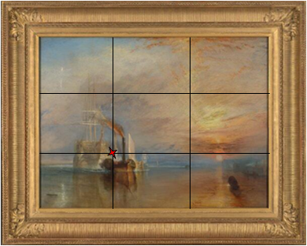
Figure 4. Joseph Mallord William Turner (1775-1851) The Fighting Temeraire, tugged to her last Berth to be broken up, 1838 [adapted] (1839), Oil on canvas, 90.7 x 121.6cm. Image: The National Gallery, London, England.

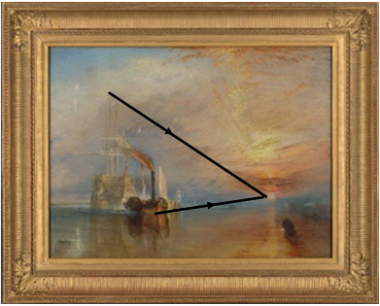
Figure 5. Joseph Mallord William Turner (1775-1851) The Fighting Temeraire, tugged to her last Berth to be broken up, 1838 [adapted] (1839), Oil on canvas, 90.7 x 121.6cm. Image: The National Gallery, London, England.

In terms of compositional colour/ art medium choices Turner started his artistic career as a watercolourist. However, this presented an insurmountable barrier to the ever ambitious, professional status seeking artist; as you could not be elected to the post of Royal Academician unless you exhibited oil paintings-so Turner adapted. Compared to his first piece, in the style of the Old Masters’ (skilled European painters from the 13th to 18th Century), this piece of artwork contained much hazier contours and lines and leaned towards a softer palette. Turner’s artistic style had evolved in order to compete in the increasingly competitive oil painting market found in England.. Albright and Huybers state this was “a progression that is typically characterised as moving from a more figurative to an impressionistic style” a move that was occurring in the art world with Romanticism flourishing in Turner’s lifetime. ‘The Fighting Temeraire’ was a product of the time in which Turner lived. The timescale of which he created pieces of art was reflective on the art mediums available. Sketches and notes would have led to oil paintings created over several weeks/ months as he waited for the oils to dry or simultaneously worked on other pieces necessary for exhibition in order to sustain his income and improve his notoriety. Additionally, his preferred style of painting reflected cultural changing trends. Absent was the influence of the pre-1800’s Rococo movement style which, favoured asymmetrical curves, decoration and frivolity and rejected was the Neo-Classicism (mid-18th century- early 19th Century) controlled, high minded and moralistic art created with sharp colours, here instead was a true Romanticised impression of the world. I took my photo of ‘Sunset over the fields’ on my smartphone on the 24th February 2026 at 5.35pm, this was first of a series of photos that I took for one of the weekly tasks for my Sacred Skies module to capture /observe where the sun rose or set from one observation point. I chose sunsets at a local vantage point as firstly, I am not an early riser, much preferring to stay up late as a night owl, so capturing the sunrise was never going to be a positive or rewarding experience for me. Secondly, from my home, I could not see the natural horizon, so my sunset observations were going to have to take place away from my residence. My first attempt had nearly ended in complete and utter failure. Living near the Pagham beach I had assumed that standing on the top of the beach I would be able to see the sun as it disappeared below the horizon; I thought I would be looking out to sea, or at least over the Pagham harbour peninsula. Having hurried home from work and arriving on the beach at 5.27pm I came to the unhappy conclusion that my geographical awareness was lacking. The sun had yet to set and was nowhere to be seen. What followed was a mad dash to the only other place where I thought I could see the horizon and sun set across the fields. At 5.35pm I captured my photo with a great sense of relief, awe and a humbling awareness that I really didn’t know my own locality, despite 38 years of living here. With the rush to capture the image came very little time to decide upon perspective and composition of the landscape. I took four images that day; 3 landscape and 1 portrait with varying magnifications. I chose the 1.0 x magnification, as I felt that looking ‘through’ the higher magnifications, it didn’t do justice to the vastness of the area. I had stood in awe at this amazing sight, I am using the term here as described by Kelner and Haidt “awe involves being in the presence of something powerful” being faced by something vaster than the self, beyond our current understanding, and so without overthinking the composition, I just captured the image. It was a huge realization that the next night when I returned, now with time to spare and in a more relaxed manner that I was engaging more in Wonder, as described by Kerns as “a wonderous approach to life… to explore, discover, learn and solve mysteries.” This time I observed what differences I could ascertain through capturing the sky though different perspectives; discovering and learning how framing the image in different ways, (through the trees, removing foreground objects or moving close enough so that it appeared that there was no chain link fence) could alter my responses to it. I realised I was trying to solve the puzzle of which combination of elements would make the best composition- I was thinking not really observing. Looking reflexively at my choices, I am using the term reflexively as suggested by Probst, my hectic work schedule didn’t encourage or give me any time to take those photographic images and create my own representation. I felt I didn’t have the time to sit, contemplate, draft, create and improve a piece, as it wouldn’t truly capture the vastness and beauty of what I had seen; and I felt saddened by this realisation. Gone were my university years where reading a History and English Creative writing degree, meant that vast parts of my ‘studying’ was to have contemplative moments to go and sit, observe, record and create. After observing my photograph, I gained an understanding that my cultural expectations of being seen and achieving as a busy ‘scheduled-in’, working adult, although leading to income and enjoyment, meant I had lost some of that childlike wonder and ability to create something other than what work demanded. I reflected on how my semi rejection of the cultural boom in technology (I still had a Nokia flip phone until six years ago, and have only joined WhatsApp for work related matters, with no other social media) affected how I was capturing the sky. Even with all of the options I could undertake, given technology in 2026, it was something about that first hurried captured image that spoke to me the most- that was my prefect image. Perhaps something in the ‘just do it' process spoke to me, reminding me of younger days where I could be a little braver, more impetuous and not worry that the outcome needing to be perfect. Upon reflection of the photograph, I also realised that there was something about the composition of this shot that appealed visually to me. The road/ footpath I had stood on led from the foreground to the background, almost as if it was inviting me to travel along with it, to delve deeper, to be enchanted. Currey states “that enchantment in art, both in its creation and appreciation, transcends individuals but also depends upon them.” This photograph was phenomenological landscape, as described by Salwa, the photo symbolised my own cultural upbringing and growth; how my life leaving the well paid but incredibly demanding and stressful teaching profession four years ago to gain a happier and healthy work- life balance shows I am also on a journey- walking a path to find out who I am. Additionally I was drawn in by the height of the dark, looming telegraph pole, with the darkness of colour in the in the foreground, the soft hazy palette in the sky, and the steep angle to the bright intense sun set in the central horizon. It encouraged the me to scan the artwork from right to left, from the foreground to the background, implying vastness. (Fig. 6) The setting sun forewarned of a transition to haziness and diminishing colours. This process can be seen mirrored in today’s culture with the increasing occurrence of people with Alzheimer’s with the cognitive and behavioural process known commonly as ‘sundowning.’ Poet Deb O’Rouke wrote “the onset of night madness…their grace receding with the light: comfort and sanity swept away like flotsam on the retreating tide of day.” The setting sun seemingly precipitating and/or intensifying certain disruptive behaviours, and amplifying diminishing memory, speech function and kinetic abilities.
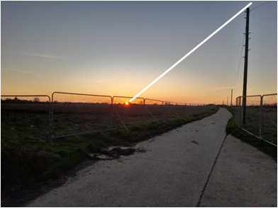
Figure 6. Sunset Across the Fields [adapted], Tuesday 24th Feb 5.35pm 2026, Photograph on smartphone: Gemma Cook
In conclusion, in this section both pieces of two-dimensional sun set representations were critically examined through the theme of Composition. The artists used, and captured, elements of colour intensity and darkness transitioning to lighter, softer, hazier tones from one area of the artwork to another, to evoke a sense of emotional foreboding from the audience. Both images have essentially frozen a moment in time, capturing a sense of inevitable loss. With the placement of a tall object in the fore/ middle ground and the sunset being located at angle back and down from the top most point of the tall object, both pieces implied a sense of vastness and directionality. Both pieces in their choice of subject are displaying an inferred movement or a potential distance/ journey to be travelled. However, my own photo captured these elements sub-consciously, but somehow still symbolically represented my own current life choices of starting a new journey. Whereas, Turner had an eye for dramatic composition and used this to put greater meaning into the landscape, to depict a story in order to stand out from the artistic crowd and gain cultural status.

Transformation
In this section both of the images will be explored in regards to the theme of Transformation. Cambridge dictionary online states that the word Transformation means “a complete change in the appearance or character of something or someone.” Turner’s painting was a sun set landscape depicting the final journey of a decommissioned Royal Navy veteran warship. In a very real sense, the final journey of the Temeraire was one of a ship transitioning from life to death. The name Temeraire had already seen transformation in its life. The original ship boasting the name Temeraire was in fact La Témérarie, a successful, French, ex flagship, 74 gunner who had been captured in 1759. It had been a strategic and great psychological victory for the British giving great honour to its sailors, the British admiralty and epitomized Britian as a great seafaring nation. In 1793 construction on the new, wholly British, Temeraire commenced and in 1805 it saw action in the Napoleonic Wars, playing a distinguished role defending Nelson’s flagship, the Victory, at the Battle of Trafalgar; this event was commemorated in Turner’s only Royal commission piece exhibited in 1806. Turner exhibited ‘The Fighting Temeraire’ in only the second annual exhibition to be held, in the then newly built National Gallery, which rather poetically sat in the building area that would become Trafalgar square, and would only a few years later hold the 169-feet tall Nelson’s column. The piece was a cultural product of a proud seafaring nation, also gripped by the celebrations of a new young Queen Victoria, who had been crowned only a year before; it was to be a new era of progress. Apart from any patriotic sense of honour that Turner may have had to the nation, he was also shrewd when it came to capitalizing on new trends and opportunities to increase/ promote his own status and profits. In order to survive, and thrive he needed to stay in the forefront of the public and art critics’ minds. At times he depended on, or at least benefitted from financial backing from individuals or consortiums to fund his European jaunts for inspiration, this was the 1800’s cultural version of crowdfunding. Turner was living in a time where cultural recognition and status was reliant on having artwork either commissioned and /or bought by patrons and clients, some of whom being of noble birth could grow or doom his career. It seems therefore fitting that Turner sought some sort of self and nationalistic closure to record the final journey of the Temeraire in 1838. His actual presence to record an eye witness account of the final journey is somewhat disputed. Venning states “several unreliable stories place Turner as an eye witness at some point in this two-day journey.” The National Gallery, which holds the painting, agrees with this, stating that Turner may have actually been in Europe. The cultural movement of Romanticism looked wherever at whatever they wanted for artistic stimulus, often journeying off to Europe for inspiration and Turner’s repeated trips to Europe reveal himself to be a product of this cultural phenomenological belief. Turner’s physical absence may explain certain inaccuracies in the depiction of the painting; it is not a documentary image but an impressionistic memorial piece. Therefore, the inaccuracies need to be examined to identify what Turner was trying to convey. Firstly, it seems unlikely that experienced sailors would have chosen to complete the final stages of the Temeraire’ s fifty-five-mile journey arriving in darkness, as the sun set. Hence the setting sun may be considered to purely be symbolic; for Turner the sun was powerful and divine. Turner’s choice to portray the journey of the Temeraire as the sun set may be significant in portraying that he (if he was in attendance, or at least the public) were witnesses to the fading of the glorious seafaring days of both the ship and the nation. The sky was accessible to all, so that everyone who saw a sunset in his artwork could relate to a sense of loss; loss of the sun’s warming, life giving rays. John Ruskin (1819-1900) as Turner’s friend and biographer commented that “In Turner’s distinctive work… the sunshine is his treasure… wherever the sun is not, there is always melancholy or evil” Stein argues Ruskin stressed the heroism of sacrifice that could be found in Turner’s paintings. Indeed, the notable absence of the Temeraire’s known striking black and gold paintwork, instead in its place a ghostly white figure, seems to suggest death and transformation. However, whilst the symbolism may be likely, it seems shortsighted to examine the picture no further. If Turner was resolute in his endeavour to show the lamentation of an era, why did his painting also contain inaccuracies enabling the Temeraire to retain some of its dignity. Turner painted it how he wanted it to be remembered, rigged with masts and sail, not the helpless, unpowered hulk that she had become. Willis states that like all decommissioned ships, all masts and yard would have been removed before its auction and sale, she was in essence, just a wooden hull. Turner was living in and representing a time of transition and transformation, of progression, with many supporters and some very vocal critics. Venning states that many writers reporting at the time, cast the role of villain onto the steamboat tugging the Temeraire; it was a violent, shrouded, mechanical assassin demonstrating superiority over the older river draft. Whilst, Turner used the steam boat to contrast the stark differences in technology and aesthetic appeal between it and the Temeraire, one can also argue that perhaps Turner in this instance was merely documenting (albeit inaccurately) the Temeraire’s means of locomotion. Steamers had garnered attention and recognition for being compact machines of power, enabling more regulated sailing scheduling due to being less reliant on the whims of the wind. Turner portrayed Britain’s transition and transformation into the age of steam and coal in several of his other paintings, most notably in his piece ‘Rain, Steam and Speed- The Great Western Railway in 1844’. In it he included the steam powered train, but also emphasised the theme of speed by including two small details; a small boat and a man driving a horse-drawn plough. Turner frequently painted scenes of contemporary life and often used new forms of transport, alongside previous versions in his pieces, showing all subjects to be worthy of being painted. Ormiston stated “Steam power was more productive, but not as Romantic”. It can be argued that Turner was not rejecting the transformation of Britian into a more industrialised nation but merely communicating technological and social progression through the cultural medium of art. Turner himself transitioned though modernity; he was born during the Age of Sail and died in the Age of coal and steam. However out of all his landscapes, depicting a range of characters and social changes, this was the one he kept until his death. Bailey records that Turner had written “no considerations of money or favour can induce me to lend my Darling again.” If the painting was merely a representation of cultural societal and technological transformation, with no emotive connections, why would Turner not part with it? Whilst reflectively examining my own photographic art piece I came to realise that like Turner’s ‘The Fighting Temeraire’ my own composition displayed Transformation. I came to the Pagham area when I was 18 months old, my parents having moved down from the busier city of Epsom, Surrey, just south of London in order to enjoy a quieter, less busy and crowded way of life. I grew up taking the dog for walks out down to the beach and into the countryside through various public footpaths, that led over muddy fields, across streams and through vast swaths of agricultural fields. This was the epitome of what a countryside childhood meant for me. I have always found a certain respite striding out into the fields and a peacefulness to it all. In retrospect it gave me the quiet headspace, that was severely lacking in a working week. I left a fourteen-year career in Primary Education Teaching due to the intense workload and unrealistic demands that led me to eleven-hour days. Three years on I am happy, having re-trained and splitting my time between three education jobs in the leisure industry and museum heritage. However, there is still an insistent need to be available and have all the answers, to be accountable for progression or sales figures, thanks to cultural technological progression, whether it be through email, text or WhatsApp. Work burnout is a very real and potentially dangerous cultural phenomenon that has dramatically increased in the last decade, multiple reports into how to alleviate symptoms have taken place in the fields of education, law, and health to name a few. After many reports and investigations, numerous institutions and work places have taken on board the importance of Mental Health; training mental health first aiders or hiring burnout advisors. Some burnout advisors offer techniques and strategies to avoid burnout, such as meditation and unplugging completely. Thinking reflexively, using Probst’s description of the term, perhaps this is why taking myself away from it all on a long walk through the fields has become so important and why even just engaging with a photo of this alleviates stress Captured in my photo, transformation is about to occur, planning application to build sixty-five homes onto these fields has been approved, hence the chain link fences in the photo. This is part of a wider cultural trend where local councils are being driven by government targets to increase affordable housing availability due to rising population numbers and increasing financial challenges. The BBC stated “The government aims to build 1.5 million more homes in the next five years, helped by… the reintroduction of mandatory housing targets for local authorities.” This can be evidenced by the over 1000 homes having been approved or under construction in or near my village. Not only does the chain link fence in my photograph represent a death blow to my quiet peaceful village life, but this transformative industrialization will also obliterate one of the few places where I can actually see a sun set on the natural horizon. My photo has captured a sky scene, showing the brink of change, elements indicating the forward progression, yet the vast land and sky seemingly making a final defiant stand. In my mind, the sun set I captured in this picture, truly does symbolize a chilling melancholy prophecy of death. In conclusion, in this section the theme of Transformation has been examined. ‘The Fighting Temeraire’ certainly encompassed the cultural transitions and transformation of Turner’s lifetime- literally in the ending of the wooden war veteran’s operational life, and perhaps figuratively in the decline of the golden age of sail. My photography also displays Transformation, like Turner’s piece it documents a societal trend and cultural ‘progression’ towards industrialisation. Both art pieces evoke a deeply emotional response, from an audience local to both sites of the captured image. For Turner the piece was well received, for whilst it was debated for its lack of accuracy, it was simultaneously lauded when it tugged at the heart strings of the appreciative patriotic audience. My own piece I can only view it with sadness on what both the chain link fence and sun set symbolically represent for the future; it will never be my ‘darling’.
Conclusion
This essay critically examined the sky in relation to material culture through the following two examples of two-dimensional images: A photograph of a ‘Sunset across the Fields’ taken my myself (Fig. 1) and Joseph Mallord William Turner’s painting ‘The Fighting Temeraire’ tugged to her last berth to be broken up, 1838’ (Fig. 2) through the themes of Composition and Transformation. The findings of this study in the themes of Composition found that both pieces used the sky as a familiar backdrop, a canvas or sorts, to capture the landscapes’ s colour intensity and diminishing brightness. This evoked the viewers’ sense of awe; demonstrating the magnificence of the celestial event, as well as provoking a sense of foreboding and doom. Turner’s composition was a result of an evolution (or stepping away from) cultural artistic thought, trends and personal preferences. The piece was considered and constructed over time, in order to meet the of approval of his cultural peers, critic and supporters, my own hastily captured piece demonstrated limitations about work -life balance and personal life choices from the work heavy, technologically rich culture I which reside in. In the investigation and examination of the theme of Transformation both artists’ pieces could be analysed and assessed as historical documents depicting industrialization and change. The backdrop of the setting sun was used as a familiar cultural phenomenological experience for its audience to engage with the artists’ symbolic inclusions, narrating their own feelings towards transformative events within their lifetimes. My own art piece using instant capture technology, available to me in my culture, (with no editing or adaptations in this instance) has documented the scene as it was, any symbolism is contemplated in the observation after the taking of the photo. Whereas, Turner’s choices of art medium, partially dictated by the cultural time in which he lived, allowed him to use artistic license to over time, document, embellish and edit the painting, in order to tell the ‘story’ of the event in the way he wanted people to remember it.

Figures
Figure 1. Cook, Gemma, Sunset Across the Fields, Tuesday 24th Feb 5.35pm 2026, Photograph on smartphone.

Figure 2. Turner, Joesph Mallord William, (1775-1851) The Fighting Temeraire, tugged to her last Berth to be broken up, 1838, (1839) Oil on canvas, 90.7 x 121.6cm. Image: The National Gallery, London, England. < https://www.nationalgallery.org.uk/paintings/joseph-mallord-william-turner-the-fighting-temeraire> [accessed 20th April 2026].

Figure 3. OpenStreetMap, Church Barton Footpath aerial view, [adapted] 2026, Image: Footpathmap.com < https://footpathmaps.com/?lat=50.772823&lng=-0.746984&zoom=15&marker_lat=50.775081&marker_lng=-0.741223 > [accessed 20th April 2026].

Figure 4. Turner, Joesph Mallord William, (1775-1851) The Fighting Temeraire, tugged to her last Berth to be broken up, 1838, [adapted] (1839) Oil on canvas, 90.7 x 121.6cm. Image: The National Gallery, London, England. < https://www.nationalgallery.org.uk/paintings/joseph-mallord-william-turner-the-fighting-temeraire> [accessed 20th April 2026].

Figure 5. Turner, Joesph Mallord William, (1775-1851) The Fighting Temeraire, tugged to her last Berth to be broken up, 1838, [adapted] (1839) Oil on canvas, 90.7 x 121.6cm. Image: The National Gallery, London, England. < https://www.nationalgallery.org.uk/paintings/joseph-mallord-william-turner-the-fighting-temeraire> [accessed 20th April 2026].

Figure 6. Cook, Gemma, Sunset Across the Fields [adapted], Tuesday 24th Feb 5.35pm 2026, Photograph on smartphone.

Bibliography

Albright, Anna Lea., Huybers, Peter., ‘Paintings by Turner and Monet depict trends in 19th century air pollution’, Proceedings of the National Academy of Sciences of the United States of America, Vol. 120, No. 6 (February 7, 2023)pp1-8.

American Psychiatric Association, Diagnostic and Statistical Manual of Mental Disorders, (1994) Cited in Garce, Melinda La., ‘Daylight Interventions and Alzheimer’s Behaviours- A Twelve-Month study’, Journal of Architectural and Planning Research, Vol. 21, No. 3 (Autumn, 2004), pp. 257-269.

Arun District Council, ‘Arun.Gov.UK’, (1996) https://www.arun.gov.uk/church-barton-land-at-church-barton-house-horns-lane/ [accessed 24th April 2026].

Bailey, Anthony., Standing in the Sun A Life of J. M.W. Turner (London: Tate Publishing, 1990)

BBC, ‘BBC News’, (1997) <https://www.bbc.co.uk/news/61407508> [accessed 24th April 2026].

Birch, Dinah., ‘“The Sun Is God”: Ruskin’s Solar Mythology’ in Bullen, J. B., (ed.), The Sun Is God: Paintings, Literature and Mythology in the Nineteenth Century (Oxford: Oxford University Press, 1989), p111, Cited in Campion, Nicholas., A History of Western Astrology Volume 2 The Medieval and Modern Worlds (London: Continuum International Publishing Group Limited, 2009).

Braff, Danielle., ‘LAW FIRMS: Fighting Burnout’, ABA Journal, Vol. 108, No. 6 (December-January 2022-23), pp. 13-15.

Cambridge University Press and Assessment, Cambridge Dictionary Online, (2026) < https://dictionary.cambridge.org/dictionary/english/transformation > [accessed 24th April 2026].

Campion, Nicholas., A History of Western Astrology Volume 2 The Medieval and Modern Worlds (London: Continuum International Publishing Group Limited, 2009).

Curry, Patrick., Art and Enchantment How Wonder Works (Routledge, 2023).

Ditner, David C., ‘Claude and the Ideal Landscape Tradition in Great Britain’, The Bulletin of the Cleveland Museum of Art, Vol. 70, No. 4 (Apr., 1983), pp. 147-163.

Greene, Gary., Artist’s Photo Reference Landscapes (Ohio: North Light Books, 2003).

Hamilton, James., Turner and the Scientists, (London: Tate Gallery Publishing, 1998) Cited in Albright, Anna Lea., Huybers, Peter., ‘Paintings by Turner and Monet depict trends in 19th century air pollution’, Proceedings of the National Academy of Sciences of the United States of America, Vol. 120, No. 6 (February 7, 2023), pp1-8, p5.

Hodge, A.N., The History of Art Painting from Giotto to the Present Day (London: Arcturus Publishing Limited, 2014).

ilivehere, Socio-economic statistics for Pagham, West Sussex, (2003) < Socio-economic statistics for Pagham, West Sussex> [accessed 20th April 2026].

Kearns, Laura-Lee., ‘Subjects of Wonder: Toward an Aesthetics, Ethics, and Pedagogy of Wonder’, The Journal of Aesthetic Education, Vol. 49, No. 1 (Spring 2015), pp. 98-119.

Kelter, Dacher., Haidt, Jonathon., ‘Approaching Awe, a Moral, Spiritual and Aesthetic Motion’, Cognition and Emotion, Vol 17, No 2 (2003), pp297-314, p303. < https://studylib.net/doc/25367472/approaching-awe---keltner---jonathan- haidt.2003?p=7> [accessed 25th April 2026].

Lyles, Anne., ‘“The ‘Fighting Temeraire”. London, National Gallery.’ The Burlington Magazine, Vol. 137, No. 1110 (Sep., 1995), pp. 633-634.

Moyle, Fanny., The Extraordinary Life and Momentous Times of J. M. W Turner (London: Penguin Random Hose UK, 2016).

Nodine, C. F., Locher, P. J., Krupinski, E. A., ‘The Role of Formal Art Training on Perception and Aesthetic Judgment of Art Compositions’, Leonardo, Vol. 26, No. 3 (1993), pp. 219-227.

Numiko, ‘The Wallace Collection’ (2008) <https://www.wallacecollection.org/explore/explore-in- depth/turner/the-artist/the-art-world-of-turners-youth/> [accessed 24th April 2026].

Ormiston, Rosalind., J. M. W. Turner Masterpieces of Art (London: Flame Tree Publishing, 2014).

Ostberg, René., (ed) Encyclopædia Britannica (1995) < https://www.britannica.com/art/Romanticism> [accessed 23rd April 2026].

Parish Online, Pagham Parish Council, (1999) < https://paghamparishcouncil.gov.uk/> [accessed 20th April 2026].

Probst, Barbara., ‘The Eye Regards Itself: Benefits and Challenges of Reflexivity in Qualitative Social Work Research.’ Social Work Research, Vol. 39, no. 1 (2015), pp. 37–48.

Rodner, William S., ‘Humanity and Nature in the Steamboat Paintings of J.M.W. Turner’, Albion: A Quarterly Journal Concerned with British Studies, Vol. 18, No. 3 (Autumn, 1986), pp. 455-474.

O’Rouke, Deb., ‘Sundowning (Excerpt from the long poem Into the Bardo)’, Ars Medica, A Journal of Medicine, The Arts and Humanities, Vol 17, Issue 1, (2023), <https://ars-medica.ca/index.php/journal/article/view/1721> [accessed 26th April 2026].

Salwa, Mateusz., ‘Landscape, Phenomenology and Aesthetics’, Popular Inquiry: The Journal of Kitsch, Camp and Mass Culture, Vol 1, (2022) < https://aaltodoc.aalto.fi/items/908bcd86-1ea6-406d-8a25-b371d611f5f6> [accessed 24th April 2026].

Stein, Richard L., ‘Remember the Téméraire: Turner's Memorial of 1839’, Representations, No. 11 (Summer, 1985), pp. 165-200.

Sussex Exclusive, Discover, explore and savour the best of Sussex, (2020) <https://sussexexclusive.com/pagham-harbour-a-harbour-like-no-other/> [accessed 20th April, 2026].

The Board of Trustees of the Tate Gallery, ‘Tate Modern’ (2007) < https://www.tate.org.uk/art/art- terms/r/romanticism> [accessed 23rd April 2026].

‘The National Gallery’ (1997) < https://www.nationalgallery.org.uk/paintings/joseph-mallord- william-turner-rain-steam-and-speed-the-great-western-railway> [accessed 20th April 2026].

‘The National Gallery’ (1997) < https://www.nationalgallery.org.uk/paintings/catalogues/egerton- 2000/the-fighting-temeraire> [accessed 20th April 2026].

‘The State Heritage Museum’ (1998) < https://www.hermitagemuseum.org/digital- collection/28279?lng=en> [accessed 21st April 2026].

‘The State Heritage Museum’ (1998) < https://www.hermitagemuseum.org/digital- collection/35846?lng=en>; [accessed 21st April 2026].

Venning, Barry., Turner (London: Phaidon Press Limited, 2003).

‘Victoria and Albert Museum’ (2001) <https://collections.vam.ac.uk/item/O124417/sunset- on-a- bay-with-oil-painting-libert-georg-emil/> [accessed 21st April 2026].

Willis, Sam., The Fighting Temeraire (London: Quercus, 2009).

Wilton, Andrew., Turner in His Time (London: Thames & Hudson, 2006), pp231-237.

Sussex Exclusive, ‘Discover, explore and savour the best of Sussex’, (2020) <https://sussexexclusive.com/pagham-harbour-a-harbour-like-no-other/> [accessed 20th April, 2026].
Parish Online, ‘Pagham Parish Council’, (1999) < https://paghamparishcouncil.gov.uk/> [accessed 20th April 2026].
ilivehere, ‘Socio-economic statistics for Pagham, West Sussex’, (2003) < Socio-economic statistics for Pagham, West Sussex> [accessed 20th April 2026].
‘The National Gallery’ (1997) < https://www.nationalgallery.org.uk/paintings/catalogues/egerton-2000/the-fighting-temeraire> [accessed 20th April 2026].
Anne Lyles, ‘“The ‘Fighting Temeraire”. London, National Gallery.’ The Burlington Magazine, Vol. 137, No. 1110 (Sep., 1995), pp. 633-634.
Sam Willis, The Fighting Temeraire (London; Quercus, 2009), p220.
Barry Venning, Turner (London: Phaidon Press Limited,2003) p240.
René Ostberg (ed) ‘Encyclopædia Britannica’ (1995) < https://www.britannica.com/art/Romanticism> [accessed 23rd April 2026].
The Board of Trustees of the Tate Gallery, ‘Tate Modern’ (2007) < https://www.tate.org.uk/art/art-terms/r/romanticism> [accessed 23rd April 2026].
‘The State Heritage Museum’ (1998) < https://www.hermitagemuseum.org/digital-collection/28279?lng=en> [accessed 21st April 2026]; ‘The State Heritage Museum’ (1998) < https://www.hermitagemuseum.org/digital-collection/35846?lng=en>; [accessed 21st April 2026].
‘Victoria and Albert Museum’ (2001) <https://collections.vam.ac.uk/item/O124417/sunset-on-a-bay-with-oil-painting-libert-georg-emil/> [accessed 21st April 2026].
C. F. Nodine, P. J. Locher, E. A. Krupinski, ‘The Role of Formal Art Training on Perception and Aesthetic Judgment of Art Compositions’, Leonardo, Vol. 26, No. 3 (1993), pp. 219-227, p220.
David C. Ditner, ‘Claude and the Ideal Landscape Tradition in Great Britain’, The Bulletin of the Cleveland Museum of Art, Vol. 70, No. 4 (Apr., 1983), pp. 147-163.
Andrew Wilton, Turner in His Time (London: Thames & Hudson, 2006), pp231-237.
David C. Ditner, ‘Claude and the Ideal Landscape Tradition in Great Britain’, The Bulletin of the Cleveland Museum of Art, Vol. 70, No. 4 (Apr., 1983), pp. 147-163.
Gary Greene, Artist’s Photo Reference Landscapes (Ohio: North Light Books, 2003), p12.
The Board of Trustees of the Tate Gallery, ‘Tate Modern’ (2007) < https://www.tate.org.uk/art/art-terms/r/romanticism> [accessed 23rd April 2026].
Numiko, ‘The Wallace Collection’ (2008) <https://www.wallacecollection.org/explore/explore-in-depth/turner/the-artist/the-art-world-of-turners-youth/> [accessed 24th April 2026].
Anna Lea Albright, Peter Huybers, ‘Paintings by Turner and Monet depict trends in 19th century air pollution’, Proceedings of the National Academy of Sciences of the United States of America, Vol. 120, No. 6 (February 7, 2023), pp1-8.
Numiko, ‘The Wallace Collection’ (2008) <https://www.wallacecollection.org/explore/explore-in-depth/turner/the-artist/the-art-world-of-turners-youth/> [accessed 24th April 2026].
Anna Lea Albright, Peter Huybers, ‘Paintings by Turner and Monet depict trends in 19th century air pollution’, Proceedings of the National Academy of Sciences of the United States of America, Vol. 120, No. 6 (February 7, 2023), pp1-8, p1.
A. N. Hodge., The History of Art Painting from Giotto to the Present Day (London: Arcturus Publishing Limited, 2014), pp70- 87.
Dacher Kelter and Jonathon Haidt, ‘Approaching Awe, a Moral, Spiritual and Aesthetic Motion’, Cognition and Emotion, Vol 17, No 2 (2003), pp297-314, p303. < https://studylib.net/doc/25367472/approaching-awe---keltner---jonathan-haidt.2003?p=7> [accessed 25th April 2026].
Laura-Lee Kearns, ‘Subjects of Wonder: Toward an Aesthetics, Ethics, and Pedagogy of Wonder’, The Journal of Aesthetic Education, Vol. 49, No. 1 (Spring 2015), pp. 98-119, p99.
Barbara Probst, ‘The Eye Regards Itself: Benefits and Challenges of Reflexivity in Qualitative Social Work Research.’ Social Work Research, Vol. 39, no. 1 (2015), pp. 37–48.
Patrick Curry, Art and Enchantment How Wonder Works (Routledge, 2023), p49.
Mateusz Salwa, ‘Landscape, Phenomenology and Aesthetics’, Popular Inquiry: The Journal of Kitsch, Camp and Mass Culture, Vol 1, (2022) < https://aaltodoc.aalto.fi/items/908bcd86-1ea6-406d-8a25-b371d611f5f6> [accessed 24th April 2026].
Deb O’Rouke, ‘Sundowning (Excerpt from the long poem Into the Bardo)’, Ars Medica A Journal of Medicine, The Arts and Humanities, Vol 17, Issue 1, (2023), <https://arsmedica.ca/index.php/journal/article/view/1721> [accessed 26th April 2026].
American Psychiatric Association, Diagnostic and Statistical Manual of Mental Disorders, (1994) Cited in Melinda La Garce, ‘Daylight Interventions and Alzheimer’s Behaviours- A Twelve-Month study’, Journal of Architectural and Planning Research, Vol. 21, No. 3 (Autumn, 2004), pp. 257-269.
Cambridge University Press and Assessment, Cambridge Dictionary Online, (2026) < https://dictionary.cambridge.org/dictionary/english/transformation > [accessed 24th April 2026].
Sam Willis, The Fighting Temeraire (London: Quercus, 2009), pp41-45
Sam Willis, The Fighting Temeraire (London: Quercus, 2009), p41.
Sam Willis, The Fighting Temeraire (London: Quercus, 2009), p222.
Fanny Moyle, The Extraordinary Life and Momentous Times of J. M. W Turner (London: Penguin Random Hose UK, 2016), p383.
Fanny Moyle, The Extraordinary Life and Momentous Times of J. M. W Turner, p383.
Fanny Moyle, The Extraordinary Life and Momentous Times of J. M. W Turner, p184.
Fanny Moyle, The Extraordinary Life and Momentous Times of J. M. W Turner, p83.
Barry Venning, Turner (London: Phaidon Press Limited,2003) p240.
‘The National Gallery’ (1997) < https://www.nationalgallery.org.uk/paintings/catalogues/egerton-2000/the-fighting-temeraire> [accessed 20th April 2026].
A. N. Hodge., The History of Art Painting from Giotto to the Present Day (London: Arcturus Publishing Limited, 2014), p87.
‘The National Gallery’ (1997) < https://www.nationalgallery.org.uk/paintings/catalogues/egerton-2000/the-fighting-temeraire> [accessed 20th April 2026].
Nicholas Campion, A History of Western Astrology Volume 2 The Medieval and Modern Worlds (London: Continuum International Publishing Group Limited, 2009), p202.
Dinah Birch, ‘“The Sun Is God”: Ruskin’s Solar Mythology’ in J. B. Bullen (ed.), The Sun Is God: Paintings, Literature and Mythology in the Nineteenth Century (Oxford: Oxford University Press, 1989) p111, Cited in Nicholas Campion, A History of Western Astrology Volume 2 The Medieval and Modern Worlds (London: Continuum International Publishing Group Limited, 2009), p202.
Richard L. Stein, ‘Remember the Téméraire: Turner's Memorial of 1839’, Representations, No. 11 (Summer, 1985), pp. 165-200.
Sam Willis, The Fighting Temeraire (London: Quercus, 2009), p237
Barry Venning, Turner (London: Phaidon Press Limited,2003) p240.
William S. Rodner, ‘Humanity and Nature in the Steamboat Paintings of J.M.W. Turner’, Albion: A Quarterly Journal Concerned with British Studies, Vol. 18, No. 3 (Autumn, 1986), pp. 455-474.
‘The National Gallery’ (1997) < https://www.nationalgallery.org.uk/paintings/joseph-mallord-william-turner-rain-steam-and-speed-the-great-western-railway> [accessed 20th April 2026].
‘The National Gallery’ (1997) < https://www.nationalgallery.org.uk/paintings/joseph-mallord-william-turner-rain-steam-and-speed-the-great-western-railway> [accessed 20th April 2026].
Rosalind Orminston, J. M. W. Turner Masterpieces of Art (London: Flame Tree Publishing, 2014), p25.
James Hamilton, Turner and the Scientists, (London: Tate Gallery Publishing,1998) Cited in Anna Lea Albright, Peter Huybers, ‘Paintings by Turner and Monet depict trends in 19th century air pollution’, Proceedings of the National Academy of Sciences of the United States of America, Vol. 120, No. 6 (February 7, 2023), pp1-8, p5.
Anthony Bailey, Standing in the Sun A Life of J. M.W. Turner (London: Tate Publishing, 1990), p347.
Danielle Braff, ‘LAW FIRMS: Fighting Burnout’, ABA Journal, Vol. 108, No. 6 (December-January 2022-23), pp. 13-15.
Barbara Probst, ‘The Eye Regards Itself: Benefits and Challenges of Reflexivity in Qualitative Social Work Research.’ Social Work Research, Vol. 39, no. 1 (2015), pp. 37–48.
Arun District Council, ‘Arun.Gov.UK’, (1996) <https://www.arun.gov.uk/church-barton-land-at-church-barton-house-horns-lane/ > [accessed 24th April 2026].
BBC, ‘BBC News’, (1997) <https://www.bbc.co.uk/news/61407508> [accessed 24th April 2026].

