Assignment
Regaining Paradise? Sustainability in the Early Years
(ECEY6005/C)
Word Count: 2293

By Becci Griffiths, 2014404

My name is Becci Griffiths and my student number is 2014404.
My presentation is on sustainability in the early years and is in two parts.
My first aim is to share with you my experiences in putting together a scrap book as part of the John Muir award.
John Muir was a Scotsman (1838-1914) who campaigned to protect wild places for the well-being of wildlife and people. The Award scheme is intended to encourage sustainability, care and learning for the outdoors in a fun format with Four Challenges to “Discover, Explore, Conserve and Share.” It can be used within the delivery of the Curriculum for Wales, to support the four purposes of developing healthy confident individuals who are ambitious, capable learners as well as ethically informed citizens who are also enterprising and creative contributors to society.
Using a child centered approach for the Award, I tried to make a child-friendly scrapbook. I will refer to page numbers within this as I present.

DISCOVER

The natural area I decided to use is my garden in Penclawdd.
it overlooks the villages of Crofty and Llanmorlais, and the Loughor Estuary. It is a large area of about two acres and a very special place to me, full of many natural living things, with beautiful trees, flowers and animals.

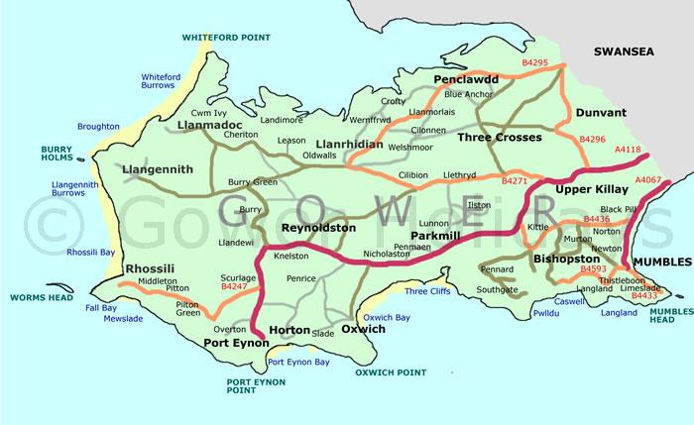
EXPLORE
We have a wide range of different trees and flowers, some left to grow naturally and some more cultivated. Plants are an essential resource, particularly needed to absorb carbon dioxide as we strive to reduce our carbon footprint. They also provide food and shelter for small animals, insects and birds. Page 5.
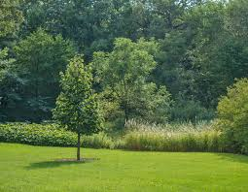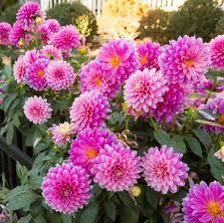
I saw many woodlice, ladybirds, bees, spiders, ants and butterflies. Some insects are more useful to us than others in the garden ecosystem. For example, bees are essential for pollination, without which plants cannot produce seeds for further growth. Butterflies also help with this and are a food source for other animals, like birds. Woodlice feed on plants that are decomposing and help with natural recycling.
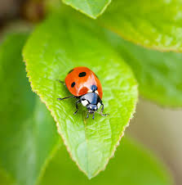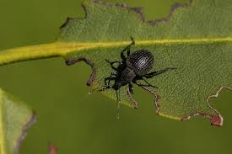
Birds, from the blue tit to the crow, nest in the trees and garden hedges. Whilst there are many insects and small animals for them to feast upon, we provide bird feeders too, to sustain the food supply for the smaller birds, with all the competition they face. Page 6.
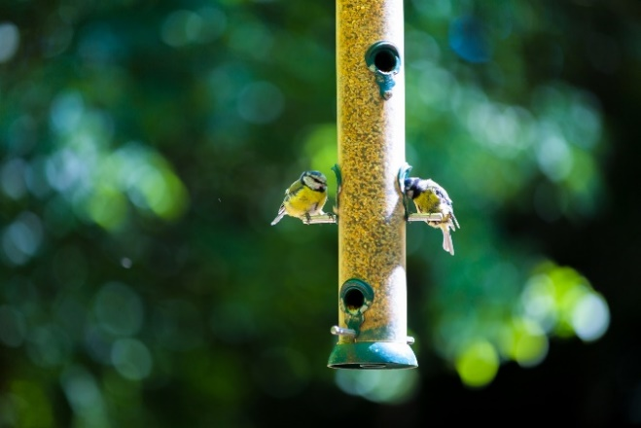
With spring well underway, the vegetables in the greenhouse and vegetable patch are now starting to develop. The insects and animals in the garden have food available to them naturally, but we need food too – beans, potatoes, onions, tomatoes and cucumbers, to name a few. By growing our own food, we are trying to be more sustainable. Page 9.
Some free-range chickens and ducks help themselves to our food waste and provide us with eggs, whilst their dung is used to fertilize the garden. Page 8.
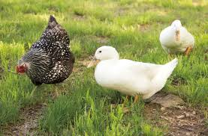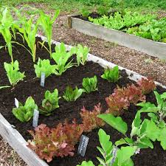
CONSERVE
Many of the things in the garden are reused to try to reduce waste and recycle, all important in sustainability. For example, some of the garden furniture has been made from discarded pallets.
To support conservation in the garden I made a bug hotel from a reused pallet, cutting it into smaller pieces and making different sections for different insects. I also made bird feeders, using used toilet roll bases, coated with peanut butter and seeds. It is particularly important to feed the birds during the winter when it is harder for them to find insects and the ground is hard. Pages 10 and 11.
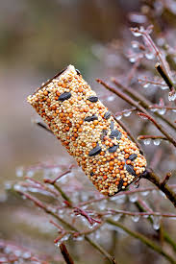
SHARE
It is very easy to take things for granted. Revisiting my garden and looking at it through the eyes of sustainability has made me look at it in a different way. The plants, animals and all of us are interdependent. Reusing a wooden pallet reduces the need to chop down another tree; leaving an area of the garden grow naturally lets the plants and insects thrive.
I hope you have enjoyed me sharing this experience with you and the scrapbook evidence that goes with it.
Second Part:
My aim in the second part of my presentation is to explore and critically evaluate the relevance of sustainability to early years education.
“Sustainability is our society’s ability to exist and develop without depleting all of the natural resources needed to live in the future.” Building systems that support sustainability, involving all groups, from local through to global, is known as sustainable development. (Coursera, 2024).
In 1987, the Brundtland report, entitled ‘Our Common Future’, was published. It defined sustainable development as “development that meets the needs of the present without compromising the ability of future generations to meet their own needs”. (European Union Law, no date found).
In 1992 a conference was held in Brazil that became known as the Earth Summit. Over 178 countries agreed to work together to protect the environment and help to make all people’s lives better. In 2015, after years of work, involving the United Nations, a global partnership was called for, involving all countries, to work urgently towards seventeen specific Sustainable Development Goals. These goals aim to reduce poverty, improve health, and address climate change. (United Nations, Department of Economic and Social Affairs, no date found).
According to Early Childhood Peace Consortium, (2024) Goal number four aims to develop learning that is lifelong and recognises the importance of early childhood development, noting that it is linked to many of the other goals.
According to Well-being of Future Generations (Wales) Act 2015, (2015) in 2016 the Well-being of Future Generations Act was embedded in Welsh law, recognising the many challenges ahead, including climate change and health. It requires all public bodies to work together in accordance with the principles of Sustainable Development, i.e. to make sure that present needs are met but that it does not compromise generations in the future from doing the same.
Education for Sustainable Development (ESD) aims to allow all learners to be able to work together on common global problems environmentally. (United Nations Laboratory of Ideas, 2023).
Education for Sustainable Development and Global Citizenship (ESDGC) is Wales’s application of the international ESD, and it is compulsory now for all state educators to apply this across all age groups, as well as respecting the United Nations Convention on the Rights of the Child. It has been important to acknowledge how much education and children impact on sustainability within any environment. Research carried out by Tinney, (2013) revealed may practical activities available to early years students, in response to ESDGC. These included making wildlife gardens, composting, and recycling to name a few, allowing children to participate in being citizens who care about their environment. (Understanding sustainability in early childhood education, 2018).

Teaching children in the early years about sustainability involves making them aware of what makes a society that is healthy and equitable. They need to be taught about how important it is to reduce our waste, and conserve our resources, to protect the environment. (The Curiosity Approach, 2024).
Strategies suitable for early years children successfully learning about sustainability and developing have been advocated by educational theorists like Froebel, Dewey, and Steiner.
Froebel, a German educator, introduced the term ‘kindergarten’. He said that children should experience nature “in all its aspects – form, energy, substance, sound and colour”. Froebel determined that playing outside in gardens and other natural areas helped children learn about how living things depend on one another. This is fundamentally linked to understanding sustainability. (The Froebel Trust, no date found).

According to Tovey, (2024) the idea of traditional teacher led learning was not accepted by Froebel and he saw play and practical activities, for early learners, as the best method for development of independent thinkers in a ‘child-led’ manner.
John Dewey, an American philosopher, also promoted a hands-on approach to education in his theory of “learning by doing”. (Monroe College, 2024).
He believed that children could develop their own understanding by exploring and interacting with their environments. (John Dewey's Theory, no date found).
A holistic theory of child development was promoted by Steiner, an Austrian. The Steiner approach places an emphasis on time spent outdoors because of the stimulation it can bring to all senses and because of how it can trigger imagination. Simple, natural resources like leaves and sticks can be utilised for play. (The Steiner Approach, 2019).
By exploring, the learning is ‘hands-on’ with self-discovery as the focus. (Monroe College, 2024).
The Early Years Foundation Stage Statutory Framework (EYFS) recognises that creativity is an important part of ESD and identifies three major areas for focus: playing and exploring, where children can try new things; active learning, encouraging children to concentrate and not give up on tasks; creativity and critical thinking, where children have the opportunity to develop their own ideas. A key goal is Understanding the World, where children can investigate their natural surroundings. (Early Years Sustainability Resource, 2024).
Natural environments, as a learning setting, enable children to develop a greater self-awareness and confidence. (Council for learning outdoors, 2023). Self-esteem, confidence, and independence are all enhanced by playing outdoors and children can attempt new activities. (NI Direct Government Services, 2024). Environments outside encourage physical activity and learning in a different environment. (Virtual Lab School, 2023).
ESDGC is about an ethos that is embedded in schools and learning, and schools are challenged with giving opportunities for children to investigate and understand the environment and wider issues. It is not a subject to be studied but is more about attitudes, understanding and values. (Welsh Assembly Government, 2008).
The John Muir Award scheme provides an opportunity within schools to develop their Education for Sustainable Development in a way that fully engages the child. The Award allows children to experience the outdoors in a semi-structured way that encourages conservation ideas, collection and sharing of their findings. Muir loved nature and, as well as trying to encourage people to look after it, he thought that it helped us develop in its surroundings. (John Muir Trust, 2024).
Participating in the Award myself, as discussed in part 1, enabled me to consider the impact it may have on a child and how it relates to ESD. The task was open ended, which could allow children of different ages to engage at various levels with different outcomes related to sustainability and provided practical learning opportunities for all. Instead of just ‘playing’, a purpose was set to pick an area and explain why it was chosen. There was a goal to explore which would raise awareness of surroundings. In this way, all children could have some access to learning from nature. The target to conserve provides the opportunity for children to think about what they can do to help maintain a specific part of their environment and could allow them to participate in ‘taking action’, as a global citizen. In these ways, the principles of the Award provide experiences to support the themes and aspirations of ESD.
Activities such as nature walks and trips to beaches etc provide other opportunities for ESD beyond school yards or fields but many present challenges. Risk assessments need to be in place, parents/carers need to understand the value of the activities to support them, and staffing ratios must be adhered to. Travelling further than about 20 minutes with early years children brings problems of travel sickness and toilet requirements. Exploration closer to base is much better but may not provide the range of options desired. (Early Education, 2021).
Problems have also been presented in trying to make links between ESDGC and the early years curricula for staff. Research revealed that a shortage of time made ESDGC delivery difficult in the early years sector. It also showed that some felt ESDGC was like an additional subject and that it may be too difficult for early years children to understand, despite it being about an ethos. Others thought that ESDGC was just to raise awareness of environmental issues and not linked to the holistic idea of sustainability, which is its aim. This has led to teacher training establishments highlighting the holistic basis of ESDGC. (Early Years Education and ESDGC, 2018).
Some consider that the John Muir Award is more linked with the environment than the holistic side of sustainability and the trust themselves promote that fact. They also state that the Award is probably more suited to children older than early years. (John Muir Trust, 2024).

CONCLUSION AND SUMMARY
Our planet and people are in trouble. Natural resources are being used up faster than they can be replaced. Ecosystems are being destroyed. Global warming is causing ice caps to melt and sea levels to rise. We need to look after the Earth in a way that ensures that it can provide a continuing habitat for us all. Poverty is extreme in some places and there is not equal access to health and education.
Much research has been done and policies put in place to try to secure our futures. The Well-being of Future Generations Act in Wales, and the implementation of Education for Sustainable Development ensure that children from an early age are brought up with the common goals for Sustainable Development. Whilst applying this across the Curriculum may present a few problems it is essential and not without solutions.
The John Muir Award is just one way of raising awareness for sustainability. Although environmentally based, it is a wonderful place for early years children to begin and enjoy. Despite being more ideal for the slightly older child, they can still share their findings through pictures and talking. The approach to learning encouraged by the Award is supported by theory from past educationalists like Froebel, Dewey and Steiner.
If sustainability is both a local and global aim, involving all people, then it makes sense that its concept is introduced at an early age so that it can become a way of life.

Reference List

Coursera. (2024) ‘What Is Sustainability?’. Available at: https://www.coursera.org/articles/what-is-sustainability (Accessed: 20th May 2024).

Council for learning outdoors. (2023) ‘Council for Learning Outside the Classroom Evidence Note Learning Outside the Classroom: in natural environments’. Page 4. Available at: https://www.lotc.org.uk/wp-content/uploads/2023/02/Summary-of-Evidence-LOtC-in-Natural-Environments-Nov-2022.pdf (Accessed: 24th May 2024).

Early Childhood Peace Consortium. (2024) ‘Sustainable Development Goals’. Available at: https://ecdpeace.org/work-content/2030-sustainable-development-goals#:~:text=It%20is%20also%20time%20to,school%20performance%2C%20and%20adult%20income. (Accessed: 23rd May 2024).

Early Education. (2021) ‘Making trips out meaningful’. Available at: https://early-education.org.uk/making-trips-out-meaningful/ (Accessed: 25th May 2024).

Tinney, G. (2018) ‘Early Years Education and Education for Sustainable Development and Global Citizenship’. Available at: https://repository.uwtsd.ac.uk/id/eprint/912/1/Tinney,%20Glenda%20and%20Merriman,%20Eileen%20(2018)%20Early%20years%20education.pdf (Accessed: 24th May 2024).

Early Years Sustainability Resource. (2024) ‘An Early Childhood Education for Sustainability resource that embeds the Sustainable Development Goals and STEM into pedagogical practice’. Page nine and ten. Available at: https://www.ncfe.org.uk/media/xbcbjrfj/early-years-sustainability-resource.pdf (Accessed: 24th May 2024).

European Union Law. (No date found) ‘Sustainable Development’. Available at: https://eur-lex.europa.eu/EN/legal-content/glossary/sustainable-development.html#:~:text=Sustainable%20development%20was%20first%20defined,to%20meet%20their%20own%20needs'. (Accessed: 22nd May 2024).

Future Generations Commissioner for Wales. (2024) ‘Well-being of Future Generations (Wales) Act 2015’. Available at: https://www.futuregenerations.wales/about-us/future-generations-act/#:~:text=The%20Future%20Generations%20Act%20defines,out%20five%20ways%20of%20working (Accessed: 22nd May 2024).

Dewey, J. (No date found) ‘John Dewey's Theory: Reforming Education Through Experiential Learning’. Available at:https://elearningindustry.com/john-deweys-theory-reforming-education-through-experiential-learning (Accessed: 24th May 2024).

John Muir Trust. (2024) ‘Award Suitability’. Available at: https://www.johnmuirtrust.org/john-muir-award/get-involved/award-suitability (Accessed: 25th May 2024).

John Muir Trust. (2024) ‘About John Muir’. Available at: https://www.johnmuirtrust.org/about-us/about-john-muir#:~:text=Muir%20believed%20visiting%20wild%20places,people%20to%20care%20for%20it. (Accessed: 24th May 2024).

John Muir Trust. (2024) ‘Families and self-guided participants’. Available at: https://www.johnmuirtrust.org/john-muir-award/get-involved/families-and-self-guided-participants (Accessed: 24th May 2024).

John Muir Trust. (2024) ‘Sustainability’. Available at: https://www.johnmuirtrust.org/assets/000/001/082/Sustainability_Resource_Guide_2019_original_original.pdf?1610652302&1565009528#:~:text=The%20John%20Muir%20Award's%20Conserve,enjoying%20nature%2C%20people%20are%20more (Accessed: 20th May 2024).

Monroe College. (2024) ‘Early Childhood Education History: Theorists and Theories’. Available at: https://www.monroecollege.edu/news/early-childhood-education-history-theorists-theories#:~:text=Learning%20by%20Doing%20%E2%80%93%20Bank%20Street%20%7C%20John%20Dewey&text=In%20these%20preschools%2C%20the%20child,%2C%20puzzles%2C%20and%20building%20blocks. (Accessed: 23rd May 2024).

NI Direct Government Services. (2024) ‘Playing Outdoors’. Available at: https://www.nidirect.gov.uk/articles/playing-outdoors#:~:text=Playing%20outdoors%20allows%20children%20to,try%20new%20activities (Accessed:24th May 2024).

The Curiosity Approach. (2024) ‘Sustainability in Early Years’. Available at: https://www.thecuriosityapproach.com/blog/sustainability-in-early-years#:~:text=In%20the%20early%20years%2C%20sustainability,a%20healthy%20and%20equitable%20society. (Accessed: 22nd May 2024).

The Froebel Trust. (No date found) ‘Froebel’s theory’. Available at: https://www.froebel.org.uk/training-and-resources/children-and-nature (Accessed:24th May 2024).

The Steiner Approach. (2019) ‘Steiner’s theory’. Available at: https://theeducationhub.org.nz/wp-content/uploads/2020/08/The-Steiner-approach-1.pdf (Accessed: 24th May 2024).

Tovey, H. (2024) ‘Froebel’s principles and practice today’. Page four. Available at: https://www.froebel.org.uk/uploads/documents/FT-Froebels-principles-and-practice-today.pdf (Accessed: 23rd May 2024).

Understanding sustainability in early childhood education. (2018) ‘Early Childhood Education’. Available at: https://read.kortext.com/reader/pdf/496294/104 (Accessed: 25th May 2024).

United Nations, Department of Economic and Social Affairs. (No date found) ‘Department of economics’. Available at: https://sdgs.un.org/goals (Accessed: 24th May 2024).

United Nations Laboratory of Ideas. (2023) ‘What is education for sustainable development?’. Available at: https://www.unesco.org/en/education-sustainable-development/need-know#:~:text=I%20get%20involved%3F-,What%20is%20education%20for%20sustainable%20development%3F,use%20of%20resources%2C%20and%20inequality. (Accessed: 23rd May 2024).

Tovey, H. (2024) ‘Froebel’s principles and practice today’. Page 4. Available at: https://www.froebel.org.uk/uploads/documents/FT-Froebels-principles-and-practice-today.pdf (Accessed: 23rd May 2024).

Virtual Lab School. (2023) ‘The Outdoor Environment: Designing for Learning’. Available at: https://www.virtuallabschool.org/school-age/learning-environments/lesson-3#:~:text=The%20purpose%20of%20an%20outdoor,in%20a%20variety%20of%20environments. (Accessed: 24th May 2024).

Well-being of Future Generations (Wales) Act 2015. (2015) ‘Well-being of Future Generations (Wales) Act 2015’. Available at: https://www.futuregenerations.wales/wp-content/uploads/2017/01/WFGAct-English.pdf (Accessed: 22nd May 2024).

Welsh Assembly Government. (2008) ‘Education for Sustainable Development and Global Citizenship A Common Understanding for Schools’. Available at: https://hwb.gov.wales/api/storage/eaf467e6-30fe-45c9-93ef-cb30f31f1c90/common-understanding-for-school.pdf (Accessed: 25th May 2024).

