

Name: Hafeezur Rehman
Student ID: 2435516
Module: Employability and Career Development
Table of Contents
Job Advert 3
Cover letter 6
Curriculum Vitae 8

Job Advert
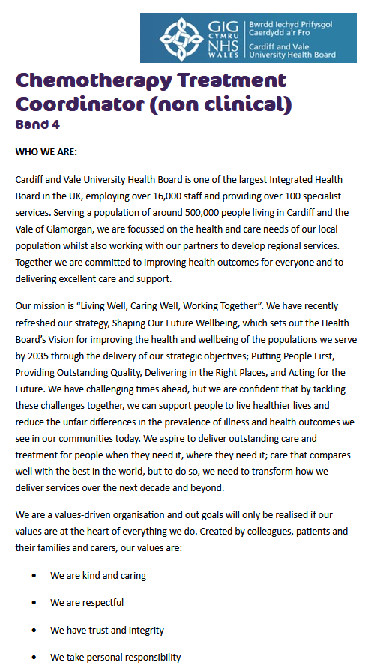
Figure 1: The job and the Organization
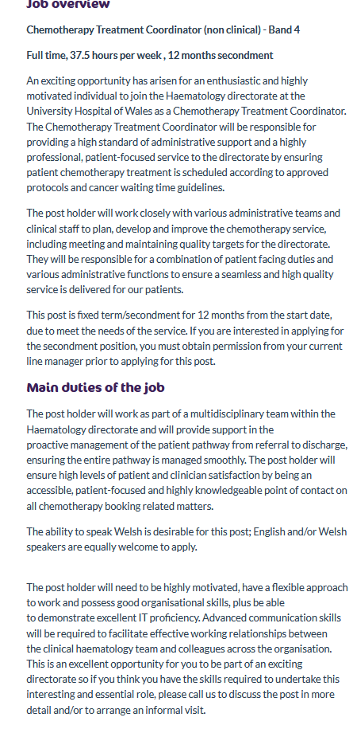
Figure 2: Job Overview
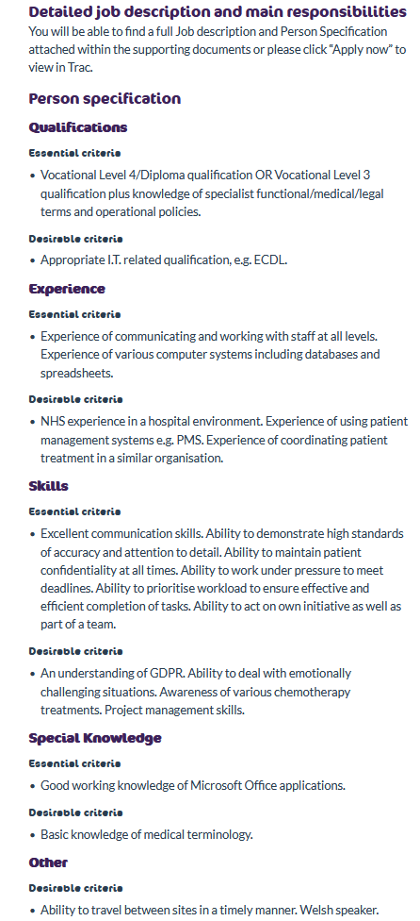
Figure 3: Person Specifications

Cover letter
Hafeez Ur Rehman
Birmingham, United Kingdom
07737 496652
Hafeez126@hotmail.com
[Date]
Dear Hiring Manager,
I would like to apply for a role within Cardiff and Vale University Health Board as a Chemotherapy Treatment Coordinator (non clinical). I'm interested in this role because it is a combination of patient support, administration and communication in a healthcare environment, all of which I have extensive experience of in my career.
I have been a Freelance Interpreter for a number of years in NHS healthcare appointments, GP consultations, social services, home visits and police interviews. This has deeply impressed me with the importance of accuracy, confidentiality and professionalism in handling sensitive information. It has also given me the opportunity to be able to communicate well with others, be steady in times of pressure and serve them in a respectful, patient manner.
Additionally, I have experience in management and operations as an Assistant Manager at Starbucks, where I assisted in daily operations, trained and supervised employees, monitored stock levels and ensured that the service provided to customers was of high quality. This experience helped me to develop my organisation, attention to detail and efficient working in a busy environment. My time management, reliability and prioritising skills have also been enhanced by my role as a Delivery Rider, more recently.
I think that these skills will be applicable to the Chemotherapy Treatment Coordinator job, as it involves ensuring a smooth path for the patient, communication with clinicians and colleagues and keeping accurate records. I am confident in my ability to work in a fast pace environment and to use computers and understand the importance of being reliable, friendly and adaptable when service requirements change.
I would be happy to join your team with my experience, work ethic and quality care. I appreciate your consideration in my job application. I am looking forward to discussing my suitability further.
Yours sincerely,
Hafeez Ur Rehman

Curriculum Vitae
HAFEEZ UR REHMAN
ASSISTANT MANAGER
Birmingham, United Kingdom | +44 7737 496652 | Hafeez126@hotmail.com
PROFILE SUMMARY
Professional and reliable Freelance Interpreter with extensive experience supporting patients and professionals within the National Health Service. Experienced in medical, social services, and police settings, ensuring accurate, confidential, and culturally sensitive communication. Multilingual and highly adaptable, with a strong understanding of safeguarding, confidentiality, and equality principles.
EXPERIENCE
Delivery Rider 2022 – Present
- Responsible for collecting the correct order from the merchant, maintaining its temperature/condition during transit, and delivering it to the correct customer promptly.
- Strategically positioning myself in busy restaurant zones during peak hours (breakfast, lunch, dinner) to maximise order frequency and minimise wait times.
Freelance Interpreter 2009 - Present
Provide interpretation services for:
- NHS healthcare appointments
- Social Services
- Police interviews
- GP consultations
- Home visits
- Ensure accurate, confidential, and culturally sensitive communication Support clients in high-pressure and sensitive environments.
Assistant Manager Starbucks | 2004 – 2009
- Lead and supervise daily store operations and shift management
- Manage, train, and support team members to deliver high performance
- Oversee stock control, ordering, and inventory management
- Ensure excellent customer service and compliance with company standards
- Handle cash management, reporting, and operational procedures
Manager New Linkers International | 1997 – 2003
- Managed office operations and supervised a team of 5 staff
- Coordinated export processes and international logistics
- Maintained client relationships and ensured timely shipment handling
- Oversaw administrative systems and workflow efficiency.
EDUCATION
- GCSEs (1997)
- Delia Memorial School, Hong Kong
SKILLS
- Excellent verbal communication skills
- Professional ethics and impartiality
- Time management and reliability
- Team collaboration with healthcare professionals
Certificates
- Health and Safety Certificate
- First Aid Certificate
LANGUAGES
- English (C1 -Advanced)
- Cantonese
- Urdu
- Pushto

