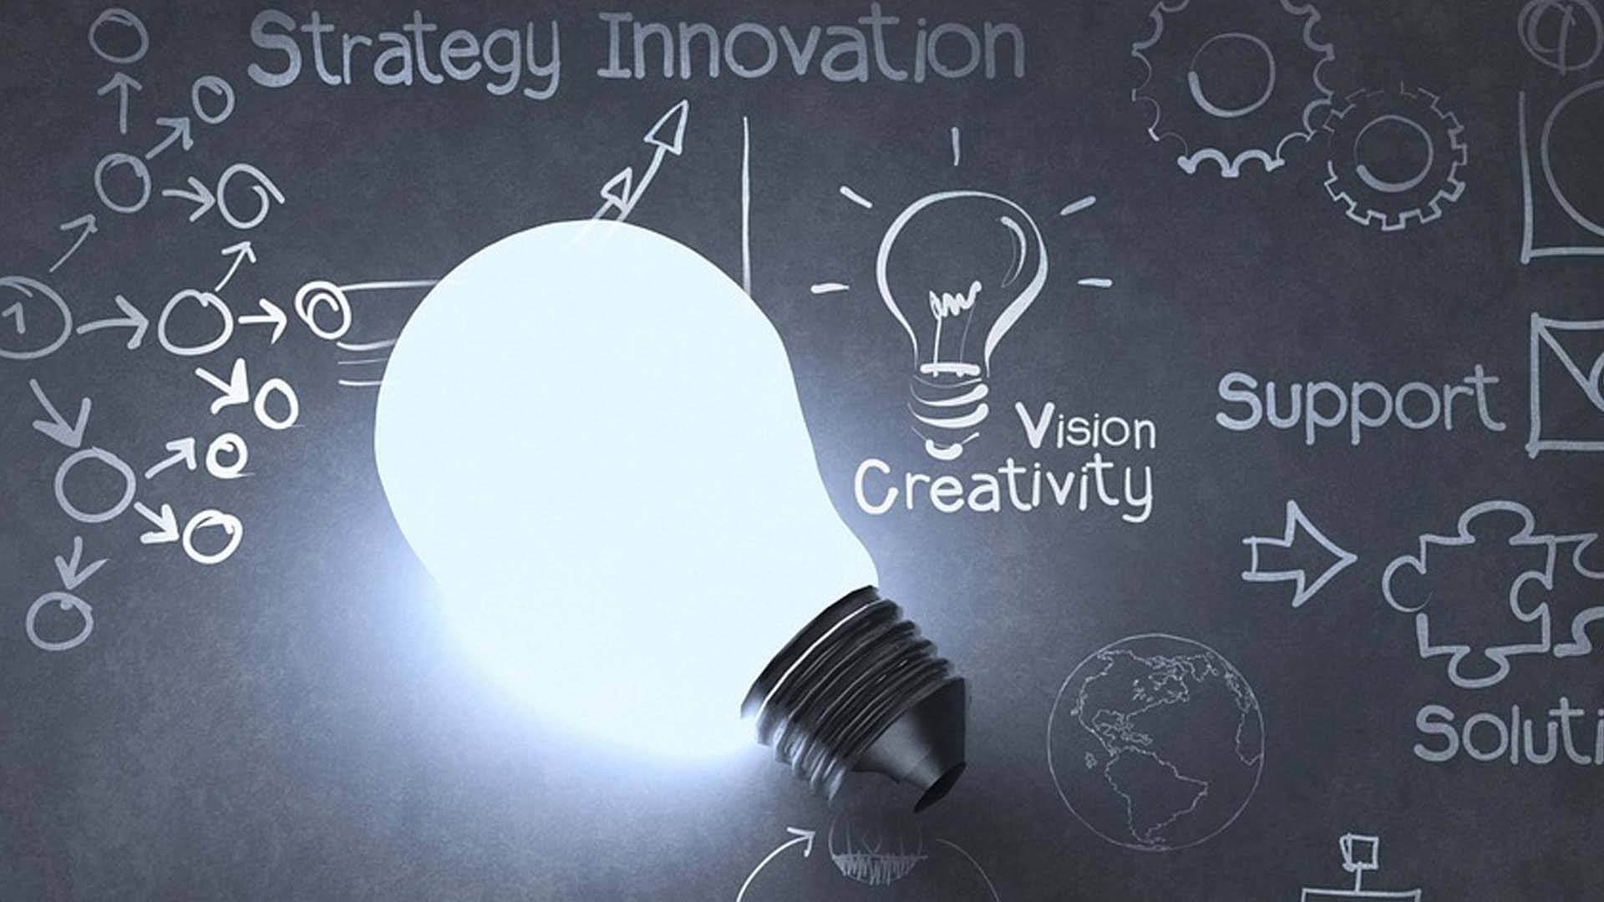
  - CHANGEMAKERS: creativity and value creation
  - Portfolio – Assignment one
Sarah Carr | BA Business Management | November 2022
Student ID - 2107448
Assignment one – Portfolio

Contents Page

Page 3 – Mind Map
Page 4 – Mind Map References
Page 5 – Written Summary
Page 6 – Written Summary References
Page 7 – Flyer
Page 9 – Flyer Elevator Pitch Link and References
Page 10 – Poster
Page 11 – Poster References

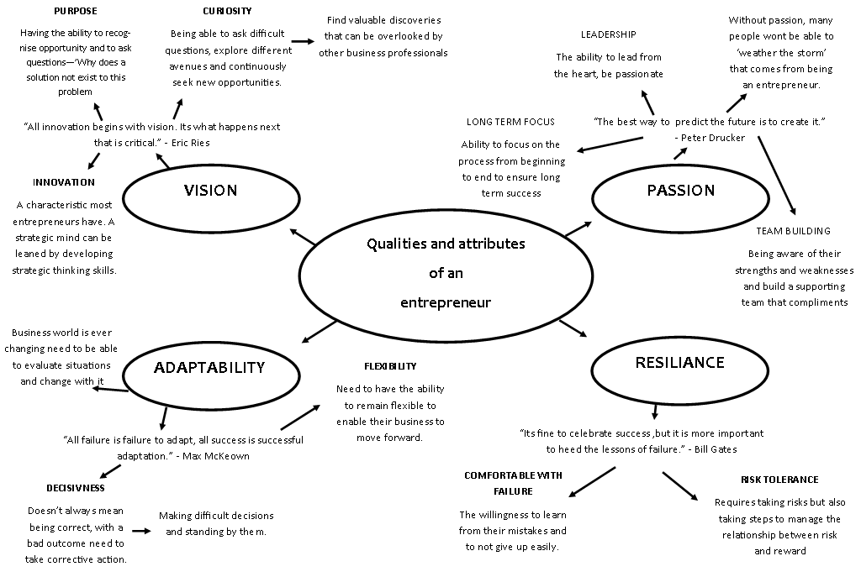
Mind Map References
Word count – 288 words
Carlson, N. (2012, November 24). 20 quotes that reveal how Bill Gates became the world’s richest man. Retrieved November 20, 2022, from Business Insider: https://www.businessinsider.com/bill-gates-quotes-2012-11?r=US&IR=T
Drucker Institute. (2011, May 24). Joe's Journal: On creating the future. Retrieved November 20, 2022, from Drucker Institute: https://www.druckerinstitute/thedx/joes-journal-on-creating-the-future/
McKeown, M. (2012, March 12). All failure is failure to adapt. Retrieved November 20, 2022, from Management-Issues: https://www.management-issues.com/opinion/6435/all-failure-is-failure-to-adapt
McLaughlin, M. (2022). The four character traits of entrepreneurs. Retrieved November 20, 2022, from McLaughlin: https://www.mclaughlinpc.com/blogs/the-four-character-traits-of-entrepreneurs
Miller, K. (2020, July 7). 10 Characteristics of successful entrepreneurs. Retrieved November 13, 2022, from Harvard Business School: https://online.hbs.edu/blog/post/characteristics-of-successful-entrepreneurs
Strategies for influence. (2022). Eric Ries - The lean start up. Retrieved November 20, 2022, from Strategies for influence: https://strategiesforinfluence.com/eric-ries-the-lean-startup/

Written Summary
We have had entrepreneurs since the ancient times. Before the industrial revolution changed the world people took big risks by conducting distant trades, possibly across continents in order to produce and receive goods that they needed. Within recent years companies like Apple, Microsoft and Google are changing the way we live our life, and this is particularly down to Entrepreneurs looking to create prosperity for themselves and society.
Drucker says that ‘The entrepreneur always searches for change, responds to it and exploits it as an opportunity’ REF. Entrepreneurship isn’t for everyone. At the core entrepreneurs are responsible for developing economies by creating new products, services, and production methods. Many entrepreneurs are driven by the thought of making lots of money, but true entrepreneurs are motivated by the desire to be recognised as a leader in a specific field. By sharing their knowledge and engaging other with their ideas.
One of the best benefits of being an entrepreneur is the money you can make. If your idea, product, or service is a hit you can be paid for the value of your idea and gain financial freedom and also the ability to financially help yourself and those closest to you. Many entrepreneurs have had difficult times in their past whether it be at school, work or at home dealing with authority. The freedom that comes with being your own boss is a preferable outcome for many rather than taking orders from other people. This allows them to decide on the big decisions, how long they want to work and who they want to work with. By working for themselves they are able to decide who will inspire them to work harder and contribute to their best ideas to your business.
Being an entrepreneur not only benefits the person but also society as a whole. By producing a new product or service they are contributing to the economy by increasing economic growth and job creation. The economic advancements has resulted in entrepreneurs finding new ways to supply new better or cheaper goods and services providing better options for the consumer and improving their way of life. The development of a successful business aids the entrepreneur to earn an increased revenue and profit, which contributes to society through taxes, charitable donations and the possibility of expansion and more jobs for the community.
Companies like The Co-operative in the UK, started with one mans idea of fairly priced food for everyone, have now become a Nationwide business. The Co-operative Food is a company that thrives on giving back to the local communities that they are in. They do this by donating to local food banks, community project grants and using their customers to earn and donate a small amount of their member rewards to worthy causes in their area.
Summary word count - 465
Summary References
Business and Fnance. (2018, August 4). Advantages of entrepreneurship make it a great choice in spite of the risks involved. Retrieved November 23, 2022, from Business and Finance: https://businessandfinance.expertscolumn.com/advantages-of-entrepreneurship
The Co-operative. (2021). Communities. Retrieved November 18, 2022, from The Co-op: https://www.coop.co.uk/communities
Seth, S. (2021, March 4). How entrepreneurship affects the economy. Retrieved November 18, 2022, from Investopedia: https://www.investopedia.com/articles/personal-finance/101414/why-entrepreneurs-are-important-economy.asp
Surkin, R. (2016, September 7). This is what entrepreneurs need to thrive . Retrieved November 18, 2022, from World Economic Forum: https://www.weforum.org/agenda/2016/09/this-is-what-entrepreneurs-need-to-thrive/

Flyer – side 1
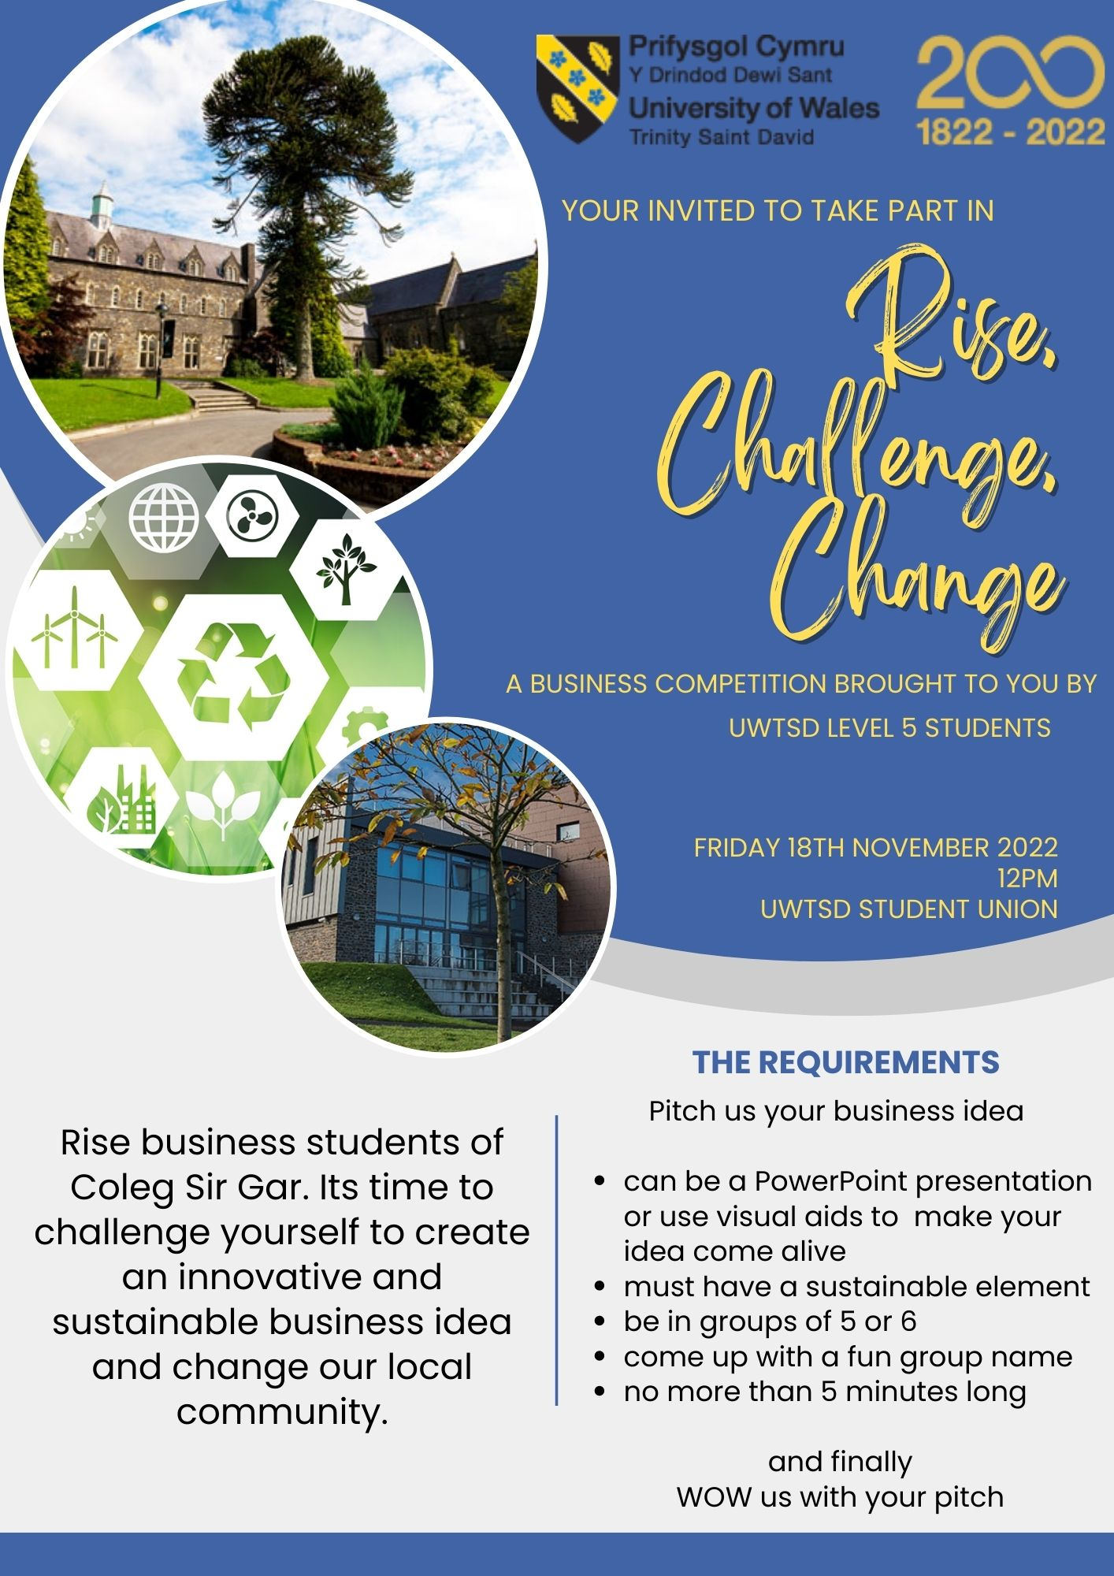
Flyer – side 2
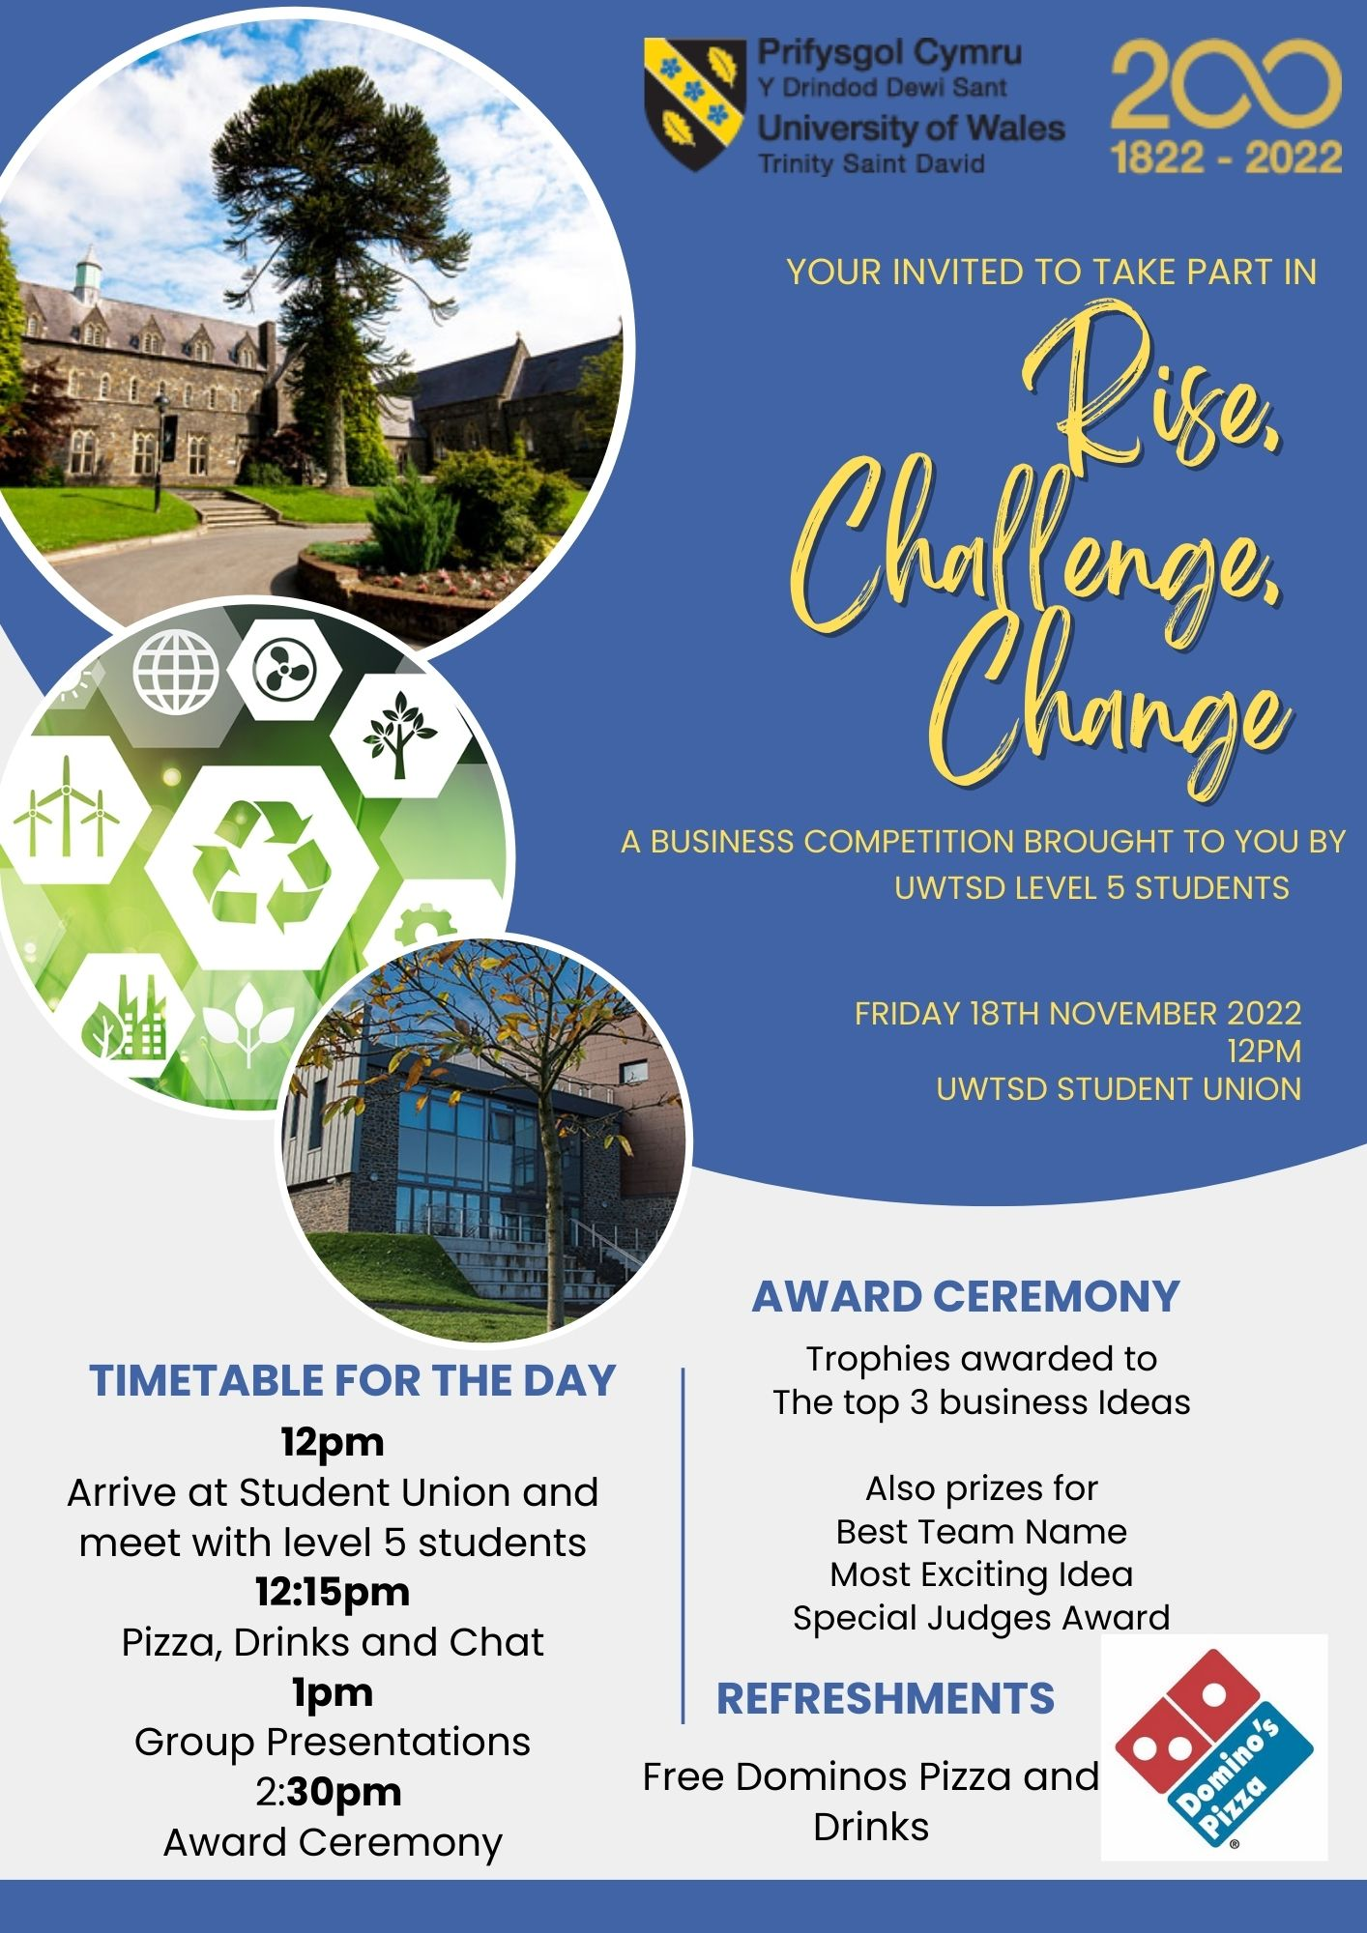

Link to elevator style pitch
https://uowtsd-my.sharepoint.com/:p:/r/personal/2107448_student_uwtsd_ac_uk/Documents/Flyer%20elevator%20pitch.pptx?d=w9609cd905ab942088f1f560509a2cd6a&csf=1&web=1&e=fyW0yo

Flyer References
University of Wales Trinity StDavid. (2022). UWTSD at the heart of Carmarthen. Retrieved November 20, 2022, from UWTSD: https://www.uwtsd.ac.uk/
Francis, M. K. (2021, March 21). Sustainability 101 what does it all mean. Retrieved November 20, 2022, from MS Consultants: https://www.msconsultants.com/sustainability-101-what-does-it-all-mean/

Poster
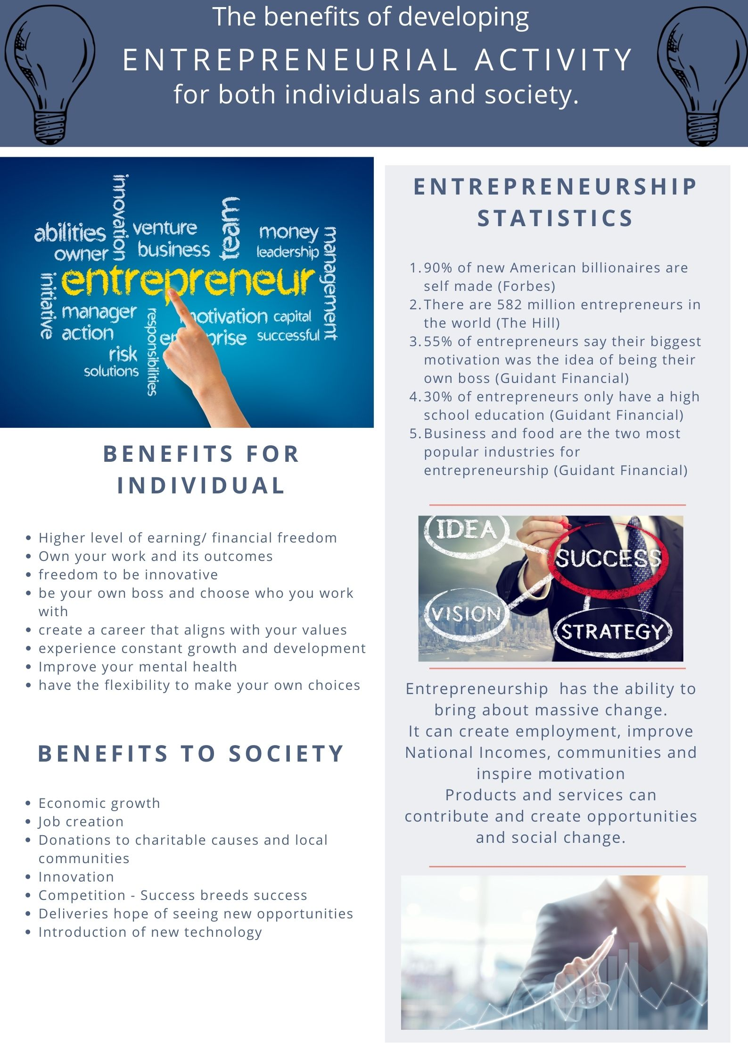
Poster Reference
Lynn, S. (2022, February 4). 7 benefits of Entreprenurship to the community. Retrieved November 25, 2022, from itzinya: https://www.itzinya.org/blog/7-benefits-of-entrepreneurship-to-community/
Rose, J. (n.d). 10 suprising benefits of being an entrepreneur. Retrieved November 25, 2022, from Journal How: https://journalhow.com/benefits-of-being-an-entrepreneur/#:~:text=10%20benefits%20of%20being%20an%20entrepreneur%201%201.,You%20can%20improve%20mental%20health%20...%20More%20items
Simovic, D. (2022, July 28). 39 entrepreneur statistics you need to know in 2022. Retrieved November 25, 2022, from Small business stats and facts: https://www.smallbizgenius.net/by-the-numbers/entrepreneur-statistics/#:~:text=Fascinating%20Entrepreneurship%20Statistics%3A%201%2090%25%20of%20new%20American,businesses%20fail%20within%20the%20first%20year.%20More%20items
Trenchard, R. (2015, November 17). What impact do entreprenuers have on society? Retrieved November 25, 2022, from Virgin: https://www.virgin.com/about-virgin/latest/what-impact-do-entrepreneurs-have-society

Figure 1 – available at https://www.freelionaire.com/4-characteristics-successful-entrepreneurs/
Figure 2 – available at https://berkshirebsa.com/planning-for-business-success-in-2020/
Figure 3 – available at https://www.smallbusinessconnection.com/5-traits-of-a-successful-entrepreneur/

