ASSESSMENT SPECIFICATION

ACCA5023

COMPONENT 1

REPORT

NAME: Vladimir Quansah

STUDENT ID : 2419110

Task1

- Research on Hypervisor:

When it comes to hypervisor it’s an software that allows several virtual machine also called VMS for short to run on physical computer like a laptop or desktop the virtual machine act like separate computers even though you can share the same hardware they can be two main type of hyper visor type 1 the host/client type 2 the server also known as bare the metal and the hosted and that depends on the systems in the hardware [1].

First, we need to identify the type 1 and server roles when the hypervisors are directly on the physical machine, without requiring a separate operating system. After we download the enterprise client and server, we can proceed. For this, the server 2022 topology is used when we run the hypervisor. The system needs a 64-bit processor with virtualisation support. This is very important because the machine requires at least 16 GB of RAM, or at least 8 GB, to run, which is recommended and sufficient [2]. The main advantage is that it provides strong security isolation, which improves performance and efficiency when running the server. In that case, we are running a GUI, for example. Another reason is that efficient resource management and features such as live migration and failover (e.g., clustering) are available. This means it provides an overall view or an ideal for business, where reliability and data protection can be important [3].

Furthermore, when it comes to Debian, it's kind of different work, similar, but it works with no GUI and works with Linux, so with commands. Regarding its servers, it supports virtual environments and uses Linux commands to operate them. Debian generally has lower hardware requirements because it doesn’t require a full GUI, making it quite lightweight and stable. It can also be a type 2 solution, like VirtualBox, for testing purposes [3], [4]

Overall, the type 1 hypervisors, such as Hyper-V, are better suited for enterprise use, while Debian offers a flexible and cost-effective virtualisation option
I will consider Windows 22 more suitable for the domain because, based on the domain's enterprise needs, I think it can integrate directly with Active Directory and is designed for management. Even though the hardware can be limited for Debian, it still may be more practical due to its lower system requirements and its lightweight performance overall [5]

- Research on IP Addressing:

IP addresses are very important to us; we use them daily when connecting to the internet on our phones, even when we click on a website or go to Netflix. The computer solution identifies what we need to connect: our IP address to theirs. The fundamentals component knows the protocol allow to connect to the network assigned a unique IP address

IP addresses enable routing within networks. What this essentially means is that the route has to be identified enabling routing of our location of our devises routers this determine the best path for the data packets to travel between the router and the device for the networks this will essentially improves its efficiency given us users reduces congestion and ensure efficient communication the IP address also supports subnetting what that means it can all the large networks to be divide Into smaller networks by taking the bits making it smaller segments to ensure better performances and security of the network[6]

IPv4 and IPv6 use different address formats, and it's important to understand what they do and how they are used. IPv4 uses a 32-bit address format. This writing uses decimal notation because computers only know 0 and 1, but in this case, the decimal point is part of the number. For example, it can be 192.186.11, which means it has been divided, and when they are divided into four decimal the range can be from 0 to 255, and it all ways will always be that rule; however, due to IPv4 being smaller group it can grow rapidly growth of the internet for connected device which can be come limited which is why IPv6 come in play [7]

Furthermore, IPv6 addresses solve that limitation for users because they are 128 bits long, which is much longer than IPv4 addresses. When it came to IPv6, it had a larger address space, and it improved its security features and became more efficient in routing since IPv6 uses hexadecimal, which makes it a larger number [8]

In conclusion, IP addresses are essential for communication, organisation, and scalability in modern networks. For this reason, we constantly collect data and access the network; many users do the same. It is very important for the IP address to come into play and help us configure what networks

- Research on Routing:
The routing process allows data to travel between different networks. Topology tells us there are two different networks. For example, Birmingham has 172.16.1.0/24, and the London one has 172.16.2.0/24 this mean that they are connected through the router networks 10.0.0.0/30 the router essentially mean the router are necessary because the devices from Birmingham need to communicate with device to communicate with London and one the ways to do that is connecting with internet because with the routing the communication would be limited this why we needs a best performance connecting the Birmingham and London [9]

Furthermore, routing protocols help routers decide the best path to send data. Their main priority is to ensure the information reaches the other devices, so in this case its London to Birmingham or the other way around. Dynamic routing protocols automatically share routing information between routers; they usually calculate the best route. The dynamic routing essentially allows automatically learn each other's networks and makes small changes if the connection fails[10]

Static routing, however, is manually configured by the network. This means that administrators, in this case, Birmingham router, could be manually set to send traffic through the interface of the static routing, which essentially does this; it gives full control, but it does not adapt automatically if the network changes[11]

Overall, the main difference is flexibility. The static routing works well in small, stable networks, while dynamic routing is better suited for larger, more complex networks, which helps [12]

- Research on Network Services: (Maximum: 250 Words)
VPNS allows user to securely access their private network over the internet this very useful and can be important because for like remote workers who need access to company system and make sure not any outsider can interrupt in their private files or document and they can access the system from home with very useful instead staying at home office one of the main features is that VPN are like encryption so it hard to find the device and location and hide its user browsing the internet which can protect them from the data for this example the like accessing their companies another way protecting data is that VPN can be use as authentication methods as well to verify the user before granting access this can ensure the users that be authenticated and can connect to the Internal network [13]

In DHCP, IP addresses are automatically assigned to devices on the network. This can be useful; you don’t have to do it manually because it’s set up automatically on each computer. For example, it provides the IP address and subnet mask, and when the DNS settings are already automatic, the key features are that it already has automatic address allocation, which makes the user network management for users easier and reduces configuration errors[14]

Furthermore, in Active Directory, Domain Services provide control over users, computers, and resources within the network domain. It will allow the administrator to create user accounts, manage passwords, and apply group policies to control access permissions within the domain. One of the key advantages of that centre authentication meaning users can log in once and access multiple network resources securely[15]

Overall, VPN and DHCP improve security quality and efficiency, and it centres the management in modern enterprise networks

Task 2

Word Limit: 1250 words equivalent

Deliverables
- Report: Technical Documentation – 50 Marks Maximum

The aim of this document is to configure the VirtualBox network topology for Debian servers with dual interfaces, providing LAN and WAN connectivity. The Windows client resides on the same internal LAN subnet. When doing this, we need to have the correct Ip address and adapter configurations, and enable successful communication with both clients, which is why we ping each other, to verify them ping testing

  - Choose your Hypervisor: Based on the above research, justify with concrete evidence and strong statements that influenced your choice of hypervisor to complete this network.
For below Tasks:
Note: The timestamp must show that the task was completed regularly, rather than as last-minute work, to be considered excellent.
Note: Without a timestamp in the screenshots submitted for task 2.2, “Time Management, Planning, Exercise of personal responsibility and decision-making, complete tasks and procedures” will be marked zero.
  - Download and Setup:
    - Download the chosen Hypervisor and Server, Client Operating Systems for the relevant Sources. Evidence for downloading from relevant/ appropriate resources will be considered as exceptional work
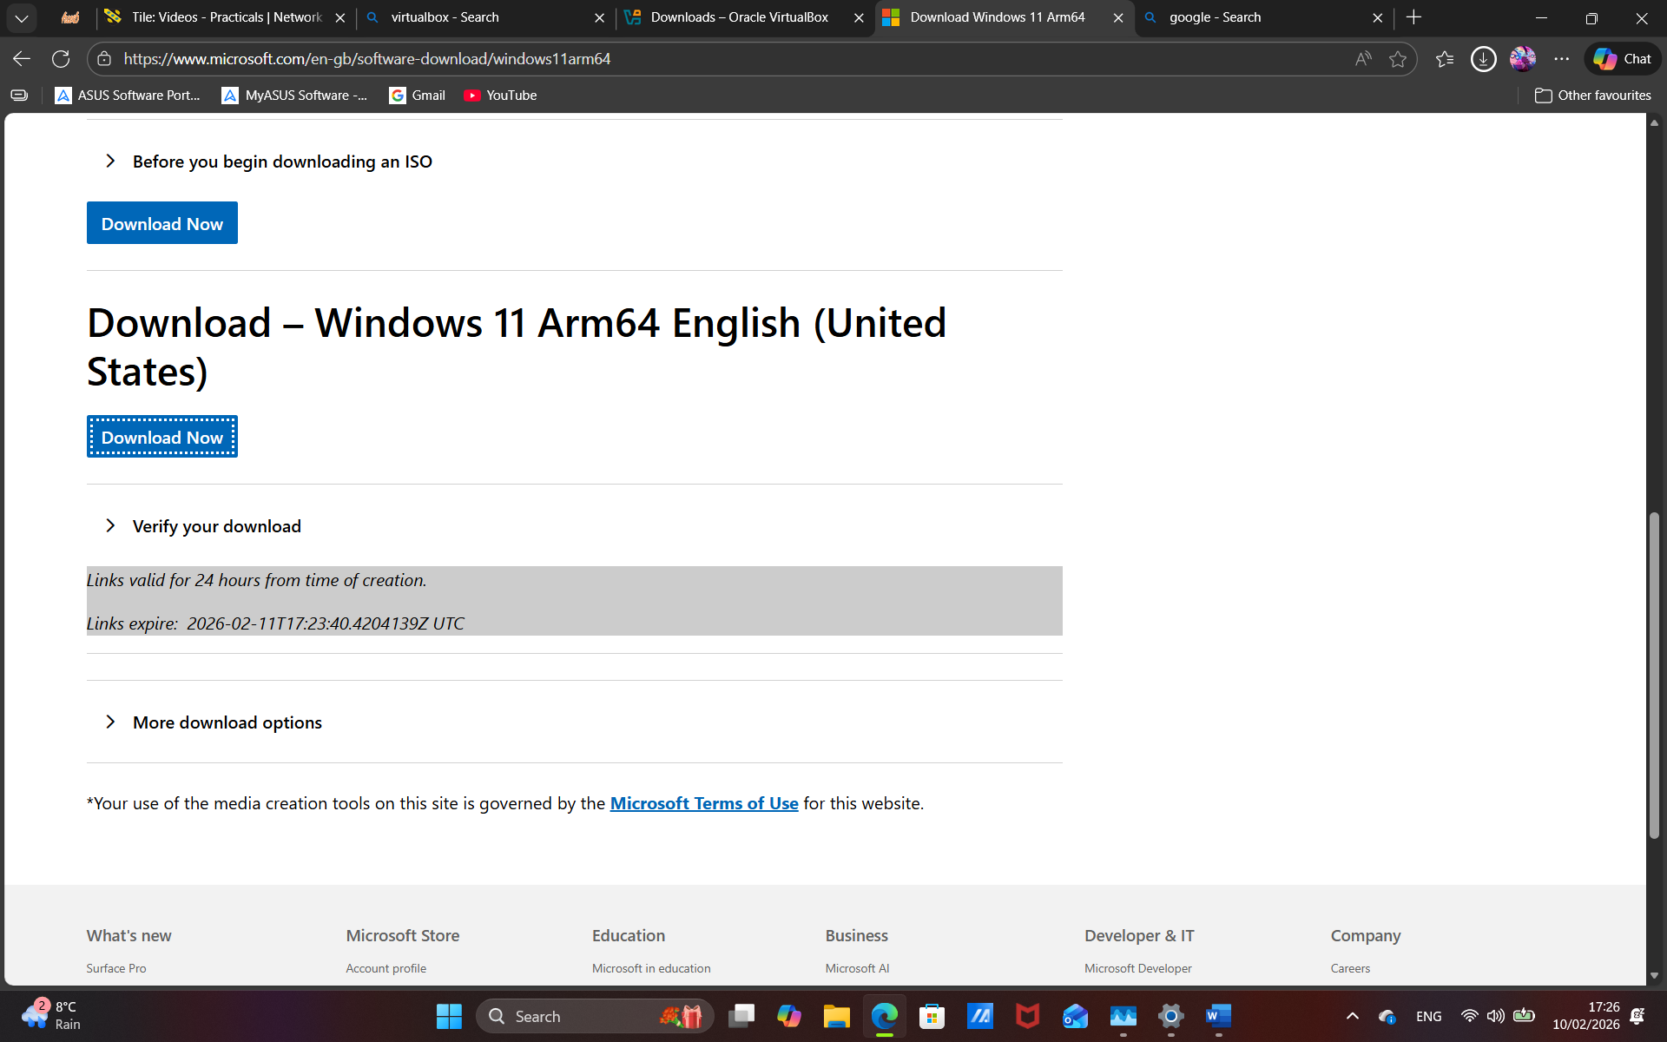
The hypervisors I will be using are Windows Client and Server 22 and Debian Client, but before downloading the VirtualBox, this software will allow me to operate these servers and client

This second step of downloading the iso and client for my Windows server allows me to apply and use it as the iso image once it is downloaded and used in the virtual box

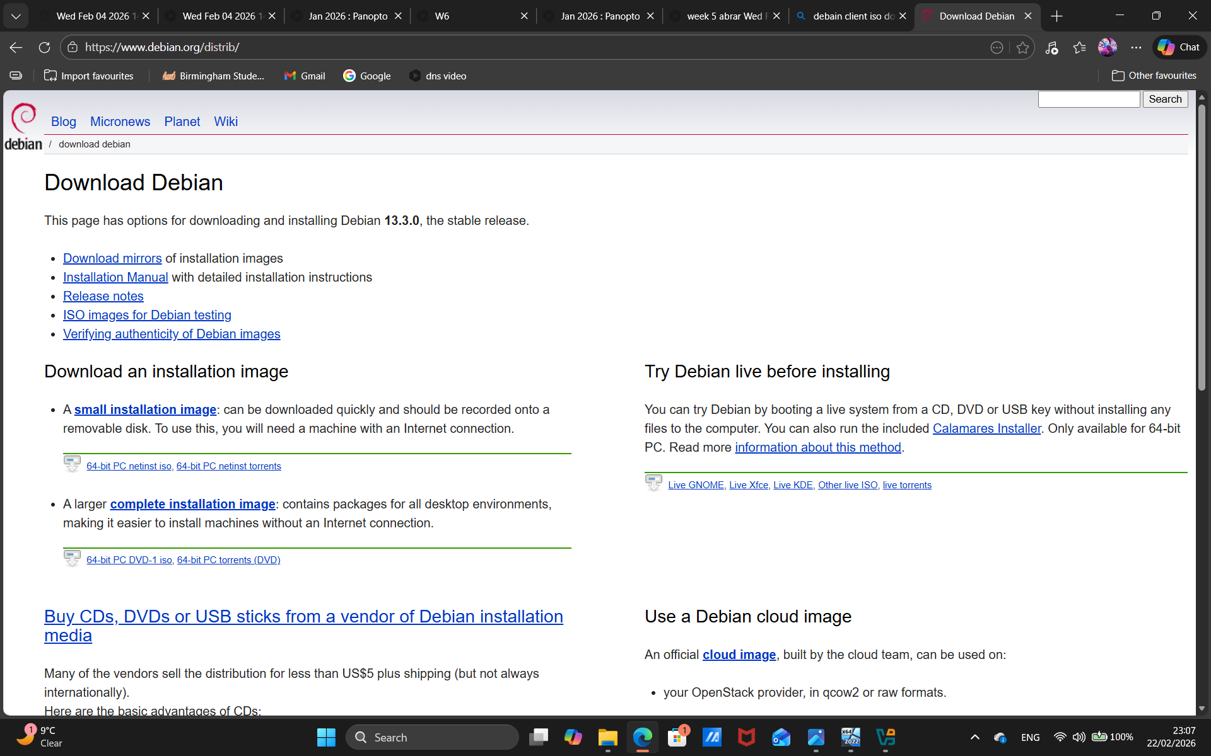

This Debian server and iso page allows me to download and use for iso images and apply them in my virtual box for further steps that will be done later, like ping and configuration between the two

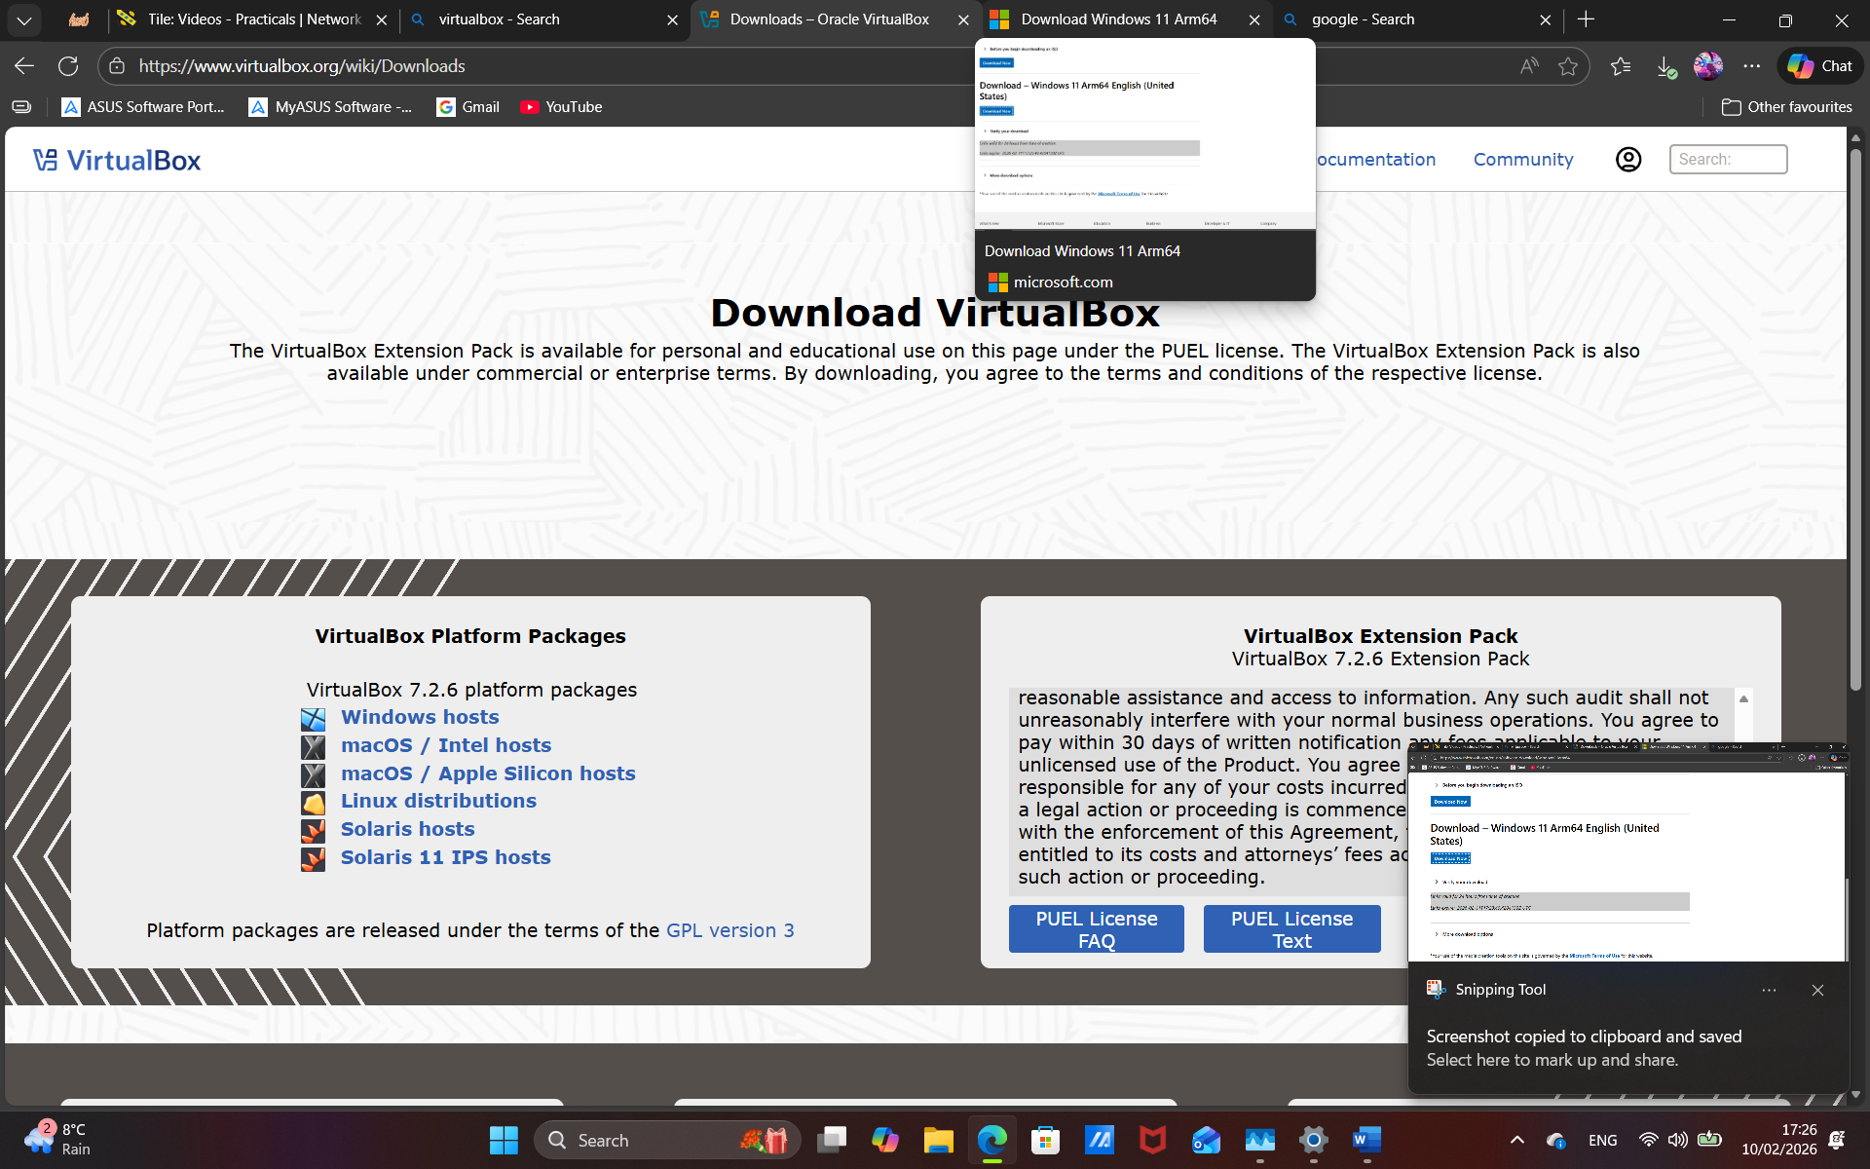
And lastly, this is a very important step of important steps to create a virtual machine and test the pings and try to configure the Ip address and pinging both clients or just the server

  - Configure IP Addressing
    - Appropriate IP addressing
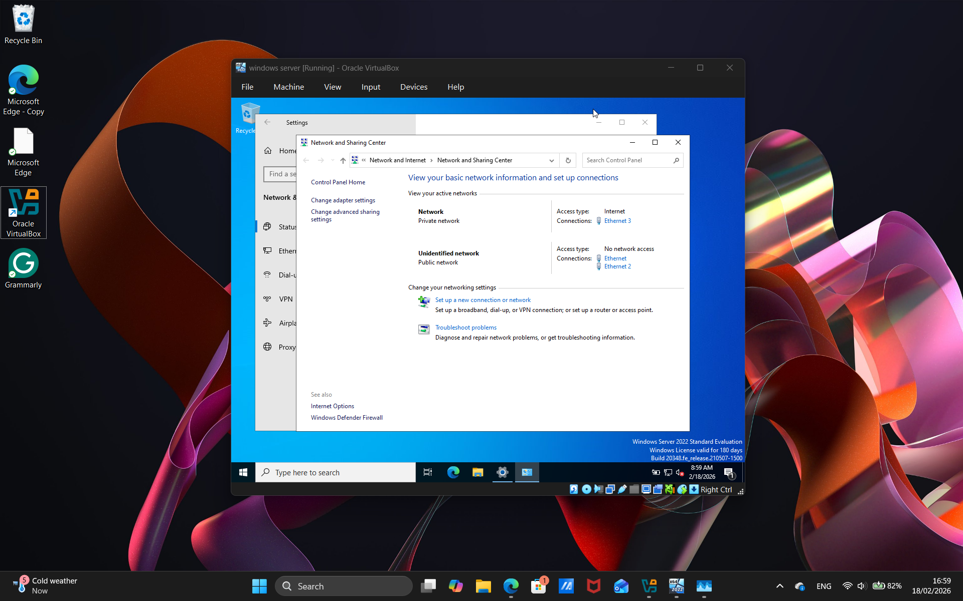
This step for the Windows server is fixing the IP networks, and from the server to the client, so we firstly go internet and networks or change the adapter for the IIPV4

This image showcases that we have changed the IPV4 and set up the IP address for it work very important that we do otherwise, we aren’t able to connect to the networks
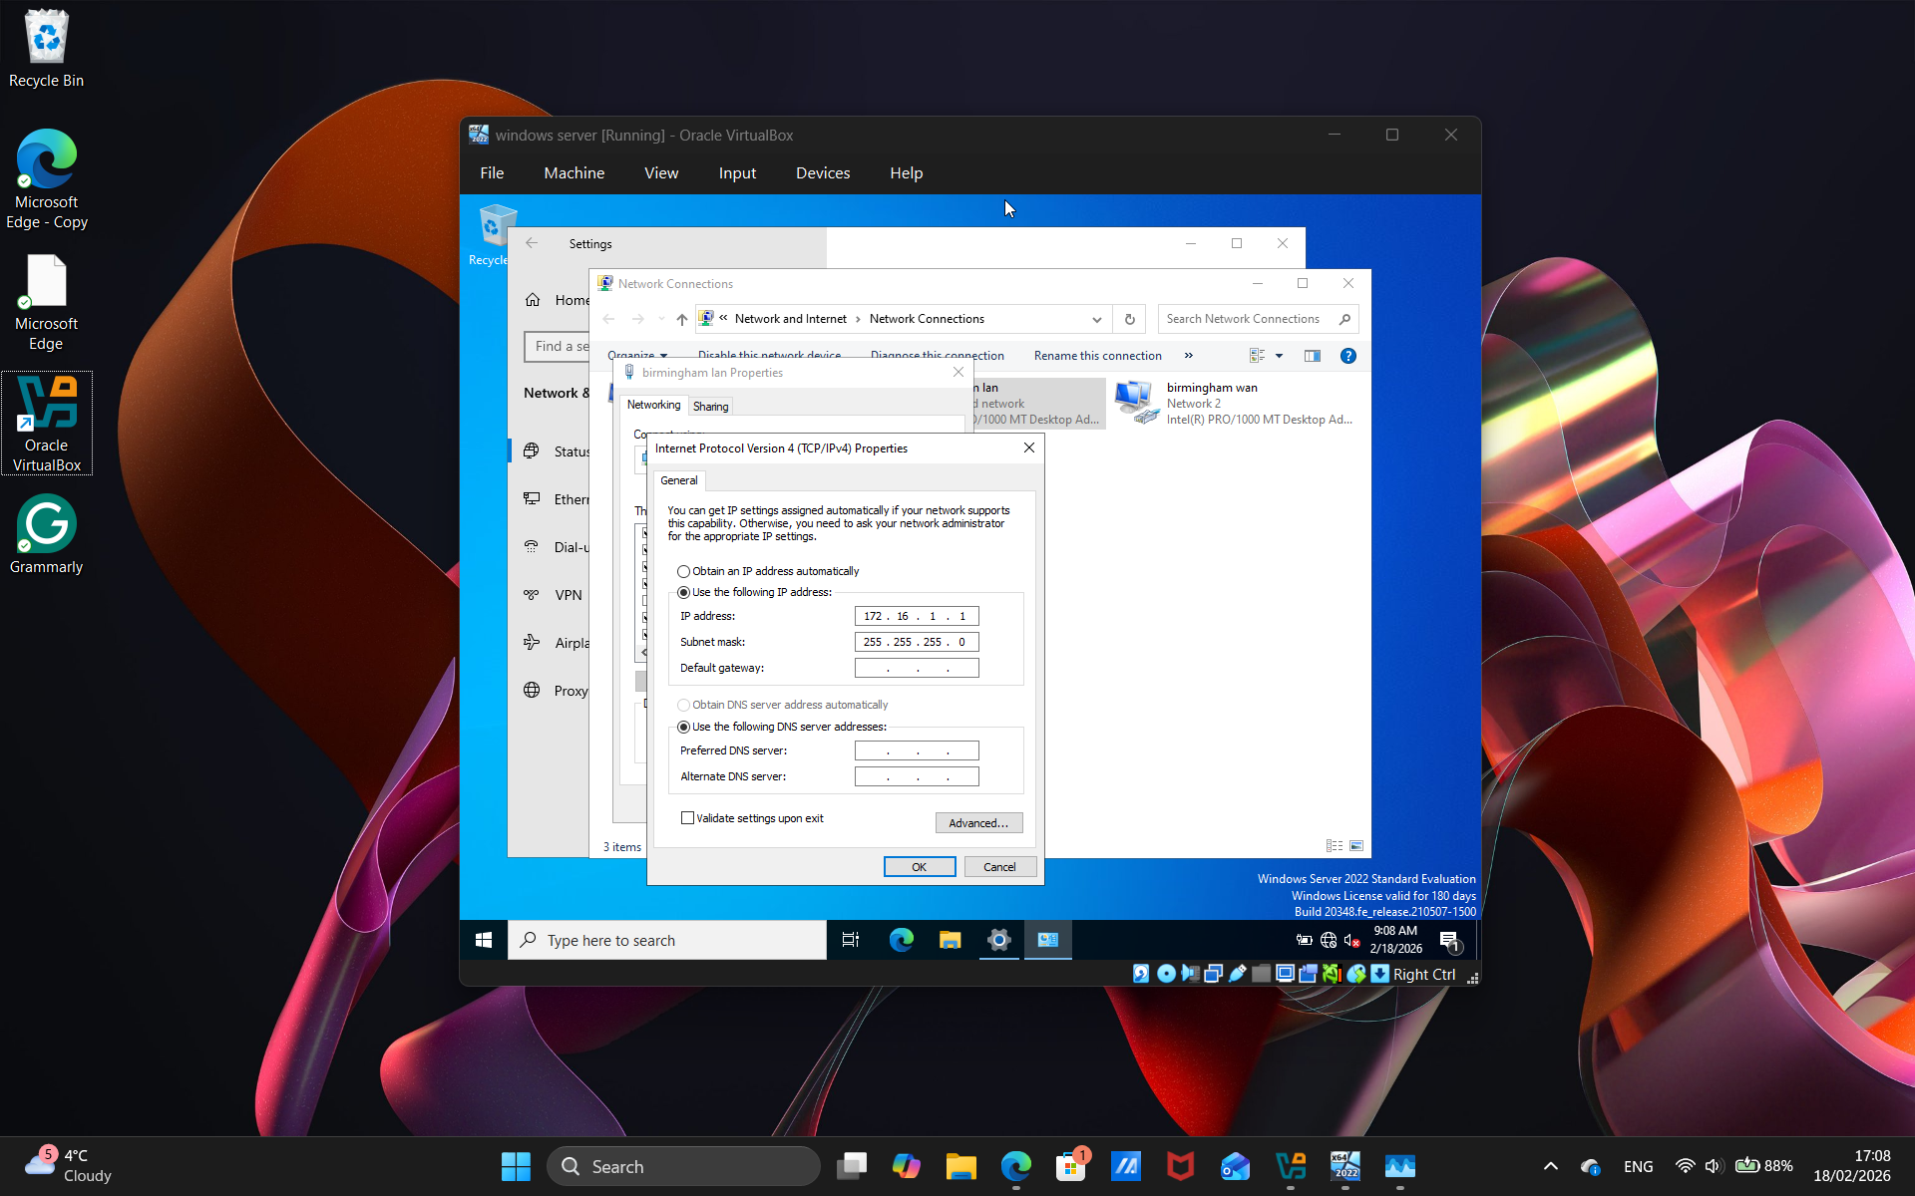

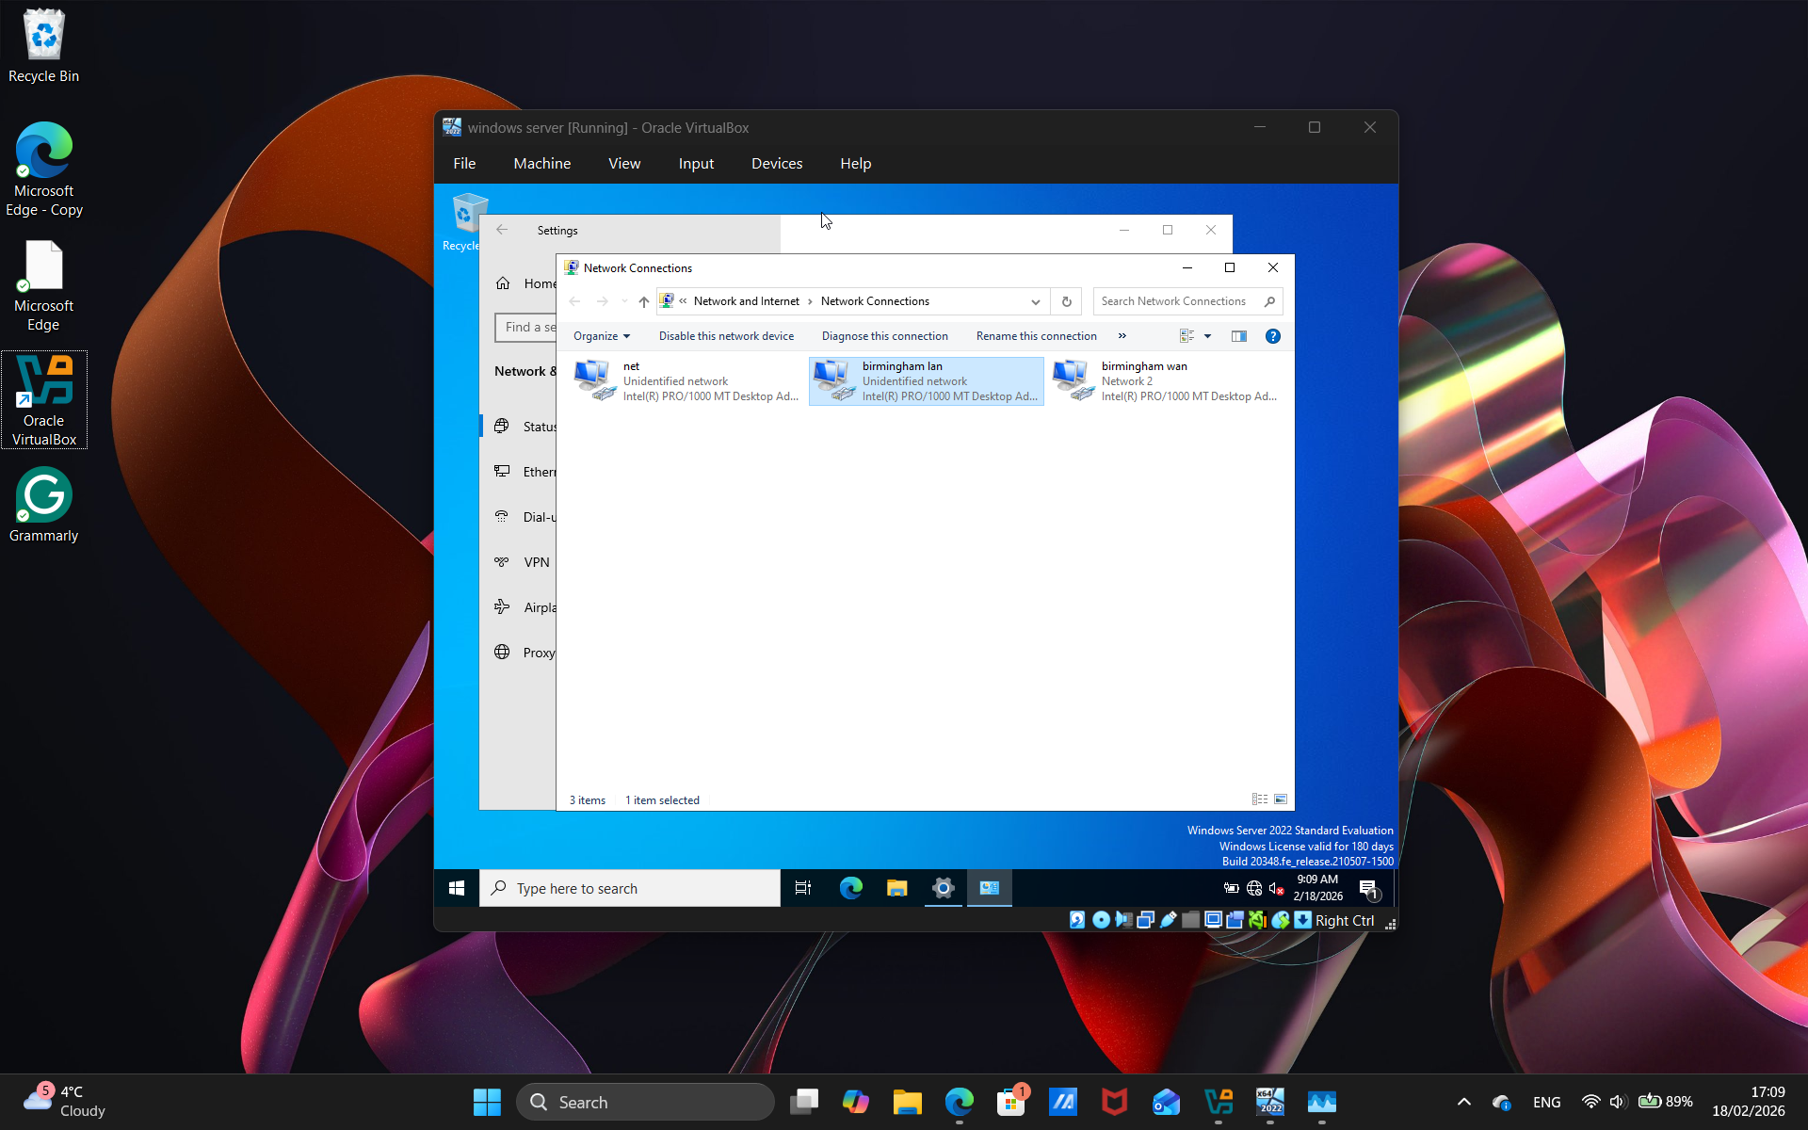
Lastly, this image showcases the name we match VM adapters so that it is easy for us match connections and successfully configure the server and the client

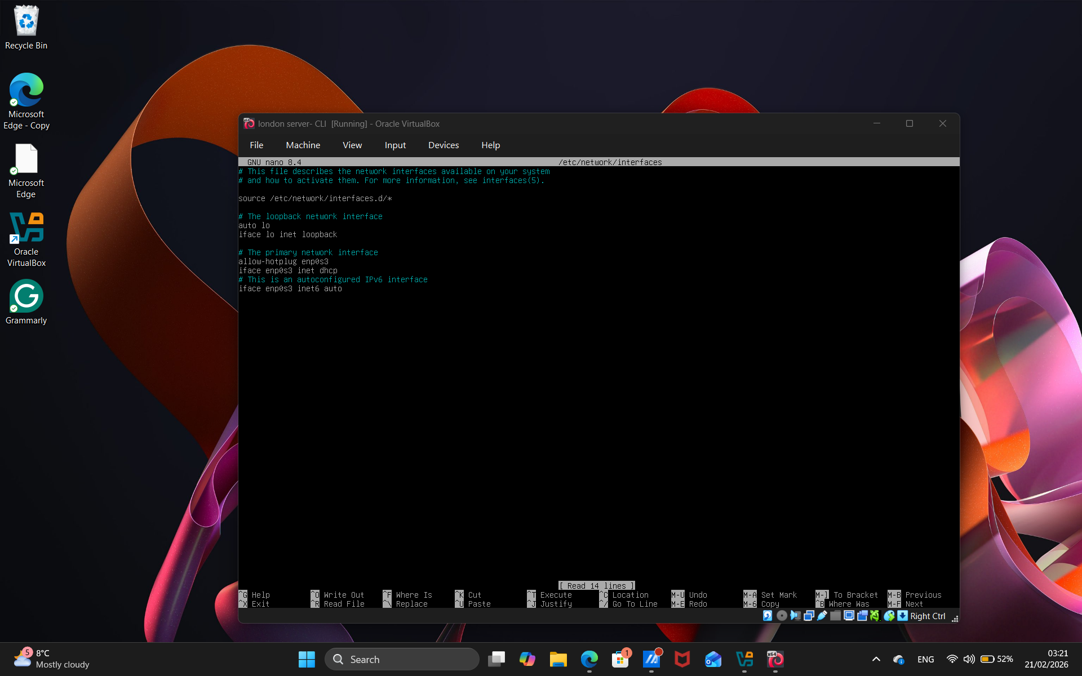
For Debian, it’s a little different because, as shown in the images, it doesn’t use any GUI; it shows Linux commands. Before we do that, write the command nano etc/network/interfaces. This will open scripts for us to open the IP address and configure them

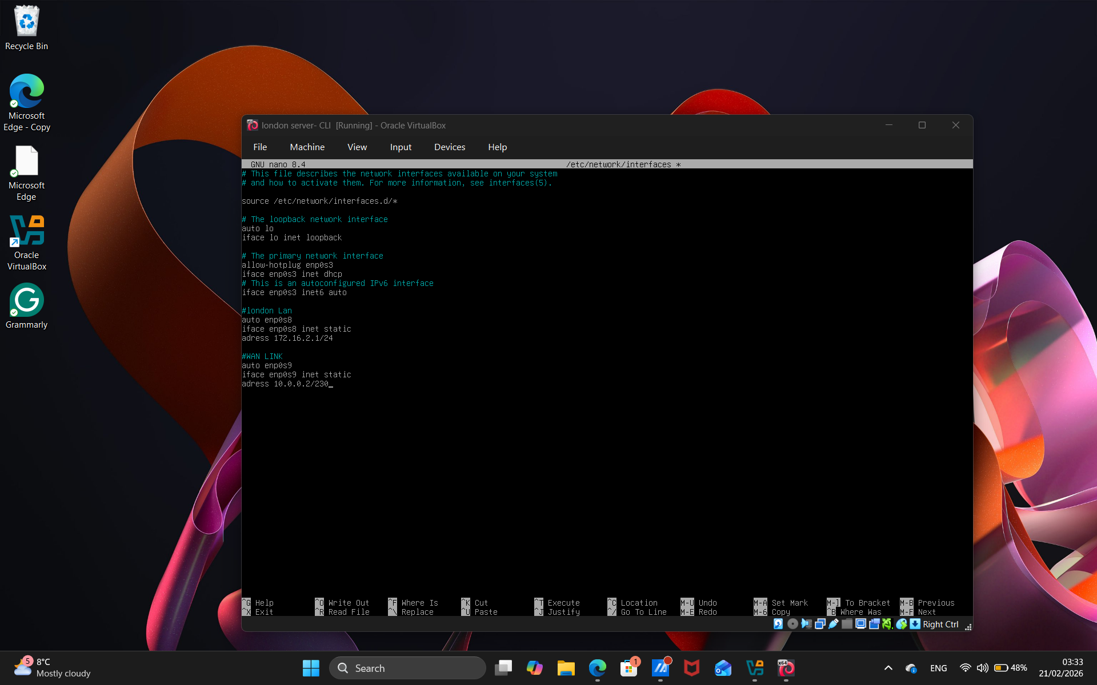
The next stage is the script. This image shows the IP addresses assigned to our enp0s8 and enp0s9 interfaces to get them up and running. In theory, it should work.

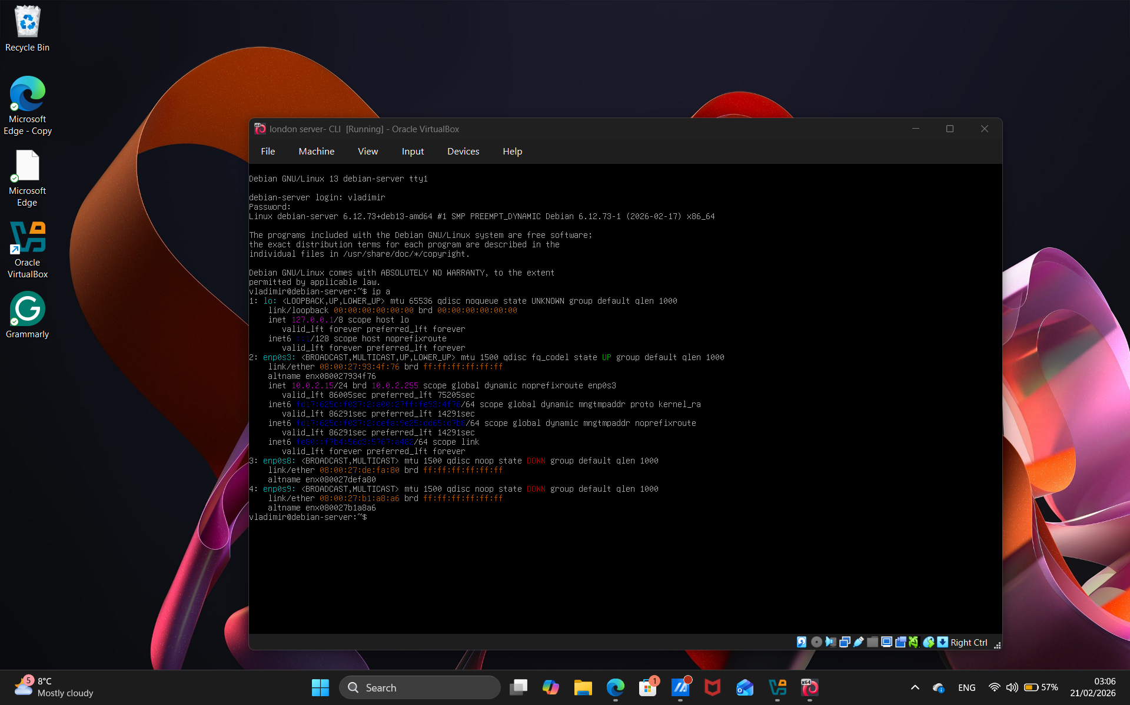
The next step was to put the nano command before, as shown in the last two, which are down and appear in red with the IP address.

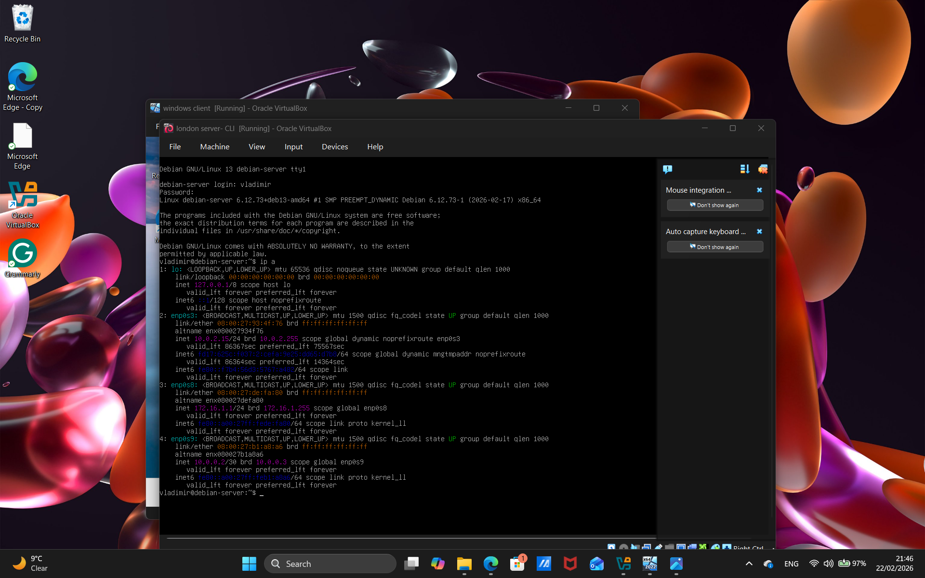
And last, after multiple takes in my case, trying to figure out why it won't load in the image showcase, the last two are up and showing green like the rest of them, with the IP addresses.

  - Test and Troubleshoot

You need to achieve the following:
    - Perform Connectivity tests
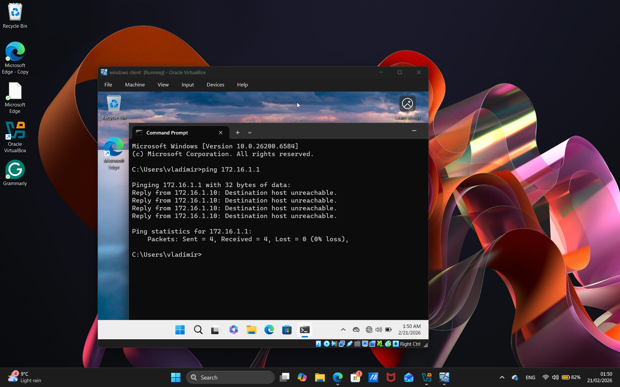
In this image, the network shows that the aim was to ping the server, but it had some difficulties and was not reaching it, which is why it said unreachable. The packet was lost, so there was a problem with the IP address: it couldn’t be reached or found.

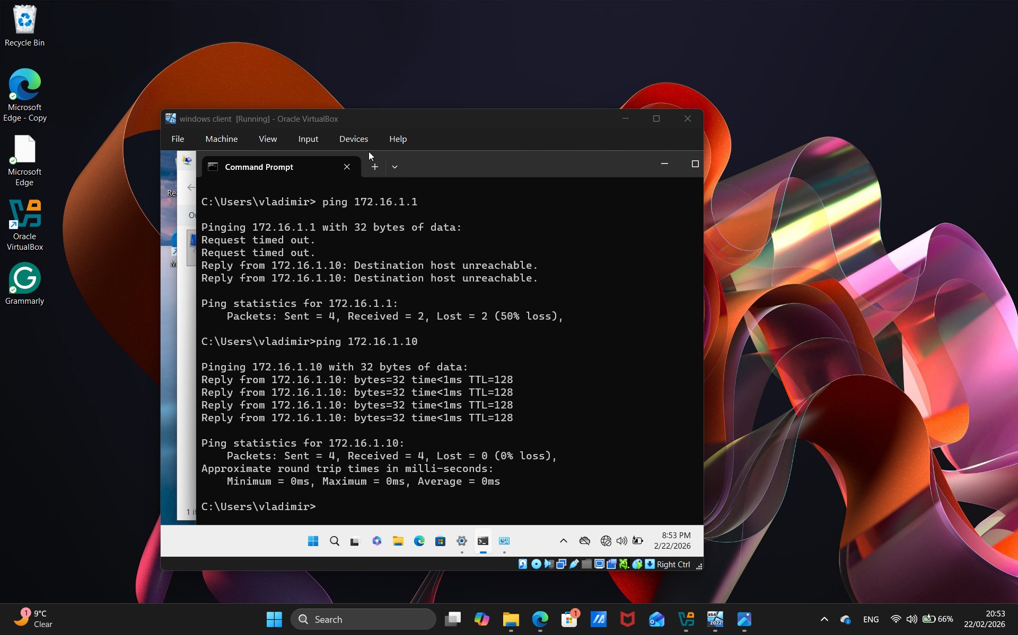
For this image, I successfully pinged it, meaning the ping reached its destination; in this case, the server responded before the ping succeeded. The failed one reported 50 losses, and the successful one reported 0, indicating it had reached its goal.

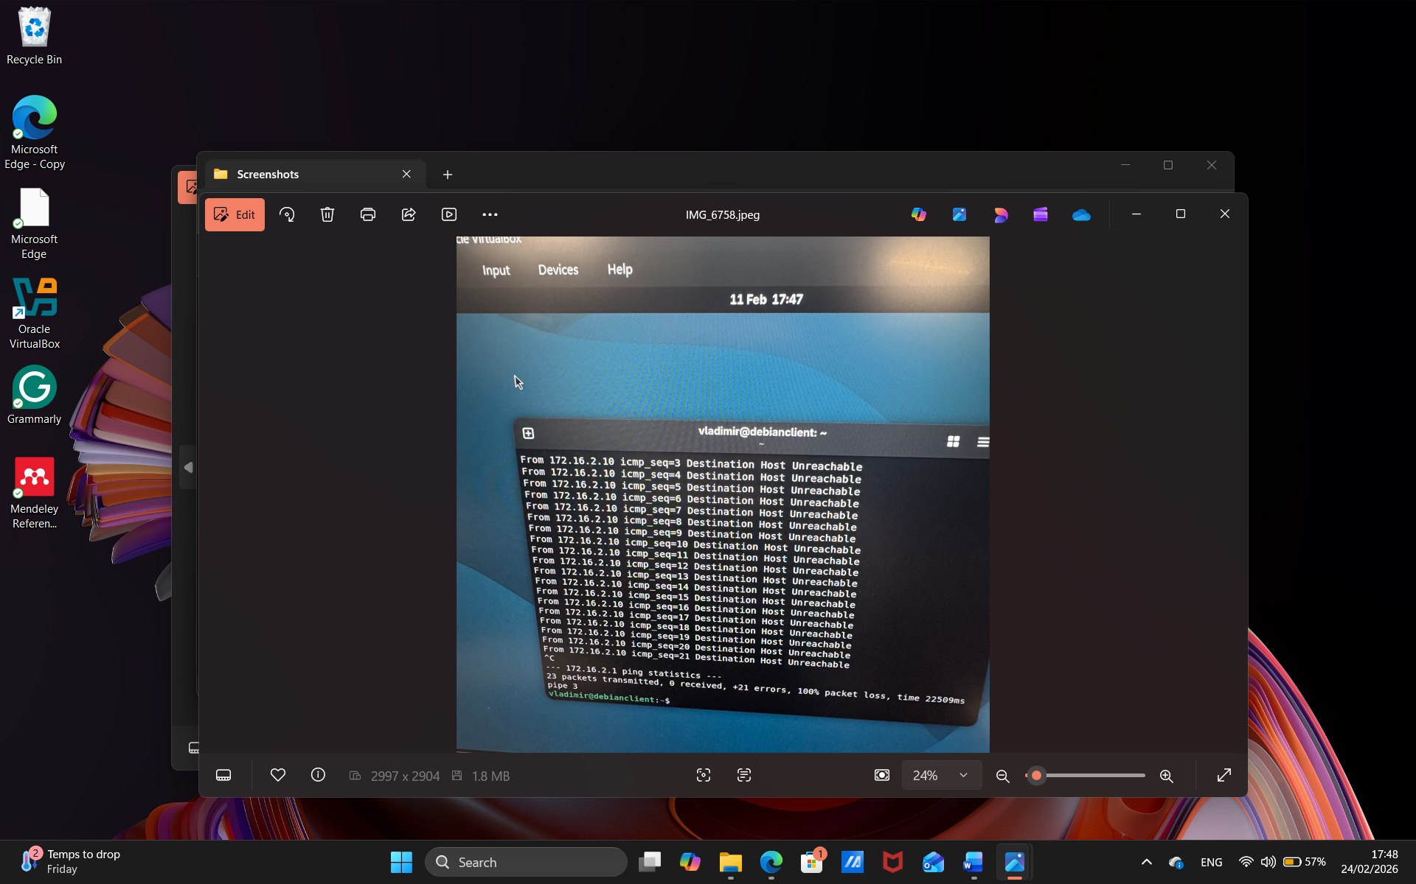
This image showcases the Debian side from the ping, as shown, it tells it is not reachable, similar to Windows, the ping has not reached the server, so making a mistake and figuring out what went wrong, making changes to the servers and connecting them to the same network, enabling them to ping.

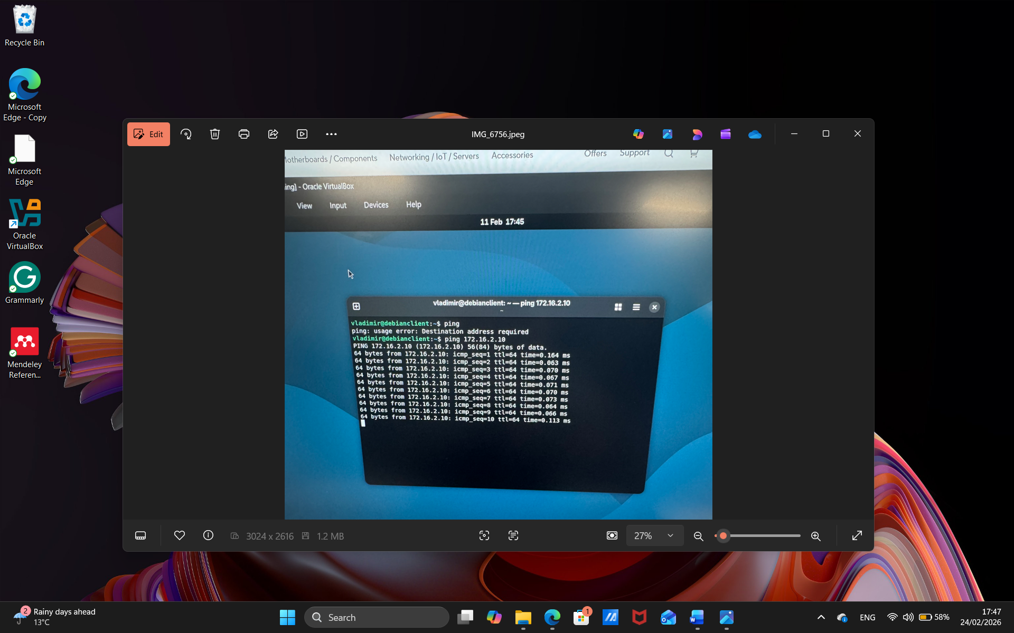
Finally, at the end, the network matched, and pinging it worked, even though, for the first time learning it, it did take me a while to figure out what went wrong and that the IP address had to match, and that the adapter from intnet-London had to match as well.

Task 3

Word Limit: 250 words

Deliverables
- Report: Reflection – 10 Marks Maximum

Overall, this was a huge challenge learning from my addressing how an IP address can ping the client and server, and from the

  - Reflect on the following
    - Write a Technical reflection covering network deployment and testing.
Hint:
as first time learner it took couple tries to get ping to work but before ping to work I had to understand the dns and adapter have to be align and been sync together then it would work learning this it took me couple tries for it somehow work and change it the first step in task 2 was configuring the dns from learning from lectures I first had to go to window server and go to network so in this case it was birm or Birmingham lan and changing the wan as well so I had to change it and press ipv4 and press properties to change dns so in this case for example it will be 172.16..1.10 this will allow me ping from the client to the server and this also apply to Debian server but a little different I had to use nano code command and write the script for IP a command to show me the update IP address it took couple tries and finally it appeared

    - Write your Personal Reflection
I encourage myself to encounter and learn the mistakes and learn mistakes especially for a first time the difference between to the two server one the main get around was the Debian server since it didn’t have GUI to guide throughout the process learning the command was very useful to learn and knowing what each is use full finding the ping and seeing which one work and which one fails during the process.

Referencing

[1] “What Is a Hypervisor? A Complete Guide to Virtualization.” Accessed: Feb. 24, 2026. [Online]. Available: https://www.scalecomputing.com/resources/what-is-a-hypervisor
[2] “What is Hypervisor? Types, Use Cases, and Benefits.” Accessed: Feb. 24, 2026. [Online]. Available: https://www.theknowledgeacademy.com/blog/what-is-hypervisor/
[3] “What is Hypervisor? | Glossary | HPE United Kingdom.” Accessed: Feb. 24, 2026. [Online]. Available: https://www.hpe.com/uk/en/what-is/hypervisor.html
[4] “What is a Hypervisor?” Accessed: Feb. 24, 2026. [Online]. Available: https://www.vmware.com/topics/hypervisor
[5] “What is a Hypervisor? - Hypervisor Explained - AWS.” Accessed: Feb. 24, 2026. [Online]. Available: https://aws.amazon.com/what-is/hypervisor/
[6] “What is an IP Address? How it works? How to Locate it? | Fortinet.” Accessed: Feb. 24, 2026. [Online]. Available: https://www.fortinet.com/uk/resources/cyberglossary/what-is-ip-address
[7] “What are IPv4 and IPv6? | HPE United Kingdom.” Accessed: Feb. 24, 2026. [Online]. Available: https://www.hpe.com/uk/en/what-is/ipv4-vs-ipv6.html
[8] “IPv4 vs IPv6 - Difference Between Internet Protocol Versions - AWS.” Accessed: Feb. 24, 2026. [Online]. Available: https://aws.amazon.com/compare/the-difference-between-ipv4-and-ipv6/
[9] “What is routing? | IP routing | Cloudflare.” Accessed: Feb. 24, 2026. [Online]. Available: https://www.cloudflare.com/learning/network-layer/what-is-routing/
[10] “What is Routing? - Network Routing Explained | Comms InfoZone.” Accessed: Feb. 24, 2026. [Online]. Available: https://www.comms-express.com/infozone/article/routing/
[11] “What is Static Routing?” Accessed: Feb. 24, 2026. [Online]. Available: https://www.cbtnuggets.com/blog/technology/networking/what-is-static-routing
[12] “Static routing – Knowledge and References – Taylor & Francis.” Accessed: Feb. 24, 2026. [Online]. Available: https://taylorandfrancis.com/knowledge/Engineering_and_technology/Computer_science/Static_routing/
[13] “What is a VPN? Why Should I Use a VPN? | Microsoft Azure.” Accessed: Feb. 24, 2026. [Online]. Available: https://azure.microsoft.com/en-us/resources/cloud-computing-dictionary/what-is-vpn
[14] “What is DHCP? | EfficientIP.” Accessed: Feb. 24, 2026. [Online]. Available: https://efficientip.com/glossary/what-is-dhcp-and-why-is-it-important/
[15] “What is Active Directory (AD)?” Accessed: Feb. 24, 2026. [Online]. Available: https://www.cyberark.com/what-is/active-directory/

