Prepared by Annie Martin
P143830




An Investigatory Study into how the participation in charity events can be increased
Dissertation for BA Events Management (M6X9083)
DECLARATION
This work has not previously been accepted in substance for any degree and is not being concurrently submitted in candidature for any degree

Signed……………………………………………
Date………………………………………………
STATEMENT 1
This dissertation is being submitted in partial fulfilment of the requirements for the degree of BA.

Signed…………………………………………….
Date………………………………………………
STATEMENT 2
This dissertation is the result of my own independent work/investigation, except where otherwise stated.
Other sources are acknowledged by footnotes giving explicit references. A bibliography is appended.

Signed……………………………………………
Date………………………………………………
STATEMENT 3
I hereby give consent for my dissertation, if accepted, to be available for photocopying and for interlibrary loan, and for the title and summary to be made available to outside organisations.

Signed………………………………………………
Date…………………………………………………
STATEMENT 4
I hereby give consent for my dissertation, if accepted, to be available on the university’s IT system to those who have consent to use the system.

Signed………………………………………………
Date…………………………………………………

Acknowledgements
The last three years have undoubtedly been a learning curve for me and one that I have thoroughly enjoyed. The past 7 months however, have been somewhat of a challenge and there have been many times where I did not think I would reach this point, so I would like to take this opportunity to thank the many people who have helped me get to where I am now.
Firstly, I would like to thank my family for their support and love which I have received in many shapes and sizes over the last three years.
Secondly, I would like to thank my lecturers at UWTSD and dissertation tutor Suzanne Wells, who have provided their ongoing support and well wishes when I needed it the most. Thirdly I would like to thank Joshua Nicol who has been my rock through one of the most difficult times in my life to date. His patience and support have been invaluable throughout this process.
I would also like to take this time to say a massive thank you to all the respondents who took the time to be interviewed and be part of my study. I am appreciative of every one of you.
My final and very special thank you goes to Stephanie Jones. I will never quite find the words to express just how grateful I am for Steph’s never ending kindness and support, not just throughout this study but during my time at UWTSD. Steph has gone above and beyond on many occasions during the highs and lows, laughs and tears and this is something I will forever cherish.
My achievements to date would not have been possible without this invaluable support network and the continual support from my friends.
Thank you all so much for making this journey possible and a lot more bearable.

Abstract
The aim of this investigatory study was to explore the motivations of individuals who take part in charity events to promote increased participation.
The aim was fulfilled by looking at previous research that has already been undertaken in addition to:
- Investigating the motivational factors that affected participation in charity events
- Contrasting different ‘challenge-based’ charity events to explore which ones promoted participation

The researcher reviewed relevant literature and debates, which allowed a greater insight into the topic. The researcher then undertook her own primary research.
The phenomenological approach was deemed as the most appropriate paradigm for this study as the primary data focussed on subjective opinions and behaviours of respondents who have participated in more than one charity event in the last five years. Qualitative data was collected during six semi-structured interviews and the study incorporated a purposive and snowball sampling method. To increase reliability of the study, the interview questions were adapted from two reliable sources. A pilot study was conducted to increase validity of the data.
The interviews were transcribed and a matrix table was compiled using data from the transcriptions. This allowed the researcher to audit the data. The matrix table allowed key themes to be highlighted. Following this, the data was triangulated against statuses and pictures taken from the respondents’ social media accounts. The key themes were highlighted as: social impacts and camaraderie, the team, the challenge, sense of achievement and pride, the charity and the event. These themes were contextualised against the theory and discussed by the researcher as motivations for further participation in charity events.
The results suggest that individuals are motivated by intrinsic rewards such as the sense of achievement and pride, which is fulfilled by engagement in challenging, social events. Recommendations were put forward by the researcher suggesting that charities need to ensure events are socially engaging, innovative and present a challenge for those participating.
An additional recommendation was to investigate the topic further by undertaking another study. This would mitigate some of the limitations discussed within the study such as time frame and sample size.

Table of Contents

1.0 Introduction 1
1.1 Study Overview 2
2.0 Literature Review 5
2.1 Contextualising Events 6
2.2 Size 6
2.3 Motivation 6
2.3.1 Theories of Motivation 7
2.3.1.1 Maslow’s Hierarchy of Needs 8
2.3.1.2 Social Psychology: Self-Determination Theory 9
2.3.1.3 The Psychological Continuum Model 9
2.4 Third Sector 11
2.5 Participation 12
2.6 Social Impacts 12
3.0 Methodology 14
3.1 Aim and Objectives 15
3.2 Primary and Secondary Data 15
3.3 Phenomenology Vs Positivistic 15
3.4 Quantitative v Qualitative 16
3.5 Interpretivist v Positivist 16
3.6 Sampling 16
3.6.1 Snowball Sampling 16
3.7 Research Strategy and Data Collection Methods 17
3.8 Study Population and Sample 17
3.8.1 Sample Demographics 18
3.9 Reliability and Validity 18
3.10 Pilot Study 19
3.11 Ethnography and Autoethnography 19
3.12 Social Media 20
3.13 Triangulation 20
3.14 Data Analysis Techniques 21
3.15 Ethics 21
3.16 Limitations and Recommendations for Improvement 21
4.0 Analysis 22
4.1 Contextualising Results 23
4.2 Matrix Table 23
4. 3 Triangulation 23
4.4 Key Themes 23
4.4.1 Social Impacts and Camaraderie 23
4.4.1.2 Social Impacts and Camaraderie Social Media Analysis 24
4.4.2 The Team 26
4.4.2.1 The Team Social Media Analysis 26
4.4.3 Challenge 29
4.4.3.1 Challenge Social Media Analysis 29
4.4.4 Sense of Achievement and Pride 31
4.4.4.1 Sense of Achievement and Pride Social Media Analysis 31
4.4.5 The Charity 33
4.4.5.1 The Charity Social Media Analysis 34
4.4.6 The Event 35
4.4.6.1 The Event Social Media Analysis 35
5.0 Conclusions and Recommendations 38
5.1 Conclusions 39
5.2 Recommendations Considered as Motivations 41
5.3.1 Additional Recommendations for a Further Study 41
6.0 References 43
6.1 Reference List 44
7.0 Bibliography 50
7.1 Bibliography List 51
8.0 Appendices 52
8.1 Appendix 1: Pilot semi structured interview schedule 53
8.2 Appendix 2: Amended Interview Schedule 53
8.3 Appendix 3: Triangulation Model 55
8.4 Appendix 4: Ethics Form 55
8.5 Appendix 5: Consent Forms 61
8.6 Appendix 6: Interview Transcripts 64
8.7 Appendix 7: Matrix Table 77

Table of Figures
Figure 1: Methods of Charitable giving 2015/2016 (Charities Aid Foundation, 2016). 4
Figure 2: Maslow's Hierarchy of Needs (McLeod, 2007) 7
Figure 3: Motives for Event Attendance 11
Figure 4: Sample Demographics 15
Figure 5: Social Impacts and Camaraderie Social Media Findings 20
Figure 6: The Team Social Media Findings 23
Figure 7: The Challenge Social Media Findings 25
Figure 8: Sense of Achievement and Pride Social Media Findings 27
Figure 9: The Charity Social Media Findings 28
Figure 10: The Event Social Media Findings 30

1.0 Introduction

1.1 Study Overview
This report considers the motivations of those who participate in charity events in order to promote further participation. This aim is fulfilled by investigating motivational factors for participation through primary and secondary research. The data is contextualised with that of other researchers. The researcher analyses the data and gives detail to key themes highlighted within this process. Following this, recommendations for further participation are put forward.
A charity event can be defined as an experience whereby a participant pays a registration fee to take part, with proceeds furthering the work of an assigned charity (Filo, et al., 2013). Webber (2003) suggests that charity events are a way of accessing a variety of income streams that other methods fail to meet. i.e. government agencies. Such events provide an invaluable platform for charitable organisations to create awareness of the charity as well as communicating the mission and aims of the organisation on a large scale (Filo, et al., 2012). As illustrated, charity events are instrumental in generating recognition for the charity which in turn creates awareness and revenue for the organisation.
Webber (2003) discusses differentiation of charity events, suggesting there are numerous types of charity events depending on the aim of the organisation. Webber (2003) gives detail to this differentiation suggesting acquisition of new supporters, upholding the brand name, attendee networking and developing existing donors are all common typologies when referring to charity events. Furthermore, with the inundation of planned events saturating the current market, differentiation of events becomes a valuable strategy for charities (Rundio, et al., 2014). Therefore, it is essential to distinguish the type of charity event required and the overarching aim during the planning stages, to ensure that the event content is in keeping with the purpose and desired result.
As previously discussed there are many ways in which events, in particular charity events, can be defined, however, these can be further broken down into specific activities. A comprehensive list of fundraising ideas has been compiled by Cancer Research UK and range from sporting events such as abseiling and marathons to bake sales, cinema evenings and open garden days (Cancer Research UK, unknown). Baum, et al., (2009) suggest there has been substantial global growth in non-profit events, creating a positive influence on the economic, environmental and social impacts of events. This concurs with the studies mentioned previously by Rundio et al (2014), highlighting the inundation of charity events within the sector.
Figure 1 demonstrates the methods in which people have given to charities in 2015/2016.

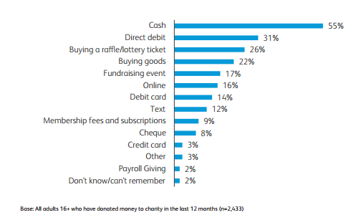
Figure 1: Methods of Charitable giving 2015/2016 (Charities Aid Foundation, 2016).

According to CAF (2016), fundraising events are the fifth highest form of giving, with this type of revenue making up 17% of the overall total. In proportion to the amount of ways in which money can be raised, this form of giving is relatively high.
With the event sector portraying such a diverse and dynamic approach to new and existing events, the benefit to charitable organisations are tremendous. This allows scope to create bigger and better events in the future to further increase revenue generated. Therefore, it is vital that this study takes into consideration innovative ideas during the planning stages of new charity events, to ensure maximum awareness and participation of the event.
This study focuses on the experiences of those who have taken part in these events. A further discussion of why charities are relying more on fundraising events can be seen in Chapter 2.
Chapter 3 of this report discusses the methodology employed for the study, giving detail to the study population and sample.
The findings of the study and analysis of the research is set out in Chapter 4. The data is contextualised with that of the literature discussed in Chapter 2.
Chapter 6 presents the conclusions and recommendations of the study. This chapter includes recommendations for future participation in charity events, in addition to recommendations for a further study. This final chapter is followed by the appendices.

2.0 Literature Review

2.1 Contextualising Events
Getz (2012) defines an event as a means to an end. Specifying a set time and place, establishing the circumstances behind the occurrence as well as distinguishing a purpose for the occasion are vital factors that must also be integrated into a key definition when contextualising an event (Getz, 2012).
Eventology is a term widely deliberated and utilised among theorists within event studies, however, particularly useful for this discussion is Goldblatt’s (2011) interpretation of this term as a study of planned events, with the purpose of promoting positive social benefits. Planned or special events can fall under several classifications based on the size and scale of the event as well as the organiser’s motivations and type of event along with the desired audience profile (Van der Wagen & White, 2010). Therefore, it is imperative to understand the range of event classifications to fully comprehend the purpose.

2.2 Size
Irrespective of how an event is defined, each event bears great purpose and has a significant impact on the host community. Each event possesses the potential to greatly improve social benefits by promoting community togetherness and attracting revenue from tourism.
Mega events are defined as the largest in size and scale and often appeal to an international market, while increasing tourism, creating a positive effect on the economy as well as providing global media coverage (Van Der Wagen & White, 2010; Allen, et al., 2010). Van Der Wagen and White (2010) and Allen et al (2010) suggest that Hallmark events are those which develop an identity within the region it is being held, as well as a widespread recognition and a greater tourism appeal to that specific destination. Major events, in contrast, have the capabilities of attracting a larger audience than hallmark events (Baum, et al., 2009). Van der Wagen and White (2010) suggest that a major event generates significant interest from the local community as they have a positive impact on the local economy via revenue through increased tourism.
In context to this investigation, the study will be looking at community-based charity events. As previously mentioned, these types of events have a social rationale, in keeping with the aims and objectives of the host community for holding an event. It is important that this study looks at community events to ascertain whether social factors are deemed as a key motivation for participation.

2.3 Motivation
In contrast to defining an event by size, classification by the organiser motives, type and audience profile is an additional way to outline the purpose. As discussed by Van der Wagen and White (2010), organisers have a range of motives for hosting an event which can include selling a product or service, to raise money or provide entertainment for the community. The audience profile of an event can differ depending on typology. Event type is a never-ending list, however, Shone and Parry (2004) suggest that cultural, personal, sport and leisure along with charity and organisational purposes, are common classifications when discussing event typology. Based on the discussions of Shone and Parry, this study will be investigating challenge-based charity events which fall into the aforementioned categories. Consideration will be given to which of these types of events further promotes participation.
Classification is a useful tool when analysing the content of an event as well as managing the expectations from those attending. It could be argued that by having clear motives and accurately categorising the event type and purpose, could potentially lead to greater event success and attendee satisfaction. This study will investigate which types of events gain greater participation by contrasting different challenge-based events, in addition to discussing the expectations of those who participate, prior to taking part. The researcher will investigate whether the event type is a greater motivator than the charity itself.

2.3.1 Theories of Motivation
Wilkie (1986) and Dawson (1988) define motivation as the process which moves a person to act in a certain way. Furthermore, Robinson et al (2010) suggest that motivation is a unique phenomenon that is experienced in a different way by individuals, promoting voluntary behaviours. Although there is not one distinct definition of motivation, it is clear that there is a trend amongst theorists and their views. It could be suggested that motivation is an internal factor that drives an individual to perform a specified task.
To further understand motivation, one must look at the driving factors that encourage individuals and investigate further as to where motivation originates from. Locke et al (1984), propose that obtainable goals that are easily achieved are extremely motivating. This study will discuss whether fulfilling personal goals by participating in a charity event, acts as a motivator for further participation. For example, if the individual has set a goal to cycle 20 miles and the opportunity to complete this arises by completing a group charity bicycle ride. The researcher will examine whether this will motivate the participant to fulfil additional, personal goals by taking part in further charity events that present a challenge to the individual.
Motivation is widely accepted as a two-dimensional approach that refers to intrinsic and extrinsic motives (Frey & Osterloh, 2002). Ryan and Deci (2000), suggest that an intrinsic motivation is prompted by the sense of receiving an internal reward and focuses on the inherent satisfaction of performing a task. Locke et al (1984) propose that an intrinsic motivation can also be defined as goal achievement. This suggests that the consensus for defining an intrinsic motivation is to be able to set an internal personal goal which has an easily achievable result that will provide the individual with a sense of accomplishment.
In contrast, extrinsic motivations are propelled by the sense of an external gain, which focuses on achieving some form of separable outcome (Ryan & Deci, 2000). Extrinsic motivations can be seen in the form of tangible prizes and rewards (Locke et al, 1984). Therefore, it is important for this study to understand whether individuals are compelled to participate due to internal factors such as a sense of achievement and pride, as discussed by Maslow (1954) or by external factors where instant gratification is received. For this study, the researcher will consider whether verbal praise, an award or something of monetary value would be a greater motivator for participants (Frey & Osterloh, 2002).

2.3.1.1 Maslow’s Hierarchy of Needs
This study will take into consideration Maslow’s hierarchy of needs theory when investigating individual’s motives. The study will consider whether self-actualisation is achieved through the participation of charity events. Maslow’s hierarchy of needs is depicted in Figure 2.

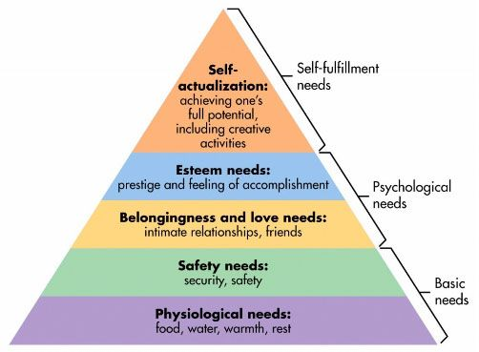
Figure 2: Maslow's Hierarchy of Needs (McLeod, 2007)
Maslow dictates that as an individual moves up the hierarchy, satisfying each level of basic needs, the motivation transitions from self-interest to that of selflessness, which leads to an individual dedicating a larger proportion of their time to external causes (D'Souza & Gurin, 2016). Maslow suggests that once the individual reaches the pinnacle of the hierarchy, a state of self-actualisation has been achieved (Maslow, 1974).
It is argued that Maslow’s hierarchy of needs is the most prominent theory of motivation (Maslow, 1973). Therefore, it is important that this study gives consideration to Maslow’s hierarchy of needs to ensure the findings are coherent to that of D’Souza and Gurin (2016) and Lester (2013). This suggests that an individual’s motives are driven by their own personal sense of fulfilment. This would advocate that as a participant transitions between the hierarchical levels, towards self-actualisation, their motives would shift from extrinsic to intrinsic. The study will investigate which type of events support the fulfilment of an individual’s intrinsic needs. An understanding of this could aid with charities’ future event planning by ensuring the event allows the participant to gain a sense of achievement and pride by taking part.

2.3.1.2 Social Psychology: Self-Determination Theory
Deci and Ryan (2012) discuss motivation in terms of self- determination, more specifically an individual’s personality functions and how these develop in a social situation. In coherence with Locke et al (1984), Frey & Osterloh (2002) and Maslow (1973, 1974), self- determination derives from theory relating to intrinsic and extrinsic motives, suggesting that an individual’s intrinsic motivations have a direct effect on the extrinsic reward received (Deci & Ryan, 2012). Deci and Ryan (2012) further discuss the effect of an individual’s social environment, on satisfying basic needs within self-determination theory and the potential of the environment creating either a positive or negative effect. Therefore, this would suggest that the social environment in which an individual is exposed to can either help or hinder one’s motivation and development. Therefore, an individual suitably choosing a social situation that they can fully engage within, would, in turn, satisfy intrinsic needs, leading to fulfilment and meeting basic human needs, coherent to Maslow’s hierarchy of needs theory.

2.3.1.3 The Psychological Continuum Model
This research will be looking at the Psychological Continuum Model (PCM) advocated by Filo et al (2012) to investigate whether this is an appropriate model for analysing the research findings. The PCM is a framework which explores the behaviours and motivations of those participating in charity sporting events, suggesting four stages within in this: awareness, attraction, attachment and allegiance (Funk & James, 2001 & 2006). The initial stage awareness is the realisation process whereby environmental inputs such as media, family and social events or agents, make people aware that an event is taking place (Filo, et al., 2012). The attraction stage is built around intrinsic and extrinsic motivations such as the individual’s perceived satisfaction of motives through participation and event marketing, with the interaction of these perceived needs resulting in a positive attraction outcome (Filo, et al., 2009). The attraction stage would suggest that by behavioural engagement in an event that the individual is interested in, will lead to satisfying the individual’s personal needs and raising self-esteem. Funk and James (2006) suggest that the attachment stage occurs when the event is internalised, revealing a symbolic, functional or emotional meaning to the individual, strengthening the psychological connection to the event. Trail et al (2000) discuss the sense of attachment an individual can experience to a sports object. In context to this study, this theory will apply to the attachment to a specific charity and or charity event. As the psychological connection evolves, the transition into the allegiance stage will occur, thus creating a strong relationship between the individual and the charity (Funk & James, 2006). The Psychological Continuum Model can be seen in the context of sporting events, therefore this model will be relevant when comparing challenge based charity events. These findings will allow the researcher to ascertain which type of event generates greater participation, which will be used during analysis of motivation within this study.
Filo et al (2013) conducted a study into the motives encouraging participants to take part in the Livestrong challenge, which comprised of four focus groups. The study revealed a set of seven specific motives that drove the participants to take part: intellectual, social, physical, reciprocity, self-esteem, need to help others and desire to improve the charity. Although this table of events motives can be analysed using Maslow’s hierarchy of needs theory, the motives within Filo et al (2008) study, can be closely linked to the findings within the Psychological Continuum Model. The comparisons can be contextualised as the following: the intellectual motives being within the awareness stage, social and physical motives being met in the attraction stage, self-esteem and desire to improve the charity falling under the attachment stage and finally reciprocity and need to help others as the fourth allegiance stage. Despite this, both Maslow and Funk and James models can be used to understand individual’s motives to participate in a charity event, with basic, psychological and self-fulfilment needs all being met.
It is argued that being able to fully understand the motivations of attendees is instrumental to event organisers. Crompton and Mckay (1997), discuss the importance, suggesting that by being aware of consumers’ behaviours and motives to participate, is a means to enhance the design and development of an evaluate as well as a valuable evaluation tool to measure satisfaction, creating a greater insight into the decision-making process to participate. In addition to this, Baum et al (2009) suggest that in order to maximise attendee participation, understanding the motives to attend is an invaluable tool. Therefore, it is imperative to this study that the participant’s individual motives are analysed and contextualised in order to put forward strategic recommendations for greater involvement.

2.4 Third Sector
The National Audit Office states that third sector organisations ‘are neither public sector nor private sector’ and can include ‘voluntary and community organisations (both registered charities and other organisations such as associations, self-help groups and community groups), social enterprises, mutual and co-operatives’ (National Audit Office, 2010).
To give context to the study, Robinson et al (2010) define a charity as an organisation with a charitable status, which operates without profit, with the aim to provide a service to those in need. A charity must have, what is defined by the Charities Commission as a ‘charitable purpose’ which they must set out in their objects clause when the organisation is established (Gov.uk, 2013). This study will consider whether participants are motivated by charitable giving and the sense of doing ‘good’ of whether they are motivated by their own gain and participant for themselves. Brandsen and Pestoff (2006) deliberate the extensive research that has been conducted over recent years into the third sector, discussing the work of the sector within the provisions of public services. With ever growing financial pressures due to stagnant incomes and a decrease in public spending, as well as an increasing demand for services provided by charities, notably, there has been a significant shift in the third sector over the last few years (Goulden, 2014).
A report compiled by the Charities Aid Foundation (CAF) in 2016, confirmed that 98% of UK households have had contact with a charity at least once with 83% having utilised a charity within the last 12 months. Therefore, it is essential that charities continue to generate adequate revenue to ensure they are meeting their aims and can provide essential help to those who are in need, whether this is finding information on a website or accessing services.
Du Bois (2016), proposes that charities need to re-engage themselves with their target audience to re-establish their identities and purpose. With Government cuts to social care, services such as at-home care are diminishing and hospitals have found themselves in a challenging position with limited beds for patients, leading to overcrowding (Campbell, 2016). This would suggest that charities now have to work harder than ever to engage with those supporting third party organisations. Charities need to ensure that they are meeting their objectives by focussing on those who are in need of help as well as generating adequate revenue to fund the services they provide.
CAF have compiled a comprehensive survey documenting the attitudes of those who donate to charities, producing a UK Giving report, originating in 2004 (Charities Aid Foundation, 2016). Comparing results from 2010 and 2015 would suggest that there has been an increase in adults donating from 56% of the total population in 2010 to 67% in 2015 along with the typical amount donated per month rising from £12 to £14 (Charities Aid Foundation, 2010) (Charities Aid Foundation, 2016). Despite an apparent increase in charitable giving between 2010 and 2015, CAF reports an overall decline in total revenue received by charities from £10.6 billion in 2010 to £9.6 billion in 2015 (Charities Aid Foundation, 2010 & 2016). In addition to these statistics, the telegraph reported an increase of more than a quarter with donations through the Just Giving online site, suggesting that social media and a rise in smartphone technology has positively contributed to the ease of donating (Williams, 2015).
With an increasing demand for charities to cover the shortfall when it comes to government cuts and stretching their resources further afield, it is imperative that charities continue to actively encourage philanthropy. Actively promoting philanthropy, will, in theory, hinder the drop in charitable donations, enabling third party charity organisations to provide the vital services required by those in need of support and advice.
It could further be argued that by actively encouraging philanthropy, may potentially have a knock-on effect on an individual’s motivation. The factors that individuals have to motivate them to take part in charity events, could potentially be very different to the perception of the charities themselves. If the charities are not doing enough to motivate individuals to participate, the revenue generated by events will decrease. Therefore, it is essential that this study investigates the intrinsic and extrinsic motivational factors of participants to ensure the charities and the events they host, are meeting these internal and external needs.

2.5 Participation
According to the Institute of Fundraising (2015), fundraising and participation in charity events have undoubtedly increased over the years, with 87.11% of charitable organisations confirming a rise in income from charity events in 2015. The compiled report suggests that corporate events are the most popular type of charity event closely followed by sporting events, however sporting events create a greater revenue with corporate events generating the second highest income (Institute of Fundraising, 2015).
With respect to the chosen case studies for this research, participants for charity sporting events will be interviewed to establish their personal motivations for participation.

2.6 Social Impacts
Getz (2005) discuss motivation for participation in terms of meeting personal, physical and social needs. Therefore, examining the social impacts of an event is imperative to this study. Raj and Musgrave (2009) suggest that events play an important role in a community and their behaviours. Events can be considered as a social catalyst to improving integration and enhancing relationships between individuals within a community (Raj & Musgrave, 2009). Cohesive to this theory, Shone and Parry (2010) discuss the historical social demand for events, suggesting social integration, mutual support and bonding are important factors.
In agreement to the aforementioned, is the theory of social phenomenon. Social phenomena is described as a set of values in which a community regard as essential in terms of event functions, these include a desire to increase leisure time, take part in new experiences as well as creating awareness of an event (Cooper, et al., 2005). Therefore, in terms of this study, it is necessary to explore these values to ascertain whether these are coherent to the primary research.
Bowdin et al, (2006) further concur with the theory of social motives. Figure 3 demonstrates a motives table for attending events.
Social Motives | Organisational Motives
- Social Interaction with others  - Creation of community spirit  - Status or recognition of achievements  - Philanthropy or charitable contributions | - Status or recognition  - Sponsorship or community support
Physiological Motives | Personal Motives
- Relaxation or recreation with others  - Exercise or physical challenge | - Seeking new experiences  - Fulfilment of ambitions

Figure 3: Motives for Event Attendance
Although this study will explore the social impacts as discussed in abundance by theorists, it will be interesting to identify whether motivation, in fact, incorporates aspects of the four motives illustrated above.
To conclude, Teare et al, (1994) discuss motivation in terms of primary and secondary factors. This study will consider whether the primary motivation for participation is, in fact, the social aspect and the charitable aspect is the secondary motive for the individual.

3.0 Methodology

3.1 Aim and Objectives
Research can be defined as the process of discovery, which is vitally important for further learning (Veal, 2011). Veal (2011) describes this process as investigating something that is previously unknown, to make the information known. Therefore, the aim of this investigatory study was to explore the motivations of individuals who take part in charity events in order to promote increased participation.
The aim was fulfilled by looking at previous research that has already been undertaken in addition to:
- Investigating the motivational factors that affected participation in charity events
- Contrasting different ‘challenge based’ charity events to explore which ones promoted participation
- Conducting primary research
- Contextualising own research to that of other research
- Evaluating research and put forward best practice recommendations for continual participation in charity events

3.2 Primary and Secondary Data
According to Colin and Hussey (2009) secondary data is the collection of information that has been gathered and published by another person and is available from an existing source such as books, journals and internet sources. Primary data is information that is gathered by the research and is from an original source and are in the form of interviews and questionnaires. This study has incorporated both primary and secondary methods of data collection. Using both methods has allowed the researcher to have background knowledge of previous, similar investigatory studies and allowed for further research to be undertaken. This has allowed the researcher to gain additional, specific findings, relevant to the study.

3.3 Phenomenology Vs Positivistic
Phenomenology, as a research method, has a philosophical underpinning with a subjective approach (Introna & Ilharco, 2011). This would suggest that this form of approach focusses on reality and knowledge as well as individuals’ feelings and opinions, with small sample sizes, leaning towards the production of qualitative data. Whereas the positivistic paradigm uses larger sample sizes, testing theory, which would lean towards the production of quantitative data (Collis & Hussey, 2009). Based on subjective opinions and behaviours, the phenomenological approach was deemed the most appropriate paradigm for this study. However, as a researcher, it is appreciated that there are disadvantages of the phenomenological approach such as subjectivity of the data in addition to participants not expressing their true opinions and feelings. This is deemed as a disadvantage as it can prove difficult to establish the reliability of the research.

3.4 Quantitative v Qualitative
Quantitative research predominantly focuses on retrieving structured data that can be presented in a numeric form, whereas qualitative research methods are fundamentally concerned with an individuals’ opinions, beliefs and feelings (Matthews & Ross, 2010). The primary data collected for this study would be defined as qualitative research. This was due to the exploration of the opinions and feelings of individuals who have participated in charity events during the data collection process. Qualitative data allows for a deeper, richer account of a person’s feelings supported by Watkins (2012).

3.5 Interpretivist v Positivist
When collecting data, it is important to look at both the interpretivist and positivist approach. The positivist approach refers to the scientific method of collecting data, therefore a quantitative method would be used (Riyami, 2015). Hair (2011) proposes that an interpretivist approach focuses on human actions and institutions, consequently a qualitative method of data collection is preferred for this type of technique. Furthermore, Thanh & Thanh (2015) discuss the strong correlation between the interpretivist paradigm and a qualitative method. Subsequently, the data collection method took on an interpretivist approach for this investigatory study as the data retrieved was of a qualitative nature.

3.6 Sampling
Sampling, defined by Fridah (2002) is the selection process of a suitable sample population, to distinguish similar characteristics in line with the research. For the purpose of this study, the sample are those who have participated in challenge-based charity sporting events. Sample members were drawn from the Swansea area for several reasons: according to Enjoy Swansea Bay, there are in excess of 10 highly popular challenge-based sporting charity events each year within the Swansea region (City and County of Swansea, 2017), which houses a population of 242,400 residents (City and County of Swansea, 2016). These statistics and access to multiple challenge-based events, as well as location within Wales’ second city, were further factors considered when selecting the population sample.

3.6.1 Snowball Sampling
Snowball sampling is the process whereby the researcher identifies further individuals of interest following the interview of a participant (Robson, 2011). Collis and Hussey (2009) suggest that snowball sampling is commonly associated with an interpretivist study, therefore this method of sampling was incorporated in to the research stages. The researcher deemed this method effective, with respondents giving reference to additional, relevant interviewees.

3.7 Research Strategy and Data Collection Methods
The research strategy for this study incorporates complimentary data collection methods, which included semi structured interviews and analysis of social media accounts. The data received via interviews was compared to that of the respondent’s social media accounts to ensure the feelings expressed during the interview was true to that published on social media. A semi-structured interview method allows the interviewer to have a guide whereby essential questions can be asked, but the order and or wording can be modified depending on the answers given from the interviewee (Robson, 2011).
The data was collected via semi-structured interviews and social media analysis, as this method conformed to the philosophy of the methodology for this investigatory study. Interviews enabled the researcher to ascertain individuals’ thoughts and feelings which in turn enabled the study to assess motivations for future participation. This form of data collection allowed for the answers to be followed up, as well as allowing deviation from the schedule to gain further information when necessary. This included prompting during the interview stage, emphasising the feeling of self-improvement and self-actualisation as well as social motivation and motivation for giving. This was to ensure that the true feelings of the respondents were expressed and allowed for fluidity of the interview. Although semi structured interviews allow scope for further discussion, time left for interviews was a disadvantage to this method of data collection. It was imperative that the interviews remained as relevant as possible and followed structure when possible, to ensure that the information required was being received by the researcher and that interviews did not over run. This also aids in the production of reliable data.

3.8 Study Population and Sample
The study had a sample size of 6 individuals which operated a purposive and then snowballing sampling method, as those selected were chosen based on their experiences and led to other appropriate participants. Ritchie, et al (2014) define purposive sampling as a method based on known characteristics and experiences, therefore the sample focused on those who have taken part in one or more charity events in the last year. The sampling framework for this study included individuals who have taken part in more than one charity event in the last 5 years and were available to the researcher. The time-frame stipulation on participation was to allow for up to date research when putting forward recommendations for future participation. The interviewees were from different backgrounds, social class and locations. In addition, one of the study population was interviewed as a direct result of snowball sampling and all interviews took place locally to the researcher. As discussed above, the location offered choice in challenge-based charity events to those residing in the region, therefore, the researcher deemed this as appropriate, with potential of investigating a diverse range of experiences from the sample members.

3.8.1 Sample Demographics
Figure 4 illustrates the sample demographic used within this study.
Respondent | Age | Gender | Number & Type of Events
1 | 45-54 | Male | 10 – Sporting Events
2 | 45-54 | Female | 10-15 – Sporting Events
3 | 25-34 | Male | 10-15 – Mainly Sporting Events
4 | 45-54 | Female | 10 plus – Sporting Events and Charity Ball
5 | 45-54 | Female | Over 5 – Sporting Events
6 | 55-64 | Female | 3 - 2 Sporting Events and a Charity Concert

Figure 4: Sample Demographics
Respondent 6 took part in short, one-day events, dissimilar to respondents 1-5 who have taken part in longer challenge based events. Therefore, the researcher expected that the data received from respondent 6 would differ from that of respondents 1-5.

3.9 Reliability and Validity
Matthews and Ross (2010) define reliability as a measure that allows research to be replicated. The questions compiled for this study have been adapted from 2 appropriate sources (Bennett, et al., 2007 & Filo, 2009) this gives a greater reliability to this study as the methods have previously been tested before. The research from these studies was analysed and adapted to form questions that would be relevant to gain the data required for this study.
As this study was in the form of semi-structured interviews, the data collection method is considered not to be reliable since you cannot reproduce the situation exactly as you could an experiment in a lab, for example. However, due to the nature of the study, it is not necessary for the data to be reliable. Despite this, in a plight to aid the reliability of the study, a pilot, discussed by Kelley et al (2003) as a preliminary small-scale experiment study, was undertaken to ensure the questions were understood. Furthermore, the researcher adhered to good practice examples of qualitative research methods, discussed by Schneidera and Wagemann (2010) by ensuring there was uniformity in the conditions during the interviews. The environment in which the interviews took place remained the same throughout, with each interview lasting between 20 and 25 minutes. In addition, the questions followed a semi-structured interview schedule, with each respondent being asked the same set of basic questions. Uniformity of conditions will increase the replicability of the study.
Validity is a measure of research quality (Matthews & Ross, 2010). The study required validity as the data collected was in the form of individuals’ opinions. This however, will always prove problematic as the opinions given by participants need to be trusted and truthful. The questions asked during this study were adapted from previous, similar studies to increase the credibility of the data being received. The validity of the data received from the interviewees remained unknown during the data collection process. However, to counteract this issue, following interviews, social media analysis was conducted to ensure validity as well as comparing to other research.

3.10 Pilot Study
The pilot study allowed the researcher to make small adaptions to the questions, to ensure the data collected was as relevant to the study as possible. It also included some background to the investigatory study, allowing further insight for the interviewee as well as including two quantitative questions. This allowed a further understanding of how many events the interviewee had participated in and the locations which aided when contextualising the results. The pilot interview schedule can be seen in appendix 1 with the amended document in appendix 2.

3.11 Ethnography and Autoethnography
Ethnography is discussed between academics as a method whereby the researcher observes patterns in human behaviours and activities (Collis & Hussey, 2009). The aim of this method is to understand the environment in the same way as the participant. In contrast, autoethnography is the reflection of one’s own experience within a social setting (Chang, 2016). The researcher can apply both methods to the study to further check the validity of the data, as the researcher has been present while the interviewees have participated in one or more charity events, as well as personally taken part alongside those who were interviewed. However, ethnography can be seen as a subjective approach with Tanggaard (2014) contesting this method, suggesting that it is virtually impossible for the researcher to remain ‘native’. This would propose that the author would have had an impact on the relationship between the interviewee, as just the mere presence would be enough to have some form of influence. However, in this study, it was considered to have a positive influence as the researcher understood the environment due to like experiences. Despite this, ethnography was considered an appropriate method for this study as it is vital for the researcher to play an active role in order to gain qualitative data.

3.12 Social Media
Self-representation within social media is discussed as a personal, social moment that is made for the here and now rather than eternity, with the aim of impressing and or entertaining the audience (Rettberg, 2017). Permission was sought from the respondents to cross-reference comments posted at the time of the event, on their social media accounts, to explore the validity of the data received during interviews. The researcher conducted a data audit on the individual’s social media accounts and compared the findings to the interview. This enabled the researcher to establish whether the respondents elaborated or even changed their answers during the interview as they had time to reflect on their answers. Social media, as discussed in the theory, gives a representation of the here and now thoughts and feelings and is not meant for longitudinal effect. Comparing a range of methods for self-representation, at differing stages, pre, during and post event aided in the triangulation of the data, as below, further increasing the validity of the research.

3.13 Triangulation
To further ensure the validity of the data collected through semi-structured interviews, triangulation was integrated by comparing different sets of data. The study applied a qualitative method in the form of interviews as well as using data from social media and blogs. The opinions and motivations suggested by participants’ online profiles were compared to those of the interview research to identify whether the two types of data were in accord. The use of triangulation ensured consistency throughout the data (Matthews & Ross, 2010).
Erzberger and Prein (1997) supports triangulation, suggesting that utilising multiple methodological paradigms will increase the validity of the research data. For the purpose of this study, compatible sources of information such as qualitative questions, social media accounts, blogs a literature search and secondary data were analysed to further support and validate the research as well as supporting academic theories, as Facebook statuses would suggest how the individuals felt pre, during and post participation.
A triangulation model has been compiled, which is specific to sources used for this study, to further comprehend, the methods used. The model was adapted from a study conducted by Pool et al (2010). The model can be seen in appendix 3.

3.14 Data Analysis Techniques
A matrix table was used to analysis the data, following the transcription of the interviews. This method was favoured for the study as it allowed ease for the researcher to draw conclusions based on repetitive words, known as thematic analysis (Braun & Clarke, 2006). The researcher was able to highlight key themes during the analysis stage which are discussed as motivational factors in the results chapter.

3.15 Ethics
For the purpose of this investigation, consideration was given to the importance of ethics during the research stage, due to the nature of the content of information requested from the interviewee. A copy of the ethics form submitted within the proposal can be found in appendix 4. Adhering to ethical norms while carrying out an investigatory study is supported by Resnik (2015), suggesting there are several key elements which contribute to the importance. Promotion of actuality, highlighting the aims of the research while being truthful and providing knowledge, being accountable while acting in a fair manner and maintaining confidentiality, as well as promoting moral values and social responsibilities (Resnik, 2015).
The relationship between the interviewer and the interviewee was considered in the format of semi-structured interviews, with the age limit being set at 18 years and above for the purpose of eliminating any vulnerable feelings coming back from the questions asked. Each participant was issued with a consent form, which they signed and returned, advising of the aim of the study and highlighting their right to withdraw at any time. The consent forms can be seen in appendix 5. Furthermore, the questions asked were structured around participation level rather than engagement at charity level. This was to ensure the interview remained neutral and deviated away from generating too much sensitivity.

3.16 Limitations and Recommendations for Improvement
The time frame in which this study was conducted was considered as a limitation. The time scale in which the study was conducted limited the accessible resources and number of interviews that could take place, thus making it a small scale study. A longitudinal study would allow the researcher to explore a greater variety of event types with a diversified geographical background. Conducting the study over a longer time frame would also increase the reliability of the data.

4.0 Analysis

4.1 Contextualising Results
This section will discuss key themes which were addressed during the analysis of primary research in line with objective one and two:
- To investigate motivational factors that affect participation in charity events
- Contrasting different ‘challenge based’ charity events to explore which ones promoted participation

The purpose of this study was to investigate motivation, therefore this was the overarching focus. Following analysis of the data, the motivational factors have been sub-divided and as a result, several key themes have been investigated within that, as featured within the chapter.
A variety of challenged-based charity events were explored during this study. The purpose of this was to determine which aspects of the more challenge orientated events, prompted participants to take attend.

4.2 Matrix Table
To allow for the data to become purposeful, the interviews were summarised in the form of a matrix table, following transcription, to allow for the information to be analysed. The interview transcribes can be seen in appendix 6 and the matrix table in appendix 7. From the summarising process, key themes were highlighted which allowed for analysis of each main category. These key themes were then interpreted alongside the literature in the analysis section.

4. 3 Triangulation
As discussed in the methodology section, to further validate the data, triangulation was implemented by auditing the respondents’ personal Facebook pages. This enables the cross-referencing of research types against each other to present a more validate result (Hair, et al., 2011). The researcher focussed on key charity events, discussed during the interview, to examine whether the prominent themes correlated with the respondents’ social media posts. Respondent 6 does not use social media due to personal reasons, therefore, the researcher was not able to use this form of triangulation to validate the interview data.

4.4 Key Themes

4.4.1 Social Impacts and Camaraderie
The first key motivational theme identified from the matrix table, highlighted in yellow, is the social aspect and the camaraderie that the participant experiences from taking part. All respondents apart from respondent 6, referred on at least one occasion, to the social involvement and feeling of camaraderie and friendship. Respondent 1 commented ‘the social aspect, there’s nothings better than meeting a new person, talking to that person and suddenly finding three years later you are in a pub, having a pint’ with respondent 4 suggesting ‘it’s more about the banter, having a laugh’ and respondent 5 referring to ‘camaraderie’.
The primary research confirms the findings of Getz (2005) and Shone and Parry (2010), who discuss motivation in terms of social integration and bonding with others, suggest that events are historically driven by the participants’ need to meet personal social needs. Planned events are intended to positively promote social benefits, consistent with self- determination theory, which stipulates that a positive social experience can further support the fulfilment of personal needs (Goldblatt, 2011; Deci and Ryan 2012). Therefore, having the opportunity to interact and fully engage in the social environment which the event generates, has the potential to aid the participants in satisfying their personal intrinsic needs, demonstrated by Maslow in his hierarchy of needs (Frey & Osterloh, 2002; Maslow, 1973, 1974).

4.4.1.2 Social Impacts and Camaraderie Social Media Analysis
Figure 5 suggests that respondents 1, 3 and 5 referred to the social aspect of the event. Respondents 2 and 4 did not have any apparent reference to the social impacts on their account, although it was mentioned during the interview.
Interestingly, respondents 2 and 4 are both female and in the same age bracket of 45-54. Expressing the social impacts they received on their social media pages may not be deemed as important, compared to respondents 1 and 3 who are both males. Respondents 1 and 3 also have similarities in that they have both taken part in at least 10 events each. Respondent 6 was the only participant that did not mention the social element. The amount and type of charity events that respondents 1-5 have participated in compared to respondent 6 could be a reason as to why the social aspect of taking part was not as important to this respondent. Respondents 1-5 have participated in at least 5 events each, whereas respondent 6 has only participated in 3 and these were not challenge-based events. The following photos from social media illustrate the importance of camaraderie and the social aspect as motivation for participation by showing groups of people and referring to friends.

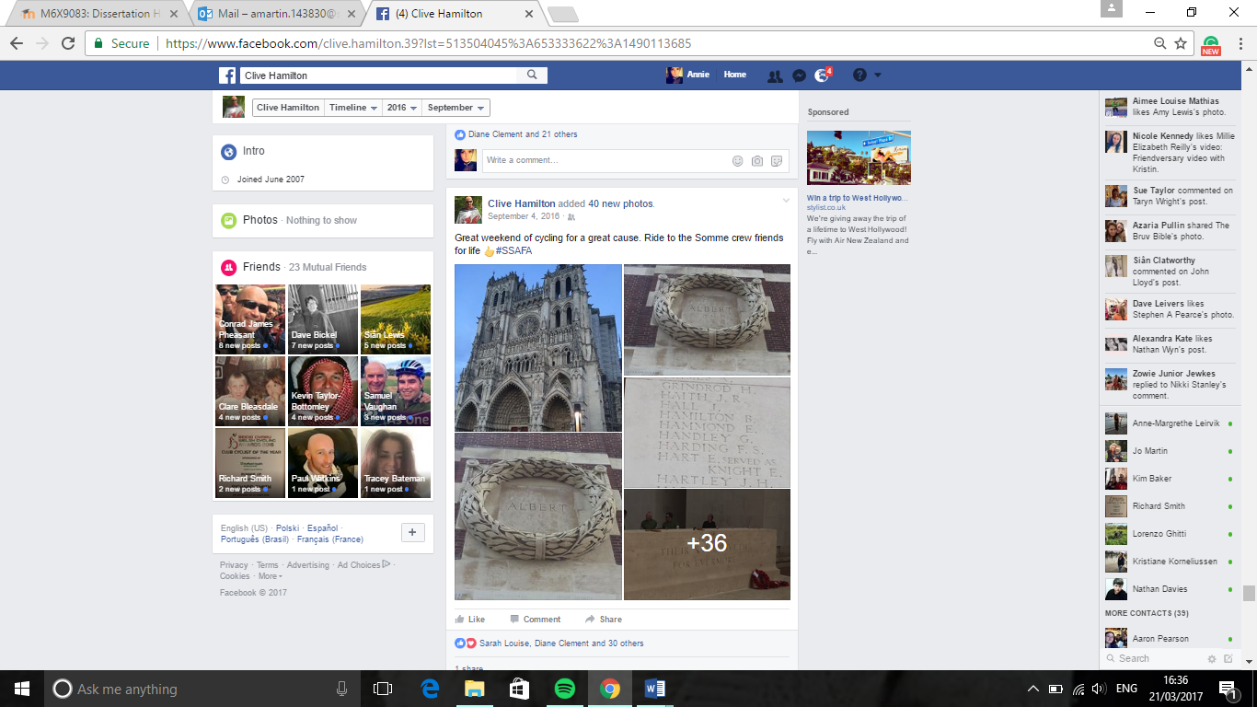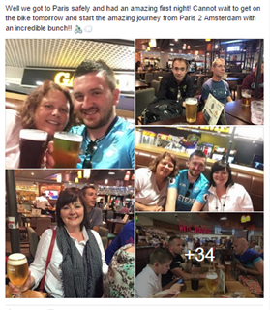

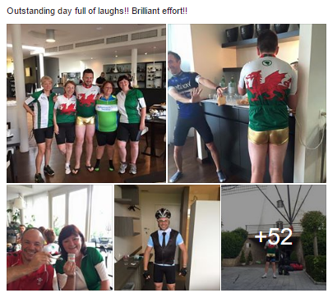
Figure 5: Social Impacts and Camaraderie Social Media Findings

4.4.2 The Team
Being part of a team is deemed as a sub-theme that was very closely linked with the social impacts of participating during the analysis. Highlighted in green, respondents 1, 2, 4 and 5 made several references to the importance of being part of a team during an event, with respondent 3 referring to being ‘Motivated by the support of others on the team’. Respondent 6 however, did not make any reference to the importance of team work throughout the interview. Team work is discussed under social impacts as it encapsulates findings relating to social integration and community spirit (Bowdin et al, 2006).

4.4.2.1 The Team Social Media Analysis
All respondents referred to the team and the people they were with and this is demonstrated in Figure 6. This is representative of the data received during interviews.
It is interesting to observe that all respondents apart from respondent 6 have expressed that the social impacts created by an event are vital contributing factors to participating. The number of events that respondent 6 has participated in compared to respondents 1-5, along with the intensity of the events, could be an explanation as to why social aspects and team work were not regarded as highly as respondents 1-5. The following photos from social media illustrate the importance of a team as motivation to participate by showing individual teams and referring to those who they were with.

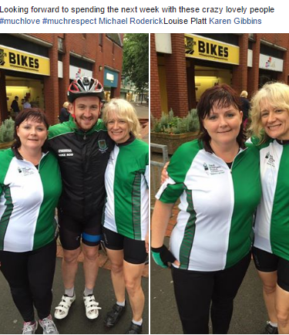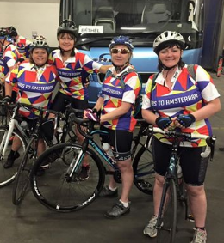

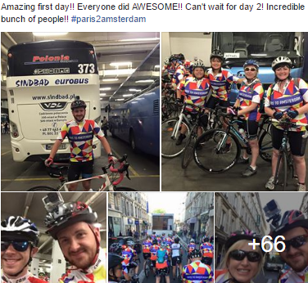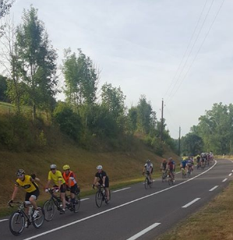

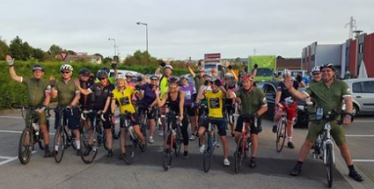
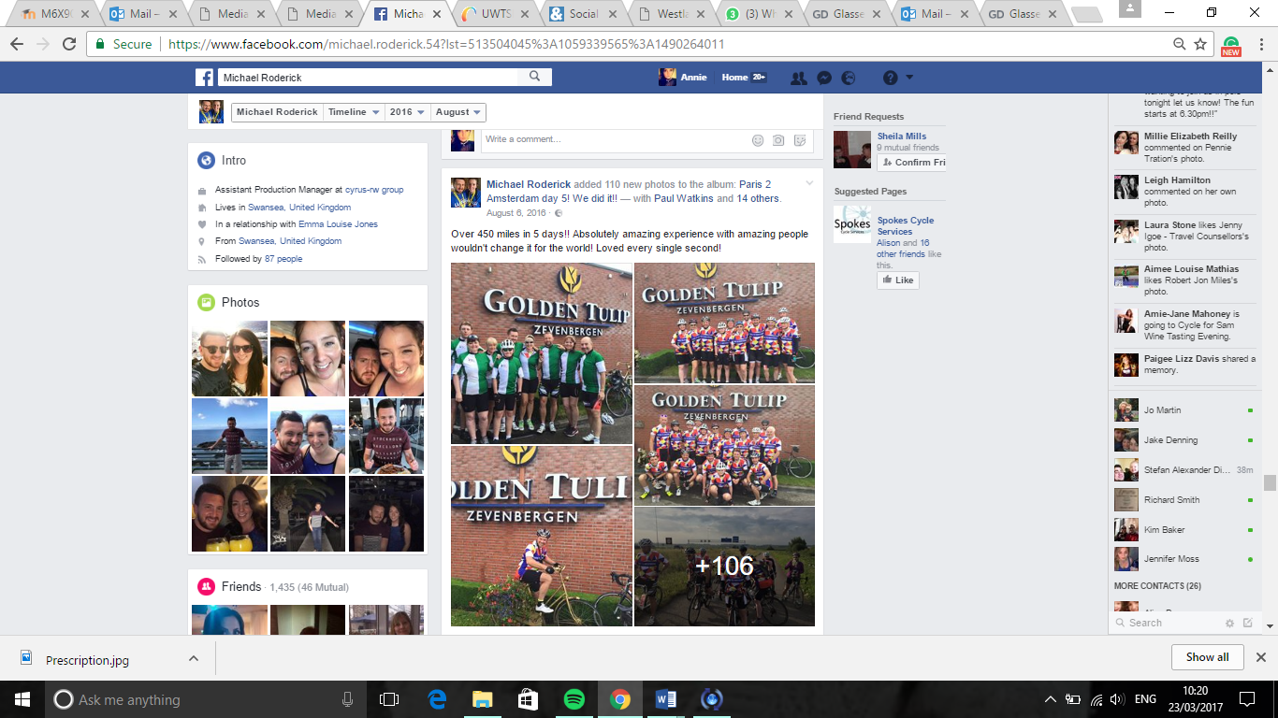

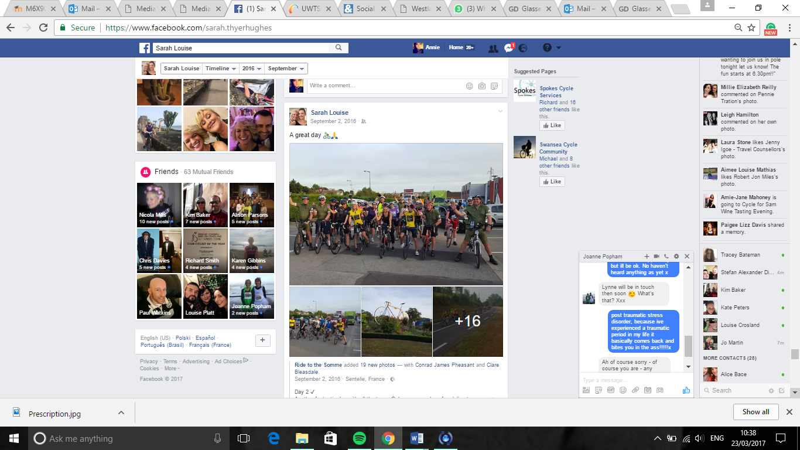

The following social media statuses also demonstrate how important the team was to the particpants.

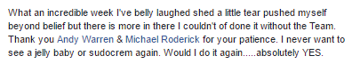
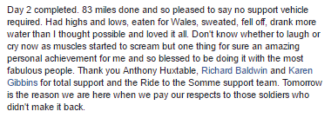

Figure 6: The Team Social Media Findings

4.4.3 Challenge
Motivation to participate, spurred on by the challenge of the event itself, was something that was repeated 20 times between respondents 1-5, with respondent 1 advising ‘I’m always looking for new challenges’ and respondent 5 suggesting they like ‘to keep pushing the boundaries’. This can be seen in the results section highlighted in pink. Again respondent 6 did not mention this during the interview. This concurs with the physiological motives, defined by Bowdin et al (2006) as an individual’s need for exercise or a physical challenge which agrees with the findings of Maslow, proposing after basic needs are met, an individual then seeks to meet physiological needs (Maslow, 1973, 1974). Seeking new experiences, defined as personal motives, could be argued as further correlation between Bowdin’s findings and motivational factors, with respondent 1 and 3 stating they are always looking for new challenges. Therefore, this would suggest that new challenging experiences could be a contributing factor.

4.4.3.1 Challenge Social Media Analysis
Figure 7 demonstrates how respondents 1 and 5 referred to the event being a challenge in their posts. Respondents 2, 3 and 4 did make suggestion towards the events being a challenge, however, these respondents did make reference to the event itself, which could be construed as the event in terms of ‘challenge’. This is highlighted later.
Respondents 1 and 5 are in the same age category and both have established and successful careers. Being at a stage in their lives where they have achieved work-related success, could be a factor as to why they are looking for a challenge outside of their daily life. The following photos from social media illustrate the importance of a challenge by referring in their photo captions and statuses.

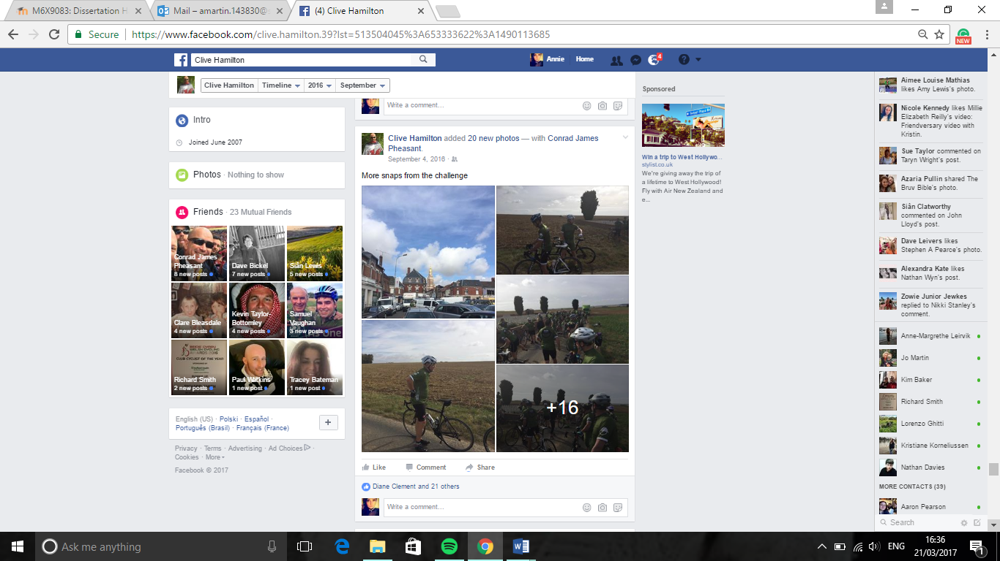

The following social media status makes reference to the individual pushing themselves, further emphasising the challenge they endured.

Figure 7: The Challenge Social Media Findings

4.4.4 Sense of Achievement and Pride
Interestingly, all the respondents stated on at least one occasion during the interview that participating in a charity event brought about feelings of achievement and pride. This is highlighted in red. Respondent 2 commented ‘Amazing, proud, sense of achievement!!’ These results are typical to the feelings that the researcher thought would emerge through the interviews. These feelings experienced by the respondents concur with the findings of Reci and Deci (2000), suggesting that motivation is driven by an intrinsic reward. In the case of this study, it could be proposed that the respondents’ motivation to participate is driven by the internal sense of pride and achievement they experience by participating. All respondents gave reference at least once to the intrinsic rewards they received, with none of the respondents referring to extrinsic rewards such as verbal praise, a reward of something of monetary value. These findings would suggest that it is essential to consider the internal drivers of the participants when discussing motivation. Therefore, it is crucial that these intrinsic factors, in the form of the participants’ feelings, are satisfied at every event to ensure continual participation.
In accord is Maslow’s hierarchy of needs, which further supports the findings of the above results. Self-esteem, also categorised as meeting psychological needs, gives details to the feeling of accomplishment and prestige that an individual may feel before they reach self-actualisation (Maslow, 1973, 1974). It is clear from the results that these feelings are a crucial aspect when discussing motivation, with all the respondents expressing that they have experience personal fulfilment by taking part.
This would suggest, participating in an event aids towards self-actualisation, as discussed in the literature. The findings depict an individual’s physiological needs, categorised by Maslow, as being fulfilled at some stage during the event.

4.4.4.1 Sense of Achievement and Pride Social Media Analysis
Although all respondents referred to the sense of achievement and pride they feel when participating, only respondents 2 and 4 made direct reference to this on their social media account. This is illustrated in Figure 8.
Respondents 2 and 4, as mentioned above, are both female and in the same age bracket. Highlighting the sense of achievement and pride on their social media accounts may be deemed as more important to them than the social impacts during and directly after the event. It could be suggested that the social aspect may be considered a secondary factor to this demographic, compared to that of males. The following photos from social media give emphasis to the sense of pride and achievement by referring to these feelings in the captions and photos.

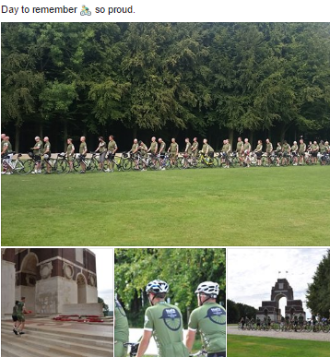

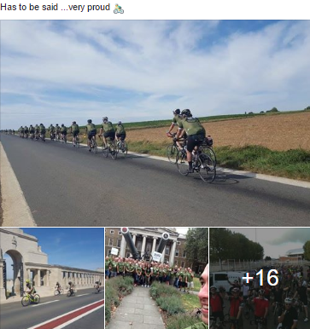

The following social media status further demonstrates the importance of these feelings to the individual.
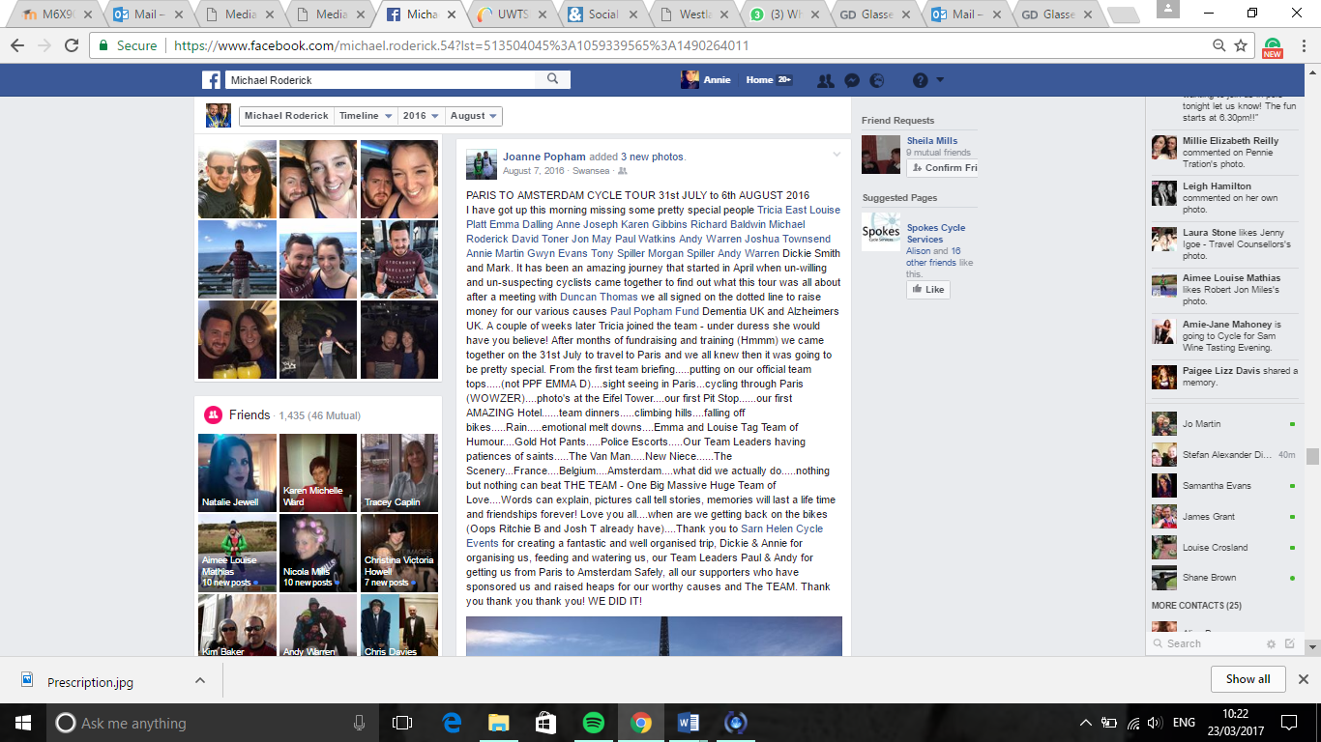

Figure 8: Sense of Achievement and Pride Social Media Findings

4.4.5 The Charity
Typically, participating for charitable purposes is a theme that would be expected to prevail when analysing the data. Therefore, it is not surprising that all respondents made reference, at least once during the interview, to the charitable aspect of the event. This is highlighted in blue. Respondent 2, 5 and 6 however, were affiliated in some way with the charities, therefore the data presented could be seen as representative for these participants due to their loyalties to the organisation. Respondents 1, 3 and 4 commented on the personal connections that they had for the charities, for example ‘To raise money for the chosen charity that had personal connections’ as noted by respondent 3. Loyalty and personal connections with the charity itself give an additional dimension to an individual’s motives to participate. These findings agree with the psychological continuum framework (PCM), discussed by Funk and James (2001, 2006), as a four-stage framework, incorporating attachment and allegiance as the end process. Attachment occurs when the participation in the event bears an emotional or functional purpose for the participant. Allegiance manifests itself following the transition from the attachment stage, once the individual has formed a strong bond with the charity (Funk and James, 2006). This connection could materialise after one or several events, however, in the case of the study, it is apparent that the data is in agreement with the PCM, with all respondents sitting within either the attachment or allegiance stage.

4.4.5.1 The Charity Social Media Analysis
Interestingly, Figure 9 reveals that only respondents 1, 2 and 4 referred to the charity. Respondent 2 was affiliated with the charity, as mentioned above, so this would be typical to the researcher’s expected findings. The following photos depict the importance of the charity to the respondents, with reference being made in the captions and photos.

The following social media statuses also demonstrates how important the charity was to the participants.
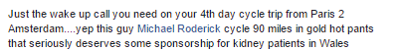
Figure 9: The Charity Social Media Findings

4.4.6 The Event
The data would suggest that respondents 2, 3, 4 and 5 all make reference to the event itself as a driving factor for participation, highlighted in grey, with respondent 3 quoting ‘it’s the event itself’ and with respondent 5 suggesting ‘It is more about the event then the charity’. Interestingly, respondents 2, 3 and 4 have all participated in over 10 events in the last 5 years. This may give some context as to why they deem the type of event as an important factor for motivation, due to the volume of events in which they participate. This key theme is in agreement with the theoretical underpinning of self-determination theory, Maslow’s hierarchy of needs and the PCM. The data would suggest that participants choose an event that they are able to fully engagement in, which is consistent with self-determination theory (Filo et al, 2012). In addition, theory suggests that an individual’s intrinsic, physical needs will be met if they are able to fully engage in an event, which further leads to self-fulfilment and self-actualisation, encapsulated by the findings of Deci and Ryan (2012), Maslow (1973, 1974) and Funk & James (2006).

4.4.6.1 The Event Social Media Analysis
In accord with the data deriving from interviews, all respondents’ social media posts, seen in Figure 10, refer to the event itself.
This concurs with the thoughts of the researcher, as traditionally the participant would undoubtedly want to seek some form of enjoyment from the specific event to spur initial interest in taking part. Challenge-based events can be very intense and hard going, therefore, as highlighted in the research, all respondents have enjoyed the events they have taken part in. The following photos from social media give detail to the importance of the event by showing happy participants and captions within the photos.

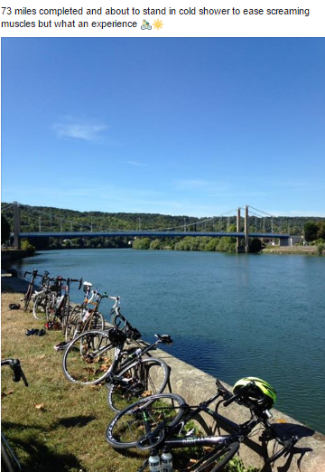
The following statuses from social media illustrate the event as an important factor to the participants by expressing their enjoyment and suggesting they would take part again.

Figure 10: The Event Social Media Findings
Although the themes recognised during the interviews were not always consistent with the respondents’ social media posts, all themes were highlighted at least once across the sample with a clear correlation with the data. This data accords with the findings of Rettberg (2017), who suggests that self-representation via social media is representative at that moment in time and is not for eternity, therefore, it could be argued that the ‘here and now’ motivations of participants are those which are posted on social media, while additional, long-term motivations become more apparent following reflection of the event.

5.0 Conclusions and Recommendations

5.1 Conclusions
The purpose of this study was to examine the motivations of individuals who take part in charity events in order to promote and put forward strategic recommendations to further increase participation. This was achieved by reviewing the current literature, in addition to relevant debates and other studies as well as conducting primary research in the form of semi-structured interviews and a social media audit.
Motivation, although not defined under a single classification, is widely discussed amongst theorists as a voluntary behaviour that encourages an individual to act in a certain way (Dawson, 1988; Robinson et al, 2010). Motivation is discussed as a mechanism which allows an individual to fulfil their intrinsic and extrinsic needs, driven by internal and external motives (Frey & Osterloh, 2002). Intrinsic motives, when discussing motivation, are defined as the feelings an individual receives from taking part in an event such as pride and achievement, with extrinsic motives being something more tangible such as an award or medal (Locke et al, 1984; Ryan & Deci, 2000).
Fulfilment of these intrinsic and extrinsic needs, allows the individual to meet their basic human needs, discussed by Maslow (1973) within his hierarchy of needs, which in turn aids in reaching self-actualisation. Maslow gives detail to the point of self-actualisation, suggesting it is the pinnacle of achievement and satisfaction (Maslow, 1974). Maslow’s hierarchy of need is the most distinguished theory of motivation. It was important that this study investigated the individual’s personal feelings during the primary research stages, to decipher whether taking part in challenge-based charity events fulfilled their intrinsic and basic needs.
Motivation is further discussed using the PCM, suggesting that an individual’s motivations and behaviours follow a four-stage process when taking part in a charity sporting event (Filo, et al., 2012). Funk and James (2001 & 2006) refer to the four stages within this model, suggesting the individual experiences: awareness, attraction, attachment and allegiance. This study considered the PCM while collating and analysing the data, consistent with the correlation between the aforementioned theories, as discussed in the literature review.
A greater understanding of motivation in relation to challenge-based charity events is argued as an invaluable tool for event organisers (McKay, 1997). Investigating motivation within this study has given the researcher an insight into consumer behaviours and given detail into the contributing factors that initially attracts an individual to an event, in addition to the drivers that motivate them to follow through and participate.
This study took on a phenomenological approach, as the research set out to investigate individuals’ feelings and opinions (Introna & Ilharco, 2011). To fully investigate motivation, it was necessary for the study to examine individuals’ feelings, opinions and behaviours, therefore the study followed a qualitative data collection process, consistent with the phenomenological approach (Matthews & Ross, 2010).
These individual motives, as previously discussed, were investigated using complementary data collection methods. This consisted of 6 semi-structured interviews and analysis of the interviewees’ social media accounts. The sample used for this study was selected based on their previous experiences and had all taken part in at least one charity event in the last 5 years.
With every study, it is important to consider reliability and viability during the data collection process (Matthews & Ross, 2010). To allow for the study to be replicated, the interview questions were adapted from two sources that were deemed appropriate for this study (Bennett et al, 2007; Filo, 2009), this will increase the reliability of this study.
The validity of the data received during the interviews could be argued, as the research relied on the interviews to give a true account of their opinions and feelings. To validate the quality of the data, the researcher conducted an audit of the individuals’ social media accounts and compared these findings to the answers given during interviews in addition to comparing the results to the literature.
Following the data collection process, the interviews were transcribed and presented in a matrix table format, which allowed the researcher to highlight key themes within the data. The results were analysed and discussed, forming links between the study’s findings and the supporting literature. The analysis process within this study allowed the researcher to form strategic recommendations to further increase participation in charity events. These recommendations are discussed at the end of this chapter.
During the analysis process, the following six key themes were consistent throughout; social impacts and camaraderie, the team, the challenge, sense of achievement and pride, the charity and the event. Each respondent referred to the sense of achievement and pride that they received by taking part in a charity event as well as suggesting that they were motivated by thoughts of the charity they were supporting. Social impacts and camaraderie, the team and the challenge were discussed as motivations to participate by respondents 1-5. Respondent 6 did not suggest these were factors that they consider when choosing to participate, however, this could be due to the type of events that respondent 6 has taken part in. As respondent 6 has only taken part in smaller, one-day events, camaraderie may not be seen as an important factor for these type of events, as opposed to longer, multiple day events. Respondents 1 and 6 did not indicate that the event was a motivator for them, although respondent 1 made several references to the challenge of the event being an important factor.
It was clear from the findings that the motivations emphasised by the respondents, concur with those discussed within the literature. The theories discussed within the literature were apparent throughout the analysis section. Bowdin et al (2006) discuss motivation in terms of social impacts, which incorporates the respondent’s themes defined in this study as social impacts and camaraderie and the team. In addition, Getz (2005) and Shone and Parry (2010) suggest that motivation is driven by social integration. Furthermore, Goldblatt (2011) and Deci and Ryan (2012) support the findings of Maslow (1973, 1974), suggesting that the social impacts individuals experience by participating in a charity event, aid in the fulfilment of intrinsic, personal needs, thus leading to self-actualisation.

5.2 Recommendations Considered as Motivations
The key themes discussed within the results chapter, highlighted as; social impacts and camaraderie, the team, challenge, sense of achievement and pride, the charity and the event can all be considered as motivational factors. Continual participation in fundraising events is essential for the sustainability of charities, as discussed in chapter 2, to ensure the charities can continue to provide support and resources to those who need it. The literature and results within this study suggest that charities cannot rely solely on repeat participation based on the individual’s attachment and allegiance to the chosen charity. Analysing the results has allowed the researcher to put forward recommendations for further participation in future charity events. Consistent with the key themes discussed in chapter 4 and the literature in chapter 2, individuals are motivated by intrinsic rewards such as the sense of achievement and pride which is fulfilled by taking part in a challenging event. In addition, social engagement and the sense of team spirit, are further factors that motivate individuals to participate in charity events. Charities need to ensure that events are innovative and inclusive of the aforementioned factors. Furthermore, the positive impacts derived from participating contextualised as social engagement, fulfilment of needs, team work and camaraderie, need to be actively promoted by charities during the awareness and attraction stages.

5.3.1 Additional Recommendations for a Further Study
An additional recommendation could be for a further study to be initiated to investigate this topic further. This would mitigate some of the limitations of the study, for example, the reliability of the qualitative research and the replicability of the data collection process could be problematic. The researcher ensured that the study adhered to good practice methods, ensuring uniformity of conditions in addition to including the interview schedule and transcripts. This will allow for the study to be audited and further increased the quality of the data.
In order to avoid the limitations produced when conducting the qualitative research, a further study could adapt the methods. The new study could use questionnaires to limit researcher bias and increase confidentiality of the data.
The population and small sample size, due to the time-scale of the study, could be highlighted as a further limitation of the study. The respondents within this study were from similar areas and had similar experiences in terms of the challenge-based charity events they had participated in. This could have led to a replication in the key themes due to their experiences being similar. The impact of this was minimised by ensuring the study took on a demographic diverse in age and population, with a variety of charity event experience.
Limitations in population and sample size could be overcome by extending the timeframe of the study. This would allow the researcher access to a larger demographic of respondents with differing experiences. Although the key themes highlighted within the study were interlinked and consistent with that of the literature, extending the timeframe and sample size could potentially diversify the results, leading to additional emerging themes.
Confidentiality could be considered as a further problematic area for the study as individuals were asked to express their feelings and opinions, which were deemed as sensitive information by the respondents. The researcher supplied each respondent with a confidentiality form prior to the interview to address this limitation, a copy of this can be seen in appendix 4.

6.0 References

6.1 Reference List
Allen, J., O'Toole, W., Harris, R. & McDonnell, I., (2010) Festival and Special Event Management. 5th ed. Milton, Qld: John Wiley & Sons Australia Ltd.
Baum, T. et al., (2009) People and Work in Events and Conventions: A Research Perspective. Cambridge, USA: CABI.
Bennett, R., Mousley, W., Kitchin, P. & Ali-Choudhury, R., (2007) Motivations for particpating in charity-affiliated sporting events. Journal of Customer Behaviour, 6(2), pp. 155-178.
Bowdin, G. et al., (2006) Events Management. Oxford: Butterworth-Heinemann.
Brandsen, T. & Pestoff, V., (2006) Co-production, the third sector and the delivery of public services. Public Management Review, 4(8), pp. 433-501.
Braun, V. & Clarke, V., (2006) Using thematic analysis in psychology. Qualitative Research in Psychology, 3(2), pp. 77-101.
Campbell, D., (2016) Social care cuts take English service to tipping point, regulator warns. [Online]
Available at: https://www.theguardian.com/society/2016/oct/13/social-care-cuts-take-english-service-to-tipping-point-regulator-warns (Accessed 28 November 2016).
Cancer Research UK, (Unknown) A-Z Fundraising Ideas. [Online]
Available at: http://www.cancerresearchuk.org/support-us/do-your-own-fundraising/fundraising-ideas (Accessed 29 November 2016).
Chang, H., (2016) Autoethnography as Method. Oxon: Routledge.
Charities Aid Foundation, (2010) UK Giving 2010 An overview of charitable giving in the UK, 2009/10. [Online] Available at: https://www.cafonline.org/docs/default-source/about-us-publications/uk-giving-2010_101210.pdf?sfvrsn=4.pdf
(Accessed 29 November 2016).
Charities Aid Foundation, (2016) Chartity Street 2 The value of charity to British households. [Online]
Available at: https://www.cafonline.org/docs/default-source/about-us-publications/160704_caf_charity_street_report_web.pdf (Accessed 28 November 2016).
Charities Aid Foundation, (2016) UK Giving 2015 An overview of charitable giving. [Online]
Available at: https://www.cafonline.org/docs/default-source/personal-giving/caf_ukgiving2015_1891a_web_230516.pdf?sfvrsn=2 (Accessed 29 Novemeber 2016).
City and County of Swansea, (2016) Population. [Online]
Available at: http://www.swansea.gov.uk/population (Accessed 18 April 2017).
City and County of Swansea, (2017) Charity Upcoming Events. [Online]
Available at: http://www.enjoyswanseabay.com/events/categories/charity/ (Accessed 16 April 2017).
Collis, J. & Hussey, R., (2009) Business Research; A pratical guide for undergraduate & postgraduate students. 3rd ed. Hampshire: Palgrave Macmillan.
Cooper, C., Taylorb, P., Smith, N. & Catchpowled, L., (2005) A discussion of the political potential of Social Accounting. Critical Perspectives on Accounting, 16(7), pp. 951-974.
Crompton, J. L. & McKay, S., (1997) Motives of visitors attending festical events. Annals of Tourism Research, 24(2), pp. 435-439.
Dawson, S., (1988) Four motivations for charitable giving: implications for marketing startegy to attract monetary donations for nedical research. Journal of Health Care Marketing, 8(2), pp. 31-37.
Deci, E. L. & Ryan, R. M., (2012) Self-Determination Theory. In: P. A. M. V. Lange, A. W. Kruglanski & T. E. Higgins, eds. Handbook of Theories of Social Psychology. London: Sage Publications Ltd, pp. 419-437.
D'Souza, J. & Gurin, M., (2016) The Universal Significance of Maslow's Concept of Self-Actualization. The Humanistic Psychologist, 44(2), pp. 210-214.
DuBois, M., (2016) The attitudinal shift of turning audiences into participants. [Online]
Available at: http://www.thirdsector.co.uk/attitudinal-shift-turning-audiences-participants/digital/article/1386722 (Accessed 2016 Novemeber 2016).
Erzberger, C. & Prein, G., (1997) Triangulation: Validity and empirically-based hypothesis construction. Quality and Quantity , 32(1), pp. 141-154.
Filo, K., (2009) Turning a Meaningful Charity Sport Event Expereince into Social Change. South Carolina, Griffith University.
Filo, K., Funk, D. & O'Brien, D., (2009) The meaning behind attachment: exploring camaraderie, cause and competency at a charity sport event. Journal of sports management, 23(3), pp. 361-387.
Filo, K., Groza, M. & Fairley, S., (2012) The Role of Belief in making a difference in Enhancing Attachment to a Charity sport Event. Journal of Nonprofit & Public Sector Marketing, Issue 24, pp. 123-140.
Filo, K., Groza, M. & Fairley, S., (2012) The Role of Belief in Making a Difference in Enhancing Attachment to a Charity Sport Event. Journal of Nonprofit & Public Sector Marketing, Issue 24, pp. 123-140.
Filo, K. R., Funk, D. C. & O'Brien, D., (2013) Social Responsbility and LiveSTRONG. In: J. L. P. Salcines, K. Babiak & G. Walters, eds. Routledge Handbook of Sport and Corporate Social Responsibility. Oxon: Routledge, pp. 79-90.
Filo, K., Spence, K. & Sparvero, E., (2013) Exploring the properties of community among charity sport event participants. Managing Leisure, 18(3), pp. 194-212.
Frey, B. S. & Osterloh, M., (2002) Successful Management by Motivation: Balancing Intrinsic and Extrinsic Incentives. Berlin: Springer-Verlag .
Fridah, M., (2002) Sampling In Research. [Online]
Available at: https://profiles.uonbi.ac.ke/fridah_mugo/files/mugo02sampling.pdf (Accessed 15 March 2017).
Funk, D. & James, J., (2001) The psychological continuum model: A conceptual framework for understanding an individual's psycholoigcal connection to sport. Sport Management Review, Issue 4, pp. 119-150.
Funk, D. & James, J., (2006) Consumer loyalty: The meaning of attachment in the development of sport team allegiance. Journal of Sport Management, Issue 20, pp. 189-217.
Getz, D., (2005) Event Management and Event Tourism. 2nd ed. Putnam Valley: Cognizant Communication Corporate.
Getz, D., (2012) Events Studies, Theory, Research, and Policy for Planned Events. 2nd ed. Abingdon: Routledge.
Goldblatt, J., (2011) Special Events: A New Generation and the Next Frontier. 6th ed. New York: Wiley.
Goulden, H., (2014) 10 years time: Which charities will prosper in the next decade?. [Online]
Available at: https://www.theguardian.com/voluntary-sector-network/2014/jan/27/10-years-time-how-charities-will-prosper (Accessed 28 November 2016).
Gov.uk, (2013) What makes a charity?. [Online]
Available at: https://www.gov.uk/government/publications/what-makes-a-charity-cc4/what-makes-a-charity-cc4 (Accessed 28 November 2016).
Hair, J. F. et al., (2011) Essentials of Business Research Methods. 2nd ed. New York: M.E Sharpe Inc.
Institute of Fundraising, (2015) Closing The Loop, A research report into events fundraising in 2015 and. [Online]
Available at: file:///C:/Users/Invate/Downloads/closing-the-loop-report-final%20(2).pdf (Accessed 3 December 2016).
Introna, L. D. & Ilharco, F. M., (2011) Phenomenology, Screens, and : Returning to the World Itself. In: The Oxford Handbook of Management Information Systems: Critical Perspectives and New Directions. s.l.:Oxford University Press, pp. 1-46.
Kelley, K., Clark, B., Brown, V. & Sitzia, J., (2003) Good practice in the conduct and reporting of survey research. International Journal for Quality in Health Care, 15(3), pp. 261-266.
Lester, D., (2013) Measuring Maslow's Hierarchy of Needs. Psychological Reports, 113(1), pp. 15-17.
Locke, E., Frederick, E., Lee, C. & Bobko, P., (1984) Effect of self-efficacy, goals, and task strategies on task performance. Journal of Applied Psychology, 69(2), pp. 241-251.
Maslow, A. H., (1973) Dominance, self-esteem, self-actualization: germinal papers of A. H. Maslow. The University of Michigan: Brooks/Cole Publications.
Maslow, A. H., (1974) Creativity in self-actulization people. In: T. M. Covin, ed. Readings in Human Development: A Humanistic Approach. Troy State University: New York, pp. 107-117.
Matthews, B. & Ross, L., (2010) Research methods a practical guide for the social sciences. Harlow: Longman.
McLeod, S., (2007) Simply Psychology. Maslow's Hierarchy of Needs. [Online]
Available at: http://www.simplypsychology.org/maslow.html (Accessed 5th December 2016).
National Audit Office, (2010) National Audit Office Annual Report 2010. [Online]
Available at: https://www.nao.org.uk/report/national-audit-office-annual-report-2010/ (Accessed 26 November 2016).
Pool, R. et al., (2010) A Mixed Methods and Triangulation Model for Increasing the Accuracy of Adherence and Sexual Behaviour Data: The Microbicides Development Programme. Methods in Microbicides Trials, 5(7), pp. 1-10.
Pratt, M., (2009). FOR THE LACK OF A BOILERPLATE: TIPS ON WRITING UP (AND REVIEWING) QUALITATIVE RESEARCH. Academy of Management Journal, 52(5), pp. 856-862.
Raj, R. & Musgrave, J., (2009) Event Management and Sustainability. Wallingford: CABI.
Resnik, D. B., (2015) What is Ethics in Research & Why is it Important?. [Online]
Available at: https://www.niehs.nih.gov/research/resources/bioethics/whatis/
(Accessed 21 February 2017).
Rettberg, J. W., (2017) Self-Representation in Social Media. Sage Handbook of Social Media, p. Forthcoming.
Ritchie, J., Lewis, J., Nicholls, C. M. & Ormston, R., (2014) Qualitative Research Practice: A Guide for Social Science Students and Researchers. 2nd ed. London: Sage Publications Ltd.
Riyami, T. A., (2015) Main Approaches to Educational Research. nternational Journal of Innovation and Research in Educational Sciences, 2(5), pp. 412-416.
Robinson, P. Wale, D. Dickinson, G., (2010) Events Management. Wallingford: CABI.
Robson, C., (2011) Real World Research. 3rd ed. Chichester: John Wiley & Sons Ltd.
Rundio, A., Heere, B. & Newland, B., (2014) Cause-related versus Non-Cause-Related Sport Events: Differentiating Endurance Events Through a Comparison of Athletes' Motives. Sport Marketing Quarterly, Issue 23, pp. 17-26.
Ryan, R. & Deci, E., (2000) Self-Determination Theory and the Facilitation of Intrinsic Motivation, Social Development, and Well-Being. American Psychologist, 55(1), pp. 68-78.
Schneidera, C. Q. & Wagemann, C., (2010) Standards of Good Practice in Qualitative Comparative Analysis (QCA) and Fuzzy-Sets. Comparative Sociology, Volume 9, pp. 1-22.
Shone, A. & Parry, B., (2004) Successful Event Management: a Practical Handbook. London: Thomson Learning.
Shone, A. & Parry, B., (2010) Successful Event Management. 2nd ed. Hampshire: Cengage Learning .
Tanggaard, L., (2014) Ethnographic Fieldwork in Psychology: Lost and Found?. Qualitative Inquiry, 20(2), pp. 167-174.
Teare, R., Mazanec, J. A., Crawford-Welch, S. & Calver, S., (1994) Marketing in Hospitality and Tourism: A Consumer Focus. London: Cassell.
Thanh, N. C. & Thanh, T. T. L., (2015) The Interconnection Between Interpretivist Paradigm and Qualitative Methods in Education. American Journal of Educational Science, 1(2), pp. 24-27.
Trail, G., Anderson, D. & Fink, J., (2000) A theoretical model of sport spectator consumption behaviour. International Journal of Marketing Management, Issue 1, pp. 154-180.
Van Der Wagen, L. & White, L., (2010) Events Management: For Tourism, Cultural, Business and Sporting Events. Frenchs Forest NSW: Pearson Australia.
Veal, A. J., (2011) Research Methods for Leisure and Tourism. 4th ed. Essex: Pearson Education Ltd.
Watkins, D. C., (2012) Qualitative Research: The Importance of Conducting Research That Doesn’t “Count”. Health Promotion Practice , 13(2), pp. 153-158.
Webber, D., (2003) Understanding charity fundraising events. International Journal of Nonprofit and voluntary Sector Marketing, 9(2), pp. 122-134.
Wilkie, W. L., (1986) Consumer Behaviour. New York: John Wiley & Sons.
Williams, C., (2015) JustGiving donations surged by a quarter in 2014. [Online]
Available at: http://www.telegraph.co.uk/finance/newsbysector/mediatechnologyandtelecoms/digital-media/11320351/JustGiving-donations-surged-by-a-quarter-in-2014.html (Accessed 5 December 2016).

7.0 Bibliography

7.1 Bibliography List
Berumen, S. A., Perez-Megino, L. P. & Ibarra, K. A., (2016) Extrinsic Motivation Index: A New Tool for Managing Labor Productivity. International Journal of Business Science and Applied Management, 11(1), pp. 1-17.
Breeze, B., (2010) How donors choose charities: Findings of a study of donor perceptions of the nature and distribution of charitable benefit, London: Alliance Publishing Trust.
Bur, M., (2016) How to get a head start in the race for better run/walk/ride events. Non Profit Pro, Volume 8, pp. 20-22.
Coghlan, A., (2012) An autoethnographic account of a cycling charity challenge event: Exploring manifest and latent aspects of the experience. Journal of Sport & Tourism, 17(2), pp. 105-124.
Hendriks, M. & Peelen, E., (2013) Personas in action: linking event participation motivation to charitable giving and sports. International Journal of Nonprofit and Voluntary Sector Marketing, 18(1), pp. 60-72.
Landreth, A., (2009) The Emerging Theory of Motivation. In: J. Bickle, ed. The Oxford Handbook of Philosophy and Neuroscience. Oxford: Oxford University Press, pp. 1-36.
Milohnic, I., Lesie, K. T. & Slamar, T., (2016) Understanding the motivation for event partipating - A prerequisite for sustainable event planning. s.l., 23rd Biennial International Congress, pp. 204-218.
Rundio, A., Heere, B. & Newland, B., (2014) Cause-related versus Non-cause-related sport events: Differentiating endurance events through a comparison of athletes' motives. Sport Marketing Quarterly, 23(1), pp. 17-26.
Wale, D. & Ridal, A., (2010) Marketing Events. In: P. Robinson, D. Wale & G. Dickson, eds. Events Management. Oxford: CAB International, pp. 137-143.

8.0 Appendices

8.1 Appendix 1: Pilot semi structured interview schedule
Age:
Gender:
Occupation
1. Why do you take part in Charity events?
Prompts: Friends, charity/cause, the trip, the challenge
2. Why have you chosen those particular events to participate in?
Prompts: Friends, the sport, charity, location, type of event, the challenge
3. What makes you keep participating?
Prompts: Friends, the cause/charity, the type of event, the trip, fundraising amount
4. Which events do you enjoy the most and why?
Prompts: Friends, location, organisation of event, type of event, fundraising amount, the challenge
5. Are there any events that you haven’t enjoyed and why?
Prompts: Location, challenge, organisation of event, cost, friends
6. Are there any events that you would not participate in again and why?
Prompts: Cost, fundraising amount, location, challenge, friends
7. What feeling do you have while you are participating?
Prompts: Enjoyment, social engagement
8. What sort of feeling do you have after you have completed the event?
Prompts: Satisfaction, achievement, proud

8.2 Appendix 2: Amended Interview Schedule
Age: 18-24, 25-34, 35-44, 45-54, 55-64, 65 +
Gender:
Occupation:
1. In the last 5 years, how many charity events have you participated in?

2. What were these events and where were they located?

3. Why did you take part in these Charity events?
Prompts: Friends, charity/cause, the trip, the challenge

4. What prompted you to keep participating after your first event?
Prompts: Friends, the cause/charity, the type of event, the trip, fundraising amount

5. Which events did you enjoy the most and why?
5a. Have you ever considered participating in other events? Why/Why not?
Prompts: Friends, location, organisation of event, type of event, fundraising amount, the challenge

6. Are there any events that you haven’t enjoyed and why?
Prompts: Location, challenge, organisation of event, cost, friends

7. Are there any events that you would not participate in again and why?
Prompts: Cost, fundraising amount, location, challenge, friends

8. What feelings did you have while you were participating in the event?
Prompts: (Self-improvement/self-actualisation) Social motivation, motivation for giving, enjoyment, social engagement, challenging

9. What sort of feelings did you have after you had completed the event?
Prompts: (Self-improvement/self-actualisation) Social motivation, motivation for giving, satisfaction, achievement, proud

10. Is there anything else you would like to add?

8.3 Appendix 3: Triangulation Model

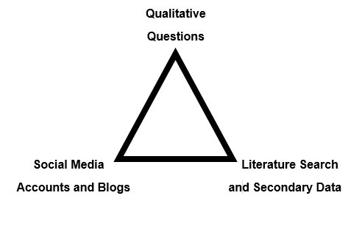

8.4 Appendix 4: Ethics Form

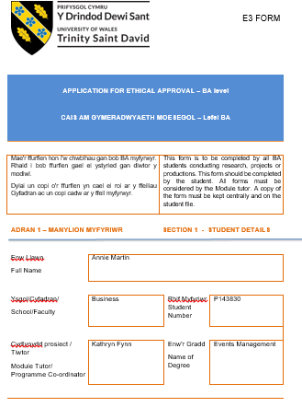
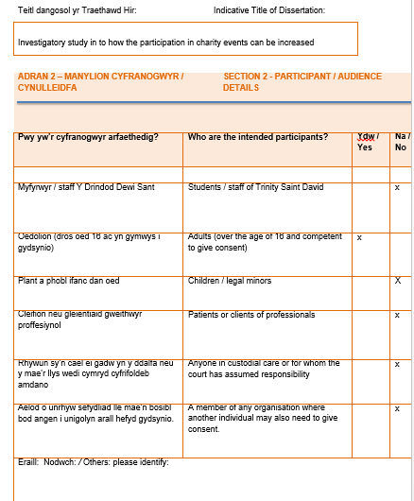

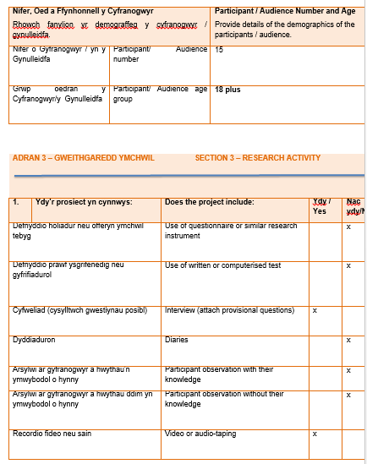

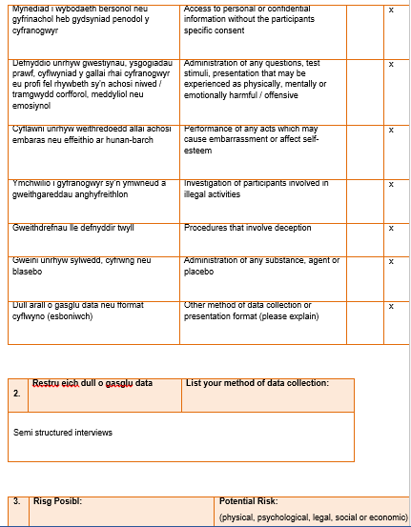

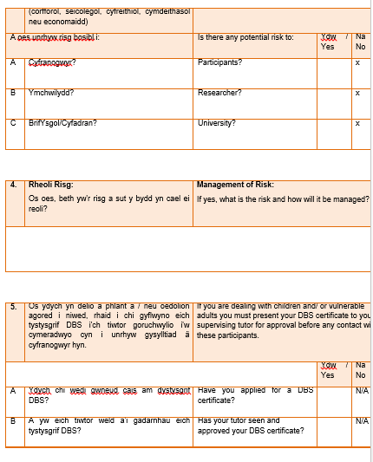

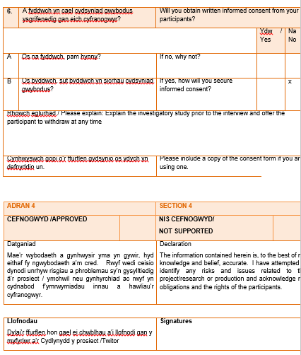

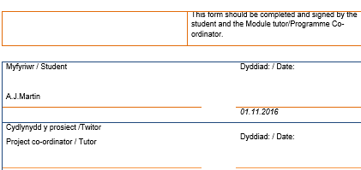

8.5 Appendix 5: Consent Forms
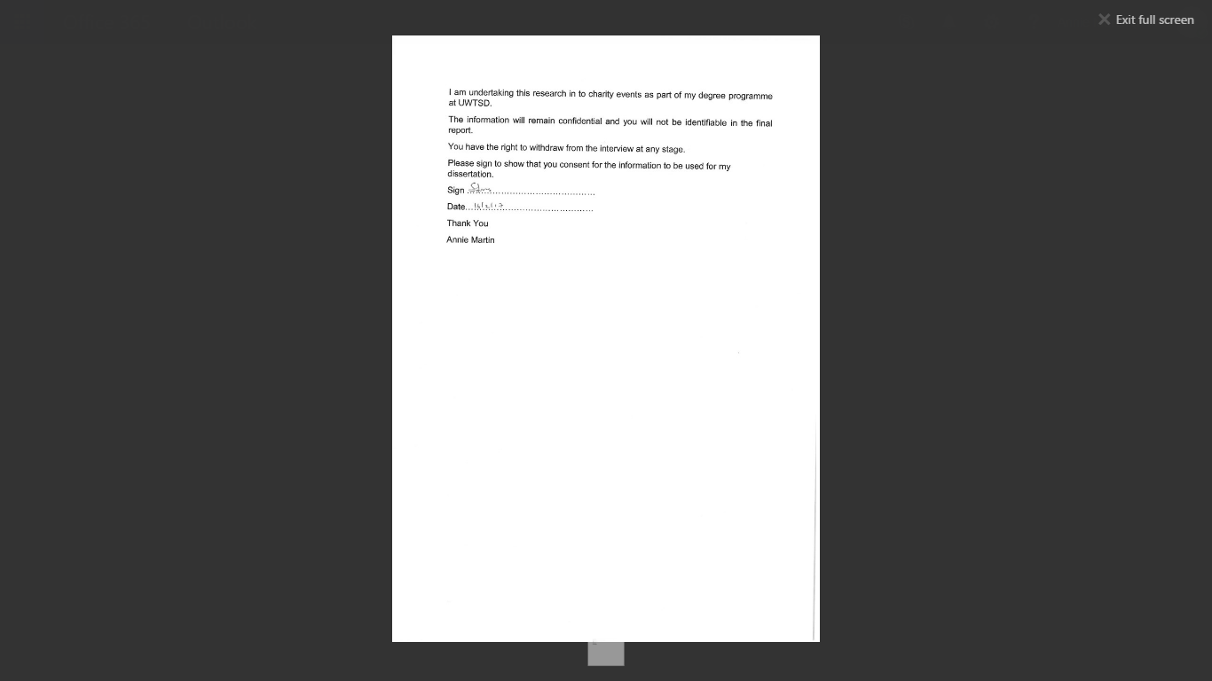

I am undertaking this research in to charity events as part of my degree programme at UWTSD.
The information will remain confidential and you will not be identifiable in the final report.
You have the right to withdraw from the interview at any stage.
Please sign to show that you consent for the information to be used for my dissertation.

Sign
Date: 20.2.2017
Thank You
Annie Martin

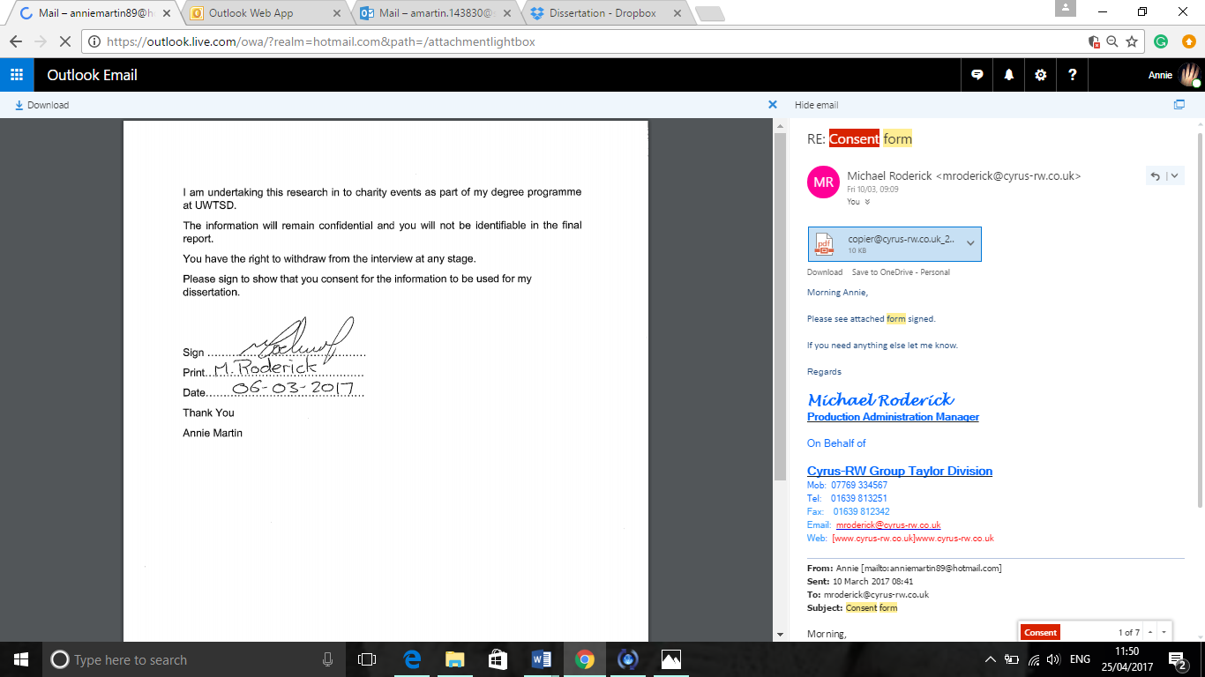

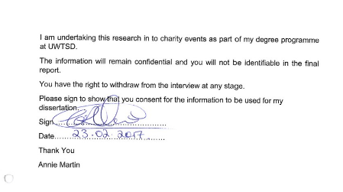

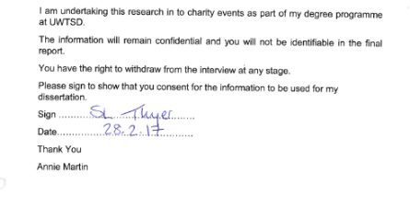

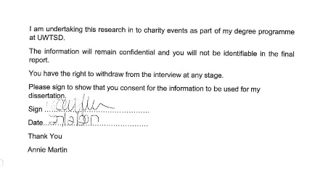

8.6 Appendix 6: Interview Transcripts
Respondent 1
Age: 45-52
Gender: Male
Occupation: Director of Business
1. Guestimate probably 2 a year so roughly 10
2. A number of different events generally to do with walking, rowing climbing, cycling, rugby, very much sport related and anything from riding to the Somme, I’ve ridden to Paris twice from Cardiff, we’ve rowed the Thames, climbed the three welsh peaks, climbed the three national peaks, we’ve done the Gower ride, Carten twice, you get the vibe. Prostate rugby match for The Vets, a number of different events within sports but ranging a different breath of activity
Have you ever done anything on your own or is it all with friends and family? I tried to do it with friends, family, groups of people as ultimately, it’s about getting everyone else involved and making it a fun aspect for yourself so it’s an enjoyable, social thing. You create the social circle and set yourself a target not to let the charity down and do it with other likeminded people who you make friends for life with
3. It started off 5-7 years ago, I gave up rugby and I didn’t want to lose the locker room banter feeling on a Saturday. When you give up rugby you’re no longer part of that scene. You lose your social circle and for me, when I took that first charity event, I’ll tell you what it was, it was the Gower and Mumbles British heart foundation ride and I did that with a friend of mine whose father had a heart attack. We got together as there’s heart disease in my family and I thought ohh I liked that, then we did the dragon ride and I got 7 people doing that.
So why did you do that ride? It was about getting together 7-8 people I played rugby with and getting us together, training and having that little bit of banter and to raise money for that charity. Also the challenge itself, everyone talks about The Dragon ride as being a difficult ride, so we thought we may as well aim for it and give it a go which is what we did
4. Generally, because of the social side and because of the competiveness so not what to lose, you don’t want to admit that you can’t do something so it’s very important for me to put a steak in the ground and say right 6 months’ time were going to do this, anyone in for this? I’m quite a good sales man so I sell it to everyone and get them all on board
5. Ummmm, so I enjoyed my first trip to Paris as it was probably the biggest challenge I’ve done out of rugby, raising the money for Shelter Cmyru, meeting new people, 18 of us went and did it and we had a fantastic time, I’m still I’m contact with a lot of people that did that and that must have been 6 years ago. I enjoyed that because it was different and it was a sense of achievement when you get to the Eiffel Tower and go ‘WOW’. We had come from the Millennium Stadium to the Eiffel Tower, it was s**t weather, sorry terrible weather, the worst weather they see, wettest on record and we were cycling from Cardiff to Paris. SO that was a good sense of achievement. A different reason for a sense of achievement was Ride to the Somme, I think the emotional aspect of it, I think there was a larger group of people from all over, there was a reason for everyone on that trip to be there, not just about the charity but they all had their own little personal reasons for doing it and I think you couple that with people that do these events and the way that they are with the emotional side of why they wanted to do it and the banter and a friendly repertoire with complete strangers over a space of 4 days, you become closer than your bleeding parents. I think that was a real plus. Another one for me was The National Three Peaks, I organised this and a few of them myself and that was a good one. We had 8 wagons of 8 people to Ben Nevis and we stayed in the commando centre in Fort William and we had the British Military to do it with us and they did the monitoring and time scales for us and we all did it in under 22 hours
5a. Always considering any event really, like I said before, I suppose it’s my way of winding back the clock, meeting new people, meeting new friends and I think in life you have to give and bit back and do the right thing. I’m always looking for new events and challenges, the only thing that gets teased away from you is time really. It’s finding the time as kids and family grow up and with work, then you get a little bit older and you lose a little bit of motivation and a little bit of energy, I think having the challenges there keeps that flame going
So you say you lose a little bit of motivation, what then motivates you to do your next event? Well picking a challenge, as its not me I’m letting down then if I back out it’s the charity, so I don’t like letting people down so if I say I’m going to do it I’ll try and do it
So it’s about that challenge and when you have that in place you say, right I’m going to do this? Correct
Is there anything specifically you know now that you want to do in the future? Yes there are, I’ve got a bucket list over the next 10 years, there’s a load of things I want to do for myself and charity. We have the ride this year, I want to organise my own ride for a cancer charity, which is the three Welsh peaks but I want to climb the three Welsh peaks but cycle in between them. We’ve organised just something daft, it’s the 360 what goes around comes around, 4th March we have organised a climb up Pen y Fan, I’m trying to get 40-50 people together, ill but the bacon rolls and the coffee for my friends wife who had breast cancer, who is now over it and for another friends son from the rugby club who had an asthma attack when little and suffered brain damage. Everyone puts a tenner in and in 2 hours it’s the quickest way, a) you do a bit of exercise and b) you get a load of people together who probably from different walks of life, you know 50 people who will meet each other and at one moment in time in that two hours will be touched by each in a nice, positive way and you know when you see someone in 5 years ‘Oh I did that walk with you and that’s why I do it and that’s what excites me, that’s why I keep doing that every year. So I don’t have anything specifically I want to do but if someone say to me tomorrow, do you want to climb Kilimanjaro in 3 years’ time, if I can fit that in then I will do it, simple as and yeah it will be difficult and we will joke about it up until the year before, then we will get serious and get training and that’s the motivation to drive it on.
So, It all excites me, it all interests me and it’s all about giving something back
6. So as much as I loved the first one to Paris I didn’t enjoy it because as I’ve already said it was the wettest September in history, the winds were howling, I’ve never seen anything as wet and cold and I spent 6 years in the Navy, that’s how wet and windy it was
7. I think it’s all difficult really, if you’ve done something you’ve ticked it off your box, it’s done but sometimes it’s not about the challenge or the money, it’s always difficult to raise the money because I’m going after the same old people every year. It’s gets to a point where I just stick the money in myself now just to cover the costs. I think it’s about the people you meet, the only reason why I’m doing the Somme ride this year is because the people that did it last year, most of them said, ohhh I’m doing it again and that’s the only reason why I’m doing it. I’ve done it, I’ve ticked the box, was it difficult no, was it easy, it wasn’t easy it wasn’t hard, it was middle of the road, it was a challenge, a great cause, very emotional but it was the people that made it for me and that’s why I’m doing it again. I could do something else but I didn’t want to, I wanted to do that. If I commit I commit
8. I think its exhilarating to be able to do it, anyone that says it isn’t is lying to themselves and everyone else around, and of course it’s good to do it. I think for me it’s about that social side of things, there’s nothings better than meeting a new person, talking to that person and suddenly finding three years later you’re in a pub, having a pint or in Uplands diner having a breakfast!!
It’s also about giving confidence to people who didn’t think they could do it and helping people that struggled who didn’t think they had it in them. On the ride last year, there was one guy called Sam who was literally holding on at the back of the pack, who had epilepsy, who was shaking as he hadn’t had time to eat and I gave him a pack of sweets and a drink, as we all take that for granted doing 24 mph because we can. I am still in contact with him now and social media allows that, you see that man was not the same man that he was on that trip. For me he was a boy on that ride and now he is a man, he’s doing all sorts of new things, park runs, cycling living in Denmark and I think it’s really enjoying the people you do it with. That’s what I enjoy the social aspect, the banter, life’s too serious as it is and it’s far too short, you got to get in there and take the piss out of people and have a laugh
And at any point during the challenge do you ever think about the charity you are doing it for? All the time, the main reason you’re there is because you are doing it for that and that’s the reason why you don’t give up and it’s not a failure for yourself if you do, it’s a failure for that charity and letting people down that needs it
The Shelter Paris ride, someone wrote to me, thank you very much for the charity ride you did this year, it was a tough one, bad weather, but just to put your mind at ease 18 families were housed for Christmas with the money you raised. Now for me and I remember that every time
9. Thank god it’s over!! Again it’s exhilarating, I deny any person not to be a little bit emotional no matter what they are doing. When’s the next one? And that sense of achievement goes through you and warms the blood of everybody because you all want to do it again and reflect on what you have just done. It may be hard doing it but once it’s over the hardness is forgotten, it’s about the fun and the banter, the charity, how much money you’ve raised, what you’ve done collectively and when you look back on it I think you appreciate it the more you do. So yeah the feeling I get is a sense of achievement, it’s a sense of pride and a sense of being able to do the next
10. No, I think we have ab-libed quite a bit there
Thank you

Respondent 2
Age: 45-54
Gender: Female
Occupation: CEO of Paul Popham Fund
1. I’ve taken part in, I’d say, about 10 half marathons and cycle ride last year, so between 10 and 15 events I’ve taken part in.
Where they all running apart from the cycle? Yes and three peaks
2. The cycle was Paris to Amsterdam, the Welsh three peaks and the half marathons were Edinburgh, Cardiff and Swansea
3. First I love running so that’s the reason why I do a lot of running events. Second of all I was working for the charity and it was a way of creating awareness for the charity, raise funds and participate and do something I love doing at the same time so it was easy, it’s an easy event to do as it’s an event I love. The cycle event was something new and exciting to do and I love cycling. I’d never road biked before so it was something entirely new and it enlightened my passion again for cycling. So I’d say again, that’s raising a lot more money for the charity because you get a team to work together, raising that much money and you raise more awareness at the same time. The three peaks, I think it was to do a lot of challenges in one year and three peaks was something we had never done for the charity before and again for the same reason you have to raise a lot more money than you have when you do a running event, so you work together as a team to raise that money and you train together, so the challenge and doing it with friends. With the running, when I first did a half marathon it was on my own, second year I realised that I could be more of a team event we’ve had 10-60 people take part in the event, so same as the climb and the cycling, we all train together and raise our money together, so you’re doing something you enjoy, doing it with your friends and raising awareness and money for charity
4. The running because I’ve always run and it’s such a lovely thing to do in a group, to have 10-30 people running with you in a half marathon is amazing, it’s just the sheer team spirit, the fact that you can raise a lot of money in one half marathon, so if you’ve got 10 people running a half marathon you are looking at £1000 for the charity with 10 – 30 people running a marathon with your charity tops on, it’s a no brainer in terms and I love running so yeah. The cycling event was something different and we are doing it again now consistently and I’m taking part in it because I enjoy it, so cycling again is more of a team thing and it’s not like, even though it’s my job, it’s not like I’m working, you are bringing people together who have the same goals as you, they enjoying keeping fit, they enjoy getting on the bike, they want to raise money for your charity because they have that connection to it and we all train together and again it raises a lot of money for the charity. Three peaks I won’t take part in again as it’s not something I love but I will organise it. All of the events whether you participate or organise, you are bringing people together who love to take part in that sport. They have a personal goal and the desire to work together as a team so they support one another to achieve their goals and they are raising awareness and money for that charity.
If it wasn’t your charity do you think you would still do those events? Yes, definitely, id definitely still do the running and cycling, I wouldn’t do the climbing again as it not something I’m passionate about
5. The running and the cycling again as running is my sport of choice and cycling would be my second sport of choice because the team spirit in both sports is just fantastic
5a. Yeah, it’s all to do with sport, family fun days, like rounders, football tournaments, just bringing the community together and getting them out of their normal day lives and taking part and supporting each other and raising money for a worthy cause. So family days possibly, duathlons and things like curry and quiz nights and balls
6. The climbing, because I didn’t enjoy the challenge itself
7. Yeah, for example there’s a team now doing Llanelli half, that’s not an event that I’d like to do, one because it’s local and there’s no excitement about it and two it’s a double loop
So location is quite important for you and you like to go somewhere new? Yeah, you want somewhere new and the route or the running route itself has to be exciting so it’s more of a challenge
8. Running it’s the adrenaline as you are on a high, as my goal is always to do a personal best, crowds are amazing and when you are running a half marathon or you are cycling it is entirely different. Cycling is more fun I guess as you are working with a team so the team spirit you motivate each other
Are you enjoying it? Absolutely, yes, the half marathons always good fun so the minute you start you are with your team, so from the start, the build-up, when you run you are generally on your own but the other runners are supporting each other, then when you finish its amazing then and you wait for the rest of your team to come in
While you are participating do you find it challenging? Oh hell yeah, so every mile you are breaking it down, the runs are much harder as you really have to dig deep if you want to do a personal best, your digging deep, your pace is faster so you generally finish and you’re exhausted. The cycling, as it’s all the day, the challenge there is doing the whole day so it’s exhausting but you have your team to do it and generally there’s not a cycling event that I’ve been on where there’s not that support and you keep encouraging each other to do it
9. Generally doing the event, so the half marathon for example and really given it my all I feel I’m never doing that again as you’ve exhausted yourself but then straight away after when you’ve finished it and days and days after you are already recruiting people to do it again with you as you love the feel of the team and the community and the training together as a group so that carries you through. The cycling, I guess only on rainy days or hills you think no I’m never doing that again, but the team and the training together and the community thing will help. There’s no way that you think I’m not going to not do that again
How do you feel personally when you do it? Ahhh amazing, you just feel proud that you’ve achieved it
Once you’ve finished it or during it do you have thoughts of the charity? Yeah, ummm, I think, I don’t know if this is the same for everybody but generally, the only time you think about the charity is before and after not during the event, not for running anyway. Cycling is a bit different as at the end of the day you can post to the charity to raise more money so cycling is slightly different but I guess for running it’s just the run up you know why you are running the race, you get your sponsorship but during the race you’re generally not thinking about it. Cycling you probably are more as at the end of each day you post as you’re raising more money but you’re more thinking about how you are getting through the day rather than oh I’m doing this for this cause
10. About the events, uhhh no I don’t think so
Thank you very much

Respondent 3
Age: 25-34
Occupation: Assistant production manager in an engineering company based in Briton Ferry, Neath
1. In the past 5 years I have participated and hosted multiple events. I have taken part in various long distance races including the Great North Run, The Birmingham Half Marathon, The Cardiff Half Marathon, The Great South Run, The Swansea Bay 10k, The Survival of the Fittest in Cardiff just to name a few. I have also taken part in two Charity Tandem Skydives, created and participated in my own 5k Race on the Swansea Prom, hosted a charity fun day in Cwm Level Park, Landore which included fairground rides, food stalls, bouncy castles and more activities for adults and children to enjoy. I have hosted a charity Christmas fete in the special needs school i was raising money for at the time which included approx. 20 stalls of local Swansea businesses selling everything from cupcakes to homemade hats and gloves.
Was the school in Swansea? The School was Ysgol Crug Glas in Dyfatty Swansea, I raised just over £5000 for them over the course of 12 months, I also did a 12 hour charity spinathon in the LC as part of the fundraising for the school.
I’ve taken part in Two Long distance bike tours, from Paris 2 Swansea in 2015 which was for raising money for Ysgol Crug Glad and more recently Paris 2 Amsterdam in 2016 which i raised money for The Paul Popham Fund, i also took part in several fundraisers for them doing various charity spins at supermarkets leading up the event. I am on the committee now for the Paul Popham Fund and helped to organise the Paul Popham Fall Ball in 2016 and will be part of the team organising the 2017 ball also.
3. I have taken part in charity events and raised money for various charities now for the past 10 years, I have always felt that even though I am enjoying taking part in these events and they are incredible achievements and memories for myself, it is nice to see other people receive something from it too, there has always been a specific reason why I have chosen each charity and that is what makes it even more special because then there is a personal connection and it makes me more committed to raising as much money as possible for that cause.
So would you say it’s for your own personal challenge as well for the good it’s doing for your own personal charities? Yes I would completely agree with that, I like to see how far i can push myself and that is why I started with a 10k race and now I’ve completed two marathons all for charity, and the same with cycling, also when I did my first skydive I had never actually been up in a plane before so it was an incredible achievement for me but the charity I was raising money for benefitted from that because I raised a lot of money for them because of it and it was great to see where the money was going and I still receive booklets off the charities i've raised money for which is nice and brings back some lovely memories!
Is there any social aspect to participating for you? in the last few years definitely, I have met some very inspirational and incredible people and also made some amazing friends through doing these charity events, it was not the reason I do them but after doing Paris 2 Swansea especially in 2015 I went there not knowing a single rider and came back with friends who I will have for life and I felt very lucky to have bonded so quickly with everyone. You soon realise that the vast majority of people who raise money all do it to help others and that is something you all have in common so you form a terrific bond with these people and share your stories and then in future charity fundraisers its these people you know you can rely on to support and help you as well.
4. My first event was the Swansea bay 10k dressed as batman & robin and I enjoyed it so much I wanted to keep doing it, the rewarding feeling knowing you’re doing something good to help others spurred me on to drive me into the bigger events and also to get more involved with organising charity events as well and that is now how I’ve become a valued member of the Paul Popham fund committee, along with being a coach for a football team, a running club and a cycling club.
5. I think my favourite events have been the London marathon both times I’ve completed it, despite suffering a nasty injury in both I loved the whole build up to it, the fundraising and the participating it is something I would recommended any runner to try and do. I also particularly loved my 1st skydive, mainly for the reasons i mentioned earlier that i had never been in a plane and I am petrified of heights so it was extremely nerve racking for me but I loved every single second of it and that’s why i did another one in 2015 and will be doing my 3rd in July / August of this year.
5a. i am constantly looking for new challenges now to push the boundaries and see what new events I can enter, this year with me being part of the Paul Popham Fund Charity now all my fundraising will be for them but I am already involved in new events for this year, I am taking part in the Mumbles Duathlon on March 25th which is a 5k run, a 20 mile bike ride and then another 5k run. This is something I’ve been working towards entering since I started road cycling but will be my first multi-sport event which I’m really looking forward to. I am also taking part in Two Velothon Bike Races this year, one in Wales & one in Birmingham. These are closed road 80 mile plus bike races and again something I’ve never done before which I’m really excited about! In the pipeline for the further future, again with the Paul Popham Fund myself & my girlfriend are looking into one of their 2018 events which is Base Camp Everest. We are both very active people and to go to a place like Everest and achieve something like that would be a fantastic experience but that’s not confirmed yet
6. If I’m totally honest there haven’t been any I haven’t enjoyed, the charity fun day that i organised in 2015 in Cwm Level Park was very stressful due to the fact it rained all morning and we nearly had to cancel last minute but we went ahead and ended up raising over £350 on the day, the same with the Christmas Fete i organised in the School that was very stressful because it was organised in a very short space of time and wasn't as popular as i'd hoped but again still managed to raise around £150 on the day and I learnt a lot from those two events with regards to planning future events.
7. To be completely honest no every single event I have created, hosted, helped out in or participated in I would happily do again in the future I have thoroughly enjoyed being part of them all. That is down to various reasons such as the event itself or the people involved or the achievements!
So, if you had the chance, would you do every single event again? Most definitely, a lot of the events I have originally done for charity like the Swansea Bay 10k & The Great North Run I have done several times since not for charity and just for personal achievement and chose to attempt different events to raise money.
8. During the events I took part in, especially the physical ones such as the half marathons it was a very nice feeling knowing I was going to finish this at the same point the charity was going to get something from it. My worst feeling was during my 1st London Marathon which I was doing for Multiple Sclerosis, i suffered a nasty ligament injury 10 miles from the finish and i was beating myself up because i felt i didn’t want to let the charity down by not finishing, i managed to struggle around the rest of the course and finish the marathon and that was a tough mental challenge, i think if it hadn't of been for the 1000's of supporters and the Ambulance services assisting me with Ice Pack's i would never have got to the end but that was more a relief to finish than an achievement. Both skydives were just pure adrenaline rushes, there's no other words to describe those, fallen 6000ft travelling at 90mph you haven’t really got much time to think of anything else! The Two bikes tours ive taken part in, especially Paris 2 Swansea a lot of the time i couldn’t believe i was actually cycling from France back to Wales in 4 days and it didnt feel real until i got into Swansea. But the feeling when ive finished every single event is that i want to go and do it again and push myself further and do bigger challenges and i think thats what keeps me going and hungry for new adventures, raising money for fantastic causes as i go along.
What spurs you to keep going when you find the events challenging? I think its the fact I know I can keep pushing the limits, i have done some tough events but there's plenty of challenges out there to find and i think it’s the fact that i feel even though ive been fundraising for 10 years ive only just scratched the surface with regards to events or scenario's i can take part in to raise money for.
Is it just yourself that motivates you or is it others as well? a lot of it is the motivation and support i get of my family, friends & loved ones. I am pretty strong minded and when i set myself a task or challenge i focus and push myself to achieve this but i dont think i could have done any of the events or fundraisers without the tremendous support i've had
9. After every event no matter what the event was I always felt very proud to have said I had completed it and finished and that I could say I did that and raised money for a brilliant charity
10. Not really only that I hope that I can continue to raise money and take part in fantastic challenges all over the world and keep making amazing memories whilst meeting new people along the way!

Respondent 4
Age: 45-54
Gender: Female
Occupation: Legal Executive
1. Over 10
2. Charity Pen y Fan for Children in need and also Saint David’s Hospice, so climbed twice for two different charities, ride to the Somme for SSAFA as well as a charity ball which was in Swansea, rainbow run for Ty Haven and I can’t remember the others
3. To raise money for the chosen charity and for enjoyment.
The chosen charities, were they close to you, was it for personal reason or friends? Ummm, both really, for personal reasons and for the challenge and the event itself
4. Enjoyment and belief in the actual charity for example, SSAFA that charity stood out to me as its helping veterans and families
Ok and what about the events themselves, was it the type of event? Yes, because of the type of event and the challenge and the social aspect of it
5. Ride to the Somme because of the personal achievement of cycling over 200 miles in 3 days and it being abroad and the fact of it being 100 years anniversary of the battle of the Somme
5b. Yeah, I’d like to do base camp Everest for a chosen charity. I don’t want to do anymore events for the big charities such as help for heroes as they have enough money, I want to do it for the smaller organisations and charities
So what is it about base camp Everest that appeals to you? I’d like to do that just for the personal satisfaction and the challenge and going to Nepal and seeing it and experiencing being in high altitudes
6. Ummm, no I don’t think so, I think I’ve enjoyed all of them really. The Gower bike ride for the British heart foundation was a bit difficult in the rain but we still did it. No they’ve all been good
7. I can’t do running events due to hip injury, I wouldn’t do sky diving as I’m terrified of jumping out of a plane amongst other things. I probably wouldn’t do anything that included pot holing
Are there any events that you’ve already done that you wouldn’t do again? No, I don’t think so, they’ve all been pretty good. I like to do different things so it would be nice to do something different, have variety. I think ride to the Somme is an exception, I wouldn’t do it again next year
What made you do it again this year? I want to support SSAFFA, my friends are doing it, it was such an amazing experience and we are going to different parts this time, so I think it will be a really great event
8. At the beginning, excitement. Half way through, wanting to give up, then at the end a massive sense of achievement
Do you find it challenging during the event? Yes, well it depends which one. Cycling, yes, walking not so much
At times do you enjoy them, is there anything that spurs you on? Getting to the end and raising the money and not letting people down. While I’m taking part thought, I love it
Is it yourself that motivates you to get to the end? Yes, well myself and the people I’m with. It’s a team effort, I don’t do anything on my own as a challenge even though I’d like to, it’s just the camaraderie and being in a team and getting to the end
9. It’s a great sense of achievement, happiness, fulfilment, bonding people that maybe I didn’t know so well before and just being part of a great experience
While you’re taking part do you think about the charity? No, not always to be honest. It’s more about the banter and having a laugh and just the personal challenge
10. No, I think that’s everything
Thank
Respondent 5
Age: 45-54
Gender: Female
Occupation: NHS
1. Over 5 charity events
2. Paris to Amsterdam bike ride, swimathon for cancer charity, 5k breast cancer race for life, organised ladies lunches, organised a Paul Popham Charity ball, the ‘Sam’ ball and the Paris to Swansea bicycle ride which is in August 2017
Apart from the bike rides, the rest of the events were held locally in Swansea
3. A lot of it was to challenge myself, so the events were quite challenging, like the swimathon and Paris to Amsterdam bike ride, so to push my own boundaries and to raise money for local charities. There was a social element to it and helping a friend with their charity, but the social aspect probably came out more.
With the cycling was it location or just challenge? Was just the challenge
4. It’s just to keep pushing the boundaries, Paris to Swansea, I want to do that, I’ve always wanted to do that. The element of the social side and keeping that up and the ball I’m organising is more of a personal thing as it’s for a friend and it’s her charity.
Does the fundraising aspect of it bother you? This time I’m struggling a bit more but not before, it’s been really good fun.
Has the charity aspect Previous one not particular but this one is more of a personal one (Sam) before it’s just been about the event, nothing around the charities that have pulled on my heart strings. It’s because I’ve wanted to do the event
5. It was a camaraderie of the team work, team bonding, I loved that, I really enjoyed it. Just on the bigger events, Paris to Amsterdam. The swimathon and runs were more about personal.
So was it P2A that you enjoyed the most? Yes
6. Yeah probably, trying to do speed dating now but it’s a disaster. Trying to organise now, you would think it would be a big winner, but not getting anywhere.
If someone else was to organise a speed dating event would you go? Yes
Are there any other events that you have looked at and thought oh I’d like to do that? Ummmm none that I can think of off the top of my head, no ive enjoyed the ladies lunches they are good fun to do and this year going to do bbq event in cricket club and wine tasting, those I haven’t done before.
Again are these just because you like the challenge of doing it? Yeah, these are for P2S so for me it’s the coming home thing for me and also it’s a charity that is more personal (Sam Charity)
The running parts, you know when I do a triathlon, I hate it because I’m a crap runner.
Are there any of the whole event you didn’t enjoy? No, no, just hate the running.
The ball was stressful for Paul Popham, I did enjoy it but it was very stressful but more because of who I had to organise it with.
7. Umm I wouldn’t do the 5k run again, again because it’s running, I don’t enjoy it
Did you enjoy any aspect of it? Again the camaraderie, I enjoyed spending time with my sister so enjoyed the social aspect of it
Ummm, no nothing else, no
8. Ummm, well its all different feelings, your emotions are all over the shop, sometimes of a real sense of achievement and sometimes absolute low as low as you can go until you get through that wall, it’s a rollercoaster of emotions I find.
Do you feel at points find it challenging? Oh god yeah
What overcomes the challenging parts? The team your with, camaraderie, the
Social engagement? Yeah
Any points of enjoyment? Oh yeah
Whilst you are actually participating do you ever have thoughts about the Charity or is it more about what you are doing and what you are achieving? Yeah, it’s more about what I am doing, not so much about the charity at that point
9. Its usually one of exhilaration and then relief, relief it’s over and it’s that real sense of achievement
Do you feel anything related to the charity as in, I’ve done this and raised x amount for the charity? Yeah in fairness after the Paul Popham (ball) yeah, we raised a lot of money for that so there was a lot of good feeling and good feeling about the children we were going to help and there was that attached to it
10. Hmmmm, I’m not doing anymore after this year
Are you sure? Yeah, I don’t think so, just won’t have the time

Respondent 6
Age: 56
Gender: Female
Occupation: Education Manager
1. How many charity events have you participated in? the last five years? 3
2. What were the events and the locations of these events? Sons school (gowerton), Llanelli (millennium walkway), Blackpill (community hall) (all local)
3. Why do you take part in Charity events? Those particular events were already involved in, fundraising for PT (school), Millennium sea front was to do with women’s aid was trustee of Llanelli women’s aid and playgroup as secretary of Welsh medium playgroup
PTA school fete, millennium sponsored walk, playgroup fundraising concert
Prompts: Friends, charity/cause, the trip, the challenge
4. What prompted you to keep participating after your first event? Involvement with the charity. Haven’t continued after these due to family commitments, have attended the odd one that is special, have continued every year
Need to amend to after a first what promoted you to do another
Prompts: Friends, the cause/charity, the type of event, the trip, fundraising amount
5. Which events did you enjoy the most and why?
Enjoyed the concert the most but that was because of seeing the children rather than own participation
5a. Have you ever considered participating in other events? Why/Why not?
No, due to family commitments, unfortunately a lot of family illness so have been needed elsewhere (shopping, cleaning), physically don’t have the time
Prompts: Friends, location, organisation of event, type of event, fundraising amount, the challenge
6. Are there any events that you haven’t enjoyed and why? The PTA was least enjoyable as it was more like a competition between parents eg cake making, most expensive raffle prize
Prompts: Location, challenge, organisation of event, cost, friends
7. Are there any events that you would not participate in again and why?
No, I would participate again due to the sense of duty. However I wouldn’t go on a long bike ride due to the length of time being away from my family
Prompts: Cost, fundraising amount, location, challenge, friends
8. What feelings do you have while you are participating?
All depends. Sponsored walk is nice if it’s a nice day. Sense of camaraderie and sense of doing something positive. Feel like trying to make a difference even if it is in a very small way. The women’s aid – the way its funded they get a lot of money from the council to support them but certain women don’t have access to public funds so the only way women’s aid would be able to help would be by fundraising, so this was an incentive
Prompts: (Self-improvement/self-actualisation) Social motivation, motivation for giving, enjoyment, social engagement
9. What sort of feeling do you have after you have completed the event?
Warm and fuzzy that you have done something positive and that there may be some benefits. I don’t feel like I have personally benefitted apart from I’ve felt like I’ve had to do. Achieved something for somebody else. Sponsored walk – been out in the fresh air, good community spirit and a good chunk of exercise
Prompts: (Self-improvement/self-actualisation) Social motivation, motivation for giving, satisfaction, achievement, proud
10. Is there anything else you would like to add?
No, apart from I wish you good luck!!

8.7 Appendix 7: Matrix Table


