Hotel Placement – Managing Guest Service Operations

Student Name: Mihaela Mirabela Martineac
Student ID: 2013903

Table of Contents

Introduction 3
Overview 3
Gibbs Reflective Cycle 4
Conclusion 7
References 7

Introduction
This report is a learning log of a supervisory position within Guest Service Operations. A learning log or journal is a way to keep a record of some topic’s learning and its progress around the topic (Quick et al., 2020). The learning log aims to provide a self-reflection on the progress. Self-reflection does not give positive solutions every time (Kross, Ong and Ayduk, 2023). I shadow in a supervisory position of Guest Service Operations at Double Tree Hilton Bristol Hotel UK. The hotel it is in Woodland Lane, Bradley Stoke BS32 4JF, UK (Hilton, 2023). In this placement learning log (ASET and Contributors, 2013), I will apply Gibbs's Reflective model to show my progress in the Managing Guest Service operation position.
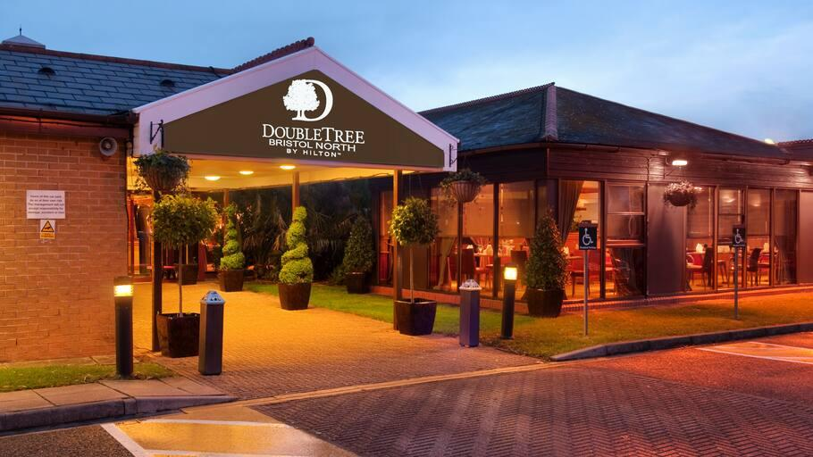
Figure 1: DOUBLE TREE HILTON BRISTOL HOTEL UK
(Source: Hilton, 2023)
Overview
- As a BA 3rd year International Hotel Management student, I got placed in the DoubleTree by Hilton Bristol hotel’s supervisory position of guest service (Hilton. 2023). The guest service manager role is to manage a superior level of satisfaction for the guests by administering the front desk actions. (Johnston, Clark and Shulver, 2012). The responsibilities of a guest service supervisor are hiring and conducting training for the other employees and understanding the guest's expectations and solving guests' problems. Guest supervisor play the role of a mediator between guests and hotel management.
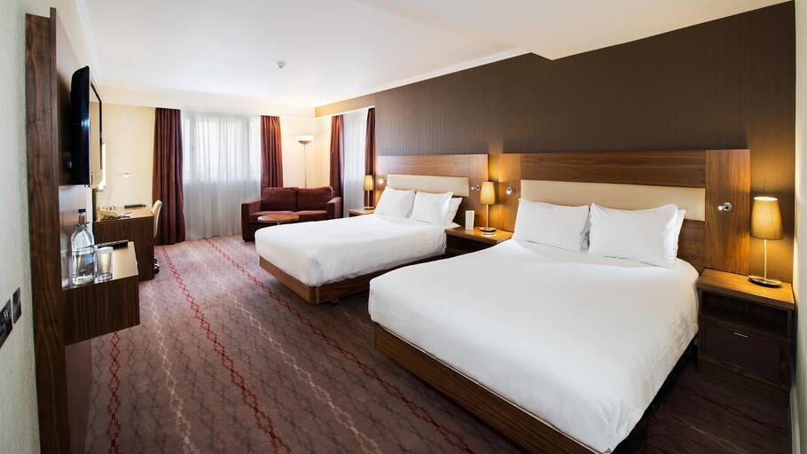
Figure 2: DOUBLE TREE HILTON BRISTOL HOTEL UK
(Source: Hilton, 2023)
Gibbs Reflective Cycle
In this log I will use Gibbs's reflective model to show my learnings and progress.
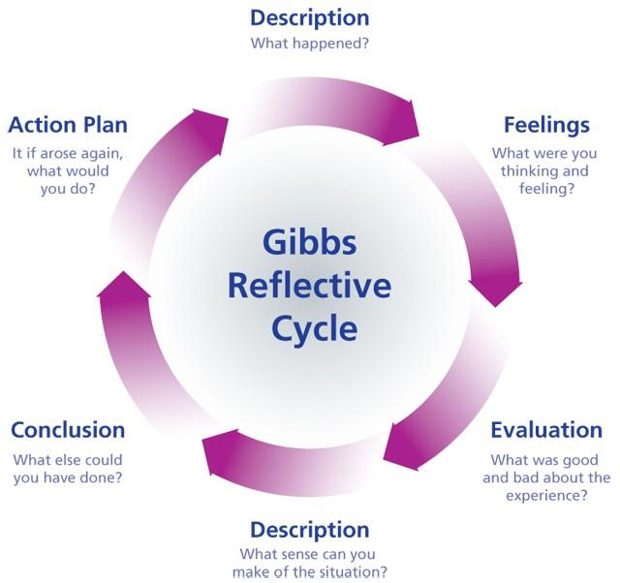
Figure 3: Gibbs Reflective Cycle
(Source: University of Cumbria, 2020)
Description
I am a 3rd-year hotel management student. I was shadowing as a manager guest service operations position at Double Tree Hilton Bristol Hotel UK. As a hotel management student, I chose hospitality management because of what this industry can offer and the opportunities that I have. I have learned different responsibilities such as restaurant and bar functions, reception and concierge services, management, marketing and administration activities. I have supervised reception or front office work (Wiley & sons, 2000-2022), housekeeping, living well club, etc. I have participated in resolving an issue regarding a complain that was made by a group that was supposed to be pick up by a bus reserved by the Double Tree Hilton team. The group waited an hour for the bus to come and, they were students’ minors. Safeguarding was raised and the Double Tree team managed with success to bring another bus in a short time. The manager also made official complain to the bus company and this will be sort it out internally. I have learnt the management procedures in that case (Adeani, Febriani and Syafryadin, 2020).
Feelings
I enjoyed learning all new procedures, policies and how this applied to each complain or issues that must be resolved. So, I feel confident to do these again. After joining my placement, I had some problems with the staff. Was something new for them and for us. Doing the work such as team management, task management, and maintaining punctuality in this practice I have not learned about housekeeping because they are another company contract. I am facing some challenges with the staff and procedures relating to delivering guest services, marketing, guest service strategies, training, and a low number of staff (University of Cumbria, 2020).
Evaluation
The things that went well were the fact that I already had an idea about guest service. Because I have learnt guest servicing in my academic course how to sort out the guests complains as well. But I have a problem with team management and a shortage of employees in my team. Because team members were not cooperative, and I could not understand the tasks at first. That affected my learning a lot. The organisation is having some policy issues, quality issues, and management structural issues. That is affecting guest service including myself. I must look after resource allocation problems and marketing, cultural, health and safety issues that are affecting the guest service experience.

Analysis
I have successfully managed the front desk work and have shown a great outcome in guest services. Housekeeping I was not able to and just a few hours spend in the living well area. I professionally dealt with some guests complains that I have learnt in my academic course. I have a huge problem with professional communication regarding staff members. I am facing problems in teamwork, task management and maintaining punctuality because everyone is working individually. I have tried my best to engage and to learn as much I could. This is my first-time working experience in this industry. And I was interested to accumulate a lot of knowledge regarding the practice experience. The hotel is not paying much attention to the marketing sector and there are some problems with guest service policies. I have understood that I must work on team management skills, increase professional communication skills and organisational issues that are affecting the guest service experience (University of Cumbria, 2020).

Conclusion
From this situation, I have learnt that I must develop my communication skills and team management as well. I think the hotel should improve its health and guest service policies to increase guests' appearance. The Hotel should hire more employees in management teams so that they never face employee shortage issues that affect events and the marketing team to improve and add more publicity to the Hotel. I think I should talk to the other experienced person about how to improve my communication skills regarding to manage the team. I have successfully developed expertise in guest management services and front office tasks. The hotel must look at its organisational issues to increase guest functionality. The hotel should improve its marketing strategy to make itself a brand in the hotel industry (Adeani, Febriani and Syafryadin, 2020). I think I would arrange a training program for employees to improve team management work and to understand the procedures how to improve their time management.

Action Plan

Goal | How to improve | Duration
Communication skill | I have talked to seniors who have more experience in this sector. I should take online classes to improve my skills and utilise my learning in my work. | 4 weeks
Task management skill | I should focus on one task at a time and maintain a schedule of tasks. I can break big tasks into smaller tasks as well. | 2 weeks
Team management skill | First, I must establish good communication practices. I should focus on collaboration and establish a unique development style for managing the team. Staff time management is important. | 4 weeks
Punctuality | First, I must make up my mind that I am currently shadowing, and I have a huge responsibility of a hotel to manage guests and front desk and staff punctuality, etc. | 2 weeks

Conclusion
Here in this learning log, I have talked about my practice as a guest service manager at Double Tree Hilton Bristol Hotel UK. I have reflected on my academic and professional development in this log. I have used Gibbs's reflective cycle to take out my developments. I have found my plus points and my drawbacks. I have found my skills in dealing with complaints, events, guest servicing and front office work. My drawbacks are professional communication skills, team management, task management and punctuality. I have decided to rectify all my drawbacks such as taking a class on communication and talking to the experienced to gather knowledge about task management and team management. I think organisations should clarify their problems as well. They should monitor their marketing strategies and improve their guest policies and staff policies.

References
‌ Casado, M.A., 2011. Housekeeping management. Wiley Global Education. (Casado, 2011)
Adeani, I.S., Febriani, R.B. and Syafryadin, S., 2020. USING GIBBS REFLECTIVE CYCLE IN MAKING REFLECTIONS OF LITERARY ANALYSIS. Indonesian EFL Journal, 6(2), pp.139-148.
ASET and Contributors. 2013. ASET Good Practice Guide for Work based and Placement Learning in Higher Education. [Online] (Available At: https://www.asetonline.org/wp-content/uploads/2017/09/ASET-Good-Practice-Guide-eWBPL.pdf) [Accessed on 10th February, 2023]
Hilton. 2023. DoubleTree by Hilton Bristol North [Online] Available At: https://www.hilton.com/en/hotels/bstbrdi-doubletree-bristol-north/[Accessed On 10th February 2023]
Johnston,R.Clark,G.Shulver,M. (2012) Service Operations Management, Pearson, London.
Kross, E., Ong, M. and Ayduk, O., 2023. Self-Reflection at Work: Why It Matters and How to Harness Its Potential and Avoid Its Pitfalls. Annual Review of Organizational Psychology and Organizational Behavior, 10, pp.441-464.
QAA, 2018 UK Quality Code, Advice and Guidance:Work-based Learning, QAA, London.
Quick, J., Motz, B., Israel, J. and Kaetzel, J., 2020, March. What college students say, and what they do: aligning self-regulated learning theory with behavioral logs. In Proceedings of the tenth international conference on learning analytics & knowledge (pp. 534-543).
University of Cumbria 2020. Gibbs’ reflective cycle. [online] University of Cumbria, University of Cumbria, p.1. Available At: https://my.cumbria.ac.uk/media/mycumbria/documents/ReflectiveCycleGibbs.pdf. [Accessed On 10th February 2023]

Wiley & Sons. 2000-2022. Hotel Front Office Management. [Online] [Available at: https://www.wiley.com/en-nz/Hotel+Front+Office+Management%2C+5th+Edition-p-9780470637524] [Accessed 10 February, 2023].

www.canarytechnologies.com. (n.d.). 14 Creative Hotel Guest Services You Can Offer. [online] Available at: https://www.canarytechnologies.com/post/hotel-guest-services [Accessed 9 Mar. 2023].

skytouchblog (2022). 8 Tried & True Best Practices in Hotel Customer Service. [online] SkyTouch Technology. Available at: https://skytouchtechnology.com/bestpractices-hotelguest-service-quality/.

Polland, J. (n.d.). Hilton Has Ruined The Whole Point Of Staying At A Luxury Hotel. [online] Business Insider. Available at: https://www.businessinsider.com/hilton-hotel-ends-room-service-2013-6?r=US&IR=T [Accessed 19 Feb. 2023].

Pegasus. (2016). 7 ways to turn an OTA guest into a future loyal customer | Pegasus. [online] Available at: https://www.pegs.com/blog/7-ways-to-turn-an-ota-guest-into-a-future-loyal-customer/.

Asksuite | Hotel Chatbot. (2021). How To Improve Hotel Customer Service by Training Staff. [online] Available at: https://asksuite.com/blog/customer-service-in-hotels-tips/.

