JOB ADVERTISEMENT
Jewellery Sales Consultant — Sonny’s Jewellers
Source: SimplyHired.co.uk | Birmingham Jewellery Quarter | Screenshots viewed 13 October 2026
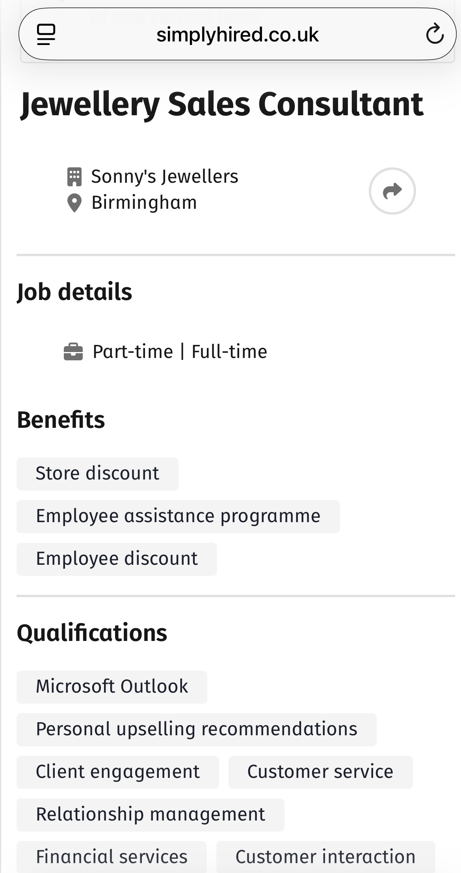 | 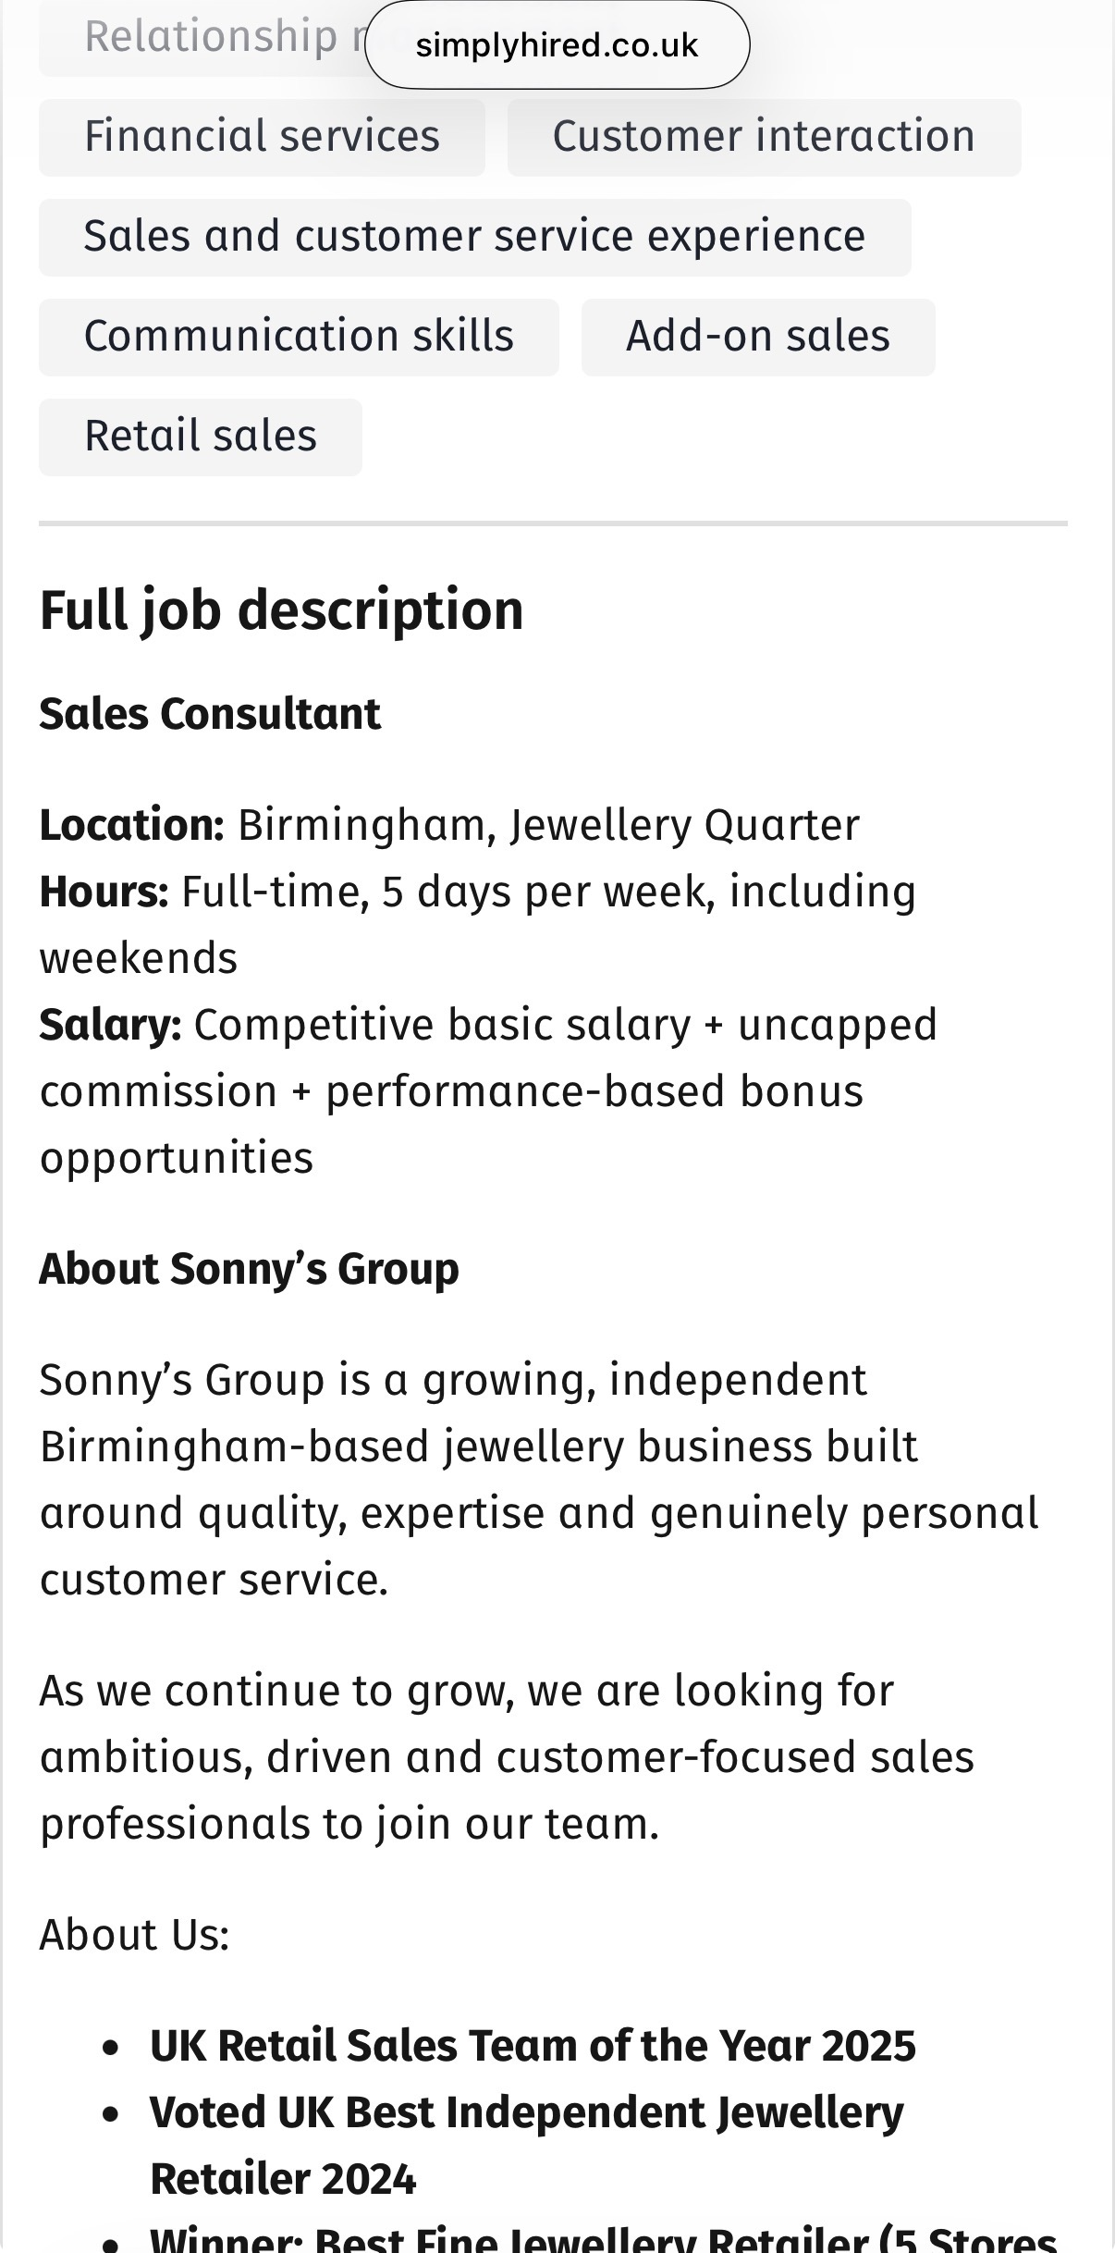
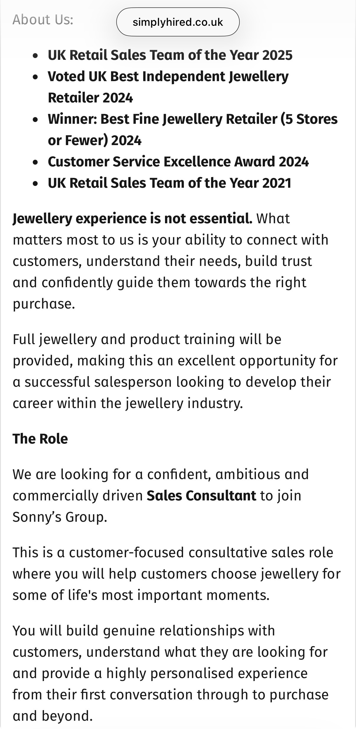 | 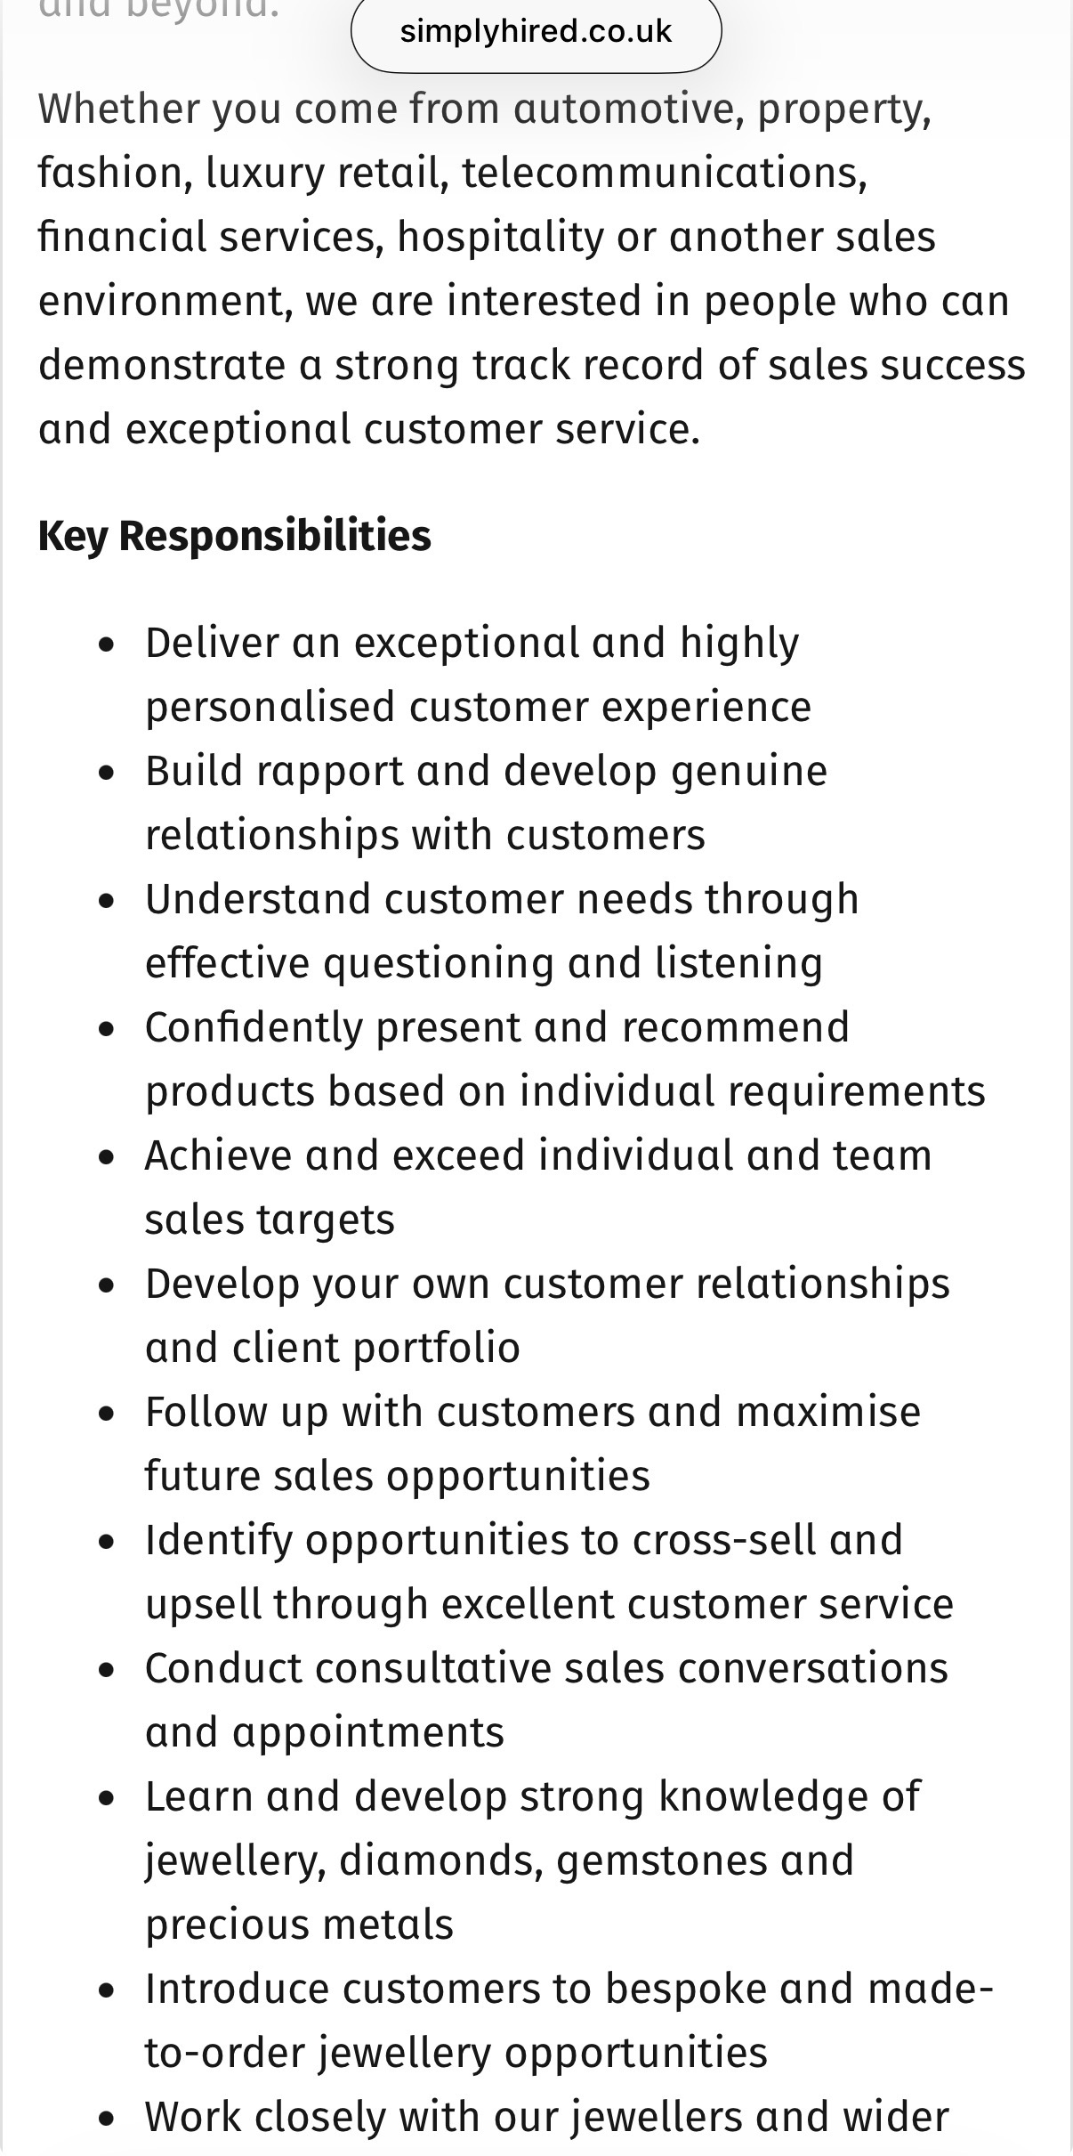

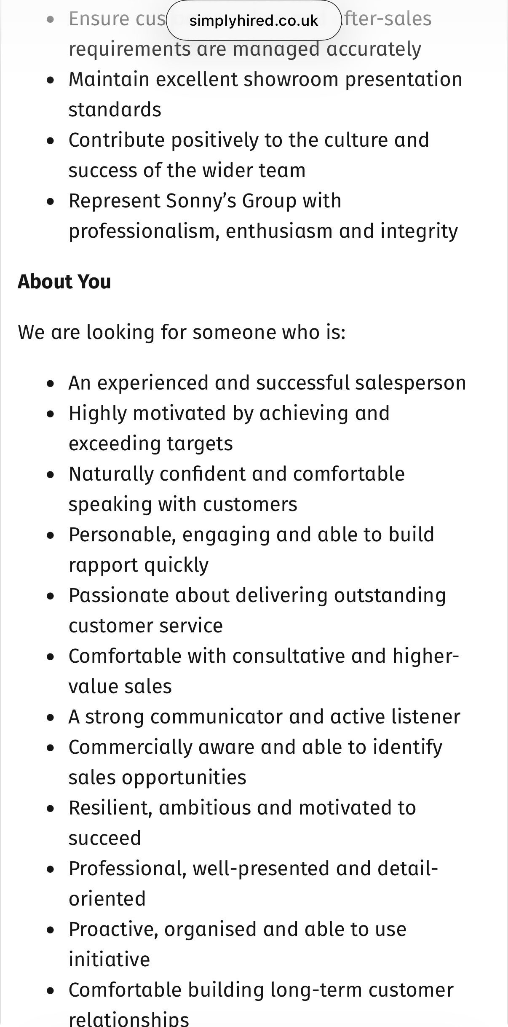 | 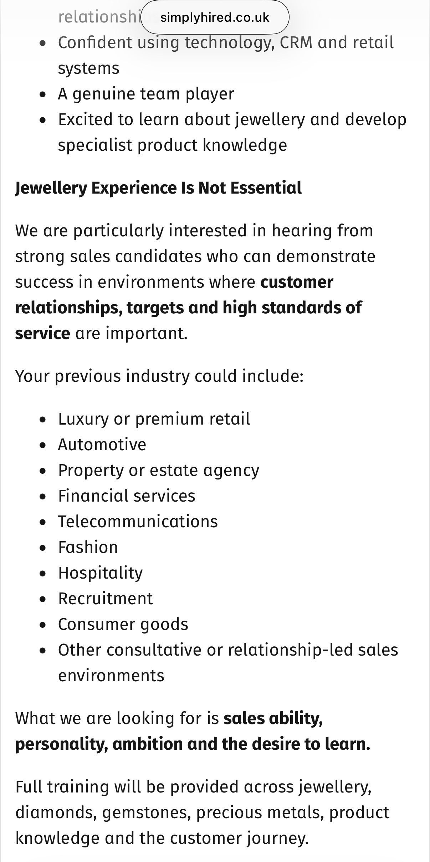
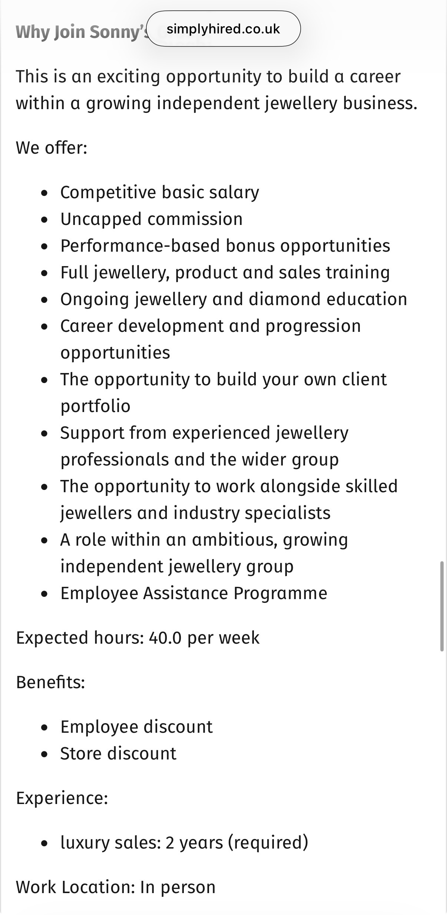

KRISTINA CHUHAI
JEWELLERY SALES CONSULTANT | LUXURY RETAIL
Birmingham, United Kingdom

PROFESSIONAL PROFILE
Motivated, adaptable and customer-focused professional seeking to build a long-term career in the luxury jewellery industry. My background includes customer-facing work in the UK, management and administration experience in Ukraine, and development within the beauty industry. These experiences have helped me build communication, organisation, people skills and the ability to adapt to different responsibilities. I am genuinely interested in fine jewellery, diamonds, gemstones and precious metals. I take responsibility for my own development, enjoy reading and learning, and absorb new information quickly so I can apply it effectively and achieve strong results. I would bring a disciplined, positive and professional attitude to customer service while developing the specialist knowledge required for luxury jewellery sales.
KEY SKILLS
Customer service and clear communication
Building rapport and understanding people
Management and administrative experience
Organisation and taking responsibility
Attention to detail and following standards
Fast learner; committed to continuous development
Interest in jewellery, diamonds and gemstones
Teamwork, adaptability and problem-solving
CAREER OBJECTIVE
To develop into a knowledgeable and trusted jewellery sales professional, combining customer service skills with a genuine interest in fine jewellery. I am particularly motivated to learn about diamonds, gemstones, precious metals and jewellery characteristics through training and practical experience. My longer-term goal is to build strong client relationships and progress within luxury retail.
WORK EXPERIENCE
Customer Service Team Member | Domino’s Pizza, United Kingdom
Provided friendly and efficient customer service in a busy, fast-paced environment.
Communicated with customers and responded professionally to individual requests and enquiries.
Worked under pressure while maintaining accuracy and service standards.
Supported colleagues and contributed to an effective team environment.
Demonstrated reliability, adaptability and the ability to learn procedures quickly.
Production & Packing Operative | Food Manufacturing, United Kingdom
Worked in busy production and packing environments where accuracy and attention to detail were essential.
Followed established procedures, hygiene requirements and quality standards.
Demonstrated reliability, time management and the ability to complete tasks consistently.
Worked collaboratively with colleagues and adapted quickly to different tasks.
ADDITIONAL EXPERIENCE
Club Manager / Administrator | Ukraine
Built experience working with people in a management and administrative capacity.
Communicated with different people and adapted my approach to suit different needs and situations.
Developed transferable skills in organisation, responsibility, coordination and day-to-day problem-solving.
Gained a broad understanding of how to support people and keep activities organised.
Beauty Industry Experience & Development | Ukraine
Developed experience and knowledge within the beauty industry, an area that continues to interest me professionally.
Strengthened my interest in personal presentation, client expectations and the importance of a professional, individual approach.
Continued to invest in personal learning and development, with a focus on expanding my skills and knowledge.
EDUCATION
University of Wales Trinity Saint David (UWTSD)
CertHE Business Skills for the Workplace | United Kingdom
Relevant areas: Employability and Career Development; Business Communication; Problem Solving and Decision-Making; Teamwork; Professional Development.
CUSTOMER SERVICE APPROACH
I believe excellent service begins with listening carefully and understanding what each customer genuinely wants. Jewellery can be connected to important personal occasions, so patience, trust, attention to detail and a personalised approach matter. I would aim to make customers feel comfortable and valued, understand their preferences and help them make an informed choice. I also recognise the importance of being honest about product knowledge and asking an experienced colleague when I need to confirm information.
LEARNING, RESPONSIBILITY & PERSONAL DEVELOPMENT
I take responsibility for my own development and actively look for ways to improve. I enjoy reading, learning new skills and applying what I learn in practice. I learn quickly, respond positively to feedback and work towards strong results. Regular exercise, going to the gym and maintaining a healthy lifestyle are important parts of my routine; they help me maintain discipline, consistency and a goal-oriented mindset. I consider myself a versatile person who is open to new challenges and committed to continuous growth.
LANGUAGES
Ukrainian — Native | Russian — Fluent | English — Working proficiency
INTERESTS
Reading • Personal development • Fitness and healthy living • Luxury jewellery • Diamonds and gemstones • Fashion • Customer experience

COVER LETTER
KRISTINA CHUHAI
Birmingham, United Kingdom
APPLICATION FOR JEWELLERY SALES CONSULTANT

Hiring Manager
Sonny’s Jewellers
105 Vyse Street
Birmingham B18 6LP
13 October 2026
Subject: Application for Jewellery Sales Consultant
Dear Sir/Madam,
I am writing to apply for the Jewellery Sales Consultant position at Sonny’s Jewellers. I am motivated to build a long-term career in luxury jewellery and believe that my customer service experience, communication skills and enthusiasm for learning would help me contribute positively to your team.
I am particularly interested in fine jewellery, diamonds, gemstones and precious metals. I understand that choosing jewellery can be a personal and meaningful experience, so I would aim to make each customer feel welcome, listen carefully to their needs and help them make an informed choice. I would also be careful to give accurate product information and ask an experienced colleague whenever I needed to confirm a detail.
My experience at Domino’s Pizza in the UK has helped me develop customer communication, teamwork and the ability to work effectively in a busy environment. My work in food production and packing has strengthened my reliability, attention to detail and ability to follow procedures. I also bring management and administrative experience from Ukraine, which has helped me develop organisation, responsibility and people skills.
One of my strongest qualities is my willingness and ability to learn. I enjoy developing new skills, absorb information quickly and work hard to apply what I learn to achieve strong results. I would welcome the opportunity to develop specialist knowledge of jewellery and diamonds through training and practical experience, and I am committed to growing into a knowledgeable and trusted jewellery sales professional.
Thank you for considering my application. I would welcome the opportunity to discuss how my skills, motivation and commitment to professional development could contribute to Sonny’s Jewellers.
Yours faithfully,
Kristina Chuhai

