UNIVERSITY OF WALES TRINITY SAINT DAVID
BIRMINGHAM CAMPUS

Entrepreneurship
M5X01926
Assignment 1

Student : Florin Amos
Student ID. : 1815218
Lecturer : Dr David Jenkins

Table of Contents

Introduction 1
Task 1: Critical evaluation the entrepreneurial motivations and characteristics using appropriate academic models 2
Definition of entrepreneurship and the importance of entrepreneurship 2
Different perspectives in understanding entrepreneurship 2
Entrepreneurial traits and motivations 3
The role of the entrepreneur: Managerial versus the entrepreneurial mindset 5
Developing entrepreneurial skills 6
Conclusion 7
References 8

Introduction

Entrepreneurship skill is the variety of skills which can be achieved through observation, analytical ability, and learning capability. The entrepreneurs constantly observe the area, environment to understand the customers’ needs, society’s needs, and the users’ utilities. The necessity for the desired product or services raises the necessity of the initiative taken by the entrepreneurs. The analytical ability, market research capability, and understanding of the behavior of the customers make a successful entrepreneur. The customers want unique products and the entrepreneurs should have the ability to raise the need after innovating a product and spread the usefulness of the product so that the customers needed the product will use it.

Task 1: Critical evaluation the entrepreneurial motivations and characteristics using appropriate academic models
As the report suggests to pick an entrepreneur to conduct this research, Bill Gates, founder of Microsoft Corporation, has been chosen because of entrepreneurial skills and motivations to carry on his successful endeavor.

Definition of entrepreneurship and the importance of entrepreneurship
Entrepreneurship is the thinking to avail the opportunities to make money to invest in some unique projects or business endeavors and the entrepreneurs have to take the financial risk of losing the capital he invested in the business (Audretsch et al., 2015). The available resources, opportunities and drive to lead the passion to create something unique make a person as an entrepreneur. Since the understanding ability of the people’s demand for specific products makes the business successful.
Entrepreneurship has its importance in the economy since the economy is run by the steps taken by the businessmen. The entrepreneurs provide jobs for unemployed people, creates products or services for the customers (Barringer and Ireland, 2008). From the generation of the products or services to the distribution of the products or services, this process relates a lot of people who work in the organization and mend the economy by increasing GDP of the country and making the inflation rate stable by increasing the currency value of the country which as a result cements the economy. The production of unique products by the entrepreneurs makes the life of the customers easier since they are always looking for unique products so that their necessities are fulfilled alongside the unemployment rate decreases.

Different perspectives in understanding entrepreneurship
The entrepreneurial perspective answers the question that how the business works and what the work is to be done to carry on the business process. The business process is seen to be the result for the customers and other stakeholders to fulfill their necessities. The business is a place where the outer results have been produced for the customers and other stakeholders (Burns, 2006). The entrepreneurial perspective says that it all starts with the imaginary picture to be successful and the effort begins to change the present to be the future. The entrepreneurial perspective is an integrated vision that thinks for the people and for the fulfillment of the desire of the people since the people depend on the products and services of the entrepreneurs. A different perspective is necessary to see entrepreneurship as a vision or a well-defined picture and the conversion of which is possible to that well-defined picture if the entrepreneurs want to take the financial risk and apply his entrepreneurial skills to the business.

Entrepreneurial traits and motivations
Bill gates in his early life took the motivation to pursue his career as a programmer from a school program (Butler, 2010). Since he was interested in programming, he competed in the basic GE program in his school days and he was successfully preparing his first computer software for the program where he took all the motivation.
Availability of the resources: From the Timmons model of the entrepreneurial process, it is identified that the resources were available in that time when he wanted to write a software program since the availability of the resources works as a tonic for the entrepreneur. The resources motivated him to write a computer program. When he along with four friends competed in the program, he discovered his leadership skills (Cooney, 2012). According to Timmons, the three components such as opportunity, resources, and team are necessary to conduct an entrepreneurial project which provided him motivation. The drive to do something for his satisfaction leads him to be a programmer in his early days. The leadership skills can work the resources to make the business successful. Because of his leadership skills, he was able to write the software program and helped his team to win the program (Fairlie and Holleran, 2012). The leadership skill creates a way to do something for the customers and to innovate something which will fulfill the necessity of the entrepreneurs’ inner mind and the resources can image the idea of the entrepreneurs sometimes since the availability of the resources can help him to think forward and innovate something unique to capitalize the resources.
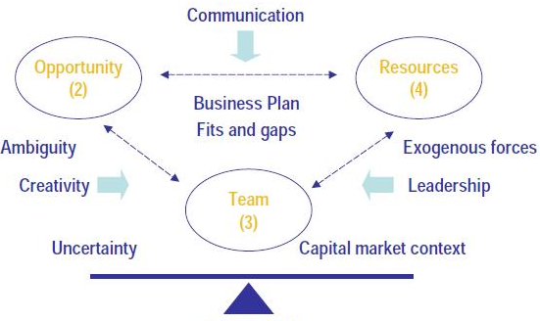
Figure 1.0: The Timmons model of the entrepreneurial process
(Source: Timmons and Spinelli, 2008)
Imaging the future success: The entrepreneurs see the future and try to transform the present to the future. Bill gates in his early days of programming have been able to predict the future of the information technology and work on achieving the necessary skills to convert the present to the future (Williams, 2009). The prediction became true which made him the most successful entrepreneurs of all time. From the Timmons entrepreneurial process, the opportunities helped him to predict the future and the resources were available and his team helped him to achieve success (Galindo and Méndez‐Picazo, 2013). The team which has the same dream Bill gates predicted in the past. The opportunities, availability to ample spaces to create new things and the group make his endeavor successful.
Characteristics:
Self-motivation: The self-motivation is the key to success for the entrepreneurs since the motor drives the passion of the entrepreneurs to create his business successfully. Bill gates motivated him by predicting the future (Hisrich et al., 2008). The three C’s models of entrepreneurial success in this case made him optimistic and provided him an openness to work on his curiosity.
Risk-taking ability: The entrepreneurs have to take the financial risk since the business can be unsuccessful. The three C’s model has provided him creativity and imagination power to predict the future. Correctly identification of the future by the imagination power can make any business successful.
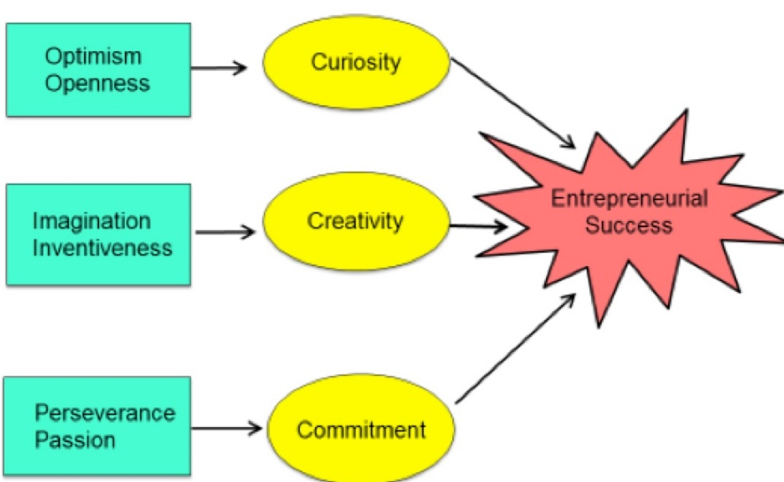
Figure 2.0: The three C’s model of entrepreneurial success
(Source: Timmons and Spinelli, 2008)
Passion: Passion is the thing that makes the entrepreneurs believe that he can achieve success. Since he has applied curiosity, creativity in the business and the commitment to drive success can make him successful (Toma et al., 2014).

The role of the entrepreneur: Managerial versus the entrepreneurial mindset
Entrepreneurs have a different role in the organization. Most importantly they must have the leadership skills to conduct the business. The leadership skills provide the flexibility to the entrepreneurs to adopt managerial skills or entrepreneurial skills in different situations. The skills attitude directs the entrepreneur to grab managerial skills in the organization (Rae, 2008). The entrepreneur needs to have managerial skills that are directed by different skills of him. The behavioral skills make the way for the entrepreneurs to shape the behavior of the people working in the organization. Because of these two attributes, the entrepreneurs become managers or entrepreneurs (Zimmerer and Scarborough, 2011). Motivating the people by the speech of the entrepreneur is a difficult thing to do since the people are motivated and directed by other individuals, only they are directed by the entrepreneurs to take the required behavior which will generate the best results for the organization.

Developing entrepreneurial skills
To be a great entrepreneur, the person wishing to be an entrepreneur needs to have some of the mentioned skills, and the skills if not existed within can be developed by the constant practice.
Curiosity: Curiosity is the skill that is generally developed within a person. This skill creates new and unique products for the customers (Rickman and Roddick, 2013). The curiosity and drive to create new things for the self-content of the entrepreneur are driven to achieve great things.
Time management: Time management skills of the entrepreneurs can be developed through constant practice to be disciplined since the entrepreneurs who are not disciplined and serious about the time management cannot motivate the employees to be disciplined.
Strategic thinking: The prediction of the future is the ability of the entrepreneur which helps him to predict the future and he can work on his prediction (Sexton and Bowman-Upton, 2011). Strategic thinking can be developed by practicing analytical ability and solving reasoning questions.
Networking: The networking skills can be developed by constantly connecting with people by the amiable behavior of the entrepreneur since the connectivity is the key for any business which provides and creates a network for the business.

Conclusion

Since the entrepreneurs apply optimism, curiosity, commitment, imagination power, they have to be successful if they can predict the future correctly. The entrepreneurs help the economy to make the value of the currencies. They create options for the unemployed people and raise the standard of living gradually. The government and other stakeholders knowing the importance of the business emphasize the business in any country.

References
Audretsch, D.B., Belitski, M. and Desai, S., 2015. Entrepreneurship and economic development in cities. The Annals of Regional Science, 55(1), pp.33-60.
Barringer, B. R. & Ireland, R.D. (2008) Entrepreneurship: Successfully Launching New Ventures, 2nd Ed., Prentice Hall:New Jersey
Burns, P. (2006) Entrepreneurship and Small Business, 2nd Ed., Palgrave Macmillan: Basingstoke
Butler, D. (2010) Enterprise Planning and Development: Small Business and Enterprise Start-up Survival and Growth. Routledge.
Cooney, T.M., 2012, November. Entrepreneurship skills for growth-orientated businesses. In Report for the Workshop on ‘Skills Development for SMEs and Entrepreneurship, Copenhagen (Vol. 28).
Fairlie, R.W. and Holleran, W., 2012. Entrepreneurship training, risk aversion and other personality traits: Evidence from a random experiment. Journal of Economic Psychology, 33(2), pp.366-378.
Galindo, M.Á. and Méndez‐Picazo, M.T., 2013. Innovation, entrepreneurship and economic growth. Management decision.
Hisrich, R.D., Peters, M.P. & Shepherd, D.A. (2008) Entrepreneurship, 7th Ed.,McGraw Hill: NY
Rae, D. (2008) Entrepreneurship: from opportunity to action, 2nd Ed., Basingstoke: Palgrave Macmillan
Rickman, C., & Roddick, D. (2013) The Small Business Start-Up Workbook: A step-by-step guide to starting the business you’ve dreamed of. London, How To Books
Sexton, D.L. and Bowman-Upton, N.B., 1991. Entrepreneurship: Creativity and growth. New York: Macmillan.
Timmons, J. & Spinelli, S. (2008) New Venture Creation: Entrepreneurship for the 21st Century, McGraw Hill: Boston
Toma, S.G., Grigore, A.M. and Marinescu, P., 2014. Economic development and entrepreneurship. Procedia Economics and Finance, 8(0), pp.436-443.
Williams, S. (2009) FT Guide to Business Start Up 2009: The only annually updated guide for entrepreneurs, 4th Ed.,Financial Times Press: Harlow.
Zimmerer, T.W. & Scarborough, N.M. (2011) Essentials of Entrepreneurship, 6th Ed., Prentice Hall: New Jersey

