
NAME: Alina Olaru
ID: 2123361
Evaluating the interests of Individual British Investors in Dubai’s Short-Term Rental Market: A Focus on Airbnb Partnerships

BA (Hons) Developing Leadership and Management

July 2025

Declaration
This work has not previously been accepted in substance for any degree and is not being concurrently submitted in candidature for any degree.
Signed: Alina Olaru
Date 15/07/2025
STATEMENT 1
This dissertation is being submitted in partial fulfilment of the requirements for the degree of BA.
Signed: Alina Olaru
Date: 15/07/2025
STATEMENT 2
This dissertation is the result of my own independent work/investigation, except where otherwise stated. Other sources are acknowledged by footnotes giving explicit references. A bibliography is appended.
Signed: Alina Olaru
Date: 15/07/2025
STATEMENT 3
I hereby give consent for my dissertation, if accepted, to be available for photocopying and for interlibrary loan, and for the title and summary to be made available to outside organisations.
Signed: Alina Olaru
Date: 15/07/2025
STATEMENT 4
I hereby give consent for my dissertation, if accepted, to be available on the university’s IT system to those who have consent to use the system.
Signed: Alina Olaru
Date: 15/07/2025

Table of Contents
Chapter 1: Introduction 7
1.1 Research and organisational background 7
1.2 Outline of the issue/problem or challenge being researched 7
1.3 Research aim and objectives 8
1.4 Research questions 8
1.5 Rationale of the research 9
Chapter 2: Literature Review 10
2.1 How investors set goals for building a portfolio 10
2.2 Historical context of investment in the rental and property market 10
2.3 Review of emerging markets and their attractiveness for investors 11
2.4 Digital Transformation and the Influence of Airbnb 12
2.5 Strategic investment drivers in the short-term rental market 13
2.6 Emerging challenges as well as opportunities 15
2.7 Theoretical underpinnings of investment behaviour 16
2.7.1 Maslow’s hierarchy of needs in Real Estate Investment 16
2.7.2 The convergence of digital and traditional investment models 16
2.7.3 Investor psychology and behavioural finance 16
Chapter 3: Methodology 19
3.1 Aims and Objectives 19
3.2 Research Rationale 19
3.3 Research Design 20
3.4 Research Paradigm 21
3.5 Data Collection 21
3.6 Population and Sample 22
3.7 Data and Analysis 22
3.8 Reliability and Viability 22
3.8.1 Limitations of the Research 23
3.9 Research Ethics 23
Chapter 4: Analysis and Discussion 24
4.1 Presentation and Interpretation of the Data 24
4.1.1 Introduction 24
4.1.2 Questionnaire 24
4.2. Discussion 35
Chapter 5: Conclusion and Recommendations 41
5.1. Conclusion 41
5.3. Recommendations 42
References 44
Appendix: Survey Questions 52

List of Figures
Figure 4.1: Primary motivations for investing in short-term rentals 24
Figure 4.2: Location of Dubai for attractive short-term rental investments 25
Figure 4.3: Importance of regulatory environment for making investment decisions 26
Figure 4.4: Factors regarding investments in short-term rental markets in Dubai 27
Figure 4.5: Planning finance in Dubai’s short-term rental market 28
Figure 4.6: Acceptable occupancy rate for Airbnb investment 29
Figure 4.7: Likelihood to invest in the short-term rental market of Dubai 30
Figure 4.8: Preferred property for short-term rentals in Dubai 30
Figure 4.9: Interest in using investment advisory service 31
Figure 4.10: Impact of Airbnb’s brand reputation on the decision to invest in short-term rentals in Dubai 32
Figure 4.11: Consideration of direct partnership with Airbnb 33
Figure 4.12: Support that can encourage investment in Dubai’s short-term rental market 34

Acknowledgement
While developing the research on the topic “Evaluating the interests of Individual British Investors in Dubai’s Short-Term Rental Market: A Focus on Airbnb Partnerships”, I have come across different people for whom my bag of knowledge over the subject is filled. Firstly, I can say that my mentor Marie Pitson has supported me wholeheartedly in completing the research thoroughly. Secondly, my friends and my parents always encouraged me a lot to be engaged in each stage of the research and collect data relevant to my topic. Lastly, I have knowledge on discussing the topic with my relatives also.
With regards,
Alina Olaru

Chapter 1: Introduction

1.1 Research and organisational background
Dubai is known to be a global leader in the field of innovation in real estate and tourism. The property market, in its own dynamic way, favourable taxation policies, robust infrastructure and high standards of service have attracted much international attention, including from British property investors (Vij and Rizwan, 2022). Dubai has been through a sudden change in recent years, with the coming of the sharing economy, platforms such as Airbnb in particular (Frankporter, 2018). This shift has been a flexible and profitable way for investors who would otherwise have preferred long-term rental or even commercial investment.
Dubai’s short-term rentals are fast becoming of interest to individual British investors as they diversify their portfolio and appetite for intermarries (Vij and Rizwan, 2022). Real estate investments have become desirable to individuals that facilitate them, which have started to expand their offerings for this segment of the market as a matter of necessity, that is, combining traditional property investment principles with the novel approaches in the constitution of Airbnb’s operations (Kashanizadeh et al., 2024). The changing landscape has therefore led to the need for research into the decisions of individual British investors concerning new age partnerships in property management and investment, especially through Airbnb. Combining perspectives from the property management experts, regulatory authorities, as well as financial analysts, the research offers a multi-dimensional view of the changing market dynamics. This aim underlies the attempt to gain insights into individual investor behaviour at a nuanced level to inform stakeholders, like government policymakers and private enterprises, regarding the creation of a more supportive framework for international real estate ventures.

1.2 Outline of the issue/problem or challenge being researched
Due to its image as an attractive destination for robust economic growth and booming tourism industry, individual British investors experience a heterogeneous portfolio of opportunities and challenges when working with the short-term rental market in Dubai (Linkedin, 2025). The regulation is one of the core challenges, particularly as it can be complex as the legal practice in Dubai is different from that in the UK. Uncertainty and increased perceived risks are introduced by regulatory discrepancies, evolving guidelines, and stringent operational requirements (Settembre-Blundo et al., 2021). The market is also highly competitive and undergoes rapid technological change. Investors must decide how volatile relying on a platform like Airbnb can be compared to traditional investment risk (Frank,2025) 2025). However, it is often difficult for investors to fully understand the short-lived legal framework which governs short-term letting in specific areas (Autio et al., 2023). This can act as a significant deterrent because the lease conditions, property rights, and taxes are unknown. Airbnb partnerships increase the possibilities of having access to a huge customer base and reducing the complexity of property management, however, they bring in operational challenges. Maintenance of property standards and dealing with guest expectations are among these, whereas occupancy rate fluctuations directly affect profitability (Candra et al., 2023). In Dubai, something may be as common as Culture, business environment, and guest preferences and service expectations may be completely different from the UK. This divergence can lead to complications in making decisions and executing operations.

1.3 Research aim and objectives
The aim of this research is to evaluate the factors that drive individual British Investors in Dubai's short-term rental market like Airbnb. The objectives of this research are:
- To evaluate the factors that drive individual British Investors in Dubai's short-term rental market like Airbnb.
- To assess the role of Airbnb in giving investment opportunities to individual British investors.
- To identify challenges individual British investors face in the Dubai short-term rental market.
- To provide recommendations for enhancing investor experience and optimising Airbnb partnerships in Dubai.

1.4 Research questions
- Which elements of Dubai's short-term rental industry appeal to individual British property investors?
- How do individual British investors decide about business opportunities through Airbnb partnerships?
- What obstacles did individual British investors encounter while beginning operations and taking control of short-term rental properties in Dubai, particularly through Airbnb?
- What measures should Dubai government officials and Airbnb operators take to enhance investment conditions for international investors?

1.5 Rationale of the research
There are several rationales for this research to occur. But the study itself is essentially about trying to explain what made individual British investors join Dubai’s short-term rental market with Airbnb. The short-term rental sector is growing at alarming rates in large cities across the globe, and as such. a focus on how international investors navigate the changing landscape of this new industry is essential (Antunes and Ferreira, 2021). The study fills a gap in the literature related to cross-cultural investment strategies, digital platform integration and interaction between the regulatory environment and the entrepreneurial decision-making.
The research analyses specific factors that attract individual British investors in order to find issues in investor motivation (market potential, diversification strategy, innovation in technologies, or any combination of these factors). Yet, in conceiving rational proposals, it is necessary to know what reversible inhibitors of investor success.

Chapter 2: Literature Review
​Real estate investment, technological advancement and investor behaviour are the subject of the literature review, where the landscape of real estate investment is evolving. Examining the trends of changing investment strategies through digital platforms, the psychological basis of determination of investors’ decisions, additional challenges for such platforms, and possible new opportunities in the short-term rental market.

2.1 How investors set goals for building a portfolio
British investors in Dubai’s short-term rental industry want high-return prospects, notably Airbnb partnerships. British investors are using Airbnb to manage homes remotely because of Dubai's tax-free revenue, expanding tourism and flexible rules. According to Liuzzo (2023), goal-based investing entails the investor having their strategic goal in becoming financially oriented, regarding their own objectives based upon the specified schedules that the investor chooses for the investments, which they create after getting advice from professionals. This approach starts off by identifying specific and measurable goals such as saving for retirement, buying a house, and funding education (Jover and Cocola‐Gant, 2023).
It is needed to evaluate goals on their time horizon and financial needs to account, among other things, for inflation, expected returns, and so on. Then, the investor evaluates a measure of his risk tolerance and capacity, as to whether or not the selected vehicles of investment have been chosen in accordance with his comfort level and finances. As per Cochrane (2022), investors usually build a portfolio with such a mix of asset classes that the mix aims to balance risk and return to meet investors’ goals and time frames. Regular monitoring and rebalancing of the portfolio on a periodic basis is required to track changes in market conditions and the changing situations of the investor so as to keep up with the evolving goals of the investor regarding the investment strategy. On the other hand, Alrawabdeh, 2022 noted that, As a consequence, investors can make well-informed decisions, stay on track with their long-term goals, and can adapt to the changing situation over time.​

2.2 Historical context of investment in the rental and property market
British investors have always preferred Dubai’s property market owing to its tax-free profits, political stability and high rental yields. Dubai’s real estate market has attracted UK diversifiers since the early 2000s and Airbnb has made short-term rentals more flexible and profitable that making them attractive to British investors wanting to capitalize on tourism and Dubai's worldwide appeal. As per the description of Cohen (2024) the first shareholders of the Dutch East India Company brokered equity stakes through informal gatherings and enforced such an arrangement relying on reputation-based enforcement, an ‘extra-legal’ system that preceded formal court oversight and structured trading venues. What Swanzy-Impraim et al. (2021) add to this is that even if there is a central bourse established in 1796, trading continued to be organised in self-governing clubs, and thus fragmented price information and wide bid-ask spreads persisted well into the nineteenth century. Taylor (2022) demonstrates in the modern era, as in the history of finance, that the move to electronic trading platforms and longer hours of market has measurably improved the diversification and risk-adjusted return of retail investors, providing economic support for greater market access. According to Guttentag et al., (2018), the real-time data feeds and low-cost online brokers 'democratised finance' allow individuals to use sophisticated strategies unavailable to any but the institutional actors.

2.3 Review of emerging markets and their attractiveness for investors
UK individual property owners should invest in Dubai because its regulatory structure protects guest safety and investment trust and tech-enabled Airbnb services boost visibility. According to Wijburg et al., (2025), emerging markets can be characterised by evolving regulatory frameworks, rapid economic growth, as well as significant infrastructural advancements, which have successfully captured the attention of different global investors. As per Angelov (2024), the diversified investment benefits and exceptional growth potential of the emerging markets are the main reasons why investors are showing interest in investing in emerging markets. Industrial expansion and dynamic urbanisation in these regions are creating opportunities for investors in long-term strategic returns. The current evolution of Dubai into a metropolitan city has been embedded into high-speed urban transformation. According to Adel (2020), the infrastructural investments made in the city, which spans state-of-the art hospitality, transportation and innovative urban planning, has created such an environment that improves the appeal of real estate investments.
All of these advancements are directly contributing to robust rental yields and increased property values. As per Zaidan and Abulibdeh (2021), in Dubai, investors are benefitting from a proper synergy between the dynamic local environment and large-scale urban renewal projects that are able to cater for the different opportunities for both business tourism and leisure. Due to this urban vibrancy, it is not only possible to attract a consistent influx of tourists but also to create different opportunities for investors seeking both long-term growth and short-term returns. Zaimovic et al. (2021), suggest that investors have long been attracted to emerging markets to realize higher returns and diversify risk off. However, these markets, in the form of Asia, Latin America and some parts of Africa, create markets fuelled by fast economic growth, great demographics and the force of integration into the global economy. Vîrjan et al. (2023) described that investors are attracted to the idea of capitalising during the period of economic expansion and the growing consumer base in these regions. Relatively low valuations and strong corporate earnings growth also help attract the allure of emerging markets. Key emerging market corporates are suggested by analysts to outearn developed market corporates, which makes them attractive investments.
Favourable currency valuations, strong economic fundamentals as well as rising commodity prices are also boosting their attraction. Nevertheless, investments in emerging markets are not easy. According to Iriani et al. (2024), political instability, regulatory uncertainties, market volatility, are the things that investors have to go through. According to Dinan (2024), all of these risks are why emerging markets are such an attractive addition to a well-balanced investment portfolio because of the high return potential and diversification that it provides. These markets are ready to take their place in the realm of investment and preferably, this role is increasing every day as global economic dynamics evolve.

2.4 Digital Transformation and the Influence of Airbnb
Airbnb’s AI-driven customization, cloud infrastructure and key alliances like Dubai’s DET have improved distant work and tourism. These innovations draw British investors to Dubai’s burgeoning short-term renting industry. Airbnb’s marketing, dynamic pricing and regulatory compliance help investors maximize profits. As per Zeqiri (2024), digital platforms like Airbnb have entirely redefined the entire investment landscape in the entire world while streamlining the process from guest management to property listing. The global reach of Airbnb is providing investors with some extensive market exposure, which has been helpful in terms of tapping into the vast network of international and local tourists. Ekeroma (2023) described that the platform of Airbnb is quite user-friendly and is coupled with lowered operational complexities and a data-driven pricing model, which has decreased the traditional complexities associated with short-term rentals. From the perspective of the individual British Investors, leveraging Airbnb can be associated with gaining some real-time insights of customer preferences and market trends. As per Emma (2024), real-time insights into customer preferences and market trends can allow investors to adjust their marketing strategies and pricing as per the demands of the current times.
Additionally, the successful integration of different digital tools into property management has been quite helpful as a strategic asset in terms of mitigating the risks associated with cross-border investments. Niemi (2025) described that automated booking systems, advanced analytics and CRM (customer relationship management) platforms have been helpful in reducing overheads, streamlining daily operations and ensuring proper service delivery. Such technological solutions are not only helping to improve operational efficiencies but also providing investors with some comprehensive dashboards so that they can monitor occupancy rates and performance rates. This has resulted in a significant reduction of cognitive load for investors, which has allowed them to be focused on strategic decision-making instead of routine operational tasks.
As opined by Onabowale (2024), data can be described as the cornerstone of informed investment strategies in this digital age. Platforms like Airbnb are successfully offering robust and effective analytical tools that can provide some detailed and effective market insights, ranging from seasonal pricing variations to regional occupancy trends. It is now possible for investors to leverage these specific tools for forecasting market behaviour and optimising yield management while making some data-backed investment decisions. As per Aalijah (2025), strategic and effective usage of different market analytics have been useful for investors to successfully identify the emerging micro-trends within the extensive market dynamics. This can be helpful for investors in terms of positioning themselves at the forefront of investment opportunities. Such data-centric approach is not only improving the immediate financial performance but also supports the effective and efficient long-term strategic planning.

2.5 Strategic investment drivers in the short-term rental market
High tourism, high occupancy and government-supported digital nomad programs like Airbnb’s relationship with Dubai’s DET stimulate strategic investment in Dubai’s short-term rental industry. As per Ndaguba and Van Zyl (2024), the strategic investment drivers in the short-term rental market are related to optimising of the financial performance, mitigating of the operational risks and increasing of the efficiency from the digital platform. The primary driver is revenue and the real human intelligence behind these decisions are used machine learning based dynamic pricing to adjust nightly rates throughout the course of the night and with local events to boost the revenue up to 15% over fixed pricing decisions. Another critical consideration that arises from portfolio diversification is that of blended holdings which comprises of residential apartments, serviced apartments, as well as luxury villas used by investors to spread idiosyncratic risks, improve liquidity options as well as align with the principles of Modern Portfolio Theory in real estate frameworks. Gu (2024) described that peer-to-peer platforms market disintermediation halving transaction costs by diminishing the need for brokers and property manager while opening up competition in the high demand locations to small investors. Strategic site selection is also relevant to amenity driven value capture, given the correlation between these locations and better performing occupancy rates and average daily rates, and considering a location as a core determinant of investment performance.
Additionally, it has been observed by Gu (2024) that the dynamic nature of Dubai’s market is necessitating some higher degree of operational agility, where it is necessary for the investors to continuously refine their strategies in response to the existing regulatory changes, competitive pressures and fluctuating tourist demands. As per Jat et al. (2023), higher levels of operational as well as functional agility can be achieved with the proper combination of continuous market research, innovative technology adoption and some proactive risk management. Additionally, it has also highlighted that the investors who have successfully embraced adaptive strategies are quite better positioned to optimise their investment strategies and decisions in this existing volatile markets. With the help of effective strategic adaptations, it is possible to secure not only short-term gains but also an effective way for long-term capital growth, which can reinforce the overall investment resilience in the current times.
As per Echeverri et al. (2021), short term leases provide operational flexibility that allows investors to switch between personal use and revenue generation, both of which contribute to an increase of utility maximization, and add a protection from tourism sector downturns. Similarly, regulatory arbitrage influences strategic decisions since investors tend to discount jurisdictions whose licensing regimes are more streamlined and compliance guidelines clearer, which consequently reduces legal uncertainty and shields return thresholds. Marketing advantages and reputation effects come from partnership with established platforms integrating paragraph review systems and global distribution channels, even in listing which raised occupancy and achieved premium pricing due to their rating. According to Adewale (2024), strategic decision making takes place undergirded by data analytics and predictive modelling that enables investors to predictively analyse historical occupancy and pricing trends, which in turn helps optimize capital improvement and promotional campaign with evidential forecasts using the data. Risk adjusted return considerations get to asset allocation, calling for markets with stable demand elasticity and manageable supply growth for the benefit of downside protection and stable yield profiles against various other real estate investments.

2.6 Emerging challenges as well as opportunities
In this context, one of the less quantifiable yet significant challenges involve the sociocultural differences that can impact investment operations. From the perspective of the individual British Investors, they may encounter challenges related to negotiation style, local business customs of Dubai and proper community engagement. Musili (2024) described that cultural barriers during property investment can impact everything from daily property management to the formation of contract negotiation. In order to overcome these specific barriers, it is necessary to have cultural competence in addition with proper establishment of local partnerships that can bridge the gaps while facilitating effective and smoother operational integration in the current times.
As per Wang et al. (2024), the short-term rental market in the UK is a dynamic place with challenges and opportunities. The most important obstacle is precisely measuring the market dynamics, as the lack of transparency and the vectors of cross data sources render this almost impossible, and such a day is needed to perform proper due diligence for UK capital. In addition, regulatory fragmentation in different jurisdictions left little choice but to form local partnerships and specialist advisory networks to minimise risks. On the other hand, technological developments bring rich chances. According to Ndaguba and Van Zyl (2024), the dynamic pricing analytics allow investors of residential apartments to increase their nightly rates and increase their yield management without depending on local intermediaries. Among the critical enablers of UK investors to remotely manage serviced apartments and villa portfolios with greater efficiency are automation technologies like self-check-in kiosks and AI-driven guest communication systems.
Roberts (2023) described that diversification of portfolio by asset types such as urban apartments, luxury villas and branded residences helps investors to ride on the segmented demand cycles and mitigate single market volatility. Overall, UK investors must sift through data opacity and pass judgments through regulation or operating a business in the short-term rental sector in a way that provides clear improvements to revenue management models, automation technologies and targeted segmentation strategies that let them outperform other investors.

2.7 Theoretical underpinnings of investment behaviour

2.7.1 Maslow’s hierarchy of needs in Real Estate Investment
After drawing on the aspects of Maslow’s hierarchy of needs, it is possible for the existing scholars to offer some multidimensional interpretation of effective investor behaviour. According to Ahmad (2021), the physiological needs of different persons must be managed in order to ensure that their motivation and effectiveness level has been maintained successfully. From the perspective of the investors, physiological needs are associated with predictable rental income and stabilised cash flow. After the basic requirements of a person are met, attentions are made into different higher-level aspirations such as social recognition, safety as well as self-actualisation (Omodan, 2022). With the help of the application of this specific theoretical framework, it is possible to provide some clear rationale regarding why individual British Investors are willing to be engaged in different types of cross-border investments despite the inherent risks. They are actively seeking not only financial returns but also the prestige and personal fulfilment associated with successful high-value transactions.

2.7.2 The convergence of digital and traditional investment models
As per the description of Özdilek (2024), digital platforms can serve as a proper bridge between the modern digital economy and traditional real estate practices. Due to this convergence, it has been observed that the existing investment strategies have evolved to include both contextual adaptive aspects and data-driven aspects. Appropriate theoretical integration of classical investment models and digital analytics are enabling investors to mitigate the risks of investments while successfully capitalising on the emergent opportunities. After successfully aligning different investment activities within Maslow’s framework, investors are able to properly satisfy both intangible desires for self-improvement and status with tangible financial needs.

2.7.3 Investor psychology and behavioural finance
As per the research done by Zik-Rullahi et al. (2023), behavioural finance emphasises the fact that investment decisions are not only associated with the psychological factors but also can be associated with the existing market fundamentals. For example, from the perspective of individual British Investors in Dubai, a range of different factors such as risk tolerance, cognitive biases, and cultural influences play a significant role in shaping investment strategies. D’Acunto and Rossi (2023) also described the importance of digital strategies and tools in shaping investment decisions in the current times. This is because it is possible for digital platforms to further influence investment decisions by providing a continuous stream of data and market signals. These aspects can either alter or reinforce investor behaviour in the current times. Therefore, it has become quite important to successfully understand the psychological underpinnings so that proper strategies can be made while properly aligned with market realities and investor motivation.
2.7.4 Tobin’s theory of investment behaviour
Tobin’s theory of investment behavior says that investment becomes beneficial when a firm’s market value surpasses its asset replacement cost. British investors in Dubai’s short-term rental sector, notably through Airbnb agreements, benefit from Tobin’s Q. As per Mysaka and Derun (2021), integrating Tobin's q theory based on the application of Maslow's hierarchy of needs in real estate investment provides a complementary economic perspective on the investor behaviour. According to Mysaka and Derun, (2021), Tobin’s q theory claims that investment decisions are determined by the ratio of the market value to the cost of replacing an asset. When this ratio is greater than one, it means that the market considers the asset to be worth more than its replacement value, and hence, the element to initiate new investments. According to Mysaka and Derun, (2021), such a theory, in the case of real estate, assumes that investors are more inclined to invest in property markets where the market value of properties far exceeds the cost of construction of new ones. Such a situation can cause an enhanced development volume in the areas where the property price is higher than the building costs. Nevertheless, the q ratio cannot be used as an accurate measure for replacement costs for various reasons, including competing influences such as market speculation and intangible assets (Ishaq et al., 2021). Maslow’s hierarchy of needs, along with Tobin’s q economics theory, is united through a combined motivational approach for the real estate sector. While Maslow’s framework captures the intrinsic human needs at the heart of investment decisions, Tobin’s q allows one to quantify the attractiveness of investment opportunities based on market valuation.
While existing literature on international property investments and digital platforms is extensive, there remains a notable gap in understanding the micro-level challenges faced by UK investors across different investment segments. Much of the research focuses on broader economic trends, regulatory frameworks, and technological advancements, often overlooking investor-specific concerns such as varying levels of technological literacy, cultural expectations, and platform usability. In particular, little attention is given to how different investor profiles, ranging from seasoned professionals to first-time buyers, interact with digital tools, adapt to new markets, or navigate operational complexities. Moreover, while the advantages of platforms like Airbnb are well-documented, limited research explores how these platforms influence long-term investor satisfaction beyond financial returns. There is a pressing need for more nuanced, context-specific studies that capture the diverse experiences of UK investors, offering insights into how digital engagement and localised practices shape investment outcomes in real estate markets.
Dubai’s short-term rental market offers individual British investors a potent mix of urban dynamism, regulatory support, and digital innovation. The convergence of advanced infrastructure, proactive government reforms, and transformative platforms like Airbnb creates a robust environment for both immediate financial gains and long-term capital growth. This review illustrates that effective investment in this market requires a balanced strategy that integrates data-driven decision making with adaptive operational practices, while also navigating regulatory and cultural challenges. Given the identified gaps, future research should focus on contextualizing the experiential challenges and digital engagement nuances of individual British investors. Adopting mixed methodologies that combine quantitative market analysis with qualitative insights will provide a more comprehensive understanding. Such an approach is essential for informing effective investment strategies and shaping policy frameworks that further enhance market resilience.

Chapter 3: Methodology

3.1 Aims and Objectives
The aims and objectives of conducting this research are to:
- To evaluate the factors that drive individual British Investors in Dubai’s short-term rental market like Airbnb.
- To assess the role of Airbnb in giving investment opportunities to individual British investors.
- To identify challenges individual British investors face in the Dubai short-term rental market.
- To provide recommendations for enhancing investor experience and optimising Airbnb partnerships in Dubai.

3.2 Research Rationale
The rationale for this research is linked to the existing research from Abuelenain (2023), Hassan (2023) and Ásványi et al. (2022). The emergence of Dubai as a global tourism destination has catapulted it to the top of scholarly and practitioner interest when it comes to the short-term rental sector. However, according to (Wang and Zhou, 2021) most studies are on guest experiences or platform technology; the investor perspective remains mostly uncharted. Traditional real-estate finance scholarship focuses on risk–return trade-offs and the role of regulation, but such frameworks have rarely been applied in peer-to-peer platforms during fast-changing markets such as Dubai. In addition, despite sharing-economy research insights on consumer behaviour and platform effectiveness, it seldom covers cross-border capital flows and the overseas investors’ particular issues (Dabija et al., 2023).
To close the gap, the present study combines primary survey data on British investor perceptions with secondary data, occupancy rates, average daily rates, structure of licensing fees and others, to triangulate and support the findings (Denscombe, 2014). Through embedding investor choices in both micro-level financial indicators and macro-level regulatory turns, the research adds to the theoretical controversies on the joint impact of regulatory frameworks and market dynamics on international real-estate investment. This dual approach provides working policy insights about the optimisation of licensing regimes and balanced profitability and compliance for investors.
Furthermore, the choice of British investors as the focal cohort is grounded in empirical data showing substantial UK participation in Dubai’s real estate market over the past decade (Alstadsæter et al., 2022). The study’s findings will extend current knowledge by revealing which factors, economic, regulatory, and perceptual, most strongly predict investment success and risk mitigation strategies in the short-term rental domain.

3.3 Research Design
Research Design is an effective framework which can aid a researcher during the entire research process while also involving the process of setting some appropriate procedures for acquiring relevant information that can be used at the time of answering the research questions (Muzari et al., 2022). This inquiry employs a quantitative case-study design in order to realise depth as well as breadth (Collis and Hussey, 2003). The “case” involves British nationals who have either acquired or plan to acquire properties listed with Airbnb in Dubai between 2022 and 2025. A structured online survey conducted during a two-month period at the start of 2025 collects primary data on demographics, characteristics of a portfolio, yield expectations, rental performance, regulatory perceptions and risk attitudes.
Source data that are secondary in nature, such as Airbnb’s monthly reports on occupancy and ADR and Dubai Land Department’s annual transaction statistics, help to validate and fill the data vacuum in survey responses. By combining these quantitative data sets, one can model how licensing costs, occupancy and net rental yields are related, thus answering quantitative questions (Thomas, 2013; Denscombe, 2014). For instance, regression models will test hypotheses, such as; do increased regulatory fees lead to lower investor profit margins? while correlation analyses will investigate relationships between investor confidence score along macroeconomic indicators.
That is, key design considerations include cross-sectional time frame, which will enable accelerated data collection and analysis, which will align with project deadlines and resource limitations (Chirico et al., 2020). To this end, there is a snapshot approach that is supported by historical secondary data of the preceding three years as context for observed patterns. Ensuring that the standardised procedures and validated measurement scales are maintained, the design achieves its highest level of reliability and replicability, which are key values under a positivist paradigm in quantitative research (Bell et al., 2019).

3.4 Research Paradigm
British investor’s rising interest in Dubai’s short-term rental industry, concentrating on Airbnb partnerships. High rental returns, tax benefits and Dubai’s tourist industry are discussed. Investor tactics, regulatory issues and Airbnb’s flexible, tech-driven business in a competitive real estate market are also examined, revealing cross-border investment prospects and obstacles. According to Kivunja and Kuyini (2017), the research paradigm is the way of conducting a philosophical way of thinking. It is also associated with a basic set of worldviews or beliefs that guide some specific investigation or research action. The positivist paradigm drives every step of this study, as it is grounded in the premise that social occurrences, including investor decision-making, can be quantitatively analysed by empirical evidence and statistical evidence (Park et al., 2020). Positivism presupposes an external world that precedes the researcher, which it describes through its epistemological perspective of using standardised instruments to capture that reality (Alharahsheh and Pius, 2020). In the social sciences area, interpretivism or “anti-positivism” responded to positivism by pointing out that its aim for objectivity and broad applicability did not perfectly match the realities they were studying (Uduma and Sylva, 2015). Pragmatism, on the other hand, considers the practical effect of the objects of conception and sets the stage for judging ideas based on their utility rather than by the different abstract correspondence to reality (Hampson and McKinley, 2023).
Pragmatism is chosen because it allows for the use of both quantitative and qualitative methods to discover all the reasons that lead British investors to Airbnb in Dubai, examine Airbnb’s impact on making these opportunities available, identify areas where they are facing problems and give useful recommendations (Gillespie et al., 2024). A pragmatic approach overcomes solely positive or interpretive stances, and this integration means that market numbers and what people say can support each other (Elder-Vass, 2022). This methodology stresses getting results and adopting flexible ways which allow a researcher to successfully tackle challenges contributing to the creation of effective strategies for improving how investors use Airbnb in Dubai (Alharahsheh and Pius, 2020).

3.5 Data Collection
In order to collect valid data based on the topic and meet the research objectives, data collection plays a crucial role. There are two main types of data collection processes such as primary and secondary data collection (Mazhar et al. 2021). In this research the secondary data collection is not appropriate because it may provide past data that may be different in recent perspectives of Evaluating the interests of Individual British Investors in Dubai’s Short-Term Rental Market. Thus, primary data collection method is chosen here. Primary data are gathered through a structured online questionnaire distributed to British investors noticed through UK-based property investment associations and professional forums. The survey uses closed-ended questions. Some of the secondary data sources are the Economist’s monthly articles on the presentations by the Minister of Economy and Dubai in Dubai Leader, and Airbnb’s releases on Dubai’s short-term rental performance (occupancy, ADR, supply pipeline) and the annual transactions by the Dubai Land Department. These are combined to verify self-reported survey reporting and develop regression analysis explanatory variables. A mixed data collection method has been used where the primary data has been collected from doing a survey, and the secondary data has been collected from published, relevant and recent sources.

3.6 Population and Sample
The population is all British citizens who have invested, or are currently in the process of investing in Airbnb-listed short-term rentals in Dubai in 2022–2025. Random sampling of 100 of these investors is taken from membership lists of investment networks, so proper external validity can be established (Collis and Hussey, 2003). All of the participations have been made sure to be provided with appropriate chances so that they can state their perceptions and select appropriate options.

3.7 Data and Analysis
The data analysis is carried out in two stages. First, simple descriptive statistics provides summary information on important variables such as rental yields and occupancy rates and investors’ risk ratings, providing a snapshot of experiences and perceptions across the sample (Thomas, 2013). After that, the findings from the secondary data collected in the literature review section have been compared and contrasted with the findings gathered from the simple descriptive statistical analysis.

3.8 Reliability and Viability
To be reliable in research means that repeating the same process always leads to similar results (Vu, 2021). Stability, internal consistency and similarity between different observers are part of what it includes. It consists of ensuring the instrument accurately measures the theoretical concepts (construct validity), whether the discovered results are due to the studied factors (internal validity) and how well the findings can be applied in other situations (external validity). Construct validity is demonstrated by adopting measurement scales from peer-reviewed Airbnb and real estate studies matched to theoretical constructs such as “regulatory burden” and “investment confidence” (Creswell, 2003). External validity is enhanced by the randomised sampling frame and supports generalisability to the wider British investor audience. Finally, results data triangulation, convergence of survey results with secondary market metrics, increases the viability and robustness of conclusions delivered.

3.8.1 Limitations of the Research
These safeguards notwithstanding, some limitations should be noted. The cross-sectional design gets the investor perceptions at the given moment in time and does not observe longitudinal behaviour changes. This is at least partly offset by the integration of historical secondary data for the preceding three years; however, any causal inferences on temporal dynamics remain tentative (Thomas, 2013). Self-reported data has the potential to induce social desirability and recall errors, but some of the bias is removed by verifying critical financial variables against the third-party market report. Sampling bias can continue to exist if non-respondents are systematically different from the respondents. this risk is minimised using follow-up reminders and a large initial sample. Finally, the quantitative focus can downplay subtle motivations or emotional influences; future qualitative follow-up studies are advocated to examine these dimensions in depth (Karamova, 2024).

3.9 Research Ethics
Ethics is needed while conducting any research to shield participants’ rights, upkeep research standards and preserve public confidence (Drolet et al., 2023). Ethical integrity is maintained with adherence to the university’s Institutional Review Board protocols. Informed consent is given digitally where the participant is given a clear information sheet on the purpose, use of data that the study will involve, as well as voluntary inscriptions and withdrawal privileges (Biggam, 2015). Anonymity is maintained upon allocation of individual codes to each participant and by removing personally identifiable information from the analytic dataset. The measures of data security include encrypted storage of digital files in a secure personal server and access to password-protected repositories. The work conforms to the terms of the General Data Protection Regulation (GDPR) and the ethical guidelines of the British Educational Research Association in order to ensure all participants are treated fairly, their privacy is protected, and harm through real life is reduced (Phillips, 2021). Informed consent will be asked, their answers will be anonymous in the study, and participants can choose to leave anytime without being penalised. Only the research team will be able to access all data on locked, password-protected drives and physical records will remain locked and hidden from everyone else.

Chapter 4: Analysis and Discussion

4.1 Presentation and Interpretation of the Data

4.1.1 Introduction
This chapter presents and analyses the research findings from the action research described in Chapter 3. Over five academic years, module evaluations as well as the results of mock and summative exams were used to gather the empirical data. Analysis of the module evaluations, the results of the mock and summative exams, as well as the data from the questionnaire and student interviews, revealed several trends suggesting that feedback has been helpful, especially when it comes to the mock exam. This chapter also presents and discusses the findings of the semi-structured interviews conducted with the researcher’s colleagues about the use of assessment for learning and developing thinking practices.
All level 4 students enrolled in business programs in their department have received a mandatory management accounting module from the researcher, which they have taught and evaluated as part of their teaching portfolio. The module is evaluated through an examination in accordance with the professional exemptions standards established by the Association of Certified Chartered Accountants (ACCA Global, 2020). Using a multiple-choice question format, the test combines theoretical and numerical computations. An essential part of the module’s work plan is a mock exam that is administered three weeks before the final exam to get the students ready for it.

4.1.2 Questionnaire
The questionnaire examined students’ views on accounting modules, focusing on assessment techniques and feedback. The questionnaire sought to discover views, academic issues and past experiences that may affect subject involvement and performance. The sample was 60/40 male-to-female, with 75% at Level 6 or graduates and 25% at Levels 4 and 5.
Analysis
In the words of Cochrane (2022), a mixture of risks and returns can be the crucial factor for an investor to make appropriate decisions while investing in the market of Dubai market. Further, it is also found in the literature review section that goals are set by the investors based on the possibilities of returns they can derive from the market. In this regard, Taylor (2022) has also stated that risk-adjusted returns of retail investors can significantly influence their decisions as far as their investments in the later stages are concerned. This strategic allocation helps goal-based investors achieve retirement, property and education goals while minimising market volatility. After portfolio development, the investment mix must be monitored and rebalanced to match the investor's changing circumstances and market conditions. According to Liuzzo (2023), goal-based investing starts with defined and quantifiable financial objectives and an assessment of risk tolerance and ability. This assessment guarantees that investment vehicles match investors’ comfort and finances. They stay educated, make good judgments and adjust their plans with regular evaluations. This rigorous and flexible strategy helps accomplish financial goals and maintain financial progress.
What is your primary motivation for investing in short-term rentals?
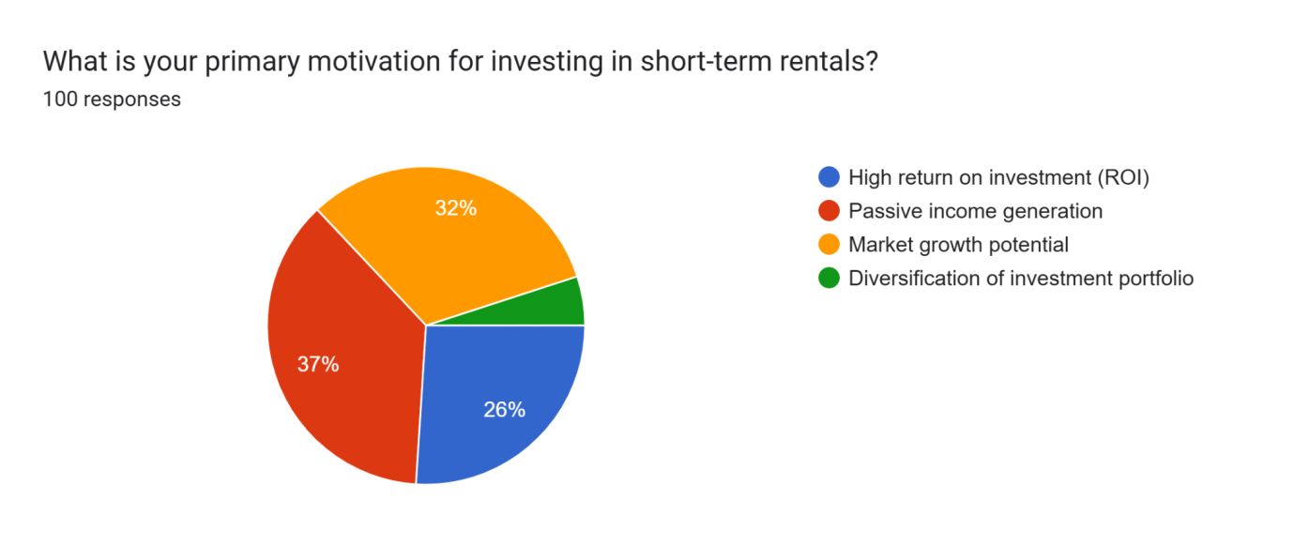

Figure 4.1: Primary motivations for investing in short-term rentals
As far as the motivation behind investing in short-term rentals is concerned, 37% of the respondents are aiming to generate passive income. On the other hand, 32% of the respondents are found to have aimed at market growth potential through the means of their investments in short-term rentals. Moreover, it highlights that 26% of the participants have been observed to have invested to derive high returns on their investments. Investor intentions for short-term rentals vary, according to current research. 37% of respondents are motivated by passive income, the study found, as this matches Cohen (2024)’s findings that early Dutch East India Company investors were motivated by financial incentives in informal and reputation-based systems. 32% of respondents said they invested based on short-term rental market growth prospects. Swanzy-Impraimet al. (2021) noted that investment activity remained decentralised and self-regulated after the central bourse was established in 1796 that reflecting an ongoing pursuit of favourable returns outside formal institutions. Further, 26% of participants cited excellent ROI as their key motive. Both historical and present research shows that passive income, growth potential and return maximisation motivate investors across asset classes and eras. Taylor (2022) claims that computerised trading platforms and expanded market hours have helped regular investors diversify and earn greater risk-adjusted returns. These technology advances have enhanced market participation and investor trust, particularly in rising and profitable markets like Dubai.This confidence in decreased market volatility stems from Taylor (2022)’s discussion of market transparency and availability. 29% invested between £50,000 and £150,000 that taking prudent risks and using new tools and platforms to make judgments.
Which location in Dubai do you find most attractive for short-term rental investments?
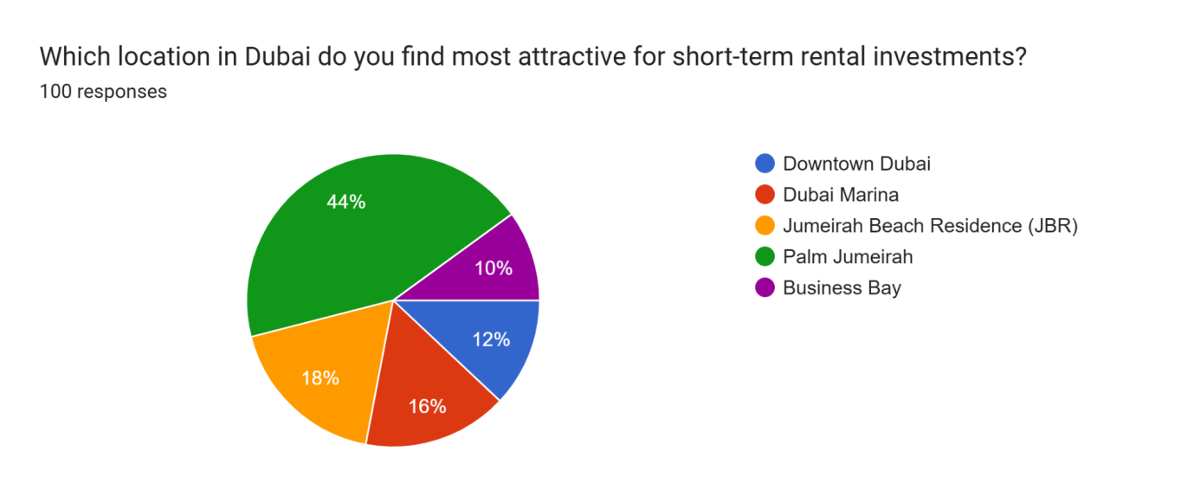

Figure 4.2: Location of Dubai for attractive short-term rental investments
As far as the most preferred location for short-term investment in Dubai is concerned, 44% of the respondents have found to have chosen Palm Jumeirah. Further, it is mentioned that 18% of the respondents have chosen to invest in Jumeirah Beach Residence, while 16% of them have chosen Dubai Marina. According to these respondents, investing in the Dubai market can turn out to be quite beneficial for them in terms of getting high returns on their investments. Global investors like emerging economies for their changing regulatory settings, fast economic growth and infrastructure improvements. Investors are drawn to this economy’s variety and development prospects, according to Angelov (2024). Dubai has become a significant metropolis due to rapid urbanisation. According to Adel (2020), the city’s substantial infrastructure expenditures in hospitality, transit and creative urban design have increased its desirability, notably in real estate.Dubai’s burgeoning property industry and worldwide demand provide short-term advantages. These selections represent Dubai's urban and infrastructure expansion, which makes it a key centre for high-return investments, according to Angelov (2024) and Adel (2020).
How important is the regulatory environment when making an investment decision?
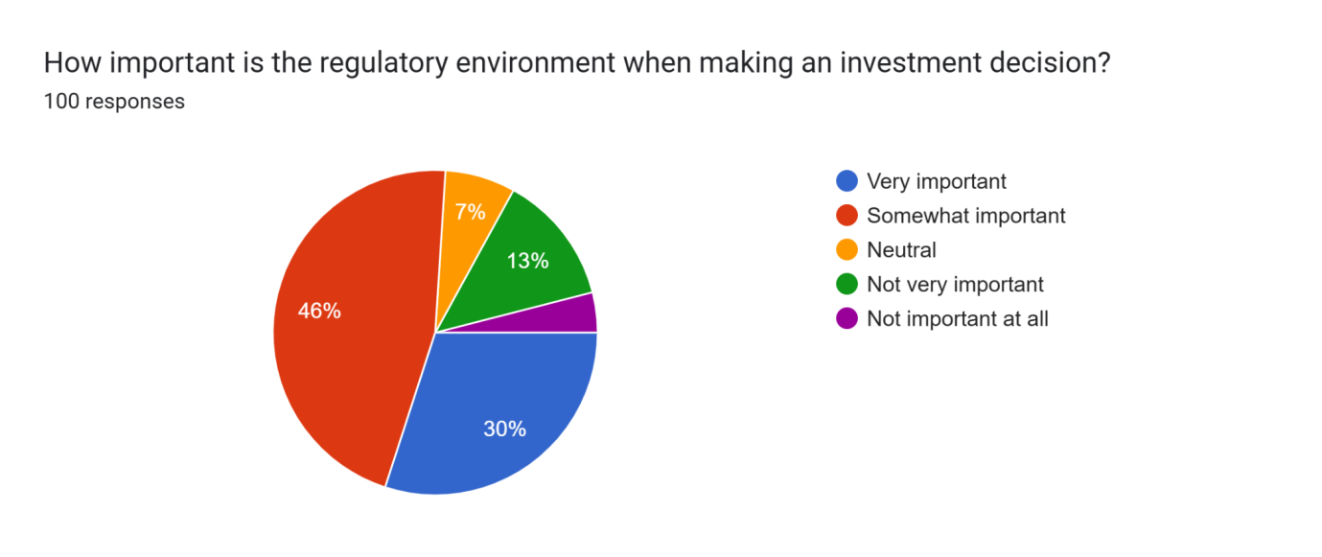

Figure 4.3: Importance of regulatory environment for making investment decisions
As the regulatory environment during making investment decisions, 46% of the respondents have stated that the same is somewhat important. Market condition is the main factor that plays a very important role in influencing the returns on investments. On the contrary, 30% of the participants have stated the regulatory environment to be extremely important as it can attract legal consequences in case of any unlawful activities. Dubai’s fast urban expansion, large-scale redevelopment projects and vibrant local environment attract investors seeking high rental returns and property prices, according to Zaidan and Abulibdeh (2021).
Vacationers and business travellers flock to this metropolitan hub, promising investors short-term earnings and long-term capital appreciation. Accordingly, Zaimovic et al. (2021) state that emerging markets like Asia, Latin America and parts of Africa are attractive to investors due to their rapid economic growth, young populations and growing integration into the global economy, which offer high investment returns and diversification.Non-compliance might result in legal consequences; therefore, 30% of participants value the regulatory environment highly. Therefore, market potential, a stable and clear regulatory environment and investor trust boost sustained investment growth.
Which factor concerns you the most about investing in short-term rentals in Dubai?
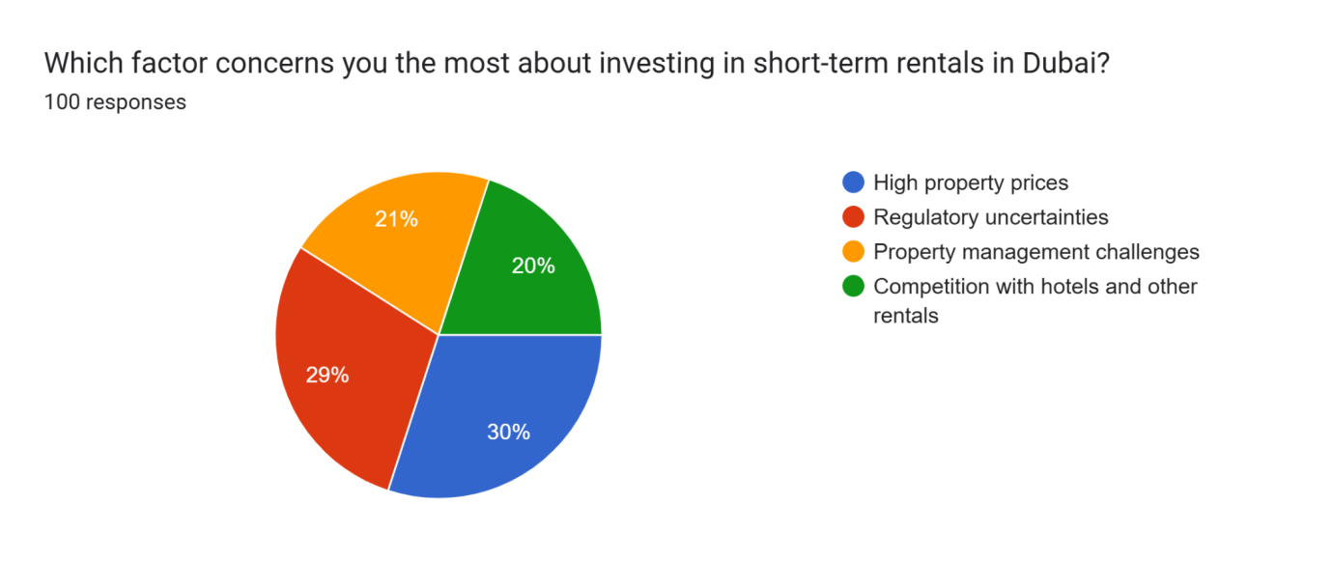

Figure 4.4: Factors regarding investments in short-term rental markets in Dubai
Among 30% of the respondents, high property prices are the most concerning factor while investing in short-term rentals in Dubai. The respondents have stated that, as a result of the high prices, sometimes it becomes quite difficult to invest in such properties. On the other hand, 29% of the participants have stated regulatory uncertainties are the most formidable challenge for inventors to invest in short-term rentals in Dubai, as the regulations tend to change quite often. Due to strong economic development, corporate profits growth, favourable currency values and rising commodity prices, Vîrjanet al. (2023) observed that investors are increasingly lured to developing economies. These qualities make such places attractive for investment. Short-term rental investors are also interested in Dubai, a real estate powerhouse.For 30% of respondents, rising property costs were the biggest worry when investing in Dubai short-term rentals. Even with considerable market potential, these respondents said high property prices made investing challenging.
This agrees with Vîrjan et al. (2023), who noted that growing markets provide profitable prospects but also create challenges. According to Iriani et al. (2024), investors in emerging markets navigate risks such as political instability, regulatory uncertainties and market volatility. However, these very challenges contribute to the appeal of such markets that offer high return potential and portfolio diversification. Reflecting this trend, 30.3% of respondents stated they expect returns between 5%-7% and 7%-10% from investing in short-term rentals in Dubai. This aligns with the growing confidence in emerging markets like Dubai, where evolving global economic dynamics and strong tourism demand enhance the attractiveness of real estate investments that position them as promising components in a well-balanced investment strategy.
How do you plan to finance your investment in Dubai’s short-term rental market?
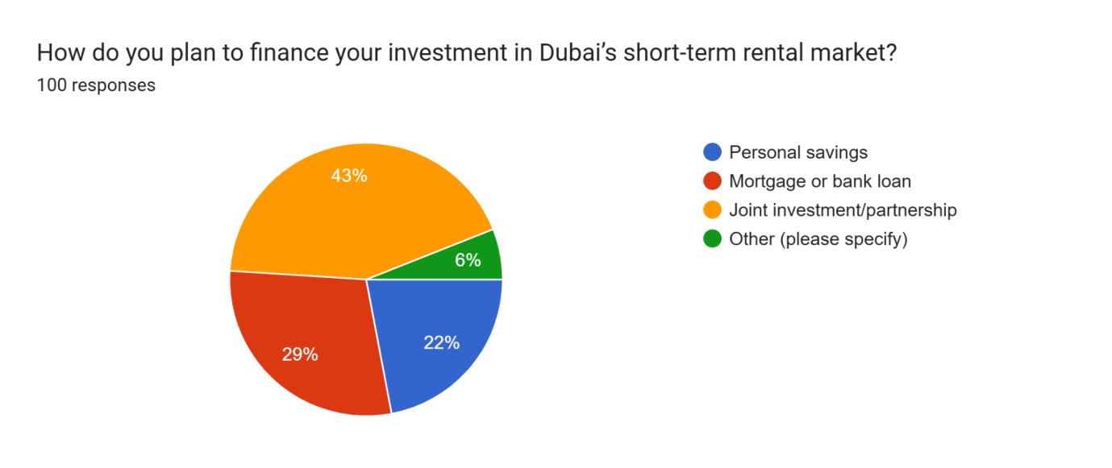

Figure 4.5: Planning finance in Dubai’s short-term rental market
43% of the respondents have stated that they aim to do a joint investment or partnership while investing in short-term rentals in Dubai. According to their opinions, doing a joint investment or a partnership with a local company can turn out to be quite beneficial as far as gathering proper insights about the concerned market. 22% of the respondents have been found to have used their savings with an aim to minimise the amount of risk. Zeqiri (2024) notes that Airbnb has simplified guest management and property listings that enable investors to access international and local travellers.
Airbnb’s user-friendly interface, decreased operational complexity and data-driven pricing make short-term renting simpler for beginners, according to Ekeroma (2023). Due to these benefits, 43% of respondents said they wanted to invest in Dubai short-term rentals through joint ventures or partnerships to share responsibility and get access to the developing industry. Emma (2024) agrees that Airbnb provides real-time client preferences and market trends. These data help British investors adapt their marketing and pricing to current needs. Real-time consumer behaviour data helps investors maximise earnings and occupancy rates. Investors increasingly want adaptable, customer-centric models in the changing rental market, thus this data-driven strategy.
What occupancy rate would you consider acceptable for your Airbnb investment to be profitable?
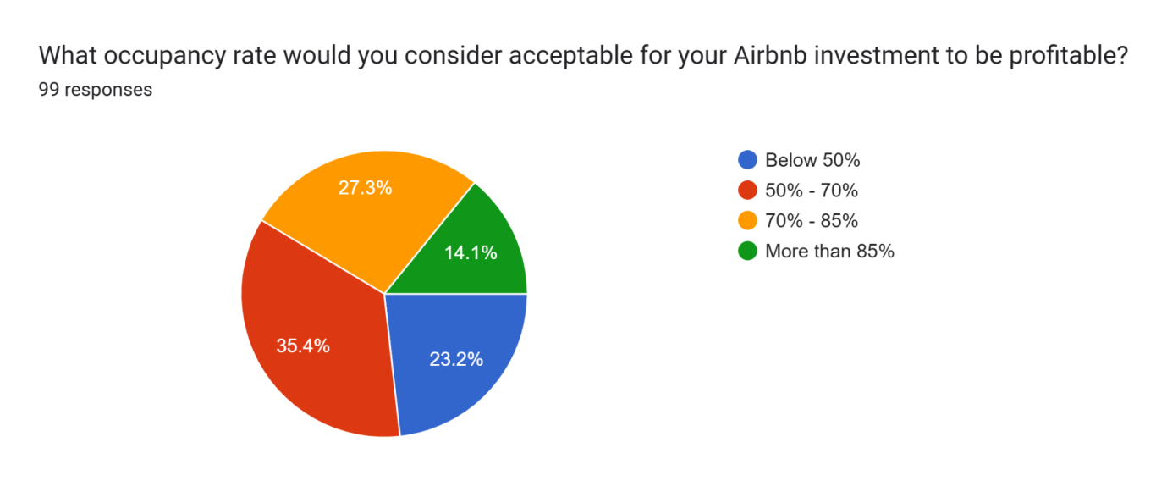

Figure 4.6: Acceptable occupancy rate for Airbnb investment
In the case of occupancy rate, 35.4% of the participants have opined 50% to 70% of the occupancy is investing in Airbnb. On a negative note, 23.2% of the participants have stated that they would prefer an occupancy rate below 50% as the risks will be on the lower side. Since Airbnb is not a reputable company, the respondents are not willing to take any major risks. Niemi (2025) encouraged investors to use automated booking systems and CRM platforms to track occupancy rates. The survey found that 35.4% of participants prefer an Airbnb occupancy rate between 50% and 70%,which indicates trust in technology-enhanced property management for best profits.
On the other hand, 23.2% favoured occupancy rates below 50% for decreased risk. These results support the idea that integrated digital solutions expedite operations and give complete data to help investors make occupancy and performance-based choices. According to Onabowale (2024), digital investment methods depend on data. Airbnb provides investors with powerful analytical tools to track seasonal pricing and regional occupancy. These data-driven tools help investors predict market behaviour and control yield. In line with this, 44% of respondents are somewhat positive about their short-term rental investments in Dubai over the next five years. This shows that credible market data and forecasting tools influence investor confidence and strategic decisions.
How likely are you to invest in Dubai’s short-term rental market within the next 12 months?
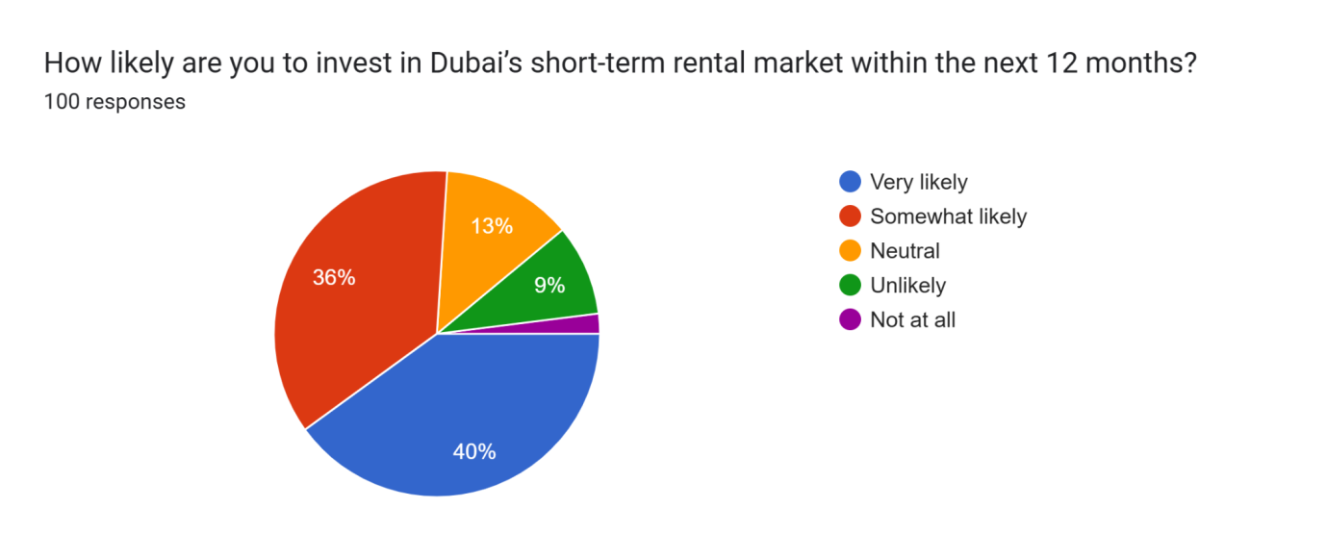

Figure 4.7: Likelihood to invest in the short-term rental market of Dubai
As far as the likelihood of investing in short-term rental markets in the next 12 months is concerned, 40% of the respondents have given a positive response to investing in short-term rentals. On the contrary, 36% of the respondents have shown some concerns about investing in Dubai’s short-term rental market in the next 12 months, as there are some regulatory turbulences and high prices of property. Aalijah (2025) states that strategic market analytics helps investors see micro-trends in market dynamics and make proactive investment choices. This data-driven approach improves short-term financial results and long-term strategy. Recent data suggest that 40% of respondents are optimistic about investing in short-term rental markets in the year. This supports findings that investors are using market analytics to capitalise on real estate investing trends and possibilities.
What type of property would you prefer for short-term rentals in Dubai?
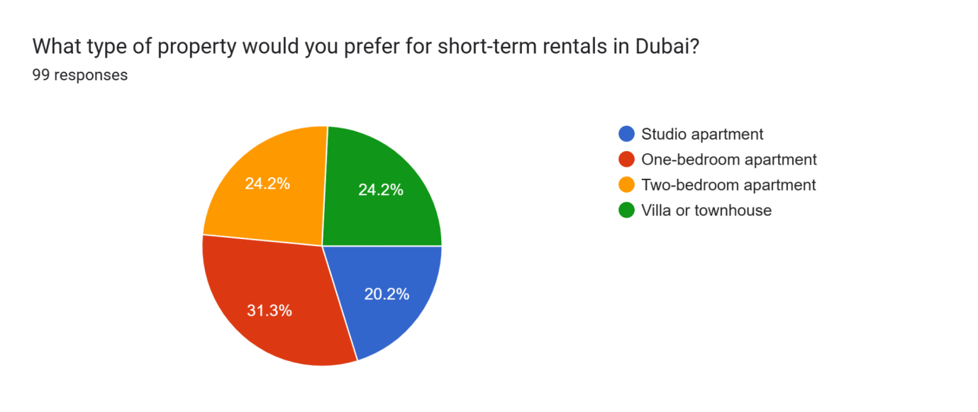

Figure 4.8: Preferred property for short-term rentals in Dubai
In case of preference for properties among the respondents, it can be observed that 31.3% of them have preferred to have a one-bedroom apartment. In this scenario, these respondents have mentioned that high prices of properties have hindered them from buying a two-bedroom apartment or a villa. On the other hand, in the case of two-bedroom apartments and villas, 24.2% of the respondents have mentioned that spending more capital can give them higher returns in future stages. 24.2% said larger capital investment may increase profits. Ndaguba and Van Zyl (2024) found that strategic investment in the short-term rental market improves financial performance, manages operational risks and leverages digital platforms for efficiency. Revenue is the main driver and machine learning-based dynamic pricing boosts income by 15%.
Would you be interested in using an investment advisory service to help with your Dubai rental investment?
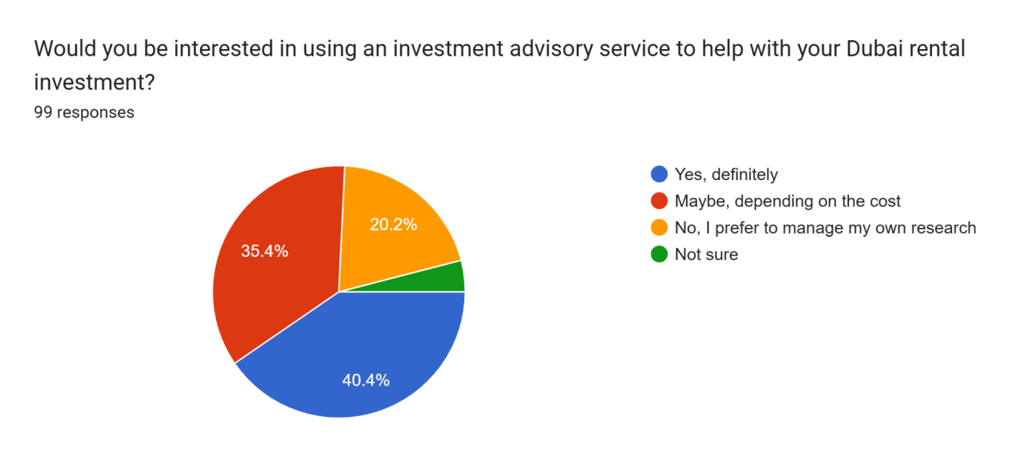

Figure 4.9: Interest in using investment advisory service
In this case, around 40.4% of the respondents have shown their interest in using investment advisory services to guide their investments in the right direction. As per the statements by this section of the respondents, investment advisory from experts in the field will enable them to derive better returns in the later stages. Strategic short-term rental market investment increases financial performance, controls operational risks and uses digital platforms for efficiency, according to Ndaguba and Van Zyl (2024). Revenue is the major engine and machine learning-based dynamic pricing increases it by 15%. Villas and apartments diversify and decrease idiosyncratic hazards. Jat et al. (2023), who noted that Dubai's market is dynamic and needs great operational agility, which typically takes significant financial resources. Capital-constrained investors may struggle to do market research, embrace new technology, or handle risks. These limits limit their capacity to improve tactics and stay competitive in a turbulent market driven by legislative changes and visitor demand. According to Echeverri et al. (2021), strategic adaptations like short-term leases may provide investors operational flexibility and market volatility protection, especially in tourism. According to 34.3% of respondents, they have hosted and stayed on Airbnb, which maximises usefulness. This method boosts long-term wealth development by letting consumers earn while maintaining privacy. Additionally, simplified regulatory frameworks affect investor decisions, decreasing legal risks and strengthening resilience.
How influential is Airbnb’s brand reputation in your decision to invest in short-term rentals in Dubai?
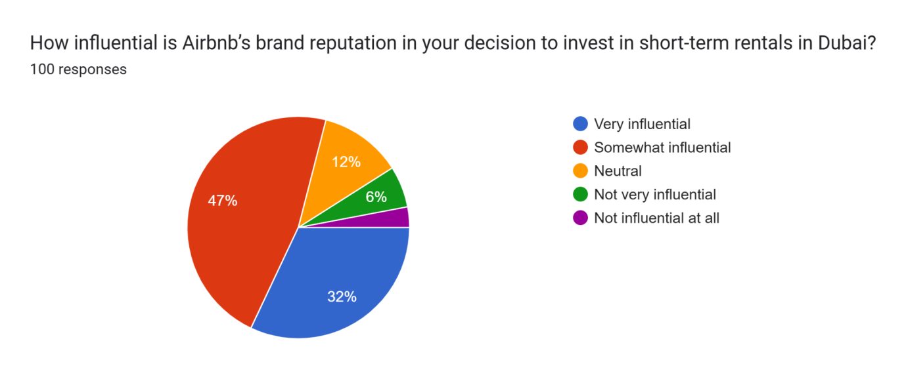

Figure 4.10: Impact of Airbnb’s brand reputation on the decision to invest in short-term rentals in Dubai
47% of the respondents have stated that the brand value of Airbnb is somewhat good in making proper decisions regarding investments in short-term rentals in Dubai. On the other hand, 32% of the respondents have given some positive response regarding their investment decisions with the help of Airbnb. Further, 12% of them have chosen to be neutral while answering this question. Well-rated listings on platforms with robust review systems and worldwide distribution channels have greater occupancy rates and premium pricing. Adewale (2024) states that data-driven strategic decision-making involves analytics and predictive modelling to help investors analyse historical patterns for capital enhancement and campaign planning. According to 47% of respondents, Airbnb’s brand value is “somewhat good” for promoting smart short-term rental investment selections in Dubai.
Would you consider partnering directly with Airbnb through its programs (e.g., Airbnb-friendly buildings, co-hosting)?
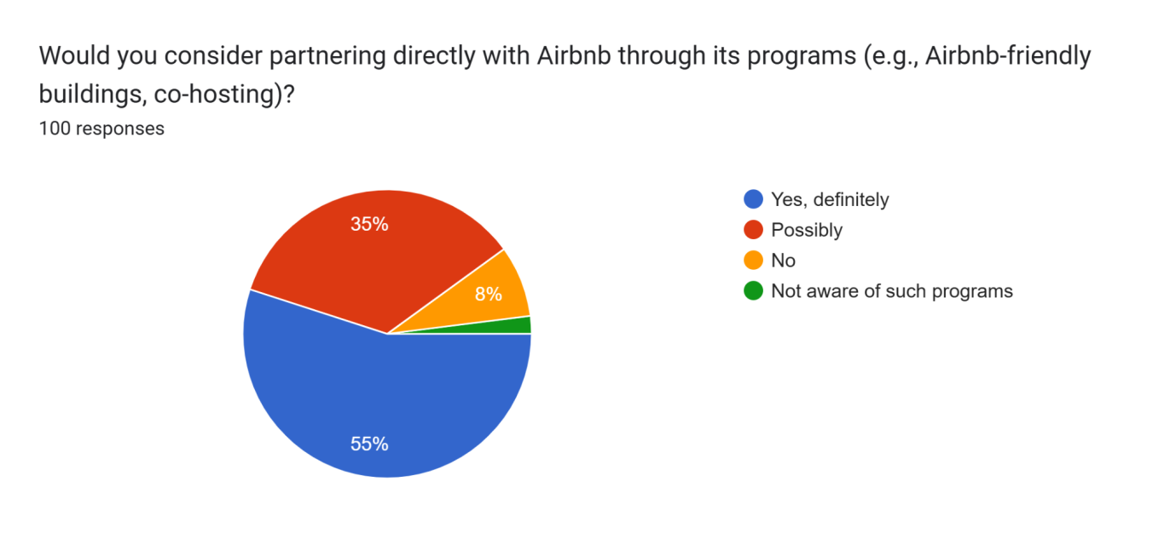

Figure 4.11: Consideration of direct partnership with Airbnb
55% of the respondents have mentioned that they will definitely be partnering with Airbnb through the means of its programs so that they can further gather useful information regarding the market situations. 35% of them showed a dilemma in partnering with Airbnb as it is not quite experienced in this field. Alongside societal difficulties, possibilities are developing. 55% of respondents said they would work with Airbnb through its initiatives to learn more about the local market. British investors increasingly utilise established platforms to traverse foreign markets like Dubai. Cultural differences affect property administration and negotiation, as Musili (2024) noted. Using local platforms like Airbnb and forming strategic alliances may help investors understand markets,overcome cultural divides and streamline investment operations and decision-making.
What kind of support would encourage you to invest in Dubai’s short-term rental market?
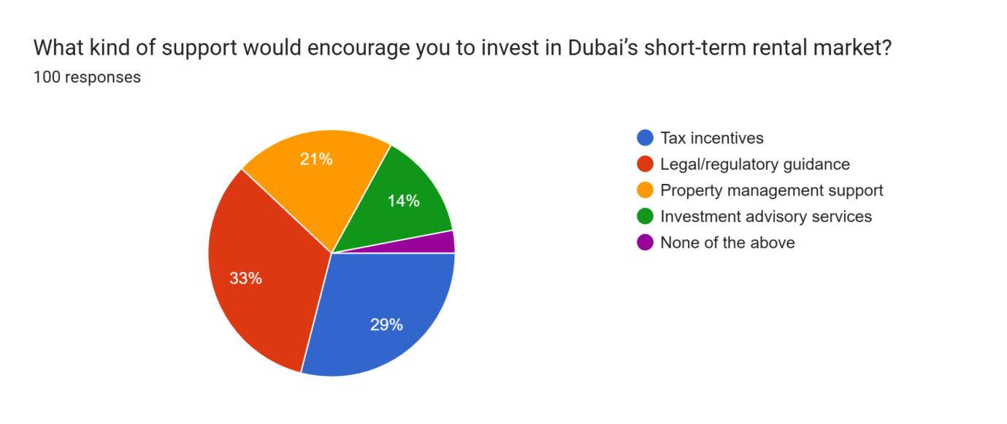

Figure 4.12: Support that can encourage investment in Dubai’s short-term rental market
While investing in short-term rentals in Dubai, 33% of the respondents have stated that legal and regulatory support will encourage them to do the same. Further, 29% of the respondents have mentioned that tax incentives in the country have encouraged them to invest in short-term rentals. The respondents have mentioned that tax incentives can provide them with better returns in future.In line with worldwide trends, 33% of Dubai short-term rental investors said legal and regulatory backing would encourage them. Local partnerships and expert networks are needed in the UK short-term rental market due to transparency and regulatory fragmentation, according to Wang et al. (2024). Ndaguba and Van Zyl (2024) also note that dynamic price analytics allow investors to maximise returns, which is crucial in Dubai's competitive market, making regulatory support and tech tools vital. UK investors increasingly favour lower-risk options with rapid cash flow and proven operational procedures. By investing in existing short-term rental properties, investors may avoid setup and benefit from customer ratings, visibility and booking history. Automation techniques like self-check-in and AI-driven guest communication boost productivity and revenue at such facilities.

4.2. Discussion
4.2.1 Appeal of the Elements of Dubai's short-term rental industry to individual British property investors
High return on investment, passive income generation, market growth and diversified investment portfolio are some of the elements that appeal to the individual British property investors in the most effective manner. As can be seen in the words of Cochrane (2022), a mixture of risks and returns can be the crucial factor for an investor to make appropriate decisions while investing in the market of Dubai market. Further, it is also found in the literature review section that goals are set by the investors based on the possibilities of returns they can derive from the market. In this regard, Taylor (2022) has also stated that risk-adjusted returns of retail investors can significantly influence their decisions as far as their investments in the later stages are concerned. Less financial risks in the Dubai market is also another factor that attracted British investors to invest in the short-term rentals market.
This study investigates why British investors choose Dubai’s short-term rental market. Maslow’s hierarchy of needs will be used to analyse how psychological and safety demands like financial stability and lifestyle aspirations align with investment motives. The perceived value and market factors driving these choices will be assessed using Tobin’s Q theory according to Ishaqet al. (2021). Moreover, a diverse range of properties in Dubai has also been one of the crucial factors that has attracted the attention of investors quite significantly. British property investors are responding to Dubai’s robust short-term rental industry, especially via Airbnb. Dubai’s worldwide tourism appeal draws millions of people yearly. Due to strong visitors, short-term lodgings are in great demand that provide investors good rental returns, particularly during vacations, international exhibits and shopping festivals (Sobha Realty, 2023).
Digital platforms simplify procedures which attract British investment. Airbnb and other platforms simplify listing, price and guest contact, making international rental property management possible. This accessibility lowers obstacles to entry and enables investors to operate in Dubai without being present, frequently using local property management services for upkeep and visitor turnover (Sobha Realty, 2023). Positive regulatory circumstances, such as loosened property ownership limits for foreigners in freehold zones, boost short-term rental profitability in Dubai. No income tax on rental profits enhances returns in Dubai, making it appealing to UK investors seeking tax-efficient property investments. Short-term rentals are more adaptable to market changes than long-term rentals. Investors may react to market demand and modify pricing tactics in real time to maximise occupancy and income. Despite greater hands-on administration, many find the short-term rewards worth it.Dubai’s short-term rental industry backed by strong tourism, digital infrastructure and investor-friendly legislation impacted British investors seeking high returns, asset diversification and entrance into a vibrant international real estate market.
4.2.2 Ways through which individual British investors decide about business opportunities through Airbnb partnerships
As far as the British individual investors are concerned, it can be observed that the regulatory environment has significantly influenced the investment decisions of the investors quite effectively. On the other hand, it is also observed that high property prices, management challenges and competition in the market are some of the crucial factors that can influence the decision-making of British investors in investing in Dubai short-term rentals. This inquiry investigates how British investors evaluate Airbnb partnership business potential from psychological and economic viewpoints. According to Mysaka and Derun (2021), Tobin's Q theory states that investors are motivated when market value exceeds replacement costs, which is pertinent to Airbnb-linked real estate enterprises. Along with digital platforms’ ongoing data flow and behavioural signals, these dynamics affect investment choices.
This study uses Maslow’s hierarchy of needs and investment incentives to examine Airbnb's individual motivations and strategic actions. As mentioned by Irianiet al (2024), regulatory uncertainties, political instability, and market volatility are some of the issues that investors have to face. Further, it can be seen in the literature review section that revenue risks and real human intelligence are behind the decision-making of investors (Ndaguba and Van Zyl, 2024). It is also observed in the literature review section that regulatory arbitrage can also have a significant influence on the decision-making process of the investors in a negative manner. Adel (2020) states that the state-of-the-art hospitality, innovative urban planning and infrastructural investment have created a positive environment for real estate investment for people. Therefore, it can be observed that all these factors can have a significant role in influencing the decision-making of the investors.
British investors analyze financial, commercial, and strategic considerations to evaluate Airbnb partnerships in Dubai’s short-term rental industry. Airbnb’s success in comparable worldwide markets like the UK helps investors assess profit possibilities. Airbnb contributed £2.9 billion to the UK economy and supported over 107,000 employment in 2022, demonstrating robust demand and platform dependability (‌Airbnb, 2023).On the other hand, income stability matters as UK hosts make over £6,000, with 40% using it to cover living expenses. Airbnb hosting provides a steady cash stream which investors want when buying rental properties overseas.
Moreover, investors examine Airbnb relationships and local regulations. Airbnb’s cooperation with local governments and ethical hosting regulations guarantees British investors of long-term profitability and decreased legal risk. Investors may see Dubai affect the company’s scalable approach with UK locations like West Midlands and Liverpool for large events. Dubai also attracts British investment due to market variety. They draw from Dubai's luxury-oriented, high-demand tourist industry and prevent overexposure to the UK property market by expanding abroad. Airbnb’s remote management tools and technology simplify abroad property administration (‌Airbnb, 2023). Automated bookings, customer service and performance statistics enable British investors to manage their Dubai properties. British investors look to Airbnb's worldwide popularity, revenue possibilities, governmental relationships and tech-driven accessibility for effective short-term rental prospects in Dubai.
4.2.3 Obstacles encountered by individual British investors while beginning operations and taking control of short-term rental properties in Dubai
It can be found that 40% of the respondents have stated regulatory concerns to be the biggest barrier in investing in Dubai’s short-term rentals, followed by financial constraints and lack of market knowledge. It can be observed that emerging markets are significantly characterised by regulatory frameworks which successfully capture the attention of global investors. In this regard, Irianiet al. (2024) have stated that political instability and regulatory uncertainties are some of the crucial factors that investors have to go through while investing in different markets. Zik-Rullahiet al. (2023) found that cognitive biases, restricted risk tolerance and cultural unfamiliarity affect British investors’ Airbnb investing choices in Dubai. D'Acunto and Rossi (2023) add that behavioural finance blends emotional and market elements that challenge decision-making in new environments. According to Özdilek (2024), digital platforms provide adaptive strategies, but integrating traditional investment methods with them is still difficult. In Dubai's dynamic real estate sector, British investors typically struggle with legal complications, operational management and technology integration while starting and operating Airbnb sites. Additionally, it is also found in the literature review section that regulatory changes can create competitive pressure on investors quite significantly while making decisions regarding investing in a foreign market.
Private British investors joining Dubai’s short-term rental sector, especially through Airbnb, face operational, legal and cultural challenges. Short-term rental providers in Dubai must be licensed by the Department of Economy and tourist (DET) and unfamiliarity with local compliance processes such registration, tourist licenses and construction permissions typically slows market entrance (AZCO, 2024). An effective property buying procedure is another obstacle. Investors unfamiliar with UAE real estate laws may encounter issues connected to property ownership rights, developer requirements and resident community limitations that prevent short-term leasing. Property managers, legal agents and renters may also struggle with cultural and language issues. Dubai’s rental market has distinct client attitudes, hospitality standards and service standards than the UK. British investors may overlook Dubai’s competitive hotel sector’s luxurious facilities and concierge-style services. Investors struggle to find dependable property management services. Guest communication, cleaning, maintenance and check-in/check-out coordination need 24/7 attention that makes self-management difficult, particularly from overseas. Financial challenges include currency rates, taxation discrepancies and unexpected expenses like tourist dirham, service charges and maintenance costs might harm profitability. British investors beginning to manage short-term rental homes in Dubai face a high learning curve due to these variables and the necessity to acquire awareness in the Airbnb market.
4.2.4 Measures taken by Dubai government officials and Airbnb operators to enhance investment conditions
In order to enhance the investment conditions, the government of Dubai will have to enhance its regularity system quite effectively so that the same can have a positive impact on the decision-making process of the foreign investors. It has been observed in the survey questions that regulatory issues in Dubai have been one of the crucial hindrances for investors,which have barred them from investing in the concerned market. Hence, addressing the regulatory issues can certainly play a crucial role to play in positively influencing the decision-making process of the investors in the most effective manner. Dubai should give tax benefits, regulatory clarity and simplified foreign property ownership regulations to attract international investors. Stronger investor rights laws and better dispute resolution may enhance investor confidence. Airbnb operators should prioritise service, property quality and local tourist restrictions.
Public-private partnerships may also boost sustainability. Dubai may attract global real estate investors seeking financial rewards, safety and prestige by addressing these areas, according to Maslow’s hierarchy. Further, it is also observed that high prices of properties can also be quite effective in terms of reducing the chances of investment from foreign investors, as they tend to take calculative risks. In such a situation, reducing the property costs can also work for the concerned government in terms of attracting foreign investors quite significantly in the long run. Additionally, it has also been highlighted in the literature review section that the investors who have successfully embraced adaptive strategies are better positioned to optimise their investment strategies and decisions in these existing volatile markets. In this case, strategic adaptations can turn out to be quite beneficial as far as ensuring long-term capital growth for the investors in the best possible way. Investors are also focusing on diversifying risks and enhancing returns in the emerging marketplace (Zaimovicet al., 2021).
Dubai’s government and industry operators have taken various innovative steps to increase investor trust and maintain short-term rental market development, notably for Airbnb. Dubai Tourism and Commerce Marketing (DTCM) license is a major government initiative (Infostride, 2025). This regulation authorizes short-term rentals if they fulfil safety, maintenance and hospitality criteria. To promote transparency and compliance, Airbnb has simplified the online licensing procedure and entry obstacles for international investors to offer homes. Additionally, the government has provided tiered fees and flexible licensing choices for various property kinds and ownership patterns. According to risk tolerance and investment capability, individual investors may grow their activities (‌Infostride, 2025). Airbnb has worked with local governments to educate hosts on regulations and best practices. Airbnb provides local host training and price optimisation tools to help hosts optimise their profits and comply with regulations. Airbnb’s host guarantee and secure payment procedures boost guest-host confidence and reduce operations risk for investors. Integration of Dubai’s property and tourism data with smart technology and AI-driven insights helps investors make data-driven choices. Dubai’s legislative clarity, operational assistance and technology integration make it a top short-term rental investment destination (‌Infostride, 2025). British investors increasingly see Airbnb partnerships in Dubai as attractive and safe businesses that meet their financial and lifestyle goals.

Chapter 5: Conclusion and Recommendations

5.1. Conclusion
This research paper has aimed at evaluating the factors that drive British investors to invest in short-term rental market of Dubai such as Airbnb. There are several factors that an investor evaluate before investing in a market such as economy, polity and many more. It is observed that digital transformation has proved to be one of the factors that attracted investors in investing in Dubai market (Globalcio, 2025). Financial performance of a market can be considered as one of the short-term drivers for investors to make decisions for investments. Further, operational agility can also play a crucial role in encouraging the investors to invest in a particular market. In certain cases, it is also observed that flexibility within a market can also encourage some investors to invest in a market for deriving the best possible financial outcomes. Among the challenges, socio-cultural differences and changing market dynamics are the mentionable ones. Considering the methodology used in this research paper, quantitative design and positivist research paradigm have helped in building a strong base for this project.
Further, it is observed that conducting the survey has proved to be extremely helpful in gathering quantitative data which is wide and diverse in nature. Maintaining ethics and integrity within the research has certainly ensured trust and confidence from the respondents and their active participation. Considering the future scope for this research paper, there is a certain chance for exploring the qualitative angle so that views and perspectives of different peers and respondents can be gathered regarding the research topic. This factor will also enhance the overall authenticity and reliability of the entire research paper. On the other hand, gathering secondary qualitative data will also provide a new angle as the opinions and perspectives of different authors and researchers can be gathered in an effective manner. The study has been limited to quantitative research which has reduced its range quite significantly. Further, conducting a quantitative research has also consumed a lot of time for the researchers which further led to delaying in the completion of the entire project. In that case, other angles and possibilities should also be explored in a proper way so that the effectiveness of this project can be enhanced in a proper way.

5.3. Recommendations
As far as the recommendations are concerned, there is a need for the Dubai government to take necessary steps in reducing the socio-cultural differences so that the overall financial performance and activities can be enhanced in the near future. On the other hand, the concerned government also need to generate effective fiscal policies so that market fluctuations can be controlled in an effective manner. Therefore, a uniformity will be observed in the financial market of Dubai which will further encourage different investors from Britain to invest in the concerned market.
Prioritize Regulatory Compliance and Local Expertise
They must engage with local legal and property management professionals to navigate Dubai’s complex and evolving short-term rental regulations. The city enforces strict licensing, operational requirements and tax rules that differ significantly from the UK with regulatory changes directly impacting occupancy and investment returns. They have to stay updated on legal frameworks by subscribing to government portals or consulting with Dubai-based real estate advisors. Regulatory shifts have previously led to an 11% reduction in Airbnb listings and residential permits in other markets, highlighting the importance of compliance for sustained profitability (‌Bekkerman et al.,2021). They can leverage digital compliance tools that automate license renewals and track regulatory updates, reducing administrative burden and risk exposure.
Harness Digital Tools for Operational Efficiency and Revenue Optimization
They must adopt advanced property management systems (PMS) and dynamic pricing software to streamline bookings, automate guest communications, and optimize nightly rates. In Dubai, the average occupancy rate for short-term rentals is 71%, with annual revenues reaching $43,000 per property (Airbtics,2025). Digital tools can help maintain high occupancy and adapt to market fluctuations. They have to utilize channel managers to synchronize listings across platforms (Airbnb, Booking.com) to minimize double bookings and maximize exposure. They must implement smart home technologies (smart locks, thermostats) to enhance guest experience, reduce operational costs, and improve security, all of which are critical in a highly competitive market.
Focus on Digital Reputation and Guest Experience
They have to invest in digital reputation management by encouraging guest reviews and maintaining high property standards. They must tailor services to local guest expectations by analysing guest feedback and leveraging data analytics. Cultural differences in Dubai mean that service standards and preferences may differ from the UK, so adapting offerings is essential for positive reviews and repeat bookings (‌Airbnb, 2023). By integrating regulatory vigilance, digital transformation, and a focus on guest satisfaction, British investors can navigate Dubai’s dynamic short-term rental market more effectively and sustainably.

References
Aalijah, K. (2025) Utilizing Social Media Analytics to Detect Trends in Saudi Arabias Evolving Market. arXiv preprint arXiv:2502.16871.
Abuelenain, E., (2023). The Role of Tourism Innovation in Selecting Potential Tourist Destinations: The Case of UAE. International Journal of Heritage, Tourism and Hospitality, 17(1), pp.93-108.
Adel, I. (2022) The Impact Of The Real Estate Market In The Urban Development Of Cities And Driving Economic Growth In Dubai/Cairo.
Adewale, T. (2024) Predictive Analytics for Alternative Investments: Hedge Funds and Private Equity.
Airbnb (2023). New report: travel on Airbnb boosts UK local communities and creates jobs. | Airbnb.com[online] Airbnb.com Available at: <https://news.airbnb.com/en-uk/new-report-travel-on-airbnb-boosts-local-communities-and-creates-jobs/>
Airbtics.com. (2025). Dubai, Airbnb Revenue Data 2025: Average Income & ROI| Airbtics.com [online] Airbtics.com Available at: <https://airbtics.com/annual-airbnb-revenue-in-dubai-united-arab-emirates/>
Alharahsheh, H.H. and Pius, A., (2020). A review of key paradigms: Positivism VS interpretivism. Global academic journal of humanities and social sciences, 2(3), pp.39-43.
Alrawabdeh, W., 2022. Seasonal balancing of revenue and demand in hotel industry: the case of Dubai City. Journal of Revenue and Pricing Management, 21(1), pp.36-49.https://link.springer.com/article/10.1057/s41272-021-00290-6
Alstadsæter, A., Planterose, B., Zucman, G. and Økland, A., (2022). Who owns offshore real estate? evidence from Dubai.
Angelov, S. (2024) EMERGING MARKETS AND INVESTMENT OPPORTUNITIES. Глобални и регионални измерения на международните икономически отношения, (1), pp.129-139.
Antunes, G. and Ferreira, J. (2021) SHORT-TERM RENTALS: HOW MUCH IS TOO MUCH–SPATIAL PATTERNS IN PORTUGAL AND LISBON. Tourism and hospitality management, 27(3), pp.581-603.
Ásványi, K., Miskolczi, M., Jászberényi, M., Kenesei, Z. and Kökény, L., (2022). The emergence of unconventional tourism services based on autonomous vehicles (AVs)—Attitude analysis of tourism experts using the Q methodology. Sustainability, 14(6), p.3691.
Autio, P. Pulkka, L. and Junnila, S. (2023) Creating a strategy framework for investor real estate management. Journal of European Real Estate Research, 16(1), pp.22-41.
AZCO (2024). Top 10 Challenges Faced by Short-Term Rental Owners in Dubai |AZCO Holiday Homes.com [online] AZCO Holiday Homes.com Available at: <https://www.azcoholidayhomes.com/top-10-challenges-faced-by-short-term-rental-owners-in-dubai/>
‌Bekkerman, R., Cohen, M.C., Kung, E., Maiden, J. and Proserpio, D. (2021). The Effect of Short-Term Rentals on Residential Investment. SSRN Electronic Journal \wbmucdn.com [online]wbmucdn.com Available at:<https://bpb-us-e2.wpmucdn.com/sites.utdallas/dist/8/1090/files/2022/02/forms-conference-2022-effect-short-term-rentals.pdf>
Biggam, J. (2015), Succeeding with your Masters Dissertation – A Step by Step Handbook, (Third Edition), Berkshire: McGraw Hill
Cameron, R. (2011), Mixed Method Approach: The Five Ps Framework, ‘Electronic Journal of Business Research Methods’, 9 (2) [Online] https://search-proquestcom.ezproxy. uwtsd.ac.uk,
Candra, P. Mahaputra, M.R. and Mahaputra, M.R. (2023) Service Quality and Customer Satisfaction Have an Impact on Increasing Hotel Room Occupancy Ratio: Literature Review Study. Greenation International Journal of Tourism and Management, 1(4), pp.400-412.
Chirico, A., Lucidi, F., Galli, F., Giancamilli, F., Vitale, J., Borghi, S., La Torre, A. and Codella, R., (2020). COVID-19 outbreak and physical activity in the Italian population: a cross-sectional analysis of the underlying psychosocial mechanisms. Frontiers in Psychology, 11, p.2100.
Cochrane, J.H. (2022) Portfolios for long-term investors. Review of Finance, 26(1), pp.1-42.
Cocola-Gant, A. and Gago, A. (2021) Airbnb, buy-to-let investment and tourism-driven displacement: A case study in Lisbon. Environment and Planning A: Economy and Space, 53(7), pp.1671-1688.
Cohen, I.T. (2024) “Lost in Translation”: Extraterritoriality, Subjecthood, and Subjectivity in the Anglo–Yemeni Treaty of 1821. Law and History Review, pp.1-23.
Collis, J. and Hussey, R. (2003), Business Research, Basingstoke: Palgrave
Dabija, D.C., Csorba, L.M., Isac, F.L. and Rusu, S., (2023). Managing sustainable sharing economy platforms: A stimulus–organism–response based structural equation modelling on an emerging market. Sustainability, 15(6), p.5583.
Denscombe, M. (2014), The Good Research Guide: For Small Scale Social Research Projects, Berkshire: Open University Press
Dinan, M.M.,(2024) Sustainable Tourism: Exploring Short-Term Rental Platforms Impacts and Measuring Tourism Market Vulnerabilitypp153.https://www.tdx.cat/handle/10803/692685
Drolet, M.J., Rose-Derouin, E., Leblanc, J.C., Ruest, M. and Williams-Jones, B., (2023). Ethical issues in research: Perceptions of researchers, research ethics board members and research ethics experts. Journal of Academic Ethics, 21(2), pp.269-292.
Echeverri, N. Jylhä, T. and Koppels, P. (2021) Searching for flexibility in corporate real estate portfolio: Six co-working strategies for user corporations. Buildings, 11(3), p.115.
Ekeroma, J.E. (2023) The Airbnb Phenomenon: A Qualitative Analysis of Its Consequences on Urban Housing Markets.
Elder-Vass, D., (2022). Pragmatism, critical realism and the study of value. Journal of Critical Realism, 21(3), pp.261-287.
Emma, L. (2024) Big data analytics for real-time insights and strategic business planning. no. December.
‌Frank, L. (2025). Are Airbnb’s A Good Investment? Pros And Cons| CipitalizeThings.com [online] CipitalizeThings.com Available at: <https://www.capitalizethings.com/investment/airbnb/>
Frankporter (2018). Airbnb is Just One Part of Dubai’s Sharing Economy| Frank Porter.com [online] Frank Porter.com Available at: <https://www.frankporter.com/blog/airbnb-is-just-one-part-of-dubais-sharing-economy.>
Gillespie, A., Glăveanu, V. and de Saint Laurent, C., (2024). Pragmatism and methodology: Doing research that matters with mixed methods. Cambridge University Press.
Globalcio (2025). UAE. Digital Transformation 2025. Insights into IT Development |Globalcio.com [online] Globalcio.comAvailable at:< https://globalcio.com/longread/Specifics-of-IT-development-in-UAE>
Gu, G.Y. (2024) Technology and disintermediation in online marketplaces. Management Science, 70(11), pp.7868-7891.
Guttentag, D., Smith, S., Potwarka, L. and Havitz, M., 2018. Why tourists choose Airbnb: A motivation-based segmentation study. Journal of Travel Research, 57(3), pp.342-359.https://journals.sagepub.com/doi/abs/10.1177/0047287517696980
Hampson, T. and McKinley, J., (2023). Problems posing as solutions: Criticising pragmatism as a paradigm for mixed research. Research in Education, 116(1), pp.124-138.
Hassan, T., (2023). Strategic Direction and Progress of the UAE Tourism Industry. Revista de Management Comparat International, 24(4), pp.580-586.
Infostride (2025). Airbnb Business Model: Building Your Platform \ InfoStride.com [online] InfoStride.com Available at: <https://infostride.com/airbnb-business-model>
Iriani, N. Agustianti, A. Sucianti, R. Rahman, A. and Putera, W. (2024) Understanding Risk and Uncertainty Management: A Qualitative Inquiry into Developing Business Strategies Amidst Global Economic Shifts, Government Policies, and Market Volatility. Golden Ratio of Finance Management, 4(2), pp.62-77.
Ishaq, M. Islam, Y. and Ghouse, G. (2021) Tobin’s Q as an indicator of firm performance: Empirical evidence from manufacturing sector firms of Pakistan. International Journal of Economics and Business Administration, IX, 1, pp.425-441.
Jat, M., Jajja, M.S., Ur Rehman, A. and Farooq, S. (2023) Manufacturer's contexts, supply chain risk management, and agility performance. IEEE Transactions on Engineering Management, 71, pp.4175-4187.
Jover, J. and Cocola‐Gant, A., 2023. The political economy of housing investment in the short‐term rental market: Insights from urban Portugal. Antipode, 55(1), pp.134-155.‌https://onlinelibrary.wiley.com/doi/abs/10.1111/anti.12881
Karamova, A., (2024). The Impact of a Confidence Building Diary on English Language Learning: A Qualitative Analysis of Student Reflections at Ca'Foscari University of Venice.
Kashanizadeh, Z. Khanagha, S. Alexiou, A. and Volberda, H. (2024) The dynamics of new sharing economy ventures strategies and ecosystem legitimacy: the case of Airbnb. R&D Management, 54(5), pp.1166-1189.
Kivunja, C. and Kuyini, A.B., (2017). Understanding and applying research paradigms in educational contexts. International Journal of higher education, 6(5), pp.26-41.
Linkedin.com. (2025). LinkedIn \Linkedin.com[online] Linkedin.comAvailable at: https://www.linkedin.com/pulse/dubais-short-term-rental-market-trends-challenges-igor-ivanchenko-gsnpc
Liuzzo, D. (2023) Empowering retail investors: implementing a goal-oriented investment strategy.
Mazhar, S.A., Anjum, R., Anwar, A.I. and Khan, A.A., 2021. Methods of data collection: A fundamental tool of research. Journal of Integrated Community Health, 10(1), pp.6-10.
Musili, D. (2024) A comparative analysis on negotiation styles between Chinese and Kenyan counterparts on cultural differences perspective. Available at SSRN 5136007.
Muzari, T., Shava, G.N. and Shonhiwa, S., (2022). Qualitative research paradigm, a key research design for educational researchers, processes and procedures: A theoretical overview. Indiana Journal of Humanities and Social Sciences, 3(1), pp.14-20.
Mysaka, H. and Derun, I. (2021) Corporate financial performance and Tobin’s Q in dividend and growth investing. Contemporary Economics, pp.276-288.
Mysaka, H. and Derun, I., 2021. Corporate financial performance and Tobin’s Q in dividend and growth investing. Contemporary Economics, pp.276-288.https://www.ceeol.com/search/article-detail?id=1080163
Ndaguba, E.A. and Van Zyl, C. (2024) Data-driven approach to optimizing property management strategies: spatial modeling analytics of short-term rentals. International Journal of Housing Markets and Analysis, 17(7), pp.44-75.
Ndaguba, E.A. and Van Zyl, C. (2024) Data-driven approach to optimizing property management strategies: spatial modeling analytics of short-term rentals. International Journal of Housing Markets and Analysis, 17(7), pp.44-75.
Niemi, J. (2025) Techno-Economic analysis of Customer Relationship Management system development in a logistics company.
Onabowale, O. (2024) The Rise of AI and Robo-Advisors: Redefining Financial Strategies in the Digital Age. International Journal of Research Publication and Reviews, 6.
Park, Y.S., Konge, L. and Artino Jr, A.R., (2020). The positivism paradigm of research. Academic medicine, 95(5), pp.690-694.
Phillips, B., (2021). UK further education sector journey to compliance with the general data protection regulation and the data protection act 2018. Computer Law & Security Review, 42, p.105586.
Roberts, S.S. (2023) International Investments in Luxury Real Estate: An Evaluation of International Real Estate Investors and Developers Entering a Cross-Continental Market (Doctoral dissertation, Massachusetts Institute of Technology).
Settembre-Blundo, D. González-Sánchez, R. Medina-Salgado, S. and García-Muiña, F.E. (2021) Flexibility and resilience in corporate decision making: a new sustainability-based risk management system in uncertain times. Global Journal of Flexible Systems Management, 22(Suppl 2), pp.107-132.
Sobha Realty (2023). Dubai Real Estate Investment Strategies: Short-Term vs. Long-Term. | Sobharealty.com.[online] Sobharealty.com. Available at: <https://sobharealty.com/media-center/blogs/dubai-real-estate-investment-strategies-short-term-vs-long-term/#:~:text=Dubai's%20global%20tourist%20appeal%20presents,and%20boost%20their%20rental%20income>
Swanzy-Impraim, S., Ge, X.J. and Mangioni, V. (2021) Barriers to institutional investment in rental housing: A systematic review of market risks. International Journal of Real Estate Studies, 15(2), pp.1-15.
Taylor, B. (2022) New Financial Indices for the History of Developed and Emerging Markets. Available at SSRN 4244322.
Thomas, G. (2013), How to do your Research Project, (Second Edition), London: SAGE Publications Ltd. - there is a newer edition available (20230
Uduma, I.A. and Sylva, W., (2015). A critique of the adequacy of positivist and interpretivist views of organisational studies for understanding the 21st century organisation (s). International Journal of Business and Management Review, 3(8), pp.44-52.
Vij, M. and Rizwan, S.A. (2022) Emerging Technologies in Tourism for a Better Experience: The Case of Dubai. Technology Application in Tourism in Asia: Innovations, Theories and Practices, pp.97-107.
Vîrjan, D. Manole, A.M. Stanef-Puică, M.R. Chenic, A.S. Papuc, C.M. Huru, D. and Bănacu, C.S. (2023) Competitiveness—the engine that boosts economic growth and revives the economy. Frontiers in Environmental Science, 11, p.1130173.
Vu, T.T.N., (2021). Understanding validity and reliability from qualitative and quantitative research traditions. VNU Journal of Foreign Studies, 37(3).
Wang, C. and Zhou, T., (2021). Trade-offs between asset location and proximity to home: Evidence from REIT property sell-offs. The Journal of Real Estate Finance and Economics, 63(1), pp.82-121.
Wang, Y. Livingston, M. McArthur, D.P. and Bailey, N. (2024) The challenges of measuring the short-term rental market: an analysis of open data on Airbnb activity. Housing Studies, 39(9), pp.2260-2279.
Wijburg, G., Garcia Pallas, M.C. and Aalbers, M.B., 2025. Tourism-Led Housing Commodification: Transnational Real Estate Networks and State-Permeated Property Investment in Havana, Cuba. Housing, Theory and Society, 42(3), pp.291-311. https://www.tandfonline.com/doi/abs/10.1080/14036096.2024.2400178
Zaidan, E. and Abulibdeh, A. (2021) Master planning and the evolving urban model in the Gulf cities: Principles, policies, and practices for the transition to sustainable urbanism. Planning Practice & Research, 36(2), pp.193-215.
Zaimovic, A. Omanovic, A. and Arnaut-Berilo, A. (2021) How many stocks are sufficient for equity portfolio diversification? A review of the literature. Journal of Risk and Financial Management, 14(11), p.551.
Zeqiri, A. (2024) From Traditional to Digital: The Evolution of Business Models in Hospitality Through Platforms. Platforms, 2(4), pp.221-233.

Appendix: Survey Questions
- Have you previously invested in the short-term rental market?
- Yes, in Dubai
- Yes, in other locations
- No, but I am considering it
- No, I am not interested
- What is your primary motivation for investing in short-term rentals?
- High return on investment (ROI)
- Passive income generation
- Market growth potential
- Diversification of investment portfolio
- What is your preferred investment budget for short-term rentals in Dubai?
- Less than £50,000
- £50,000 - £150,000
- £150,000 - £300,000
- More than £300,000
- Which location in Dubai do you find most attractive for short-term rental investments?
- Downtown Dubai
- Dubai Marina
- Jumeirah Beach Residence (JBR)
- Palm Jumeirah
- Business Bay
- How important is the regulatory environment when making an investment decision?
- Very important
- Somewhat important
- Neutral
- Not very important
- Not important at all
- Which factor concerns you the most about investing in short-term rentals in Dubai?
- High property prices
- Regulatory uncertainties
- Property management challenges
- Competition with hotels and other rentals
- What return on investment (ROI) would you expect from a Dubai Airbnb rental?
- Below 5%
- 5% - 7%
- 7% - 10%
- More than 10%
- How do you plan to finance your investment in Dubai’s short-term rental market?
- Personal savings
- Mortgage or bank loan
- Joint investment/partnership
- Other (please specify)
- What is your preferred management approach for your Airbnb property?
- Self-managed
- Professional property management company
- Airbnb co-hosting services
- Not sure yet
- What occupancy rate would you consider acceptable for your Airbnb investment to be profitable?
- Below 50%
- 50% - 70%
- 70% - 85%
- More than 85%
- How confident are you in Dubai’s short-term rental market growth over the next five years?
- Very confident
- Somewhat confident
- Neutral
- Not very confident
- Not confident at all
- How likely are you to invest in Dubai’s short-term rental market within the next 12 months?
- Very likely
- Somewhat likely
- Neutral
- Unlikely
- Not at all
- What type of property would you prefer for short-term rentals in Dubai?
- Studio apartment
- One-bedroom apartment
- Two-bedroom apartment
- Villa or townhouse
- Would you be interested in using an investment advisory service to help with your Dubai rental investment?
- Yes, definitely
- Maybe, depending on the cost
- No, I prefer to manage my own research
- Not sure
- What is your biggest barrier to investing in Dubai’s short-term rental market?
- Lack of market knowledge
- Regulatory concerns
- Financial constraints
- Uncertainty about profitability
16. Have you previously used Airbnb as a host or guest?
- Yes, as a host
- Yes, as a guest
- Yes, as both
- No
17. How influential is Airbnb’s brand reputation in your decision to invest in short-term rentals in Dubai?
- Very influential
- Somewhat influential
- Neutral
- Not very influential
- Not influential at all
18. Would you consider partnering directly with Airbnb through its programs (e.g., Airbnb-friendly buildings, co-hosting)?
- Yes, definitely
- Possibly
- No
- Not aware of such programs
19. What kind of support would encourage you to invest in Dubai’s short-term rental market?
- Tax incentives
- Legal/regulatory guidance
- Property management support
- Investment advisory services
- None of the above
20. Are you more inclined to invest in a property already listed and operating on Airbnb?
- Yes, I prefer turnkey investments
- No, I prefer to set it up myself
- Maybe, depending on the condition and earnings
- Not sure

