Appendix 1
APPLICATION FOR ETHICAL APPROVAL

In order for research to result in benefit and minimise risk of harm, it must be conducted ethically. A researcher may not be covered by the University’s insurance if ethical approval has not been obtained prior to commencement.

The University follows the OECD Frascati manual definition of research activity: “creative work undertaken on a systematic basis in order to increase the stock of knowledge, including knowledge of man, culture and society, and the use of this stock of knowledge to devise new applications”. As such this covers activities undertaken by members of staff, postgraduate research students, and both taught postgraduate and undergraduate students working on dissertations/projects.

The individual undertaking the research activity is known as the “principal researcher”.

Ethical approval is not required for routine audits, performance reviews, quality assurance studies, testing within normal educational requirements, and literary or artistic criticism.

Please read the notes for guidance before completing ALL sections of the form.

This form must be completed and approved prior to undertaking any research activity. Please see Checklist for details of process for different categories of application.

Delete the Guidance Notes at the end of the form BEFORE submitting your application

SECTION A: About You (Principal Researcher)
Full Name: |  | Ceri Anne Martin
Tick all boxes which apply: |  | Member of staff: | ☐ | Honorary research fellow: | ☐
Undergraduate Student | ☒ | Taught Postgraduate Student | ☐ | Postgraduate Research Student | ☐

Faculty/School/Centre: | Initial Teacher Education, Yr Athrofa
Campus: | Carmarthen
E-mail address: | 1803537@student.uwtsd.ac.uk
Contact Telephone Number: | 07592513586
For students:
Student Number: | 1803537
Programme of Study: | BA Primary Education with QTS
Director of Studies/Supervisor: | Dr. Sioned V. Hughes

SECTION B: Approval for Research Activity
Has the research activity received approval in principle?  (please check the Guidance Notes as to the appropriate approval process for different levels of research by different categories of individual) |  | YES | ☒ | NO | ☐
 |  |  |  | Date
If Yes, please indicate source of approval (and date where known): Approval in principle must be obtained from the relevant source prior to seeking ethical approval | Research Degrees Committee |  | ☐
 | Faculty Research Committee |  | ☐
 | Other (write in) ECAD5010 Module Lead |  | ☒ | 27.02.20

SECTION C: Internal and External Ethical Guidance Materials
Please list the core ethical guidance documents that have been referred to during the completion of this form (including any discipline-specific codes of research ethics, and also any specific ethical guidance relating to the proposed methodology). Please tick to confirm that your research proposal adheres to these codes and guidelines.
UWTSD Research Ethics & Integrity Code of Practice | ☒
UWTSD Research Data Management Policy | ☒
British Educational Research Guidelines (BERA, 2018). | ☒
 | ☐

SECTION D: External Collaborative Research Activity
Does the research activity involve collaborators outside of the University? |  | YES | ☐ | NO | ☒
If Yes, please provide the name of the external organisation and name and contact details for the main contact person and confirmation this person has consented to their personal data being shared.as part of this collaboration.
Institution
Contact person name
Contact person e-mail address

Has this individual consented to sharing their details on this form? |  | YES | ☐ | NO |  |  | ☐
Are you in receipt of a KESS scholarship? |  | YES | ☐ | NO |  |  | ☐
Is your research externally funded |  | YES | ☐ | NO |  |  | ☐
Are you specifically employed to undertake this research in either a paid or voluntary capacity? | Voluntary | YES | ☐ | NO |  | ☐
 | Employed | YES | ☐ | NO |  | ☐
Is the research being undertaken within an existing UWTSD Athrofa Professional Learning Partnership (APLP) | If YES then the permission question below does not need to be answered. | YES | ☒ | NO |  |  | ☐
Permission to undertake the research has been provided by the partner organisation | (If YES attach copy)  If NO the application cannot continue | YES | ☐ | NO |  |  | ☐

Where research activity is carried out in collaboration with an external organisation
Does this organisation have its own ethics approval system? | YES | ☐ | NO | ☒
If Yes, please attach a copy of any final approval (or interim approval) from the organisation

SECTION E: Details of Research Activity
Indicative title: | How does questioning deepen understanding?
Proposed start date: | 02.03.20 | Proposed end date: | 01.04.20
Introduction to the Research (maximum 300 words)
Ensure that you write for a Non-Specialist Audience when outlining your response to the three points below:
- Purpose of Research Activity
- Proposed Research Question
- Aims of Research Activity
- Objectives of Research Activity
Demonstrate, briefly, how Existing Research has informed the proposed activity and explain
- What the research activity will add to the body of knowledge
- How it addresses an area of importance.
Purpose of Research Activity
- To explore how the AfL strategy; questioning deepens understanding.
- To trial different research tools in practice. The research tools will be a questionnaire, interviews and a lesson observation.

(this box should expand as you type)
Research Question

How does questioning deepen understanding?

(this box should expand as you type)
Aims of Research Activity
- To explore how questions asked by teachers deepen learner understanding.
- To critically evaluate the different research tools; questionnaire, interview and observation.
- To further develop personal knowledge and understanding of AfL to help improve professional practice.

(this box should expand as you type)
Objectives of Research Activity
- To explore the AfL questioning strategies and approaches used by staff to support and develop pupils’ learning using a questionnaire.
- To interview 8-11-year-old learners to capture their views about questioning.
- To observe the questions asked by the teacher to the pupils to deepen understanding.
- To critically reflect on the process of using different research tools to collect data.
(this box should expand as you type)
Proposed methods (maximum 600 words)
Provide a brief summary of all the methods that may be used in the research activity, making it clear what specific techniques may be used. If methods other than those listed in this section are deemed appropriate later, additional ethical approval for those methods will be needed.
Interviews – Small group of children from a range of abilities from one teaching class will be involved in a semi-structured interview where they will be invited to respond to key questions. For example, can you explain how you feel when your teacher asks you a question? Can you show me a piece of work you’re really proud of? Did the questions your teacher ask you about this help you create this fantastic piece of work? These interviews will be conducted in an informal setting and I will make notes of and audio record their responses. The children will not be forced to participate, will be made aware that they can withdraw from the interview at any time. All the children will be asked if they wish to be involved. I will ask the children regularly if they are happy to continue. No names will be recorded. The class teacher will also be interviewed in a semi-structed interview where they will be asked to respond to key questions. For example, can you explain how you decide what questions to ask learners during a lesson? For example, do you plan to ask certain questions when you are planning the lesson?
Questionnaire – Small group of children from a range of abilities from one teaching class will be asked to complete a questionnaire consisting of 10 questions. For example, does your teacher ask you a question every lesson? If you don’t understand a question what do you do? The questionnaires will be completed in an informal setting within the classroom. The responses will be generated automatically. The children will not be forced to participate, will be made aware that they can withdraw from the questionnaire at any time. All the children will be asked if they wish to be involved. I will ask the children regularly if they are happy to continue. No names will be recorded.
Observation – The whole class will be observed over one lesson. The focus of the observation will be questioning strategies used by the class teacher to deepen the learners understanding. An observation sheet will be used to collect data during the observation. There will be a focus on whether the learners are asked open and closed questions, if the teacher asks a mixture of boys and girls questions and if the teacher tends to ask more questions to one learning group over the other three. The children will not be forced to participate, will be made aware that they can withdraw from the observation at any time. All the children will be asked if they wish to be involved. I will ask the children regularly if they are happy to continue. No names will be recorded

(this box should expand as you type)

Location of research activity
Identify all locations where research activity will take place.
The research activity will take place in a school in South West Wales. The school caters for children aged three to eleven years. There are approximately 400 pupils.

(this box should expand as you type)
Research activity outside of the UK
If research activity will take place overseas, you are responsible for ensuring that local ethical considerations are complied with and that the relevant permissions are sought. Specify any local guidelines (e.g. from local professional associations/learned societies/universities) that exist and whether these involve any ethical stipulations beyond those usual in the UK (provide details of any licenses or permissions required). Also specify whether there are any specific ethical issues raised by the local context in which the research activity is taking place, for example, particular cultural and/or legal sensitivities or vulnerabilities of participants.
N/A

(this box should expand as you type)
Use of documentation not in the public domain: Are any documents NOT publicly available? | NO | ☒
 | YES | ☐
If Yes, please provide details here of how you will gain access to specific documentation that is not in the public domain and that this is in accordance with prevailing data protection law of the country in question and England and Wales.

(this box should expand as you type)

SECTION F: Scope of Research Activity
Will the research activity include: | YES | NO
Use of a questionnaire or similar research instrument? | ☒ | ☐
Use of interviews? | ☒ | ☐
Use of diaries? | ☐ | ☒
Participant observation with their knowledge? | ☒ | ☐
Participant observation without their knowledge? | ☐ | ☒
Use of video or audio recording? | ☒ | ☐
Access to personal or confidential information without the participants’ specific consent? | ☐ | ☒
Administration of any questions, test stimuli, presentation that may be experienced as physically, mentally or emotionally harmful / offensive? | ☐ | ☒
Performance of any acts which may cause embarrassment or affect self-esteem? | ☐ | ☒
Investigation of participants involved in illegal activities? | ☐ | ☒
Use of procedures that involve deception? | ☐ | ☒
Administration of any substance, agent or placebo? | ☐ | ☒
Working with live vertebrate animals? | ☐ | ☒
Other primary data collection methods, please explain in this box  For example, ‘focus groups’. Please indicate the type of data collection method(s) in this box and tick the accompany box. | ☐ | ☒
Details of any other primary data collection method:  (this box should expand as you type) | ☐ | ☒
If NO to every question, then the research activity is (ethically) low risk and may be exempt from some of the following sections (please refer to Guidance Notes).

If YES to any question, then no research activity should be undertaken until full ethical approval has been obtained.

SECTION G: Intended Participants
Who are the intended participants: | YES | NO
Students or staff at the University? | ☐ | ☒
Adults (over the age of 18 and competent to give consent)? | ☒ | ☐
Vulnerable adults? | ☐ | ☒
Children and Young People under the age of 8? (Consent from Parent, Carer or Guardian will be required) | ☒ | ☐
Prisoners? | ☐ | ☒
Young offenders? | ☐ | ☒
Those who could be considered to have a particularly dependent relationship with the investigator or a gatekeeper? | ☐ | ☒
People engaged in illegal activities? | ☐ | ☒
Others (please identify specifically any group who may be unable to give consent) please indicate here and tick the appropriate box. | ☐ | ☒
Other – please indicate here:  (this box should expand as you type) | ☐ | ☒

Participant numbers and source
How will you identify participants and how will they be recruited?
How many participants are expected? | 26 participants  (this box should expand as you type)
Who will the participants be? | 1 teacher, 26 pupils (8 pupils – Year 4; 10 pupils – Year 5; 8 pupils – Year 6)  (this box should expand as you type)
How will you identify the participants? | The participants will be identified from previous PTE2 experience in the school.  (this box should expand as you type)

Information for participants: | YES | NO | N/A
Will you describe the main research procedures to participants in advance, so that they are informed about what to expect? | ☒ | ☐ | ☐
Will you tell participants that their participation is voluntary? | ☒ | ☐ | ☐
Will you obtain written consent for participation? | ☐ | ☐ | ☒
Will you explain to participants that refusal to participate in the research will not affect their treatment or education (if relevant)? | ☒ | ☐ | ☐
If the research is observational, will you ask participants for their consent to being observed? | ☒ | ☐ | ☐
Will you tell participants that they may withdraw from the research at any time and for any reason? | ☒ | ☐ | ☐
With questionnaires, will you give participants the option of omitting questions they do not want to answer? | ☒ | ☐ | ☐
Will you tell participants that their data will be treated with full confidentiality and that, if published, it will not be identifiable as theirs? | ☒ | ☐ | ☐
Will you debrief participants at the end of their participation, in a way appropriate to the type of research undertaken? | ☐ | ☐ | ☒
If NO to any of above questions, please give an explanation
(this box should expand as you type)

Information for participants: | YES | NO | N/A
Will participants be paid? | ☐ | ☒ | ☐
Is specialist electrical or other equipment to be used with participants? | ☐ | ☒ | ☐
Are there any financial or other interests to the investigator or University arising from this study? | ☐ | ☒ | ☐
Will the research activity involve deliberately misleading participants in any way, or the partial or full concealment of the specific study aims? | ☐ | ☒ | ☐
If YES to any question, please provide full details
(this box should expand as you type)

SECTION H: Anticipated Risks

Outline any anticipated risks that may adversely affect any of the participants, the researchers and/or the University, and the steps that will be taken to address them.

If you have completed a full risk assessment (for example as required by a laboratory, or external research collaborator) you may append that to this form.
Full risk assessment completed and appended? |  | Yes | ☐
 |  | No | ☒
Risks to participants
For example: emotional distress, financial disclosure, physical harm, transfer of personal data, sensitive organisational information
Risk to Participant:  - Pupils may feel under pressure to give the correct answer to the questions.  - Pupils not understanding the questions and may feel uneasy.  - Pupils may be at risk to accidents during the research project.  - Do not reference the school or any sensitive organisational information.  (this box should expand as you type) | How will you mitigate the Risk to Participant?  - Pupils will be told that there is no consequence for anything they say. I will make it clear that I want open and honest answers. I will make it clear that the answers they give will affect their education in no way and there will be no repercussions for their actions and answers in regard to the research.  - During the research an additional adult will be present.  - Anonymise the students by presenting them as ‘Pupil A’ and ‘Pupil B’.  - Reference the school as ‘School A’.  (this box should expand as you type)
If research activity may include sensitive, embarrassing or upsetting topics (e.g. sexual activity, drug use) or issues likely to disclose information requiring further action (e.g. criminal activity), give details of the procedures to deal with these issues, including any support/advice (e.g. helpline numbers) to be offered to participants. Note that where applicable, consent procedures should make it clear that if something potentially or actually illegal is discovered in the course of a project, it may need to be disclosed to the proper authorities
N/A
(this box should expand as you type)
Risks to investigator
For example: personal safety, physical harm, emotional distress, risk of accusation of harm/impropriety, conflict of interest
Risk to Investigator:  - Allegations from pupils in the classroom while completing the research.  - Ensuring that the research environment is safe to conduct the research.  - A possible hostile situation when conducting research.  - If a disclosure is made during the research from a child.  (this box should expand as you type) | How will you mitigate the Risk to Investigator?  - The majority of the research will be during a normal activity in the classroom. There will be another researcher present while interviewing is taking place.  - Ensure there is another adult present during the research.  - Immediately stop the research and notify an adult or the child protection officer in the school.  (this box should expand as you type)
University/institutional risks
For example: adverse publicity, financial loss, data protection
Risk to University:  - Not behaving in a way that could impact the relationship between school and university.  - Confidential data being lost.  (this box should expand as you type) | How will you mitigate the Risk to University:  - I will behave in a professional manner, at all times.  - I will upload all data to the university one drive instead of using a personal account.  (this box should expand as you type)

Disclosure and Barring Service
If the research activity involves children or vulnerable adults, a Disclosure and Barring Service (DBS) certificate must be obtained before any contact with such participants. | YES | NO | N/A
Does your research require you to hold a current DBS Certificate? | ☒ | ☐ | ☐

SECTION I: Feedback, Consent and Confidentiality
Feedback
What de-briefing and feedback will be provided to participants, how will this be done and when?
N/A

(this box should expand as you type)
Informed consent
Describe the arrangements to inform potential participants, before providing consent, of what is involved in participating. Describe the arrangements for participants to provide full consent before data collection begins. If gaining consent in this way is inappropriate, explain how consent will be obtained and recorded in accordance with prevailing data protection legislation.
I will converse with my class teacher and senior mentor and inform them of the research I will be undertaking, providing reason and rationale behind the research. However, I will verbally ask children identified to participate whether they wish to participate. I will also ask if they are happy to participate/answer the question, if not then I will know they are not happy to participate. This will be an individual exercise so that the children are encouraged to respond honestly with their interest and well-being in mind. Children will also be informed they can approach me at any time to ask questions and discuss their contribution to the project.

(this box should expand as you type)
Confidentiality / Anonymity
Set out how anonymity of participants and confidentiality will be ensured in any outputs. If anonymity is not being offered, explain why this is the case.
No names will be recorded. I will not disclose names. I will ensure that no individual data are made available to schools/parents.

(this box should expand as you type)

SECTION J: Data Protection and Storage
In completing this section refer to the University’s Research Data Management Policy and the extensive resources on the University’s Research Data Management web pages (http://uwtsd.ac.uk/library/research-data-management/).
Does the research activity involve personal data (as defined by the General Data Protection Regulation 2016 “GDPR” and the Data Protection Act 2018 “DPA”)? | YES | NO
“Personal data” means any information relating to an identified or identifiable natural person (‘data subject’). An identifiable natural person is one who can be identified, directly or indirectly, in particular by reference to an identifier such as a name, an identification number, location data, an online identifier or to one or more factors specific to the physical, physiological, genetic, mental, economic, cultural or social identity of that natural person. | ☐ | ☐
If YES, provide a description of the data and explain why this data needs to be collected:
(this box should expand as you type)
Does it involve special category data (as defined by the GDPR)? | YES | NO
“Special category data” means sensitive personal data consisting of information as to the data subjects’ –  (a) racial or ethnic origin,  (b) political opinions,  (c ) religious beliefs or other beliefs of a similar nature,  (d) membership of a trade union (within the meaning of the Trade Union and Labour Relations (Consolidation) Act 1992),  (e) physical or mental health or condition,  (f) sexual life,  (g) genetics,  (h) biometric data (as used for ID purposes), | ☐ | ☐
If YES, provide a description of the special category data and explain why this data needs to be collected:
(this box should expand as you type)
Will the research activity involve storing personal data and/or special category data on one of the following: | YES | NO
Manual files (i.e. in paper form)? | ☐ | ☐
University computers? | ☐ | ☐
Private company computers? | ☐ | ☐
Home or other personal computers? | ☐ | ☐
Laptop computers/ CDs/ Portable disk-drives/ memory sticks? | ☐ | ☐
“Cloud” storage or websites? | ☐ | ☐
Other – specify: | ☐ | ☐
For all stored data, explain the measures in place to ensure the security of the data collected, data confidentiality, including details of password protection, encryption, anonymisation and pseudonymisation:
(this box should expand as you type)
All Data Storage
Will the research activity involve any of the following activities: | YES | NO
Electronic transfer of data in any form? | ☐ | ☐
Sharing of data with others at the University? | ☐ | ☐
Sharing of data with other organisations? | ☐ | ☐
Export of data outside the European Union or importing of data from outside the UK? | ☐ | ☐
Use of personal addresses, postcodes, faxes, emails or telephone numbers? | ☐ | ☐
Publication of data that might allow identification of individuals? | ☐ | ☐
Use of data management system? | ☐ | ☐
Data archiving? | ☐ | ☐
If YES to any question, please provide full details, explaining how this will be conducted in accordance with the GDPR and DPA (and/or any international equivalent):
(this box should expand as you type)
List all who will have access to the data generated by the research activity:
(this box should expand as you type)
List who will have control of, and act as custodian(s) for, data generated by the research activity:
(this box should expand as you type)
Give details of data storage arrangements, including security measures in place to protect the data, where data will be stored, how long for, and in what form. Will data be archived – if so how and if not why not.
(this box should expand as you type)
Please indicate if your data will be stored in the UWTSD Research Data Repository (see https://researchdata.uwtsd.ac.uk/ ). If so please explain. (Most relevant to academic staff)
(this box should expand as you type)
Confirm that you have read the UWTSD guidance on data management (see https://www.uwtsd.ac.uk/library/research-data-management/) | YES | ☐
 | NO | ☐
Confirm that you are aware that you need to keep all data until after your research has completed or the end of your funding | YES | ☐
 | NO | ☐

SECTION K: Declaration
The information which I have provided is correct and complete to the best of my knowledge. I have attempted to identify any risks and issues related to the research activity and acknowledge my obligations and the rights of the participants.

In submitting this application I hereby confirm that I undertake to ensure that the above named research activity will meet the University’s Research Ethics and Integrity Code of Practice
Signature of applicant: | CMartin | Date:  27.02.20

For STUDENT Submissions:
Director of Studies/Supervisor: | Dr. Sioned V. Hughes | Date:  27.02.20
Signature: | S.V.Hughes | Date:  27.02.20

For STAFF Submissions:
Head of School/Assistant Dean: |  | Date:
Signature: |  | Date:

Checklist: Please complete the checklist below to ensure that you have completed the form according to the guidelines and attached any required documentation:
☒ | I have read the guidance notes supplied before completing the form.
☒ | I have completed ALL RELEVANT sections of the form in full.
☒ | I confirm that the research activity has received approval in principle
☐ | I have attached a copy of final/interim approval from external organisation (where appropriate)
☐ | I have attached a full risk assessment (and have NOT completed Section H of this form) (where appropriate) ONLY TICK IF YOU HAVE ATTACHED A FULL RISK ASSESSMENT
☒ | I understand that it is my responsibility to ensure that the above named research activity will meet the University’s Research Ethics and Integrity Code of Practice.
☒ | I understand that before commencing data collection all documents aimed at respondents (including information sheets, consent forms, questionnaires, interview schedules etc.) must be confirmed by the DoS/Supervisor, module tutor or Head of School.
☒ | I have deleted the guidance notes before submitting the PG2 for consideration

Appendix 2 – observation sheet blank
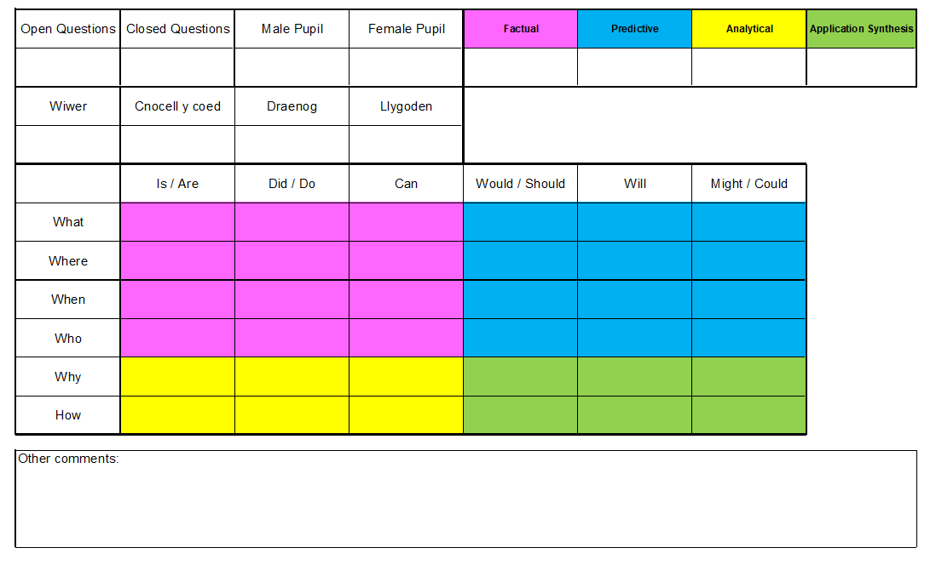

Appendix 3

Questions for Learners
How does questioning deepen understanding?
- What is your favourite thing about school?
- Can you explain how you feel when your teacher asks you a question?
- Why do you think your teacher asks you questions during the lesson?
- How do you know when you have answered a question correctly?
- If you get a question wrong how does your teacher let you know?
- Do you feel your teacher gives everyone a chance to answer questions?
- Do you ever feel that your teacher asks you a question that is too easy or too hard?
- Can you show me a piece of work you’re really proud of?
- Did the questions your teacher ask you about this help you create this fantastic piece of work?
- Show me a piece of work you found hard. What questions did your teacher ask you to help you understand?

Appendix 4
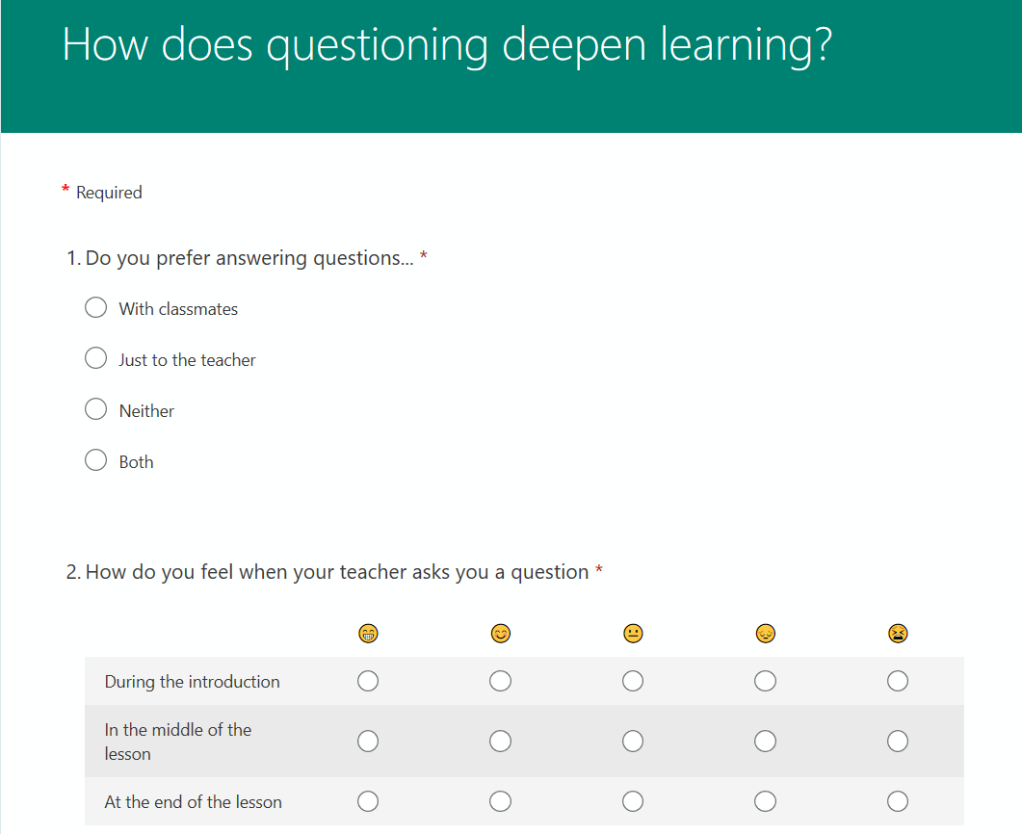

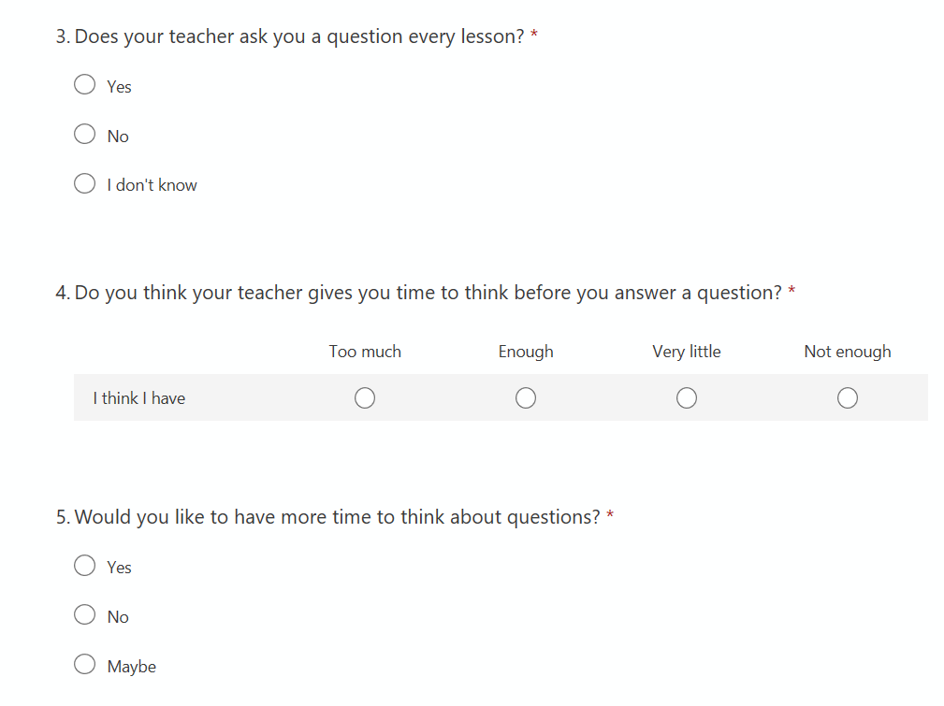

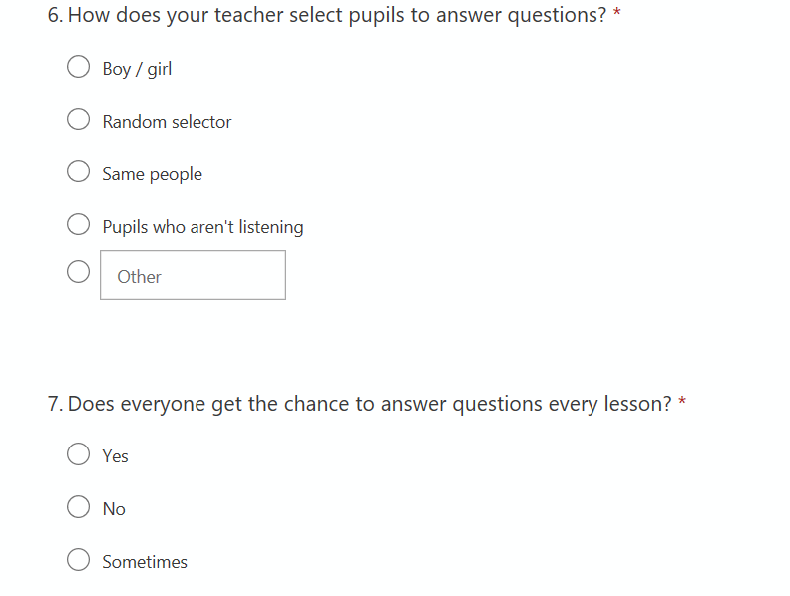

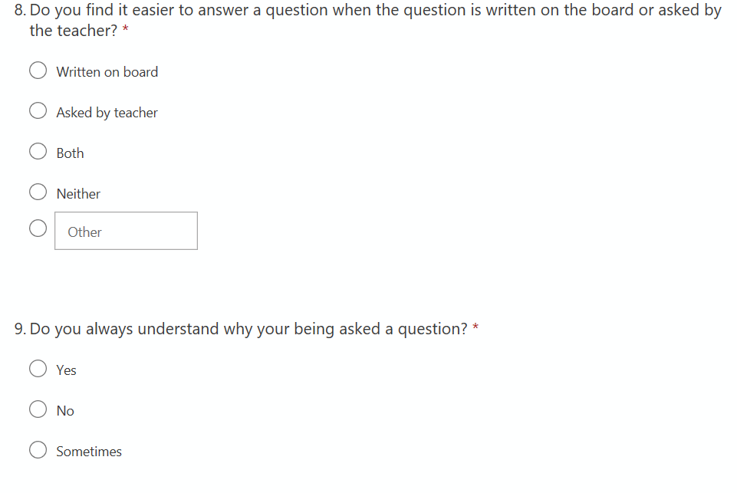

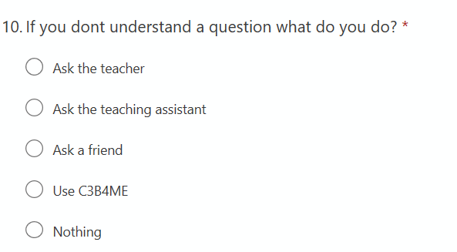

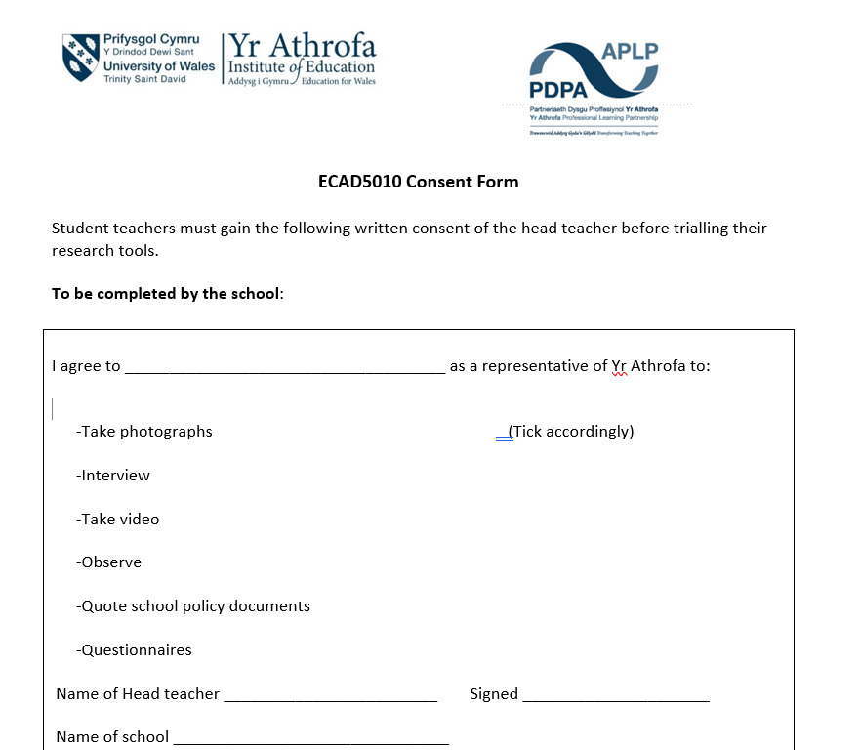
Appendix 5
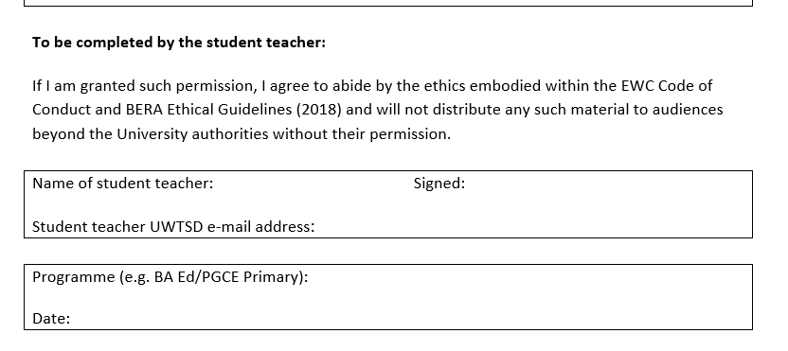

Appendix 6
 | Why do you think your teacher asks you questions during the lesson?
A | In case something went wrong.
B | To help me learn and give me confidence
C | To see how good my knowledge is.
D | To see what we already knew about it.
E | Because like to express our answers with the teacher and the rest of the class
F | To show if we have been listening and to show if we know what she’s on about.

Appendix 7
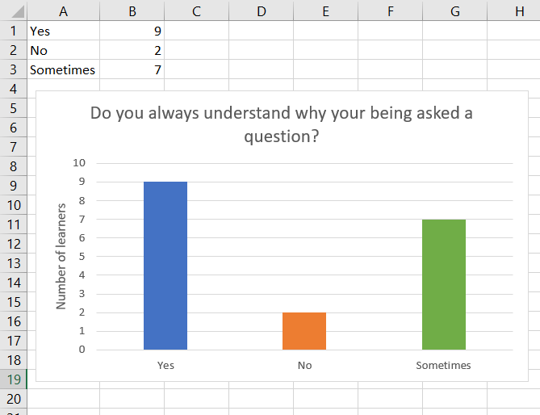

Appendix 8

 | Did the questions your teacher ask you about this help you create this fantastic piece of work?
A | No, we asked the them questions.
B | No.
C | I forgot.
D | I don’t really remember but I really like my handwriting in this work, but the teacher is really lovely helps us with our work.
E | Not really. they like said stuff to add in.
F | No, not that I remember.

Appendix 9

Class Teacher interview
Interviewer: Can you explain how you decide what questions to ask learners during a lesson? For example, do you plan to ask certain questions when you are planning the lesson?
Teacher A: I think at the back of my mind I've always got some questions to ask certain people. Especially if there's some children who are quite quiet in the class as some who are quite loud so I’m always thinking of different questions to ask but obviously it depends on the lesson. So, if I'm obviously doing something on English say I was doing fact or opinion. I've always got those questions in my head already to ask them so I can get an idea of like activating their prior knowledge. Or whether they already know something so I can develop them with differentiation as well, so I know exactly what questions to ask them obviously based on the topic. Sometimes I kind of extend those questions as well asking for reasons.
Interviewer: Ok brilliant. You have basically answered the second question which is What strategies do you use to help learners who give an answer that is off target? For example, paraphrasing, probing, asking the question in a different way.
Teacher A: I think if I ask a question and they give me an answer that's way off course or it's the wrong answer you kind of try to rein them back in. Or you say well done for giving me that answer why don’t you think about it in this way? Some of the children like to help each other as well. A lot of the children are very good role models in the class anyway. So, they kind of tell each other in a way that their answers aren’t wrong but maybe they should try answering it in another way. Ill give them ideas as well but it’s always about the praise first like well done for giving me that answer but how do you feel about your answer? Or I might change my questioning slightly differently as well giving them an easier option and try not to make it too tricky for them.
Interviewer: Great! So how do you pose questions to children? Do you differentiate or do you like to ask the same question to all the children?
Teacher A: I tend to ask the same question to all the children but then obviously if I’m asking my lower ability children questions you kind of rephrase it, so they understand it easier. For example, I might have some autistic children in the class so my questioning technique with them has got to be slightly different to somebody who’s more able that understands instructions and questioning. And it depends on the year group as well. So, like we have year 4, 5 and 6 in the class so it all depends on that as well.
Interviewer: So, how long do you wait once you’ve asked a question before you expect the learners to respond? Do you have any strategies? Do you count to 10?
Teacher A: No, I don’t have a strategy. I tend to just wait a while and sometimes it’s the same children who put their hands up. So, I wait a while and sometimes suggest talk partners. Talk partners is really helpful because if I ask a question, the children who are quite quiet in the class have someone to talk to next to them. It helps them to bounce ideas of each other then. So, they then feel like the are answering the questions together. There’s always someone in the class who has the answer. So, I tend to wait at least 10 or 20 seconds so that there’s more hands going up. But sometimes I’ll notice children who haven’t got their hands up and I might kind of ask them as well. Or sometimes I’ve got the randomiser on the Dojo or the lollipop sticks as well to get them to answer the questions.
Interviewer: Ok brilliant, do you think questioning learners deepens their understanding? And if you do, what’s your opinion?
Teacher A: I do think it helps them. I mean sometimes it’s hard when you’ve got certain children who don’t want to ask the questions. Their answers tend to be closed like yes or no or quick answers. So, it’s about my questioning but their understanding of what I am asking them as well. So sometimes they may not understand, and they may need me to explain a little more to them. So, I definitely think it helps them because without the questioning they can’t develop discussion skills or the oracy skills. Especially with their talking partners. But we do a lot of partner work and group work in class as well. With guided reading its really good because we have a questioner on the table. They have cards so that the questioner always has questions to ask about the text.
Interviewer: That’s great. Thank-you for taking the time to answer these questions.
Teacher: No problem.

Appendix 10

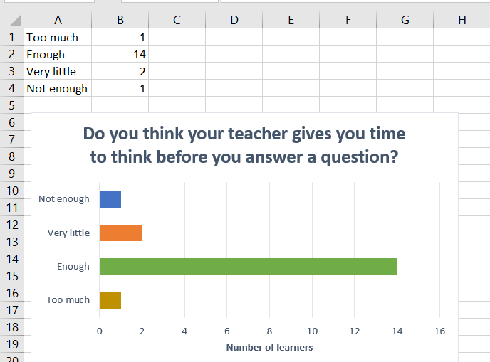

Appendix 11 – observation sheet filled

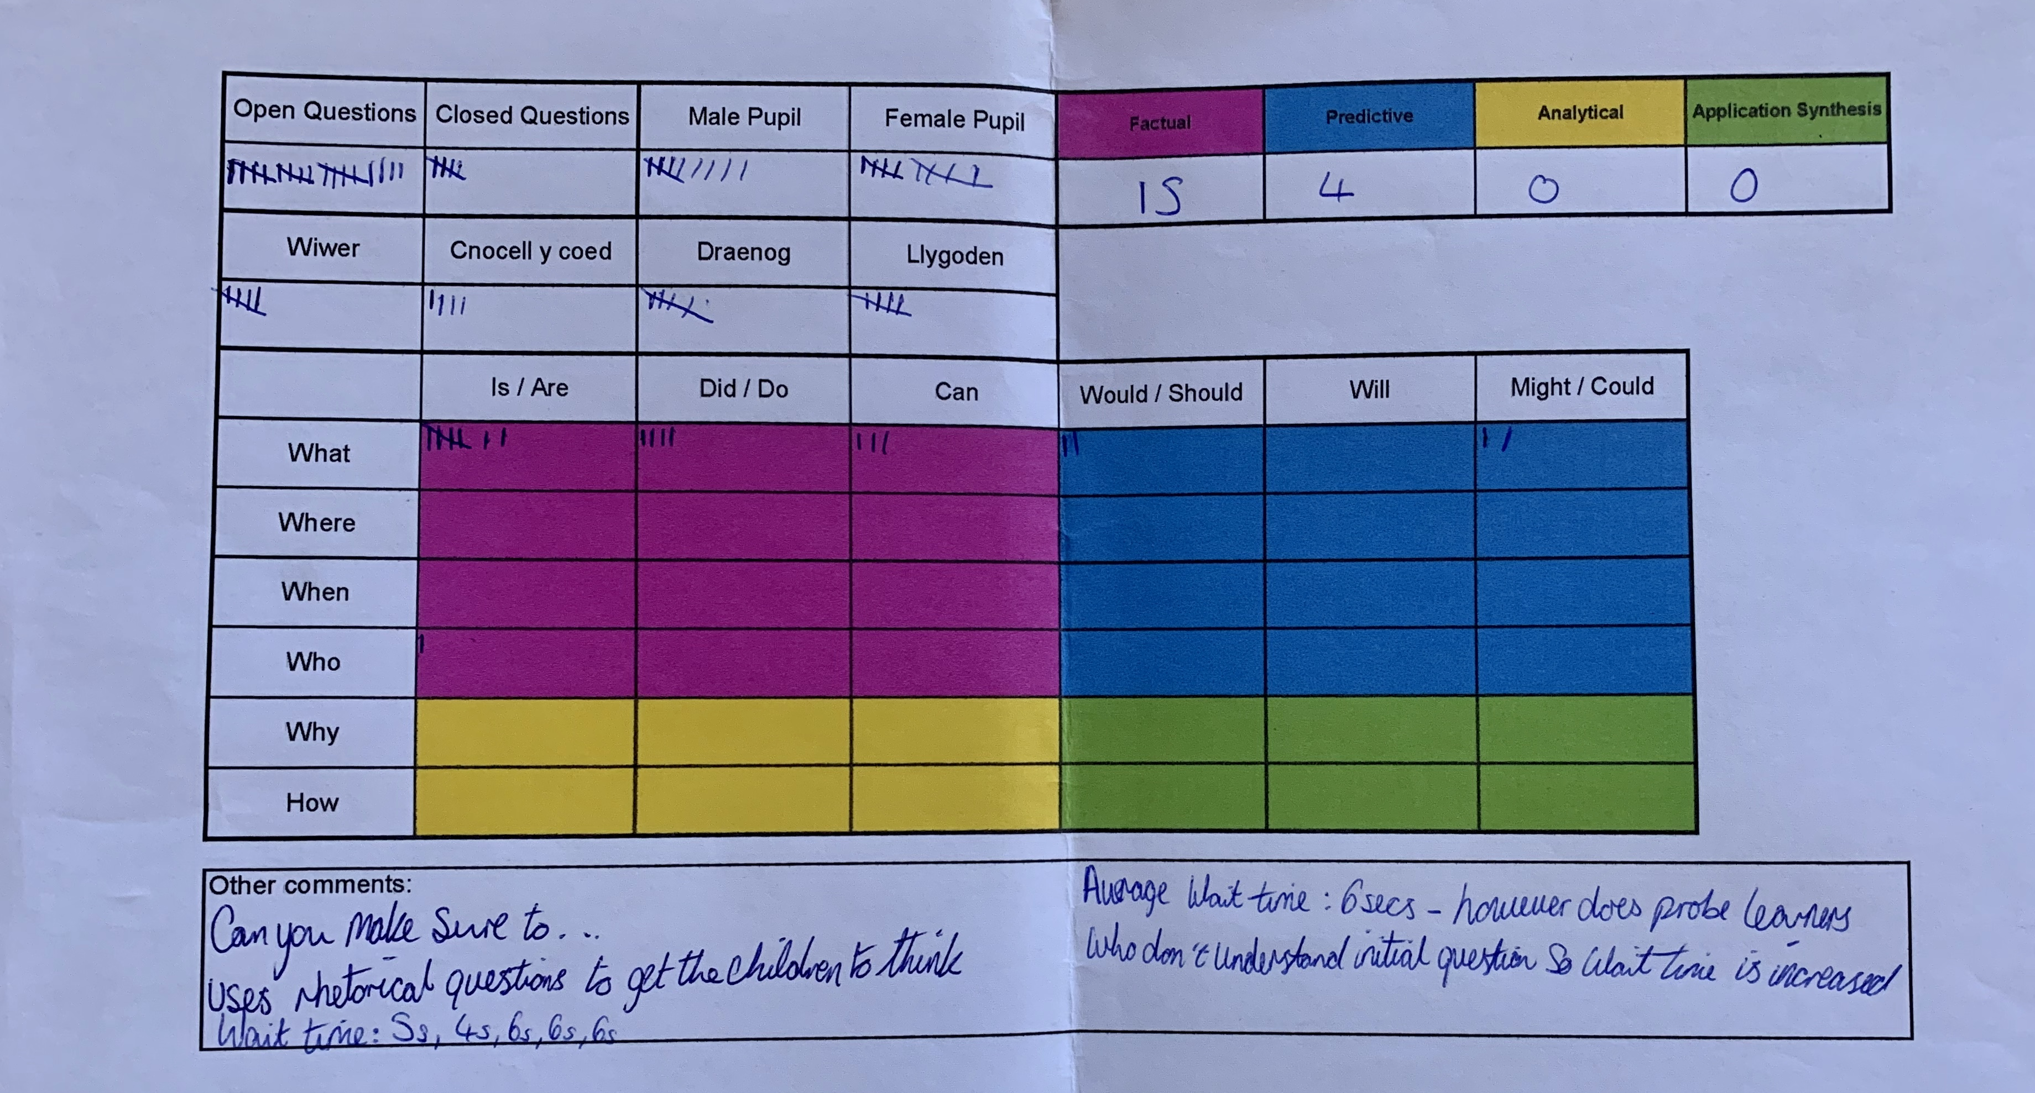

Appendix 12
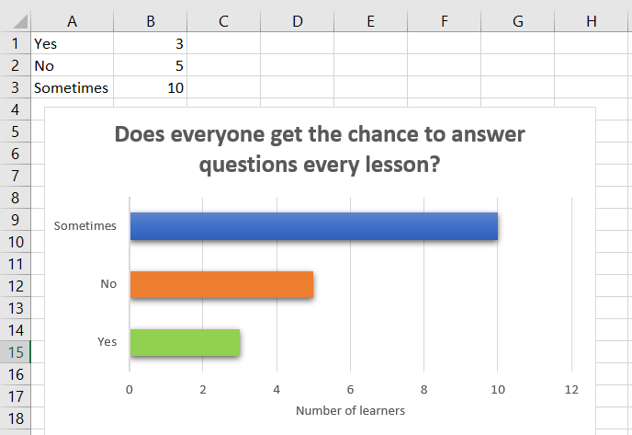

Appendix 13 – interview questions

Questions for Learners
How does questioning deepen understanding?
- What is your favourite thing about school?
- Can you explain how you feel when your teacher asks you a question?
- Why do you think your teacher asks you questions during the lesson?
- How do you know when you have answered a question correctly?
- If you get a question wrong how does your teacher let you know?
- Do you feel your teacher gives everyone a chance to answer questions?
- Do you ever feel that your teacher asks you a question that is too easy or too hard?
- Can you show me a piece of work you’re really proud of?
- Did the questions your teacher ask you about this help you create this fantastic piece of work?
- Show me a piece of work you found hard. What questions did your teacher ask you to help you understand?
Questions for Teacher
- Can you explain how you decide what questions to ask learners during a lesson? E.g. do you plan to ask certain questions when you are planning the lesson?
- What strategies do you use to help learners who give an answer that is off target? E.g. paraphrasing, probing, asking the question in a different way
- How do pose questions to learners? E.g. do you differentiate, or do you like to ask the same question to all the children.
- How long do you wait once you have asked a question before you expect your learners to respond?
- Do you think questioning helps deepen learners understanding?
- If so, can you give me your opinion?

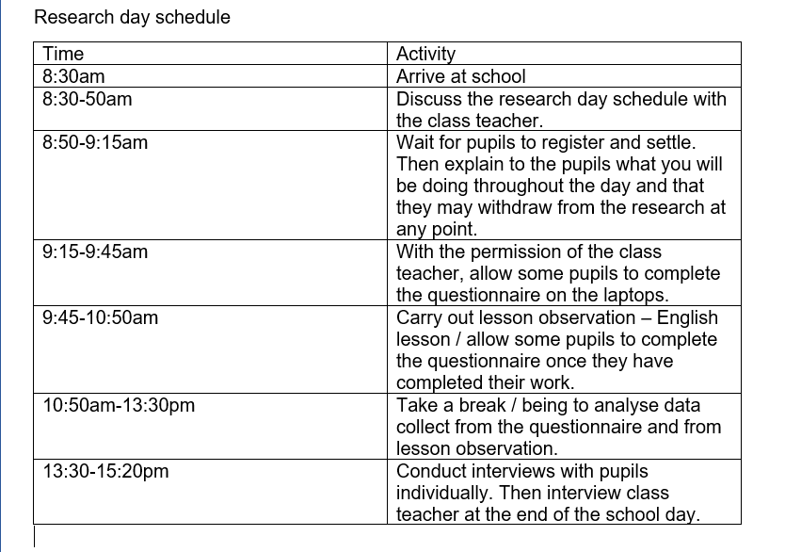
Appendix 14

Appendix 15 – Learner transcripts
 | What is your favourite thing about school?
A | Learning, Maths.
B | Learning and spending time with friends.
C | Rugby, when you get into a sports team.
D | Definitely working with my friends and having fun.
E | I get to see my friends all the time.
F | I guess the teachers and friends and spending time together.

 | Can you explain how you feel when your teacher asks you a question?
A | Fine, I don’t know.
B | Thinking, well I’m thinking really hard.
C | Nervous.
D | Normally I get a bit shy because I feel like I’m going to say something wrong. But after a while I feel fine.
E | I just feel like if it’s something about the work I’m happy to answer it but if it’s something random I’ll like still to answer it.
F | Well I think of the answer first and then I would give her a question back.

 | Why do you think your teacher asks you questions during the lesson?
A | In case something went wrong.
B | To help me learn and give me confidence
C | To see how good my knowledge is.
D | To see what we already knew about it.
E | Because like to express our answers with the teacher and the rest of the class
F | To show if we have been listening and to show if we know what she’s on about.

 | How do you know when you have answered a question correctly?
A | I don’t know, you wouldn’t know until the teacher says it is right.
B | Well, the teacher just tells me.
C | Because the teacher marks it.
D | Well when the teacher marks it.
E | The teacher just doesn’t say the answer. They just say well done if it’s the answer or ok if it isn’t.
F | Usually if you get to know the teachers well, they may show you signs and say things like “make sure your listening” which tells me I’ve probably done something wrong. But Teacher C tells you straightaway if your wrong or right. But Teacher A makes us think before they tell us.

 | If you get a question wrong how does your teacher let you know?
A | They’ll do an arrow or a dot. They tell us sometimes.
B | Well she uses a purple highlighter and pen.
C | They make you go back to it or they marks it.
D | By telling us. They normally give us our books back and help us with it.
E | They just put an arrow on our work, or they just say you need to do this question again. Then we go back and do it again.
F | They would just I guess tell you by saying “so close”, or they’d correct you on the spot.

 | Do you feel your teacher gives everyone a chance to answer questions?
A | Yes.
B | *Nods head yes*
C | Yes.
D | Yeah, they’re a really nice teacher and a good teacher.
E | Yes *nods head yes*
F | Yeah definitely *nods head yes*.

 | Do you ever feel that your teacher asks you a question that is too easy or too hard?
A | Sometimes.
B | Well I feel like most of them are too hard. I think it’s because she wants me to learn more.
C | Both.
D | No, I feel like the teachers’ questions are good questions.
E | Sometimes like because we’re in the top group they ask us hard questions so yeah.
F | Well more in-between.

 | Can you show me a piece of work you’re really proud of?
A | *Nods head yes*
B | Yeah.
C | Yes.
D | Yes.
E | *Nods head yes*
F | Yeah.

 | Did the questions your teacher ask you about this help you create this fantastic piece of work?
A | No, we asked the them questions.
B | No.
C | I forgot.
D | I don’t really remember but I really like my handwriting in this work, but the teacher is really lovely helps us with our work.
E | Not really. they like said stuff to add in.
F | No, not that I remember.

 | Show me a piece of work you found hard. What questions did your teacher ask you to help you understand?
A | I don’t think they asked us questions, we just did why we should stay healthy and stuff.
B | *Nods head yes* They didn’t ask me questions.
C | Yeah, that *shows work* I think so.
D | *Didn’t show work* There was a piece of maths work I didn’t get. But when I worked with friends, I feel more confident than just working on my own.
E | I think it was this one *shows work*. The name and stuff, so I had to write the answer to the question.
F | Yeah that one *points to piece of work*. They said use as much colours as you can.

Appendix 16 – questionnaire results


