
Skills for the Workplace
Module Assignment Submission
Student Name: | Alin Chirila
Student Number: | 2008838
Module No: | BMSK4006
Module Title: | Part 1 Business Plan

Statement of Confirmation of Authenticity
By the act of making this submission, the student declares that this is the work of the student named above. The work has not, in whole or in part, been knowingly presented elsewhere for assessment, or where assessment has been built on a previous assessment, this has been identified. Where materials have been used from other sources it has been properly acknowledged. If this statement is untrue, the student acknowledges that an assessment offence has been committed.
Attention is drawn to the plagiarism and unfair practice policies of both the University and of ILM.

Table of Contents
Title Page 3
Executive Summary 3-4
Business/Industry Overview 4
Market Analysis and Competition 5-6-7-8
Sales and Marketing Plan 9
Product or Service Offerings 10
Pricing Strategy 10
Sales and Distribution 11
Advertising and Promotion 11
Ownership and Management Plan 12
Operating Plan 13
Financial Plan 13-14-15-16-17
Appendices 18-19-20

Title Page
Business Plan for " Cocktail Club"
• Date-09/10/2021
• Business address-11 Caer Street, Swansea SA1 3PP
• Phone-07853330940
• Email- Not yet applied
• Website URL-Not yet applied

Executive Summary

This business plan is made by personal experience and my dream of running a night club/bar. Since I started in 1994 as a waiter moved to deputy manager in several years, working in Romania, London, Cardiff, and Swansea in some very famous clubs, I always wanted to run my own nightclub. This is the reason I am studying the Business Management at university, as always, I had a felling my knowledge and experience was not enough.
The second-largest city from Wales, with a large student population and a huge range of bars is Swansea. The most popular nightlife street in Swansea is Wind Street. This location is very close to Wind Street. Wind Street is the centre of Swansea’s nightlife, it’s a street packed with far more wine bars, pubs, restaurants, and clubs than is at all necessary. This increases the competition between clubs and bars. Most of them offer cheap cocktails and drinks, or other princely cocktails and drinks. In 2014 I started to work on Wind Street till 2016 when I changed my job, mostly because I had to take care of my family. I always wanted to open a nightclub with over 20 years’ experience in hospitality industry, I was waited for the right time to start my own business. On the time I spent on Wind Street I was observing other bars and clubs and none of them have high standards, this mostly due of lack of trained personnel. My mission will be to focus on hight quality and customers standards, this will be the way of standing out compare with others. I have trainer skills course done and with my previous experience I can create professional bartenders in a very quick time. My vision is to create an amazing atmosphere where you can come and have a great time with your friends, this including music, temperature, staff, lights, outside smoking area and management. In exchange for staff, we pay a good wage to staff and the tips they can keep it and extra bonuses and weekly competitions. To provide a high standards of customer service and super quality on drinks as mixologists. The primary target market for this venue is the age group of 18 to 45.

Location
The premises is accessed via Caer Street, situated off Castle Gardens. Situated in the heart of the City Centre of Swansea, this period property is a short distance from the Quadrant Bus Station and benefits from a prominent kerbside trading position.
Description
Accommodation comprises of a ground floor retail area as well as basement accommodation, with kitchen and WC facilities also available. The premises was previously used as a tattoo parlour.
Services
The property benefits from all mains utilities.
Size
Ground Floor - 95.82 Sq. m (1031 Sq. ft)- the main bar and tables until 21:00 after converted in dance floor.
Basement - 80.77 Sq. m (869 Sq. ft)-DJ booth and another small bar
This accommodation has an approximate Net Internal Area of 176.59 m2 (1900 ft2). Full capacity of 250 people on both floors.

The main services we offer to our customers are those common to any club or bar, the difference will be high quality products and served in a professional manner. In addition, we want to offer as many interactive shows as possible with live bands Monday to Thursday, Sunday salsa lessons, evenings with different themes like Halloween, Christmas period (one of the busiest periods), Beaujolais Day and many more.
Due to the location, we must address young people, students, young professionals. The club targets 60% of these categories with ages between 18 and 30 years. We will address young people by providing services and shows like student nights Monday to Thursday. To attract this usually is to get in contact with students trade union services and can some deals be made.
On the other hand, we also address people between the ages of 30 and 45, targeting 40%. By creating an environment that attracts this category Friday and Saturday by attracting Hens parties, offer high quality services including famous cocktails served with fresh herbs and fruits not out of date compared with other bars.

Business/Industry Overview

The nightclub will be focus on quality and premium spirits, a warm place where you can spend your night out with your friends and enjoy a good music, DJ and live bands, Sunday salsa lessons, different student night on Wednesday with quality products instead cheap drinks.
Market Analysis and Competition
Wind Street is the most competitive street in Swansea for nightlife, on the other hand have an immense footfall on customers. The strength is being a small nightclub can select your clientele much better with prices and no need of a big promotion as the place is small very quick will be at full capacity compare with other venues, they need time to build up.
Since 2020 two big brands close their door on Wind Street on is Walkabout part of a big company in UK, closed suddenly in January 2020 after 20 years. And the other one was Idol opened in 2006 and after 15 years was closing for good. Most of them because of the pandemic. This is the unknown scenario and most of the people who run nightclubs are scared it will happen again with the introduction of restriction or the hospitality industry to close again.
SWAT analysis of competitors.

 | Peppermint Bar  The Bucket List  Bambu Beach Bar | No Sign Wine Bar | Revolution | The Perch
Strength | Same owner  Trying to manipulate the other bars | Small company, owner of Noah bar in uplands, good quality. | Part of big company, with 66 venues in UK, unlimited cash flow | Formers General Managers from  Peppermint Bar  Bambu Beach Bar  Cocktails specialist
Weakness | Too many, hard to reach the targets.  Covid-19 | Attract people over 30.  Covid-19 | Big company pushes for unreached targets  Covid-19 | Small place but amazing atmosphere.
Opportunities | Expanding on other places | Expanding on other places.  Small business dealing better with new trends. | Small business dealing better with new trends. | Expanding on other places but less than others
Threats | New business  New deals with student unions  Small business  Covid-19 | New business  New deals with student unions  Small business  Covid-19 | New business  New deals with student unions  Small business  Covid-19 | New business  New deals with student unions  Small business  Covid-19

There are a lot of variety of bars but only few are putting accent on quality, most of them target students offering big discounts and cheap prices. This is decreasing the quality of Wind Street as people are too quick intoxicated with alcohol and especially when student night is.
The products I will offer are the best on quality. using premium spirits and the freshest ingredients possible from the market will attract a lot of people who like this.
There are few places and most of them are small business like The Perch, as to keep control on quality is better to have small bars to run, very difficult when you have 4 or 5 bars and 30 -50 staff. Also, a good management team, however most of places don’t have managers with experience and they hire and fire on daily basis. Most of them are student who like to earn some money, but owners have different views and clash between then are very common. Because of this you don’t have a team and the quality is always low. My plan is to create a strong team investing money and time for them to reach the professional level. People they like to have a good night out without having mega headaches next day because of poor quality on spirits. Moreover, some people are intoxicated with food poison because of the fruits are not checked properly and not discharged in every day. Our brad will build customer loyalty as most customers over 25 are looking for this. in exchange we will create a loyalty card, offering 10% discount any days they visit.
The overall capacity footfall per days is:

Days | Customers overall per day | Minimums spend per person | Maximums spend per person | Overall spend per person | Total customers per day x  Overall spend
Wednesday | 100 | £5 | £10 | £7.5 | 750
Thursday | 200 | £10 | £15 | £12.5 | 2500
Friday | 500 | £15 | £30 | £22.5 | 11250
Saturday | 600 | £15 | £30 | £22.5 | 13500
Sunday | 100 | £5 | £10 | £7.5 | 750
Total |  |  |  |  | £28750

The estimates sales compare with other competitors in my experience when I was working on Wind Street is 20% of their sales. This is better for me as has let me to choose specific clientele as have less people to enter in my venue and always will look busy from outside.

SWOT analysis:

STRENGTHS  Quality of products and service.  Organizing evenings with different themes.  Attractive design.  Entertainers who maintain the atmosphere.  Professional bartenders.  Competent staff to highlight the quality services that the club promises to its clients.  Smoking area.  Outside area with tables. | WEAKNESSES  Lack of a reputation on market.  Lack of parking.  Insufficient funds.
OPPORTUNITIES  High demand for services of this kind.  The new always attracts and that is why many people will be eager to visit the club. | THREATS  Fierce competition in the location area  Government regulations  Incorrect forecasts regarding the potential of the number of customers, the revenues collected, etc.  Covid-19

Sales and Marketing Plan
The marketing strategy is essential for our club. The key points are:
• exceptional quality of services
• the unique features of the club
• target customers
We follow the practice of average prices, preparing properly for high quality services. The salaries paid and the training of the employees must ensure high quality. The price will be calculated depending on what we serve. All items in the menu will have moderate prices with premium spirits used in cocktails and fresh fruits and condiments.
Since this club is on two levels, it will operate daily between 14:00 to 21:00 on relax and ambient atmosphere with background music for customers to relax, and as a club, between 21:00 – 3:00 from Wednesday to Sunday. Our target are customers who spend their nights in the club, but at the same time we want to attract the customers who can come the day to relax before the club is opening. Monday is going to be end of the week with stock counting. Monday and Tuesday close to save with the staff full time the days off and cost of running the business.
Every Wednesday on Wind Street is student night, a very busy night with most of the Swansea student out for a fun night. On this night our strategy is to attract student on small prices but on premium prices this will decrease the gross profit but will increase the quality of the drinks an ordinary student usually has when out. On this day will be a charge of £2 to enter in club to balance the premium spirits loss and to hire some local bands with this money.
Another strategy is to include Happy Hour in every day from 19:00 to 20:00 where we can offer some discounts, for example 50% off on all cocktails, or 50% on beers and ciders when important football or rugby matches are lives.
Our specific training programs aim to prepare the employee for professional customer service with high standards of behaviours, to serve any customer in a professional manner and to learn to solve problems without waiting to consult supervisor or manager in charge. This including: acceptable bartending standards, unacceptable bartending standards, techniques resulting in termination, personal appearance, uniforms, proactive bartending, alcohol consumption & tolerance, alcohol awareness policy, up selling, suggestive selling, terminology, cocktails, house rules, payment methods, comps & voids, shift responsibilities, recipes, preparing drinks, anatomy of a cocktail, and many more. This program is inhouse program developed by me and run 3 weeks before the club opening. Every week will run competition between bartenders to stipulate upselling. And target bonuses if the target will be reached.
Our promised strategy of fulfilling quality services can be the most important thing.

Product or Service Offerings

The club will offer high quality on products. using only premium spirits in cocktails and premium champagne, beers, and cider. The staff will entertain with dancing on the bar when is full and bar flair, and mixology lessons when not busy. Free internet access via wi-fi to all customers, a powerful internet provider will be chosen when open like Virgin Media. Dry Martini, Manhattan, Old-Fashioned, Mint Julep, Mojito, Margarita, Daiquiri, Tom Collins, Martinez, Brandy Cocktail… to fusions cocktails, sours, shooters and many more.
Student night will attract student, but the prices will be only 50% off not student prices below £1 with cheap spirits. Whit this we attract students to be aware of the danger of consuming cheap drinks and the responsibility to drink, enjoying the time spend out not being intoxicated with alcohol.
Happy Hour will run in every day from 19:00 to 20:00 to offer the opportunity of other people to taste a quality cocktail.

Pricing Strategy

Not always Low prices are the most attractive offers. Our strategy on prices will be premium, as in exchange we offer a high quality of services and products. We target the audience who seek quality over a good deal. on other hand we have Happy Hour for people who would like to taste our quality of premium products. The quality of product will create a fine clientele, no need to cut people from door, we cut people with prices and quality. Our aim is to create a clientele who like to spend more money on quality and excellent service and to meet other people in a safe environment.

Sales and Distribution

Every Monday will be stock counting and end of the week with all the cash to be banked, and order to be ordered for the week in course. All the spirits are delivered on Wednesday morning when one floor staff must organize in the cellar. The products must be fill up in that day, including every night after club close, and must be first in first out basis, this will reduce the wastage. All the orders will be paid electronically. All the fruits and condiments must be ordered in every night to be delivered next day with exceptions on Saturday, Friday must be ordered for Sunday as well. All fruits must be fresh, as fresh as can be for the quality. When order make sure you check for promotions as always big distribution company are running, example if order 12 Single Barrel Jack Daniels, they give you for free a bottle of Absolut vodka. Most of the stock will be delivered by truck, plenty of space in front of the club for this. From there the bartenders will sell by products or mixed in cocktails. The method of payments will be cash and card. We will encourage the customers to use touchless payment as this is the most used these days because of COVID-19.

Advertising and Promotion

The easiest way promote is via social network Facebook, YouTube, LinkedIn and many more, free of charge. This is our objective to hire one sale team to promote on social media, presenting and focusing on quality we offer and the cocktails we sell.

Ownership and Management Plan

Sole proprietorship and General Manager run by me Alin Chirila. I have personal licence holder without this you cannot sell alcohol. Also Designated premises supervisors. A designated premises supervisor (DPS) is the person who has day-to-day responsibility for the running of the business. In charged with Street team, marketing, student promoting, health and safety of the premises, fire safety of the premises, risk assessment, Personal protective equipment (PPE)
1 Bar Manager who will be in charge with staff rota and stock, complain. Must have personal licence.
1 Bar Supervisor-in charge with all the bars to run on maximum capacity, staff breaks, open and close (cleaning, enough stock, cover bars when busy), staff incentive.
6 Bartenders- on daily base rota, main objective to entertain and sell drinks.
4 Floor Staff- on daily base rota, to clear table and make sure enough stock is on bars and utensils and glasses. Moving furniture when change to nightclub. Preparing outside area for smoking area and queuing for entry.
4 securities- on daily base rota, in charged with customer and staff safety, customers numbers to make sure no we don’t go over nightclub capacity.
2 Cleaner- morning nightclub cleaning (toilets, table, floor, and windows)
2 Street Team – promoting the club in specific locations. Bring customers in club.
1 Accountant - Oversee the ongoing maintenance of accounts, payrolls, support management in the accurate production of budgets, ensure cashflow is utilized properly, audit financial information for inconsistencies, provide strategies in accordance with existing legislation
1 sales team -can work from home, promoting for free on social media, must have very good IT skills and connections with students’ unions.

Operating Plan
The club will be operating:
Wednesday student night: 16:00-03:00
Thursday: 16:00-03:00
Friday: 16:00-03:00
Saturday: 16:00-03:00
Sunday Salas lessons: 16:00-00:00
Monday and Tuesday: closed

Financial Plan

Expenses for renovating and opening the nightclub:
2 bars -one with one station and one with 2 stations - including granite top and pluming. - cost £6000
2 large fridges for fruits and beer -cost £2000
Ice machine -£1500
3 small fridges for cider, beer, and some spirit like Jägermeister -£1500
Floor tools: buckets, emergency maintenance tools, mop, broom, brush, paper, napkins. -£300
Toilet fully equipped man and women refurbished -£5000
Bar equipment: glassware, mixers, jiggers, muddlers, cocktail shakers, cocktail spoon, citrus juicers, cap catchers, bottle and can openers, jiggers, cocktail shakers, cocktail strainers, garnishing tools, straws, and stirrers, cutting boards, napkins and coasters, bar mats, bar towels, liquor bottle pourers, containers for garnishes and bitters, ice buckets, wine openers. -cost £ 3000
8 tables + 32 chairs-£5000
Interior design: walls, cellar toilet, electric, heater, doors, and windows -cost £10000
Exterior design: walls, lights, signs-cost £5000
DJ booth: mixer + electric part -£2000
Lights dance floor: -£3000
Sound system: -£4000
4 Tv –£2000
Safe -£1000
Cash on premises -£5000
CCTV -£1000
PC office +3 cash register -£1500
Posters and flyers -£500
Miscellaneous -£700
Total cost £60000 without the rent and stock.
Rent per year-£22000
Bar stock -£12000
Premium spirits: vodka, gin, tequila, whiskey, scotch, bourbon, rum- £3000
Beer and cider: -£3000
Liqueurs: amaretto, coffee liqueur, dry and sweet vermouth, Irish cream liqueur, orange liqueur-£3000
Non-alcoholic mixers: lemon and lime juice, orange juice, cranberry juice, grapefruit juice, pineapple juice, tomato juice, bitters, simple syrup, sour mix, grenadine, milk, bottle of water, soda, half & half or cream, Tabasco sauce and Worcestershire sauce-£2000
Fruits and condiments: lemons, limes, oranges, maraschino cherries, olives, cocktail onions, mint, salt and sugar, cinnamon, grated nutmeg celery or pickles, whipped cream-£1000
Drink stock will be delivered every Wednesday and order online on Monday after stock counts. fruits and condiments daily to be as fresh as possible with possibility to buy daily from market for fresher test.

Staff cost per week:
Floor staff -£11 per hour
Bartenders including supervisor -£15 per hour
Security -£17 per hour
Accountant salary -£30000 per year/£576 per week
Bar manager -£30000 per year/£576 per week
General manager -£40000 per year/£769 per week
Cleaners -£15 per hour
Street team-£1 per customer.
Sales team-£10000 per year part time /192 per wee
Staff rota:
Monday and Tuesday closed managers will work but are on salary.
Total staff cost per week is £3013 not included the management, sales, and financial team:
Total cost including all staff:
Accountant salary -576 per week
Bar manager -£576 per week
General manager -£769 per week
Staff cost: £3013
Total: £4934
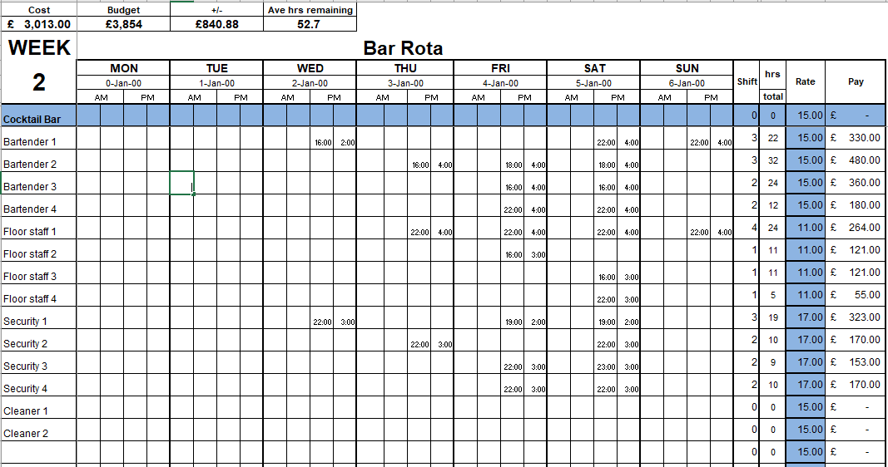

The total sales per month is £115000.
Utilities including Tv licence, gas, electricity, premises licence -£4000 per month
Building and content insurance -£400 per month
HSBC loan repayment will start from 2nd month after opening and is £4000 per month.
Rent £1834 per month -£22000 per year
Restock £6000 every week.
Marketing 1st month included in investment after will be £800 per month mostly on flyers and posters.
Cash flow prediction January 50% low as the work month people recover after Christmas spending. February and March start to increase as people have more money.
Back to normal from April and May as spring starts and Easter. Dropped slightly on summer June, July and August people tend to go abroad and students back to their hometowns.
September welcome back to students and increase until January as Halloween, Beaujolais day and Christmas period.
Total profit per year £390000.
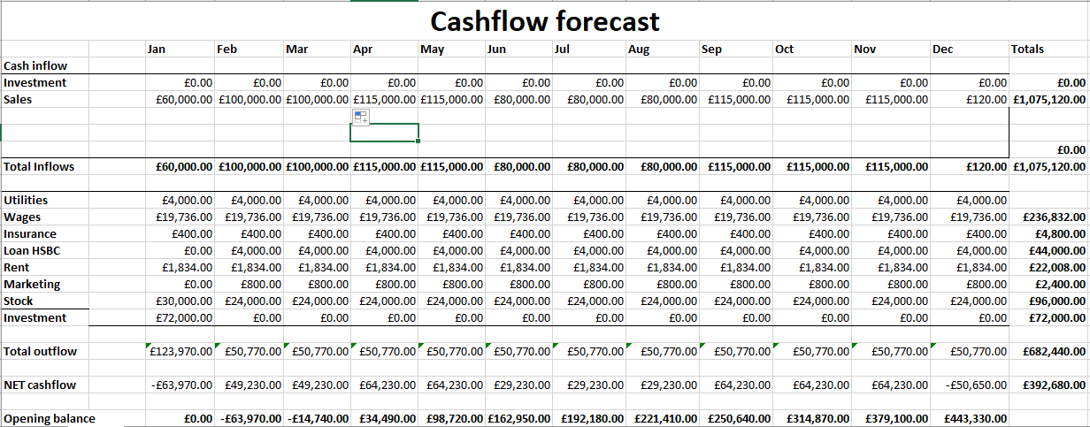
Appendices

Starting your own enterprise Strength and Weakness Audit
The table of general business skills below will help you to identify your strengths and weaknesses to give you a better idea of whether you are ready to start your own business.
Examine each of the skills areas listed in the table.
Ask yourself whether you possess some or all the skills listed.
Then rate your skills in each area by ticking the appropriate number, using a scale of 1-5, with 1 as low, 2 as between low and medium, 3 as medium, 4 as between medium and high, and 5 as high.
 | Rating  Low to High |  |  |  |  | Average Rating
Skills | 1 | 2 | 3 | 4 | 5
Selling & Marketing
Market research |  |  |  |  | x
Knowing your competitors |  |  |  |  | x
Market planning |  |  |  | x
Negotiating |  |  |  |  | x
Tracking competitors |  |  |  |  | x
Customer service |  |  |  |  | x
Pricing |  |  |  |  | x
Financial Planning & Accounting
Cash flow planning |  |  |  |  | x
Monthly financial monitoring |  |  |  |  | x
Bank relationships |  |  |  |  | x
Monthly profit and loss statements/balance sheets |  |  |  |  | x
Bookkeeping |  |  |  |  | x
Administrative
Work Scheduling |  |  |  |  | x
Payroll handling | x
Benefits administration |  | x
Personnel management
Hiring employees |  |  |  | x
Firing employees |  |  | x
Motivating employees |  |  |  |  | x
Staff training |  |  |  |  | x
General management skills |  |  |  |  | x
Personal business skills
Oral presentation skills |  |  |  |  | x
Written communication skills |  |  |  |  | x
Computer skills |  |  |  |  | x
Word processing skills |  |  |  |  | x
Fax, e-mail experience |  |  |  |  | x
Organisational skills |  |  |  |  | x
Intangibles
Ability to work long and hard |  |  |  |  | x
Ability to manage risk and stress |  |  |  |  | x
Family support |  |  |  |  | x
Ability to deal with failure |  |  | x
Ability to work alone |  |  |  |  | x
Ability to work with and manage others |  |  |  |  | x
Total | 1 | 1 | 2 | 2 | 26
Conclusion
After you have rated yourself in each area, total up the numbers. Take the average score on the rightmost section of the table and total them to get the Grand Total. Then apply the following rating scale:
If your total is less than 20 points, you should reconsider whether owning a business is the right step for you
If your total is between 20 and 25, you are on the verge of being ready, but you may be wise to spend some time strengthening some of your weaker areas
If your total is above 25, you’re ready to start a new business now



