Data Analysis & Visualization

Module code: LCBB5000
|Assessment 2
Student name: Onisor Opris
Student ID:2022780

Table of Contents
Introduction 3
Part 1 4
Determination of sales and profits decline over the years using pivot table 4
Determination of sales and profits decline over the years using the SUMIFS function 6
The trend of sales and profits using charts 7
Use of Excel for pre-processing, analysing and visualising the data 11
Part 2 14
2.1 Students who like the vanilla flavour of ice-cream 14
2.2 Gender of students 14
2.3 Mean and median for students who like ice-creams with chocolate and strawberry flavours 16
2.4 Example of clustering in SPSS 16
2.5 Explanation of the most common data mining and text mining methods that can be used in business with real-world examples 22
2.6 Advantages and disadvantages of using SPSS and Excel using relevant practical examples 22
Conclusion 25
References 26

Introduction
This report consists of two parts. In the first part, the use of pivot table and summits function in determining the trend of sales and profits over the last four years for a comparably large dataset has been presented with details. The findings have been demonstrated in the same section using different charts. It also involves explaining the benefits of Excel in ensuring data pre-processing, analyzing, and visualizing. The next part involves the application of SPSS software to find answers to some given scenarios based on the given CSV file.

Part 1

Determination of sales and profits decline over the years using pivot table
A pivot table is a built-in function in Excel that aids in summarizing and diversely organizing large datasets. The customization option of pivot tables gives the users the liberty to present and interpret data in as many ways as possible (Jelen, 2019). The different datasets have different insights and what would be the best for a particular dataset can be identified through a trial-and-error process using the pivot table.
Table 01: Sales and profits over the period
Source: Self-made
The above-presented pivot table has been constructed from the superstore sales dataset. The column “order date” has been placed in rows and sales and profit columns have been placed in the value segment of the pivot table. The value has been presented in total format. In 2009, total sales revenue of the superstore was £4 million which declined to £3.7 million in 2012. Over the years, sales performance was declining for the firm/ The profits calculated in the pivot table also bears the same message.
Table 02: Sales and profits over the period in percentage
Source: Self-revenue
The difference between this table and the previous pivot table is that sales and profit values have been presented here in percentage form to make things easier to compare (Cosma, 2019). Putting 4 years’ sales and profit data altogether, it has been seen that as the years advanced further, the share of sales and profit started to fall.
Table 03: Sales and profits over the period by quarters
Source: Self-made
The pivot table shows the profit and sales breakdown over the years quarterly. For the year 2009, the first quarters’ sales performance was better than others. In 2010 and 2011, the firm did better in the last quarter whereas, in 2012, good performance was observed in the first quarter. Though the percentage of sales over the 12 quarters was in the range of 5% to 8%, with time, sales showed a slow declining move. The profitability of the firm also declined throughout the quarters.
Table 04: Sales over the period by regions
Source: Self-made
Table 05: Profits over the period by regions
Source: Self-made
The pivot table presented here shows sales and profits of the superstore by region. The firm’s products were available for sale in 8 regions. The highest sales were observed in Ontario, West, Prarie and Atlantic regions in 2009 whereas, in Ontario, Prarie and Atlantic reported higher profits. The next year, both sales were higher in Ontario and the West regions. The same trend was observed for the years 2011 and 2012. So, the main problem of the superstore is that in some regions, its sales performance was poor, and things did not improve with time (Liu, 2018). The firm could have taken different promotional activities into hand to boost sales in those regions.

Determination of sales and profits decline over the years using the SUMIFS function
Using the SUMIFS formula, the yearly sales and profit volume of the superstore have been determined (Rangkuti and Harahap, 2020). The formula used to find total sales value in 2009 is as follows.
=SUMIFS('Superstore Sales '!$F$3:$F$8401,'Superstore Sales '!$C$3:$C$8401,">="&DATE(2009,1,1),'Superstore Sales '!$C$3:$C$8401,"<="&DATE(2009,12,31))
By inserting this formula and pressing enter, the sales value was found to be £4.2 million in 2009. The formula would be the same except for a change in the year data for the following three years.
The formula used for finding out total profits year by year is as follows.
=SUMIFS('Superstore Sales '!$I$3:$I$8401,'Superstore Sales '!$C$3:$C$8401,">="&DATE(2011,1,1),'Superstore Sales '!$C$3:$C$8401,"<="&DATE(2011,12,31))
In the following example, the formula for determining the profit for 2011 has been demonstrated. As in the given dataset, profit was recorded in the I column, the same column has been defined as the sum range while calculating yearly profits.
Table 06: Percentage change in sales and profits
Source: Self-made
Percentage changes in sales and profits have been determined using the following formula.
% Change in profit 2010= (Profit in 2010- Profit in 2009)/ Profit in 2009 (Raghunathan, 2020)
The output table shows that Sales were declining year by year from 2010 except the last year, 2012 which recorded an 8% rise in sales revenue compared to that in 2011. Profit also demonstrated a falling trend except for the year 2011 which reported a 4% rise in profit from that of 2010.

The trend of sales and profits using charts
The line chart is more compatible and appropriate for showing the time trend of the following line chart shows the financial performance of the given superstore over the last 4 years ranging from 2009 to 2012.

Figure 01: Sales over the period by region
Source: Self-made
The year 2011 was a recovery year for the company as it experienced a positive growth rate of profit and a lower declining rate of sales in this year. The other years showed a declining rate of sales and profits for the firm. In 2010, sales declined by 15.44% and profit by 15.94%. In 2012, sales declined by 15.44% and profit by 9.96%.

Figure 02: Sales over the period by quarters
Source: Self-made
The column chart shows the total sales revenue and profit of the superstore for each quarter. The sales figure is more apparent to claim immediately by looking at the graph that the revenue is falling though the decreasing rate is slow (Hiljazi and Curtis 201,8). Profit was also reflected in the same scenario but the profitability of the firm is more volatile than sales over the years.

Figure 03: Yearly sales as a percentage of total revenue
Source: Self-made
The pie chart represents the four years’ sales performance of the superstore firm in 8 different regions altogether. Of the total sales revenue earned by the enterprise from 2009 to 2012, the highest revenue was earned in 2009. In this single year, more than one-fourth of the total revenue was generated (Cabinova, 2021). The company for the next three years could not break this record. Those years’ share of sales was limited to 23% to 24.91%.
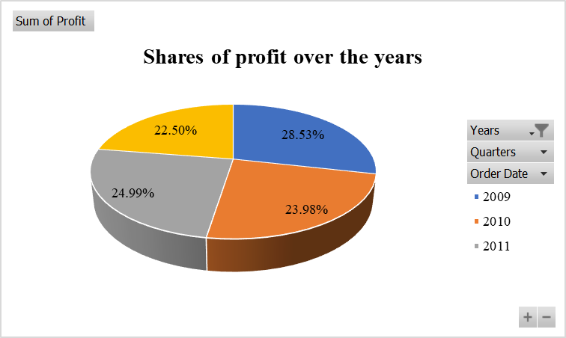
Figure 04: Yearly profits as a percentage of total revenue
Source: Self-made
The pie chart of profits shows that 28.53% of the four years’ total profit was shared in 2009. In 2011, the sharing portion fell to 23.98% and then it showed an insignificant rise from the previous level by gaining a profitability level of 24.99%. The earning capacity again declined in 2012 reflecting a decline in profit on average by the firm.

Figure 05: Yearly profits as a percentage of total revenue
Source: Self-made
The above-presented column chart has been constructed taking the output from the application of the SUMIFS function. It shows sales and net earnings in absolute form for the four years. Over the financial periods, the column chart reflected a slower performance falling condition.

Use of Excel for pre-processing, analyzing and visualizing the data
Excel in data pre-processing: The combination of raw data in a dataset does not make it appropriate for going through the processing step. Data preprocessing simply refers to the actions taken to make the data valid for running any model without any disruption (Li, 2021). Use of excel in data pre-processing:
- Using Excel, blank cells can be identified and then those blank cells can be removed to prepare a structured and balanced data set.
- In a data set, there might be different types of variables including date, number, currency, percentage etc. These variables can be defined in Excel by selecting a particular column and going into number format to select the format that best matches the values in that column.
- Data validation is a crucial part of data analysis (Abdul-Rahman, 2021). Using different features of Excel, data validation can be checked, and the data set can be made more user-friendly.
- The pre-processing step involves defining and constructing a table that can be made using Excel. At the same time, a list of variables can be developed like the ones made in VLOOKUP and HLOOKUP functions to make the data searching process quick and real-time responsive when dealing with a large dataset (Yi, Herdsman and Morris, 2019.).
Excel in data analysis: Analysis of data is the main essence of using Excel. The following are some applications of facilities that can be enjoyed by MS Excel.
- MS Excel has functions to develop descriptive statistics of different variables. A user only needs to select the input and output range along with the summary statistics that are desired to be there in the output table. Descriptive statistics will provide a meaningful inside regarding the characteristics of different variables in the data set (Varshini and Kalpana, 2021).
- Regression analysis, determination of correlation coefficient and drawing liner regression line from a model can be shown using Excel. These are the basic functions of this software. The regression analysis includes both linear and multiple regression analysis.
- There are different built-in formulas in Excel that can be used in analyzing the dataset under different conditions. The formula makes it easier to come up with the final output from a large volume of the dataset in the blink of an eye. Examples of some most used and recognized built-in formulas are IF, COUNTIF, SUMIF, SUMIFS, SUM, AVERAGE, GEOMEAN, CORR, VAR, STDV, etc. Many of these formulas can be used at the same time when the criteria are diverse. So, there is a scope of creativity to apply while analyzing data as per the requirement of data analysis.
- LOOKUP functions are another wonder of MS Excel that can enrich the data validation and data management techniques. Data normalization is another feature that eases the way the dataset is handled. If data is normalized, the value of data after normalization ranges from 0 to 1.
Excel in data visualization: After data analysis comes to the stage of data presentation. A researcher might do excellent in data analysis by using sophisticated and advanced statistical software but if the output is not presented understandably, the purpose of the analysis often goes in vain. Studies found that on average 62% of people use Excel for data visualization (Lu, 2018). The rest of them take the help of advanced statistical software like Stata, SPSS etc. The following are some cases where MS Excel can present the data more easily and understandably.
- Different lines, columns, bars, clustered columns, combo, pie and other charts and graphs can be constructed in MS Excel and the resulting chart is easy to understand for users irrespective of their respective backgrounds. So, they remain the top choice of researchers when it comes to presenting data precisely.
- The pivot table and other tables ensure that data of different categories can be presented by drawing a connection with one another, by developing relevant classification to explain the data etc.

Part 2

2.1 Students who like the vanilla flavor of ice-cream
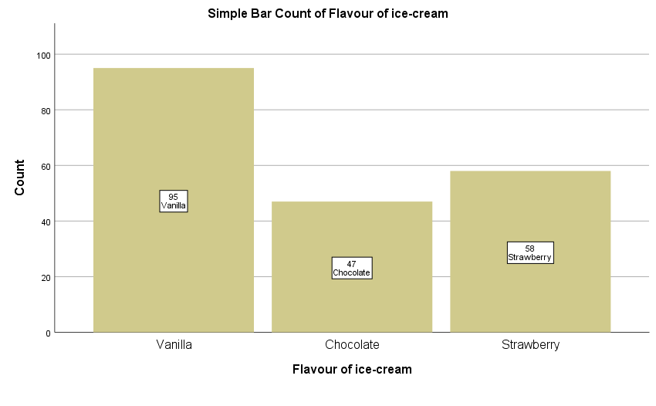
Figure 06: No. of students who prefer vanilla flavored ice-cream
Source: Self-made
The above-presented bar chart has been created using SPSS software. The bar chart shows that 95 students like vanilla flavored ice-creams, 47 high-school students like chocolate flavored ice-creams and the rest 58 students like strawberry flavored ice-creams. Vanilla-flavored ice-creams are liked by the majority of the students.

2.2 Gender of students

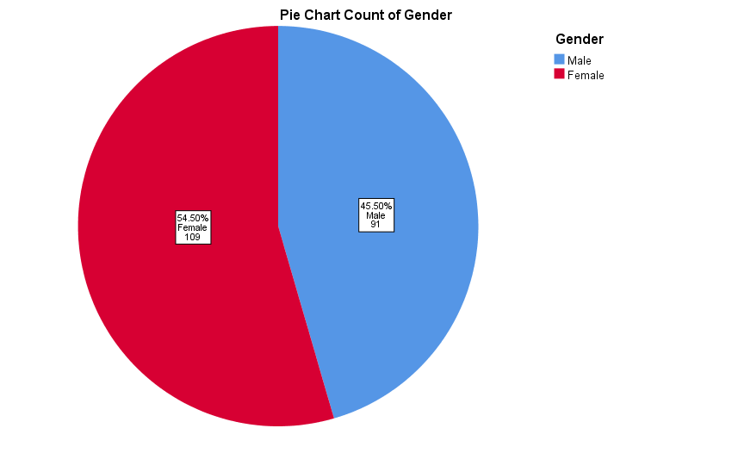
Figure 07: Gender of the students
Source: Self-made
109 out of 200 students, that is, 54.50% of the total students are female and 91 students (45.50% of all students) are male.

2.3 Mean and median for students who like ice-creams with chocolate and strawberry flavors’
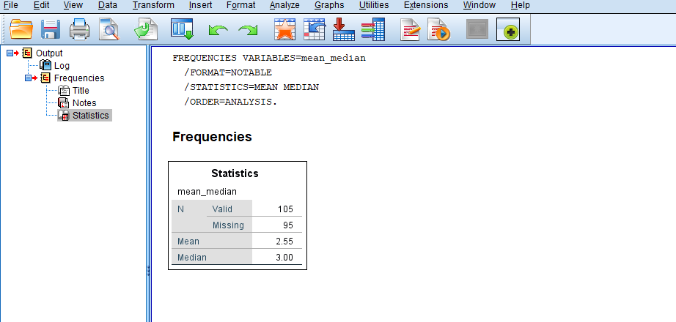
Table 06: Mean and median application experience
Source: Self-made
Out of the 200 students, 105 students either liked chocolate-flavored or strawberry-flavored ice creams. In the data set, response 2 was labelled against students who liked chocolate and 3 for those who liked strawberries. The mean value is 2.55 which indicates most of the students in these two groups liked chocolate-flavored ice creams. The median value of 3 indicates that strawberry was preferred the most.

2.4 Example of clustering in SPSS
By K-means clustering, groups are formed depending on the scores across multiple dependent variables (Sallis, 2019). In this case, how high school students group together based on video game scores and puzzle scores is going to be analyzed using K-Means clustering.
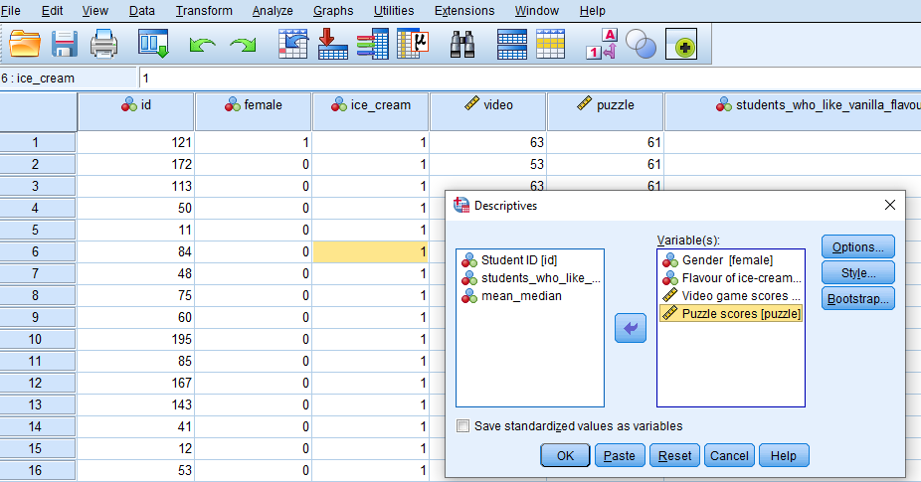
Table 07: Building up clustering
Source: Self-made
First of all, the gender information, scores of video games and puzzles and the ice-cream flavors they prefer have been standardized. It has been done by going to descriptive statistics’ descriptive function from the “Analyze” dialogue box and selecting the dependent variables. After pressing OK, the following table shows up as output.
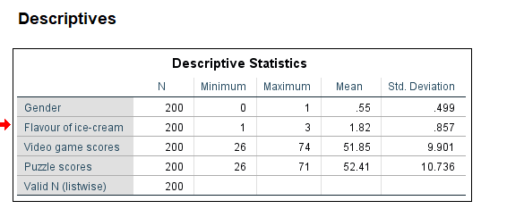
Table 08: Descriptive statistics of the variables
Source: Self-made
The meaning of gender does not make any meaningful insight. The average score in puzzles was a little bit higher than the average video games score with minimum scores for the two variables being the same. Video game scores have a lower standard deviation than puzzle scores.
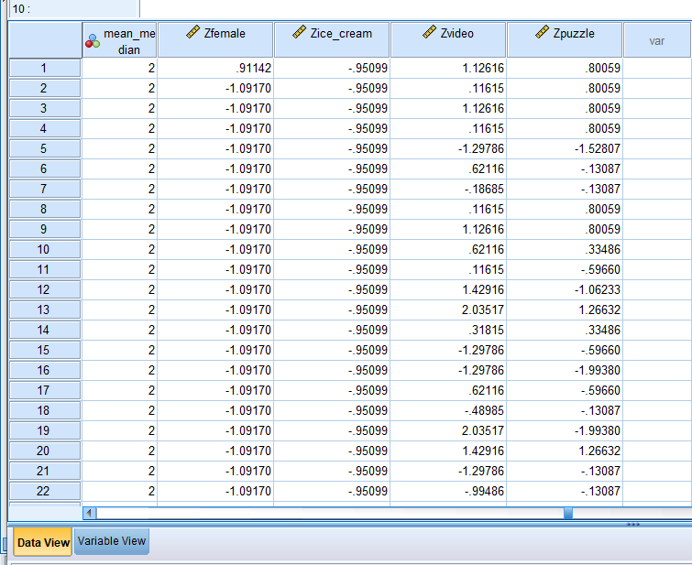
Table 09: Standardization of the variables
Source: Self-made
The new four columns with headline Zfemale, Zice_cream, Zvideo and Zpuzzle represent the standardized value from the raw input for each record. Now the data is ready for running the K-means clustering test (Cleff, 2019). After going to Analyze, then classify and then K-means step by step, the following output has been found.
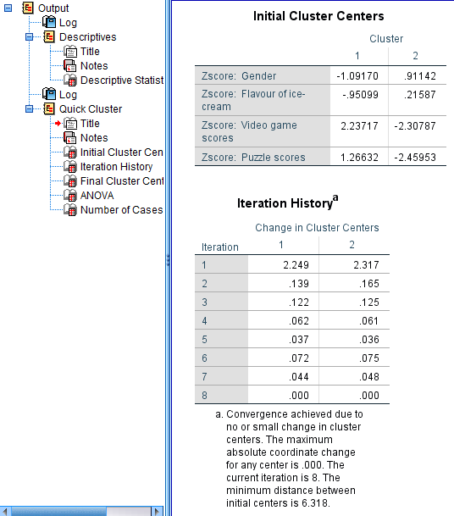
Table 10: Initial cluster centers
Source: Self-made
The initial cluster centers show 2 groups of clusters that have gone through 8 iterations or 8 changes in cluster centers. After that, the final cluster centers were generated.
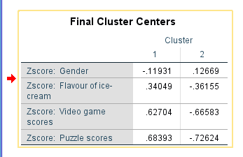
Table 11: Final cluster centers
Source: Self-made
The final cluster centers demonstrate z scores for gender, ice-cream flavor, video game scores and puzzle scores for 2 different clusters. The z score is different for a particular variable in the two cases.
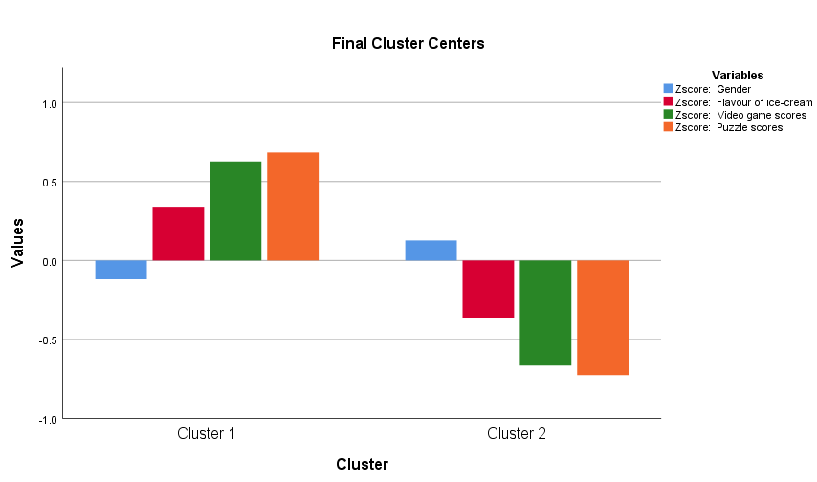
Figure 08: Bar charts of clustering groups
Source: Self-made
In cluster 1, ice-cream flavor and other scores show positive value except for gender and the situation is the opposite in cluster 2. That is, only gender shows a positive value, and the rest of the variables demonstrate negative scores.
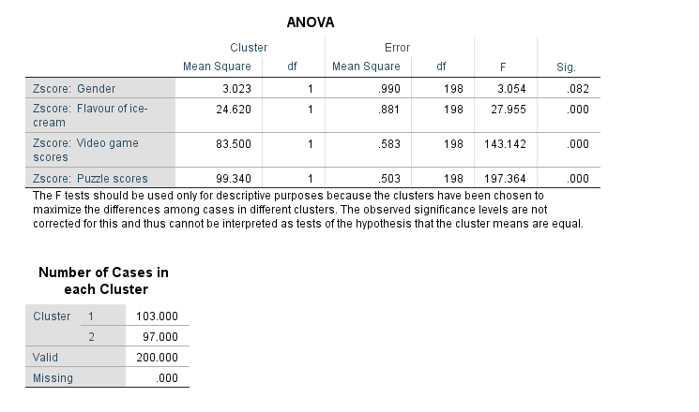
Table 12: ANOVA table
Source: Self-made
Looking at the ANOVA table, it is apparent that ice-cream flavors, video game scores and puzzle scores have a significant impact on determining which student would group into which cluster as these 3 variables are statistically significant at a 1% significance level. Gender is also significant at a 10% significance level but if the significance level is 5% or 1%, then gender would have no statistically significant impact on determining students’ cluster.
So, the final table shows that in cluster 1 there would be 103 students and in cluster two, there would be 97 students. The clustering can also be conducted using 3 or more clusters.

2.5 Explanation of the most common data mining and text mining methods that can be used in business with real-world examples
Data mining methods: The use of different sophisticated software in converting raw data into information or valuable insight is considered the data mining process. Clustering is one of the most common data mining procedures. It involves the visualization of data under different criteria of classification. Businesses use clustering methods to predict different buying groups of a product based on the characteristics of the target customers (Saura and Bennett, 2019). Grocery storekeepers and retailers identify demand for a product and predict sales within a particular period using clustering methods. Marketing and promotional strategies are devised using association which is another method of data mining. If a retailer searches for information regarding a particular product from the database, it is considered a single-dimensional association and if more than one piece of information is searched, it will be a multi-dimensional association.
Text mining methods: Identifying relevant and value-additive information from raw text data, tokenization, text preprocessing etc. falls under the purview of text mining. Information extraction is one of the most frequently used text mining methods that businesses use to extract data from large data sets by searching for phrases, entities, sentence segmentation etc. (Tao, Yang and Feng, 2020). Using information retrieval methods, search engines tend to gather documents that are relevant to some phrases used in search engines. Using natural language processing as a text mining method, businesses minimize the communication gap between non-technical employees and computer applications.

2.6 Advantages and disadvantages of using SPSS and Excel using relevant practical examples
 | Advantages | Disadvantages
SPSS | - It has a dynamic scope of work, and the application software is fast with command.  - It is user-friendly and easy to operate.  - It is appropriate for dealing with a large volume of datasets.  - Due to its capacity to operate in different languages, a large number of audiences can use the software (Mishra, 2019).  - It is useful for both descriptive and numeric data.  Example: In maintaining the public health industry, SPSS is used dominantly by medical institutions. | - When the data set is very large, SPSS would not be the appropriate application software to analyze the data.  - It is almost similar to Excel. So, it adds little additional value to the users.  - The functionality and service features of SPSS are very limited compared to other software (Navidinia, Akar and Hendevalan, 2019).  - SPSS is mostly appropriate for research areas related to social science rather than statistical area.  - Defining variables manually might be found cumbersome by beginners.  Example: MNCs do not use SPSS at all rather they depend on NLP, BI and business automation.
Excel | - Excel is easy to operate, learn and perceive.  - From simplest to harder mathematical and analytical processing options are available in Excel.  - Data can be visualized most efficiently.  - Users irrespective of educational background and research area can use the application with the same emphasis.  - Reports can be printed easily from MS Excel.  Example: Employees on average spend 38% of their time using Excel. | - It is not effective to work with large datasets using Excel.  - Many advanced statistical applications are not available here.  - It is more time-consuming and detailed to run any operation that can be completed using other software within seconds.  - It is not conducive to making quick and real-time decisions (Dumford, and Miller, 2018).  - Collaborative working is not compatible with this application software.  Example: Businesses are switching to different cloud servicing and SaaS services along with other trends of BI in place of Excel to derive the best output.

Conclusion
Microsoft Excel is the first stepping stage for each researcher to deal with data processing, analysis, and interpretation. But in real-life business scenarios, businesses come across and store trillions of unorganized data that cannot be stored and maintained in Excel. Therefore, the application of different advanced statistical software like Stata, e-views, SPSS, Python etc. becomes a necessity for enterprises. In today’s era, firms are searching for the perfect embedded applications of business intelligence that would make use of the available big data in the most insightful way and will lead the firm to make the right strategic moves at the right time.

References
Abdul-Rahman, M., Chan, E.H., Wong, M.S., Irekponor, V.E. and Abdul-Rahman, M.O., 2021. A framework to simplify pre-processing location-based social media big data for sustainable urban planning and management. Cities, 109, p.102986.
Canova, V., 2021. Innovative methods of evaluating business efficiency: A comparative study. 684080133.
Cliff, T., 2019. Applied statistics and multivariate data analysis for business and economics: A modern approach using SPSS, Stata, and Excel. Springer.
Cosma, E., 2019. Pivot Table: A Tool to Calculate, Summarize, and Analyze Data. Ovidius University Annals, Economic Sciences Series, 19(1), pp.161-166.
Dumford, A.D. and Miller, A.L., 2018. Online learning in higher education: exploring advantages and disadvantages for engagement. Journal of Computing in Higher Education, 30(3), pp.452-465.
Hiljazi, S. and Curtis, T., 2018. Developing an Introductory Class in Business Intelligence (BI) Using MS Excel PowerPivot. Association Supporting Computer Users in Education.
Jelen, B., 2019. ROLLING 12 MONTHS IN A PIVOT TABLE. Strategic Finance, 100(10), pp.56-57.
Li, H., Li, W., Zhang, Z., Yuan, H. and Wan, Y., 2021, December. Machine learning analysis and inference of student performance and visualization of data results based on a small dataset of student information. In 2021 3rd International Conference on Machine Learning, Big Data and Business Intelligence (MLBDBI) (pp. 117-122). IEEE.
Liu, C.H., Silva, C.C., Wang, L. and Way, A., 2018, October. Pivot machine translation using Chinese as a pivot language. In China Workshop on Machine Translation (pp. 74-85). Springer, Singapore.
Lu, J., 2018, September. A data-driven framework for business analytics in the context of big data. In European Conference on Advances in Databases and Information Systems (pp. 339-351). Springer, Cham.
Mishra, P., Pandey, C.M., Singh, U., Gupta, A., Sahu, C. and Keshri, A., 2019. Descriptive statistics and normality tests for statistical data. Annals of cardiac anaesthesia, 22(1), p.67.
Navidinia, H., Akar, M. and Hendevalan, J., 2019. Using translation in language teaching: Exploring advantages and disadvantages from linguistic, humanistic and practical perspectives. International Journal of English Language and Translation Studies, 7(2), pp.12-18.
Raghunathan, P., 2020. Data Analysis and Decision Making: Using Spreadsheets and “Pivot Tables” To Get A Read On Energy Numbers. In Information Technology for Energy Managers (pp. 157-169). River Publishers.
Rangkuti, K. and Harahap, M., 2020. Development Of Business Analysis Learning Model Using The Microsoft Excel Application. Jasc (Journal Of Agribusiness Sciences), 3(2), pp.77-84.
Sallis, J.E., Gripsrud, G., Olsson, U.H. and Silkoset, R., 2021. Research Methods and Data Analysis for Business Decisions: A Primer Using SPSS. Springer International Publishing.
Saura, J.R. and Bennett, D.R., 2019. A three-stage method for data text mining: Using UGC in business intelligence analysis. Symmetry, 11(4), p.519.
Tao, D., Yang, P. and Feng, H., 2020. Utilization of text mining as a big data analysis tool for food science and nutrition. Comprehensive reviews in food science and food safety, 19(2), pp.875-894.
Varshini, S. and Kalpana, M., 2021, May. Stock data analysis with Ulpath automation. In 2021 5th International Conference on Computer, Communication and Signal Processing (ICCCSP) (pp. 1-6). IEEE.
Yi, G., Herdsman, C. and Morris, J., 2019. A MATLAB toolbox for data pre-processing and multivariate statistical process control. Chemometrics and Intelligent Laboratory Systems, 194, p.103863.

