

Full Name: Febechukwu Miriam Iwuala
Student ID Number: 2409092
Programme: BSc Health & Social Care
Module: Creativity and Value Creation
Component 1 – Online portfolio of Set Exercises
Module Code: BMHP5014
Lecturer: Zarah Ahmed

Task 1 – Concept Map

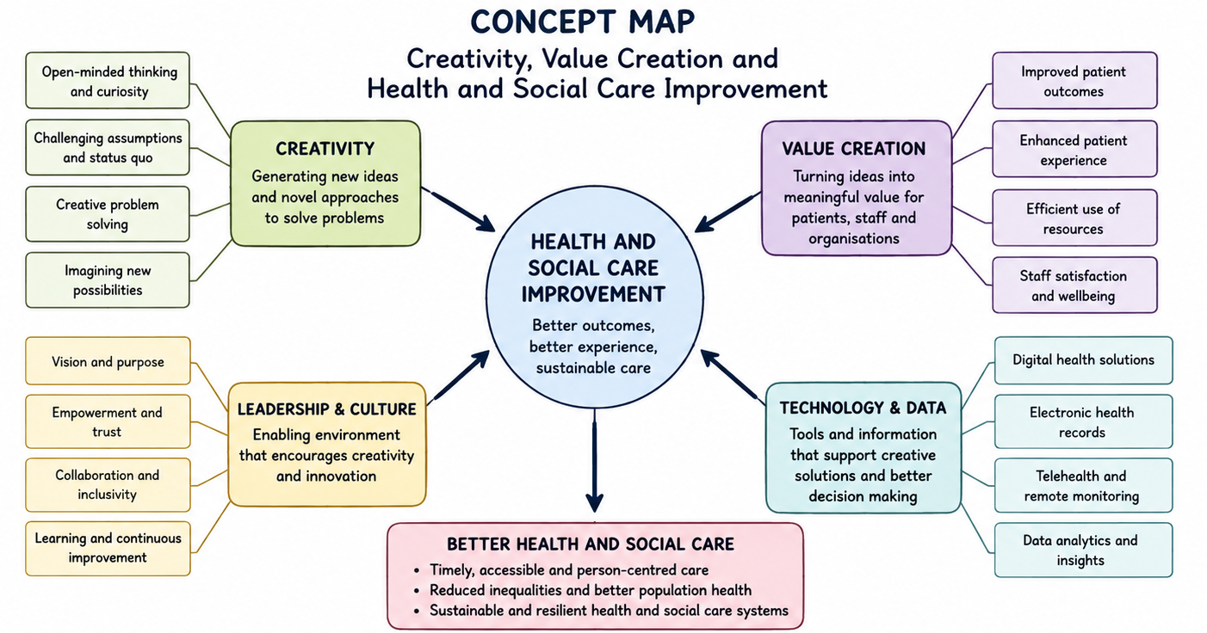

Creativity, value creation, leadership, and technology are closely interconnected in improving health and social care services. Creativity enables healthcare professionals to develop innovative solutions to complex challenges such as increasing patient demand, workforce shortages, and financial pressures. Rather than relying solely on traditional methods, creative thinking encourages new approaches to service delivery that improve patient care and organisational performance (West and Farr, 1990). Value creation refers to delivering better outcomes for patients while making efficient use of available resources. In healthcare, value is achieved by improving patient safety, patient experience, quality of care, and clinical outcomes while reducing unnecessary costs and waste (Porter, 2010). Creativity supports value creation by identifying opportunities to redesign services, improve workflows, and strengthen collaboration between multidisciplinary teams.
Leadership and organisational culture play a vital role in fostering creativity and innovation. Effective leaders create environments where staff feel empowered to share ideas, embrace continuous learning, and work collaboratively to solve problems. A positive organisational culture encourages innovation, supports staff wellbeing, and promotes continuous quality improvement, enabling organisations to adapt to changing healthcare needs.
Technology further strengthens creativity and value creation through digital innovations such as electronic health records, telehealth, artificial intelligence, and remote patient monitoring. These technologies improve communication, reduce duplication, support clinical decision-making, and increase access to healthcare services while promoting person-centred care.
Together, creativity, leadership, technology, and value creation drive continuous improvement across health and social care. Their interaction enhances patient safety, improves partnership working, promotes sustainable service delivery, and ensures that health and social care organisations are better equipped to meet the evolving needs of individuals, families, and communities.

Task 2 - Self-Reflection of Group Activity

6 Six Stages Of Gibbs' Reflective Cycle: Paperclip Thinking Activity
1. Description
During the paperclip thinking activity, our group was asked to generate as many alternatives uses for a paperclip as possible. The purpose of the exercise was to demonstrate divergent thinking, where participants generate a wide range of ideas without judgement, before using convergent thinking to evaluate those ideas and identify the most practical solutions. At the start of the activity, I believed there would only be a limited number of possible uses for a paperclip. However, as the discussion developed, I observed that creativity increased when everyone was encouraged to contribute freely and build on each other's ideas. This reflected the lecture discussion that innovation often begins by exploring many possibilities before narrowing them down to the best option.
2. Feelings
Initially, I felt uncertain about sharing my ideas because I was concerned, they might not be useful or creative enough. However, as other group members openly shared their suggestions and responded positively to one another, my confidence increased. I felt more comfortable contributing and realised that there were no "wrong" answers during the divergent thinking stage. I noticed that I naturally enjoyed generating multiple ideas rather than immediately deciding, which was best, suggesting that I am more of a divergent thinker. At the same time, I recognised the importance of convergent thinking in helping the group organise and select the most realistic and effective ideas.
3. Evaluation
The activity was successful because it clearly demonstrated the difference between divergent and convergent thinking, as discussed during the lecture. Divergent thinking encouraged creativity and allowed the group to explore a wide range of possibilities, while convergent thinking enabled us to critically evaluate those ideas and agree on the most practical solutions. I believe I added value during the divergent thinking stage by contributing several ideas and encouraging the flow of discussion. However, I also noticed that some quieter members contributed less frequently, meaning that valuable perspectives may not have been fully explored. A more balanced level of participation could have generated an even wider range of creative ideas.
4. Analysis
The activity reinforced the lecture's message that both divergent and convergent thinking are essential components of effective problem-solving. Although I naturally preferred divergent thinking because I enjoyed brainstorming creative possibilities, I recognised that convergent thinking was equally important for making informed decisions. In health and social care, professionals must first consider a variety of possible interventions before critically evaluating the evidence to determine the safest, most effective, and person-centred approach. This balance between creativity and critical judgement supports high-quality decision-making. The exercise also demonstrated that collaboration strengthens creativity because group members can expand on one another's ideas, leading to solutions that individuals may not have developed independently.
5. Conclusion
Reflecting on the activity, I recognise that I could have contributed further by encouraging quieter members to participate through open questions or by inviting their opinions. Doing so would have created a more inclusive discussion and increased the diversity of ideas generated. I also learned that while my strength lies in divergent thinking, developing stronger convergent thinking skills will help me become more balanced when making decisions in professional practice. The experience changed my understanding of creativity by showing that it is not simply an individual talent but a collaborative skill that develops through effective communication, teamwork, and reflective practice.
6. Action Plan
In future group activities and professional practice, I will continue to contribute creative ideas while also developing my ability to critically evaluate different options before making decisions. I will encourage open communication, actively involve quieter team members, and value diverse perspectives to promote inclusive problem-solving. Within health and social care, I will apply both divergent and convergent thinking to ensure that decisions are creative, evidence-based, and person-centred. This experience has reinforced the importance of reflective practice in improving future performance. As Gibbs (1988) suggests, reflection enables individuals to learn from experience and continuously develop their knowledge, skills, and professional practice.

Task 3 - Case Study of a UK innovation

Case Study: The NHS App
The NHS App is a major digital innovation introduced by NHS England to improve access to healthcare and patient experience. It allows users to book GP appointments, order repeat prescriptions, view medical records, access health advice, and manage referrals through one platform (NHS England, 2023). The app shows how creativity and technology can improve healthcare delivery while creating value for patients, professionals, and the wider NHS (Topol, 2019).
The NHS App was developed in response to growing patient demand, workforce pressures, and the need for more accessible services (NHS England, 2023). By replacing many face-to-face and telephone interactions with digital services, it enables patients to manage routine healthcare independently. During the COVID-19 pandemic, the app was expanded to include vaccination records, test results, and the NHS COVID Pass, helping maintain access to healthcare while supporting the public health response (WHO, 2021; NHS England, 2023). The pandemic also highlighted the need for digital solutions to manage increased demand and maintain continuity of care (The King's Fund, 2022).
The app creates value by improving access, reducing waiting times, and encouraging patients to take a more active role in managing their health (NHS England, 2023). Features such as digital medical records and repeat prescriptions support informed decision-making and better communication with healthcare professionals (Topol, 2019). For healthcare organisations, the app reduces administrative workload, lowers missed appointments, and frees staff to focus on patients with more complex needs, improving efficiency and continuity of care (NHS England, 2023; The King's Fund, 2022).
Despite these benefits, challenges remain. Digital exclusion affects older adults, people with disabilities, those with limited digital skills, and individuals without reliable internet access, which may increase health inequalities (The King's Fund, 2022). In addition, protecting patient data and maintaining cybersecurity require ongoing investment and effective governance (NHS England, 2023). These issues show that digital innovation must be implemented inclusively to ensure equal access.
Overall, the NHS App demonstrates how creativity and digital technology can transform healthcare through person-centred service redesign. Its rapid development during the COVID-19 pandemic shows how innovation can respond to changing healthcare needs while improving accessibility, patient engagement, and efficiency (WHO, 2021; NHS England, 2023). However, reducing digital inequalities and maintaining public trust in data security remain essential to ensuring long-term value for all users (The King's Fund, 2022).

Task 4 - Research Task

Current Issue: Workforce Shortages in UK Health and Social Care
One of the biggest challenges facing UK health and social care is workforce shortages. Staff shortages have increased pressure on NHS services, leading to longer waiting times, heavier workloads, staff burnout, and reduced quality of care. Two academic studies highlight the causes and impact of this issue.
Buchan et al. (2019) argue that shortages are driven by an ageing population, rising demand for healthcare, and difficulties recruiting and retaining staff. They also identify Brexit, poor workforce planning, and high staff turnover as key factors, leaving many NHS organisations unable to meet growing demand.
Aiken et al. (2018) found that low nurse staffing levels are linked to higher patient mortality, lower patient satisfaction, and more missed nursing care. They conclude that safe staffing improves patient outcomes while reducing workload pressures and supporting person-centred care.
Together, these studies show that workforce shortages are caused by increasing demand and inadequate workforce planning. Addressing the issue requires investment in recruitment, education, retention, and leadership to improve patient safety, reduce staff burnout, and deliver high-quality, person-centred care across the NHS.

Task 5 - Podcast
￼..
podcast task 5.m4a

Task 6 - NHS Leadership Framework Analysis
The NHS Leadership Framework outlines the knowledge, skills, and behaviours required to deliver high-quality, person-centred healthcare. It encourages leadership at all organisational levels, recognising that effective leadership is the responsibility of everyone, not only senior managers. The framework promotes collaborative working, continuous improvement, innovation, accountability, and a commitment to delivering safe, compassionate care (NHS Leadership Academy, 2013).
The framework consists of nine dimensions: Inspiring Shared Purpose, Leading with Care, Evaluating Information, Connecting Our Service, Sharing the Vision, Engaging the Team, Holding to Account, Developing Capability, and Influencing Results. Together, these dimensions encourage leaders to communicate effectively, build positive working relationships, support staff development, and improve organisational performance.
Within health and social care, the framework supports person-centred care by promoting shared decision-making, teamwork, and continuous service improvement. Leaders are encouraged to create inclusive environments where staff feel valued and empowered to contribute ideas that improve patient outcomes. This approach strengthens collaboration between multidisciplinary teams and supports the delivery of safe, efficient, and compassionate healthcare. By embedding these leadership behaviours across NHS organisations, the framework helps develop a culture of innovation, learning, and continuous quality improvement.

Using "Engaging the Team" to Encourage Creativity
One of the most important dimensions of the NHS Leadership Framework is Engaging the Team. Effective leaders encourage open communication, trust, and collaboration, creating an environment where staff feel confident sharing ideas and identifying opportunities for improvement. When employees are actively involved in decision-making, they are more likely to develop innovative solutions to healthcare challenges.
For example, a ward manager may invite nurses, healthcare assistants, therapists, and pharmacists to contribute ideas during regular improvement meetings. Staff suggestions could lead to redesigned patient discharge processes, improved communication, or new ways of reducing medication errors. Encouraging participation also improves staff motivation, job satisfaction, and teamwork, which ultimately benefits patients. By valuing diverse perspectives and supporting innovation, leaders can develop a positive organisational culture that promotes creativity, continuous improvement, and high-quality person-centred care throughout the NHS.

Task 7 - Self-Reflection Journal Entry
Throughout this module, my understanding of creativity and value creation in health and social care has developed significantly. I previously viewed creativity as simply generating new ideas, but I now recognise it also involves identifying problems, challenging existing practices, and developing practical solutions through leadership, collaboration, and continuous improvement.
The module has also broadened my understanding of value creation. I now appreciate that value is achieved not only through better outcomes but also by improving service users' experiences, promoting person-centred care, strengthening multi-agency working, and using resources effectively. Learning about digital technologies, Integrated Care Systems, and leadership has shown me how innovation can improve communication, efficiency, and continuity of care.
As a future social worker, I will apply these skills by carrying out holistic assessments, developing person-centred support plans, and working with multidisciplinary teams to meet the needs of individuals and families. I will use reflective practice to evaluate my decisions, improve my professional development, and ensure my interventions remain evidence based. I will also use digital tools, such as the NHS App where appropriate, to help service users access support and reduce barriers to care.
Overall, this module has strengthened my critical thinking, creativity, and reflective practice. It has prepared me to contribute to innovation in social work by promoting strengths-based, person-centred practice that improves outcomes for service users and supports continuous improvement across health and social care.

Reference List
Aiken, L.H., Sloane, D., Ball, J., Bruyneel, L., Rafferty, A.M. and Griffiths, P. (2018) 'Patient satisfaction with hospital care and nurses in England: An observational study', BMJ Open, 8(1), e019189. Available at: https://bmjopen.bmj.com/content/8/1/e019189 (Accessed: 24 July 2026). https://doi.org/10.1136/bmjopen-2017-019189.
Buchan, J., Charlesworth, A., Gershlick, B. and Seccombe, I. (2019) A Critical Moment: NHS Staffing Trends, Retention and Attrition. London: The Health Foundation. Available at: https://www.health.org.uk/publications/reports/a-critical-moment (Accessed: 24 July 2026).
Department of Health and Social Care (2022) Health and Care Act 2022. London: The Stationery Office. Available at: https://www.legislation.gov.uk/ukpga/2022/31/contents (Accessed: 24 July 2026).
Gibbs, G. (1988) Learning by Doing: A Guide to Teaching and Learning Methods. Oxford: Oxford Polytechnic.
Glasby, J. and Dickinson, H. (2018) Partnership Working in Health and Social Care. 2nd edn. Bristol: Policy Press.
NHS England (2023) NHS App. Available at: https://www.nhs.uk/nhs-app/ (Accessed: 24 July 2026).
NHS Leadership Academy (2013) Healthcare Leadership Model. Available at: https://www.leadershipacademy.nhs.uk/resources/healthcare-leadership-model/ (Accessed: 24 July 2026).
Porter, M.E. (2010) 'What is value in health care?', New England Journal of Medicine, 363(26), pp. 2477–2481. Available at: https://www.nejm.org/doi/full/10.1056/NEJMp1011024 (Accessed: 24 July 2026). https://doi.org/10.1056/NEJMp1011024.
The King's Fund (2022) The Digital NHS: Progress and Challenges. Available at: https://www.kingsfund.org.uk/insight-and-analysis/long-reads/digital-nhs (Accessed: 24 July 2026).
Topol, E. (2019) The Topol Review: Preparing the Healthcare Workforce to Deliver the Digital Future. Available at: https://topol.hee.nhs.uk/ (Accessed: 24 July 2026).
West, M., Eckert, R., Steward, K. and Pasmore, B. (2014) Developing Collective Leadership for Health Care. London: The King's Fund. Available at: https://www.kingsfund.org.uk/publications/developing-collective-leadership-health-care (Accessed: 24 July 2026).
World Health Organization (2021) Global Strategy on Digital Health 2020–2025. Geneva: World Health Organization. Available at: https://www.who.int/publications/i/item/9789240020924 (Accessed: 24 July 2026).

