Assignment 2 - Information Engineering
Jordan Soroko, 1805357, BSc Computing
User requirements
The client requests an easy to use and efficient database system as per their expansion of their business therefore we have implemented a solution that represents a realistic approach to populating a database with suitable information and additions such as queries in order to make the system navigable for both staff to obtain crucial information but also customers to look towards filtering and ordering books of their desire.

Database Implementation
The database was designed to be easy to use and efficient for users so multiple features such as forms and reports were added.
To begin here are the forms added to make the database interface as user friendly as possible:
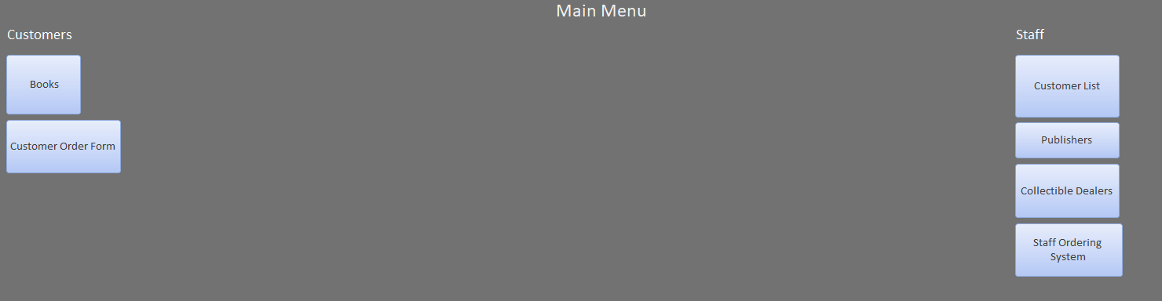

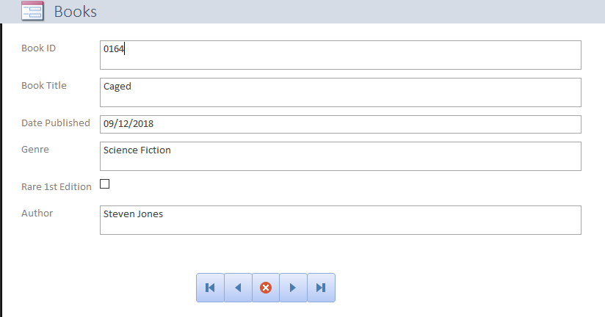

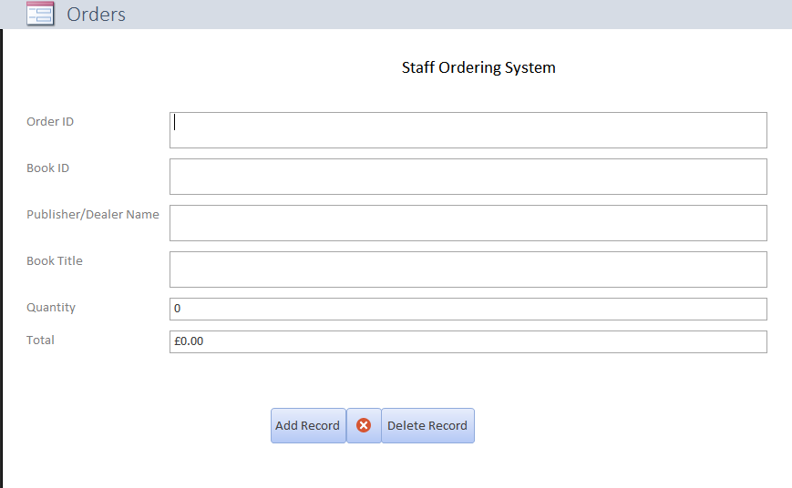

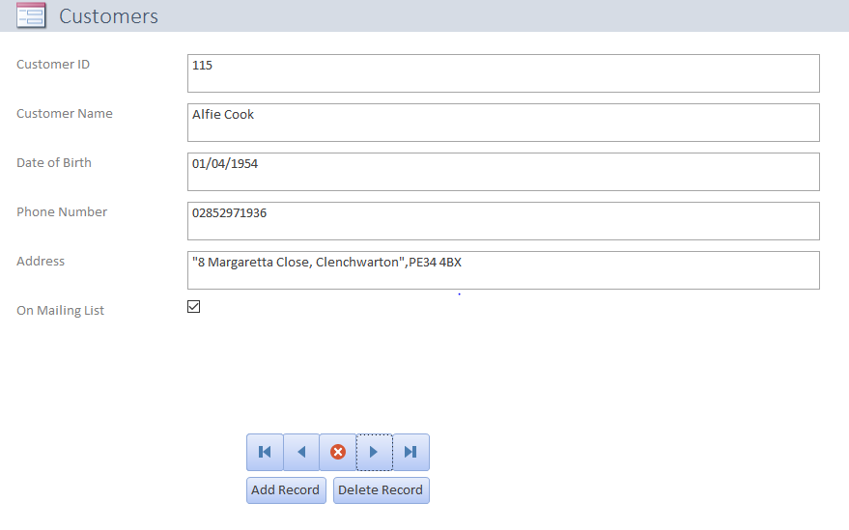
Here is a query created in order to filter and see what some customers are commonly looking for that being the collectible books:
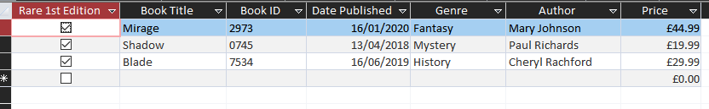

Reports were created to be able to print out and view items such as available books, order summary/document and customer lists which can be filled out by the user.
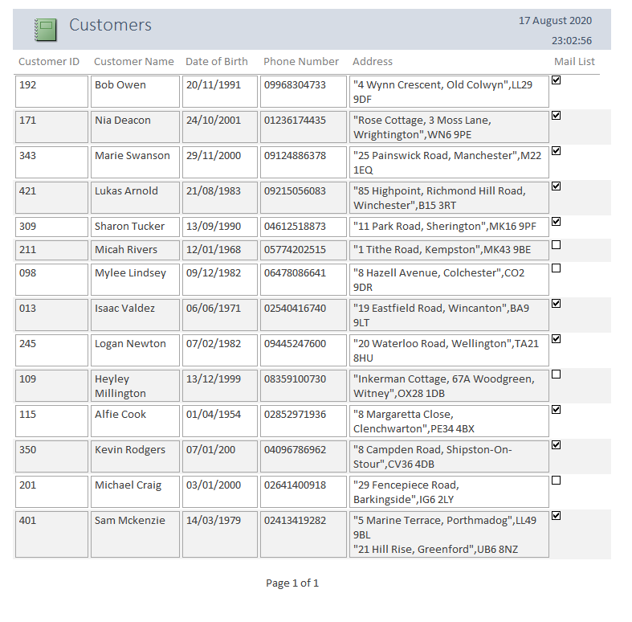
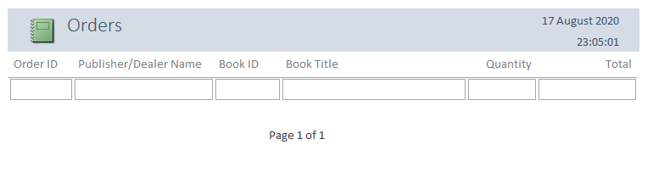
Relationships
The initial Design of relationships between entities required in this database:
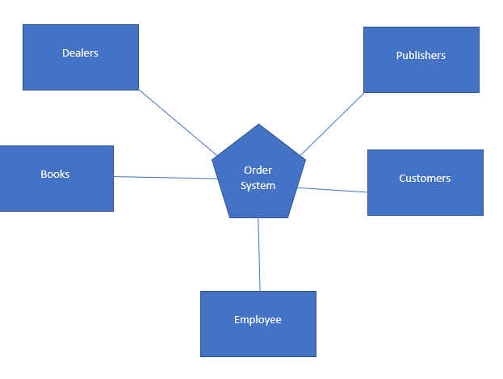

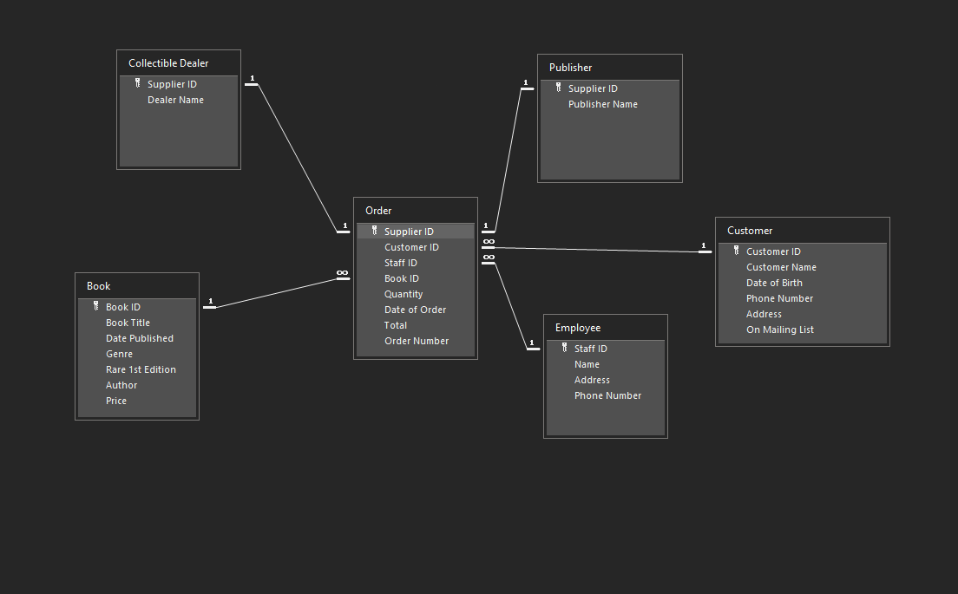
Here are the access relationships with such added attributes and types of relationships involved with each other:

SQL
SQL was added in as an alternative method of creating and entering data into the database:
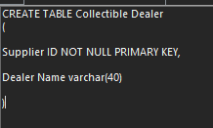
The user required that if customers wanted, they could sort between regular books and the rare collectible books sold by traders, here is the addition of filtering for the specific field in SQL:
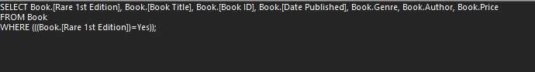
User Guide
As the user loads up the database they are firstly brought to the main menu as was the designed implementation for the database. This was done by going into the options and upon first load up we selected the main menu form to display as oppose to nothing which is not as user friendly as it could be. A message box macro was also added with the company name as title greeting the user by saying “welcome”.
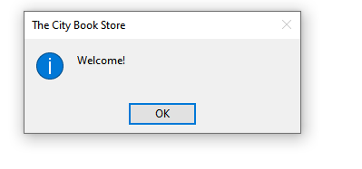
Past the main menu there are buttons that lead to crucial information and items for business for both (but separately) the customer and staff members.
For the customer, books available to be sold can be found presented neatly in a table with information such as the genre and title etcetera, as well as this the user can use the books identification number for later purchase in the ordering system depending on if they want to buy either a regular book or a collectible, rare first edition version of the book.
Upon first look the user will find a navigation bar underneath the table which can used at their own discretion, as with all other forms.
The customer can proceed to place an order on the system by clicking on the customer order form and filling out the relevant information.
On the staff/employee side, they can find access to a customer list to easily store and use with the benefit of one of the user requirements being present finding out if a customer is subscribed to their own mailing list or not.
Staff also have access to their own ordering system like the customer order form but with editions exclusively for them to use such being the publisher and or dealer information which can also be found throughout the form.

Bibliography

[1] | GCF Global, "Access 2016 - Designing a Simple Query," [Online]. Available: https://edu.gcfglobal.org/en/access2016/designing-a-simple-query/1/.
[2] | Tutorialspoint, "MS Access - Macros," [Online]. Available: https://www.tutorialspoint.com/ms_access/ms_access_macros.htm.
[3] | Database Guide, "Microsoft Access Tutorial (Part 3): Queries, Forms, & Macros," [Online]. Available: https://database.guide/microsoft-access-tutorial-part-3-queries-forms-macros/.
[4] | Microsoft, "Access SQL: basic concepts, vocabulary, and syntax," [Online]. Available: https://support.microsoft.com/en-us/office/access-sql-basic-concepts-vocabulary-and-syntax-444d0303-cde1-424e-9a74-e8dc3e460671.

