
Cover Page
Student’s Name: Jude Adimonye
Student’s ID: 2320539
Module Title: Change Maker: Building Your Personal Brand for Sustainable Employment
Module Code: BMHP5015
Assignment Title: Component 1: Online Portfolio of Exercises
Lecturer’s Name: Raheela Shaikh

Task 1 – Personal Brand
Write about your own person brand and how you could develop this to enable you to reach your employment goals (200 words- 2 referenced sources)
My personal brand is based on respect for different viewpoints, advocacy for others, empathy, and straightforward communication. These principles influence my approach to challenges, problem-solving, and interpersonal interactions. I make an effort to actively listen, encourage co-workers, and foster inclusive settings. My brand is centred on communication; I make sure that everyone feels heard and appreciated by emphasizing the polite and clear expression of thoughts

In order to further establish my personal brand and accomplish my career objectives, I intend to make investments in ongoing professional development, such as leadership courses and communication training. Emotional intelligence, which includes self-awareness and empathy, is essential for success in the job, according to Goleman (1998). By improving these abilities, I can lead and collaborate with others more successfully.

Personal advocacy and networking will also aid in the expansion of my brand. I may interact with like-minded individuals and highlight my strengths by developing a professional online presence that represents my values, such on LinkedIn. According to Peters (1997), people need to carefully manage their personal brands much like businesses do with their corporate brands.

I can establish a meaningful, purpose-driven job path and forge good relationships by remaining true to myself, exercising empathy, and advocating for polite communication.
References:
Goleman, D. (1998) Working with Emotional Intelligence. New York: Bantam Books.
Peters, T. (1997) ‘The brand called you’, Fast Company, (10), pp. 83–90. Available at: https://www.fastcompany.com/28905/brand-called-you (Accessed: 21 October 2025).

Task 2 - Network Map and Rationale
Create a map of your own network considering career, support, social and community dimensions. Additionally, you should provide a supporting rationale explaining and critically assessing this (200 words- 2 referenced sources).

My Personal and Professional Network
Support Care Worker I Health and Social Care Level 5 Student
Tutor
Placement Supevisor
Course Peers
Employeer / Collegues
Linkedin / Professional
Networks
Career / Professional Network Support Network

Family
Close Friends
Health Professionals
Mentor / Support
Worker
JUDE
Support Care Worker Health & Social Care Student

Social Network
Friends Group
Classmates
Online Study Group
Hobby / Interest Groups
Group

Community Network
Friends Group
Online Study Group
Voluntary Organizations
Local Health Networks

My personal network is centered around my career development within health and social care, with four interconnected dimensions: career, support, social, and community. At the center sits myself, surrounded by professional mentors, colleagues, academic tutors, family, friends, and local community organizations.
The career circle includes university lecturers, placement supervisors, and professional peers who provide guidance, feedback, and opportunities for skill development. The support dimension includes family, close friends, and mentors that offer emotional stability and encouragement, which are vital for resilience and motivation. Social connections, such as peers from study groups and online professional forums, facilitate collaboration, idea-sharing, and the development of interpersonal skills. Finally, the community circle includes voluntary organizations and local health networks, offering engagement with diverse populations and practical insight into service delivery.
Critically, this network enhances both professional competence and personal well-being. However, its effectiveness depends on active engagement and reflection to maintain balance and reciprocity (Boud & Walker, 1998). Expanding links with professional associations could strengthen my long-term career growth and employability (Coleman, 2011).
References
Boud, D. & Walker, D. (1998) Promoting reflection in professional courses: The challenge of context. Studies in Higher Education, 23(2), 191–206.
Coleman, J. (2011) Social capital in the creation of human capital. American Journal of Sociology, 94, S95–S120.
Task 3- Blog
Write a blog exploring a current topic or issue of your choice within the health and social care sector in the UK. The purpose of this is to inform a specific target audience of your choosing (300 words)

Food Insecurity and Health Inequality in the UK: A Growing Crisis
Food insecurity has become one of the most pressing social and health issues in the UK today. With the ongoing cost-of-living crisis, millions of households are struggling to afford healthy, nutritious food. According to The Food Foundation (2025), more than one in five UK households have experienced food insecurity in the past year. This reality is not only a social concern but also a major public health issue.
When families cannot afford balanced meals, they often turn to cheaper, processed foods that are high in salt, sugar, and fat. Over time, this contributes to chronic conditions such as obesity, diabetes, and heart disease — widening existing health inequalities between high- and low-income groups (NHS, 2023). Children are particularly vulnerable, with evidence linking food poverty to poor concentration, delayed development, and reduced academic performance (Child Poverty Action Group, 2024).
Health and social care professionals are witnessing the effects first-hand. Increasingly, GPs and community workers are referring patients to food banks or “food on prescription” initiatives — a form of social prescribing that connects individuals with local food partnerships, cooking classes, and budgeting support (NHS England, 2024). However, these measures only address symptoms, not the root causes.
To create lasting change, government and local authorities must adopt a whole-system approach that links food access with broader policies on housing, income, and health promotion. Investment in sustainable local food networks and school meal programmes could help ensure that nutritious food is treated as a basic human right, not a privilege.
Food insecurity is more than hunger — it reflects a deeper social divide. Tackling it requires collaboration across health, education, and welfare sectors to build a fairer, healthier UK for all.

Task 4- NHS Equality, Diversity and Inclusion Quiz (250 words equivalent)
1.What is the primary goal of the NHS Equality, Diversity, and Inclusion Improvement Plan?
(Answer in one or two sentences.)
2.How does the NHS EDI Improvement Plan propose to tackle the gender pay gap?
(Answer in one to two sentences.)
The NHS Equality, Diversity, and Inclusion (EDI) Improvement Plan aims to create a fair, inclusive, and supportive workplace where everyone feels valued and has the opportunity to grow, while also delivering the best possible care (NHS England, 2023).

And to encourage fair promotion procedures, boosting transparency, and assisting women in advancing into senior leadership roles, the plan seeks to close the gender pay gap (NHS England, 2023).
3. What is meant by the term ‘intersectionality’ as used in the NHS EDI Improvement Plan?
(Answer in one to two sentences.)
Crenshaw (1989) explains intersectionality as the idea that different parts of a person’s identity—such as their gender, race, or disability—overlap and shape their experiences, sometimes creating unique challenges or forms of discrimination.
4. Why is it important for the NHS to create a psychologically safe work environment? (Answer in one to two sentences.
Employees can voice concerns, exchange ideas, and own up to mistakes in a psychologically safe workplace, which enhances patient care and learning (NHS England, 2023).
5. How does the NHS EDI Improvement Plan suggest improving the experience of internationally recruited staff?
(Answer in one to two sentences. This strategy suggests improving assistance for foreign-hired employees by providing fair career advancement possibilities, cultural sensitivity training, and mentorship.
6. What role does leadership play in advancing EDI objectives according to the NHS Improvement Plan?
(Answer in one to two sentences.)
By setting an example of inclusive behaviour and guaranteeing accountability for advancement at all organisational levels, leadership plays a crucial role in integrating EDI principles.
7.Identify one way the NHS EDI Improvement Plan aims to reduce health inequalities within the workforce.
(Answer in one to two sentences
Health inequalities can be reduced by implementing focused interventions, like expanding access to occupational health and wellness services, the plan aims to lessen health disparities within the workforce.
8. Why does the NHS EDI Improvement Plan emphasise the importance of collecting and analysing data on protected characteristics?
(Answer in one to two sentences.)
Collecting and analysing data on protected characteristics helps organisations spot inequalities, monitor progress over time, and make informed, evidence-based decisions that genuinely support people’s needs.
9. Explain how flexible working policies can contribute to equality and inclusion in the NHS workforce.
(Answer in one to two sentences.)
By encouraging work-life balance, lowering stress levels, and facilitating involvement from a variety of groups, such as parents and carers, flexible working fosters equality.
10. What is one strategy mentioned in the NHS EDI Improvement Plan to combat bullying and harassment in the workplace?
(Answer in one to two sentences.)
The NHS wants to combat bullying and harassment by establishing zero-tolerance standards, encouraging a respectful attitude, and offering private channels for reporting incidents.
Task 5- A Letter to Yourself
Think of a time in the past when you may have been experiencing issues or difficulties, and after considering what you have learned in this module about emotional intelligence and resilience write a letter to your younger self explaining how these attributes were important at that time and perhaps how developing these areas could have been useful (250 words)

Dear younger me,
I am aware that you frequently felt overburdened by difficulties, particularly when things didn't go according to plan. You struggled to remain composed under pressure and were afraid of disappointing other people. In retrospect, I realise that cultivating resilience and emotional intelligence would have enabled you to handle such situations with greater assurance and self-compassion.

The ability to identify, comprehend, and control your own emotions as well as those of others is known as emotional intelligence (Goleman, 1995). You might have viewed obstacles as chances for personal development rather than failures if you had taken the time to think things through before acting. You may have improved your communication and bolstered your relationships if you had developed self-awareness.

According to Masten (2001), resilience is the capacity to bounce back and adjust constructively in the face of hardship. The lessons you learnt from your setbacks in life were what made you stronger, not what defined you. You would have recovered more quickly and been able to keep perspective under pressure if you had learnt to remain upbeat and adaptable.
Therefore, trust yourself if I were to give you one bit of advice. Every challenging event fortifies your emotional fortitude, and cultivating resilience will take you farther than you may have thought.

With love and encouragement,
Your future self.

Task 6- GANTT Chart (200 words equivalent)
Compile a Gantt chart which illustrates the tasks you have to complete to achieve your future employment goals.
A Gantt chart is an effective planning tool that helps organise key activities, set deadlines, and monitor progress towards achieving career goals (Lock, 2020). My Gantt chart outlines the essential tasks required to complete my Level 5 and Level 6 Health and Social Care studies, alongside my ongoing professional development as a support worker.
At the moment, my focus will be to complete Level 5 in Health and Social Care through coursework, exams, and practical learning. During this time, I will also continue working to gain more experience and build my confidence within the care sector. Then, from January 2026 to December 2026, I will progress to Level 6 in Health and Social Care, concentrating on advanced learning, leadership development, and research projects. In parallel, I plan to attend training workshops, update my CV and LinkedIn profile, and apply for senior or supervisory roles in the sector.
Gantt Chart of a Support care Worker Studying Health and Social Care

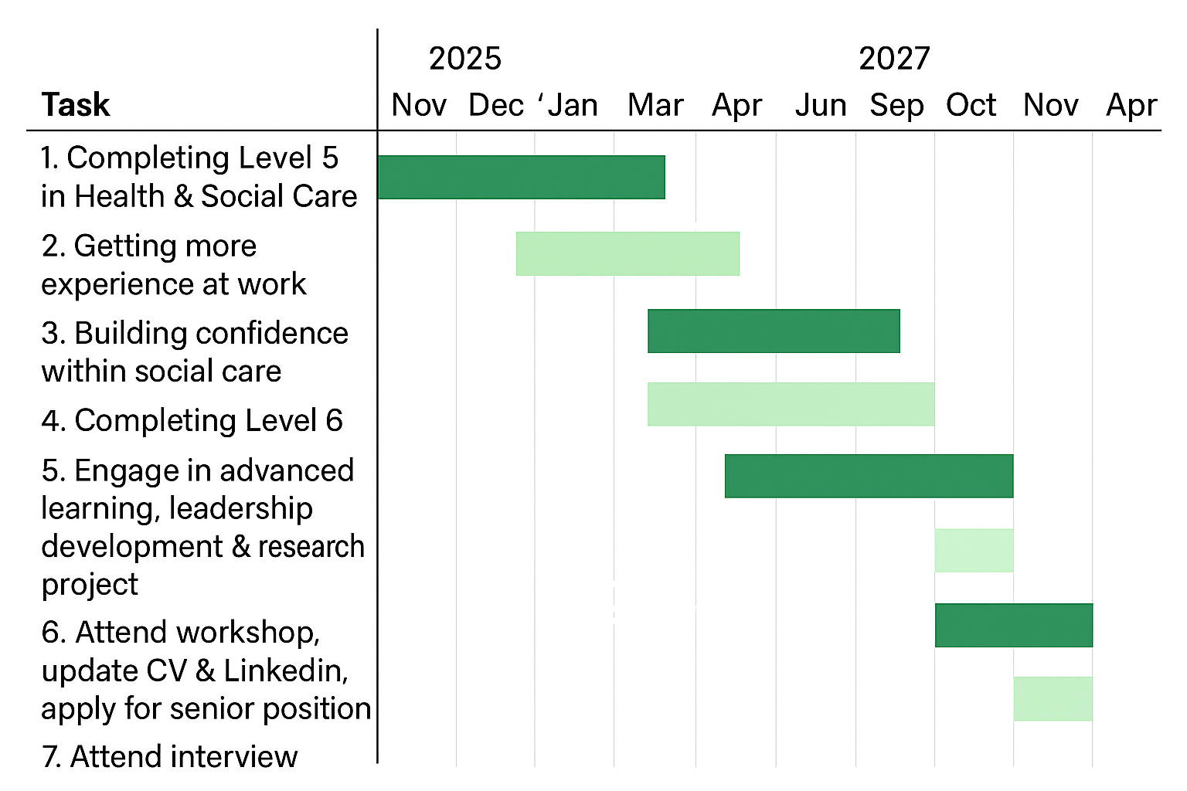

Task 7- Making Changes- Report
You are the manager of a care home and want to make changes your workplace. Identify one specific change that you want to implement and write a brief report on how this is going to be achieved considering the necessary skills needed and addressing possible barriers to success. Relevant change models can be highlighted (250 words- 2 referenced sources).
As the manager of a care home, I intend to implement a new digital care planning system to replace paper-based records. This change aims to improve efficiency, accuracy, and communication among staff, ensuring residents receive consistent and person-centred care. The transition will also enhance compliance with data protection and regulatory standards.
To make this change work well for everyone, strong leadership and honest, open communication will be key. I plan to start by talking with staff to really understand their needs, worries, and expectations. By involving them from the very beginning, they can feel heard and supported throughout the process. I will also offer practical training sessions to help build digital skills and boost confidence, so everyone feels comfortable and prepared when using the new system. Kotter’s (1996) Eight-Step Change Model will guide the process by creating urgency, forming a guiding coalition, communicating the vision, and embedding the new system into daily practice.
Potential barriers include staff resistance, limited technological skills, and time constraints. These can be mitigated through continuous support, feedback opportunities, and recognition of staff efforts. As Lewin’s (1951) Change Management Model suggests, successful change involves “unfreezing” existing habits, introducing the change, and “refreezing” new practices to ensure sustainability. By fostering collaboration, maintaining transparency, and supporting staff development, this change can lead to long-term improvements in care quality and workplace efficiency.
References
Kotter, J.P. (1996) Leading Change. Boston, MA: Harvard Business School Press.
Lewin, K. (1951) Field Theory in Social Science. New York: Harper & Row.
Task 8- Self-Reflection
Using one of the highlighted models of reflection, reflect on what you have learned about yourself during this module as well as the knowledge you have gained, and explain how this has developed your skills and informed your future practice (250 words- you must reference the model you use)
Using Gibbs’ (1988) Reflective Cycle, I have reflected on my learning from the Module Building My Personal Brand for Sustainable Employment and how it has helped me develop as a Level 5 Health and Social Care student and support worker.
Description:
This module focused on understanding personal values, strengths, and professional identity. It taught me how to build a personal brand that reflects my skills and ambitions within the care sector.
Feelings:
At the start, I felt unsure about how to present myself professionally and didn’t fully understand the importance of personal branding. As I engaged in activities such as self-assessment and career planning, my confidence grew. I began to see my experience and compassion as valuable assets.
Evaluation:
The module helped me identify my transferable skills, such as empathy, teamwork, and communication. I also learned the importance of continuous learning and self-reflection in achieving long-term career goals.
Analysis:
Reflecting through Gibbs’ model helped me understand how my values align with my career path. I realised that building a strong personal brand means demonstrating reliability, integrity, and leadership—qualities that employers look for in senior carers or managers. This insight has strengthened my motivation to develop professionally and contribute meaningfully to care services.
Action Plan:
I plan to keep reflecting on my progress, update my CV and LinkedIn profile, and seek mentorship to prepare for future leadership roles in health and social care.
Reference List
Boud, D. & Walker, D. (1998) ‘Promoting reflection in professional courses: The challenge of context’, Studies in Higher Education, 23(2), pp. 191–206.
Child Poverty Action Group (2024) The Cost of Missing Meals: Food Poverty and Education in the UK. London: CPAG.
Coleman, J. (2011) ‘Social capital in the creation of human capital’, American Journal of Sociology, 94, pp. S95–S120.
Gibbs, G. (1988) Learning by Doing: A Guide to Teaching and Learning Methods. Oxford: Oxford Polytechnic.
Goleman, D. (1998) Working with Emotional Intelligence. New York: Bantam Books.
NHS (2023) Health Inequalities and Diet-related Disease. London: NHS England.
NHS England (2024) Social Prescribing and Community-Based Support. Available at: https://www.england.nhs.uk/personalisedcare/social-prescribing (Accessed: 18 October 2025).
Peters, T. (1997) ‘The brand called you’, Fast Company, (10), pp. 83–90. Available at: https://www.fastcompany.com/28905/brand-called-you (Accessed: 21 October 2025).
The Food Foundation (2025) Food Insecurity Tracking: UK Household Data 2025. London: The Food Foundation.

