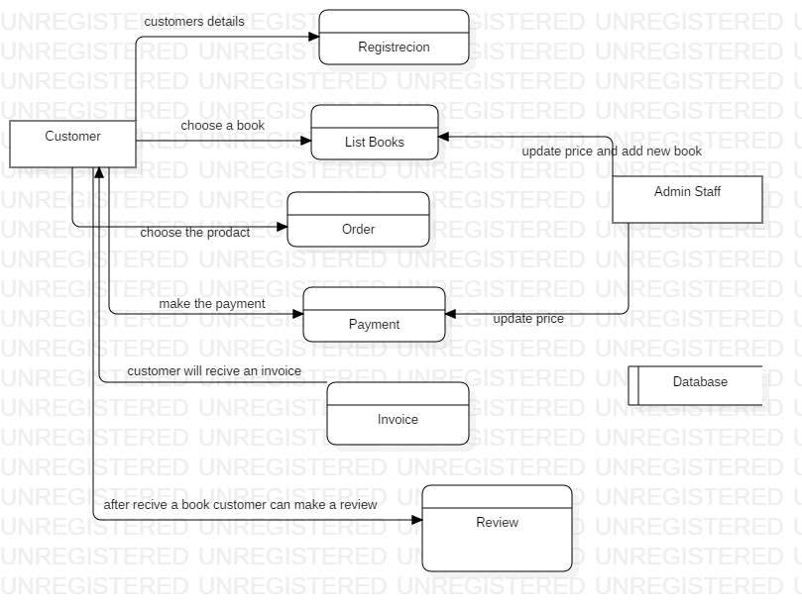
DFD

Additional text for benefit of student who forgot to add themselves. Minimum text required is twenty words.

Use Case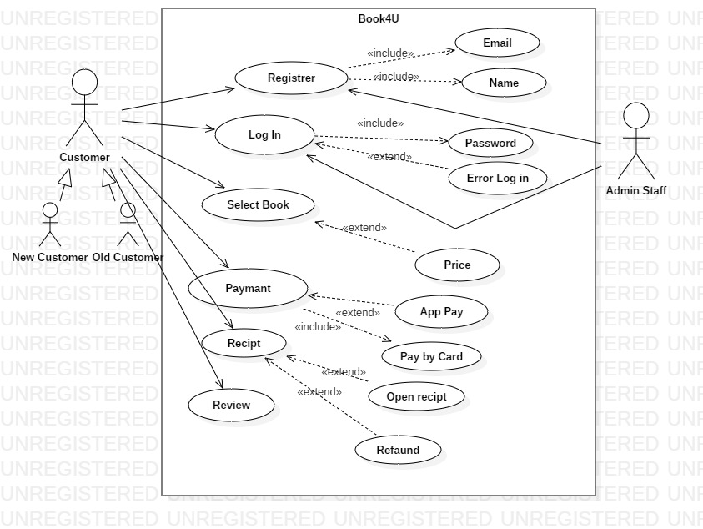

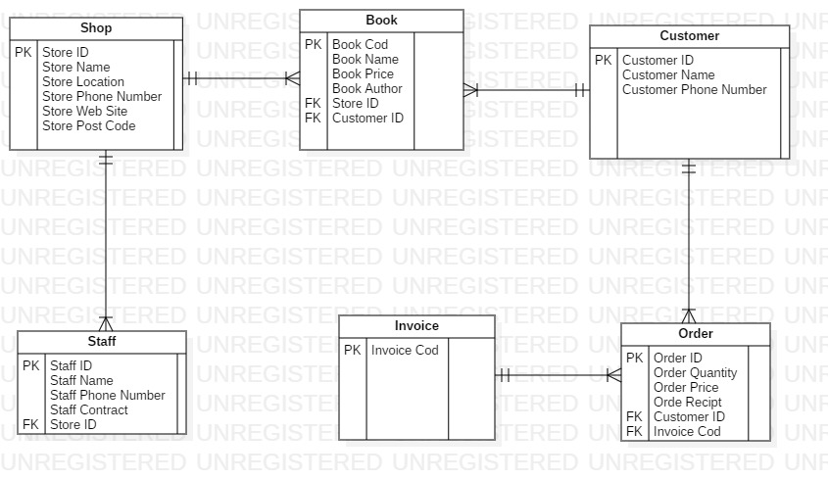
ER

