University of Wales Trinity Saint David (UWTSD)
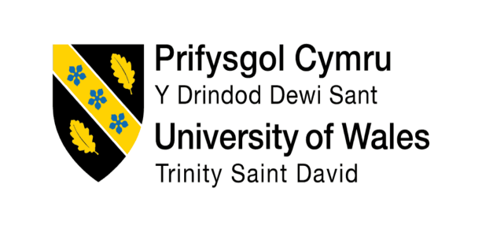

Assignment Title: “The Influence of National and International Labour Markets on HRM and IHRM Strategies”

Programme: Master of Business Administration (MBA)
Module: Human Capital Management
Module Code: LCMB7023
Lecturer: Dr Charles Oham
Student Name: Marzana Hasan Mita
Student ID: 2504068
Word Count: 2659
Submission Date: 14th November 2025

Executive Summary
This report provides a critical analysis of the way national and international labor market dynamics impact on Human Resource Management (HRM) and International Human Resource Management (IHRM) strategies. It discusses four important themes (1) technological change, (2) demographic and geopolitical change, (3) approaches to managing global skills deficits, and (4) a retrospective on the capabilities of the world and the professions. Based on the current literature, organizational case studies, and world data points such as the International Labor Organization (ILO) and World Economic Forum (WEF), the report uses such models as PESTLE analysis, Talent Management frameworks, and the Resource-Based View (RBV). The results bring out the increasing value of digitalization, workforce diversity, and continuous learning in the development of global HRM practices. Skills like teamwork, communication, leadership, and technological adaptability, which are transferable to succeed in an international environment are highlighted in the reflective section.

Table of Contents
Executive Summary 2
Introduction 4
1. Technological Advancements and Their Implications for HRM and IHRM 5
1.1 PESTLE Analysis: Technological Context 5
2. Demographic and Geopolitical Factors Influencing Employment Markets 8
2.1 Implications for HRM and IHRM 9
3. Addressing Skills Gaps and Talent Shortages through Strategic HRM 11
3.1 The Resource-Based View (RBV) 12
4. Reflective Report on My International and Professional Capabilities 14
Technology 14
Communication 14
Teamwork 15
Leadership 15
Self-Directed Learning 16
References 17

Lists of Table
Table 1: PESTLE analysis of technological impact on HRM/IHRM 7
Table 2: HRM/IHRM strategic responses to demographic and geopolitical challenges. 9

List of Figure:
Figure 1: The Resource-Based View (RBV) 12
Figure 2: Global Skill Shortages by Sector 13

Introduction
Human Capital Management (HCM) is crucial in ensuring organizations effectively use and develop their workforce in a bid to counter the changing forces of labour market. The changes in socio-economic conditions, digital transformation, and globalization have changed the way organizations undertake HRM and IHRM (Armstrong & Taylor, 2023). The report discusses the impact of national and international labour market on HRM and IHRM strategies through theoretical framework and practical examples. Using the macro-environmental changes and HR strategic responses, the report links those using frameworks like PESTLE analysis, Talent Management models, and the Resource-Based View (RBV). The global view is taken to examine how the HR policy making is affected by demographic shifts, technological change and skills gaps. The discussion will end by a self-reflective analysis of the professional competencies in line with the postgraduate employability outcomes. In the recent times of high globalization, organizations have to keep adjusting to the changing labour dynamics and employee expectations. Such trends make it necessary to gain a deeper insight into the potential of integrated HRM frameworks to maintain the local responsiveness and global competitiveness.

1. Technological Advancements and Their Implications for HRM and IHRM
The advancement in technology has emerged as a force of change in the contemporary employment practices and the systems of management. As the world is quickly becoming digital, HRM and IHRM are changing to reflect the global trend of automation, AI, and data-driven decision-making.The development of technologies has had a significant impact on the national and global labour markets and has changed the approaches to the shaping and execution of Human Resource Management (HRM) and International Human Resource Management (IHRM) strategies. The combination of automation, artificial intelligence (AI), and digital tools of collaboration has transformed the skills that the current organization requires, making HRM more responsive, data-oriented, and morally responsible.According to evidence provided by the World Economic Forum (2024), 44 percent of the core skills of workers will be upended by AI by 2027; hence, strategic HR responses where workforce reskilling and technological literacy should be prioritized (Lammi, 2024). The increasing digitalization of the HR processes (including cloud-based systems, people analytics, and AI-based recruitment) has enabled organizations to coordinate the teams that were globally dispersed to gather and coordinate in a more efficient way. As an example, Unilever operates AI-based recruitment systems to evaluate candidates all over the world and minimize human influence and maximize the selection process (Koturanova and Shapa, 2025). Equally, the Work Trend Index by Microsoft (2024) proves that AI-assisted HR analytics has enhanced the supervision of remote workers in over 100 countries (Paciello, 2024).These examples describe how technology increases operational efficiency and inclusivity among the international workforces.

1.1 PESTLE Analysis: Technological Context
This is why it is essential to implement the strategies of balance and ensure the sustainability and integrity of the technological use in HR practices based on analytical frameworks such as PESTLE. Figure 1 gives out PESTLE of technological effects on HRM and IHRM. In the economic sense, more automation increases labour costs and employment patterns, and in the social dimension, the demand of flexible employed patterns such as hybrid and remote ones is on the increase. The technological application of AI in the recruitment processes, analytics, and performance management is becoming more and more widespread, and the legal jurisdiction is becoming more focused on algorithmic transparency and responsible AI use. Green technologies are environmental-friendly and contribute to the corporate social responsibility and sustainability (WEF, 2024). These factors are multi-dimensional that emphasizes the interdependence between technology and HR strategy. The digital workforce requires something more than technical skills but flexibility, life-long learning, and cross-cultural cooperation abilities. This fact implies that IHRM has to survive with such problems as fair pay, jurisdiction, and virtual training of leaders (Loonam & O’Regan, 2022). As organizations automate repetitive tasks, job roles are being redefined in an attempt to focus more on a human-AI collaboration and problem-solving. The use of predictive analytics has entered HRM practices in order to make a forecast of the future workforce needs and to identify the skills gaps and to create particular learning programs. By making certain that the final answer to responsible digital transformation must include lifelong learning and responsible AI usage, Pappas and his colleagues (2023) make sure that the ethics of responsible HR practices are not neglected in the new development.The technological innovativeness is changing HRM and IHRM both on the low-level and on the high-level and the staff needs to take into consideration the digital literacy, data governance, and data ethics framework in its strategy. As a re-interpretation of work perimeters is being taking place due to automation and AI, HR leaders must ensure that technological progress does not undermine human values. HRM, anyway, has a future in the creation of agile, intercultural and ethically informed workforce that can work in the digital economy.

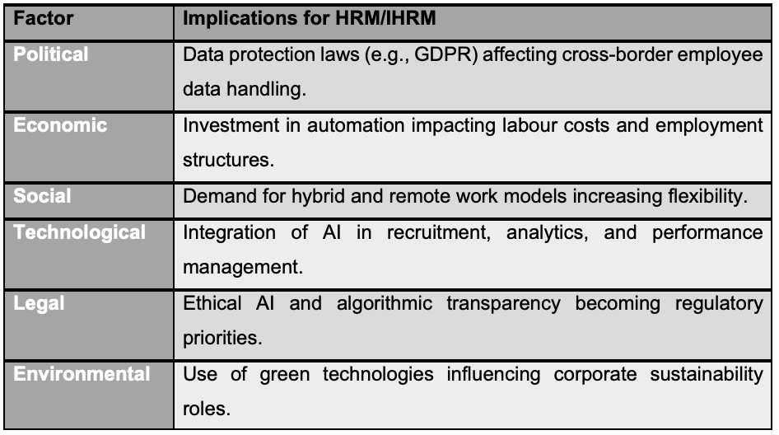
Table 1: PESTLE analysis of technological impact on HRM/IHRM
Source: (WEF, 2024)
To conclude, technology has transformed HRM and IHRM in a positive way by increasing efficiency, inclusivity, and global coordination but has also brought such problems as data ethics and cybersecurity to the fore. That is why a moderate solution based on models like PESTLE is the key to sustainable technological integration in human resources.

2. Demographic and Geopolitical Factors Influencing Employment Markets
The global labour markets are being redefined by demographic changes and geopolitical changes necessitating HRM and IHRM to be flexible, inclusive and adaptative to diverse and dynamic workforces.The employment environment in the world is becoming more and more organized due to the changing demographic and geopolitical trends that have a direct impact on Human Resource Management (HRM) and International Human Resource Management (IHRM) approaches. The ageing populations, migration trends, and political unrests have altered the pattern of national and international labour markets. HR leaders would be required to develop flexible policies that would tackle the two-fold issues of workforce diversity and economic instability. The workforce planning is worsened by the introduction of the remote and hybrid workforce model, which requires the HR to balance flexibility, and productivity. Consequently, strategic vision and responsiveness have been created as valuable HR capabilities in navigating such complex challenges.Calzavara et al. (2020) state that the percentage of individuals between the ages of 60 and above is estimated to rise to one out of six individuals globally by 2030, which indicates a major requirement of organizations to adopt flexible work schedules and re-skilling opportunities to their older workforce. Boehm et al. (2021) believe that HR policies like hybrid retirement plans and flexible working opportunities are vital to HR as they allow keeping employees productive and inclusive in their age. Geopolitical developments in the recent past, including Brexit, conflict between Russia and Ukraine, and tight foreign policies have hindered migration and labour mobility and affected labour flows in sectors such as healthcare and hospitality.These realities force HRM and IHRM to reconsider the traditional expatriation paradigms and build up the local and virtual talent tactics. An example of such programs is Global Mobility Program at Deloitte, which allows facilitating virtual cross-border cooperation without having to rely on physical mobility but maintaining exchange of knowledge. Gamso et al. (2023) emphasize that multinational companies such as Shell and BP diversify their activities to reduce the risks in politically volatile countries. HRM planning based on scenarios therefore comes in as an important matter in dealing with uncertainty and making organizations resilient. Moreover, the changing family structure, the participation of more women, and the transformation of gender norms have transformed demographics in the workplace necessitating inclusive HR practices to promote gender equity and diversity. HRM and IHRM must also have the capacity to inculcate cross cultural abilities so as to facilitate cross boundary collaboration and information sharing. Wellbeing and flexible benefits communication is also beneficial in increasing employee engagement and retention. These combined solutions assist organizations to navigate in complex demographic and geopolitical environments and remain competitive in a market.HRM and IHRM are subjected to the strong forces of demographic and geopolitical factors that change the nature of labour availability, skills, and strategic priorities. The HR professionals have to be flexible, inclusive, and forward-thinking in a manner that acknowledges the fact that demographic diversity and geopolitical change are interdependent. With resilience planning, diversity management, and global collaboration, HRM and IHRM will be able to create an agile, equitable, and prepared workforce to meet the demands of an ever-changing global economy rapidly.

2.1 Implications for HRM and IHRM
The following table (Table 2) summarizes strategic HRM and IHRM responses to key demographic and geopolitical challenges:
Key Factor | HRM/IHRM Response
Ageing workforce | Lifelong learning, hybrid retirement, and flexible work.
Migration barriers | Global recruitment partnerships and virtual teams.
Geopolitical conflict | Scenario planning and remote leadership.

Table 2: HRM/IHRM strategic responses to demographic and geopolitical challenges.
Source: (Boehm et al., 2021; Calzavara et al., 2020; Gamso et al., 2024; and WEF, 2024).

HRM and IHRM should adopt resilience, diversity as well as global partnership to create nimble, just, and ready workforces that can overcome the complicated demographic and geopolitical elements.

3. Addressing Skills Gaps and Talent Shortages through Strategic HRM
Global skill shortages demand strategic HRM practices that focus on talent development, predictive workforce planning, and partnerships to sustain long-term organizational competitiveness.The global labour markets are experiencing serious challenges because of broadening skills gaps and chronic shortages in talents in the industries. Such shortages have a direct impact on the organizational competitiveness and productivity forcing HRM and IHRM to seek innovative and strategic methods of workforce planning.Bilan et al. (2020) state that 69 percent of employers have problems with the appropriate ability to recruit employees. Lubis (2022) states that human capital is among the most sustainable competitive advantages sources in the Resource-Based View (RBV). Predictive analytics are used by Google to detect the emerging skills gaps (Tatineni, 2022), whereas OECD (2024) data reflect the sectoral skills gaps, Technology (72%), Healthcare (65%), Engineering (60%), Hospitality (55%), and Financial Services (52%). The Future Fit program of Unilever is a combination of the sustainability and employee development (Wang, 2023), and UK Hospitality Sector Council partnerships correspond with the industry needs to the education. According to Pappas et al. (2023), lifelong learning and ethical innovation can help in sustainable change. According to the RBV, the emphasis on internal talent development in place of external recruiting is associated with the creation of unique competencies that are hard to copy. The creation of internal talent that entails special skills that competitors can hardly replicate is according to the Resource-Based View (RBV) (see Figure 1). Figure 2 shows the level of skill shortages in the global sectors, with Technology (72%) and Healthcare (65%) ranking as the most impacted sectors. To maintain flexibility in the dynamic marketplace, companies are training, developing employees, and embedding learning programs to develop capabilities within employees. To generate robust and flexible workforces to meet the global digital economy, HRM should integrate digital upskilling and analytical training in the culture. Ethical innovation contributes to sustainable talent approaches and enhances staff loyalty and engagement. Strategic HRM assists companies in assuming the initiative to convert skill deficiencies into competitive advantage through the adoption of organizational workforce competencies that align with the strategic goals of the organization.Global talent shortages would require a comprehensive and progressive HRM strategy that incorporates internal growth, strategic planning, and inter-sector cooperation. With the application of such frameworks as RBV and the focus on continuous learning and the partnership between the government and the company, HRM can turn the problem of skills deficiency into the chance of the long-term organizational stability and competitiveness.

3.1 The Resource-Based View (RBV)
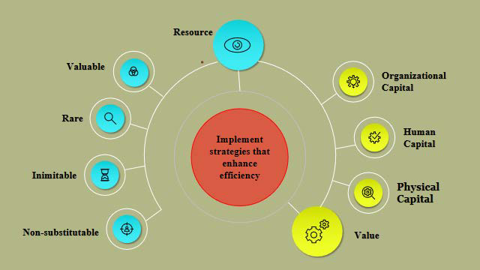
Figure 1: The Resource-Based View (RBV)
Source: (OECD, 2024).
The simplified global skill gaps are demonstrated below (Gamso et al., 2024)
Sector | % of Employers Reporting Gaps
Technology/AI | 72%
Healthcare | 65%
Engineering | 60%
Hospitality | 55%
Financial Services | 52%
Source: (OECD, 2024)

Figure 2: Global Skill Shortages by Sector
Source: (OECD, 2024)
Strategic HRM changes the skill gaps into opportunities by means of constant learning, teamwork, and the capacity building inside the organization to guarantee long-run development and the ability of the global workforce to endure.

4. Reflective Report on My International and Professional Capabilities
In a rapidly growing global and technologically sophisticated business landscape, employees should have displayed flexibility, cross cultural competence, and a desire to learn constantly. In this reflective part, I use Gibbs Reflective Cycle (1988) as my framework to evaluate my development in five main skills areas, i.e., technology, communication, teamwork, leadership, and self-directed learning (Adeani et al., 2020). These considerations relate my development opportunities in the MBA course to the practical skills needed in the global HRM and IHRM environment, which demonstrates what has been accomplished and what needs more development.

Technology
In the modern digital economy, technological literacy becomes a mandatory skill of HR professionals. Talerico (2022) emphasizes that data-driven decision-making and analytics are the most relevant HRM skills nowadays, which proves the importance of the discussed skills. Nonetheless, I also realized that my expertise in higher analytics, specifically predictive analysis of the workforce, is one of the aspects that I should improve on. In such a way, the introduction to HR technology has preconditioned a path toward lifelong learning, which is the current tendency in the global HR management.

Communication
Successful collaboration in international business is based on good communication. This exposure enabled me to communicate complicated ideas in a more comprehensible manner and also adjust my style of communication to suit multicultural audiences. The transformational leadership model by Bass and Riggio (2006) focuses on the role of inspirational and motivational communication with others (Setiono et al., 2019).To reinforce this part, I will participate in executive communication courses and train to make concise and persuasive presentations.I will be able to develop such capabilities and be able to convey the strategic HR information to foreign environments, which is a crucial skill in the global HRM practice.

Teamwork
Teamwork has been part and parcel of my MBA learning process. Working with other professionals of different fields enabled me to learn to be empathetic, to listen and negotiate. Evidence: My coordinating experience in group works served to balance the participation and get tasks done so that we would be inclusive and respect one another. To develop my teamwork skills further, I intend to become a member of such international HR organizations like SHRM Global. Connection: This promise of teamwork building is an indication of the global HR focus on inclusivity and shared problem solving.

Leadership
The most appropriate leadership model to adopt my leadership style is the transformational model proposed by Bass and Riggio (2006) and is premised on the concepts of motivation, inspiration, and inclusiveness. I generally assumed the role of the energizer in my academic work where innovative ideas and open-minded environment were encouraged. However, I must also confess that I have yet to develop a stronger strategic decision making and resiliency in facing the uncertainty, which are the key characteristics of HR leaders functioning in mobile global markets. To develop these competencies, I will engage in executive games and leadership mentoring programs, which will focus on making decisions when information is not available. This will help me shift my thinking towards being more of a strategic leader, which is the direction of being an international HRM leader.

Self-Directed Learning
One of my best competencies is self-directed learning, which is demonstrated by my skills in independent research, critical thinking, and the desire to get feedback in the course of my learning. I have acquired this skill both in academics and as a professional. According to Adeani et al. (2020), structured reflection is a method that improves the learning outcome in that it bridges theory with practice. A reflective practice in my career development will help me be flexible, knowledgeable, and motivated in the attainment of long-term professional objectives. This is also similar to the focus of HRM on lifelong learning and self-improvement.

References
Adeani, I.S., Febriani, R.B. and Syafryadin, S., (2020). Using GIBBS’reflective cycle in making reflections of literary analysis. Indonesian EFL Journal, 6(2), pp.139-148.
Armstrong, M. and Taylor, S., (2023). Armstrong's handbook of human resource management practice: A guide to the theory and practice of people management. Kogan Page Publishers.
Bilan, Y., Mishchuk, H., Roshchyk, I. and Joshi, O., (2020). Hiring and retaining skilled employees in SMEs: problems in human resource practices and links with organizational success. Business: Theory and Practice, 21(2), pp.780-791.
Boehm, S.A., Schröder, H. and Bal, M., (2021). Age-related human resource management policies and practices: Antecedents, outcomes, and conceptualizations. Work, Aging and Retirement, 7(4), pp.257-272.
Calzavara, M., Battini, D., Bogataj, D., Sgarbossa, F. and Zennaro, I., (2020). Ageing workforce management in manufacturing systems: state of the art and future research agenda. International Journal of Production Research, 58(3), pp.729-747.
Gamso, J., Inkpen, A. and Ramaswamy, K., (2024). Managing geopolitical risks: the global oil and gas industry plays a winning game. Journal of Business Strategy, 45(3), pp.190-198.
Koturanova, T. and Shapa, N., (2025). Features of Using Innovative Technologies in Recruitment Through Artificial Intelligence Tools. Economics and Education, 10(2), pp.7-12.
Lammi, D., (2024). Focal issues of Sustainable Development presented by the World Economic Forum 2024.
Loonam, J. and O'Regan, N., (2022). Global value chains and digital platforms: Implications for strategy. Strategic Change, 31(1), pp.161-177.
Lubis, N.W., (2022). Resource based view (RBV) in improving company strategic capacity. Research Horizon, 2(6), pp.587-596.
Microsoft. (2024). Work Trend Index Report 2024. Microsoft Corporation.
Paciello, L., (2024). Human capital efficiency: a comprehensive overview.
Pappas, I.O., Mikalef, P., Dwivedi, Y.K., Jaccheri, L. and Krogstie, J., (2023). Responsible digital transformation for a sustainable society. Information Systems Frontiers, 25(3), pp.945-953.
Talerico, C.K.M., (2022). Assessing the analytic competency gap for HR professionals: Providing HR a roadmap to data-driven decision-making.
Tatineni, S., (2022). Integrating AI, Blockchain and cloud technologies for data management in healthcare. Journal of Computer Engineering and Technology (JCET), 5(01).
Wang, T., (2023). The Impact of Board Characteristics on Corporate Performance: A Case of Unilever PLC. Journal of Humanities, Arts and Social Science, 7(8).
World Economic Forum. (2024). The Future of Jobs Report 2024. Geneva: WEF.

