Key partners  ALEXANDRINA BAR AND GRILL  - Bulgarian food importers (cheese, lyutenitsa, spices and wines)  - Local UK suppliers for fresh meat, vegetables and dairy  - Deliveroo, Uber Eats and Just Eat  - Local bakeries supplying fresh bread  - Beverage suppliers (Bulgarian wines and rakia)  - London cleaning and waste management companies  - Accountant and legal adviser  - Social media marketing agency  - Local Bulgarian community | Key Activities  - Preparing authentic Bulgarian meals  - Maintaining high food hygiene and safety standards  - Excellent customer service  - Managing takeaway and delivery services  - Social media marketing and promotions  - Staff recruitment and training  - Purchasing fresh ingredients daily  - Organising Bulgarian cultural evenings and live music events  - Managing reservations and private events | Value Proposition  - Authentic homemade Bulgarian cuisine prepared using traditional recipes.  - Fresh, high-quality ingredients imported from Bulgaria and sourced locally.  - A warm family atmosphere reflecting Bulgarian hospitality.  - Affordable prices compared with other European restaurants in London.  - Vegetarian, vegan and gluten-free menu options.  - Fast takeaway and delivery service.  - Regular cultural events featuring Bulgarian music |  | Customer Relationships  - Friendly and personalised service  - Loyalty card programme  - Birthday discounts  - Online reservations  - Fast response through social media  - Customer feedback surveys  - Email newsletter with monthly offers  - Strong engagement through Facebook, Instagram and TikTok | Customer Segments  - Bulgarian community living in London  - British customers interested in international cuisine  - Families  - University students  - Office workers  - Tourists  - Balkan communities (Romanian, Serbian, Macedonian, Greek)  - Corporate clients for catering services
 | Key Resources  - Restaurant premises in London  - Professional kitchen equipment  - Experienced Bulgarian chefs  - Trained waiting staff  - Traditional Bulgarian recipes  - POS payment system  - Restaurant website and online booking platform  - Strong brand identity  - Licences and food safety certificates  - Relationships with trusted suppliers |  |  | Channels  - Dine-in restaurant  - Official website  - Facebook  - Instagram  - TikTok  - Google Business Profile  - Deliveroo  - Uber Eats  - Just Eat  - Word-of-mouth recommendations  - Local Bulgarian community events
Cost Structure  Fixed Costs  - Rent  - Staff salaries  - Insurance  - Business rates  - Licences  - Marketing  - Internet and phone  Variable Costs  - Fresh food ingredients  - Imported Bulgarian products  - Utilities (gas, electricity, water)  - Packaging  - Delivery commissions  - Cleaning supplies  - Equipment maintenance |  |  | Revenue Streams  - Dine-in food sales  - Drinks sales  - Desserts  - Takeaway orders  - Delivery orders  - Catering for weddings and private events  - Corporate lunch catering  - Special Bulgarian holiday events  - Merchandise (Bulgarian sauces, spices and wine)  - Gift vouchers
Business Model Canvas Credit – Strategyzer.com
Key partners  Some activities and resources in your business may need outsourcing. List the key partners and activities they will perform.  Who are your key partners?  Who are your key suppliers?  Which key resources are you acquiring from partners?  Which key activities do partners perform?  What are your motivators for this partnership?  - Acquisition of resources  - Reduction of risk and uncertainty  - Optimisation and economies to scale | Key Activities  Actual tasks and activities required to create and deliver the business offering. List the key activities required to be successful.  What key activities are needed for:  - value proposition  - distribution channels  - customer relationships  - revenue streams | Value Proposition  Your Value Proposition is the reason why customers turn to your company over another. It solves your customer's problem or satisfies your customer's need.  What value do you deliver to the customer?  What problem do you help to solve for your customer  What product and / or service will you be offering?  Which customer needs are you satisfying?  Characteristics of value proposition  - Newness  - Performance  - Customisation  - Design  - Brand / status  - Price  - Cost Reduction  - Accessibility  - Convenience / visibility |  | Customer Relationships  It is essential to establish and maintain relationships with customers. Clarify the type and purpose of the relationship.  What type of relationship does each of our customer segments expect us to establish and maintain with them?  Which ones have you established?  How are they carried out  How much will it cost? | Customer Segments  For whom are you creating value? How can you identify your customers and the segments f customers you will have?  Who are your most important customers?  Are your customers individuals / business / individuals with a business  What will they expect:  - Self service  - Automated service  - Personal Assistance  - Communities  - Co-creation  What does your customer segments look like:  - Mass market  - Niche market  - Segmented  - Diversified  - Multi sided platform
 | Key Resources  What key resources does your value proposition need.  What key resources are needed for:  - value proposition  - distribution channels  - customer relationships  - revenue streams  Types of resources – Physical, Intellectual (brand, copyright, patents, data) Human, Financial. |  |  | Channels  How will you communicate?  Through which channels do our customer segments want to be reached?  How are you planning to reach them?  Are your channels integrated?  Which ones work best?  Which ones are most cost effective?  How do you plan to integrate them in you customer routines  Channel types – Sales force, web sales, own shops / stalls, partnership shops, wholesalers
Cost Structure  What are the most important costs inherent in your business.  - Which key resources are the most expensive  - Which key activities are the most expensive  Is your business more  - Cost driven (leanest cost structure, low price value proposition, maximising automation, extensive outsourcing)  - Value driven (focused on value creation, premium value proposition  Consider- Fixed costs such as salaries, rentals, utilities  Income, expenses, earnings or profit, sales, gross margins, break even. |  |  | Revenue Streams  Consider how the business will charge and receive income.  What are your customers willing to pay?  What do they currently pay and how does your offering differ?  What is your revenue model?  What are your pricing structures?  How do your customers pay now?  How would they refer to pay?  How much does each revenue stream contribute to the overall revenue?  Will you use: Fixed pricing, list pricing, product feature, customer segment or value dependent
Business Model Canvas

Referencies
. Office for National Statistics (2025) Economy, business and jobs. Available at: https://www.ons.gov.uk (Accessed: 21July 2026).
. Department for Business and Trade (2025) Set up a business in the UK. Available at: https://www.gov.uk/set-up-business (Accessed: 23July 2026)
. Department for Business and Trade (2025) Set up a business in the UK. Available at: https://www.gov.uk/set-up-business (Accessed: 25 July 2026).

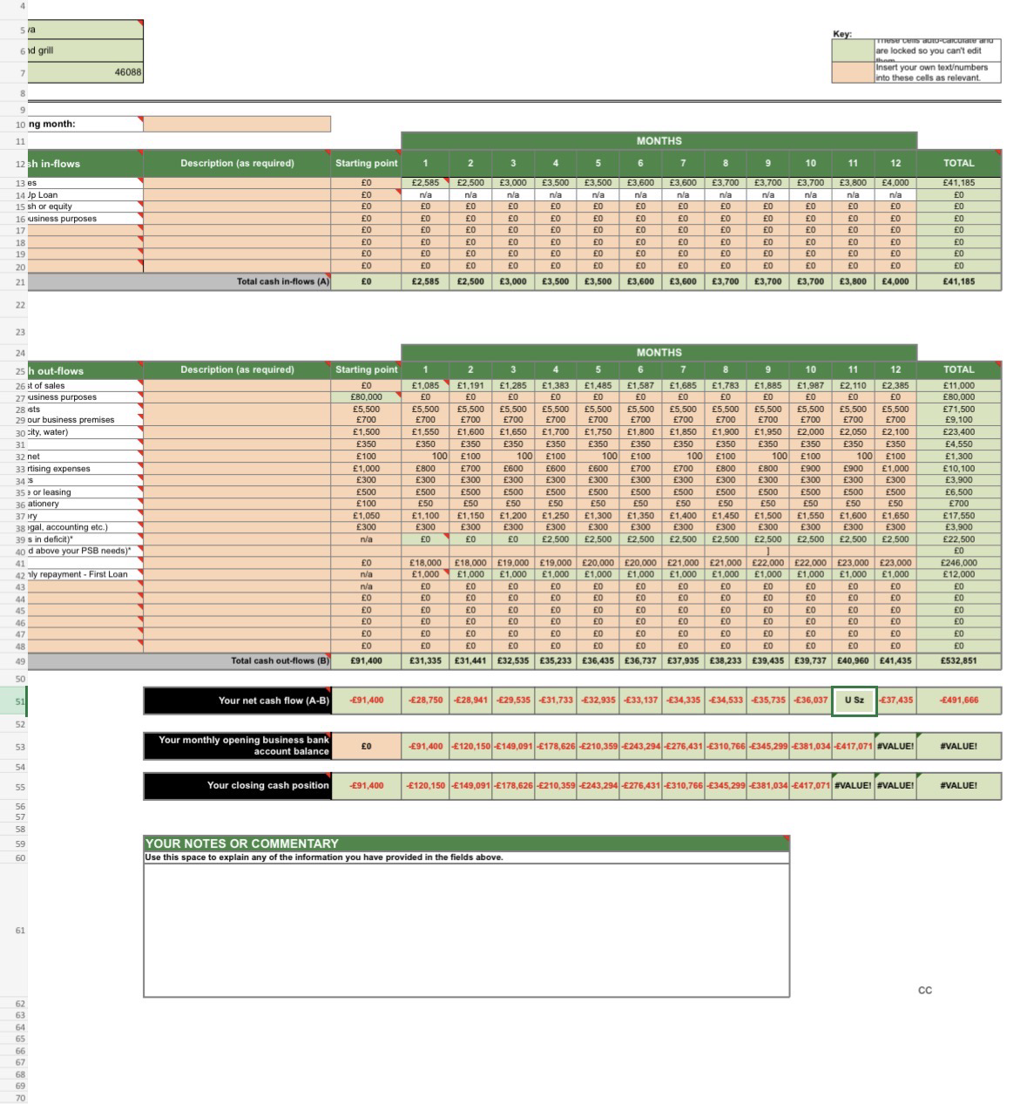
Appendix business model canvas (blank and example) (1) (2).docx Credit – Strategyzer.com

