Kai Conan Barkla
HPAR6005

Jakawitz:
A New World Troy?
Comparing the narrative of the Popol Vuh with the archaeological record.
Contents

Summary 3

Introduction 4

Methodology 5

Discussion of Findings 10

References 13

Appendices 14

Glossary 15

Summary
Key Words: Conflict, Popol Vuh, Jakawitz, K’iché, Narratology.
The K’iché Mayan epic the Popol Vuh is a narrative of Mayan mythology, of which the last two of five parts contains much conflict between the first mortals of the world including a Battle on the mountain Jakawitz. The physical remains of the ancient Mayans also attest to conflict, whether it be violent iconography or sacked ruins. It is the objectives of this report to discover if the Battle of Jakawitz occurred in Mayan history and to what extent the conflict of the Popol Vuh is similar to that of documented Mayan warfare.
Of the results found, no solid conclusion could be garnered from the weapon fragments or fortifications as they went against the narrative of the Popol Vuh. Instead physical remains at the site of Chuitinamit that could be found seem to suggest that the citadel was sacked and left in the state as found today. It does seem however, to be the right location as described in the Popol Vuh. Supporting evidence from Spanish accounts and Classic iconography suggests that such conflict wouldn’t have been implausible and considering the existence of fortifications, the defensive location and the political power exuded by the K’iché capital it is almost certain that conflict did occur in the area of Jakawitz, the Chujuyup valley. Whether these conflicts resembled those in the Popol Vuh is still undetermined.
What this report did find is that the conflict in the Popol Vuh is very much a reflection of actual Mayan military etiquette, with some elements seeming to originate from central Mexican cultures and some carried over from Classical customs. Overall, perhaps the most valuable result of this report is finding the reflection of conflict within the Popol Vuh and the ritualistic and religious part it plays within the K’iché mindset.

Introduction
The Popol Vuh, meaning ‘book of council’ is the K’iché Mayan epic of five parts including myths of the creation of the world, animals and the first humans as well as intertribal relations of the highland Mayans. The forth and fifth part of the Popol Vuh is relatively more terrestrial than the other parts, seeing the first K’iché defend themselves, their gods and their families from a coalition known as the 13 Tribes. The conflict is defined by multiple acts of trickery by the K’iché and their gods but is eventually decided by a battle at Jakawitz mountain with the 13 Tribes becoming vassals to the K’iché.
At Santa Rosa Chujuyup where the citadel Chuitinamit sits atop Jakawitz, multiple physical archaeological remains such ramparts, scorched buildings and projectile points suggest conflict. Such warfare appears also in Classic murals of skirmishes and triumphant general-kings on stelae. This militarism is no less strong in the Postclassic period, the epoch that the Popol Vuh is likely to have been compiled in, with Spanish accounts recording chiefdom feuds and experiencing attacks first hand during the conquest of Central America.
Parallels could be drawn between the Popol Vuh and Jakawitz to the Iliad and Troy. Two epics steeped in cultural lore but also containing echoes of a possible event in history. Though the historical authenticity of the Iliad has been examined before, it’s equivalent: the Popol Vuh has not had the same attention and considering the more earthly and mortal elements within the fourth and fifth parts it is possible that the battle of Jakawitz did take place.
The aims of this report are to analyse two data sets: the Popol Vuh and the archaeological record. With the final objectives of this report are: 1) To determine whether the conflict described in the Popol Vuh was derived from an actual battle at Jakawitz 2) To explore the extent that the warfare in the Popol Vuh correlates to documented Mayan military etiquette as recorded in the archaeological record.
The reason for this report is to better understand the early to middle Postclassic period, a particularly undocumented part of Mayan history. By allowing the Popol Vuh and what little archaeological remains to compliment one another, it is the intent of this report to help fill in this part of pre-Columbian history and to better understand the ancient Mayan mindset, through not only the physical evidence they have left behind but their very own message for future generations.

Methodology
To conduct these aims this report used these sources for data source 1, the Popol Vuh:
Christensen 2007, Tedlock (with translation notes) 1996
For data set 2, the archaeological record this report used these sources:
The Bonampak Murals (Classic period iconography of Mayan warriors), Carmack & Weeks 1981 (archaeological ruins), Canvas of the Tlaxcala (Lienzo de Tlaxcala-Postclassic period/contemporary iconography of Mesoamerican warriors) Christensen’s translation footnotes 2007 (comments on K’iché culture and historical context),Coe & Houston 2015 (Mayan culture and history, supporting source) Cortés 1986 (contemporary eyewitness), Diaz 1963 (contemporary eyewitness), Fox 1989 (archaeological ruins), Mayor 2015 (Animals in warfare, supporting source), Webster 2000 (Mayan warfare)
This report deemed the highest priority to find the most likely geographical location of Jakawitz and the battle that took place there. This was done by analysing the epic and comparing them with the archaeological records.
“Chitinamit-Chujuyup fits the Jacawitz of the siege episode in name and description, called specifically Chitinamit, Chu(vach)juyup, and Jacawitz (Popol Vuh 1971:204-209).”
Fox (1989:674)
“Carmack and Fox identify this mountain with the site of Chitinamit, a fortified settlement located on a high hill at the western edge of the Chujuyup Valley overlooking the Queca River (Fox 1978, 57-58; Carmack 1981, 65). … Akkeren concurs that Pa Tohil and Pa Auilix were located in the Chuyup Valley, however, he suggests that Hacavitz was located south of Chichicastenango (Akkeren 2000, 42).”
Christensen (2007:210) [Footnotes]
“And then Hacauitz [Jakawitz] was placed at the top of a great pyramid. Hacauitz [Jakawitz] is the name of the mountain today, and it became their citadel. So the god Hacauitz [Jakawitz] remained there…”
Tedlock (1996:159)
“Then Hacavitz [Jakawitz] was left on top of a great fire house. Hacavitz [Jakawitz] is the name of the mountain today. This they made their citadel, and this was where the god’s dwelling came to be. Hacavitz [Jakawitz] it was called.”
Christensen (2007:210-211)

With the data sets analysed, the site of Jakawitz mountain is with considerable certainty located at a mountain site of Santa Rosa Chujuyup that contains the ruins of a citadel known as Chuitinamit confirming Postclassic occupation similar to that described in the epic.
This report examined using textual analysis of the Popol Vuh and compared the passage attaining to fortifications at Jakawitz with those mentioned in the archaeological record of the mountain citadel, Chuitinamit.
“Chitinamit-Chujuyup fits the Jacawitz of the siege episode in name and description, called spe cifically Chitinamit, Chu(vach)juyup, and Jacawitz (Popol Vuh 1971:204-209). Two of these names still adhere. So, too, are its stone terraces (tz'alam) and rampart (q'ox'tun) distinguished. While numerous lance projectile points littering the last occupation attest to a battle, Chitinamit's scorched buildings belie defeat and abandonment (Fox 1987:Figure 6.2)”
Fox (1989:674)
“They made a fence at the edge of their citadel. They just made a palisade of planks and stakes around their citadel. “
Tedlock (1996:171)
“The materials for this structure are tz’alam, glossed as “board”… …and ch’ut, glossed as “sharp point”… …This was definitely not stonework.”
Tedlock (1996:312) [Notes on trans.].

Thusly, there was no similarity between the data provided by this specific archaeological analysis and the textual analysis of the epic as the physical remains yielded evidence of stone works which were not present in the translation. The next analysis of the archaeological record that this report took was to compare the Popol Vuh passage with an eyewitness account given by Cortés.
“This town stands upon a high rock: one side of it is skirted by a great lake and the other by a deep stream which runs into the lake. There is only one level entrance, the whole town being surrounded by a deep moat behind which is a wooden palisade as high as a man’s breast. Behind this palisade lies a wall of very heavy boards, some twelve feet tall, with embrasures through which to shoot their arrows; the lookout posts rise another eight feet above the wall, which likewise has large towers with many stones to hurl down on the enemy…”
Cortés (1986:371) Cited by Webster (2000:79-80).
“They made a fence at the edge of their citadel. They just made a palisade of planks and stakes around their citadel. “
Tedlock (1996:171)

This inquiry did not provide a decisive answer that physical archaeological records would have yielded- instead the passage attaining to fortifications from the Popol Vuh is only supported by the eyewitness account given by Cortés which gave similar data on Postclassic fortifications as those described in the epic.
This report then looked for any record of weapons discovered at the site that match mentioned weapons as described in the Popol Vuh.
“While numerous lance projectile points littering the last occupation attest to a battle, Chitinamit's scorched buildings belie defeat and abandonment (Fox 1987:Figure 6.2)”
Fox (1989:674)
“…all decked out with weapons and shields. …So then all the lance-bearing warriors of the tribes were armed. …And now they couldn’t feel a thing when they were hit with arrows and cut with axes.”
Tedlock (1996:170-173)
“We shall arm ourselves with arrows and with shields. …They were struck with arrows and chopped with axes…”
Christensen (2007:232, 237)
This report found that the archaeological record suggests that there is evidence of common Postclassic weapons at the site of Jakawitz, however they alone do not support the occurrence of the battle as described in the Popol Vuh as the projectile point assemblages were not in the location needed to support the events as described in the epic.
Other weaponry described in the epic were the use of hornets and wasps as agents of biological warfare. No material attaining to Mesoamerican tactics was found to suggest that Mayans used hornets as weapons in the archaeological record.
“Early people quickly discovered that enraged bees, wasps, or hornets, could send a real army into chaotic retreat. …Evidence from Greco-Roman historians texts tell us that bees, hornets, wasps, and scorpions (venomous arthropods) were purposefully used in wartime as agents for both offence and defence. …Hive ‘bombs’ plugged with mud were probably among the first crude projectile weapons, according to Edward Neufeld (1980)…”
Mayor (2015:3)
“…they had gone to get these insects and come back with them they put them inside four gourds… The yellow jackets and wasps were shut inside these gourds. …And then the gourds were opened up-there were four of them around the citadel-and the yellow jackets and wasps were like a cloud of smoke… There were yellow jackets and wasps everywhere, landing to sting their eyes. They had to watch out for whole swarms of them, there were insects going after every single person.”
Tedlock (1996:172-173)
The next procedure that this report took was to compare the decorations of the warriors as described in the epic. The passage attaining to military decorations was first compared with physical evidence which yielded no results, then compared with Spanish accounts which yielded supportive evidence. Finally, these descriptions were compared with Mayan Bonampak murals and the Spanish ‘Canvas of the Tlaxcala’.
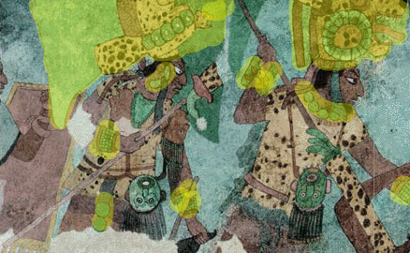
Fig.1
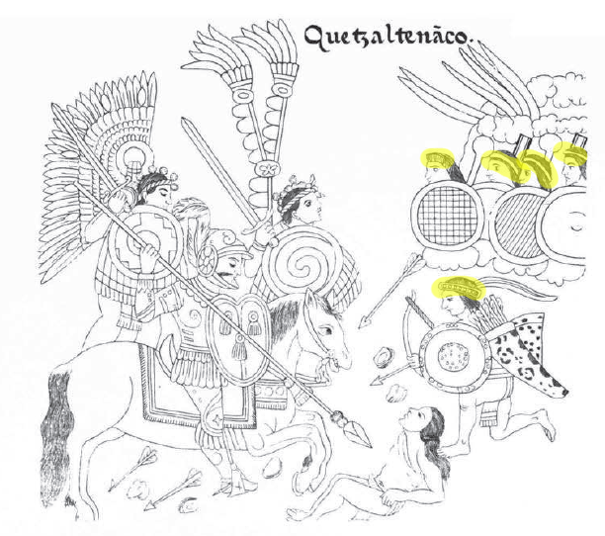
“…all decked out now with weapons and shields. Their metal ornaments were countless, they looked beautiful, all the lords… …And then the metal was undone from their cloaks, along with their headdresses. And their necklaces came off too, and the necks of their staffs. Their metal was taken…”
Tedlock (1996:170-171)
Fig.2

Though the report found multiple iconographic and eyewitness examples of warriors decorated with feathers, headdresses, cloth and jade jewellery in the archaeological record, there were none that displayed the metal ornaments similar to those described in the epic.
This report also examined the aftermath of the battle in the Popol Vuh, analysing the passage attaining to the defeat and vassalage of the 13 Tribes by the K’iché, forcing them to pay tribute. This was compared with the archaeological record to find whether this was a common consequence for the defeated party in Mayan warfare.
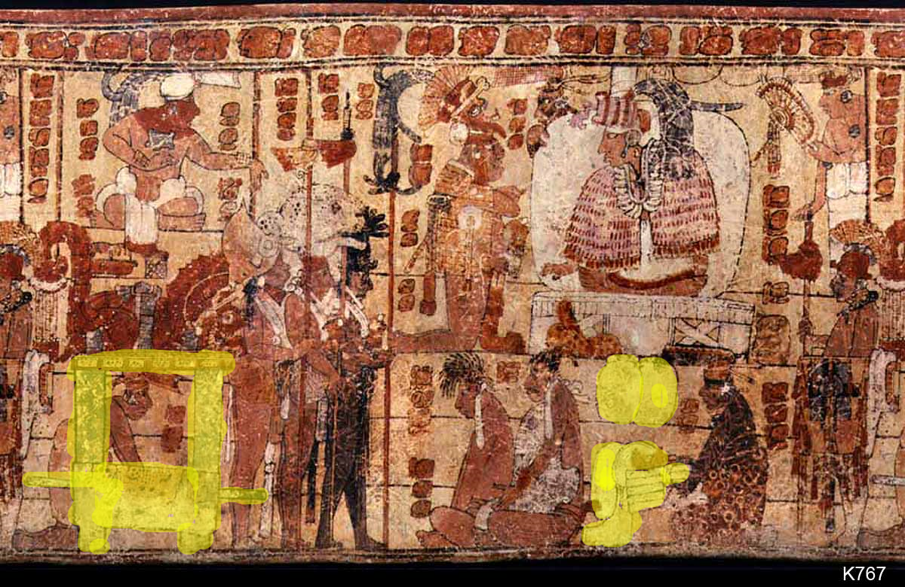
“Although you were destined to join the dead, you will be payers of tribute for as long as there are days and as long as there is light.”
Tedlock (1996:173)
“There were not then even one or two groups among the nations that did not bring their tribute. Their citadels fell, and they brought tribute”
Christensen (2007:262)
“…the Quiche [K’iche] managed to subjugate close to a million people, organize numerous provinces into tribute-paying units…”
Carmack & Weeks (1981:323)
“Tribute scenes have only recently been recognized and hint at some of the motivations for Classic warfare… Successful wars brought tribute of many kinds (including labor) to royal capitals, where it funded the enormous households of rulers as well as state projects such as the construction of temples and irrigation systems.”
Webster (2000:94)

Fig.3

This report found within examples in the archaeological record that almost all defeated parties were forced to pay tribute in Mesoamerican warfare and become vassals and is therefore similar to the narrative of the Popol Vuh.

Discussion
This report finds only supporting evidence of whether the Battle of Jakawitz occurred or not, and thusly does not fulfil the primary object of the report. Both aims were completed to relative degrees of success, the most problematic element of the report’s inquiry was the limited information within data set 2, the archaeological record: though there is a considerable amount of data from Mayan iconography and Spanish accounts of certain parts of the Mayan cultural area, there is almost no data attaining to a possible conflict at the site of Jakawitz as a specific area. Although the Mayans made great effort to preserve historical events through public artwork in the Classic period, this tradition did not continue into the Postclassic, this combined with the general lack of remains relevant to the objective proves problematic for this report. Though this report can not provide definitive proof that the Battle of Jakawitz did or did not occur, this report did have sufficient data to confirm that the Battle of Jakawitz could certainly have been a possible event in Mayan history. As the Popol Vuh’s account of the Battle of Jakawitz did match Mayan military etiquette, it can be said that this report achieved its second objective: to explore the extent that the warfare in the Popol Vuh correlates to documented Mayan military etiquette.
The results that I find confirms the location of Jakawitz mountain to the area Santa Rosa Chujuyup, where the large citadel of Chuitinamit lies. It is with the consensus of Christensen (2007:210, Fox (1989:674) and Carmack & Weeks (1981:324) that this report considers the site to be that mentioned in the Popol Vuh. A couple of sources that this report examines seem to argue that the area of Jakawitz was occupied before the K’iché (Carmack & Weeks 1981:325), with Coe & Houston (2011:226) specifically naming the Poqomam Mayans as the original inhabitants. This is highly contradictory to the accounts of the Popol Vuh who neglect to mention them as the original inhabitants or even as one of the 13 Tribes. The only possible mentioning being the ‘mountain people’ (Tedlock 1996:150, 193) that occupied the mountains as nomadic hunter-gatherers. Here, this demonstrates how the ambiguity of the epic may hinder investigations. Chuitinamit, though quite defensible enough rests upon a naturally defensible location on infertile land, suggesting that the site was chosen for its strategical and by extension political potential. Though the Popol Vuh notes the area for its divine connections, the geopolitical power that the location exudes may well invoke Jakawitz as a magically charged area.
I find that in the reports of the Chuitinamit ruins, much of the descriptions of the citadel do not match those in the epic, however contemporary eyewitness accounts of Cortés (1986:371, Cited by Webster 2000:79-80) did provide supporting evidence. Most of note is the disparity between the wooden palisades of the Popol Vuh and the stone rampart of the site of Chuitinamit. Tedlock (1996:312 note on trans.) insisted that these walls in the Popol Vuh were not stonework. In regard to translation Tedlock translated ‘tz’alam’ as meaning ‘board’ while Fox translated ‘tz’alam’ as ‘plaza’, it is entirely possible that translation errors or lost nuances may alter this data collection and its accuracy. Another likely possibility is that the citadel was remade several times over, with its defences upgraded over time, which would explain the possible divide between the current ruins of Chuitinamit and the fortifications of the Popol Vuh as the wooden fortifications may have been present, but eventually replaced with stone work.
Evidence of weapons are found at Chuitinamit, however their position indicates that they were not part of the battle of Jakawitz and instead were part of a conflict that resulted with the razing of the settlement (Fox 1989:674). Aguateca, a late Classic city-state suffered the same fate, was also found with points within the settlement and destroyed buildings (Aoyama 2005) suggesting that that military sites located on infertile land were razed rather than captured. With no evidence of repairs and debris left around the site it is probable that Chuitinamit, like Aguateca was abandoned after a conflict, leaving behind projectiles that had been damaged but salvaging fallen hand-to-hand weapons like spears and bludgeoning weapons. It should be of note that almost all Mesoamericans used either obsidian or flint for weaponry, therefore it is possible that many weapons remains are mistaken for common stones and cannot be found using metal detectors. Thusly, this report acknowledges that its current findings are only based off assemblages found and cannot speculate further than this on possible hidden assemblages.
This report finds that there is no evidence for weaponised insects in the archaeological record in eyewitness accounts of Mayan warfare. Peripheral evidence suggests, however, that such tactics are not implausible (Mayor 2015). Any investigation of the use of weaponised insects is immediately faced with the issue of insect remains, which tend to be only found in extraordinary conditions such as amber or fossilisation, this severely limits this line of inquiry.
In most stelae, lintels, murals and in Spanish accounts Mayan warriors were decorated as symbols of prowess and station (Webster 2000: 66, 79)(see figures 1&2), this correlates with the large amount of adornments that the 13 Tribes’ Warriors wore including precious metals- likely gold or copper. While the Mayans rarely interacted with large quantities of metal, central Mexican cultures did and as many of the highland Mayan ruling dynasties may have been descended from Mexicanised Mayan or Mexican lineages, this culture of metallurgy may have carried over (Christensen 2007:197 notes on trans.). Despite this, according to current data, no metal has been found at the site of Jakawitz, nor have any examples of metal military decorations been found in Mayan iconography in both the Classic and Spanish iconography in the Postclassic. A possible reason for the lack of any physical evidence of decoration is due to the perishable quality of cloth, feathers and shells, while metal, jade and other precious stones may have been melted down, looted or stored in a hidden stash making it difficult to prove that decorated warriors had taken part in a battle at Jakawitz. It is also possible that the term ‘metal’ more ambiguous than specific meaning and serves as a more nuanced term.
This report finds the narrative of tribute giving and vassalage of the 13 tribes to be very much in line with traditional Mayan etiquette, both in the Classic and Postclassic periods. Further: the K’iché managed to create a large hegemony over the area becoming a highland Postclassic Mayan power, this parallels the Popol Vuh quite profoundly which exclaims their thriving success after the battle of Jakawitz up until their conquest by the Spanish. This is perhaps the most successful line of inquiry that this report has taken, largely due to the large evidence left in the archaeological record attaining to victories, tributes and vassals mostly through Classical artwork. Not only this, but due to the infertility of the land at Jakawitz the citadel most certainly depended on tribute from vassals.
In conclusion, whether the Battle of Jakawitz occurred or not is still a moot point. It should be noted however, that the Popol Vuh is an epic- a piece of cultural and ethnic identity, and much like the Iliad did not serve the same purpose as a chronicle or an account. Thusly: though the primary objective of this report is to determine whether the Battle of Jakawitz took place, the most valuable result of this report is finding the reflection of conflict within the Popol Vuh and the ritualistic and religious part it plays within the K’iché mindset.

References
Aoyama K. 2005, ‘Classic Maya Warfare and Weapons
Carmack R.M. & Weeks J.M. 1981 ‘The Archaeology and Ethnohistory of Utatlan: A Conjunctive Approach’ American Antiquity Vol. 46 No. 2 pp. 323-341. Cambridge University Press.
Christenson A.J. 2007, Popol Vuh: Sacred Book of the Quiché Maya People. Mesoweb Publications.
Coe M.C & Houston S. 2015, The Maya. 9th Edition. Thames & Hudson Ltd, London WC1V 7QX.
Fox J.W. 1989, ‘On the Rise and Fall of the Tuláns and Maya Segmentary states’ American Anthropologist Vol. 91 No. 3 pp. 656-681. American Anthropological association.
Mayor A. 2015, Animals in Warfare.
Webster D. 2000, ‘The Not So Peaceful Civilization: A Review of Maya War’ Journal of World Prehistory Vol. 14 No. 1 pp. 65-119.
Tedlock D. 1996, Popol Vuh. Touchstone, Rockfeller Center.

Appendices
Figure 1: Bonampak mural, decorated elites at war.
Kreft L. 2004, Painted Mural, Bonampak. Accessed 01/11/2018. http://www.lindakreft.com/bonampakmurals.html
Figure 2: Canvas of the Tlaxcala (Lienzo de Tlaxcala), Spanish conquest of the K’iché
Wikipedia 2018, Page from the Lienzo de Tlaxcala showing the conquest of Quetzaltenango. Accessed 01/11/2018. https://en.wikipedia.org/wiki/Spanish_conquest_of_the_Maya
Figure 3: Ceramic of an aftermath of a battle, with tribute/war booty.
Kerr J. 1998, ‘K767’. Accessed 07/11/2018 http://research.mayavase.com/kerrmaya_hires.php?vase=767

Glossary
13 Tribes- A faction described in the fourth part of the Popol Vuh and is notably the antagonist faction intent on the destruction of the K'iché and their patron gods. The tribes included are as follows: Rabinals, Caqchikels, Bird House, White Cornmeal (Salcaja or saqk’aja), Lamacs, Serpents (Kumatz), Sweat-bath House (Tujal, see Sacapulas), Talk House (Uch’ab’aja), Star House (Ajch’umilaja), Quiba House, Yokes House (Ajb’atenaja), Acul People, Jaguar House, Guardians of the Spoils (Kanchajeleb) and the Jaguar Ropes (B’alam Kolob’). It should be noted that there are more than 13 factions named, it is not known if some are moieties or clans of larger bodies or if the number is symbolic.
Aguateca- Classic site in northern Guatemala, notable for being one of the few Mayan settlements that was sacked and abandoned rather than vassalised.
Chuitinamit (Alternative Spelling: Chitinamit)- Citadel located on Santa Rosa Chujuyup/Jakawitz.
Classic and Postclassic period- Time eras of Mesoamerican history. The Classic era is usually recognised as ranging from 300BC to 800AD while the Postclassic carries on from 800AD to 1400AD after which is usually considered the colonial period.
K’iché (Alternative Spelling: Quiché)- An ethnic and linguistic group of Mayan culture. The K’iché occupied large areas and political power in the southern highlands of Guatemala finally being subdued by the Spanish by 1541AD.
Jakawitz (Alternative Spellings: Hacauwitz, Jacawitz, Hacavitz)- A mountain that can be found in modern day Guatemala, shares name with K’iché god.
Mesoamerica- A geographical location used by historians, archaeologists and other humanities disciples. Encompassing Mexico, Guatemala, Belize, Honduras as well as parts of El Salvador and Honduras. Some Mesoamerican cultures include the Aztec/Mexica, Mayans, Mixtec, Zapotec etc.
Mexicanisation- Process in which a culture adopts cultural aspects from central Mexican cultures. E.g. “Tikal exhibits stelae that show rulers dressed as the Teotihuacan god Tlaloc, thus showing Mexicanisation at Tikal”.
Poqomam (Alternative Spellings: Pokomam): Ethnic and linguistic group of the Mayan Culture. The Poqomam reside in Guatemalan highlands.

