

Assessment 1
Online Portfolio

Student name: Mirish Salieva
Student ID: 1913122

Module name: Changemakers: Building your Personal Brand for Sustainable Employment
Module code: BMHP5015
Lecturer name: Bianca Sanfilippo
Word count: 2000

Contents

Introduction ……………………………………………………..4

Personal statement …………………………………………………….. 5

Health and Social Care CV ……………………………………………6/7

Personal pitch ………………………………………………………….8/9

Conclusion ……………………………………………………………….10

References ………………………………………………………………11

Introduction

The purpose of a portfolio is to document my skills that I have achieved through my carrier and study, to challenge me to create the best work, and help me to reflect on what I have accomplished. In this portfolio will be consist of my Personal Statement about postgraduate application, my CV and my TV documentary plan.

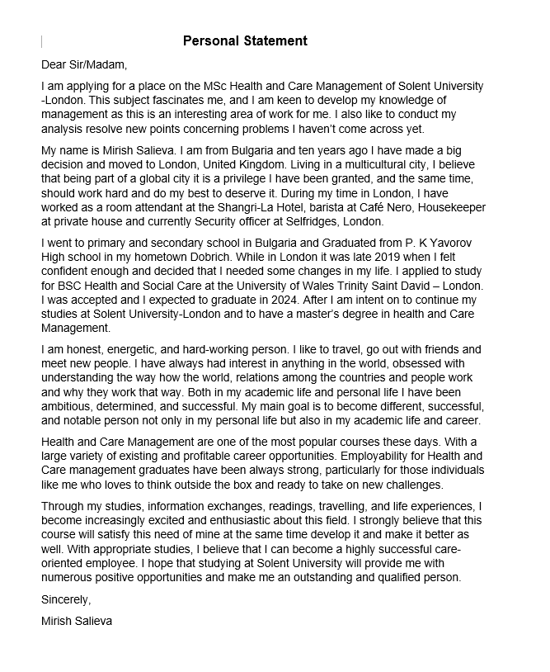

Health and Social Care CV


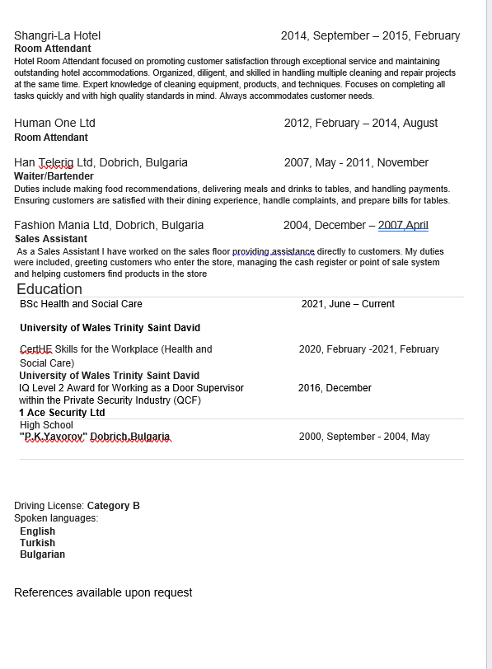

Personal pitch
Teenage obesity – Children obesity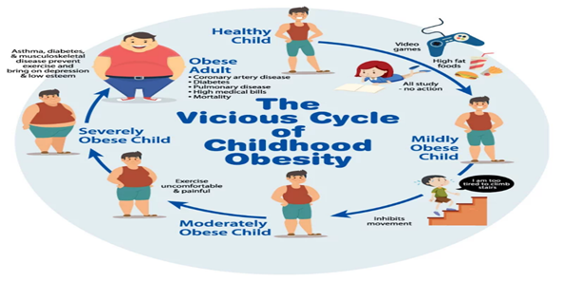(Theheartfoundation.org, 2019)

Documentary film about obesity among children and teenagers This film will demonstrate that the effects of poor food and lack of physical fitness extend well beyond diabetes and cardiovascular disease. Obesity is also detrimental to a child's psychological health, and the feelings of humiliation and isolation that result from it frequently fuel its prolonged domination in their life
Obesity and overweight in children are serious health concerns for children and their families. There may be lasting effects on a child's physical and mental health that last into adulthood. The prevalence of unhealthy and potentially hazardous childhood obesity is a nationwide public health problem. (GOV.UK,)
It is vital for teenagers who struggle with obesity to realise that there may be more causes for their weight besides their connection with food and activity. Did you realise that between 40 and 70 percent of obesity is inherited? This indicates that many adolescents with obesity have a higher hereditary risk of having this disease throughout their lifetime. (“Support for Teenagers Living with Obesity”)
In this movie we can explore the reasons of gaining weight of that young age. How can genes affect someone’s weight and how lifestyle can influence. Factors to understand are:
- How much food is eaten in a single sitting?
- How a person reacts to the feeling of fullness
- How much pleasure is derived from specific sorts of food?
- How much energy is required for the body's fundamental functions?
- How and where the body stores extra calories as fat (Schwartz, 2016)
Review of the literature explores the causes of poor nutrition and provides several insights into how parental variables may contribute to childhood obesity (Sahoo et al., 2015). Children imitate their parents' and classmates' eating habits and openness to try new foods, according to research. Healthy food accessibility and exposure over time are essential for forming preferences and can help people overcome food aversion. Evidence suggests that families that dine together consume more nutritious meals, therefore mealtime organisation is vital. Additionally, dining out or watching TV while eating is linked to greater fat intake (Sahoo et al., 2015).
The aim of this movie is to educate and promote healthy lifestyle for children and teenagers, also to show them consequences of unhealthy lifestyle in later adulthood life. A primary reason that prevention of obesity is so vital in children is because the likelihood of childhood obesity persisting into adulthood increases as the child ages. This puts the person at high risk of diabetes, high blood pressure and heart disease (John Hopkins Medicine, 2019).
This film is beneficial for parents who are seeing their child battle with weight since it's easy to feel useless or overwhelmed. However, families have a lot of options for helping their child. Early detection of obesity and weight issues can help parents lower their child's chance of major medical illnesses as they reach older (Melinda, 2019). And by including the entire family, parents may stop the cycle of weight issues and obesity, improve their child's physical and mental health, and assist them in developing a lifelong relationship with food. This documentary can educate both parent and children how to battle with obesity.
Children who are overweight have an increased risk of being teased and bullied, which can result in increased levels of stress, anxiety, and depression. When a youngster experiences depression, they may take satisfaction in food, which can lead to weight gain. (mydoctor.kaiserpermanente.org, n.d.)
This movie can be good as a model of healthy eating pattern for the whole family. Adopting good eating habits as a family assists children in achieving and maintaining a healthy weight as they grow older. Eating a range of vegetables and fruits, whole grains, lean protein meals, and low-fat and fat-free dairy products is in accordance with dietary recommendations and promotes the health of your family. (CDC, 2019)
Globally, childhood obesity has become a public health emergency. With this movie we can teach children and parents about good diet and encouraging them to be physically active, the childhood obesity epidemic may be mitigated. There are successful government interventions. So that children may adopt these healthy habits as a lifelong practise and live a healthy life, it is crucial that these treatments be sustainable. This will result in a healthier future for children across the nation. (Karnik and Kanekar, 2012)

Conclusion

Overall, I consider myself to be a dedicated, creative student who is motivated by difficulties and can benefit personally from new experiences, and I believe that a university degree in Health and Social care would be a solid basis for a successful future job, in whatever sector that may be.

References
1.CDC (2019). September is National Childhood Obesity Month. [online] Centers for Disease Control and Prevention. Available at: https://www.cdc.gov/nccdphp/dnpao/features/childhood-obesity/index.html.
2. GOV.UK. (n.d.). Childhood obesity: applying All Our Health. [online] Available at: https://www.gov.uk/government/publications/childhood-obesity-applying-all-our-health/childhood-obesity-applying-all-our-health#:~:text=Child [Accessed 15 Dec. 2022].
3. John Hopkins Medicine (2019). Preventing Obesity in Children, Teens, and Adults. [online] John Hopkins Medicine. Available at: https://www.hopkinsmedicine.org/health/conditions-and-diseases/obesity/preventing-obesity.
4. Karnik, S. and Kanekar, A. (2012). Childhood obesity: a global public health crisis. International journal of preventive medicine, [online] 3(1), pp.1–7. Available at: https://www.ncbi.nlm.nih.gov/pmc/articles/PMC3278864/.
5. Melinda (2019). HelpGuide.org. [online] HelpGuide.org. Available at: https://www.helpguide.org/articles/diets/childhood-obesity-and-weight-problems.htm.
6. mydoctor.kaiserpermanente.org. (n.d.). Blogs & News. [online] Available at: https://mydoctor.kaiserpermanente.org/mas/news/expert-advice-on-talking-to-children-about-weight-and-obesity-1880515.
7. Sahoo, K., Sahoo, B., Choudhury, A.K., Sufi, N.Y., Kumar, R. and Bhadoria, A.S. (2015). Childhood obesity: Causes and consequences. Journal of Family Medicine and Primary Care, [online] 4(2), p.187. doi:10.4103/2249-4863.154628.
8. Schwartz, C. (2016). Causes and risks for obesity in children: MedlinePlus Medical Encyclopedia. [online] Medlineplus.gov. Available at: https://medlineplus.gov/ency/patientinstructions/000383.htm.
9. Theheartfoundation.org. (2019). Childhood Obesity. [online] Available at: https://theheartfoundation.org/2018/02/09/childhood-obesity/.
10. www.truthaboutweight.global. (n.d.). Support for teenagers living with obesity. [online] Available at: https://www.truthaboutweight.global/global/en/inspiration-for-change/support-for-teenagers-living-with-obesity.html?cid=pse-ga-sea-tx-tawg&gclid=CjwK [Accessed 16 Dec. 2022].

