

Programme: Master of Business Administration
Module and Code: Human Capital Management (LCMB7023)
Assessment component 1: Individual report

Innovating New Working Practices and Breeding an Environment Where Talent May Grow

Name: AYANALI NIYAZALI SAIYAD
ROLL NO: 2610333
Lecturers name: Dr. Eno Maycock
Course: MBA INTERNATIONAL Business Management
Subject: human capital management
Word Count: 2523
Submission Date: 15_{th} October 2026

Table of Contents
TASK A: DESIGNING INNOVATIVE WORKING PRACTICES 3
1.1 Traditional versus Contemporary Work Design 3
1.2 Recommended Innovative Working Practices for NHSX 4
1.3 Integrated Framework for Innovation and Agility 6
TASK B: BREEDING AN ENVIRONMENT WHERE TALENT MAY GROW 8
2.2 Strategic Talent Growth Strategy for NHSX 9
2.3 Integrated Talent Ecosystem 11
TASK C: REFLECTIVE REPORT 13
3.1 AI as a Strategic HRM Decision-Support Tool 13
3.2 Three Examples of Using AI 13
3.3 Personal Capability Development Action Plan 14
References 15

TASK A: DESIGNING INNOVATIVE WORKING PRACTICES

1.1 Traditional versus Contemporary Work Design
A. Traditional Work Design
Traditional work design is based on hierarchy, centralisation of decision-making, standards of tasks, and vertical communication (Jerab and Mabrouk, 2023). While this can help to drive accountability and standardisation, it can also slow down decision-making, hinder employee autonomy, and foster a silo mentality within departments. The restrictions could impede NexSpace Health Systems (NHSX) from innovating and disseminating knowledge in the fast-evolving healthcare technology landscape (Baporikar, 2025).
B. Contemporary Innovative Work Design
Modern work design places importance on flexibility, teamwork, self-direction, and adaptability to changes (Savitha and Kumar, 2025). Different innovative approaches are solutions to specific organisational challenges, as opposed to traditional structures. Holacracy shares authority via established roles instead of relying only on the system of managers. Agile working involves periodic feedback and incremental development to speed up innovation. Flexible working involves having more flexibility in when and the way people work, and remote working is the use of digital technologies to enable an employee to work away from the central workplace (Ajewumi, 2024).
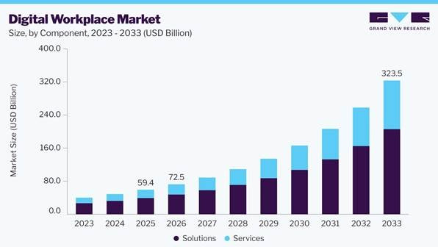
Figure 1: Digital Marketplace Market
(Source: Grandviewresearch.com, 2026)
This is further supported by the growing adoption of digital workplace technologies, as the global digital workplace market is expected to grow from USD 59.4 billion in 2025 to USD 323.5 billion by 2033 (Grandviewresearch.com, 2026). For NHSX, these methods can help to shorten the time between decisions, share knowledge and facilitate geographically dispersed teams.
C. Critical Comparison Using Theory
High-Performance Work Systems (HPWS) is an integration of employee development, sharing information and practices that are based on performance in order to enhance the capability of the organisation (Kaushik and Mukherjee, 2022). It can facilitate innovation by enhancing skills and employee contribution as compared to traditional work design (Fragoso et al., 2022).
However, High-Involvement Work Systems (HIWS) encourages knowledge, participation, sharing information and autonomy for employees (Kilroy et al., 2023). It is especially important to consider for NHSX because clinical and technical workers taking part idecision-making can help eliminate hierarchy and facilitate knowledge-sharing (Nguyen et al., 2024).
On the other hand, Sociotechnical Systems Theory highlights the human, technology and work process interactions. NHSX should thus rethink collaboration and responsibilities, as well as piloting digital health technologies, not expecting that technology alone will drive innovation (Polojaervi et al., 2023).
Overall, HPWS is concerned with employee capability, HIWS is concerned with limited participation, and sociotechnical theory relates technology to work design. They collectively form a focused basis for NHSX's recommendations.

1.2 Recommended Innovative Working Practices for NHSX
- Recommendation 1: Cross-functional Innovation Teams
There should be multi-disciplinary teams across NHSX between clinicians, AI experts, software developers, data scientists and product managers. The development of an AI-based patient-monitoring system, for instance, would enable clinical and technical staff to use their expertise to better understand patient requirements and system design (Tsvetanov, 2024). This is a direct recommendation for the departmental silos, lack of collaboration and limited knowledge sharing. A common aim, clear assignments, and frequent team meetings should minimise misunderstandings and help to pass on knowledge from one department to another.
- Recommendation 2: Agile Project Teams
NHSX should implement agile project teams with short development cycles and feedback from users and frequent reviews. For instance, a clinical decision support function could be piloted on a small scale, tested with healthcare practitioners and improved before being more broadly implemented (Rubins et al., 2022). Agile working helps to overcome slow decision-making processes within the hierarchy and delays in innovation by allowing teams to discover issues and make changes earlier. Project teams should have clear milestones and the power to make standard decisions in clinical and regulatory parameters agreed upon.
- Recommendation 3: Flexible Working
NHSX needs to implement flexible working, taking into account that, where operational, it should enable employees to adapt their hours and operational arrangements. Collaboration hours agreed would enable teams throughout the UK, India and UAE to arrange meetings while aligning with various working patterns (Ajewumi, 2024). This recommendation will look to rigid working arrangements and challenges to work coordination across geographical distances. Increased flexibility can be beneficial for work-life balance and for concentration. To avoid isolation and coordination issues, NHSX needs to set out clear availability expectations and provide fair access to information and regular communication.
- Recommendation 4: Employee Autonomy and Digital Collaboration
NHSX should provide employees with more autonomy to plan their work, make recommendations for change and implement ideas, within the parameters of the organisation's agreed standards. Communication between departments should be facilitated via shared digital workspaces, searchable knowledge repositories and communities of practice (Tremblay and Scaillerez, 2024). Employee autonomy is about a lack of decision-making authority and lack of ownership, whereas digital collaboration is about gaps in knowledge sharing and silo mentality. Staff might, for instance, report on the outcomes of projects they have finished and put them into practice again by others for good results and to prevent redoing errors.

1.3 Integrated Framework for Innovation and Agility
NHSX needs to have a scheme of work that connects organisational issues to focused work design solutions. The cross-functional teams are expected to enhance the collaboration and exchange of knowledge; the agile teams should shorten the process of decision-making and innovation; flexible working should tackle rigid working schedules and coordination issues; and employee autonomy, while benefiting from digital collaboration, should increase the sense of ownership and knowledge transfer (Rubins et al., 2022).
The implementation should start with an analysis of existing barriers, and then small-scale tests should be conducted in selected teams. Managers should be clear about roles, give proper training, and allow for collaboration tools. Progress can be monitored using indicators like time to complete the project, employee involvement, knowledge exchange, and employee feedback or employee workload indicators (Nguyen et al., 2024). NHSX would be able to tweak the practices and expand successful interventions if they had regular reviews. This is an integrated approach that is both flexible and accountable, and it promotes sustainable innovation.
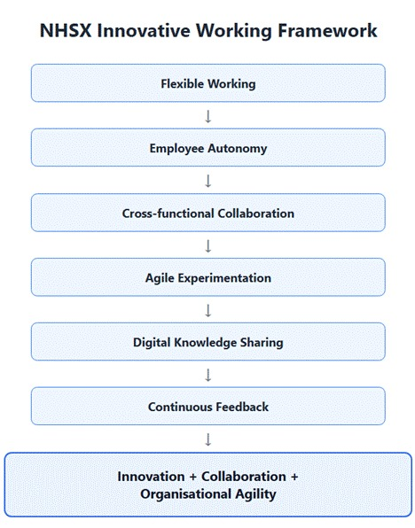
Figure 2: NHSX Innovative Working Framework
(Source: Author's framework based on the literature discussed in Task A)

TASK B: BREEDING AN ENVIRONMENT WHERE TALENT MAY GROW
2.1 Creating an Environment Where Talent Flourishes
- Learning Organisation — Senge
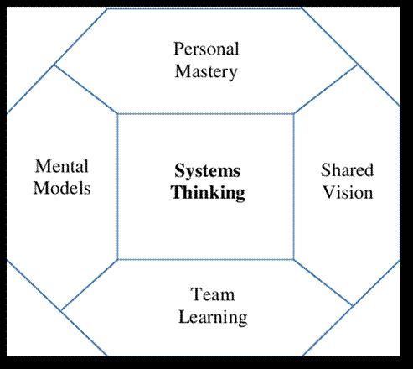
Figure 3: Learning Organisation (Senge)
(Source: Strachan, 2015)
The Learning Organisation theory is a theory that focuses on team learning, shared vision, systems thinking, mental models, and personal mastery, which are all of the essence of Senge. For NHSX, this approach helps to overcome the limitation of learning opportunities by fostering ongoing development, reflection and knowledge sharing throughout the UK, India and UAE (Springmier et al., 2024). Structured training, peer learning and opportunities to apply new skills to workplace projects should be provided by NHSX. But a learning culture does not happen just because all employees are responsible, it needs organisational support, time and resources for its development.
- Psychological Safety — Edmondson
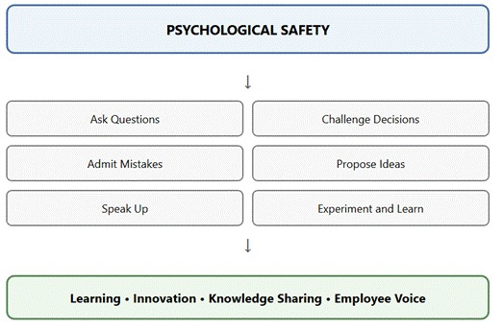
Figure 4: Psychological Safety (Edmondson)
(Source: Author)
Psychological safety allows staff to contribute without fear of humiliation or punishment, ask questions, admit errors, and challenge decisions and share ideas (Liu et al., 2024). This is particularly relevant at NHSX as staff working with AI and digital healthcare technologies should be able to raise concerns and challenge any potentially unsafe actions. Fear is a primary obstacle to psychological safety, and can harm well-being by limiting open communication. NHSX should establish supportive team discussions, regular feedback sessions and safe experimentation procedures.
- Self-Determination Theory
According to the Self-Determination Theory, autonomy, competence and relatedness are three psychological needs that are vital to motivation (McAnally and Hagger, 2024). NHSX provides staff with opportunities to make decisions, to grow professionally and build relationships across international teams. Motivation and engagement can be reinforced through giving meaningful responsibilities, development opportunities and supportive management. This theory complements the learning organisation theory by providing an understanding of how the needs of the employee affect participation in learning and development.

2.2 Strategic Talent Growth Strategy for NHSX
- Pillar 1: Individualised Learning Pathways
An individual development plan related to the needs of the organisation, the ambition of the employee and their existing skills should be introduced by NHSX, including training in AI, digital health, data literacy and project management (Silveira, 2025). Microlearning can be used to compensate for the lack of learning opportunities, as can the professional certifications, mentoring and practical projects. Progress should be monitored on an ongoing basis to make sure that employees are gaining skills that they will need in their jobs.
- Pillar 2: Career Mobility and Internal Opportunities
NHSX should create clear career progression, internal opportunities, rotations and succession plans. Declining opportunities for career advancement can lead to decreased motivation and turnover. Having published promotion criteria and competency frameworks would assist employees to understand how to move forward and what skills they should acquire (Tusquellas et al., 2024). Creating opportunities for internal staffing and promotion, and providing equal opportunities to all employees, can help to boost employee retention by showing them that they can have a career within the company.
- Pillar 3: Mentoring and Coaching
NHSX should implement senior-junior mentoring and peer mentoring and cross country coaching in the team in the UK, India, and UAE. Mentoring involves experienced staff passing on practical knowledge and sharing professional experiences and supporting the development of colleagues (Lifintsev et al., 2025). It can also improve communication between the geographically spread employees and allow them to gain insight into the different work habits. Progress would be measurable through regular mentoring meetings and agreed development goals.
- Pillar 4: Innovation and experimentation
NHSX needs to set up innovation challenges, pilot projects, hackathons and internal idea sharing platforms. Staff should be given sufficient freedom and time to experiment with new concepts, within boundaries agreed with them. The strategy approach works to overcome the lack of creativity and experimentation opportunities and involves employees in learning from feedback and experience. (Lifintsev et al., 2025) Things happens in each pilot's successful or unsuccessful work should be shared among teams. Experiments must comply with patient-safety, cybersecurity and regulatory requirements.
- Pillar 5: Well-being and Sustainable Performance
NHSX should tackle well-being issues by providing workload monitoring, practical time limits, flexibility in working and regular well-being conversations. Employees' concerns should be addressed, and managers should be trained to recognize overloaded workloads. A psychological safe environment should be an environment in which staff can talk about problems without fear of negative consequences (Liu et al., 2024). These measures can help to lower unnecessary stress and to enable sustainable performance without compromising on the organisation's objectives.
- Pillar 6: Performance and Recognition
The performance indicators for an assessment of the employees should include NHSX learning, collaboration, knowledge sharing, innovation and contribution to the organisation's objectives (Thneibat, 2022). It would be good to have both reward the individual and reward the team, without punishing the team for the individual. Performance evaluations must also include development needs, acknowledge career advancement and set future learning goals. This would link performance management to professional development and organisational enhancements.

2.3 Integrated Talent Ecosystem
Integrated Talent Ecosystem involves the linkage of recruitment, induction, development, experimenting, collaborating, recognizing, scaling-up and retaining talent. It makes sure that the talent development process is not limited only to the recruitment and training stage of the employee's life cycle (Sadeghi, 2024). Competence is developed by learning opportunities, well-being and responsible experimentation are nurtured through psychological safety, and increased mobility and recognition enhance motivation and retention. Together these elements make sure that employee development aligns to NHSX's organisational goals (Ahsan, 2025).
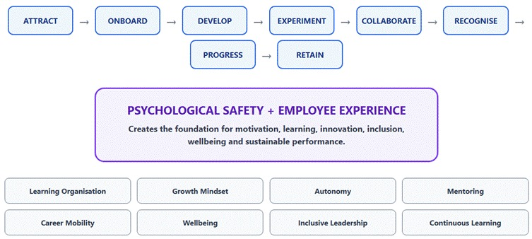
Figure 5: NHSX Integrated Talent Ecosystem
(Source: Author's framework based on the literature discussed in Task B)
Table 1: Measuring Talent Growth
Area | Key performance indicator (KPI)
Learning | Training completion and skills improvement
Career development | Internal promotion rate
Retention | Retention rate of high-performing employees
Innovation | Ideas tested and pilots implemented
Collaboration | Participation in cross-functional projects
Engagement | Employee engagement survey score
Psychological safety | Employee survey results on speaking up
Well-being | Workload, absence and well-being indicators
Performance | Achievement of individual and team objectives

TASK C: REFLECTIVE REPORT

3.1 AI as a Strategic HRM Decision-Support Tool
I understand that artificial intelligence (AI) can assist strategic human resource management (HRM) in different ways. National Health Services eXperience (NHSX) might benefit workforce planning in the UK, India & UAE with these applications. However, there are also risks of AI, such as algorithmic bias, privacy concerns and inaccurate recommendations. I understand that AI should be used to complement and not replace human judgment. HR professionals continue to have duties regarding the fairness, transparency and accountability of decisions concerning employees' careers and welfare (Zulifiqar et al., 2025).

3.2 Three Examples of Using AI
- Example 1: AI in Recruitment and Selection
I examined the potential of AI to help with application screening and finding appropriate candidates. This enabled me to gain insight into the role of technology in enhancing the efficiency of recruitment processes and minimising administrative tasks (Hawrysz, 2025). There is a possibility of bias in the algorithms, which can work against a particular applicant. Therefore, it is still important to have humans involved to make fair and inclusive recruitment decisions.
- Example 2: AI in Employee Learning and Development
I explored the potential of using AI to spot skill deficiencies within a workforce and suggest targeted training opportunities for each individual. It has enhanced my awareness and knowledge of strategic workforce planning and talent development (Madhumithaa et al., 2025). AI can only be a part of the picture; in many cases, it does not account for every learner's career goal and his or her learning style, so it is crucial that the manager uses his or her common sense and provides extra support to the individual.
- Example 3: AI in Employee Engagement and Retention
I investigated the use of AI-driven analytics for detecting employee engagement trends and signs of attrition (Madhumithaa et al., 2025). This showed the way the workforce can be used to help inform retention plans. However, privacy is an issue when employees are monitored, and it is not always possible to anticipate the circumstances and intentions of employees.

3.3 Personal Capability Development Action Plan
The three priorities in my development plan that I can execute over the next six-months are AI literacy, HR analytics and ethical decision-making.
Capability | Development action | Timescale | Success measure
AI literacy | Complete AI training and practise using AI tools for HR tasks. | Months 1–6 | Training certificate and practical HR application.
HR analytics | Develop Excel and Power BI skills and complete an HR data-analysis project. | Months 1–6 | Completed portfolio project interpreting HR data.
Ethical decision-making | Study AI bias, data privacy and responsible AI use; evaluate HR case studies. | Months 1–6 | Written case analysis identifying risks and appropriate safeguards.
Through this plan, I will have the opportunity to gain hands-on experience in AI, understand the implications of HR analytics, and make informed, ethical choices. Checking progress on a monthly basis will enable me to see where the learning gaps are and make changes to what I do in development. These are the skills that will help me to be better prepared to help with technology enabled HRM and ensure fairness, accountability and employee trust.

References
Ahsan, M. J. (2025). Cultivating a culture of learning: the role of leadership in fostering lifelong development. The learning organization, 32(2), 282-306. https://www.emerald.com/tlo/article-abstract/32/2/282/1244831
Ajewumi, O. E. (2024). The influence of agile organizational design on employee engagement and performance in the digital age. International Journal of Research Publication and Reviews. https://www.academia.edu/download/122210915/IJRPR33803.pdf
Baporikar, N. (2025). Hierarchy in Organizational Design as a Strategy to Build Resilience. In Enhancing Resilience in Business Continuity Management (pp. 77-104). IGI Global Scientific Publishing. https://www.igi-global.com/chapter/hierarchy-in-organizational-design-as-a-strategy-to-build-resilience/370110
Fragoso, P., Chambel, M. J., and Castanheira, F. (2022). High-performance work systems (HPWS) and individual performance: The mediating role of commitment. Military Psychology, 34(4), 469-483. https://www.tandfonline.com/doi/abs/10.1080/08995605.2021.2010429
Grandviewresearch.com, (2026). Digital Workplace Market Size and Trends Report, 2026-2033. [online] GrandViewInc. Available at: https://www.grandviewresearch.com/industry-analysis/digital-workplace-market.
Hawrysz, L. (2025). Artificial intelligence in candidate screening: opportunities and challenges. Zeszyty Naukowe. Organizacja i Zarządzanie/Politechnika Śląska. https://yadda.icm.edu.pl/baztech/element/bwmeta1.element.baztech-5b3a720e-8aae-4788-987f-e2eca4126710
Jerab, D., and Mabrouk, T. (2023). How to Design an Effective Organizational Structure and the 21 Century Trends. Available at SSRN 4584646. https://papers.ssrn.com/sol3/papers.cfm?abstract_id=4584646
Kaushik, D., and Mukherjee, U. (2022). High-performance work system: a systematic review of literature. International journal of organizational analysis, 30(6), 1624-1643. https://www.emerald.com/ijoa/article/30/6/1624/146759
Kilroy, S., Fu, N., Bosak, J., Hayes, R., and Schaufeli, W. (2023). Reducing day‐level emotional exhaustion: The complementary role of high involvement work systems and engaging leadership. Human Resource Management Journal, 33(4), 846-867. https://onlinelibrary.wiley.com/doi/abs/10.1111/1748-8583.12482
Lifintsev, D., Zelihic, M., Grebliauskiene, B., Wellbrock, W., Patel, S. V., and Sharma, R. K. (2025). Young professionals' perspectives on cross-cultural communication: Assessing competence and employer support across regions. International Journal of Cross Cultural Management, 25(1), 233-254. https://journals.sagepub.com/doi/abs/10.1177/14705958251319695
Liu, J. J., Ein, N., Plouffe, R. A., Gervasio, J., St. Cyr, K., Nazarov, A., and Richardson, J. D. (2024). Meta-analysis and systematic review of the measures of psychological safety. MedRxiv, 2024-02. https://www.medrxiv.org/content/10.1101/2024.02.09.24302562.abstract
Madhumithaa, N., Sharma, A., Adabala, S. K., Siddiqui, S., and Kothinti, R. R. (2025). Leveraging AI for personalized employee development: A new era in human resource management. Advances in Consumer Research, 2, 134-141. https://acr-journal.com/article/leveraging-ai-for-personalized-employee-development-a-new-era-in-human-resource-management-885/
McAnally, K., and Hagger, M. S. (2024). Self-determination theory and workplace outcomes: A conceptual review and future research directions. Behavioral sciences, 14(6), 428. https://www.mdpi.com/2076-328X/14/6/428
Nguyen, M., Pontes, N., Malik, A., Gupta, J., and Gugnani, R. (2024). Impact of high involvement work systems in shaping power, knowledge sharing, rewards and knowledge perception of employees. Journal of Knowledge Management, 28(6), 1771-1792. https://www.emerald.com/jkm/article-abstract/28/6/1771/1228779
Polojaervi, D., Palmer, E., and Dunford, C. (2023). A systematic literature review of sociotechnical systems in systems engineering. Systems Engineering, 26(4), 482-504. https://incose.onlinelibrary.wiley.com/doi/abs/10.1002/sys.21664
Rubins, D., McCoy, A. B., Dutta, S., McEvoy, D. S., Patterson, L., Miller, A., ... and Wright, A. (2022). Real-time user feedback to support clinical decision support system improvement. Applied clinical informatics, 13(05), 1024-1032. https://www.thieme-connect.com/products/all/doi/10.1055/s-0042-1757923
Sadeghi, S. (2024). Employee well-being in the age of AI: Perceptions, concerns, behaviors, and outcomes. arXiv preprint arXiv:2412.04796. https://arxiv.org/abs/2412.04796
Savitha, M., and Kumar, S. P. (2025). Building an agile organizational structure to drive innovation and technology. Cuestiones de Fisioterapia, 54(2), 2321-2334. https://cuestionesdefisioterapia.com/index.php/es/article/view/978
Silveira, P. P. (2025). Transforming Global Education through AI: Addressing Cross-Cultural Competencies and HRM Challenges in the Digital Age. Journal of Integrative Education Studies, 1(1), 20-29. https://jies.cultechpub.com/index.php/jies/article/view/4
Springmier, K., Fonseca, C., Krier, L., Premo, R., Smith, H., and Wegmann, M. (2024). A learning Organization in Action: applying Senge's five disciplines to a collections diversity audit. portal: Libraries and the Academy, 24(2), 251-263. https://muse.jhu.edu/pub/1/article/923706/summary
Strachan, G. (2015). Catalysing Change for Sustainability in Education: The relationship between sustainable building design... [online] ResearchGate. Available at: https://www.researchgate.net/publication/359898838_Catalysing_Change_for_Sustainability_in_Education_The_relationship_between_sustainable_building_design_and_institutional_change.
Thneibat, M. M. (2022). The role of performance-based rewards and developmental performance appraisal in promoting innovative work behaviour: The mediating roles of affective commitment and knowledge sharing. Jordan Journal of Business Administration, 18(4). DOI: https://doi.org/10.35516/jjba.v18i4.459
Tremblay, D. G., and Scaillerez, A. (2024). Collaborative working, coworking spaces, and communities of practice: their origins, definitions, forms, different types, and forms of collaboration. In The Coworking (R) evolution (pp. 26-40). Edward Elgar Publishing. https://www.elgaronline.com/edcollchap/book/9781802209181/book-part-9781802209181-11.xml
Tsvetanov, F. (2024). Integrating AI technologies into remote monitoring patient systems. Engineering Proceedings, 70(1), 54. https://www.mdpi.com/2673-4591/70/1/54
Tusquellas, N., Palau, R., and Santiago, R. (2024). Analysis of the potential of artificial intelligence for professional development and talent management: A systematic literature review. International Journal of Information Management Data Insights, 4(2), 100288. https://www.sciencedirect.com/science/article/pii/S2667096824000776
Zulifiqar, H., Fatima, L., Akhtar, M. S., and Akhtar, M. N. (2025). Artificial intelligence in HR: Reducing turnover intentions with AI-driven employee engagement solutions. International Research Journal of Social Sciences and Humanities, 4(1), 85-111. https://irjssh.com/index.php/irjssh/article/view/236

