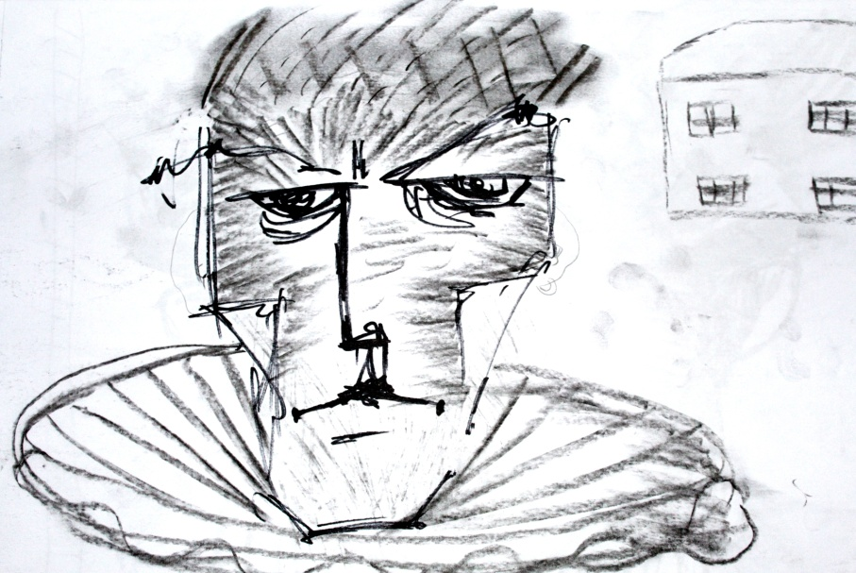

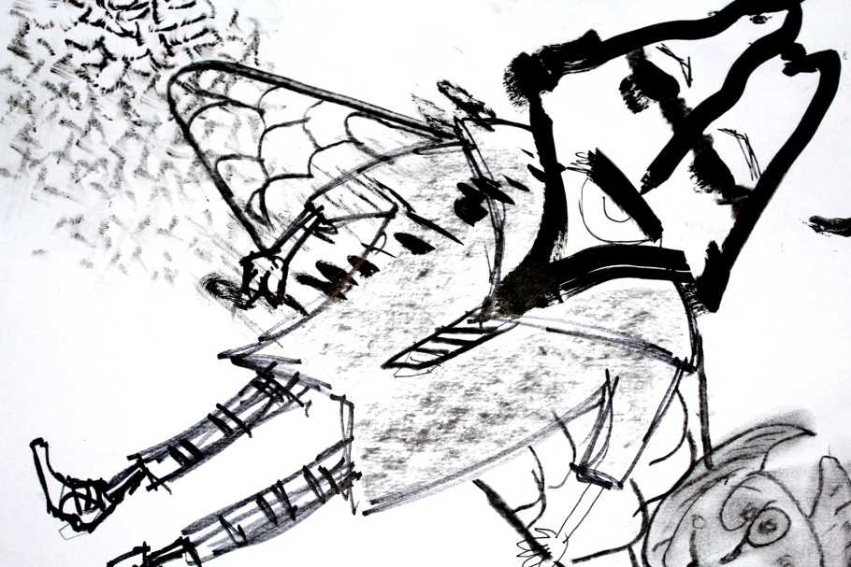
Figure 1: Students (2018) Untitled. [Drawing].

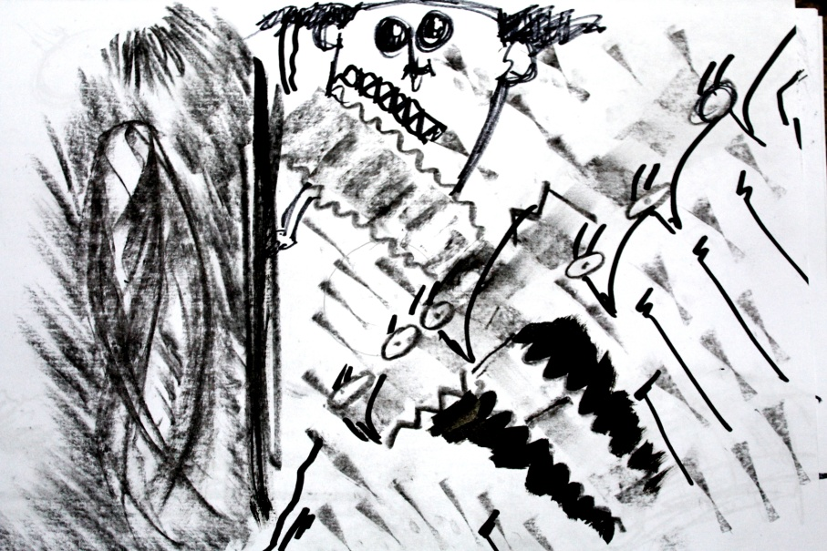
Figure 2: Students (2018) Untitled. [Drawing].

Figure 3: Students (2018) Untitled. [Drawing].

Thirty Minute Micro-Teach
Principles of Teaching, Learning and Emergent Technologies
PGCE/PCET in Post-Compulsory Education and Training
Elisabeth Rebecca Griffiths P134703
28th January 2019
Word Count: 2,700
Context
Preface page 3
Introduction page 4
Chapter One - Preparation page 5
Chapter Two - Lesson Plan page 6-7
Chapter Three - Lesson page 8-12
Conclusion page 13-14
Bibliography page 15-16

Preface
This study is an examination into the thirty minute micro-teach lesson carried out on the 26th November 2018. The document is aimed at self-reflection, to highlight positives and negative areas for improvement within my own teaching practice. The paper will consider four key areas, preparation, lesson planning, the lesson itself and conclusion. All of which will be supported by theory and feedback from the assessor.

Introduction
During the last five years I have been studying for a BA and Masters Degree in Architectural Glass within the arts. Arriving at this stage has not been an easy experience; it has taken perseverance and determination. In my late studies I was diagnosed with a dyslexia disability for which I received trained support. The member of support staff taught me the correct method of writing a formal dissertation, without this dedication and knowledge my studies would have been difficult. This guidance has given me the knowledge, awareness and confidence to complete writing tasks where I no longer need support. Recognising that the lecturers’ role is now changing where a supportive and “creative” perspective is needed (Dziuban, 2018: 3, Minton, 2005: 83, Bates, 2016: 18); this combined with my experiences of being a student has inspired me to take-up teaching. This thought process has led to my first thirty minute micro-teach session.
The thirty minute micro-teach session is a form of preparation for teacher trainees, before they enter the larger environment of teaching (Minton, 2005: 24). The aim is to present a lesson for thirty minutes in front of my fellow students. The session is not to be intimidating; it is a secure environment where peers all have a common objective in learning how to become successful teachers. Nevertheless it is still a daunting experience for the first time, especially in my case, where I have never taken a lesson independently before.
The following chapter will examine the preparations taken before writing a lesson plan. Chapter two will describe the thought process in creating the lesson plan. Chapter three will cover the lesson itself including emerging technologies. Feedback given from the assessor and fellow peers will be used as guidance. A conclusion will end the document reflecting on avenues to focus upon moving forward.

Chapter One - Preparation
The thirty minute micro-teach journey began by retrieving information, through observing the individual students that would be present in the session (Armitage, 2007: 89, Templeton, 2010: 15). Due to the higher education learning environment, there was a vast mixture of learners ranging in “ages and abilities” (Armitage, 2007: 89), many where returning to education “after a long period away” (Armitage, 2007: 94, Coles, 1991: 30). The majority had no prior knowledge in the arts let alone the specialism of architectural glass. However, from the twelve students attending there were three qualified art practitioners. This proved challenging, designing a lesson plan where each student would benefit from a learning experience.
The process began by determining a lesson topic to teach, I opted to teach a “constructivist” drawing lesson (Race, 2015: 4), combining theory with activity, instead of teaching the complicated theory of glass. This allowed students to adapt and relate to their previous experiences in-order to direct their own studies (Radmehr, 2017: 1207, Kolb, 1984: 21). Drawing is a part of any specialism within the arts; it is a way of creating ideas and thought processing. Understanding that many of the students are not familiar with the arts, the session was planned to be a basic introduction into drawing without overwhelming each individual. It intentionally moved away from an intense form of drawing in-order to reassure the students. Once a formative plan was created for the inexperienced individuals my attention changed to the experienced learners. I decided to provide these learners with roles that would question themselves as artists and open their mind to other forms of expression (Bates, 2016: 8).

Chapter Two - Lesson Plan
When the learning outcome was decided the next stage of the micro-teach was to create a lesson plan. This not only acts as a guide for the lesson and my teaching expectations, it also aids in self-reflection (Armitage, 2007: 90, Minton, 2005: 60). The lesson plan I created was an in-depth detailed description of expected outcomes, as regards learning objectives for the students. This is supported by the assessor’s feedback agreeing that the lesson was well planned and structured. The objectives were for students to have an open-mind when approaching experimenting. To consider the unexpected and not to become restricted by one idea, and recognising the technique of mark-making through different drawing mediums. This thought process would be implemented in a controlled creative manner, which would naturally proceed without the students becoming fully aware. This would lead to a subconscious form of learning, where students would become aware of the goal once the final activity is completed (Minton, 2005: 9). This is achieved by introducing a new creative skill through multiple small tasks, leading to a larger group conclusion task.
This controlled learning was highlighted at the end of the lesson plan where a timing schedule was organised (Armitage, 2007: 90, Minton, 2005: 56). For the first half I decided to introduce mark-making through a short YouTube Video leading to group discussions. I believe the video is a subtle and direct way of passing information; it is thought that technology can “improve learning [and] accessibility” (Tulinayo, 2018: 1, Arnold, 2018: 1). It also prevents the students from becoming overloaded with information. In particular this video is easy to interpret where it needs no explanation and it brings mark-making “to life” (Armitage, 2007: 118). The video additionally acts as a guide in timing the rest of the session (Minton, 2005: 56, Armitage, 2007: 119).
The lesson progresses into short timed experiments that encourage the students to draw through mark-making. The final activity would be an interactive drawing task where students would learn from one another, prompting each to think alternatively. The drawings gathered at the end of the session would become a guide in understanding if the students understood the session; and a “form of assessment” (Minton, 2005: 51). This entire session would be supported by a Sway PowerPoint presentation which acts as a visual aid for the student to connect.

Chapter Three - Lesson
Apprehension and nerves surrounded my thoughts beforehand; this was the first formal lesson I had ever taken in which I was in control (Templeton, 2010: 117-118). The unexpected had a role to play in my apprehension, as there is only so much preparation that can support the delivery of a lesson. Experience instead is an important part of development and delivery, in which I at this time lack. However, I do understand over time these thoughts and nerves will disappear as I become more confident and familiar with teaching. In contrast to these feelings, when retrieving student feedback they felt I presented myself in a clear, determined and confident manner. This highlights no matter how you feel, sometimes it is not reflected in your performance. I nevertheless still aim to feel more comfortable within the teaching environment.
The Sway PowerPoint presentation encompassed the lesson, it acted as a guide rather than being a source of information. Very little information regarding theory was placed onto the screen instead I relied upon my experience within the specialism. The PowerPoint was a way of supporting the students through each task, by giving instructions to follow and “focus” upon (Armitage, 2007: 119). This technology not only helped the students, it supported the information I was translating verbally. Incorporating visual and verbal information together helps all learners within the classroom to have equal opportunity in learning, which relates to professional standard “V2” (UKPSF, 2011: 3). This learning is influenced by my dyslexia which reinforces that everyone learns in a different manner (Donche, 2013: 239, Armitage, 2007: 94 - 95).
Visually the PowerPoint presentation created confusion; aspects were difficult to read. Coming from an art discipline my creative flare with design took over, where the aesthetics became more prominent. Creating the PowerPoint I decided to use a black background with the writing in white, this made the writing difficult to read. The large amount of black colour drowned out the white, however when I created the PowerPoint on my laptop it looked visually correct. Scale affected the appearance, once the presentation was enlarged it not only affected the colour, the writing was misaligned (Armitage, 2007: 119). On one particular slide the sentences were scattered over the screen. This is a learning curve where simplicity is best, especially when translating information. If I had not tried I would have not known, leading to experience being a form of learning (Kolb, 1984).
In advance, the aims and objectives were clearly stated giving students the awareness of what was to be expected (Armitage, 2007: 93, Minton, 2005: 51, Race, 2015: 24). Each session should always begin in this approach, as it is a decisive way in “managing learning” (Armitage, 2007: 93). I then proceeded to play a YouTube Video named “Why do we learn about Mark Making?” (Crowther, 2015). This related to individual artists, who had used this technique students were easily able to make connections and understand mark-making. This was presented though imagery and sound, where it is believed that these two communicators “evoke the senses” (Short, 2001: 1), resulting in a better connection between knowledge and application. The video itself had an effective influence; however it did not play seamlessly there where slight pauses throughout. I noticed that many of the students where looking around as if there were something wrong. This was unexpected and a reminder to check the quality, as this disrupts learning fluidity.
Students where then split into groups to have discussions about what mark-making is and how it affects the artist? I asked the experienced learners to scatter themselves amongst the inexperienced individuals’, by following “Edward Tolman” theories in-order to help and encourage other members (Bates, 2016: 34–35). This worked rather successfully as they learned “from each other” (Minton, 2005: 58, Race, 2015: x). The inexperienced students challenged the experienced; by questioning the way they applied drawing to their specialisms. “Questioning” made the experienced learners think about how they represent themselves as artists through the “powers of judgement” (Coles, 1991: 20, Bates, 2016: 8, Race, 2015: 27). Teaching students to think independently opens their learning perspectives by providing them with a “skill” (Coles, 1991: 12, Minton, 2005:69), which can increase “critical thinking, fluency and flexibility of thought” (Coles, 1991: 20). This encourages independent and self-directed learning. In reflection this process was slightly rushed on my behalf. The lesson progressed quickly with not enough time available for feedback. However, as the students were having their discussions I listened to what they were saying. I pushed their conversation in another direction, making their line of thought constantly change and evolve. The students with no experience in the arts had adapted the session to suite their individual needs. By associating mark-making with individual handwriting through “cognitive processing” (Krathwohl, 1964: 6, Donche, 2013: 239), tying together two forms of learning “humanism” and “constructivist” (Bates, 2016: 39-57, Race, 2015: 3-4, Radmehr, 2017: 1207). They were able to take mark-making, knowledge and previous experience beyond the field of art “making it their own” understanding (Coles, 1991: 27, Minton, 2005: 9, Bates, 2016, Kolb, 1984: 21, Race, 2015: 3, Radmehr, 2017: 1207), in which they began to direct their own learning. This created a stronger link between understanding and knowledge, as they began to apply their findings to experiences beyond the classroom (Coles, 1991: 27, Minton, 2005: 9, Kolb, 1984: 21).
The second half of the lesson was an opportunity for students to apply what they have learnt by taking part in a controlled drawing session (Minton, 2005: 7). At the beginning students were rather hesitant, this was to be expected. However they gave full “participation” which I was extremely grateful for as I understand this is sometimes not the case (Minton, 2005: 83, Donche, 2013). This was also highlighted by one of my fellow students suggesting that this teaching style is not suitable for everyone, for this particular lesson I would agree. However I would argue in a creative teaching environment in which my specialism lies, drawing would be an essential part of the module. Students would be expected to participate in drawing activities within the classroom; otherwise I would question the students’ intentions of being on the course.
As the activity proceeded they became more open-minded and many enjoyed the experience, one student felt as if the lesson had only been five minutes. This was reflected in the learners’ behaviour, several members where laughing and giggling throughout which gave the impression of a relaxed learning environment. This learning was prompted by the activities themselves. Some of the drawing exercises were only two minutes, forcing the students to have something down on paper. This learning style of “doing” gave the students more “confidence” as each task passed (Gibbs, 1988: 9), leading to more accomplished experimental drawings by the end (Minton, 2005: 7), they became less hesitant in expressing themselves on paper (Figure: 4 and 5).
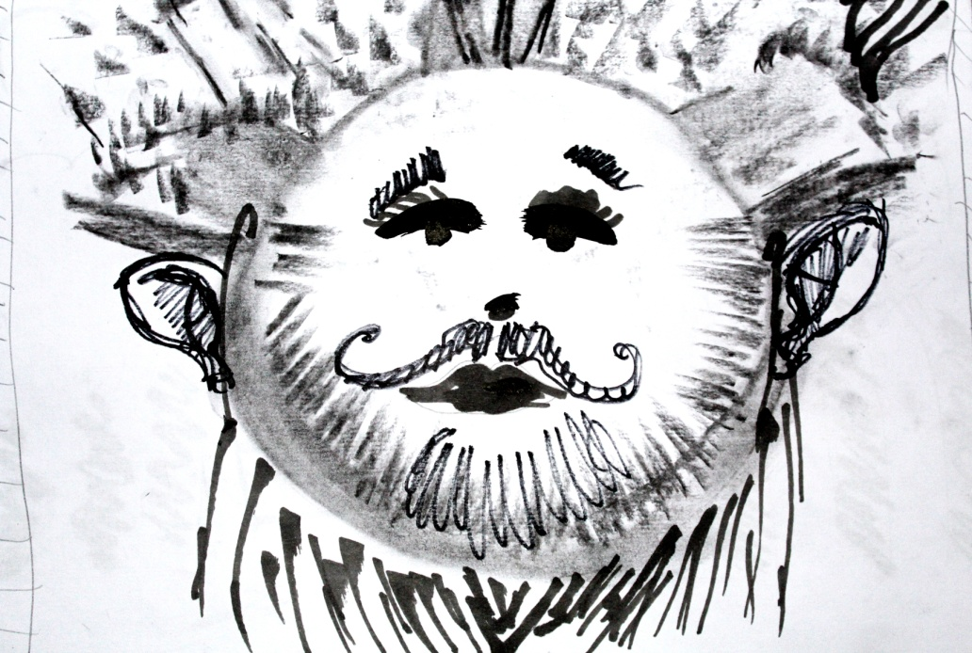
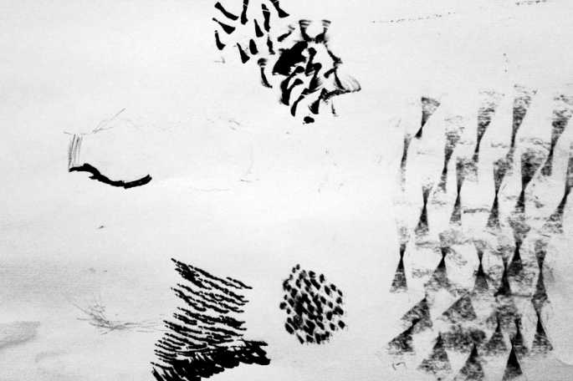

Figure 4: Students (2018) Untitled. [Drawing]. Figure 5: Students (2018) Untitled. [Drawing].

The last activity was the most influential, I asked each student to begin a drawing in any medium of their choice. After a minute had passed I wanted the students to move clockwise around the room, and start drawing on top of the drawing the other person had started. This process was repeated until they arrived back in their original place, unsurprisingly the students were shocked to see how their original drawing had evolved. All the students never imagined the drawing to end with that particular conclusion; before they started they had already pictured an end result. This learning result was designed to stop the student from restricting themselves to one particular outcome, where a sudden change can disrupt the drawing and have a beneficial result. This learning method begins to question the students as they self-reflect on their findings, leading to alternative considerations “if they did things differently” (Bates, 2016: 19, Gibbs, 1988: 9). This process is supported by “John Dewey” who believed in encouraging students in thinking differently in-order to increase development (Bates, 2016: 18-19). Having an open persona, the willingness to change, and not to be narrow-minded by following one outcome, will increase understanding, knowledge and opportunity. The drawings showed a variation of mark-making techniques that would have been impossible for the same learner to create; the drawings summarised and brought the lesson together towards the end. Looking back I did not verbalise these thoughts; I naturally assumed the learners understood. In hindsight I should have questioned the students on their knowledge by evaluating and concluding the lesson. This would finish in a productive way where the students would feel reassured to take mark-making beyond the confines of the classroom. Comparing this with “Bloom’s Taxonomy” (Radmehr, 2017: 1207-1209), “evaluating” is the most important aspect of learning followed by “creating” which sits upon the top of the list (Radmehr, 2017: 1207-1209).

Conclusion
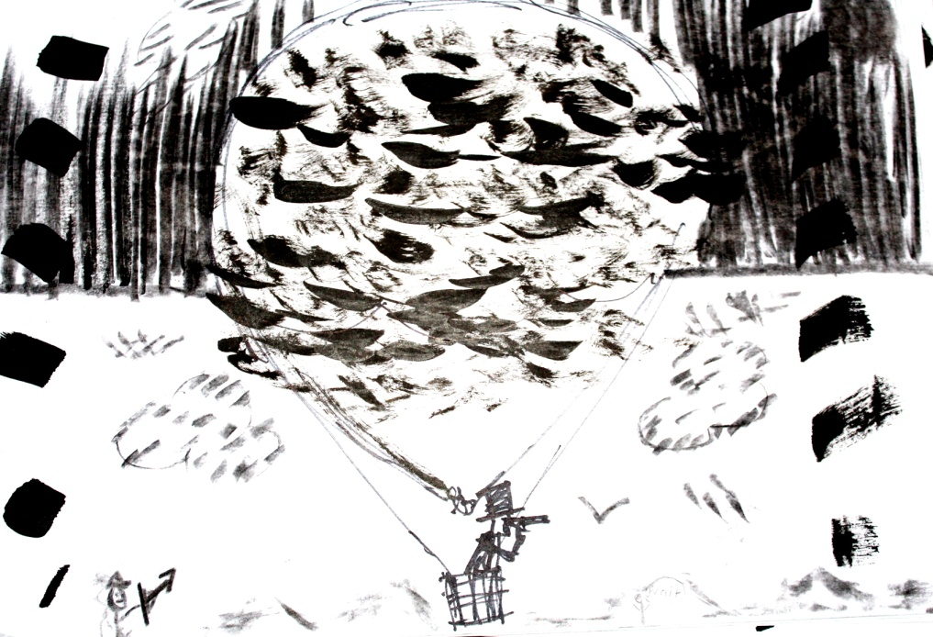
In reflection the lesson was well planned, focused and an enjoyable experience for the students. Learners understood the purpose and technique of mark-making; they also had the opportunity to apply their findings. Gradually introducing students to mark-making in stages worked effectively, students made vast improvements as the lesson evolved which is reflected in the student’s final drawings. Learners acquired a new skill and the awareness of not becoming restricted by one idea. When finishing the session a student reflected on the learning process; agreeing that it is an effective way of making the students think out of the box. The lesson also had a greater effect on the classroom where it improved the group dynamics, learners where able to bond with one another as they observed and commented on each other’s work, which resulted in self-evaluating learning (Radmehr, 2017: 1207-1209).

Figure 6: Students (2018) Untitled. [Drawing].
The lesson proved useful; however it was not executed perfectly. There were problems with both technology elements, the PowerPoint presentation and video. They became a distraction which affected the atmosphere and speed of the lesson. I should have been more aware as technology is not always the most reliable source (Armitage, 2007: 119). Timing was another issue; I tried to include too many elements within the thirty minutes lesson. This left little time for students to reflect and gather their thoughts between each exercise. A group conclusion also did not happen; nevertheless the session still came to a natural end in the sense that the lesson was self-explanatory, with the students not having any questions.
These elements have increased my understanding, where I have learnt “through mistakes” (Race, 2015: 9, Bates, 2016: 9). Indeed I do believe nerves played a part (Templeton, 2010:117-118), leading me to speed through the session. Moving forward there needs to be a larger consideration for the learners, recognising that learners take time to fully absorb information (Race, 2015: 14, Armitage, 2007). Timing is the most essential part of the learning experience, for myself as a lecturer in organising the session and for the students. Timing and becoming more aware of technology within the lesson, are the targets to improve upon as regards the next lesson.
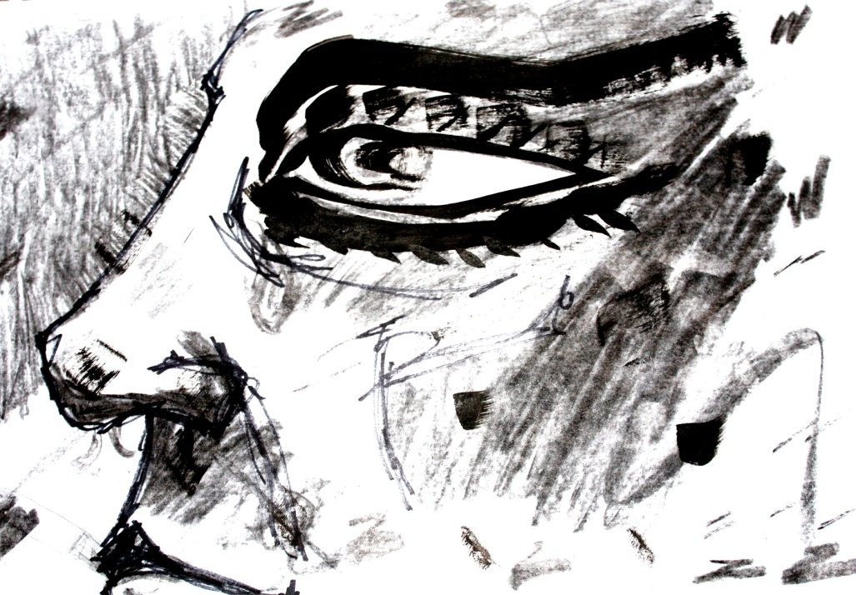

Figure 7: Students (2018) Untitled. [Drawing].

Bibliography
Armitage, & Armitage, Andy. (2007). Teaching and training in post-compulsory education. (3rd ed.). Maidenhead: Open University Press.
Arnold, D., & Sangra, A. (2018) ‘Dawn or dusk of the 5th age of research in educational technology? A literature review on (e-)leadership for technology-enhanced learning in higher education (2013-2017)’, International Journal of Educational Technology in Higher Education, 15 (1), pp. 1-29, DOI: 10.1186/s41239-018-0104-3.
Bates, B. (2016). Learning theories simplified: ...and how to apply them to teaching. London: SAGE Publications Ltd.
Coles, M., & Robinson, W. (1991). Teaching thinking: A survey of programmes in education. (2nd ed.). London: Bristol Classical Press.
Crowther, S. (2015) Why do we learn about Mark Making?[video]. Available at: https://www.youtube.com/watch?v=SPxsCOGXtOw (Accessed: 27 December 2018).
Donche, V., Maeyer, S.D., Coertjens, L., Daal, T.V., & Petegem, P.V. (2013) ‘Differential use of learning strategies in first-year higher education: The impact of personality, academic motivation, and teaching strategies’, British Journal of Educational Psychology, 83(2), pp. 238-251, DOI: 10.1111/bjep.12016.
Dziuban, C., Graham, C.R., Moskal, P.D., Norberg, A., & Sicilia, N. (2018) ‘Blended learning: the new normal and emerging technologies’, International Journal of Educational Technology in Higher Education, 15 (1), pp. 1-16, DOI: 10.1186/s41239-017-0087-5.
Gibbs, G., & Great Britain. Further Education Unit. (1988). Learning by doing: A guide to teaching and learning methods. London: FEU.
Kolb, David A., & Kolb, David A. (1984). Experiential learning: Experience as the source of learning and development (Coleg Ceredigion Education Collection: PGCE). Englewood Cliffs, New Jersey; London: Prentice-Hall.
Krathwohl, D., Bloom, B., & Masia, B. (1964). Taxonomy of educational objectives: The classification of educational goals. London: Longman.
Minton, D., & City Guilds of London Institute. (2005). Teaching skills in further and adult education. (3rd ed.). Australia; United Kingdom: Thomson Learning.
Race, P. (2015). The Lecturer’s Toolkit: A practical guide to assessment, learning and teaching. (4th ed.). New York: Routiedge.
Radmehr, Farzad, & Drake, Michael. (2017). Revised Bloom's Taxonomy and Integral Calculus: Unpacking the Knowledge Dimension. International Journal of Mathematical Education in Science and Technology, 48(8), 1206-1224.
Short, Sandra E., Afremow, James, & Overby, Lynnette. (2001). Using Mental Imagery To Enhance Children's Motor Performance. Journal of Physical Education, Recreation & Dance, 72(2), 19-23.
Students (2018) Untitled. [Drawing].
Templeton, M. (2010). Public speaking and presentations demystified (Demystified series). New York; London: McGraw-Hill.
Tulinayo, F.P., Ssentume, P., Najjuma, R. (2018) ‘Digital technologies in resource constrained higher institutions of learning: a study on students acceptance and usability’, International Journal of Educational Technology in Higher Education, 15 (1), pp. 1-19, DOI: 10.1186/s41239-018-0117-y.
UKPSF (2011) The UK Professional Standards Framework for teaching and supporting learning in higher education, Available at: file:///C:/Users/Huw/AppData/Local/Microsoft/Windows/INetCache/IE/GT6RTZ4A/uk_professional_standards_framework.pdf (Accessed 28 December 2018).

