Paul Newman 1805494
Paul_newman37@yahoo.co.uk
ACCA4017
Programming

Table of Contents
2 Table of Figures 2
3 Introduction 3
4 Exercise One 4
4.1 Exercise Two 9
4.2 Exercise Three 14
5 Personal Conclusion 20
6 Bibliography 21

Table of Figures

Figure 13: Entering Data 12
Figure 14: Output Data 12
Figure 15: Entering Letters 12
Figure 16: The output of letters Data 13
Figure 17: Entering ackeys Data 13
Figure 18: Output Data 13
Figure 19: Entering Data higher than the container 13

Introduction

In this assignment the challenge is to code 4 very different problems in to working programs, satisfying unique aspects of this assignment.

Exercise One
In this exercise the task is to declare three different Variables: -
- Int = Numbers
- Double = Numbers with points
- String = Text based and numbers

Flow Chart: -

Code: -
//Exercise One:-

#include <string>
#include <iostream>
#include <sstream>
#include <windows.h>

using namespace std;

int main(int argc, char* argv[])
//int result = GetSum()
{
string input;
string bookname;
string myname;
int amount;
double length;
stringstream stream;

//Names of User!!! String varable
system("color 9");
cout << endl;
cout << endl;
cout << "\t\t\t\t\tPlease Enter Your Name:- " ;
getline(cin, myname);
stream.str(myname);
stream >> myname;
stream.clear();
cout << endl;
cout << endl;
//end of Names!!!

//Names Book!!! String varable
system("color 9");
cout << endl;
cout << endl;
cout << "\t\t\t !!WARING This Program can only read the first word of the book you type in!!";
cout << endl;
cout << endl;
cout << "\t\t\t\t\tPlease Enter Your Favourt Book Name:- " ;
getline(cin, bookname);
stream.str(bookname);
stream >> bookname;
stream.clear();
cout << endl;
cout << endl;
//end of Book Name!!!

//Enter length!!! this is an int varable
cout << "\t\t\t\t\tPlease Enter The length of the Tape Measure you Want:- ";
getline(cin, input);
cout << endl;
stream.str(input);
stream >> length;
stream.clear();
//End of length!!!

//My Basket Items!!!
cout << "\t\t\t\t\tPlease Enter How Many Products You have in you Shopping Basket:- " ;
getline(cin, input);
cout << endl;
stream.str(input);
stream >> amount;
stream.clear();
cout << endl;
cout << endl;
//end of Basket Items!!!

system("cls");

//program output!!!
system("color B");
cout << "\t\t\t\t\tHey!:- " << myname;
cout << endl;
cout << endl;
cout << "\t\t\t\t\tYour Favourite book is :- " << bookname;
cout << endl;
cout << endl;
cout << "\t\t\t\t\tThe Tape measure you bought is :- " << length;
cout << endl;
cout << endl;
cout << "\t\t\t\t\tYour total amount in the Shopping basket is :- " << amount + 2;
cout << endl;
cout << endl;
system("color E");
cout << "\t\t\t\t\tPlease Press Enter Twice to End Program! ";
cout << endl;
cout << endl;
getline(cin, input);
//End of program output!!!
cin.get();
return 0;
}

Working Validation
Here you can see that the Book title will only display the first word of the book title as the getline function would not allow input variable to have more than one word, This could indicate a flaw in the function when casting variables. I added a + 2 to the shopping Basket to show that the Book AND tape Measure was also added to the contents of the basket.
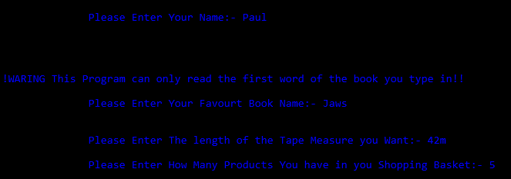
Figure 1: Entering Data
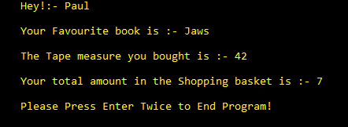
Figure 2: Output Screen

Figure 3: At Red Arrow notice the number of items in Shopping Basket
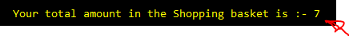
Figure 4: The Red Arrow shows an EXTRA two Items in the Basket
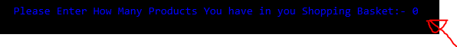
Figure 5: There is no items added
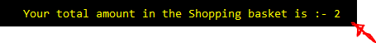
Figure 6: The Book and Tape and been added to the Basket automatically

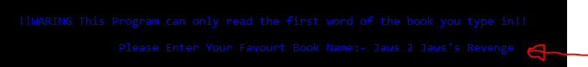
Figure 7: More than ONE word for the book
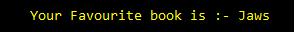
Figure 8: The rest of the Book Title will not be show due to the Getline

Trying to Break the Code
An attempt to break the code using numbers and ackeys in the wrong places,
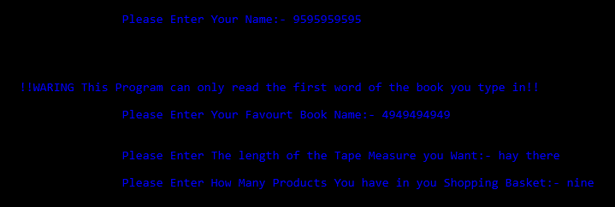
Figure 9: Typing Number where Text should be

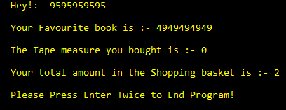
Figure 10: The Code did not break

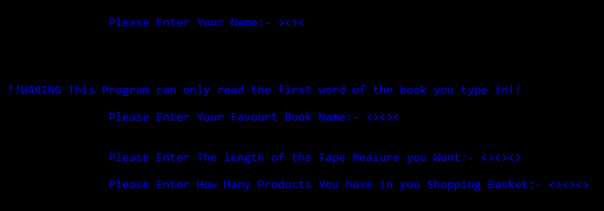
Figure 11: This time Askeys where used

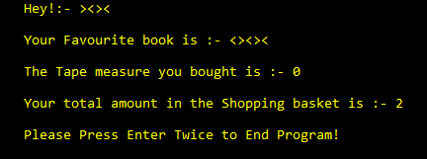
Figure 12: The Code again did not Brake

Exercise Two
Dimensions of two shapes within a container.
Procedure code: -
- Enter a value for a hight for a container (the value must be fluid and not fixed)
- Enter a value for a leigh for a container (the value must be fluid and not fixed)
- Then
- Ether a radius for a circle (the value must be fluid and not fixed)
- Then
- IF
- Circle is more than the Container
- Then (to big)
- Else output area left (of the container)
- Enter a value for the hight of a box (the value must be fluid and not fixed)
- Enter a value for a width for a box (the value must be fluid and not fixed)
- Then
- IF
- Box is more than the Container
- Then (to big)
- Else output area left (of the container)

Code: -
//Exercise Two:-
#include <string>
#include <iostream>
#include <sstream>
#include <windows.h>
#include <iomanip>
#define PI 3.142

using namespace std;

int main(int argc, char* argv[])
{
//int result = GetSum()
string input;
stringstream stream;
//Contaner floats
float conhight = 0;
float conlenght = 0;
float conarea = 0;
//Circle floats
float radius = 0;
float diameter = 0;
float circleArea = 0;
//Box floats
float boxwidth = 0;
float boxheight = 0;
float boxArea = 0;
float arealeft = 0;

void main();

//Contaner box Part and calculation's
system("color B");
cout << endl;
cout << endl;
cout << "\t\t\t\t\tPlease Enter a value for Hight: - ";
getline(std::cin, input);
stream.str(input);
stream >> conhight;
stream.clear();

cout << endl;
cout << endl;
cout << "\t\t\t\t\tPlease Enter a value for Length:- ";
getline(std::cin, input);
stream.str(input);
stream >> conlenght;
stream.clear();

conarea = conhight * conlenght;

//Circle Part and calculation's
cout << endl;
cout << endl;
cout << "\t\t\t\t\tPlease Enter a Radius for Circle :- ";
getline(std::cin, input);
stream.str(input);
stream >> radius;
stream.clear();

diameter = radius * 2;
circleArea = PI * (radius * radius);

//Box Part and calculation's
cout << endl;
cout << endl;
cout << "\t\t\t\t\tPlease Enter a Value for The Box Hight :- ";
getline(std::cin, input);
stream.str(input);
stream >> boxheight;
stream.clear();

cout << endl;
cout << endl;
cout << "\t\t\t\t\tPlease Enter a Value for The Box Width :- ";
getline(std::cin, input);
stream.str(input);
stream >> boxwidth;
stream.clear();

boxArea = boxheight * boxwidth;

//The formula used to calculate the remaining circle area after deducting the box area
system("cls");

arealeft = conarea - circleArea;

system("color E");
cout << endl;
cout << endl;
cout << "\t\t\t\t\tThe total area of Container is: " << conarea;
cout << endl;
cout << endl;
cout << "\t\t\t\t\tThe total area of circle is: " << circleArea;
cout << endl;
cout << endl;
cout << "\t\t\t\t\tThe total area of Box is: " << boxArea;
cout << endl;
cout << endl;
cout << "\t\t\t\t\tThe remaining area after taking the circle out is: " << arealeft;

arealeft = arealeft - boxArea;

cout << endl;
cout << endl;
cout << "\t\t\t\t\tThe final area after taking the box out too is: " << arealeft;
cout << endl;
cout << endl;
cout << endl;
cout << endl;
cout << endl;
cout << endl;
//End of program output!!!
}

Working Validation
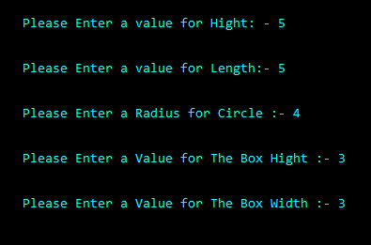
Figure 13: Entering Data
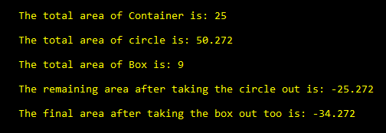
Figure 14: Output Data

Trying to Break the Code
At this point letters, ackeys and negative numbers are used to try and brake the code.
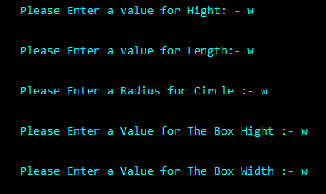
Figure 15: Entering Letters

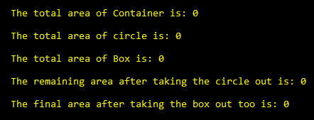
Figure 16: The output of letters Data
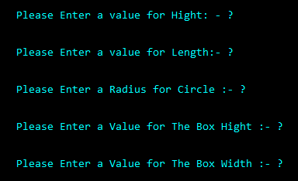
Figure 17: Entering ackeys Data
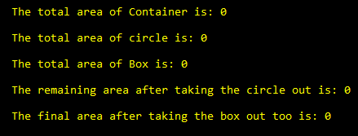
Figure 18: Output Data
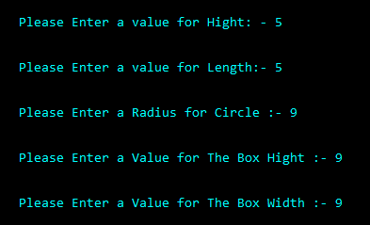
Figure 19: Entering Data higher than the container
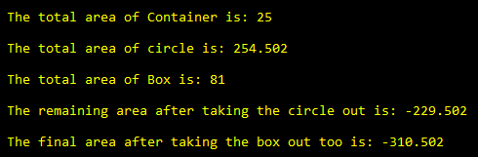
Figure 20: Output Data

Exercise Three
This Exercise is to add a variable of numbers together and then total them together and convert into Euros.
Procedure code: -
- Add 6 variable numbers
- Using doubles(variable)
- Total the 6 numbers
- Output data
- Convert into pounds
- Then
- Convert into euros
- Output data

Code: -
//Exercise Three convert pounds into euros
#include <string>
#include <iostream>
#include <sstream>
#include <windows.h>
#include <stdio.h>

using namespace std;

int main(int argc, char* argv[])
//void main()
{
double numb1, numb2, numb3, numb4, numb5, numb6, totalpounds = 0;
string input;
stringstream stream;
double euros = 0, pounds = 0, total = 0;

euros = 1.34;

//Entering the six numbers to be added up!! at his point the array would not work and so the problem was solved the long way around.
system("color B");
cout << endl;
cout << endl;
cout << "\t\t\t\t\tPlease Enter the First Value in Pounds:- ";
getline(cin, input);
stream.str(input);
stream >> numb1;
stream.clear();

cout << endl;
cout << endl;
cout << "\t\t\t\t\tPlease Enter the Second Valuein Pounds :- ";
getline(cin, input);
stream.str(input);
stream >> numb2;
stream.clear();

cout << endl;
cout << endl;
cout << "\t\t\t\t\tPlease Enter the Third Value in Pounds:- ";
getline(cin, input);
stream.str(input);
stream >> numb3;
stream.clear();

cout << endl;
cout << endl;
cout << "\t\t\t\t\tPlease Enter the Forth Value in Pounds :- ";
getline(cin, input);
stream.str(input);
stream >> numb4;
stream.clear();

cout << endl;
cout << endl;
cout << "\t\t\t\t\tPlease Enter the Fith Value in Pounds:- ";
getline(cin, input);
stream.str(input);
stream >> numb5;
stream.clear();

cout << endl;
cout << endl;
cout << "\t\t\t\t\tPlease Enter the Sith and Last Value in Pounds:- ";
getline(cin, input);
stream.str(input);
stream >> numb6;
stream.clear();
system("cls");
//End of input numbers

//Adding numbers

totalpounds = numb1 + numb2 + numb3 + numb4 + numb5 + numb6;

system("color E");
cout << endl;
cout << endl;
cout << "\t\t\t\t\tYour Total amount in Pounds is:- ",totalpounds;
cout << totalpounds;

total = totalpounds * euros;

//calculate total euros

cout << endl;
cout << endl;
cout << "\t\t\t\t\tYour Pounds have been Converted into Euros";
cout << endl;
cout << endl;
cout << "\t\t\t\t\t\tTotal Euros:- " << total;
cout << endl;
cout << endl;
cout << "\t\t\t\t\tPlease Press Enter to Continue!";
cin.get();
return 0;
}

Working Validation
Here you can see that the code is working without an array as the array was not working, this code is long winded but got the exercise to work, in the Figures below you can see the input data for normal number values work fine.
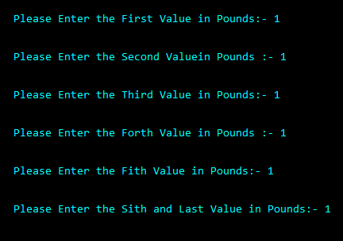
Figure 21: Entering Data
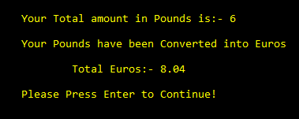
Figure 22: Output of Data

Trying to Break the Code
In this part zeros, Askeys and no values where used to test the code to see if it would break.
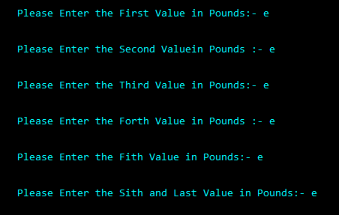
Figure 23: Using Letter for the input
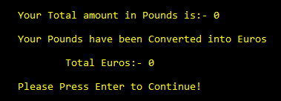
Figure 24: The output data was negative

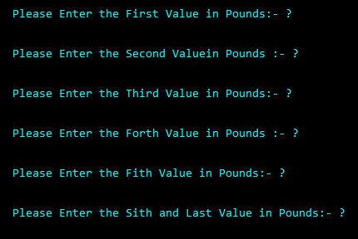
Figure 25: Using Askeys to try and brake code
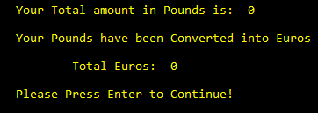
Figure 26: Still no brake
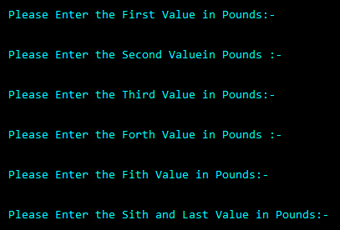
Figure 27: No values entered
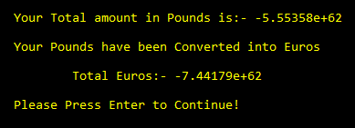
Figure 28: All Values have ben shown as negative numbers

Personal Conclusion
Each exercise had its own problems and challenges, all three codes work but was unable to get the array in exercise 3 to work so a basic form of code was used to complete the task, Exercise 4 and 5 are above the ability of the author to do at this time.

Bibliography

