Engine diagnostic
Vehicle technology
Robin Williamson-Gillie
1800974
Abi Summerfield
Contents
Introduction 2
Engine dyno test and equipment 3
Equipment used: 3
Method: 3
Results 3
Results table 3
Graphs from results 4
Results conclusion 6
Evaluation 7
Bibliography 8

Introduction
The aim of this test is to run a 1.6 VTec Honda engine on a dynamometer. The engine is from a Honda civic coupe crx (Honda motor company ltd, 1990). The aim is to collect the raw data from a complete power run of the engine. This raw data is; the load on the engine, the engine speed and the fuel flow rate. These are the base test data that will be acquired from the test run and will be used later in calculations.
The results that would be calculated are; the Torque, the SFC, the brake power, the corrected power, the brake thermal efficiency and B.M.E.P (Brake mean effective pressure).
The results would be needed in a manufacturing process for the development of the engine. This is due to the fact it will give all the relevant information, telling the developer the power and torque and at what rpm these are produced. This would then be analysed so that the correct tune for the engine could be found and set into the engines ECU. This final setup will be used on the rest of the engines produced.
In motorsport and performance tuning the data would be used in a very similar way but for a different purpose. Instead, it would be about getting the engine to run at its optimum, for example in a race engine. The aim would be to have the majority of the power in the higher RPM bracket, so that the car can be kept in lower gears. This in turn would mean the engine could sit in the higher end of the rev range, thus meaning the power would be readily available.

Engine dyno test and equipment

Equipment used:
- 1.6 Honda civic engine
- Engine dynamometer
- 20.45kg balancing weight
- Torque arms

Method:
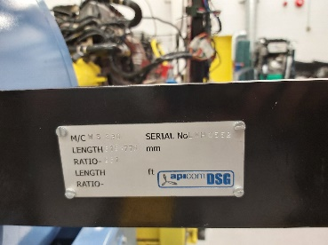
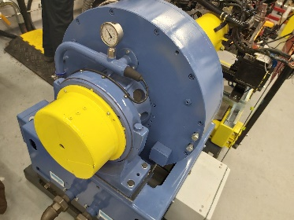
Firstly, the Dynamometer was Calibrated. To do this, two 0.815776m torque arms (figure 2) were bolted to the housing of the dyno (figure 1). A 20.45kg mass is then added to one of the torque arms. Then using the radius of the torque arms and the mass, the torque is calculated. This torque result can then be compared with the reading coming from the dyno. If the results given from both were similar, it is calibrated.

Figure 1:engine dyno housing Figure 2: Torque arm
Once the dyno has been calibrated the power run can be carried out. First to turn on the engine, the fuel pump needs to be turned on which will begin to move the fuel round the engine and allow it to carry out the power run. With the fuel pump running start the ignition.
To carry out the engine power run, the computer was used. The other option would be to manually carry the run out with the dials (figure 3), however this can cause possible errors in the results, so it is better to input the desired values into the system.
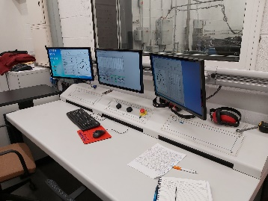

Figure 3: dyno monitors and dials
It was input that the test would start after the engine had sat at idle for 10s, then with 100N of the load on the engine, it would open 100% throttle. Then it would record the raw data values talked about in the introduction at every 50 RPM. This gap of measurement gives a large variation of data, which allows for more accurate calculations.

Results

Results table
These are the all the results taken from the test. Both the raw data and the calculated.
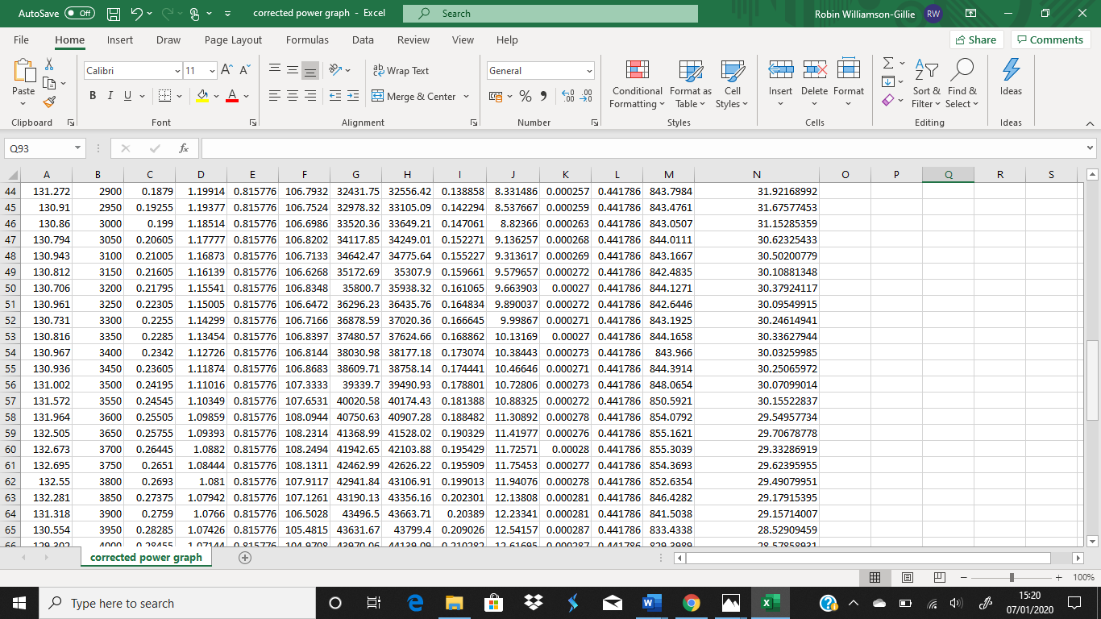
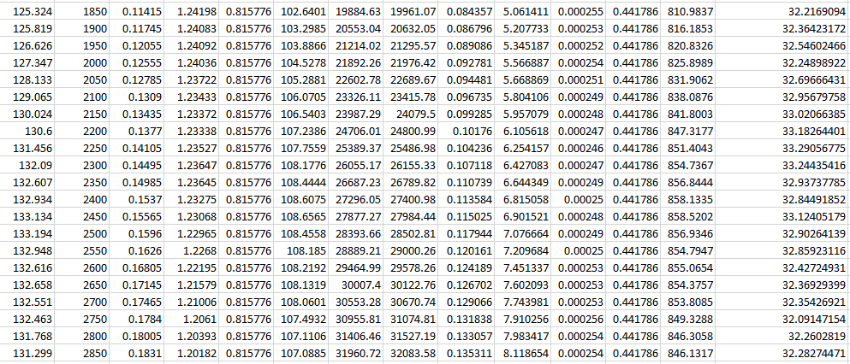
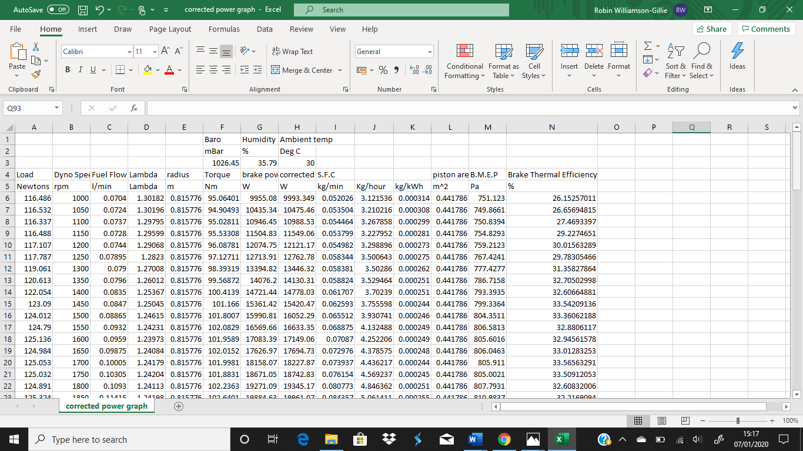

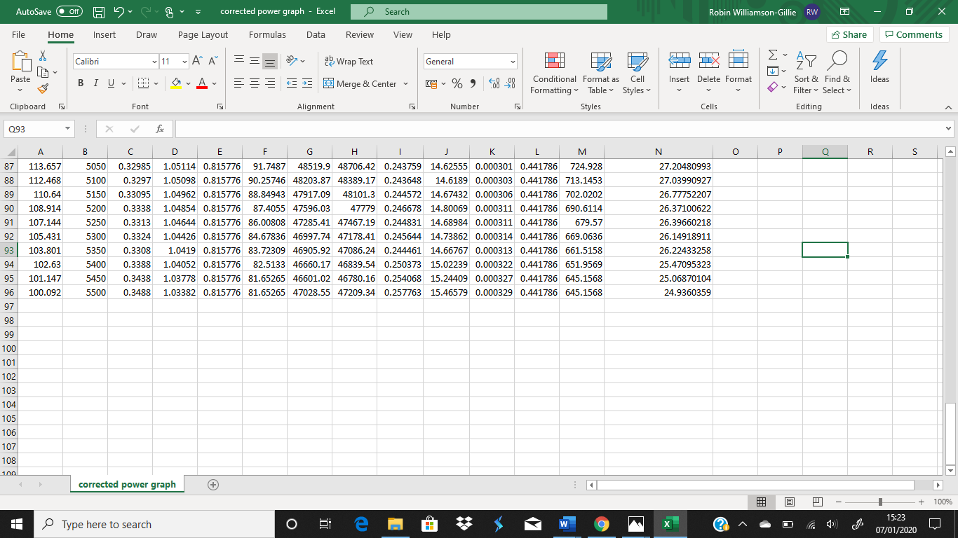
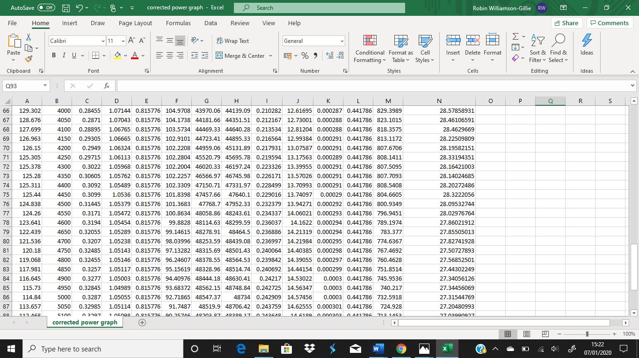

Graphs from results

Figure 4: Graph showing SFC against Engine speed
It can be seen from figure 4 that there is a direct correlation between the SFC and the engine speed, this is because as the RPM of the engine increases the SFC increases. This is because as the RPM increases the air flow increases, which means the SFC will increase. This is so the fuel air ratio is correct, achieving optimal power.
There are also short spikes through the graphs trend line, this is where there are fluctuations in the load on the engine due to external sources.
The interesting part of the graph and the section that the does not fit the trend line is at the start of the power run, where the SFC is nearly as high as it is at its maximum RPM. This occurs at 1000 RPM, this sudden spike of SFC is due to the engine being under a large amount of load with 100% open throttle. It shows that the engine is initially over fuelling to stop itself from stalling.

Figure 5:Graph showing Torque against Engine speed
The results in the torque graph are very different to the other two variables calculated. This is because it does not follow a continues trend. The torque increases as the engine speed increases, until it peaks at 3800 RPM, from here it begins to decrease. This is due to the reduced time for the exhaust gasses to escape, in turn trapping them and causing parasitic losses in the torque.
This smooth fairly flat curve shows that the engine is naturally aspirated as you get a smooth increase in power through the rev range (Cervenka, 2019). This smooth delivery of power is so that there is most power readily available, this is set like this as the average driver does not drive the engine the high RPM of the car. This is the reason for the smooth Torque curve.

Figure 6:Graph showing Brake power against Engine speed
There is a direct correlation between Brake power and engine speed, this can be seen in Figure 6 where, the brake power increases as the engine speed increases.
As the RPM increases, the engine carries out more 4 stroke cycles. This means that pistons are drawing in more air and fuel as the RPM’s increase, this mix is then being ignited by spark plugs. The energy from the mix is then released during the combustion, this in turn increases the power out put of the engine.
It can be seen at the end of the results in figure 6 that the power begins to depreciate of in high RPM, at 5000 RPM. The reason for this is because as the engine speed increases, there is a reduced time for the 4-stroke cycle too complete affectively. This is because the reduced time means that the engine cannot draw in its optimal amount of fuel, reducing the amount of energy released, in turn reducing its power.

Figure 7:Graph showing the Torque and brake power against engine speed

Results conclusion
The results found showed that there has been a serious drop in the performance of the engine. The original performance of the engine was 110,000 W at 7600 RPM for the brake power and the peak torque was 144Nm at 7100 RPM. (ultimateSPECS, 2020)
The results from the test compared to the original engine values, shows that there is a massive drop in the engines performance. The peak torque found in Figure 2 was 108.25 Nm at 3700 RPM, this compared to the original figure is a dramatic drop of 36 Nm of torque. This large drop of torque will be due to the ware of the engine, having done so many miles.
The peak engine power produced during the test was 48562 W at 4950 RPM, this can be seen in figure 4. This drop is massive compared to the out of factory power of the engine, there has been a loss of more than half the original power. Some of this loss will be due to the age of the engine, similar to the reason the torque is so low. However there must be another contributing factor that’s causing such a massive power loss, the only way to find out what this is would be to strip apart the engine a replace any damage.

Evaluation
The aims of this task were to performance specs of the 1.6 VTec civic engine, this was achieved during the Dyno test from both the raw data collected and the data calculated after.
One of the main improvements that could be made is to use a newer engine on the Dynamometer, as the one that was used had done a large number of miles and was very aged. The ageing of the engine means that it will not perform at its optimum and definitely not how it did out of the factory, this due to the ware of the engine being run, this could be small as old spark plugs or on the other end of a scale a worn cylinder head. Any of these can cause affects in the engine performance.
The way to solve this issue would be to either replace the engine with a newer model, or too break the engine down checking all the components and replace any damaged parts.
Another possible error for the results is that the weight used at the beginning to calibrate the engine had some minor errors in it. It was errored because there was damage and chunks removed from the weight, this would decrease the mass of the weight, which in turn would affect the balancing and change the calibration. This error in the calibration will latter affect the results taken from the power run. To stop this a newer weight should be used, or possibly the current weight weighed too see what its true mass was.

Bibliography
Cervenka, C. (2019, december 12). Retrieved from CJponypart.com: https://www.cjponyparts.com/resources/how-to-read-a-dyno-graph
Honda motor company ltd. (1990). shop manual. Honda motor company ltd.
ultimateSPECS. (2020). Retrieved from ultimateSPECS.com: https://www.ultimatespecs.com/car-specs/Honda/7933/Honda-CRX-II-16i-VTEC.html

