Professional Career Development
Module: PCD
Lecturer: SH: Sylvia Hoffmann
Student Name: Syed Shamim Ahmed
Student ID:1706997

Contents
1. Introduction 1
2. Self-evaluation review – self motivation and learning style 2
3. Personal development planning, SWOT analysis, SMART objectives, Johari Window 4
7
4. Review of understanding and expectations on the world of employment 8
5. Career ambition and aspirations 9
6. Personal development plan to enable myself to achieve my ambitions 10
6.1 Holistic plan: 10
6.2 Personal Development Plan: 11
6.3 Reviewing and monitoring the process of PDP and its reflection 14
Conclusion 16
References 17

Introduction
In the modern corporate world, no one can think about getting into the organization or promotion without the professional development. Professional career development refers to the process of enhancing the skills and capacity of an employee through getting training or education opportunity within the organization or outside the organization (Bard, 2011).It allows the employees to build ethics and morality in their professional life. At times professional career development is referred to as staff development. It has been worked on the ways, significance and strategies of professional career development throughout this assignment. The employability skills that were demanded by the employers have been explained in this assignment. A personal SWOT analysis has been prepared based on my personal strengths and weakness. The assignment also includes the ways of growing personal confidence. How I have used Kolb Learning Style has been given in this assignment. In this assignment, my practical professional experiences working as a store manager with Sainsbury's has been provided in line with the theoretical aspects. Sainsbury's is considered to be the second largest super chain shop covering a 16% market share in this sector(Sainsburys.co.uk, 2018).Moreover, this assignment also includes a personal and professional development plan based on the current skills and needs.

Self-evaluation review – self motivation and learning style
Self-motivation:
Self-motivation refers to the capability of accomplishing task without having the influence and persuasiveness of others (Bard, 2011). The self-motivated individuals like to perform the challenging tasks. As a store manager of Sainsbury’s I try to keep myself self-motivated in order to achieve my personal and professional goal. Being self-motivated I follow self-managed learning and lifelong learning. Self-managed learning and lifelong learning are considered as the best learning approach among the available learning approaches. An explanation of these two approaches have provided as follows:
Self-managed learning: Keeping oneself self-confident and encouraged to accomplish the assigned task in order to achieve a personal and organizational goal is known as self-managed learning. Self-managed learning allows an individual being more confident in his professional life (Tovey, 2015). Self-motivation and willpower drive the learner to overcome challenges and attain future objectives. In the self-managed learning process, the learner needs to identify the personal weaknesses and strengths. Through this learning process, an individual becomes more diligent and dedicated. Personally, I follow the self-managed learning style. I take challenges and responsibilities willingly at my workplace. To recover my weaknesses, I always knock my bosses and take help from them. Moreover, I create a benchmark and always try to meet the benchmark in terms of improving my skills. To enhance my business and corporate knowledge I always remain in touch with the business magazines and newspapers. I always keep myself motivated to overcome regular challenges. The management of Sainsbury also can comprehend my proficiency through my learning process.
Lifelong learning: Lifelong learning is a self-directed learning process quite similar to the self-managed learning process. The learners enjoy improving their skills and current knowledge level. The lifelong learners always get in touch with the learning (Bard, 2011). To adapt to the current technological world they put their best efforts. Moreover, the organizations are highly concerned about the lifelong learning of their potential employees who are considered as the critical resources of the organization. The management team of Sainsbury’s always places workshops and training to develop the skill of the employees. Lifelong learning provides benefits to both the employees and employers. The employees can improve their performance through lifelong learning that leads to attaining the organizational goal.

Learning style:
As a store manager of Sainsbury's, I have equipped a number of professional and personal skills. Still, I am on the learning process to enhance ma knowledge level and develop my professional skill. In my learning and development process, I follow Kolb Learning Style. David Kolb, a psychologist developed the theory of learning style in 1984. To flourish my current skills and acquire knowledge my followed learning style has been explained below:
Converging: The individuals in the converging learning style apply the learning in real life issues to solve the problems (Morgan, 2017). The learners are considered as having influential capabilities. They try to do their best in solving any workplace problem through applying their previous learning. As a store manager of Sainsbury's, I prefer the technical tasks such as preparing a financial report, inventory counting etc.
Diverging: The individuals in diverging learning style seem to have opposite learning pattern of the learner in converging learning style. Unlikely to converging learning individual, here the learners prefer to observe instead of doing (Reynolds, 2013). The accumulate information and visualise the solution to the problem with the analysed information. At Sainsbury, in case of facing any problem, I see the "big picture" of the solution of the particular problem and try to find out the best solution to the problem.
Assimilator: The assimilators prefer to use logic and conscience to solve any problem. They like to develop theories but are not interested to implement the theories in practical issues like the converting learners. The people in this learning style, focus more on the concepts and ideas rather than focusing on the people (Roesch, 2015). These types of learners prefer to build their career in the science field.
Accommodator: The learners in assimilating learning style hold the opposite learning characteristics of assimilators (Stumpf, 2014). They focus more on the practical experience. They prefer intuition rather than using logic in solving any problem. At Sainsbury's, as an accommodator, I like to take challenges and carry out them appropriately using practical experience.

Personal development planning, SWOT analysis, SMART objectives, Johari Window
Personal SWOT analysis refers to the analysis of personal strength, weakness, opportunities and threats based on academic and professional experience. Analysing my performance at Sainsbury’s as a store manager, I have conducted my SWOT analysis below:
Strengths:  - The accomplishment of graduation with satisfactory performance  - Good writer  - Experience of working under pressure  - The tendency of taking responsibilities  - Multi-tasking capacity  - Quick learning capacity  - Having good research skill  - Careful and patient | Weaknesses:  - Lack of creativity  - Often failing to meet the deadline  - Not good at communication  - Poor organizing skill  - Poor delivering of speech  - Lack of focus  - Lack of technological skill
Opportunities:  - Opportunity to gain technical skill through training  - The arrangement of training and workshop by Sainsbury's on the use of technology  - Taking course and training on presentation skill | Threats:  - Not getting with the new technology  - Huge competition in the current corporate sector  - Reallocation of the employees by Sainsbury’s  - Other technologically skilled employees
Table 1: Personal SWOT analysis
SMART Objectives:
The word SMART refers to specific, measureable, achievable, relevant and time-bound (Genoni and Walton, 2016). SMART objectives help an individual to make clear about his career and professional objectives and set a proper plan to achieve those objectives. According to my personal strength, weakness and professional goal, my SMART objectives have been analysed below:
Specific: The first task is to make clear goals and objectives. Without having a clear goal an employee cannot put any effective effort. In terms of clarifying one’s goal, he should specify the goal and demonstrate why he wants to achieve that particular goal (Roesch, 2015). Moreover, it should be described the importance of the goal along with the parties involved and the location. My personal objective is to become the regional manager of Sainsbury’s within five years.
Measureable: The targeted goal must be measurable. An immeasurable goal cannot be achieved. A measurable gaol helps to keep the individual on the track of progress. Moreover, it helps the individual to concentrate on the performance and be self-motivated. As a consequence the individual is able to meet the deadlines of each task. For instance, I have to measure the requirements to be the regional manager of Sainsbury’s such as several trainings on specific skills and courses.
Achievable:The goal that has been already set must be realistic to be achievable. The goal should be set assessing personal strengths and weaknesses. For instance, if I would set the objective of being the CEO of Sainsbury’s, it would be unrealistic in terms of my current strengths. I have to ask myself what skills require to be the regional manager of Sainsbury’s and whether I will be able to achieve those skills through training and learning. I need to consider the time available to achieve the goal.
Relevant:In this I should ensure that whether the goal is relevant with my other goals(Gallagher, 2010). To achieve a particular gaol, I need the support and assistance of the people of my surroundings. I have to ensure whether I am the appropriate person to that targeted position and my efforts match with the goal. For instance, I think I am the right person to be regional manager of Sainsbury’s if I can acquire certain skills.
Time-bound:To achieve any goal, the individual must set a time frame within which the gaol will be achieved (Roesch, 2015). For instance, I want to be the regional manager of Sainsbury’s within five years. In those five years I will achieve some skills like communication skill, time management skill, technological skills, presentation skill and leadership skills.
Johari Window:
The model is used to increase the perception of others on a particular individual. According to this model there are two criteria to build trust. The first one is to achieve trust through sharing accurate information to others and the second one is to learn according to the feedback of others. However, the model has been described below based on my personal assessment.

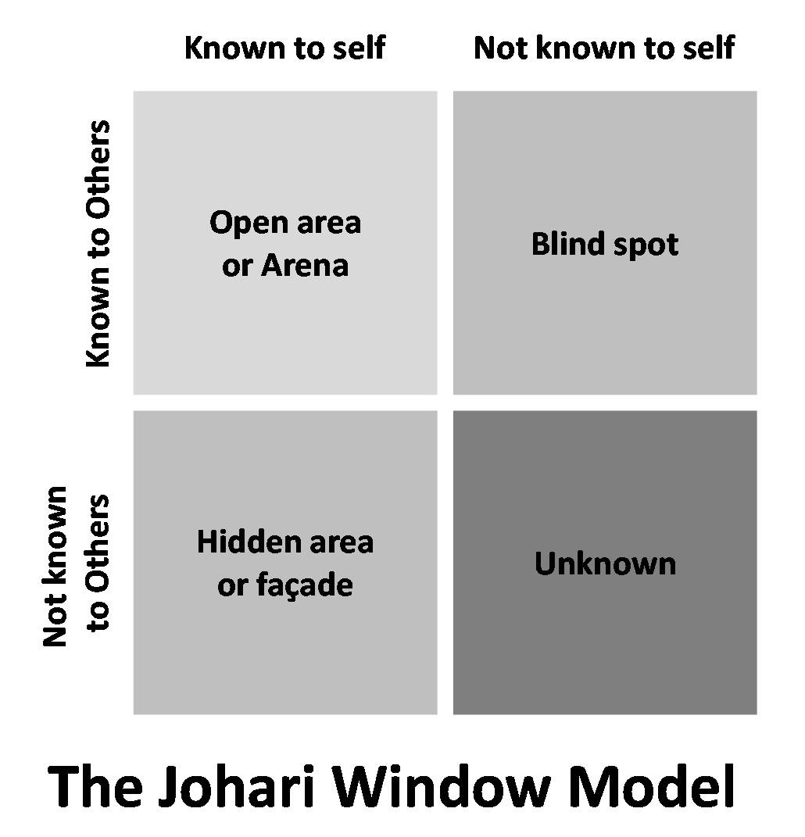

Figure 1: Johari Window Model, source: (Bard, 2011)
Open area:Here all the information of a person regarding skills, emotion, behaviour, feelings attitude are known to others. Here the individual solicits feedback from the surrounded persons of him (Gallagher, 2010). So, I also collect feedback from my colleagues, friends and family members and act according to their feedback.
Blind spot:Blind spot refers that the characteristics and behaviours of a person are known to others but the person is not aware about that. The other persons interpret the person in a different way that the person expects. As a person I am always aware of the blind spot. i keep myself careful regarding that.
Hidden area: Here the information is known to the particular individual but information is kept confidential to others. For instance, I prefer to keep my past experience, feelings, weaknesses and fears confidential to my colleagues and other people.
Unknown area:Unknown area refers to the information that is unknown to the particular individual (Gallagher, 2010). Here, this area indicates the unawareness of the individual to discover the hidden skills and qualities. I can conduct open communication with my colleagues to discover my hidden qualities.

Review of understanding and expectations on the world of employment
in the world of employment the employers have particular expectations from the potential and existing employees. The employers seek for employees who possess a set of qualities and skills. Currently, organizations ask for a number of skills from the employees. Recently I have been appointed as a store manager of Sainsbury’s. The skills and qualities I have been asked for the position of store manager at Sainsbury have been given below:
Communication skill:A Communication skill is considered to be the first required skill at the professional level (Cottrell, 2010). Communication skill includes both written and speaking skill. To survive in the corporate sector an individual needs to know how to write succinctly and how to speak clearly so that exact message can be delivered. As a store manager, I have to communicate with my subordinates, manager and customers.
Teamwork:Time work means working with people with a view to achieving a common goal. Within a team, each member co-operates each other by sharing their experience and skills(Ferguson, 2014). In my organization, apart from my position of the store manager, I work as a team leader in my team. My team comprises of the assistant store manager, cashier, salespersons, technician and guard. To run my team successfully I need the skills of planning and organizing, decision making and persuasive skill etc.
Problem-solving skill: At the present time, the organizations are getting more complex. Unusual problems are arising from a day to day life. To survive and get promoted at the organization, employees entail having problem-solving skill (Gallagher, 2010). As a store manager of Sainsbury's, I face different types of problems. I have to solve those problems tactfully and prudently. To solve the problem I have to accomplish a number of activities such as doing heavy research, dealing with the workplace compliances, discussing with other people etc.
Self-management:Self-management refers to adapt with own work without having other’s check-up or assistance in every five or ten minutes. To ensure self-management must always meet my deadline for every task. Moreover, should have the capability of delegating the task to my subordinates and monitor them whether they are performing well. One can ensure self-management skill through taking new responsibility, gathering work experience and attaching to a volunteer organization (Genoni and Walton, 2016).
Technology:In the modern world every employee is expected to have general technical knowledge such as simple concept over MS Office, internet, email etc. Moreover, in the super chain shop employees should have the introduction to other technologies (Miller, 2017). As a store manager of Sainsbury's my boss and management expect a range of technical knowledge such as scanning, automatic check out, preparing a report using spreadsheet and MS Word, mailing and digital inventory maintenance.

Career ambition and aspirations
Career ambition of a person refers to the dream and career objective that an individual aspires to be. Career ambition also refers to change the current position of professional life to else other position (Tovey, 2015). Someone aspires to be entrepreneur, some aspires to be leader and someone aspires to get promoted. To turn the ambition into reality an individual needs to set a number of short-term goals. I have been serving as a store manager of Sainsbury’s. My ambition is to become the regional manager of Sainsbury’s. In that position my responsibility will to co-operate and regulate the store managers of all outlets of a particular region or country. To fulfil my ambition I need the following two
Increased knowledge and skills: To fulfil my dream and aspiration I need to have some skills such as communication skill, technological skill, leadership skill etc (Bard, 2011). Form the collected feedback I have marked some points and areas that need to be further improved. I feel nervous while delivering a speech in front of the large audience. I need to gain confidence following the self-managed learning style. I have to grow more confidence in every aspect of my professional life. Moreover, I need some technological skills based on the contemporary used technology in the super market sector.
Peer recognition:Another requirement that I need to reach my dream is peer recognition. I have to achieve the trust and belief of my colleagues and boss that I will be able to perform up to the mark in the targeted position. To achieve peer recognition I have to contribute significantly in my team and show my competence to the team members and boss.

Personal development plan to enable myself to achieve my ambitions
Planning activities exist in every aspect of life. In both personal and organizational level plan helps to develop the present situation. I have already carried out my personal SWOT analysis. Holistic plan and a personal development plan will work as the weapon to overcome my weaknesses and threats. An effective holistic plan and personal development plan have been devised below:

6.1 Holistic plan:
The holistic plan refers to the process of self-actualization. The process includes reflection, assessment and actions (Cottrell, 2010). The holistic plan develops the physical, mental, emotional, spiritual and energetic aspect of life. My holistic plan has been devised as follows:
Components | Why I need | Ways to fulfil the need
Physical | To be physically fit for performing physical work at the organization | Going to regular morning walk and taking fresh food
Mental | To grow logic and rationality | Doing meditation and reading books
Emotional | To create sympathy inside me in order to comprehend the sorrows of employees | Getting in touch with the employee’s situation
Spiritual | To grow self-confidence | Always being prepared and taking complex things simply
Energetic | To take challenges and responsibilities spontaneously | Taking every challenge and responsibilities as a passion
Table 2: Holistic Plan

6.2 Personal Development Plan:
The plan that is devised for the improvement of personal skills and experiences is known as the personal development plan (Gallagher, 2010). My personal development plan based on my current drawbacks has been devised below:
What do I want/need to learn? | What will I do to achieve this? | What resources or support will I need? | What will my success criteria be? | Target dates for review and completion
Presentation skill | I shall always try to keep a smile on my face. I will practice a lot in front of my friends and family members who can help me to identify my flaws. Moreover, I will take part in training to make my slides more attractive. | I need the support of my boss and colleagues of Sainsbury’s. Moreover, I will use the resources of Sainsbury’s as training opportunities. | I will be able to conduct my presentation more smoothly and catch the attention of my audience. | 8 weeks (1st August 2018 – 30th September 2018)
Organizing skill | I will participate actively in organizing several events of Sainsbury’s. I will organize different meetings, seminars and workshop for Sainsbury's. | I will use the resources of Sainsbury’s while arranging any event or organizational program. | Any event or meeting or any seminar I will be able to arrange successfully. | 12 weeks (1st September to 30th November)
Technological skill | I will take a training course on the use of several dimensions of technology such as the use of spreadsheet, database and other super shop related technologies. | I shall grab the opportunity of developing my technological skill provided by Sainsbury’s. | I can use modern equipment without facing any problem at Sainsbury’s. Moreover, I can prepare the store database and financial report. | 4 weeks (1st November to 31st December)
Communication skill | I need to practice maintaining a positive attitude at the moment. I have to focus on my body language and listen to the employees carefully. Moreover, I can attend seminars and workshops. | I can take the support of my manager and colleagues at Sainsbury’s. | As a store manager of Sainsbury's, I can communicate with each party properly and deal with every business matters successfully. | 12 weeks (1st January 2019 to 31st March 2019)
Resolving conflicts | I will try to identify the reasons behind the conflict and discuss with my boss about the possible solution. I will practice keeping myself calm in case of arising from any conflict. | I will take the assistance of my boss and other employees of Sainsbury’s. | I will be able to handle any conflicts between the internal parties. | 4 weeks (1st April 2019 – 30th April 2019)
Teamwork | To work with the team effectively I need to practice being open and co-operative. Moreover, I can attend seminars based on teamwork. | I need the help of other team members of my team at Sainsbury’s. | I can assist my team to attain organizational objectives. | 4 weeks (1st May 2019 – 31st May 2019)
Table 3: Personal development plan

6.3 Reviewing and monitoring the process of PDP and its reflection
Holistic and professional development plans have been devised. Only devising a personal development plan cannot bring a satisfactory result (Genoni and Walton, 2016). It should be reviewed on regular basis and match the progress with the revised plan. If any plan is accomplished, I should move to the next plan. At the end of a few months of devising my development plan, I have prepared a progress report. My performance and outcome will reflect the progress of my plan. The progress report is as follows:
Activity | Outcome Achieved? | Time | Progress
Presentation skill | Yes | 8 weeks | I have delivered a number of satisfactory presentations and got praise from the audience.
Organizing skill | Yes | 12 weeks | I organized four successful events of Sainsbury’s.
Technological skill | Partly achieved | 4 weeks | I have brought proficiency in spreadsheet and database. But a few plans are yet to be achieved.
Communication skill | Yes | 12 weeks | I can deal with every issue of the organization. Moreover, I handled a few unexpected issues through good communication skill.
Resolving conflicts | No | 4 weeks | I couldn’t gain good command over resolving conflicts.
Teamwork | No | 4 weeks | Still, I need to focus on my team performance.
Table 4: Progress outcome of PDP

Conclusion
It has been prepared a reflective assignment focusing on the professional development. The assignment has focused on some significant areas. The skills that are demanded by the current employers are communication skill, teamwork, self-management skill, problem-solving skill and technological skill. Through the personal SWOT analysis, I have figured out that my significant strengths are multitasking capacity, patience, standard research skill and my significant drawbacks are poor presentation skill and poor technological skill. I use Kolb Learning Style in my professional development. In my personal development plan, I highlighted those areas which need to be developed to sustain in my profession. It has been found from the assignment that regular monitoring is required for the development plan. Moreover, it has been discussed handling some unexpected situations. For the advancement of one's career, the individual must be concerned about the time management. The strategies that can be followed for the time management are setting clear focus, preparing a dynamic task list, focusing on high-value activities, limiting multitasking and reviewing the day.

References
Bard, R. (2011). The Trainer's professional development handbook. San Francisco: Jossey-Bass.
Cottrell, S. (2010). Skills for success. Basingstoke: Palgrave Macmillan.
Ferguson, K. (2014). Personal and Professional Development (PPD) Facilitators' Guide. MedEdPORTAL Publications.
Gallagher, K. (2010). Skills development for business and management students. Oxford: Oxford University Press.
Genoni, P. and Walton, G. (2016). Continuing Professional Development- Preparing for New Roles in Libraries: A Voyage of Discovery.
Miller, W. (2017). A Comprehensive and Coordinated Program of Professional Career Personnel Development. Journal of Career Development, 1(1), pp.3-10.
Morgan, P. (2017). Business student's guide to study and employability. Los Angeles: SAGE.
Reynolds, C. (2013). Dimensions in professional development. Cincinnati, Ohio: South-Western Pub. Co.
Roesch, R. (2015). Time management for busy people. New York: McGraw-Hill.
Sainsburys.co.uk. (2018). Sainsbury's. [online] Available at: https://www.sainsburys.co.uk/ [Accessed 15 Jul. 2018].
Stumpf, S. (2014). Phases of professional development in consulting. Career Development International, 4(7), pp.392-399.
Tovey, R. (2015). Professional development. Cambridge, Mass.: Harvard Education Letter.

