University of Wales Trinity st Davids

Name: Babatunde Idowu

Student Number: 2516575

Module: Introduction to Web and Database Concepts
(ACCA4023)

Assignment: HTLM&CCS Web Development

Table of Contents
1. Introduction 3
2. Requirements 3
2.1 Functional Requirements 3
2.2 Non-Functional Requirements 4
3. Implementation 4
3.1 Technologies Used 4
3.2 System Structure 4
3.3 Accordion Implementation 5
3.4 Dynamic Image Loading 6
3.5 Modal Image Viewer 7
4. Validation 7
5. Evaluation 8
5.1 Usability and Usefulness 8
5.2 Search Engine Optimization (SEO) 8
5.3 Accessibility (WCAG 2.1) 8
6. Comparison of Two Live Websites 9
7. Conclusion 9
8. References (IEEE) 9
9. Appendices 10

1. Introduction
This project involves the design and development of a responsive website for Ejatechfix. The website showcases phone accessories and services using modern web development techniques. The system integrates dynamic image loading, accordion-based user interfaces, and modular design for scalability.
The goal of the project is to create a structured, user-friendly, and maintainable website that can be extended in the future.

2. Requirements

2.1 Functional Requirements
• Display products in categorized sections
• Implement accordion-style navigation
• Enable dynamic loading of product images
• Allow users to view enlarged images on click
• Provide navigation across multiple pages

2.2 Non-Functional Requirements
• Responsive design
• Fast loading performance
• Clean and maintainable code
• Accessibility compliance
• Scalability for future upgrades

3. Implementation

3.1 Technologies Used
• HTML5
• CSS3
• JavaScript (Vanilla)

3.2 System Structure
htdocs/ejatechfix/
│
├── index.html
├── products.html
├── services.html
├── contact.html
├── styles.css
└── images/
├── chargers/
├── power banks/
├── cables/
└── earbuds/

3.3 Accordion Implementation
The accordion system allows users to expand and collapse sections dynamically.

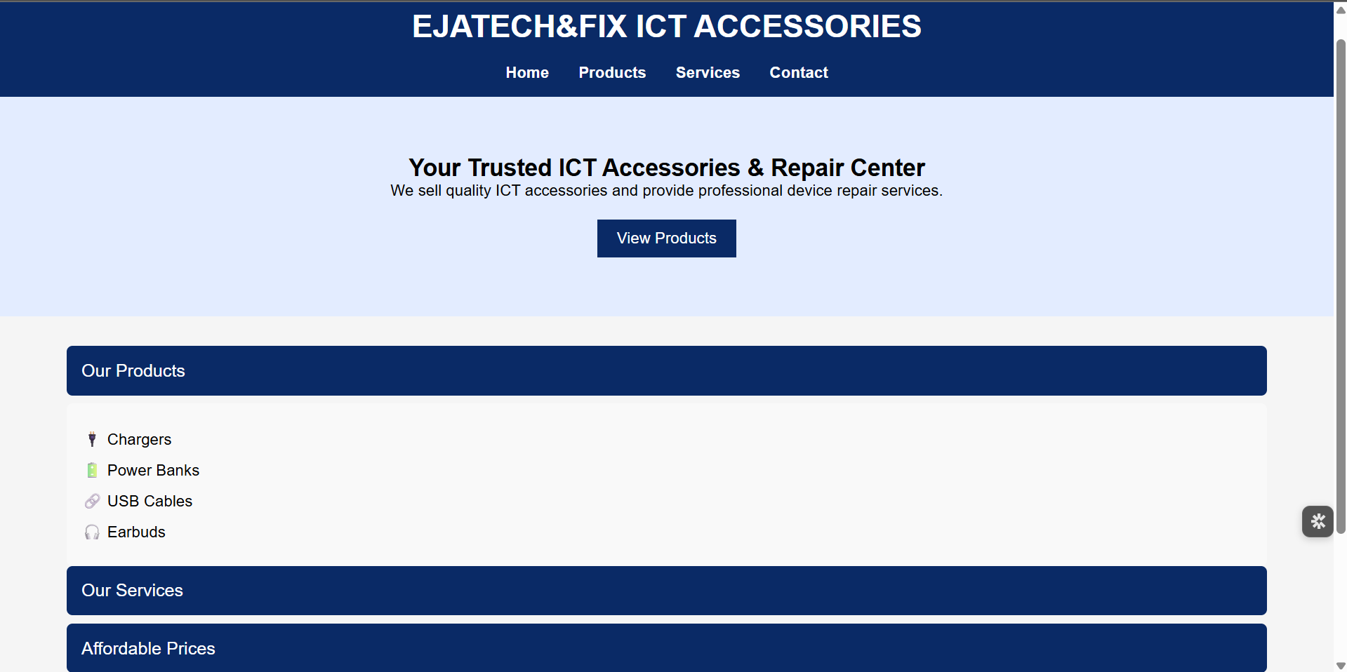

document.querySelectorAll(".accordion-header").forEach(btn => {
btn.addEventListener("click", () => {
const content = btn.nextElementSibling;
document.querySelectorAll(".accordion-content").for Each(c => {
if (c !== content) c.style.display = "none";
});
content.style.display = content.style.display === "block" ? "none" : "block";
});
});

3.4 Dynamic Image Loading
Images are loaded dynamically using JavaScript without hardcoding.
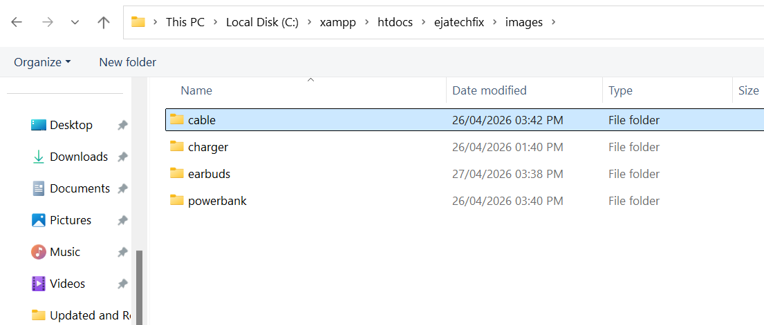

function loadNext() {
const img = new Image();
img.src = `images/${folder}/${prefix}${i}.jpg`;
img.onload = () => {
gallery.appendChild(img);
i++;
loadNext();
};
}

3.5 Modal Image Viewer
Clicking thumbnails opens a larger version of the image.
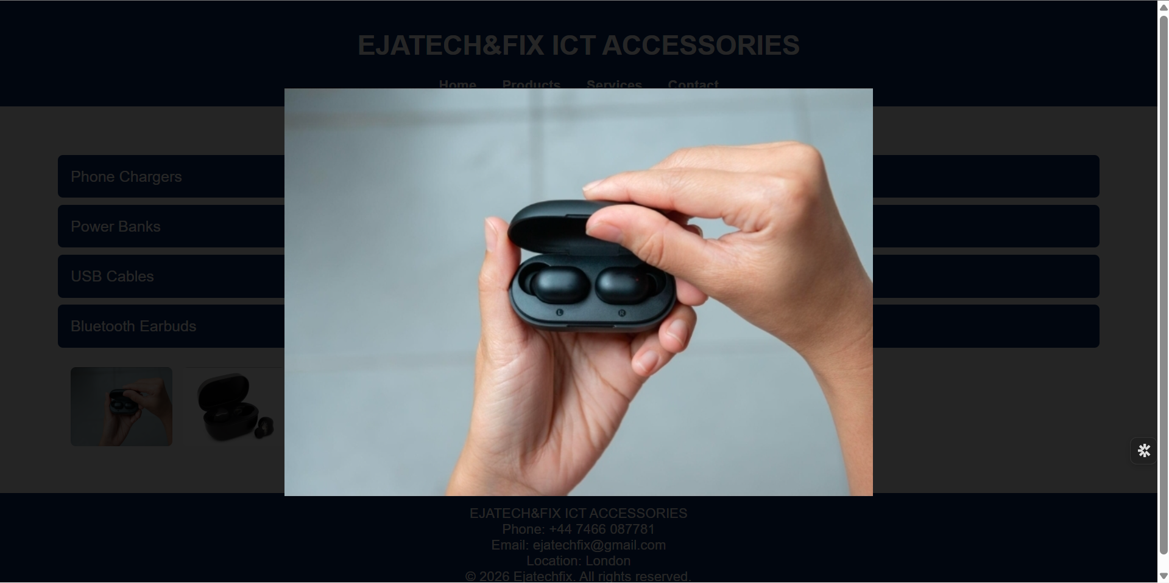

document.addEventListener("click", (e) => {
if (e.target.classList.contains("thumb")) {
modal.style.display = "flex";
modalImg.src = e.target.src;
}
});

4. Validation
The system was tested to ensure:
• Accordions expand and collapse correctly
• Images load dynamically without errors
• Thumbnails open in modal view
• Navigation between pages works properly
Testing was conducted using browser developer tools and manual interaction.

5. Evaluation

5.1 Usability and Usefulness
The system provides:
• Clear navigation through accordion UI
• Easy access to product categories
• Simple interaction via click-based image expansion
Users can quickly locate products and view details without clutter.

5.2 Search Engine Optimization (SEO)
Although the site is locally hosted, SEO principles were applied:
• Proper heading structure (H1–H3)
• Descriptive ALT text for images
• Clean file naming and structure

5.3 Accessibility (WCAG 2.1)
Accessibility considerations include:
• Use of semantic HTML
• ALT text for images
• Clear navigation structure
• Readable font sizes and contrast

6. Comparison of Two Live Websites
Website 1: Generic E-commerce Site
• Uses grid layout for products
• Heavy reliance on frameworks
• Slower load times
Website 2: Minimal Tech Store
• Clean UI design
• Faster performance
• Limited interactivity

Feature | Ejatechfix | Site 1 | Site 2
UI | Accordion-based | Grid | Minimal
Performance | Fast | Moderate | Fast
Scalability | High | High | Low
Interactivity | High | Medium | Low

7. Conclusion
The project successfully demonstrates the development of a modern, scalable website using core web technologies. The use of dynamic loading and modular design ensures maintainability and future expansion.

8. References (IEEE)
[1] W3C, “HTML5 Specification,” 2023.
[2] Mozilla Developer Network, “JavaScript Documentation,” 2024.
[3] W3C, “WCAG 2.1 Guidelines,” 2018.

9. Appendices
Appendix A: Full Source Codes
Index.html

<!DOCTYPE html>
<html lang="en">
<head>
<meta charset="UTF-8">
<meta name="viewport" content="width=device-width, initial-scale=1.0">
<meta charset="UTF-8">
<meta name="viewport" content="width=device-width, initial-scale=1.0">

<title>Affordable Phone Accessories in Abuja | Ejatechfix</title>

<meta name="description" content="Ejatechfix offers affordable phone accessories, chargers, power banks, and repair services in Abuja, Nigeria. Reliable and budget-friendly tech solutions.">

<meta name="keywords" content="phone accessories Abuja, chargers Nigeria, power banks Abuja, phone repair Abuja, Ejatechfix">

<meta name="author" content="Ejatechfix">

<!-- Open Graph (for social sharing) -->
<meta property="og:title" content="Ejatechfix - Affordable Tech in Abuja">
<meta property="og:description" content="Shop quality phone accessories and repair services in Abuja.">
<meta property="og:type" content="website">
<meta property="og:url" content="https://yourdomain.com">
<meta property="og:image" content="https://yourdomain.com/images/preview.jpg">

<!-- Favicon -->
<link rel="icon" href="images/favicon.ico">
<link rel="stylesheet" href="styles.css">
</head>

<script>
document.addEventListener("DOMContentLoaded", () => {

// 🔹 Names for ALT text
const names = {
chargers: "Phone Charger",
powerbanks: "Power Bank",
cables: "USB Cable",
earbuds: "Bluetooth Earbuds"
};

// 🔹 ACCORDION LOGIC (FIXED)
document.querySelectorAll(".accordion-header").forEach(btn => {
btn.addEventListener("click", () => {
const content = btn.nextElementSibling;

document.querySelectorAll(".accordion-content").forEach(c => {
if (c !== content) c.style.display = "none";
});

content.style.display =
content.style.display === "block" ? "none" : "block";
});
});

// 🔹 MODAL
const modal = document.createElement("div");
modal.classList.add("modal");
modal.innerHTML = "<img>";
document.body.appendChild(modal);

const modalImg = modal.querySelector("img");

// 🔹 GALLERY LOADER
document.querySelectorAll(".gallery").forEach(gallery => {
const folder = gallery.dataset.folder;
const prefix = gallery.dataset.prefix;
const count = parseInt(gallery.dataset.count);

for (let i = 1; i <= count; i++) {
const img = document.createElement("img");

img.src = `images/${folder}/${prefix}${i}.jpg`;
img.classList.add("thumb");
img.loading = "lazy";

img.alt = `${names[folder]} ${i} - Ejatechfix`;

gallery.appendChild(img);

img.addEventListener("click", () => {
modal.style.display = "flex";
modalImg.src = img.src;
});
}
});

modal.addEventListener("click", () => {
modal.style.display = "none";
});

});
</script>

<body>

<header>
<h1>EJATECH&FIX ICT ACCESSORIES</h1>

<nav>
<ul>
<li><a href="index.html">Home</a></li>
<li><a href="products.html">Products</a></li>
<li><a href="services.html">Services</a></li>
<li><a href="contact.html">Contact</a></li>
</ul>
</nav>

</header>

<section class="hero">
<h2>Your Trusted ICT Accessories & Repair Center</h2>
<p>We sell quality ICT accessories and provide professional device repair services.</p>
<a href="products.html" class="btn">View Products</a>
</section>

<section class="accordion">

<div class="accordion-item">
<button class="accordion-header">Our Products</button>
<div class="accordion-content">
<ul class="icon-list">
<li>🔌 Chargers</li>
<li>🔋 Power Banks</li>
<li>🔗 USB Cables</li>
<li>🎧 Earbuds</li>
</ul>
</div>
</div>

<div class="accordion-item">
<button class="accordion-header">Our Services</button>
<div class="accordion-content">
<ul class="icon-list">
<li>🛠 Phone Repairs</li>
<li>📶 Network Setup</li>
<li>💻 Tech Support</li>
</ul>
</div>
</div>

<div class="accordion-item">
<button class="accordion-header">Affordable Prices</button>
<div class="accordion-content">
<ul class="icon-list">
<li>🐷 Budget-friendly options</li>
<li>💰 Value for money</li>
<li>📉 Competitive pricing</li>
</ul>
</div>
</div>

</section>

<div id="footer"></div>

<script>
fetch("footer.html")
.then(res => res.text())
.then(data => {
document.getElementById("footer").innerHTML = data;
});
</script>

</body>
</html>

Products.html

<!DOCTYPE html>
<html lang="en">
<head>
<meta charset="UTF-8">
<meta name="viewport" content="width=device-width, initial-scale=1.0">
<meta charset="UTF-8">
<meta name="viewport" content="width=device-width, initial-scale=1.0">

<title>Phone Chargers, Power Banks & Accessories | Ejatechfix Abuja</title>

<meta name="description" content="Ejatechfix offers affordable phone accessories, chargers, power banks, and repair services in Abuja, Nigeria. Reliable and budget-friendly tech solutions.">

<meta name="keywords" content="phone accessories Abuja, chargers Nigeria, power banks Abuja, phone repair Abuja, Ejatechfix">

<meta name="author" content="Ejatechfix">

<!-- Open Graph (for social sharing) -->
<meta property="og:title" content="Ejatechfix - Affordable Tech in Abuja">
<meta property="og:description" content="Shop quality phone accessories and repair services in Abuja.">
<meta property="og:type" content="website">
<meta property="og:url" content="https://yourdomain.com">
<meta property="og:image" content="https://yourdomain.com/images/preview.jpg">

<!-- Favicon -->
<link rel="icon" href="images/favicon.ico">
<link rel="stylesheet" href="styles.css">
</head>

<script>
document.addEventListener("DOMContentLoaded", () => {

// 🔹 Friendly names for ALT text
const names = {
charger: "Phone Charger",
powerbank: "Power Bank",
cable: "USB Cable",
earbuds: "Bluetooth Earbuds"
};

// 🔹 ACCORDION LOGIC
document.querySelectorAll(".accordion-header").forEach(btn => {
btn.addEventListener("click", () => {
const content = btn.nextElementSibling;

document.querySelectorAll(".accordion-content").forEach(c => {
if (c !== content) c.style.display = "none";
});

content.style.display =
content.style.display === "block" ? "none" : "block";
});
});

// 🔹 MODAL SETUP
const modal = document.createElement("div");
modal.classList.add("modal");
modal.innerHTML = "<img>";
document.body.appendChild(modal);

const modalImg = modal.querySelector("img");

// 🔹 GLOBAL CLICK HANDLER (works for dynamic images)
document.addEventListener("click", (e) => {
if (e.target.classList.contains("thumb")) {
modal.style.display = "flex";
modalImg.src = e.target.src;
}
});

// 🔹 DYNAMIC GALLERY LOADER (no data-count)
document.querySelectorAll(".gallery").forEach(gallery => {
const folder = gallery.dataset.folder;
const prefix = gallery.dataset.prefix;

let i = 1;

function loadNext() {
const img = new Image();
img.src = `images/${folder}/${prefix}${i}.jpg`;

img.onload = () => {
img.classList.add("thumb");
img.loading = "lazy";
img.alt = `${names[folder]} ${i} - Ejatechfix`;

gallery.appendChild(img);

i++;
loadNext(); // continue loading
};

img.onerror = () => {
console.log(`Loaded ${i - 1} images for ${folder}`);
};
}

loadNext();
});

// 🔹 CLOSE MODAL
modal.addEventListener("click", () => {
modal.style.display = "none";
});

});
</script>

<body>

<header>
<h1>EJATECH&FIX ICT ACCESSORIES</h1>

<nav>
<ul>
<li><a href="index.html">Home</a></li>
<li><a href="products.html">Products</a></li>
<li><a href="services.html">Services</a></li>
<li><a href="contact.html">Contact</a></li>
</ul>
</nav>
</header>

<section class="page-title" align-content-center>
<h2>Our Products</h2>
</section>

<section class="accordion">

<div class="accordion-item">
<button class="accordion-header">Phone Chargers</button>
<div class="accordion-content">
<div class="gallery" data-folder="charger" data-prefix="ch">

<noscript>
<img src="images/charger/ch1.jpg" alt="Phone charger London, Abuja">
<img src="images/charger/ch2.jpg" alt="Fast charger Ejatechfix">
</noscript>

</div>

</div>
</div>
</div>

<div class="accordion-item">
<button class="accordion-header">Power Banks</button>
<div class="accordion-content">
<div class="gallery" data-folder="powerbank" data-prefix="pb">
<noscript>
<img src="images/powerbank/pb1.jpg" alt="power banks London, Abuja">
<img src="images/powerbank/pb2.jpg" alt="power banks Ejatechfix">
<img src="images/powerbank/pb3.jpg" alt="power banks London, Abuja">
<img src="images/powerbank/pb4.jpg" alt="power banks Ejatechfix">
</noscript>
</div>
</div>
</div>
</div>

<div class="accordion-item">
<button class="accordion-header">USB Cables</button>
<div class="accordion-content">
<div class="gallery" data-folder="cable" data-prefix="cb">
<noscript>
<img src="images/cable/cb1.jpg" alt="cable London, Abuja">
<img src="images/cable/cb2.jpg" alt="cable Ejatechfix">
<img src="images/cable/cb3.jpg" alt="cable London, Abuja">
<img src="images/cable/cb4.jpg" alt="cable Ejatechfix">
<img src="images/cable/cb5.jpg" alt="cable London, Abuja">
</noscript>
</div>
</div>
</div>
</div>

<div class="accordion-item">
<button class="accordion-header">Bluetooth Earbuds</button>
<div class="accordion-content">
<div class="gallery" data-folder="earbuds" data-prefix="eb">
<noscript>
<img src="images/earbuds/eb1.jpg" alt="earbuds London, Abuja">
<img src="images/earbuds/eb2.jpg" alt="earbuds Ejatechfix">
<img src="images/earbuds/eb3.jpg" alt="earbuds London, Abuja">
<img src="images/earbuds/eb4.jpg" alt="earbuds Ejatechfix">
<img src="images/earbuds/eb5.jpg" alt="earbuds London, Abuja">
</noscript>
</div>
</div>
</div>
</div>

</section>

<div id="footer"></div>

<script>
fetch("footer.html")
.then(res => res.text())
.then(data => {
document.getElementById("footer").innerHTML = data;
});
</script>

</body>
</html>

Services.html

<!DOCTYPE html>
<html lang="en">
<head>
<meta charset="UTF-8">
<meta name="viewport" content="width=device-width, initial-scale=1.0">
<meta charset="UTF-8">
<meta name="viewport" content="width=device-width, initial-scale=1.0">

<title>Phone Repair & Tech Services in Abuja | Ejatechfix</title>

<meta name="description" content="Ejatechfix offers affordable phone accessories, chargers, power banks, and repair services in Abuja, Nigeria. Reliable and budget-friendly tech solutions.">

<meta name="keywords" content="phone accessories Abuja, chargers Nigeria, power banks Abuja, phone repair Abuja, Ejatechfix">

<meta name="author" content="Ejatechfix">

<!-- Open Graph (for social sharing) -->
<meta property="og:title" content="Ejatechfix - Affordable Tech in Abuja">
<meta property="og:description" content="Shop quality phone accessories and repair services in Abuja.">
<meta property="og:type" content="website">
<meta property="og:url" content="https://yourdomain.com">
<meta property="og:image" content="https://yourdomain.com/images/preview.jpg">

<!-- Favicon -->
<link rel="icon" href="images/favicon.ico">
<link rel="stylesheet" href="styles.css">
</head>

<body>

<header>
<h1>EJATECH&FIX ICT ACCESSORIES</h1>

<nav>
<ul>
<li><a href="index.html">Home</a></li>
<li><a href="products.html">Products</a></li>
<li><a href="services.html">Services</a></li>
<li><a href="contact.html">Contact</a></li>
</ul>
</nav>
</header>

<section class="page-title">
<h2>Our Services</h2>
</section>

<section class="features">

<div class="card">
<h3>Phone Screen Replacement</h3>
<p>Broken screen replacement for all phone models.</p>
</div>

<div class="card">
<h3>Battery Replacement</h3>
<p>Original battery replacement service.</p>
</div>

<div class="card">
<h3>Software Flashing</h3>
<p>Unlock, upgrade and fix system errors.</p>
</div>

<div class="card">
<h3>Laptop Repair</h3>
<p>Keyboard, screen and motherboard repair.</p>
</div>

</section>

<div id="footer"></div>

<script>
fetch("footer.html")
.then(res => res.text())
.then(data => {
document.getElementById("footer").innerHTML = data;
});
</script>

</body>
</html>

Contact.html

<!DOCTYPE html>
<html lang="en">
<head>
<meta charset="UTF-8">
<meta name="viewport" content="width=device-width, initial-scale=1.0">
<meta charset="UTF-8">
<meta name="viewport" content="width=device-width, initial-scale=1.0">

<title>Contact Ejatechfix | Abuja Tech Support & Accessories</title>

<meta name="description" content="Ejatechfix offers affordable phone accessories, chargers, power banks, and repair services in Abuja, Nigeria. Reliable and budget-friendly tech solutions.">

<meta name="keywords" content="phone accessories Abuja, chargers Nigeria, power banks Abuja, phone repair Abuja, Ejatechfix">

<meta name="author" content="Ejatechfix">

<!-- Open Graph (for social sharing) -->
<meta property="og:title" content="Ejatechfix - Affordable Tech in Abuja">
<meta property="og:description" content="Shop quality phone accessories and repair services in Abuja.">
<meta property="og:type" content="website">
<meta property="og:url" content="https://yourdomain.com">
<meta property="og:image" content="https://yourdomain.com/images/preview.jpg">

<!-- Favicon -->
<link rel="icon" href="images/favicon.ico">
<link rel="stylesheet" href="styles.css">
</head>

<body>

<header>
<h1>EJATECH&FIX ICT ACCESSORIES</h1>

<nav>
<ul>
<li><a href="index.html">Home</a></li>
<li><a href="products.html">Products</a></li>
<li><a href="services.html">Services</a></li>
<li><a href="contact.html">Contact</a></li>
</ul>
</nav>
</header>

<section class="page-title">
<h2>Contact Us</h2>
</section>

<section class="contact">

<form>
<input type="text" placeholder="Your Name" required>
<input type="email" placeholder="Your Email" required>
<textarea placeholder="Your Message"></textarea>
<button type="submit">Send Message</button>
</form>

</section>

<div id="footer"></div>

<script>
fetch("footer.html")
.then(res => res.text())
.then(data => {
document.getElementById("footer").innerHTML = data;
});
</script>

</body>
</html>

Appendix B: Screenshots
Index.html
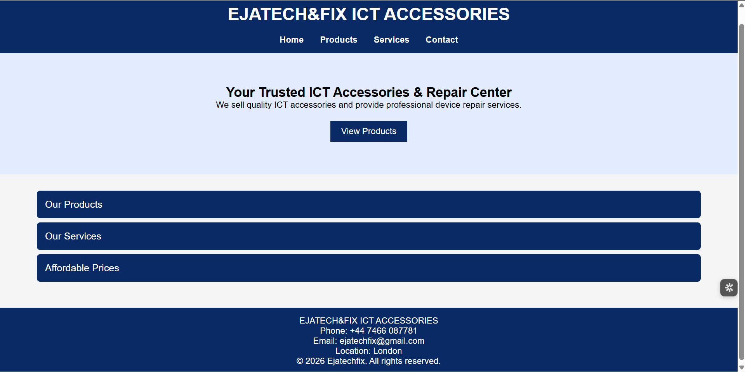

Products.html
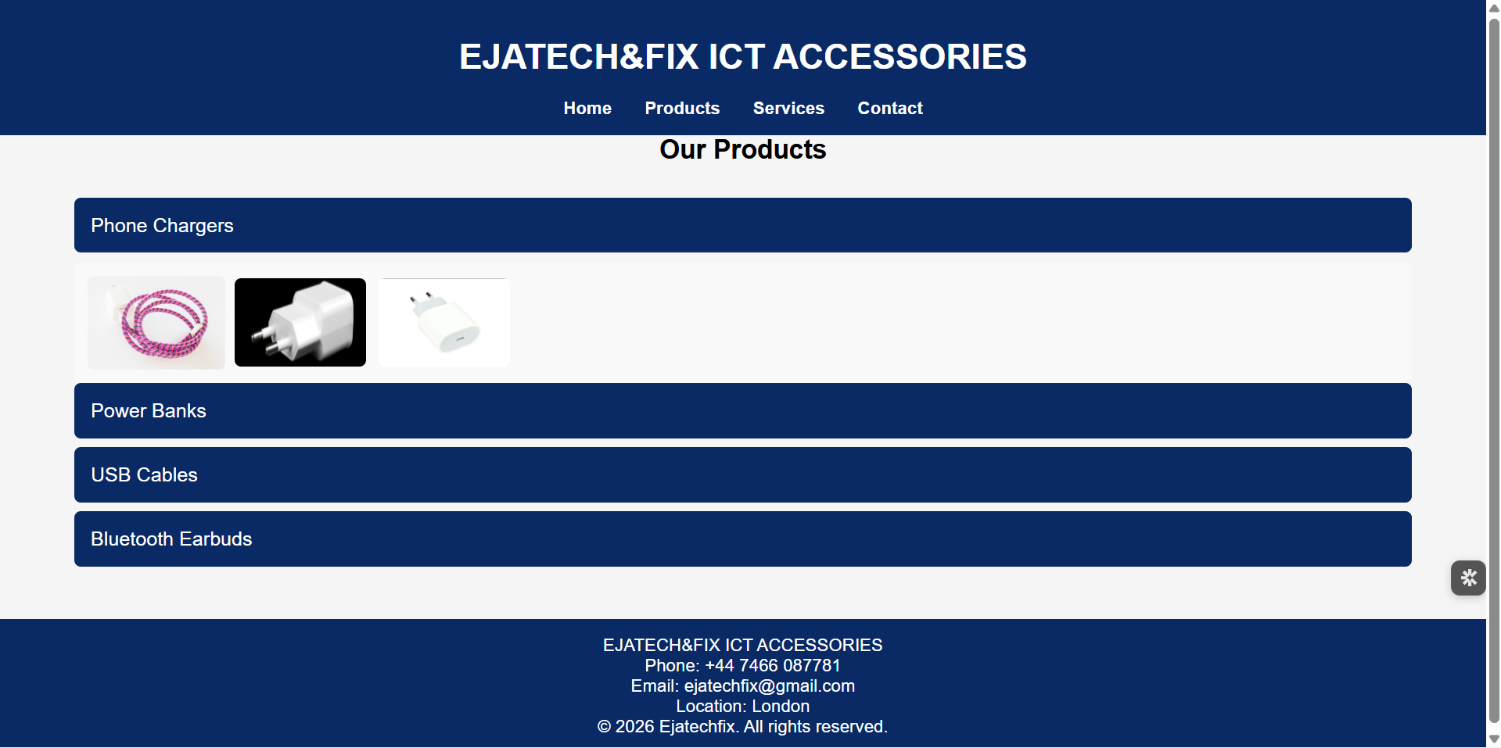

Services.html

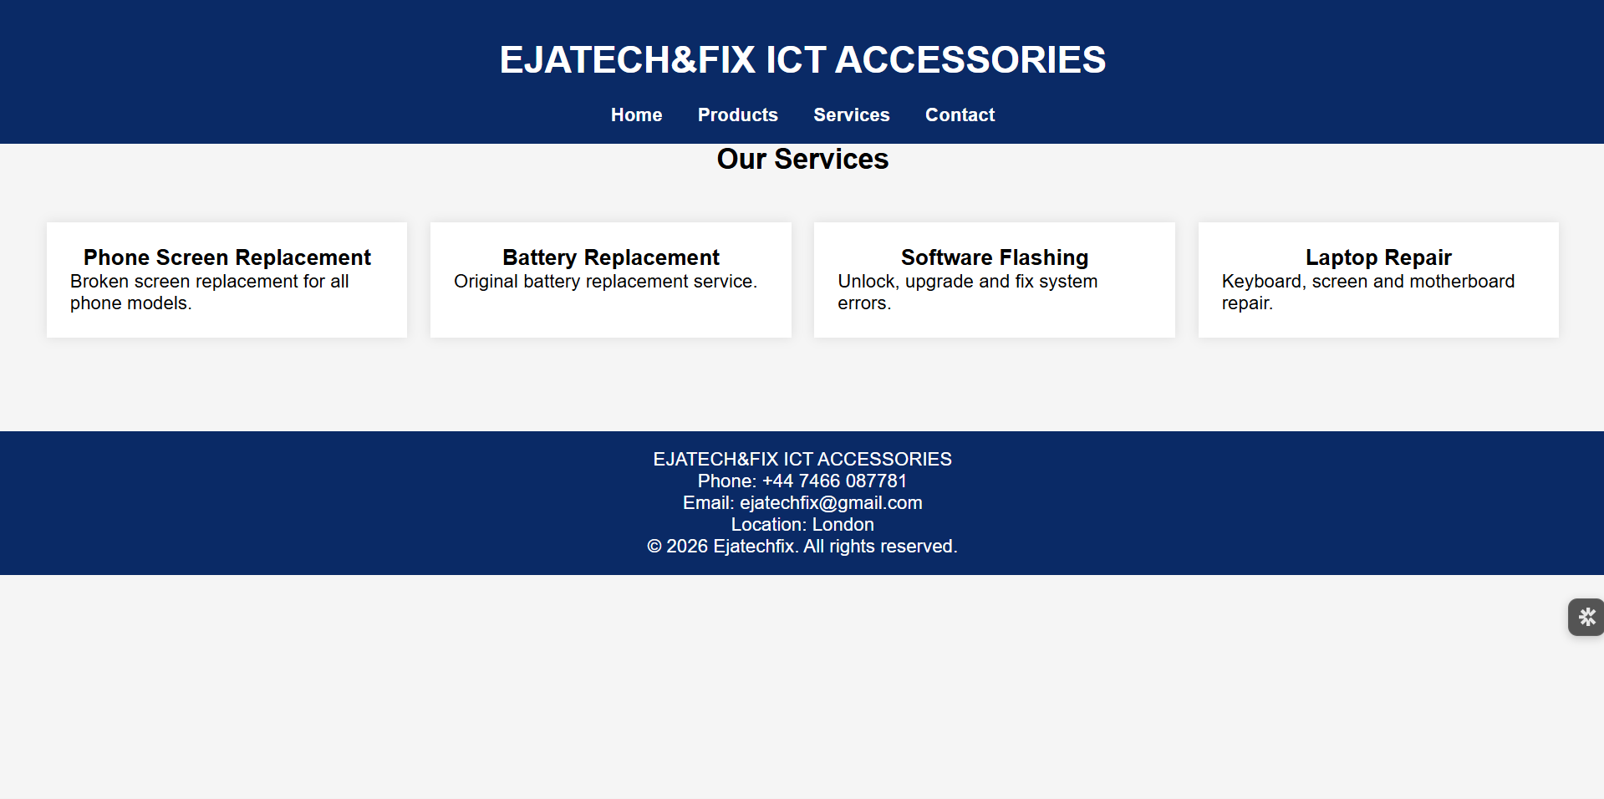

Contact.html


