Noreen Kouser
Student Number: 2433387
Module Code and Title: LCSH4009 Professional Development within Health and Social Care
Lecturer: Hajra Mustaqim
Assignment Title: Component 2

Table of Contents
Task 1: Curriculum Vitae 6
Task 2: Personal Statement 8
Task 3 : SWOT analysis and Personal Development Plan (PDP) 9
a) Personal SWOT Analysis 9
b) Personal Development Plan (PDP) 10
Task 4: Reflection Gibbs Reflective Cycle 12

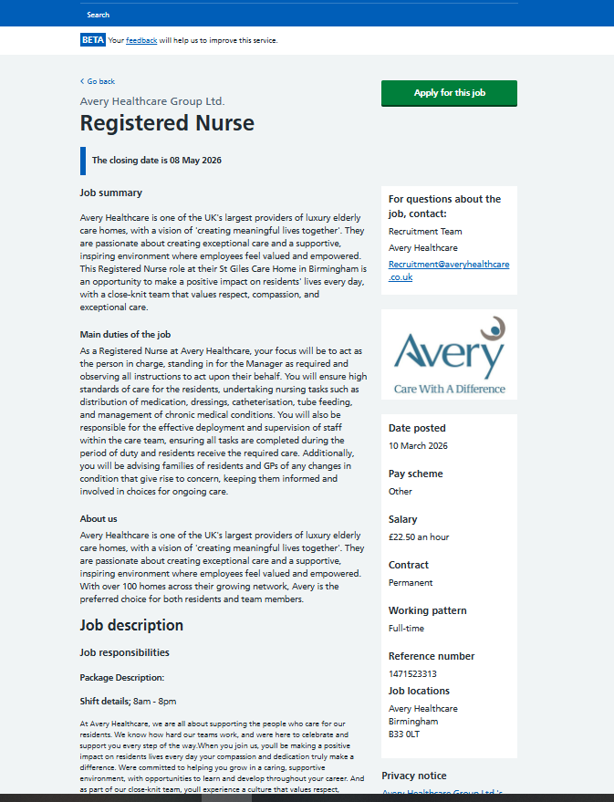
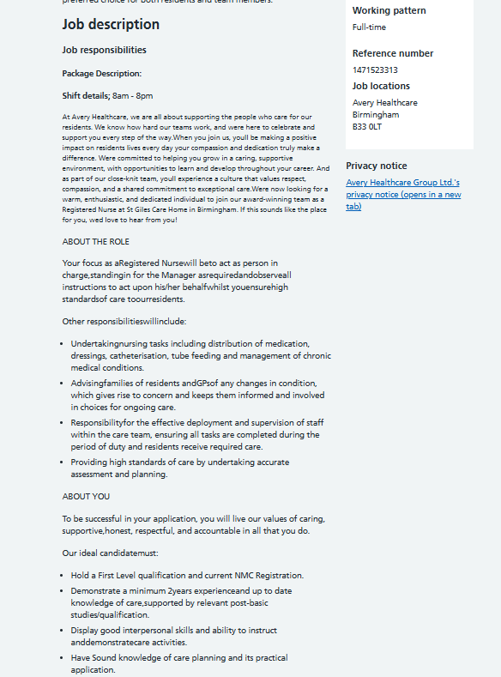
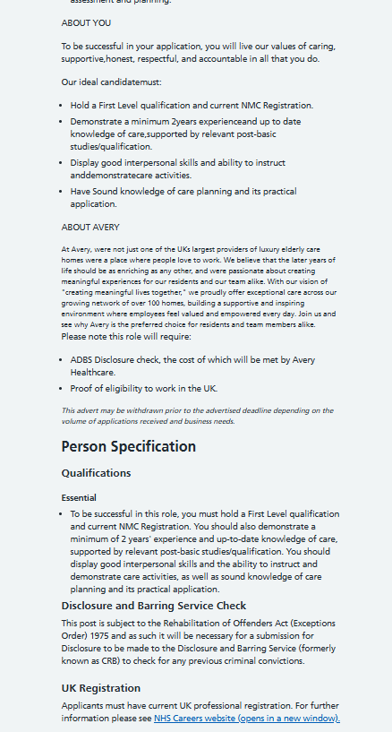


Task 1: Curriculum Vitae

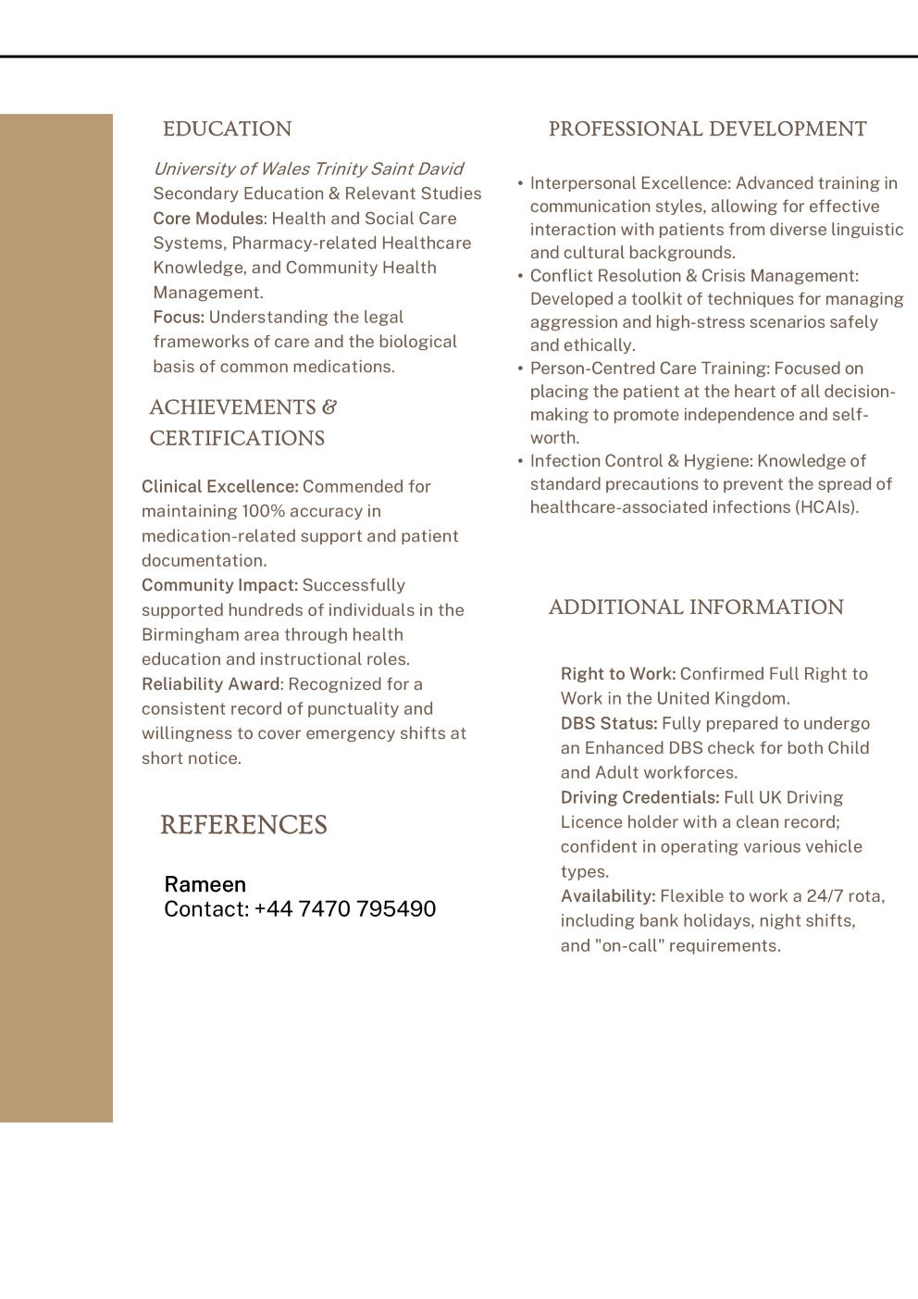

Task 2: Personal Statement
I am seeking a position in the health and social care sector as I love assisting individuals and aiding those who might require assistance in their day-to-day life. I am a caring, tolerant, and industrious individual who would always attempt to treat others with respect and understanding. I think these are extremely significant in cases of working with those, who might require care, assistance, or guidance.
I attended Saltley School where I got interested in health and social care. When I was studying, I got to know that people need to be taken care of, various needs should be respected, and people should be assisted in a safe and responsible manner. It is through my education that I realised that individuals in health and social care are required to be patient, respectful and supportive.
I have also worked in a pharmacy setting. In this position, I could see the way healthcare professionals deal with the community and make them realise their medicine and health requirements. This experience allowed me to realise the value of effective communication and how supportive people should be once they have questions or concerns regarding their health. Another lesson I got working in this environment is the importance of being polite and professional to everyone.
I am also a driving instructor besides this. The job has enabled me to acquire various useful skills that are essential in health and social care. As a driving teacher, I am in close contact with human beings and help them in the process of mastering a new skill. Some of the learners are very nervous every time they start learning how to drive; hence I should be calm, patient and encouraging. This experience has assisted me to gain better communication skills and the ability of assisting those who might be anxious or feel unsure.
I am always ready to assist people and this stands out as one of my greatest strengths. I like helping and enabling others to feel at ease and assured. I also make a responsible and reliable individual who is serious about his work. In my opinion, kindness, respect, and hard workers are very valuable traits in the field of work in health and social care.
I have the ability to work both in a team and individually. I realise that health and social care practitioners should collaborate in order to offer the best care to individuals (Rämgård, Blomqvist and Petersson, 2015). I also listen well and I put myself in the position of others by trying to know their needs first before giving assistance.
I would like to be in the field of health and social care where I can contribute to people positively under the influence of my caring nature and my experience. I am also interested in further cultivating my abilities and acquiring more experience in this sphere in order to be able to keep assisting those people who need care and support.
In my opinion, my education, the job I did in the pharmacy area, and my job as a driving instructor have enabled me to acquire valuable skills that include communication, patience, responsibility, and comprehension. Such are the skills that would enable me to work positively within an organisation that offers health and social care services.

Task 3 : SWOT analysis and Personal Development Plan (PDP)

a) Personal SWOT Analysis
Strengths | Weaknesses
Strong sense of kindness and care, helping patients feel safe and supported in difficult situations | Limited direct hands-on experience in a professional health and social care setting
Good communication skills developed through experience dealing with different individuals, including nervous or uncertain people | Lack of confidence when starting new tasks or working in unfamiliar environments

Opportunities | Threats
Access to healthcare training programmes and qualifications to improve knowledge, skills, and career progression | High competition for healthcare roles requiring continuous skill development and experience
Opportunity to gain practical experience in care homes, hospitals, and community services to improve confidence and competence | Emotional and physical demands of the role, including stress when dealing with vulnerable individuals

b) Personal Development Plan (PDP)
Goals | List the actions to complete to achieve the goal | Support/resources needed | Target date | Review date
Gain employment as a Health Care Assistant | Apply for relevant roles, prepare a professional CV, practice interview skills, register on job portals, and tailor applications to job descriptions | NHS Jobs, Indeed, CV templates, career advisors, interview preparation resources | Within 6 months | Review after 3 months
Increase healthcare knowledge | Study healthcare guidelines, complete CPD courses, read books and articles related to patient care, safety, and ethics | NHS learning resources, online platforms (e.g. CPD courses), textbooks, professional guidelines | Within 12–18 months | Review every 6 months
Develop patient care skills | Attend certified training in first aid, manual handling, infection control, and Basic Life Support (BLS), and observe experienced staff during placements | Training providers, workplace learning, online certification courses | Within 12 months | Review every 6 months
Improve communication and teamwork skills | Work closely with healthcare professionals, participate in workshops, practice active listening, and engage in team-based care activities | Mentors, supervisors, workshops, workplace training sessions | Ongoing | Review every 6 months
Build confidence in clinical settings | Take part in practical experiences, gradually handle responsibilities, seek feedback from supervisors, and reflect on performance | Supervisors, mentors, reflective practice tools, workplace support | Within 12 months | Review every 6 months
Prepare for future healthcare career progression | Research further education pathways (e.g. nursing), consult career advisors, and plan long-term professional development goals | Universities, career services, online guidance resources | Within 24 months | Review annually

Task 4: Reflection Gibbs Reflective Cycle
The Reflective Cycle (1988) by Gibbs offers a methodical approach to experience learning revisiting the activities and identifying the ways to improve them. It has found extensive application in health and social care to aid professional development.
Description:
In the assessment of the LCHS4009 Component 1, I gave a presentation on the skills in health and social care in the profession. The objective was to prove the familiarity with such important skills as communication, professional conduct, and respect to people as individuals and their dignity. I made up my slides before so as to arrange my thoughts properly and I read them before my lecturer and classmates. Subsequently, verbal feedback was provided to me that identified strong areas and aspects that needed to be improved.
Feelings:
At the time of the presentation, I was anxious and feared forgetting. Nevertheless, the preparation and practice contributed to making me more confident. I felt more comfortable as I went on with my presentation. Towards the conclusion, I was relieved and pleased with my performance.
Evaluation:
The presentation was a success in most parts. The slides were properly structured and this assisted in presentation of information in a clear manner. Nevertheless, I was too nervous, and I could sometimes talk too quickly, which could have influenced comprehension. It was mentioned that I need to take it easier and elaborate on points.
Analysis:
This experience has demonstrated the significance of effective communication in health and social care. Speaking at an inappropriate speed can be misunderstood and this can affect the management of a patient. It also demonstrated that confidence and delivery can be enhanced by more practice. Feedback was very important in determining areas where improvement was necessary.
Conclusion and Action Plan:
The experience, in general, helped me develop my presentation skills, but I realized that I should focus on better pace and confidence. I will train more and talk more distinctly and interact more with the listeners in future. I will also request feedback to keep on improving my communication skills to achieve academic and professional success.

Reference List
Harmon, A. (2024). Gibbs’ reflective cycle . [online] EBSCO Information Services, Inc. | www.ebsco.com. Available at: https://www.ebsco.com/research-starters/education/gibbs-reflective-cycle.
Koprowska, J. (2024). Communication and Interpersonal Skills in Social Work. Learning Matters.
Leigh, D. (2009). SWOT Analysis. Handbook of Improving Performance in the Workplace: Volumes 1-3, [online] 1-3(2), pp.115–140. doi:https://doi.org/10.1002/9780470592663.ch24.
Mathews, S., Golden, S., Demski, R., Pronovost, P. and Ishii, L. (2017). Advancing health care quality and safety through action learning. Leadership in Health Services, 30(2), pp.148–158. doi:https://doi.org/10.1108/lhs-10-2016-0051.
Parpucu, H. and Al-Mabuk, R. (2023). The Role of Feedback in Teacher Professional Development. EIKI Journal of Effective Teaching Methods, 1(4). doi:https://doi.org/10.59652/jetm.v1i4.77.
Rämgård, M., Blomqvist, K. and Petersson, P. (2015). Developing health and social care planning in collaboration. Journal of Interprofessional Care, 29(4), pp.354–358. doi:https://doi.org/10.3109/13561820.2014.1003635.

