Marketing Essential BMIH4005
Student ID : 2242724
Student Name: Loredana Turner
Subject Name: Marketing Plan
Lecturer : Dale Clarke
Word counter :1500

Table of Contents
Introduction 3
Situation Analysis 3
Objectives 6
Strategy 7
Tactics 8
Action 9
Control 10
Conclusion 10
References 12
Appendices 13

Marketing Plan
Company: Hilton Hotels

Introduction

As opined by Chaffey and Smith, (2022), a marketing plan relates to a detailed document which entails within its purview the distinct strategies which need to be executed for sufficing the marketing needs of an organisation.

It is to be presented to the board members and the marketing team of the Hilton Hotels.
The marketing plan has been developed through the use of 5C's Ansoff matrix, RACE framework, SWOT analysis and similar other analysis tools.

Issue: The purpose of the current marketing plan is to provide an innovative solution for encompassing the fast-changing dynamics of the marketing environment in UK in the post-pandemic period for Hilton Hotels.

Situation Analysis
5C’s
Company: SWOT analysis
Strengths | Efficient consumer retention schemes  High level of service customisation
Weaknesses | Inadequate flexibility  Low market share despite a wide portfolio of brands
Opportunities | International market expansion  Research and development
Threats | Employee attrition  Abrupt changes in the macroeconomic environment
Customers:
As mentioned by Ferrell et al., (2021), segmentation refers to the approach undertaken by a business to group its consumers on the basis of common attributes. The segmentation approach undertaken by Hilton Hotels resembles that of demographic and psychographic segmentation. The adherence to these segmentation categories enables the business to group consumers on the basis of their age, gender, income, service demand and similar other attributes, (Pride and Ferrell, 2019).
Age | 15-60-year-olds
Gender | Male, female and LGBTQ+
Income | Medium to High
Positioning map
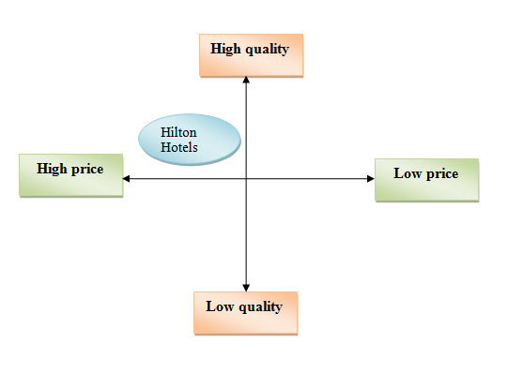
Figure 1: Positioning map
(Source: Created by the author)
Competitors: Bowman’s strategic clock
Bowman's strategic clock refers to the market positioning of a firm based on the inherent approach towards market adaptation, (Jin et al., 2019, p. 573). The strategic dimensions within the clock's purview vary from low to high on the indices of price and perceived value to the consumers, (Fahy and Jobber, 2019). Out of the eight strategic dimensions available the approach of Hilton Hotel resembles that of a hybrid which aligns with the wide variety of brands the company owns under its name. The hybrid approach enables the business to adhere to moderate differentiation as well as dynamic pricing in its market outlook, (Morrison, 2022).
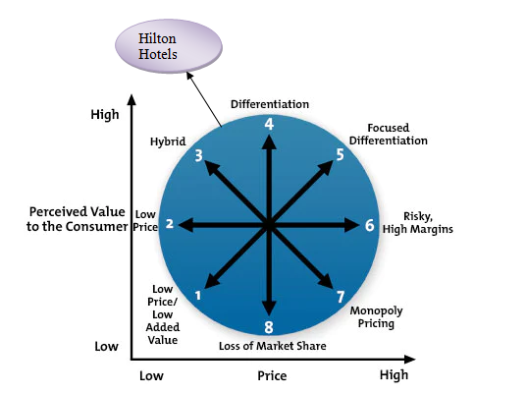
Figure 2: Bowman’s strategic clock
(Source: Created by the author)
Collaborators
The company operates through collaborative ownership across the global business environment under B2C segment. It has 19 brands under its name which have been acquired through the use of the mergers and acquisitions approach.
Climate: PESTLE
Factors | Description | Impact
Political | Post-Brexit implications | Can disrupt the supply chain relations
Economical | High inflation | Increased lending rates for the business, (Sánchez et al., 2020, p. 9926)
Social | Changing dynamics of consumer persona | Low consumption trend among UK consumers
Technological | R&D development trend | Use of digital marketing strategies based on AI, (Ducange et al., 2018, p. 329)
Legal | Employment regulations | Employee relation management
Environmental | Sustainability inclination | Brand awareness and brand image, (Kotler et al., 2020)

Marketing Mix

Product | Hospitality service
Price | Competitive pricing strategy
Place | UK and 122 countries
Process | Operational management for effective service delivery
Physical evidence | Located over 7000+ locations
Promotion | Social media advertising
People | Skilled employees

Objectives
The objective of the marketing plan is to achieve higher brand awareness to enhance the market share of the business through the use of digital marketing strategies by the end of the year.

SMART target
Objectives | Specific | Measurable | Attainable | Relevant | Time-bound
To gain higher brand awareness | Essential for increasing consumer outreach | Through an increased volume of sales | Distinct digital marketing approaches | Required to gain a competitive advantage | 6 months
To enhance the market share | Essential for strengthening business benchmarks in the hospitality sector | Through the positive performance of distinct brands owned by the company | By use of appropriate business and marketing strategies | Required to gain a competitive advantage | 1 year

Strategy
The company's current value proposition is based on the inherent application of a uniform marketing approach to cater for the advertising needs of the business. However, a renewed transition is required in this foray as the company needs to focus on the brand awareness metric by use of a distinct marketing approach for its various brands based on their individual needs. It could enable the business to create a value proposition which aligns with its consumer preferences along with the company's inherent growth needs, (Ho and Law, 2022, p. 133).

The Ansoff’s matrix depicts the various directions that can be opted by the business to enhance its competitive leverage. The adaptation of the market penetration approach is a viable strategic venture that the business can opt for to gain a higher market share in the global hotel industry.

The pricing and promotion strategies of the marketing mix are to be altered to align with the changed metrics of the business strategy.
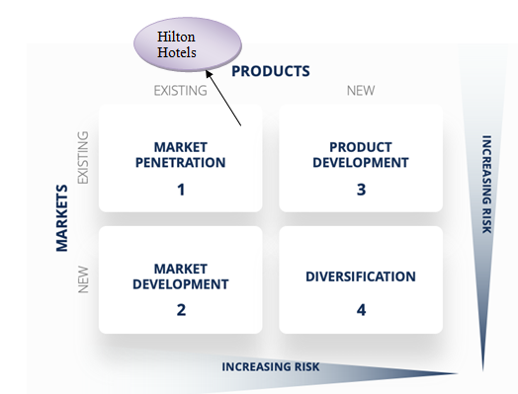
Figure 3:Ansoff matrix
(Source: Created by the author)

Tactics

The analysis of the macro and micro environment of the business has depicted the key functionalities which can be improved upon. The addressing of these issues can be overcome by the development of a comprehensive digital marketing approach for the business which caters to its wide range of service offerings, (Smith and Zook, 2020). The following communications approach can enable the company to develop a consumer-centred viewpoint in its purview along with mitigation of the key challenges faced.

RACE framework
Reach | The first step refers to the reach attribute which is to be planned by diversification of the company's social media outreach through the use of marketing campaigns. Subsequently, AI is to be deployed to recognise consumer trends and develop a marketing design that aligns with it for higher accuracy in objectives achievement, (Forbes, 2019).
Act | The development of a marketing plan, reaching out to consumers and gathering their views regarding the directed approach. Subsequently development of distinct consumer touches points that enable the business to enhance its consumer engagement, (Bowie et al., 2017).
Convert | The data aggregated through distinct sources of consumer touch points and digital marketing can entail Hilton Hotels with a large variety of consumer leads. The business can thereby develop a follow-up strategy through the use of discounts, rewards, promotional offers and personalised experience to convert potential leads into sales.
Engage | The last stage of the RACE framework relates to the engagement of the customers of the business which the company needs to emphasise by the use of customer service strategies, (Jobberand Ellis, 2020). The company is to reflect upon the various techniques that can be implemented for enhancing the experience value of the consumers during their stay at the hotel.

As discussed the social media approach of the company is unidirectional in nature and is emphasised on creating higher brand awareness however lacks the follow-up strategy required for consumer conversion. The company is involved in a host of sustainable practices which can be deployed as effective methods to gain consumer engagement and influence their brand perception. Further through the use of AI consumer trends can be recognised based on which the consumer touch points can be altered to suffice the inherent organisational needs of Hilton Hotels.

Action

Gantt chart of marketing activities

The marketing activities detailed above are to be carried out in a sequential manner to achieve the prospects of the marketing plan.

The marketing channel schedules have been planned to suffice the distinct needs of the project as well as to ensure the conduction of activities with high accuracy. The decisions taken in regards to planning and scheduling have been driven by the use of appropriate concepts and theory of project planning.

Control

The distinct metrics that can be deployed to measure the success of the proposed marketing approach of the business are:

Customer Acquisition cost | It can assist in determining the efforts business is required to induce for customer conversion and should be in declining trend, (Blakeman, 2018).
Sales volume | An increase in sales volume is a positive sign
Website Traffic generated | Higher traffic generation is to be aimed at increased market outreach
Brand perception | Positive feedback from consumers
Profit increase | An increasing trend of operating profit for the business

Conclusion

The marketing plan in its view illustrates the manner in which the contemporary issue faced by Hilton Hotels can be effectively managed to support its further organisational growth. The key marketing issue which the plan caters to address within its purview relates to the exercise of analysing the changing marketing dynamics in UK to cater to the impeding needs of competitive leverage in the hospitality industry. Based on the concerned issue the subsequent planning exercise has been developed in the study.
Through the use of distinct models and frameworks, a detailed overview of the various strategic forays which can be adopted by the business to strengthen its marketing approach has also been illustrated.

References
Marketing plan
Books
Blakeman, R., 2018. Integrated marketing communication: creative strategy from idea to implementation. Rowman & Littlefield.https://books.google.com/books?hl=en&lr=&id=m-1DDwAAQBAJ&oi=fnd&pg=PR3&dq=marketing+plan&ots=RENisukgTq&sig=yXkwMVNOSijuI7juCsp3vRHLASw
Bowie,D. Buttle,F. Brookes,M & Mariussen,A 2017, Hospitality Marketing. 3 rd ed, Routledge, London
Chaffey, D. and Smith, P.R., 2022. Digital marketing excellence: planning, optimizing and integrating online marketing. Taylor & Francis.https://books.google.com/books?hl=en&lr=&id=GmmdEAAAQBAJ&oi=fnd&pg=PP1&dq=marketing+plan&ots=aux-6xAZb4&sig=R5n6MXYp0T_vZIl3QJbxFxt8OOA
Fahy, J. and Jobber, D., 2019. EBOOK: Foundations of Marketing, 6e. McGraw Hill.https://books.google.com/books?hl=en&lr=&id=RssvEAAAQBAJ&oi=fnd&pg=PP1&dq=marketing+plan+&ots=6brKBNo-Md&sig=3JD-oPJ4h6jxwq79yjJbKlwbHLE
Ferrell, O.C., Hartline, M. and Hochstein, B.W., 2021. Marketing strategy. Cengage Learning.https://books.google.com/books?hl=en&lr=&id=SewfEAAAQBAJ&oi=fnd&pg=PP1&dq=marketing+plan&ots=PgWwzxFh-5&sig=OHqj_3HqMtrUKcfiF9AiouKs9YI
Jobber, D. and Ellis-Chadwick, F 2020. Principles and practice of marketing. 9th ed. London:
Kotler, P., Armstrong, G., Harris, L. and He, H., 2020. Principles of marketing. 8 th European ed, London: Pearson Education Limited.
Morrison, A.M., 2022. Hospitality and travel marketing. Taylor & Francis.https://books.google.com/books?hl=en&lr=&id=N6iIEAAAQBAJ&oi=fnd&pg=PT18&dq=marketing+plan+&ots=EH1jLD6U82&sig=VvNTLhmUoPhU7OK5FXJ99Q5KI1Q
Pride, W.M. and Ferrell, O.C., 2019. Marketing. Cengage Learning.https://books.google.com/books?hl=en&lr=&id=AaCgEAAAQBAJ&oi=fnd&pg=PP1&dq=marketing+plan+&ots=HJ3wgFZez1&sig=MlszOw_Q0FKvmOuN6q97QL5b5q8
Smith PR and Zook ZE 2020.Marketing Communications. 7 th ed, Kogan Page, London
Journals
Ducange, P., Pecori, R. and Mezzina, P., 2018. A glimpse on big data analytics in the framework of marketing strategies. Soft Computing, 22(1), pp.325-342.https://link.springer.com/article/10.1007/s00500-017-2536-4
Ho, G.K. and Law, R., 2022. Marketing strategies in the decision-making process for undergraduate choice in pursuit of hospitality and tourism higher education: The case of Hong Kong. Journal of Hospitality & Tourism Education, 34(2), pp.124-136.https://www.tandfonline.com/doi/abs/10.1080/10963758.2020.1791136
Jin, S.V., Muqaddam, A. and Ryu, E., 2019. Instafamous and social media influencer marketing. Marketing Intelligence & Planning, 37(5), pp.567-579.https://www.emerald.com/insight/content/doi/10.1108/MIP-09-2018-0375/full/html
Sánchez-Teba, E.M., García-Mestanza, J. and Rodríguez-Fernández, M., 2020. The application of the inbound marketing strategy on costa del sol planning & tourism board. Lessons for post-covid-19 revival. Sustainability, 12(23), p.9926.https://www.mdpi.com/904362
Websites
forbes (2019) Inside Hilton's marketing strategy, Forbes. Forbes Magazine. Available at: https://www.forbes.com/sites/paultalbot/2019/05/23/inside-hiltons-marketing-strategy/ (Accessed: May 8, 2023).

Appendices
Appendix 1: PESTLE analysis
Factors | Description | Impact
Political | Post-Brexit implications | Can disrupt the supply chain relations
Economical | High inflation | Increased lending rates for the business
Social | Changing dynamics of consumer persona | Low consumption trend among UK consumers
Technological | R&D development trend | Use of digital marketing strategies based on AI
Legal | Employment regulations | Employee relation management
Environmental | Sustainability inclination | Brand awareness and brand image
Appendix 2: Marketing mix
Product | Hospitality service
Price | Competitive pricing strategy
Place | UK and 122 countries
Process | Operational management for effective service delivery
Physical evidence | Located over 7000+ locations
Promotion | Social media advertising
People | Skilled employees
Appendix 3
Slide 1:

Slide 2:
Notes
The purpose of the current marketing plan is to provide an innovative solution for encompassing the fast-changing dynamics of the marketing environment in UK in the post-pandemic period for Hilton Hotels. It is to be presented to the board members and the marketing team of the company and has been developed through the use of 5C's Ansoff matrix, RACE framework, SWOT analysis and similar other analysis tools.
Slide 3:
Notes
The objective of the marketing plan is to achieve higher brand awareness to enhance the market share of the business through the use of digital marketing strategies by the end of the year.
Slide 4:
Notes
However, a renewed transition is required in this foray as the company needs to focus on the brand awareness metric by use of a distinct marketing approach for its various brands based on their individual needs.
Slide 5:
Notes
The Ansoff’s matrix depicts the various directions that can be opted by the business to enhance its competitive leverage. The adaptation of the market penetration approach is a viable strategic venture that the business can opt for to gain a higher market share in the global hotel industry. The pricing and promotion strategies of the marketing mix are to be altered to align with the changed metrics of the business strategy.
Slide 6:
Notes
Through the use of distinct models and frameworks, a detailed overview of the various strategic forays which can be adopted by the business to strengthen its marketing approach has also been illustrated.

Slide 7:
Slide 8:

