University of Wales Trinity Saint David

BSc Ordnance, Munitions and Explosives



Replacement of MK2 Rapid Cratering Kit Group Project (ACDA5022)

Albie Willett

2030850

Date: 19/04/2024

Lecturer: Dave Holley

Contents
1.0 Introduction Error! Bookmark not defined.
1.1 Aims & Objectives Error! Bookmark not defined.
2.0 Project Start Up Error! Bookmark not defined.
3.0 Test and Evaluation Error! Bookmark not defined.
4.0 Packaging requirements Error! Bookmark not defined.
5.0 Presentation feedback Error! Bookmark not defined.
6.0 Reference List Error! Bookmark not defined.

- Introduction
On the 12/02/2024 the Project Team were briefed on a requirement to replace the MK2 Rapid Cratering kit. This Kit was produced at ROF Chorley using the run off from the shell filling process using RDX/TNT. [1]
The Project team were briefed on how the Cratering kit is used to dig defensive positions however later in the project additional uses of the kit were uncovered and included in the requirements.
The Kit consisted of a Shock tube, Detonator, Booster, Shaped Charge and Bag Charge. Each component has a different function and this was highlighted in the Functional Decomposition in the design process.

Once the requirements were fully understood. Roles were assigned to members of the Project Team. These were broken down into Design and systems engineer, Manufacturing engineer, Test and evaluation engineer, Environmental Test engineer and Breakdown and Disposal engineer.

Once the roles were assigned and the tasks understood the team worked together to deliver on the requirements and propose a solution the meet the design brief. This proposed design was delivered to the review panel who confirmed that it was on track and meeting their requirements. This then allowed the project team to finalise the design for the presentation where it could be critiqued and then further improved.

  - Aims & Objective
The Aims and Objectives of the brief was to demonstrate excellent collaboration within the project team to help critically analyse and select appropriate OME to produce a given effect. This was to be completed using a systematic understanding of the scientific principles behind OME design. Feedback would then be incorporated into the design and this portfolio. [1]

- Project Start Up
On the 12/02/2024 the project team were briefed on the requirements of the project. The “Must have” requirements were outline in that brief. [1] After the briefing the team discussed how Milestones were going to be managed and the Communications issued between team members. Once communication methods were decided the team brainstormed ideas on how to complete the design process the chosen method was to use a systems engineering approach to guide the Design, Manufacturing process and Test plan.

On the 13/02/2024 the first systems engineering tools were used. A Stakeholders influence map was completed as a team to begin to understand what needed to be designed before designing the thing right. Once completed the team accumulated requirements from each stakeholder into Table 1 below. The lack of precise numbers for the non-functional performance requirements lead to the team to recommend with their own technical knowledge and by completing additional research on what those exact performance requirements should be.
Table 1

A functional decomposition was also completed as a team to understand how the previous design functioned which assisted the team to understanding the requirements. As seen in figure 1.
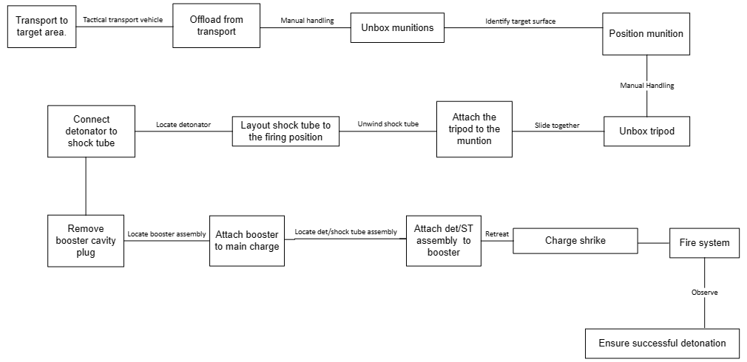
Figure 1

The Team reconvened on the 28/02/2024 with the figures for the performance requirements which then allowed the team to complete Quality Function Deployment 1 (QFD 1). The Input of the Test and Evaluation engineer in this process was to provide the exact Environmental performance requirements which were interpreted from the initial design brief and Def Stan 00-035 Pt 2 Issue 6 [3]. This information allowed for a pairwise comparison to be completed and QFD 1 to be completed effectively providing a Functional importance graph that could be used to prioritise the Functions of the design. As the minute’s taker of meetings the environmental test and evaluation engineer issued email minutes to the project team to ensure schedule adherence and clear communication. The Milestones and Meeting overview can be seen in Table 2 and Table 3 below.
Milestones | Tasks
12/02/2024 | Project initiation
15/04/2024 | Design review
23/04/2024 | Group presentation
06/05/2024 | Portfolio submission date
Table 2
Meeting Date | Meeting overview
13/02/2024 | Gathered initial requirements, assigned individuals roles and discussed preliminary design
28/02/2024 | Design review and task allocation
06/03/2024 | Project update using systems approach
12/03/2024 | Project update using systems approach
16/04/2024 | Assisted Design engineer with IM and packaging requirements
18/04/2024 | Presentation review
Table 3

- Test and Evaluation
The project was broken down into roles which were then assigned to individuals. A large role within designing a replacement or new munition is in the test and evaluation process. Due to the scale of the work, Test and evaluation was broken down into insensitive munition testing, EMTAP testing, function testing and Environmental testing. This was then distributed between 2 team members. To breakdown the Testing program all of the performance requirements outlined in QFD 1 had to be assessed. The below table shows how the requirements were split according to expertise and work load.
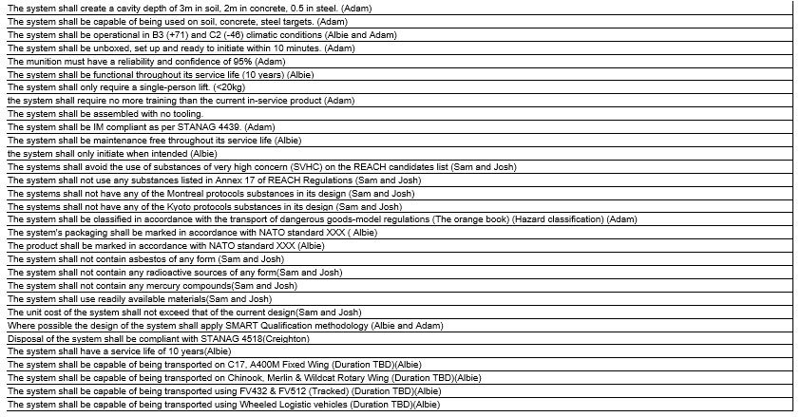
Table 4
The majority of test were split between the Test and Evaluation engineer and the Environmental test engineer.
The Environmental test engineer tasks included: Environmental testing at -46°C and +71°C, Functional over a service life of 10 years, Test if the munition was maintenance free over its service life, That the munition won’t initiate during its service life, Packaging Requirements and corresponding tests, consider the use of SMART qualification and corresponding vehicle vibration testing.

  - How to decide on the Environmental test plan?
The Environmental test plan is usually decided by the customer and where the team using the cratering kit require to use the munition. However this was not completely provided in the design brief so had to be developed by using Def Stan 00-035 Issue 6 Pt 2 [3] , Pt 3 [4], Pt 4 [5] and Pt5 [6]. Predominantly Pt 2 was used as it focuses on Environmental Trials Programme Derivation and Assessment Methodologies.
The initial requirement to select an Environmental test program is to understand the Environments that the munition will see and the sequence in which it will see it. This is laid out in a Manufacture to Disposal sequence (MTDS). Part of the environmental requirements were determined in the initial design brief [1] these included:
Desert / Hot climate operations though worldwide, all climate capability is desirable;
The system should be transportable in the current range of transport aircraft both fixed and rotary wing; Tracked and wheeled road transport are required; Product service life must be in excess of 10 years.
This information formed the backbone of the MTDS sequence however further evidence in Pt 2, Pt 4 and Pt5 of Def Stan 00-035 recommended further tests and also provided test severities.
Stage 2 of selecting a test program involves establishing critical environments to avoid repeat testing.
Stage 3 involves preparing a cost effective cost plan while ensuring safety is not compromised.
This is summarised in the below table found from Def Stan. [3]
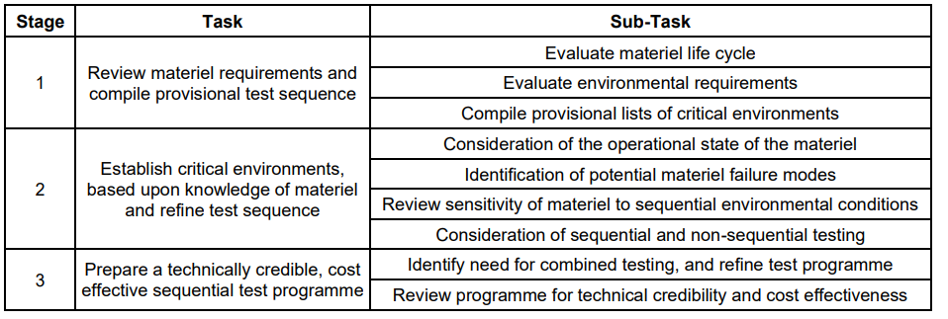
Table 5

The MTDS should be broken down into major phases these are outlined below:
Delivery, Storage, Transportation to forward depot, Transportation beyond forward depot, Field storage, Installation on deployment, Operational use, Munition return and material disposal. Once broken down tests can be selected.
3.1.1 Delivery
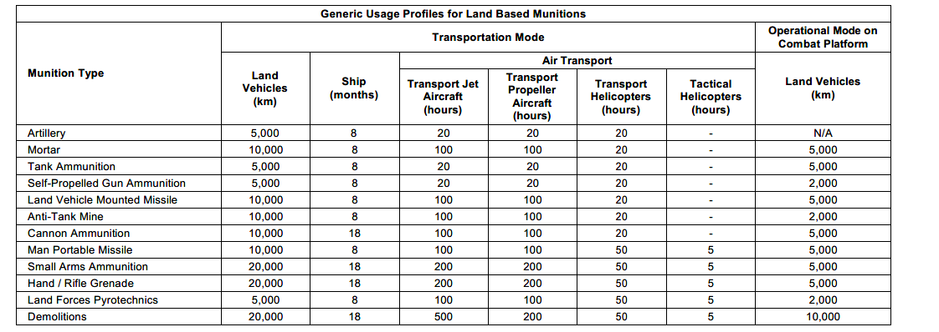
Table 6
This is the first part of the MTDS and the table above shows generic usage of a selection of munitions in particular Demolitions like the Cratering kit found in this portfolio.
Under the Demolition section the Land Vehicles can transport the munition up to 20,000km
Using this information and the information found in Def Stan 00-035 Pt 3 and Pt 5 Issue 6 the below test specifications will satisfy the requirement.
Procedure: DEF STAN 00-035 Part 3 Issue 6, Test M1 Chapter 2-01, Figure A1
Configuration: All 3 Axis
Duration: 4 hours per axis
Temperature: Hot Stream (+71) Cold Stream (-46)

Procedure: DEF STAN 00-035 Part 3 Issue 6, Test M3 Chapter 2-03, Figure A12a
Configuration: All 3 Axis
Shock Number: In accordance with figure A12a
Temperature: Hot Stream (+71°C) Cold Stream (-46°C)

During the Delivery period of a MTDS, the munition has the potential to experience a drop this is simulated with the below test.
Procedure: DEF STAN 00-035 Part 3 Issue 6, Test M5 Chapter 2-05, Table 1
Configuration: Base down and 45º
Quantity: Two drops at each conditioned temperature one in each drop configuration
Height: 0.75m
Temperature: Hot Stream (+71) Cold Stream (-46)

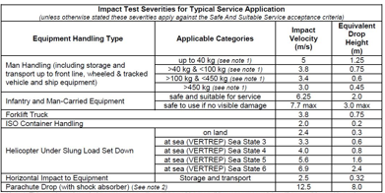
Table 7

3.1.2 Storage
The next phase of the MTDS program is storage. This is not a dynamic test however hot and cold temperatures can lead to thermal degradation of components as well as the energetics.
There are two different types of storage that the munition will experience. The first is at a Depot where the environmental conditions are controlled to be at ambient temperature. There should be very minimal degradation in these conditions and the easiest way to simulate this in a test environment is to add an additional control stream of test assets that don’t experience any testing throughout the program until Breakdown and Chemical analysis.
The other component of storage is storage at forward depot. The munition can potentially experience much greater temperature range at these facilities and the best method for testing this is by completing accelerated aging of the munition. First, the test duration has to be determined this can be outlined by the customer or by using the typical durations found below:
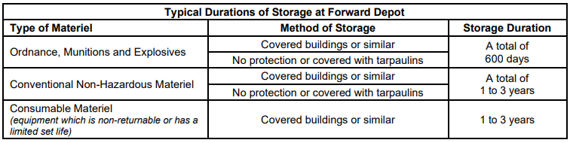
Table 8
After the duration is determined the severity of the test has to be decided this can be achieved by using part of the below flowchart and information from the customer and Def Stan 00-035 Pt 4 issue 6.

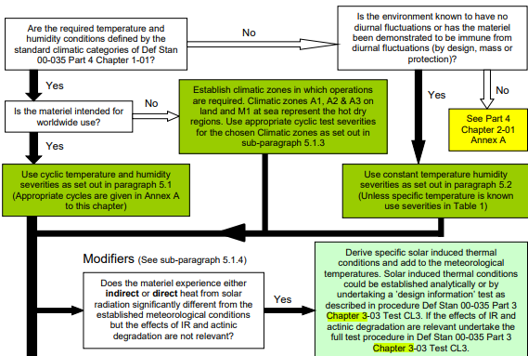

Figure 2
With this information, 3 Diurnal cycling programs would satisfy the requirements these included a high temperature low humidity cycle such as A1 conditions, A high humidity and high temperature diurnal cycle like B3 conditions and low temperature C2 conditions.
As part of stage 2 and 3 of selecting a test program it mentions that critical environments shall be examined and a cost effective program should be selected as a result. With this information in mind the Environmental test engineer has selected to remove the A1 cycling as this wold be repeated in the B3 diurnal cycling as well as reducing the cost for the program.
The selected test specifications are shown below:
B3 Storage
Procedure: DEF-STAN 00-035 Part 3 Issue 6, Test CL6, Chapter 3-06, Figure A5, B3 Storage and Transport Test Cycle
Configuration: Packaged
Orientation: base down
Duration: 56 cycles
C2 Storage
Procedure: DEF-STAN 00-035 Part 3 Issue 6, Test CL5, Chapter 3-05, Figure A5, C2 meteorological and Storage and Transit
Configuration: Packaged
Orientation: base down
Duration: 14 cycles

3.1.3 Transportation beyond forward depot
The next phase as part of the MTDS once the munition has been transported and stored at a forward depot is for the munition to be transported to theatre and beyond. This can be achieved by a range of different methods. The three main categories are by air transport, by land and by sea. The final method will not be considered for this program of work due as it is not outlined in the system requirements.
Of the two method these can both be broken down in to further sub groups. Air transport can be broken down into fixed wing and rotary wing while land transport can be either wheeled vehicle or tracked vehicle.

From the system requirements “The system should be transportable in the current range of transport aircraft both fixed and rotary wing” [1]. The current range of transport aircraft used by the British military include: A400m, C17, Chinook, Merlin and Lynx. Alongside the generic usage profile found in table 6 the test specification and severities can be determined. Air transport is used to transport the munition from forward depot to theatre where the munition can be transported to its final destination using land based vehicles. This determines the sequence of tests in the MTDS. See below test specification for each test.
Fixed:
Wing Jet Aircraft
Procedure: DEF-STAN 00-035 Part 3 Issue 6, Test M1, Chapter 2-01, Figure A5
Orientation: base down
Duration: 5 hour per axis
Temperature: Hot stream (+71°C) and the Cold stream (-46°C)
This test is equivalent to 500hrs of Air transport

A400m Propeller Aircraft
Procedure: DEF-STAN 00-035 Part 3 Issue 6, Test M1, Chapter 2-01, Figure A8 and A11
Orientation: base down
Duration: 8 hour for Vertical and 16hrs for Transverse
Temperature: Hot stream (+71°C) and the Cold stream (-46°C)
This test is equivalent to 200hrs of Air transport

Rotary:
Chinook Helicopter
Procedure: DEF-STAN 00-035 Part 3 Issue 6, Test M1, Chapter 2-01, Figure A12
Orientation: base down
Duration: 1.5 hours per axis
Temperature: Hot stream (+71°C) and the Cold stream (-46°C)

Merlin Helicopter
Procedure: DEF-STAN 00-035 Part 3 Issue 6, Test M1, Chapter 2-01, Figure A13
Orientation: base down
Duration: 1.5 hours per axis
Temperature: Hot stream (+71°C) and the Cold stream (-46°C)

Lynx/Wildcat
Procedure: DEF-STAN 00-035 Part 3 Issue 6, Test M1, Chapter 2-01, Figure A14
Orientation: base down
Duration: 2 hours per axis
Temperature: Hot stream (+71°C) and the Cold stream (-46°C)

Each Test is equivalent to 60hrs of flight time
The above tests either exceed or meet the requirements outlined in the system requirements and have simulated the munitions life cycle up until operational use in the field.

3.1.4 Operational use/ Transport to frontline
This is broken down into wheeled and tracked vehicles with the requirement from the customer stating that both are required. This will form the last part of dynamic testing in the environmental test plan as the munition will ideally be functioned at the end of it. If the munition was not to be functioned it can either repeat any of the earlier phases or be broken down and disposed of. This part of the design project was investigated by the breakdown and disposal engineer. Testing for these repeated phases has already been completed throughout the test program as the worst case scenario was selected.
Using the generic usage profile table 6 the total distance the munition could see is 10,000km. This is a combined number of both wheeled and tracked vibration. Using Table 9 the 10,000km can be broken down equally into off road wheeled transport and tracked vehicle transport.

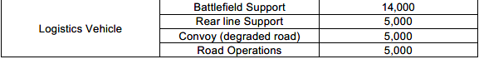

Table 9
Below are the final vibration and shock test specifications for operational use:

Off road and degraded road wheeled transport
Procedure: DEF-STAN 00-035 Part 3 Issue 6, Test M1, Chapter 2-01, Figure A2
Orientation: base down
Duration: 5 hour per axis
Temperature: Hot stream (+71°C) and the Cold stream (-46°C)

Restrained Cargo Shock
Procedure: DEF-STAN 00-035 Part 3 Issue 6, Test M3, Chapter 2-03, Figure A13a
Orientation: Base down
Shock Number: As Per Figure A13a
Temperature: Hot stream (+71°C) and the Cold stream (-46°C)

Bounce Test
Procedure: DEF-STAN 00-035 Part 3 Issue 6, Test M11, Chapter 2-11, Para 5.5b, motion as per Para 4.2.6
Configuration: Mounted in Rig
Orientation: Base Down
Duration: 20 Minutes
Temperature: Hot stream (+71°C) and the Cold stream (-46°C)

Tracked vehicle

Low Speed Portion
Procedure: DEF-STAN 00-035 Part 3 Issue 6, Test M1, Chapter 2-01, Figure A24
Orientation: Base down
Duration: 1.25 hour
Temperature: Hot stream (+71°C) and the Cold stream (-46°C)

High Speed Portion
Procedure: DEF-STAN 00-035 Part 3 Issue 6, Test M1, Chapter 2-01, Figure A25
Orientation: base down
Duration: 1.25 hour
Temperature: Hot stream (+71°C) and the Cold stream (-46°C)

The final test of the Environmental test program qualifies the munition for Desert usage. This test was left until last as it is one of the most aggressive test the unpacked munition will experience. This test is especially important as the IM design of the munition has vents these vents increase the amount of potential failure modes and the likelihood that it will fail. The Sand and dust test specification is shown below:

Sand and Dust
This test is to be carried out according to DEF STAN 00-35 Part 3 Issue 6, Chapter 3-25 Test CL25:
Test Procedure: Blown Sand Test
Sand grade: Silica sand
Particle concentration : 1.1 g/m3 ± 0.3g/m3
Temperature: 18 m/s
Duration: 3 hours per vulnerable face

3.1.5 Breakdown and Chemical analysis
This is the final test before a sample are functioned of any Environmental test program where a control sample is compared with a munition that has completed testing. If the degradation is at a tolerable level the munition has passed but if it fails it’s testing the results from those tests can help the design team to propose different design solutions to overcome the failure mode.
The breakdown component of the trial will be conducted by the breakdown and disposal engineer.

All of the above tests are summarized within the below flowchart:
Figure 3
  - How can testing be completed?
Throughout the test program tests are broken down into mechanical and climatic tests. Mechanical tests are mostly completed by Electromagnetic shaker systems. These systems can vary in size and configuration however all will be selected on their ability to complete the test. For a smaller packaged asset these vibration tests can be completed on a single shaker system with a head expander. A single shaker system cannot complete testing in all axis simultaneously this results in there being 3 different runs where the asset or shaker is rotated between each. Despite this increase in time the single shaker system is particularly effective at large displacement testing as seen in road transport and off road transport. Additionally the system is simpler than the alternatives as it can use average control of 2 or more accelerometers.

Alternatively vibration and shock testing can be completed on systems with multiple shakers. These have the ability to support larger loads and/or complete multiple axis at the same time. The limitations is that the control on the asset is harder to achieve and the systems usually cannot complete large displacement testing and prefer high frequency specifications such as air transport. Despite the time saving opportunities this testing costs more and due to the relatively small test durations of the air transport of this particular munition the time saving would not outweigh the extra cost.

Drop tests in the program include the delivery drop test this is a simple test which is achieve by using a hoist to lift the packaged munition to 0.75m where it is then dropped using a bomb release. Throughout this the test specimen must remain in the correct orientation for landing.

Bounce testing is the final dynamic test and is achieved by placing packaged items on a rig over a camshaft. This can be either synchronous on non-synchronous to replicate the munition being transported in the back of a vehicle unrestrained.

Climatic testing
All dynamic testing is completed at either Hot or Cold temperature however there are particular tests which don’t require dynamic testing and only the climatic component. Different equipment is used to achieve the climatic testing. For the Diurnal cycling a climatic chamber which can control humidity and temperature are used as seen below.
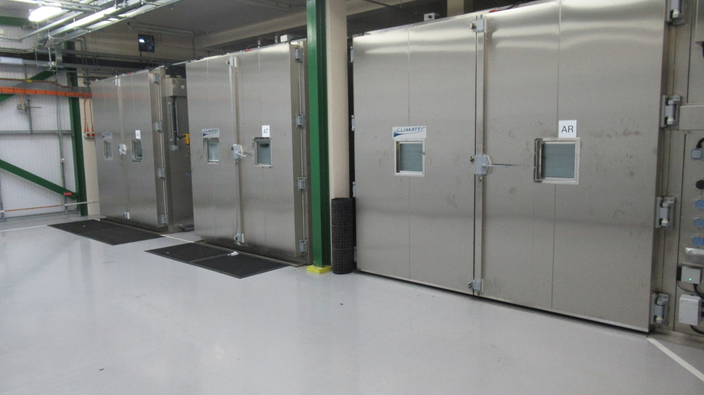
Figure 4
The final test of the program the sand and dust testing uses a more unique piece of equipment. In Def Stan 00-035 there is a recommended equipment design which can complete the tests. The schematic is shown below in figure 5.
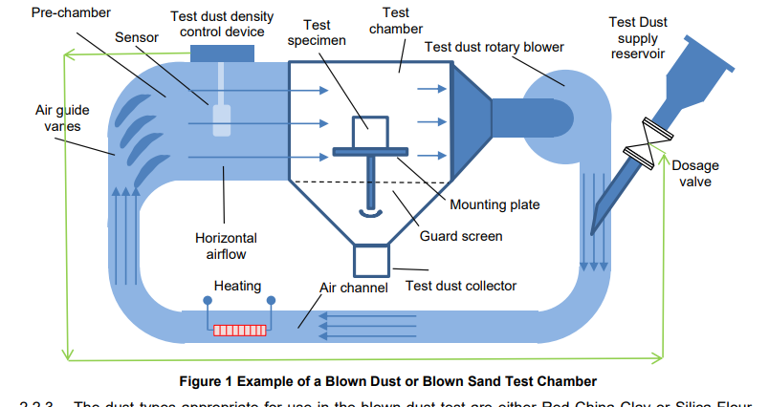
Figure 5
  - Safety
Throughout the environmental test program a safe systems of work ensure that the delivery team are less likely to be injured and the work they complete is ALARP. There is a selection of safety paperwork and procedures which form part of the safe systems of work.
- 1 Trials Set-up
- 2 Safety Documentation
- 3 Risk Assessments
- 4 Safety Brief
- 5 Movement Plan
- 6 L1 HAM Peer Review
- 7 Trial Safety Certificate
- 8 Trial Readiness Review
- 9 Trial Instruction
The list above is a rough summary of the paperwork. The two major hazards are the munition and the equipment used for the test. The equipment will have Work Instructions and will be operated by competent staff. This paperwork is written by the environmental test centre completing the work and will be transferable between different trials. There is also trial specific hazards presented from the munition. These hazards are highlighted from the safety work provided by the system and design engineer and the results from the tests completed by the test and evaluation engineer such as EMTAP data.

- Packaging requirements
To reduce the quantity of work from the systems and design engineer the Environmental test engineer was also task to investigate packaging requirements. In the system requirements there was a requirement to be transported by a single person lift of ~20kg however throughout the design process this requirement was compromised as it had a low priority. The final munition design weighed 26.05kg it was also chosen that 2 munitions will be transported in the same box bringing the total to 52.1kg. Once the weight had been calculated the box design could then be chosen. 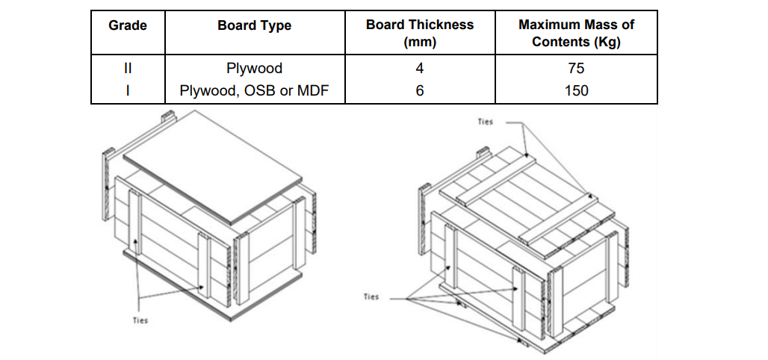 [7]
Figure 6
The above figure from Def Stan 81-008 Issue 8 show the construction of the selected box with appropriate material construction and has the ability to be lifted using a forklift using MHE to avoid unnecessary manual handling. Handles will be fitted so a multiple person lift can still move the packaging.

- Presentation feedback
Feedback on the presentation was provided on the 30/04/2024. This included questions around the Environmental plan for the Environmental Test Engineer to answer. The feedback included:
- How are cost savings made in diurnal cycling?
- What’s the difference between Chinook and other rotary wing? Have you got separate vibration cycles for these?
- How do you get the designers to pass the environmental testing first time? Small scale tests?
- Provide example of Test Report

5.1 How are cost savings made in diurnal cycling?
By implementing Stage 2 and 3 of Def Stan 00-035 part 2 a cost effective Environmental test plan has to be considered. This is achievable by reducing any repeat tests in particular repeat diurnal cycles. By selecting an extended B3 diurnal cycling it reduces the total test program duration by using a worst case environment. In this particular example B3 includes high temperature and high humidity while alternatives such as A1 cycling does not have the high humidity portion of the test. High humidity is more likely to induce moisture ingress which in turn results in degradation of explosive material or potential corrosion for some metal components.

5.2 What’s the difference between Chinook and other rotary wing?
Vibration profiles of each rotary wing aircraft have unique vibration profiles. These vibration characteristics vary as a result of relative amplitudes and frequencies of the rotor blades, tail rotor and transmission. These can vary from different flight conditions and the systems in place on the aircraft to mitigate against excessive vibration such as active mitigation systems. For the example of the Chinook vibration profile this will differ to other rotary wing profiles due to being a tandem-rotor helicopter rather than having an anti-torque rotor. The chinook as a result can travel faster, lift more and travel in more extreme conditions than other helicopters. The result of the above generates Lower frequency narrowband on the vibration profile as seen in below figures.
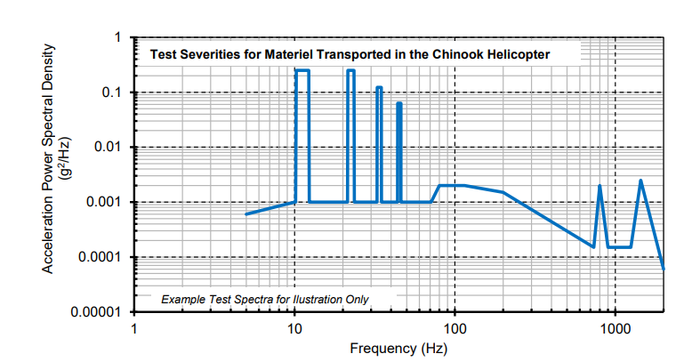
Figure 7
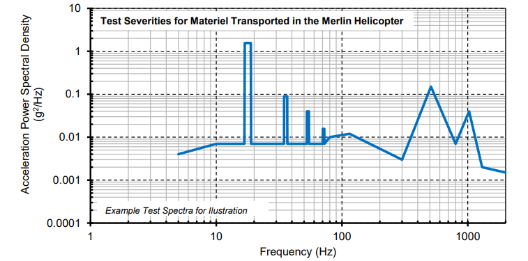
Figure 8
5.3 How do you get the designers to the pass the environmental first time?
There are a selection of methods which are used to ensure the munition passes environmental testing first time. From the design phase a critical analysis of the components and their functions helps the design engineer understand potential failure modes. This can highlight where improvements to the design need to be made.

Small scale testing is another method of ensuring the All Up Round (AUR) will successfully pass environmental testing. Small scale tests and component testing is more applicable for large complex weapon systems where they can be broken down in accordance with the architecture of the munition. This is less applicable for the chosen design of the munition as the design team has reduced the amount of parts in the rapid cratering kit. The only component that will be going through the environmental testing is the shaped charge as all the other components such as booster and detonator have completed testing already and are already qualified. The shaped charge can be broken down further to assess mechanical properties of the Liner, Case and Back plate. The energetic component has been assessed by the test and evaluation engineer.

Precursor testing prior to each environmental test is also a method which increases the chance of a munition passing. There are different types of precursor tests. Firstly there are those that use a Live Munition to complete the test prior to program items. This is not preferred as there is still an explosive hazard. Alternatively testing can be completed with a mass representative inert with similar dynamic responses. This is usually achieved by using the same casing and parts of the munition but replacing the energetic material with a wax which has similar properties to IMX – 310. This is a preferred solution as it will allow for the environmental test engineer ensure the correct test levels are achievable before testing with a live asset. This will minimise the chance that a live munition will not see the correct severity of test and the test be repeated. The disadvantage of this type of precursor testing is that the Inert Asset can potentially cost more than a live asset.

5.4 Example of Test Report
To form a Test report each test will receive a “certificate” or summary of each test with the information below:
Test Title, Items Tested, Test Specification, Tests Applied, Occurrences and Deviations, Results and Records.
This forms part of a Test report which highlights issues found with each munition that has completed the testing. This is tracked throughout the program through visual and radiographic inspections. By tracking damage sustained to the munition it can be deduced after which test the munition has failed and what damage is only cosmetic. Safety critical damage will result in the trial stopping as soon as it occurs and customer/manufacturer notified. The results from the testing allow for the munition to be assessed against the initial non-functional system requirements. If the munition was to pass these tests and meet these requirements this can be used as evidence to provide a safety case for the munition to enter service.

6.0 References

[1] | J. S. Dave Holley, ACDA 5022 BEng Group Project, Swansea: UWTSD, 2024.
[2] | D. Holley, ACDA 5022 Group Project, Swansea: UWTSD, 2024.
[3] | Defence equipment and support, Environmental Handbook for Defence Part: 02 : Environmental Trials Programme Derivation and Assessment Methodologies, Glasgow: UK Defence Standardization , 2023.
[4] | Defence Equipment and Support Part: 03 : Environmental Test Methods, Environmental Handbook for Defence Materiel, Glasgow: UK Defence Standardization, 2023.
[5] | Defence Equipment and Support, Def Stan 00-035 Environmental Handbook for Defence Materiel: Part 4 - Natural Environments, Glasgow: UK Defence standardization , 2023.
[6] | Defence equipment and support, Def Stan 00-035 Environmental Handbook for Defence Materiel: Part 5 - Induced Mechanical Environments, Glasgow: Uk Defence Standardization, 2023.
[7] | Defence Equipment and Support, Cases, Wood (Metal Edged Construction), Glasgow: UK Defence Standardization, 2023.

