
Cover Page
Student name: Sufina Begum
Student number: 2213097
Module: BMHP5015
Module name: Changemakers: Building your personal brand for sustainable employment
Lecturer name: Danielle Dunne
Component 2 – Written Assignment report

Introduction
The focus of my written assignment will be based on how I can develop my professional identity, how I can enhance my personal brand and create a network to land a successful position in social work. I will examine my own employability skills in relation to the job requirements. I will assess my abilities in relation to this job role and develop a plan of action and schedule to acquire the skills I need to succeed in it. I am interested in becoming a social worker because I have spent the past ten years, dedicating my time, commitment and passion to the most vulnerable families and children ensuring they are receiving the right level of care and support they require. To advance my career and acquire new skills, I feel prepared to take on increasingly difficult and complex cases.
Job advertisement – Social Worker
The job advertisement I have chosen is from WMJobs:

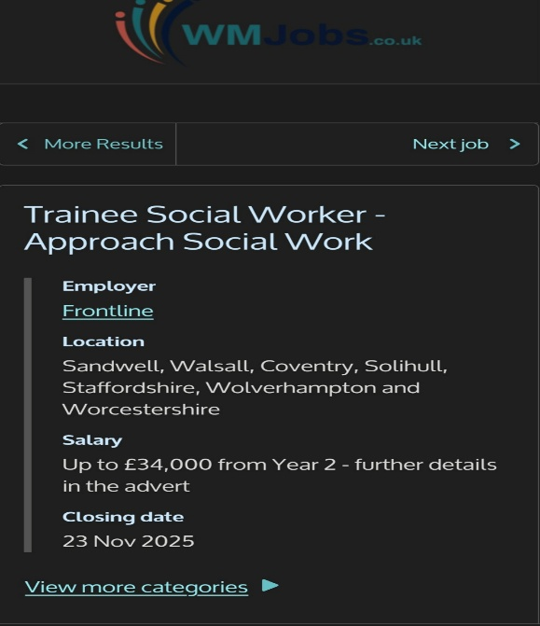
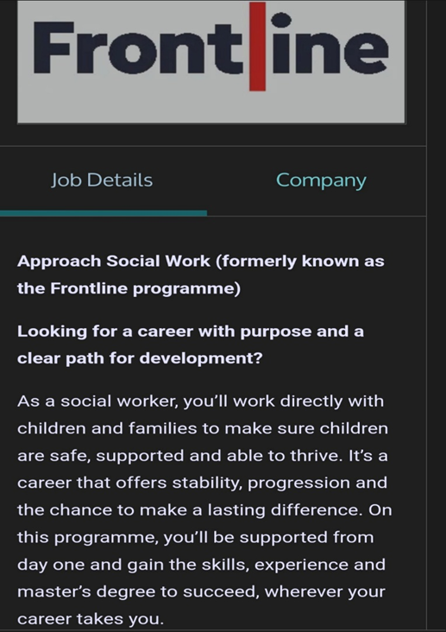

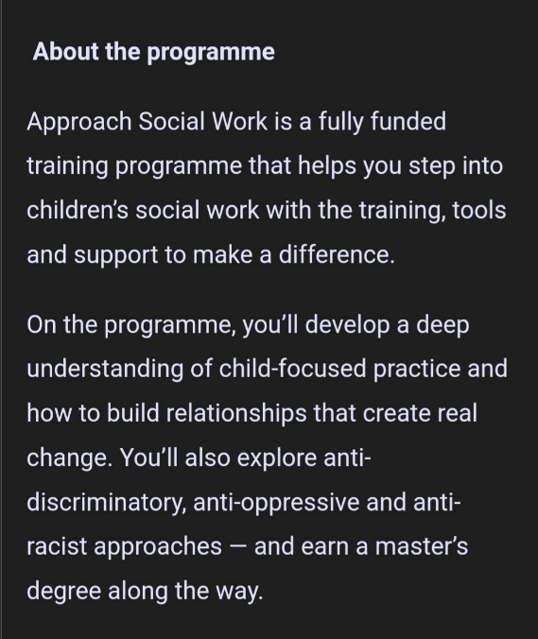
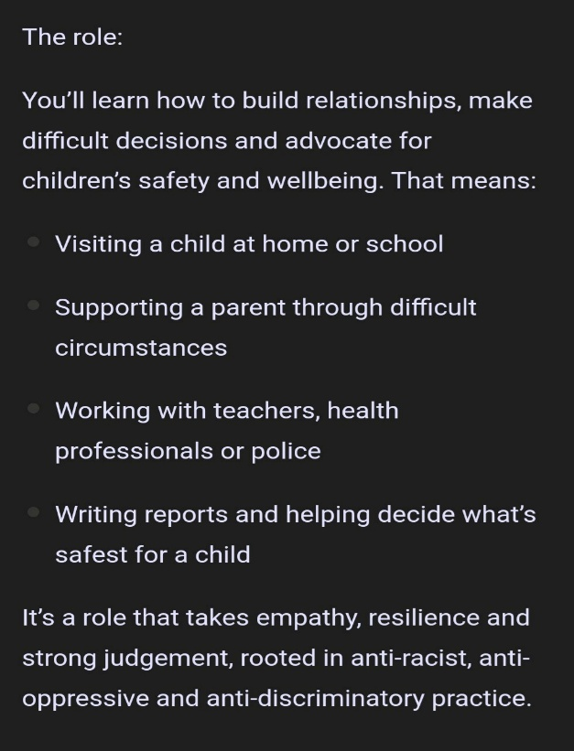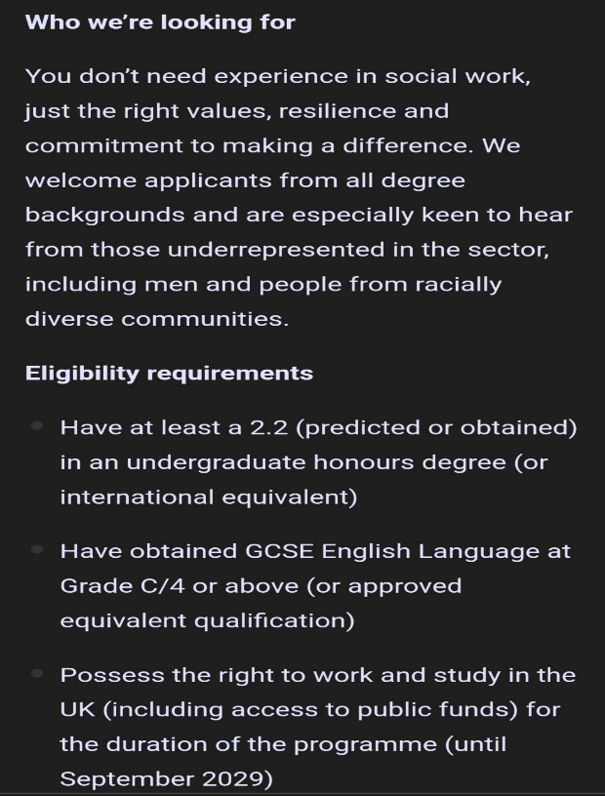

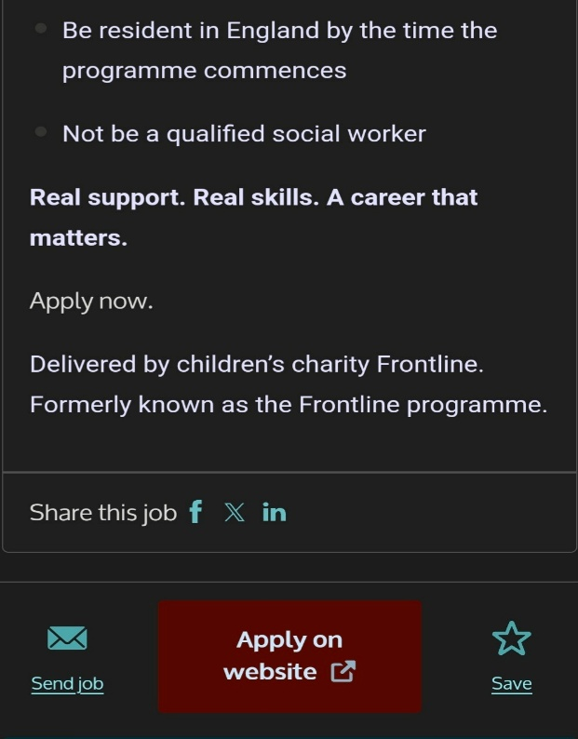

Job Role Employability Skills
The key employability skills stated in the person specification and job description are:
- child focused practice and how to build relationships to create real change
- making difficult decisions
- advocate for children’s safety and well-being
- liaising with professionals
- authoring reports and helping to decide what is the safest decision for the child
- empathy, resilience and strong judgement rooted in anti-racist, anti-oppressive and anti-discriminatory practice
Why each skill is important and how it contributes to effective performance
Young people’s needs are given priority by a child-focused social worker, allowing for targeted, interest – based interventions. According to William T and Parry S.L building solid trustworthy relationships social workers can meaningfully engage with families and children. This encourages transparency, integrity, and co-operation all essential for real change.
Social workers need to be able to make difficult decisions to uphold and balance the legal, moral and welfare duties mandated by frameworks such as the Social Care Institute for Excellence decision making tool and the professional standards of British Association of Social Workers.
Since protecting vulnerable children and advancing their welfare is a statutory duty for social workers, advocating for their safety and well-being is essential to their practice as stated by Social Work England. Social workers enhance results and lessen detrimental long-term effects like abuse or neglect by aggressively promoting the needs and rights of children according to NSPCC learning.
According to Kamrujjaman, M.D social workers collaborating with emergency medical services highlights how co-ordination of response to vulnerable individuals is improved through collaboration with other professionals. This demonstrates that social workers responses are more comprehensive and timelier when they collaborate with other professionals.
Writing reports as a social worker is crucial because it guarantees that all relevant information – facts, observations, risks, and recommendations are recorded accurately. According to the Social Care Institute for Excellence this gives multi agency teams a solid foundation for assessment, enabling them to make the best choice for the child.
Lynch, Newlands & Forrester state that empathy is crucial for a social worker: those with strong empathy reflect more, ask open ended questions and seek to understand challenging and emotionally charged experiences of the parents.
By enabling social workers to maintain their dedication and flexibility in emotionally charged and high stress environments, resilience helps social workers avoid burnout and sustain performance over time according to Kinman & Grant.
Social workers need to be fair, equal, respectful, anti-racist, anti- oppressive and anti- discriminatory. Dominelli emphasises that social workers must identify power disparities and actively combat them through inclusive, reflective practice to engage anti-oppressive practice. Social workers must support the ethical underpinnings of their profession and advance social justice by doing so.
Evaluate Your Own Skills
Self-assessment: According to Gregory, J I have effective communication skills and can work confidently with both adults and children from diverse backgrounds. My experience in inclusive environments allows me to remain impartial and professional in all interactions. I also demonstrate genuine compassion, empathy and understanding. Whether working as part of a team or independently, I consistently maintain high standards in my practice.
I hold a Level 3 Diploma in Children’s and Young People’s Workforce and a Level 4 in Health and Social Care, and I am currently progressing through my Level 5 and Level 6 in Health and Social Care. In my current role, I have strengthened my professional practice by completing Prevent Training, Basic First Aid, Level 2 in Health and Safety in the Workplace and Safeguarding Training.
Strengths: I excel at working collaboratively within teams, liaising with professionals, and supporting young people with empathy, resilience and compassion and always prioritising safeguarding. Over eight years as a Family Support worker, I supported young people and families with complex needs and previously volunteered for eight months at a Children’s Centre, gaining hands on insight into this role. According to Reengage, Safeguarding involves protecting children from maltreatment, preventing impairment of their health development, ensuring they grow up in a safe and effective care while taking action to help them achieve their best outcomes.

Areas of improvement
I can enhance my professional development by ensuring all my training and qualifications are up to date. I will also focus on pursuing employment opportunities within my preferred field and make full use of available networking platforms, such as Indeed as well as attending job fairs and industry conferences to broaden my connections. Additionally, I plan to strengthen my expertise by completing my Level 5 and Level 6 qualification in Health and Social Care.
Who can help?
Ultimately, my drive to achieve my goals must come from within. However, I recognise the value of support from others, including family and friends and personal networks who may share opportunities they come across. In addition, external resources such as the Jobcentre and job websites – including Birmingham’s Children’s Trust can also play a significant role in helping me identify relevant opportunities. As well as looking into which universities offer Social Work degrees.

Create an Action Plan and Timeline
I will be using the SMART way by Doran to create my action plan and timeline.
Short – Term Goals (0-12 months)
Goal | Action Steps | Deadline
Complete modules in Level 5 Health & Social Care | - Attend all classes.  - Complete assignments.  - Seek feedback from tutor. | Within 6 months
Begin building relevant experience and network | - Volunteer or part time in social care setting e.g. care home or community support.  - Attend at least one jobs fair or career event related to health and social care.  - Update CV with relevant experience. | Within 9 months
Apply for entry-level social care roles or apprenticeships | - Identify several job opportunities in support work, care assistant, and social care roles.  - Submit tailored applications (CV & cover letter) each month.  - Follow up applications and attend interviews. | Within12 months

Mid – Term Goals (12 – 24 months)
Goals | Action Steps | Deadline
Complete full Level 5 qualification | - Finish all required module for Level 5.  - Achieve required grades.  Reflect on strengths/weaknesses and plan for Level 6. | By 18 months
Start Level 6 in Health & Social Care | - Enrol in Level 6 programme.  - Plan out all modules and assignment deadlines.  - Create weekly study schedule and stick to it | By 20 months
Gain paid employment in Social Care field | - Apply for roles such as support worker, social care assistant or similar.  - Use network made at Jobs fair or volunteering.  - Attend two Jobs fair a year focused on social work/care professions. | By 24 months

Long – Term goals (24-48 months)
Goals | Action Steps | Deadline
Complete Level 6 qualification and graduate | - Submit all assignments and dissertations.  - Apply for certification/qualification recognition | By 30-36 months
Secure role as a qualified social worker or trainee social worker | - Research registration requirements (e.g.) Social Work England or equivalent.  - Update professional portfolio and CV to reflect full qualification.  - Apply for roles such as social worker, case manager or similar.  - Attend at least one major careers fair annually for social work. | By 36 – 48 months
Professional development & long – term career growth | - Join professional bodies (e.g.) British Association of Social Workers.  - Attend training, conferences, and specialist workshops in social work.  - Aim for promotion or specialist role (e.g. safeguarding lead, children/family social worker) within 5 years. | Ongoing from 48 months onwards
Building Your Personal Brand
Developing my strong personal brand that aligns with social work and my career goals requires presenting a consistent, value-driven professional approach across multiple platforms. I can start by creating a professional LinkedIn profile that highlights my social care background, including my core competencies, commitment, and moral behaviour. I can further develop my brand by creating a personal website that contains an online portfolio of my CV, case studies, reflective essays, and community service projects. I can also take part in online and live networking events, to establish strong connections with practitioners, organisations, and advocacy groups.
Social media platforms like Facebook, Instagram and X I can use to strategically spread relevant content, including blog posts, articles and discussions about social justice, policy reform, and community involvement. My consistent posting of perceptive reflections and evidence-based content will demonstrate my lifelong learning and professional development. I can create a cohesive online presence that highlights my passion for helping individuals and communities by integrating these resources.
Promoting Your Professional Identity
A strategic, customised approach is necessary to effectively communicate my experience and skills to employers. I can start by tailoring my CV and cover letter to each job, ensuring to emphasise my most pertinent accomplishments, abilities, and strengths. I can use websites such as the National Careers Service to keep my CV updated. To illustrate impact, I will use clear, concise language and when practical quantify my achievements. In addition, to express enthusiasm and awareness of the organisation’s values and objectives, my cover letter will explain how my experience fits into the job role.
My credibility can be further enhanced by having a strong online presence. Ensuring my LinkedIn profile is complete, current, and aligned with industry-specific content, collect endorsements and highlight accomplishments. A personal website or digital portfolio, which offers carefully chosen examples of projects, publications or creative outputs, will also give employers a better understanding of my work and professional identity.
Building a Network for Successful Employment
In the health and social care sector, networking is essential because it enables professionals to exchange best practices, take advantage of new opportunities, and stay informed about new regulations and clinical advancements. Developing solid connections can improve multi-disciplinary teams’ ability to collaborate, which will raise the standard and continuity of care. By giving access to mentors who provide direction, criticism and opportunities for advancement, networking also aids in the development of an individual’s career. Potential mentors may include social work team leaders, senior nurses, clinical educators, and experienced managers within the organisation. Mentorship programs, training, and networking communities are provided by professional associations like the British Association of Social Workers (BASW), Health and Care Professions Council (HCPC) and Royal College of Nursing (RCN). Regional social care conferences, RCN Congress and NHS Confedexpo are all excellent networking opportunities. By using these platforms, I can establish credibility.
Conclusion
In conclusion, this report has focussed on my aspiration to pursue a career as a social worker. By analysing a job advertisement, I was able to deepen my understanding of the responsibilities, expectations and key skills required for the profession. This process also enabled me to evaluate my own abilities, helping me identify both my strengths and the areas where further development is needed. It highlighted the knowledge, experience, and qualifications I already possess, as well as those I must acquire.
I have clearly outlined my short-term, mid-term, and long-term goals, establishing a structured timeline that maps out the actions necessary to meet each milestone. Additionally, this report allowed me to explore the importance of building a strong personal brand and developing a meaningful online presence through various platforms. Engaging with organisations for mentorship and attending conferences emerged as valuable strategies for networking with professionals in the field and gaining a deeper insight into industry expectation and regulation.
My motivation remains rooted in a genuine commitment to supporting others and promoting safety, well-being, and happiness within communities. This passion continues to drive my determination to become a social worker and to positively impact the lives of those who need the most support.

References
Approach Social Work. (2025). Trainee Social Worker. WMJobs. Available at: https://www.wmjobs.co.uk/243840/trainee-social-worker-approach-social-work- (Accessed: 16 October 2025).
British Association of Social Workers. (2024). Professional Development. Available at: https://www.basw.co.uk/ (Accessed: 20th November 2025).
Dominelli, L. (2002). Anti-oppressive social work: Theory and practice. Basingstoke: Palgrave Macmillan. Available at: https://link.springer/book/10.1007/978-1-4039-1400-2 (Accessed: 20th October 2025).
Doran,G. T. (1981). There’s a SMART way to write management’s goals and objectives. Journal of Management Review, 70, pp. 35-36. Available at: https://community.mis.template.edu/mis0855002fall2015/files/2015/10/S.M.A.R.T-Way-Management-Review.pdf (Accessed: 20th November 2025).
Gregory, J. (2024). ‘Understanding the communication skills that support nurses to provide person-centred care.’ Nursing Standard, 39(2), pp .61-66. doi:10.7748/ns.2024.e12132. Available at: https://journals.rcni.com/doi/pdf/10.7748/ns.2024.e12132 (Accessed: 18th November 2025).
Health and Care Professions Council. (2024). HCPC Registration and Resources. Available at: https://www.hcpc-uk.org/ (Accessed: 20th November 2025).
Kamrujjaman, M.D. (2023). ‘The role of social work for emergency medical services and ambulance callouts: a scoping review’, Journal of Social Work Practice, 37(2), pp 190-207. Available at: https://www.ncbi.nlm.nih.gov/articles/PMC10548022/ (Accessed: 20th October 2025).
Kinman,G. & Grant, L. (2011). ‘Exploring stress resilience in trainee social workers: The role of emotional and social competencies,’ British Journal of Social Work, 41 (2), pp. 261-275. Available at: https://doi.org/10.1093/bjsw/bcq088 (Accessed: 20th October 2025).
Lynch, A., Newlands, F. & Forrester, D. (2019) ‘What does empathy sound like in social work? A mixed-methods study of empathy in child protection and social care practice’, Child and Family Social Work, 24 (1), pp.139-147. Available at: https://doi.org/10.1111/cfs.12591 (Accessed: 20th October 2025).
National Careers Service. (2024). Writing a CV. Available at: https://nationalcareers.service.gov.uk/careers-advice/cv-sections (Accessed: 20th November 2025).
NHS ConfedExpo (organised by NHS Confederation & NHS England. (2026). About the event. Available at: https://www.nhsconfedexpo.org/about-us (Accessed: 20th November 2025).
NSPCC. (2025) Safeguarding and child protection. NSPCC Learning. Available at: https://www.learning.nspcc.org.uk/safeguarding-child-protection/
RCN Congress. (2025). About the event. Available at: https://www.rcn.org.uk/congresss/about (Accessed: 21st November 2025).
Reengage. (n.d.) Safeguarding children policy. Available at: https://www.reengage.org.uk/about-us-policies-guidelines/safeguarding/safeguarding-children-policy/ (Accessed: 19th November 2025).
Royal College of Nursing. (2024). RNC Membership. Available at: https://rcn.org.uk (Accessed: 21st November 2025).
SCIE. (2023). Matching interventions and people: A decision-making tool to establish the best method of working with people. London: Social Care Institute for Excellence. Available at: https://www.scie.org.uk/socialwork/advice-best-practice/matching-interventions-and-people/ (Accessed: 20th October 2025).
Social Care Institute for Excellence. (n.d). Social work recording. Available at: https://www.scie.org.uk/social-work/recording/ (Accessed: 20th October 2025).
Social Work England. (2025). What is Social Work. Social Work England. Available at: https://www.socialworkengland.org.uk/about/about-social-work/ (Accessed: 20th October 2025).
Taylor, B. (2018). Professional judgement and decision – making in social work. British Journal of Social Work. Available at: https://www.tandfonline.com/doi/full/10.1080/02650533.2018.1462780 (Accessed: 20th October 2025).
Thompson, N. (2022). The Social Work Experience. Oxford University Press. Available at: https://www.oup.com/thompson-social-work-experience (Accessed: 20th November 2025).
Williams,T. & Parry, S.L. (2023). The voice of the child in social work practice: a phenomological analysis of practitioner interpretation and experience. Children & Youth Services Review, 148, 106905. Available at: https://www.sciencedirect.com/science/article/pii/S0190740923001007 (Accessed: 20th October 2025).

