

Assessment 2
Title: Marketing Portfolio
Name: Shaunakkumar Patel
Student ID: 2504923
Module Name: Marketing Management
Module Code: LCMB7024_LON
Lecturer’s Name: Dr. Jayalakshmi Gopalkrishnan
Word Count: 2709

Term 1

Table of Contents
1. The Tesla Company and a Segmentation, Targeting, Differentiation, and Positioning (STDP) Analysis of Tesla Mobility 2
1.1. Introduction to Tesla and Its Proposed New Brand 2
1.2. Appeal of the New Brand to the Current Market 2
1.3. Market Segmentation 3
Table 1.3.1. Market Segmentations 3
1.4. Targeting Strategy 4
Table 1.4.1. Targeting Strategy 4
1.5. Differentiation Strategy 5
Table 1.5.1. Differentiation Strategy of Tesla Mobility 5
1.6. Brand Positioning 6
Table 1.6.1. Brand Positioning of Tesla Mobility 6
2. Alignment with the 4Ps marketing mix of Tesla Mobility 7
2.1. 4Ps of Marketing Mix 7
Table 2.1.1. 4P’s of Marketing Mix 7
2.2. Marketing Mix (4Ps) – Combined Critical Analysis 8
Figure 2.2.1.1. The Ansoff Matrix 8
Figure 2.2.4.1. Promotion Strategy 11
Conclusion: 12
3. Marketing Strategy Pitch 13
3.1. Poster 14
Figure 3.1.1. Tesla Mobility Poster 14
4. Critical Reflection 15
Reference 17

The Tesla Company and a Segmentation, Targeting, Differentiation, and Positioning (STDP) Analysis of Tesla Mobility

Introduction to Tesla and Its Proposed New Brand
Tesla Inc. is a globally recognized technology and automotive company known for its innovation in electric vehicles, battery technology, artificial intelligence, and sustainable energy solutions. The company has built strong brand equity based on premium quality, technological leadership, and environmental responsibility (Kotler & Keller, 2022). As urbanization increases and governments implement stricter carbon-reduction policies, micro-mobility solutions, such as e-bikes and e-scooters, have emerged as a key trend in sustainable urban transportation (EY, 2025).
To capitalize on these trends, this portfolio proposes the introduction of another brand extension, Tesla Mobility, into the AI-assisted electric bicycle and electric scooter market. Tesla Mobility shall employ the practical application of artificial intelligence to increase safety, facilitate ultra-fast recharging, optimize solar assistance on the battery structure, and seamlessly integrate with the Tesla ecosystem via the Tesla Mobile App (Wang et al., 2025). Tesla Mobility, therefore, is part of Tesla’s mission to hasten the transition to sustainable energy, along with targeting the growing micromobility industry.
Globally, the micro-mobility industry is expected to exceed $500 billion by 2030, driven by the increasing number of people dwelling in urban areas and tough environmental regulations (Research and Markets, 2024). Moreover, over 65% of commuters worldwide are ready to opt for electric micro-mobility (Statista, 2024). These points prove Tesla’s wise entry into such a sector.

Appeal of the New Brand to the Current Market
Tesla Mobility has an attractive offering in the market today by connecting with the most up-to-date sustainability initiatives, the trend towards incorporating smart technology, and changing behaviors associated with city transportation (Alam et al., 2024).
Raised environmental awareness has also greatly impacted purchasing, such that more and more youths are opting to buy products associated with sustainability. Tesla Mobility has responded to such a consideration by offering zero-carbon transport modes, recyclable materials, and battery recycling initiatives. Every individual is able to save 300 kg of CO₂ every year, which reinforces the sustainable brand image (EY, 2025).
Further, the increasing demand for intelligent, connected products also adds to the brand value. Tesla Mobility’s AI-based safety systems, fast charging, and smooth mobile connectivity provide a blend of efficiency and lifestyle benefits. Tesla Mobility’s strong brand value in areas of innovation and sustainability enables it to enter the market very quickly (Palmié et al., 2024).

Market Segmentation
Market segmentation refers to the process of fragmenting a larger market into smaller groups of people who share common needs and behavior (Kotler & Keller, 2022). Tesla Mobility operates on multiple segmentation criteria.
Demographic Segmentation | - Age group: 18-40 years  - Occupations: Students, Young Professionals, Gig Workers  - Income: Middle- to upper-middle-income consumers
Geographic Segmentation | - High-density urban & smart city locations  - Low Emission Zones & Sustainable Transport in Cities
Psychographic Segmentation | - An environmentally conscious lifestyle  - Technology-oriented behavior  - Innovation-driven consumption patterns
Behavioral Segmentation | - Regular short-distance commuters  - Preferences relating to app-linked mobility  - The need for convenience, safety, and speed

Table 1.3.1. Market Segmentations
(Self-Developed)
Tesla Mobility maps out who its probable customers are by using a nuanced, multi-faceted approach. Demographically, the range falls within people aged 18-40, with special emphasis on students, early-career professionals, and gig workers who have an ease with digital tools and significant mobility needs (Sciuva, 2025). Geographically, it emphasizes dense urban centers and smart-city settings wherein traffic jams and strict environmental regulations raise the need for low-emission transport (T et al., 2025). Psychographically, it focuses on the environmentally conscious, tech-enabled buyer who prizes innovation and sustainable living (Khandeparker et al., 2025). Behaviorally, it includes frequent short-distance commuters relying on mobile apps to provide convenience, safety, and speedy access to transport solutions.

Targeting Strategy
Tesla Mobility pursues a focused differentiation targeting approach.
Primary Target Segment | Urban students and young professionals between the ages of 18-30 years constitute the main target market for the reasons mentioned below:  - High daily commuting frequencies  - Widely adopted digital platforms  - Environmentally responsible attitudes  - Limited car owners  - High lifetime customer value
Secondary Target Segment | - Gig economy delivery riders  - Business commuters in search of more eco-friendly options

Table 1.4.1. Targeting Strategy
(Self-Developed)
According to Statista (2024), it is confirmed that this younger urban demographic demonstrates the highest intention to switch to micro-mobility solutions, making them the most commercially viable segment.

Differentiation Strategy
Tesla Mobility adopts a highly persuasive differentiation approach based on the convergence of innovative technology, outstanding safety, and a strong focus on sustainability. Unlike traditional micro-mobility brands that have the main focus of competing in terms of pricing, the Tesla Mobility brand differentiates itself in terms of safety solutions enabled by artificial intelligence innovation, real-time risk alerting capabilities, and intelligent braking systems that greatly improve the safety of the users. Additionally, the Tesla Mobility brand offers ultra-fast charging solutions and solar-powered battery solutions for increasing the range of mobility without being reliant on energy (Bathla at el., 2022). Complete connectivity to the Tesla digital ecosystem of mobile apps and intelligent devices further differentiates the Tesla Mobility brand in terms of providing a highly integrated user experience (Sterk et al., 2024).
Differentiation Dimension | Strategic Focus of Tesla Mobility
Technology | AI-powered safety systems detect hazards instantly and activate smart braking exactly when you need it.
Charging Infrastructure | Fast charge in just 5 to 10 minutes.
Energy Innovation | Solar panels extend your daily driving range, letting you travel farther without worry.
Digital Integration | Everything syncs to the Tesla app. Vehicles and smart devices
Sustainability | Uses recyclable materials and provides battery recycling programs because sustainability is important.
User Experience | Urban commuting becomes seamless, safe, and intelligent. Every trip feels effortless.

Table 1.5.1. Differentiation Strategy of Tesla Mobility
(Self-Developed)

Brand Positioning
Tesla Mobility distinguishes itself as a premium, technology-driven micromobility brand designed for smart city living. It occupies a position between inexpensive shared scooters and traditional e-bikes, delivering a high-performance, AI-enhanced ride for daily commuting (Kumar et al., 2025). Urban consumers seeking intelligent, future-proof transportation turn to Tesla Mobility for a more advanced option. The brand relies on Tesla’s legacy of cutting-edge technology and clean energy, which enhances its image, justifies its premium pricing, and fosters genuine trust and value among its customers (Forsythe et al., 2023).
Positioning Element | Tesla Mobility Strategic Definition
Target Market | Urban students, young professionals, and city commuters are seeking more from their daily ride.
Category | AI-powered e-bikes and e-scooters offer a premium micromobility experience.
Core Value Proposition | Smart, safe, and sustainable urban transport
Key Brand Attributes | Innovation, sustainability, safety, connectivity
Competitive Frame of Reference | Premium alternative to low-cost shared scooters and standard e-bikes
Brand Promise | Eco-friendly, intelligent, and seamless commuting solutions

Table 1.6.1. Brand Positioning of Tesla Mobility
(Self-Developed)

Alignment with the 4Ps marketing mix of Tesla Mobility

4Ps of Marketing Mix
Marketing Mix Element | Tesla Mobility Strategy
Product | AI-enabled e-bikes and e-scooters with smart braking systems, hazard alerts, solar-powered battery range extension, ultra-fast charging capability support, GPS tracking, anti-theft features, Tesla app connecting support, a high-end minimalistic design philosophy, and material choices with sustainability considerations.
Price | It offers premium value-based pricing options with support from ownership benefits, student discounts, and corporate leasing programs for easier access without compromising its premium brand image.
Place | Channels of distribution include Tesla stores, pop-up stores in urban areas, colleges and universities, business locations, and the Tesla mobile app for ordering and activation.
Promotion | Digital-first engagement, including social media marketing, influencer collaborations, sustainability initiatives, university ambassador programs, smart city collaborations, corporate social responsibility branding initiatives, and mobile app loyalty and referral programs.

Table 2.1.1. 4P’s of Marketing Mix
(Self-Developed)

Marketing Mix (4Ps) – Combined Critical Analysis
- Product Strategy
Tesla Mobility offers a superior and innovative micromobility solution for the modern city dweller. It is meant to meet functional requirements like fast, safe, and reliable transportation, psychological needs like experience and perception of innovation and exclusivity, and green needs like reduced emissions and environmentally responsible travel (Bretones et al., 2023). The benefit is well-articulated: innovative and safe, and environmentally positive urban transportation solutions for congestion, pollution, and efficiencies. The offering comprises AI-driven e-bikes and e-scooters with advanced braking systems and real-time hazard detection and analysis.
The augmented product features solar support for battery tech, ultra-fast charging compatibility with Tesla infrastructure, GPS tracking and theft protection, and simple connectivity with the Tesla mobile ecosystem. These augmentations increase the Tesla Mobility product’s benefit and distinguish it from more affordable shared scooters focused on accessibility rather than speed and safety. Additionally, the high-end design and advanced engineering featured within Tesla Mobility solidify the Tesla brand as one of innovation and quality (Meister et al., 2025).
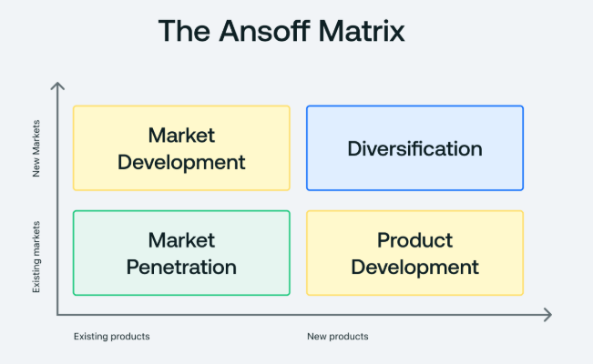

Figure 2.2.1.1. The Ansoff Matrix
(Source: Quantive)
Strategically speaking, Tesla Mobility is more focused on being a value-creation brand than a product brand. It provides both functional benefits, such as speed, safety, and reliability, and symbolic benefits, such as prestige, innovation, identity, and responsibility for the environment. Tesla is thus appealing more to younger consumers for whom consumption is increasingly being driven by personal values and lifestyle. The brand is also reinforcing its sustainability profile with recyclable material use and battery recycling facilities (Mangram, 2012).
- Price Strategy
Tesla Mobility has a premium pricing approach based on value. This is consistent with Tesla’s brand structure and positioning strategy. Tesla Mobility does not compete on price but uses them as indicators for quality, safety, innovation, and sustainability (Kotler & Keller, 2022). This puts Tesla Mobility above competitors who mainly use penetration pricing approaches for their shared mobility services and electric scooters.
The pricing framework includes outright purchase alternatives, monthly subscriptions, student pricing plans, and business leasing plans. This four-tier pricing system thereby increases market reach without compromising on the exclusivity associated with the brand. The pricing structure is based on subscriptions that represent changing trends among customers to opt for subscriptions instead of products. This is more so among the younger generation and gig workers (Statista, 2024).
From a critical analysis point, premium pricing helps boost the contribution margin and supports the significant investments required for research and development and sustainability for AI and charging stations (Bergemann, Bonatti and Smolin, 2025). However, this pricing structure may end up hindering adoption by highly sensitive customers on the pricing front, especially within developing cities. Tesla Mobility offsets this issue with student discounts and payment plans that do not affect the brand while reducing the investment impact for key target groups.
Dynamic pricing and usage-based pricing solutions can be implemented during peak periods to maximize the utilization efficiency and revenue potential. Overall, Tesla Mobility's pricing structure represents a balanced approach between the overall profits and brand integrity necessary for sustained business viability within the competitive urban mobility domain (Müller et al., 2023).
- Place Distribution Strategy
Tesla Mobility uses the concept of omnichannel distribution for urban distribution to maximize coverage and convenience through the use of both physical and digital channels. Physical channels for distribution for Tesla Mobility include its Tesla stores and pop-up mobility hubs within city centers, college campuses, and selected corporate locations. Digital distribution is handled through the Tesla mobile app for product browsing and ordering, as well as activation and tracking (Zhou, 2023).
This is due to changing trends among consumers with regard to speed and convenience, and the ability to fully control services on the internet (Kotler and Keller, 2022). Campuses and city centers allow for easy access to the primary market for customers on campus and young professionals. Business locations allow for the adoption and support of business goals for sustainability and, therefore, increase B2B revenue streams (Smith and Damron, 2016).
From the operational framework point of view, Tesla’s current international retail and service network creates substantial economies of scale and thus leaves much lower entry barriers relative to start-up operations in the micro-mobility industry (McKinsey, 2023). Tesla’s vertically integrated logistics network and software-based monitoring solutions increase service uptime and thus offer a substantial advantage over competitors within the micromobility industry.
- Promotion Strategy
Tesla Mobility has a promotional strategy that is digital-first and sustainability-driven. It is based on the consumption behavior and media preference of the target market and is consistent with Tesla’s corporate philosophy. It is highly focused on social media platforms and sustainability-driven brand building (Pathak et al., 2022). The promotional strategy is highly effective for youth groups, wherein young customers take cues from their peers and other online content while purchasing products and services (Statista, 2024).
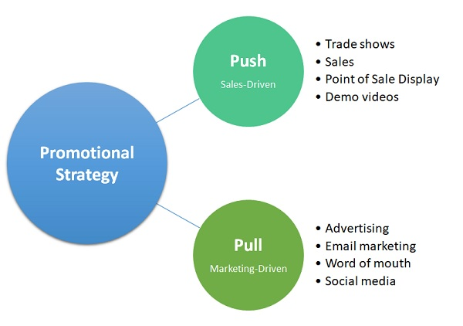

Figure 2.2.4.1. Promotion Strategy
(Source: MBA Skool)
Collaboration between influencers and tech reviewers, environmental activists, and lifestyle influencers can help increase credibility and authenticity. University ambassador programs can facilitate the grassroots adoption process and word-of-mouth transmission across closely networked communities on university campuses. Collaboration between smart city councils and other sustainability organizations can increase institutional credibility and legitimacy (Keeler et al., 2023).
Tesla Mobility focuses on other types of messages, such as environmental and emission reduction, and renewable energy use. This is consistent with the trend towards purpose-driven brands and building brand engagement (EY, 2025). The use of mobile apps and referrals is well known for enhancing relationships and retention, and revisit behavior.
Strategically speaking, having an established brand such as Tesla with significant recognition across the globe creates significant value by reducing the costs associated with building brand awareness. However, Tesla Mobility must demonstrate local and tangible approaches, such as test-driven events and safety demonstrations, to alleviate concerns with respect to the risk posed by this emerging form of mobility solutions. Relying on online methods alone might fall short on safety and regulatory fears (Cui, Tu, and Itoh, 2023).

- Integrated Strategic Analysis of the 4P’s
The overall 4Ps integration strategy pursued by Tesla Mobility demonstrates great consistency between product development, premium pricing, targeted distribution channels within select urban areas, and online promotion approaches. A highly advanced product is complemented by a pricing approach that aligns with higher safety and sustainability features (Mangram, 2012). Targeted place approaches concentrate on selecting high-value locations within urban areas to sustain the premium brand image. The promotion approach strictly identifies with online engagement and emphasizes responsible behavior within the environment. Overall, these aspects sustain a differentiation-based competitive approach (Porter, 1980). Despite potential threats from premium pricing approaches, government restrictions, and reliance on advanced technology, strategic integration within the overall marketing mix creates a great platform for sustained growth and competitive advantage development.

Conclusion:
The Tesla Mobility Marketing Mix 4Ps is evidence that the company uses a well-integrated and market-driven approach for developing a brand. The Product offers significant technological and green benefits. The Price is positioned at the higher end with flexible access solutions. The Place strategy provides easy access to the product with a seamless omnichannel customer reach, and finally, the Promotion strategy develops significant online engagement and ethical brand credibility. Overall, this approach is beneficial for developing both short-term market reach and building brand equity for the emerging global micro-mobility market (Mangram, 2012).

Marketing Strategy Pitch
I am proud to introduce Tesla Mobility – Tesla’s foray into the swiftly growing AI-powered micro-mobility industry. With the advent of smart cities and mounting pressures from environmental deregulation policies, the overall micromobility industry is anticipated to reach well over USD 500 billion by the year 2030 (McKinsey & Company, 2023; Statista, 2024). Tesla Mobility satisfies this gap within the industry with its AI-integrated e-bikes and e-scooters with ultra-fast charging capabilities and seamless connectivity with the Tesla ecosystem.
The brand mainly concentrates on targeting the youth living in urban areas who appreciate the aspects of being differentiated and connectivity. Tesla Mobility appears to be differentiated from traditional low-cost providers of micromobility services by possessing superior AI safety solutions and energy management capabilities (Kotler and Keller, 2022).
Tesla Mobility pursues a high-end value pricing approach and offers services through various means, such as subscription and student plans, to add accessibility to the market without undermining brand value. Tesla Mobility would utilize its stores at universities and colleges, and other pop-up locations around cities for distribution. Marketing and advertising would be carried out through online and other channels, such as influencers and sustainability initiatives (Pathak et al, 2022).
Even users can reduce around 300 Kg CO₂ emissions per year to meet the net-zero emissions goals (International Energy Agency, 2024). Tesla Mobility is more than just a transport system – it is a smart, safer, and more sustainable lifestyle brand for urban living.

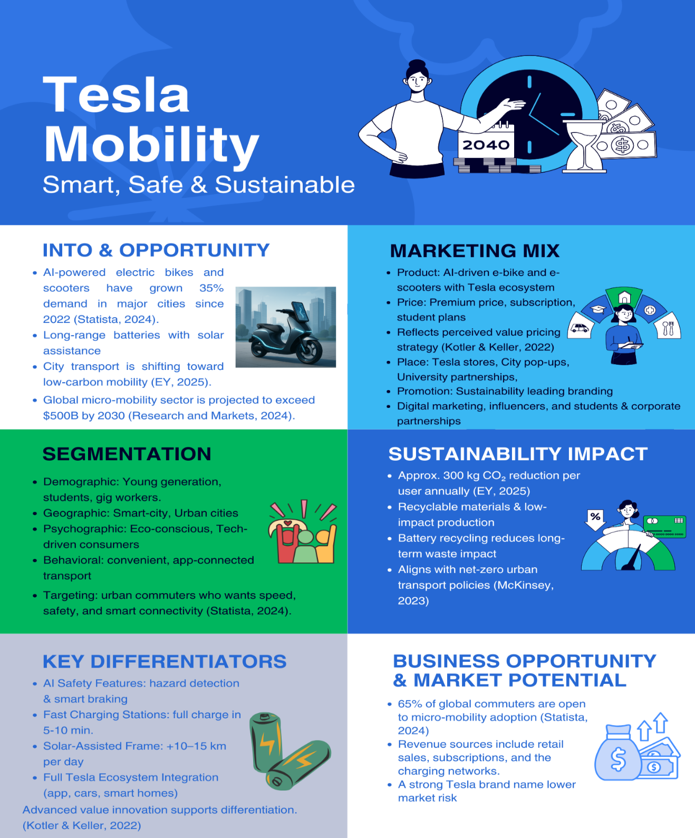
Poster

Figure 3.1.1. Tesla Mobility Poster

Critical Reflection
Working on the Tesla Mobility brand concept was a very rewarding academic and professional learning experience that really helped to add depth to my knowledge and understanding of strategic brand development and the analysis of marketing. This project really helped to develop my skills and ability to apply important knowledge from theories such as Segmentation, Targeting, and Differentiation and Positioning (STDP) (Czinkota et al., 2021), and Marketing Mix within a business context. In contrast to simply being important factors from academic theories, I was able to see the important role they play within decision-making models for strategic branding.
One of the biggest learnings for me has been the strategic fit for brand extension. Tesla’s strong brand equity for innovation and technological prowess was a great building block for the expansion of the brand in the micromobility industry. However, at the same time, I realized the imperatives for brand extensions to be successfully implemented and the strategic thinking needed for a brand extension to avoid contributing negatively to brand dilution. After doing my analysis on the competitive and consumption front, I realized that Tesla customers may not be Tesla’s core customers for this brand extension (Monga and John, 2010).
The development process for creating the segmentation and targeting approach has helped my analytical and evaluative skills considerably. I was able to layer my approach from simple demographic segmentation and include other aspects such as sustainability attitudes, online dependencies, and commute patterns (Dolničar, Grün, and Leisch, 2018). My ability to reason out decisions from a strategic market approach and not from presumptions has improved. My capacity for combining and integrating trends from consumers, urbanization processes, and concerns for the environment for overall market strategy formulation has improved.
Formulating the Marketing Mix further enhanced my ability for strategic planning. The most difficult part of this was creating a pricing strategy with a premium approach that is still feasible for students. This exercise helped increase my appreciation for the strategic positioning concept of pricing, instead of it being merely a numerical consideration. The promotions mix helped raise my appreciation for current trends within the realm of online marketing, namely the emphasis on influence and sustainability.
Working on the design for the marketing strategy presentation poster allowed me to develop my visual communication skills and learn to communicate complex strategic concepts cohesively and persuasively. Giving the presentation helped me boost my confidence and efficiency while speaking and organizing an argument to persuade and convince business audiences. I was still able to find some areas for improvement on this project, such as my public speaking expression and engagement methods with the listeners.

Reference
- Alam, T., Gupta, R., Ahamed, N., Ullah, A., Almaghthwi, A. (2024) 'Smart mobility adoption in sustainable smart cities to establish a growing ecosystem: Challenges and opportunities,’ https://doi.org/10.1557/s43581-024-00092-4
- Bathla, G., Bhadane, K., Singh, R., Kumar, R., Aluvalu, R., Krishnamurthi, R., Kumar, A., Thakur, R., Basheer, S. (2022) 'Autonomous Vehicles and Intelligent Automation: Applications, Challenges, and Opportunities', https://downloads.hindawi.com/journals/misy/2022/7632892.pdf
- Bergemann, D., Bonatti, A., Smolin, A. (2025) 'The Economics of Large Language Models: Token Allocation, Fine-Tuning, and Optimal Pricing', https://doi.org/10.48550/arxiv.2502.07736
- Bretones, A., Marquet, O., Daher, C., Hidalgo, L., Nieuwenhuijsen, M., Miralles‐Guasch, C., Mueller, N. (2023) 'Public Health-Led Insights on Electric Micro-mobility Adoption and Use: a Scoping Review', https://link.springer.com/article/10.1007/s11524-023-00731-0
- Cui, Z., Tu, N., Itoh, M. (2023) 'Effects of brand and brand trust on initial trust in fully automated driving system.’ https://doi.org/10.1371/journal.pone.0284654
- Czinkota, M., Kotabe, M., Vrontis, D., Shams, S.M. (2021) 'Market Segmentation, Positioning, and Branding', https://doi.org/10.1007/978-3-030-66916-4_7
- Dolnicar. S., Grün, B., Leisch, F. (2018) 'Market Segmentation Analysis', https://link.springer.com/content/pdf/10.1007%2F978-981-10-8818-6_2.pdf
- EY (2025) Micromobility: Moving cities into a sustainable future.: https://www.ey.com/content/dam/ey-unified-site/ey-com/en-gl/insights/automotive/documents/ey-gl-micromobility-moving-cities-into-a-sustainable-future-01-2025.pdf.
- Forsythe, C., Gillingham, K., Michalek, J., Whitefoot, K. (2023) 'Technology advancement is driving electric vehicle adoption', https://pmc.ncbi.nlm.nih.gov/articles/PMC10265978/pdf/pnas.202219396.pdf
- ‌International Energy Agency (IEA) (2024) Global EV Outlook 2024, IEA.: https://www.iea.org/reports/global-ev-outlook-2024.
- Keeler, L., Beaudoin, F., Cid, A., Cowley, R., Fahy, S., Lerner, A., Moran, C., Torney, D. (2023) 'Building transformative city-university sustainability partnerships: the Audacious Partnerships Process', https://doi.org/10.1186/s42854-022-00045-5
- Khandeparkar, K., Motiani, M., Shah, A., Chaurasia, S., Jha, A. (2025) 'The Power is Yours: How Power Drives People’s Preference for Sustainable Luxury', https://doi.org/10.1177/14413582251362364
- Kotler, P., Keller, K.L., and Chernev, A. (2022). Marketing Management, Global Edition. 16th edn. Pearson Education Limited.
- Kumar, A., Hosseini, A., Azarbayjani, A., Heydarian, A., Shoghli, O. (2025) 'Adoption of AI-Assisted E-Scooters: The Role of Perceived Trust, Safety, and Demographic Drivers', https://doi.org/10.48550/arxiv.2502.05117
- Mangram, M. (2012) 'The globalization of Tesla Motors: a strategic marketing plan analysis', https://doi.org/10.1080/0965254x.2012.657224
- ‌McKinsey & Company (2023). The future of mobility. Illustration by Peter Tarka.: https://www.mckinsey.com/~/media/mckinsey/industries/automotive%20and%20assembly/our%20insights/the%20future%20of%20mobility/the-future-of-mobility.pdf.
- MBA Skool Team (2021). https://www.mbaskool.com/business-concepts/marketing-and-strategy-terms/12823-promotional-strategy.html.
- Meister, D., Strässer, R., Brändle, F., Seidel, M., Bassler, B., Gerber, N., Kautz, J., Rommel, E., Allgöwer, F. (2025) 'Path-following model predictive control for autonomous e-scooters', https://doi.org/10.48550/arxiv.2505.05314
- Monga, A., John, D. (2010) 'What Makes Brands Elastic? The Influence of Brand Concept and Styles of Thinking on Brand Extension Evaluation, https://doi.org/10.1509/jmkg.74.3.080
- Müller, C., Gönsch, J., Soppert, M., Steinhardt, C. (2023) 'Dynamic pricing for shared mobility systems based on idle time data', https://link.springer.com/article/10.1007/s00291-023-00732-0
- Palmié, M., Miehé, L., Mair, J., Wincent, J. (2024) 'Valuation entrepreneurship through product‐design and blame‐avoidance strategies: How Tesla managed to change the public perception of sustainable innovations'. https://doi.org/10.1111/jpim.12732
- Pathak, P., Yadav, V., Pillai, S., Das, S., Kansal, G. (2022) 'Unveiling the Success Behind Tesla’s Digital Marketing Strategy', https://doi.org/10.1007/978-981-19-4193-1_24
- Porter, M.E. (1980) Competitive Strategy: Techniques for Analyzing Industries and Competitors. Free Press.
- Quantive (2024). What Is The Ansoff Matrix: Definition, Steps & Examples, Quantive.com. https://quantive.com/resources/articles/ansoff-matrix.
- Research and Markets (2025) Micro-Mobility Market – Global Forecast 2025-2030, Researchandmarkets.com: https://www.researchandmarkets.com/reports/5847052/micro-mobility-market-global-forecast
- Sciuva, E. (2025) 'Geographies of Digital Nomadism: A Research Agenda', https://doi.org/10.1111/gec3.70016
- Smith, A., Damron, T. (2016) 'Location strategies and implementations from an eco-friendly viewpoint,’ https://www.researchgate.net/publication/299549056_Location_strategies_and_implementations_from_an_eco-friendly_viewpoint
- Sterk, F., Stocker, A., Heinz, D., Weinhardt, C. (2024) 'Unlocking the value from car data: A taxonomy and archetypes of connected car business models,’ https://publikationen.bibliothek.kit.edu/1000168853
- Statista (2024) Micro-mobility usage and consumer adoption worldwide: https://www.statista.com/outlook/mmo/micromobility/worldwide?srsltid=AfmBOopuB8JUDwZam4gqqHEWzNyGQGAe-ADiINLP5A9NiwigVlBt7I09
- T, K., C., M., J, L., S., C., D., H., R, Z., R., D., R., S.U., J, K., P., P., H., R., k, S., T., Z., K., T., P., C., D.M., K. (2025) 'The SolarEV City Paradox: A Critical Review of the Fragmented Integration of Rooftop Photovoltaics and Electric Vehicles for Urban Decarbonization,’ https://doi.org/10.48550/arxiv.2511.15091
- Wang, Y (2025) 'Generative AI for Autonomous Driving: Frontiers and Opportunities.’ https://doi.org/10.48550/arxiv.2505.08854
- Zhou, S. (2023) 'Research on Omni-Channel Supply Chain Structure Based on BOPS Mode', https://doi.org/10.4108/eai.6-1-2023.2330322

