DS 1 Template

My Screenshots/Photos

Francisco C. Fernandes

Screenshot/Photo 1
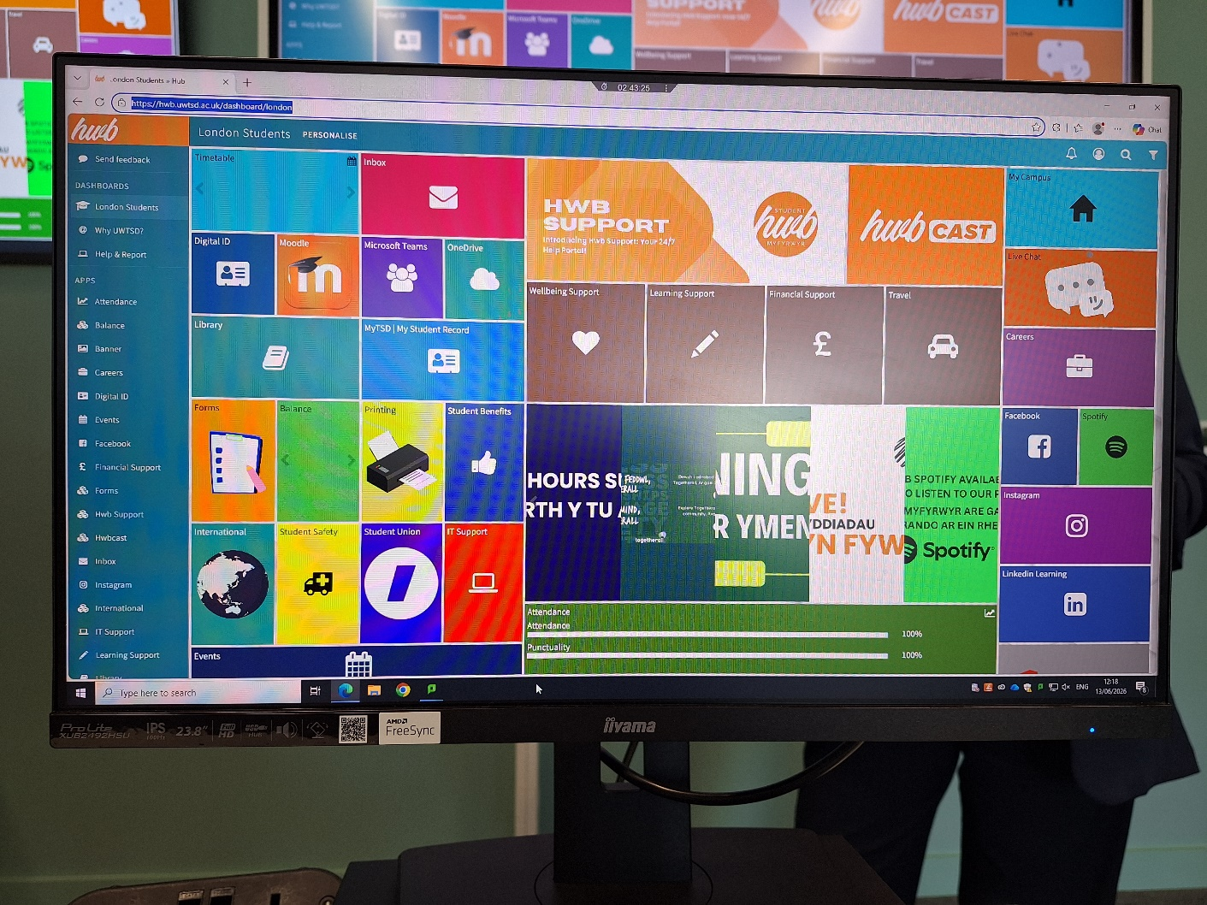
Digital Picture of the Desktop Image of UWTSD Hwb screen displayed on the screen in the Lab 102

Screenshot/Photo 2

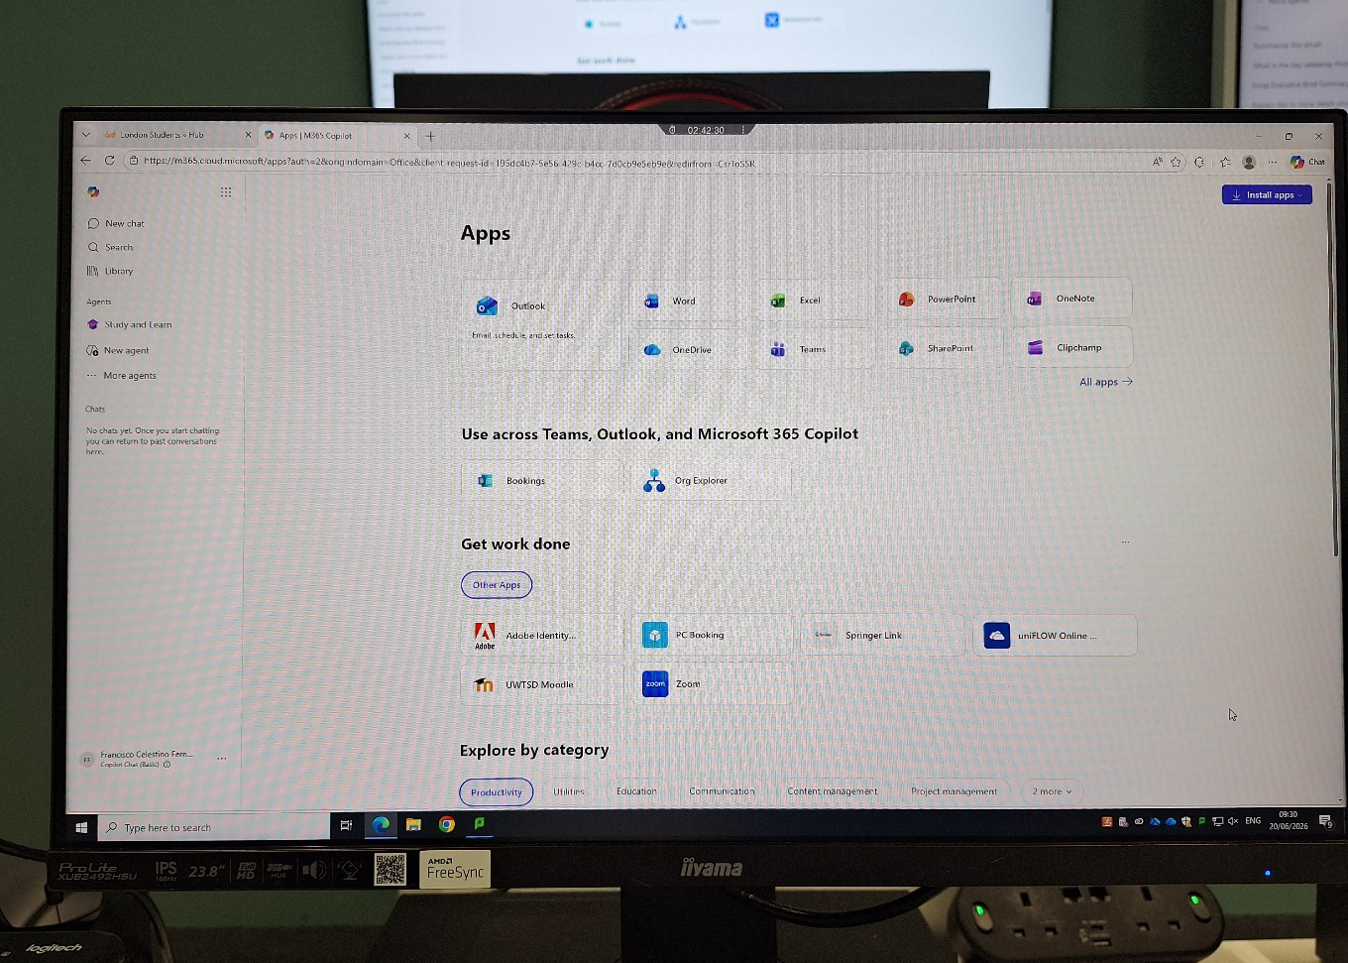
This digital picture shows the different apps available in Office 365

Screenshot/Photo 3
[Insert Photo/Screenshot below]
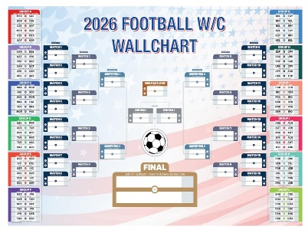 This Digital picture is a screenshot copied from Google images of the match schedule of 2026 world Cup. I have cropped it so that I can print it out and past it on my door.

Screenshot/Photo 4
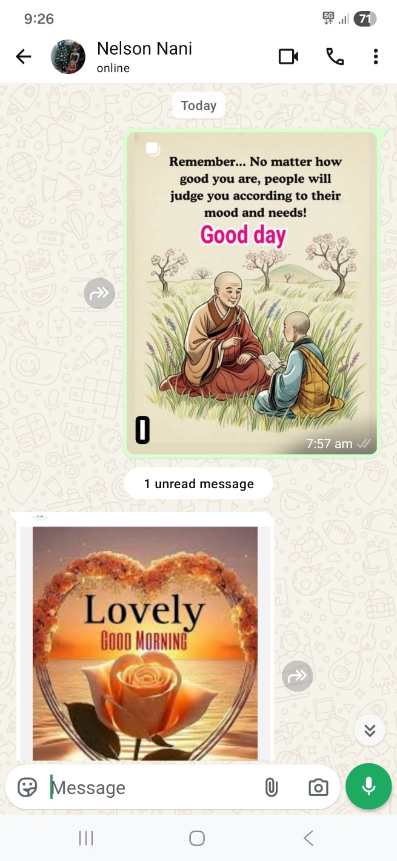
This picture is a screen shot of a good morning message send to my brother today morning on Whatsapp.

