EIGP 2 - Individual Report
Shamuel Hashan
1803153
Web Development
Lecturer: James Williams
Module: Enterprise & Innovation Group Project

Introduction
This report will discuss various things such as the marketing plan for Div Digital and the authors personal development. It is important for any business to have a marketing plan. This report will talk about who the target audience is, How Div Digital will be promoted and the branding of the company. This report will talk about how we came up with our ideas and what they represent. I will also be discussing my personal development.

Development

Going into this project the author had a various skills that he then improved on during the project. He would have had to use his skills in working in a team. His goals for the project was to help the team build an innovative website and manage the marketing and social media of the group.

One of these skills was the coding skills for when it came to developing a website. he used this skill to make the some of the pages for the Div Digital website. The improved his skills in using coding languages such as HTML, css and JavaScript.
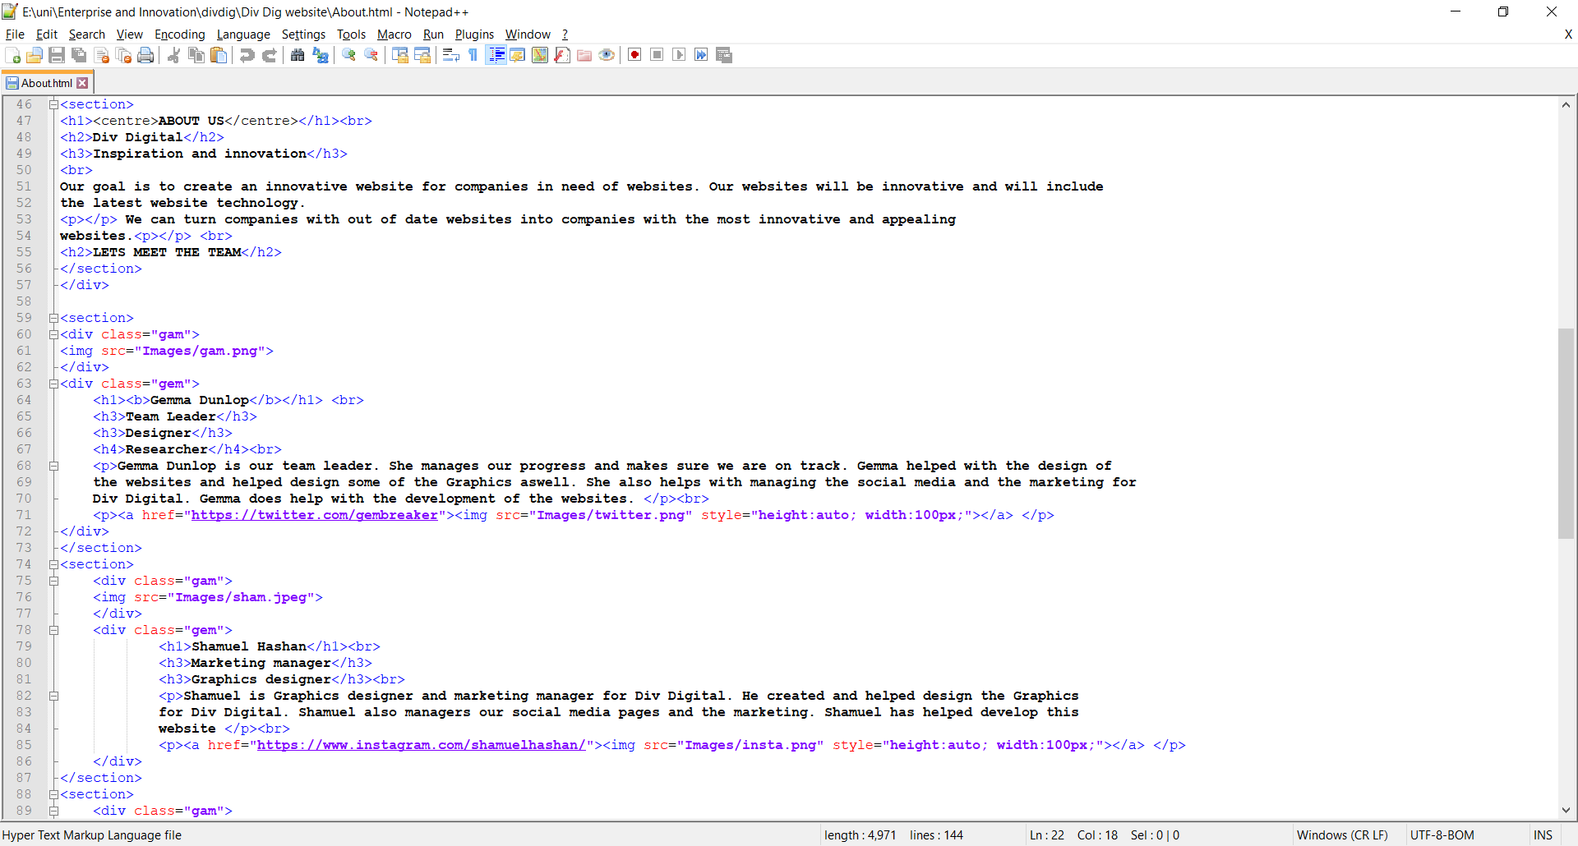

As he was the graphics designer for the company, the author had the chance to develop his skill with creating graphics as there was various graphics needed for Div Digital that was used for both websites and marketing.

This is the logo he created.
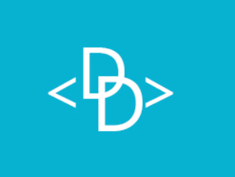
This is the banner he made for the business.


These 2 of the graphics was used on the div digital website.

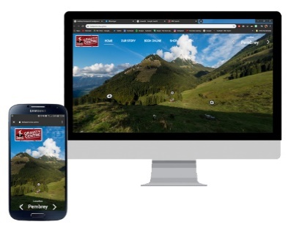
The university offered a trip to BT Towers. 4 of Div Digitals members went there including the author. He developed his knowledge of businesses during the trip to BT Tower. He developed an understanding of how the different ways BT provided their services, the testing process used in the industry and how businesses collaborate.
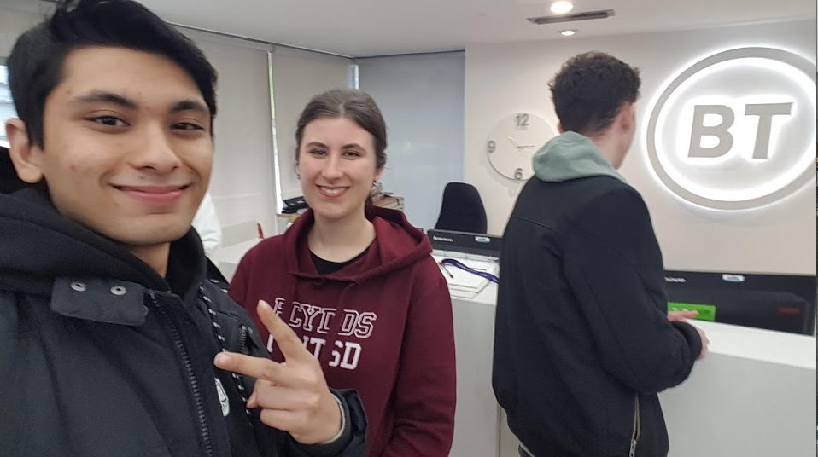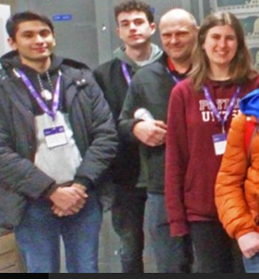

The author have also developed his skills in working in a team since he had to work with a team. The author made graphics for Rhys so he can use it for the BRD Sports website and some graphics for Gemma. The author also coded parts of the Div Digital website with Gemma as well as running the social media with her. The author has developed a better understanding of how business work from doing this project.

Prototype
One of the ways the author helped develop the prototype was by creating some of the graphics that was used on the prototype. The authors images was used for the BRD Sports website.
These graphics were used in the homepage of the BRD Sports website homepage.
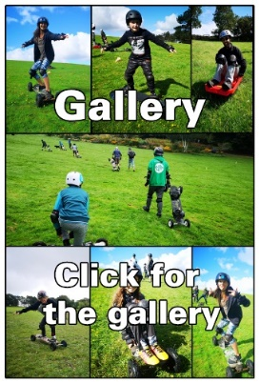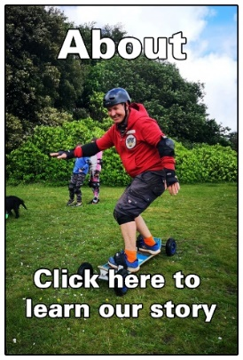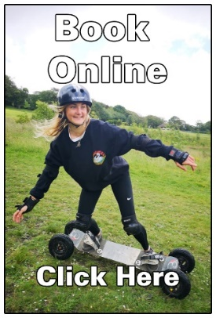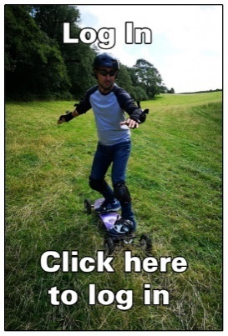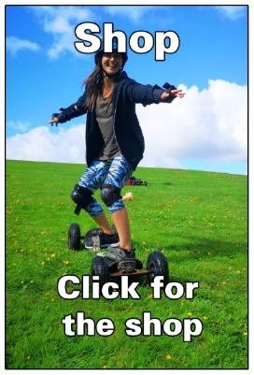
This is the gallery graphic being used here.
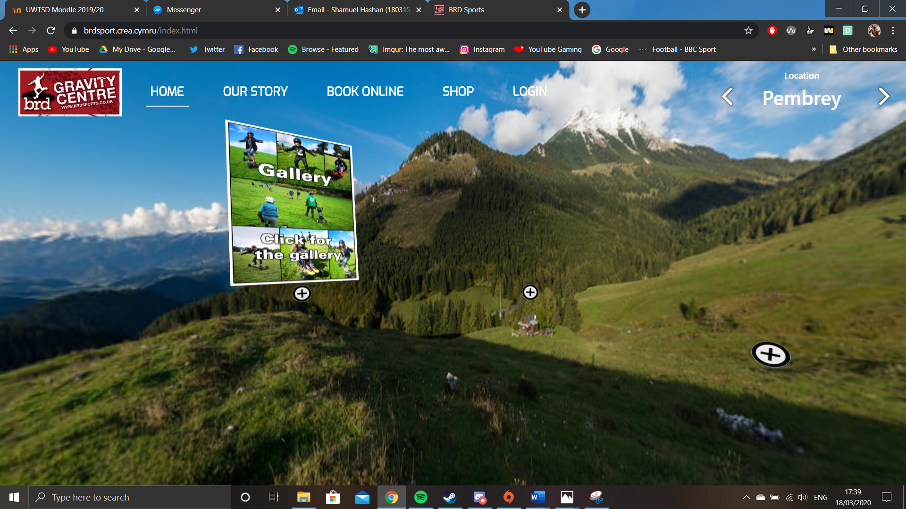
The author also went on various meetings with the CEO of BRD sports to discuss plans on making the website and helped discuss the features that could be used in the website and also helped design it.

The Marketing plan

Target Audience
Our target market are companies looking for a website. We are mostly targeting business men and women as they might be looking for websites to use for their business. Almost all businesses will benefit from using a website and there is an increasing demand for websites.

Marketing Mix

Promotion Strategy
We will be using various strategy’s when it comes to promoting DivDigital to the public. We are using social media such as Instagram, twitter and Facebook. This can help us promote our website since millions of people use these so we will be able to reach a larger audience.
One of the ways we will promote our product is by writing blog posts. The blog post can gain the interest of our target audience. In the future, we are looking at purchasing ad space from websites such as YouTube and Facebook too making short seconds ads for . We will also promote the website by getting well known people to talk about it. We could sponsor influencers and they will talk about it and their audience will then know about our website.
Div Digital plans on using animated infographics to promote the company too. This method will be an appealing way do display facts and figures while also promoting the brand.

Product Price
The prices for DivDigitals websites will be modular. The prices of the website will depend on the needs of the client. This can be between £1,000 to £100,000. We will need to take into account various services when it comes to working out the costs of the website such as the website design, maintenance of the website, costs of the databases and the cost of the website marketing. The design and development of the website can cost at least £200-£11000, the maintenance can cost from £200 to £1500 and the web hosting can cost about £150 to £1000. All of this mostly depends on our client’s needs. We looked at making our prices cheaper than other website developers since we are targeting smaller businesses and we would to offer them affordable services.

Place of development
The product was be able to be developed from various locations. One of these locations was the IQ building in the UWTSD waterfront campus. The Y Fforwm is the another location for where we worked on the prototype. The Y Fforwm had a conference room that we used so we can all work together on the project in real time. We also worked on it remotely from our homes and kept in contact by using an app called Discord so we can all join a call and communicate in real time from our own homes as well.

Distribution Method
The distribution method we are using is electronic distribution. Div Digital will be distributing our product electronically as our services are used for the electronic media. Websites are accessed online via the internet.

Brand advertising

Div Digital wants to have a good strong connection with their customers. To help achieve this, the brand be advertised on multiple platforms.

Brand image
It is important that we keep a consistent brand image. Which in our case, we are going to make sure we remain innovative since that is one of our biggest selling points. Keeping a consistent brand image will bring credibility to the company. Our brand will keep using the most innovative website tools and will be not be overpriced.
Logo
The Logo for Div Digital was designed by Gemma Dunlop and Shamuel Hashan. The logo is 2 Ds inside a div tag. A “<div>” tag is We are using a blue and white colour scheme for the company. We used blue for our colour as it is a very common colour. It is one of the most accepted colours. Blue is used by a lot of tech companies. The colour is supposed to make people feel more cool and it is one of the colours of innovation which is one of our selling points. White is associated with purity, elegance and perfection which is what we want people to think of when they think of us. Building a large social media presence can also help us in growing our business.
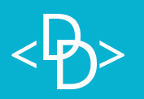
Banner
The banner was kept simple as we did not want to over complicate it. We included our logo and our name and kept the colour scheme. This banner looks very neat and the colours make it look appealing.


Social Media
Social media is also being used to advertise Div Digital. The social media is kept very active and is being used to grow more followers. It is being used to spread the message about the company and find some new clients. We do reply to messages and enquiries we get on social media. We also posts updates and photos on our social media regularly.

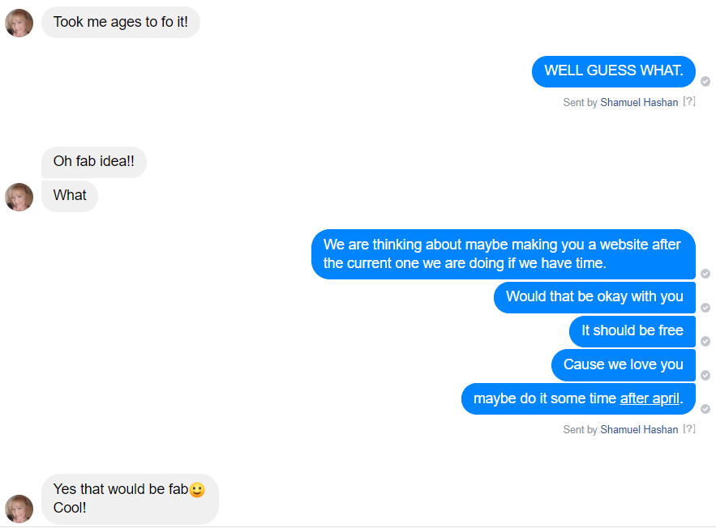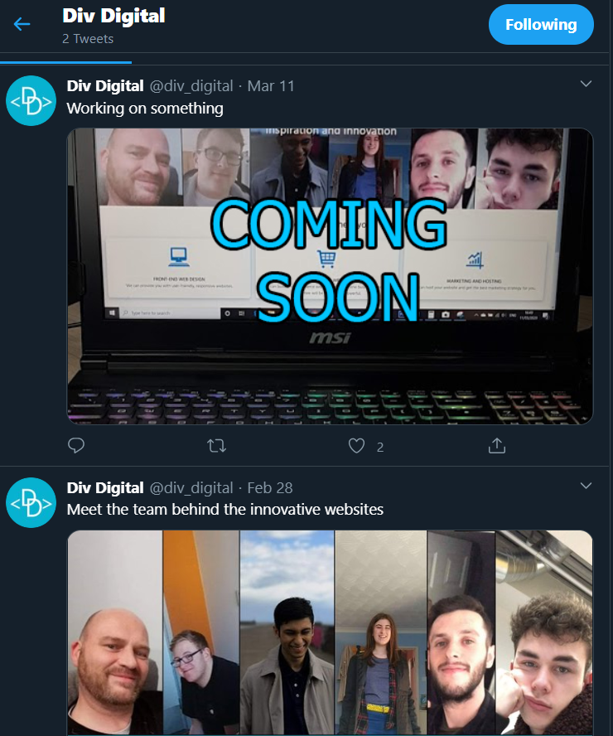
Div Digital also use the social media to ask the followers questions about websites that we could then use to see what users like to see in websites.

This is our Instagram page.
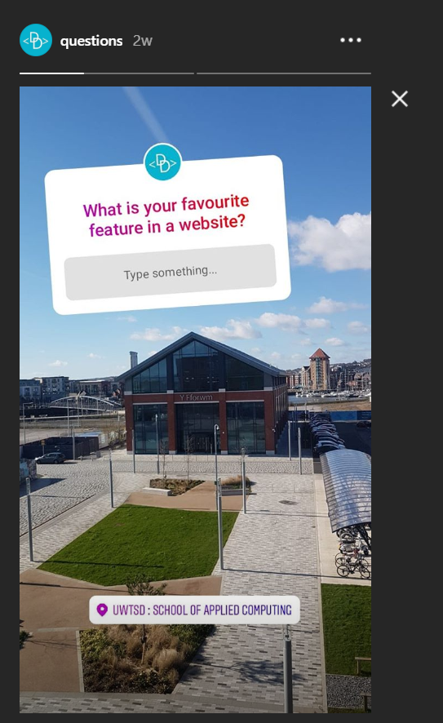
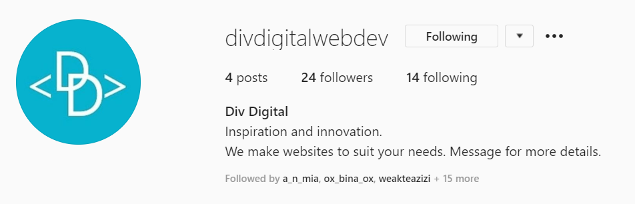
This is our twitter page.
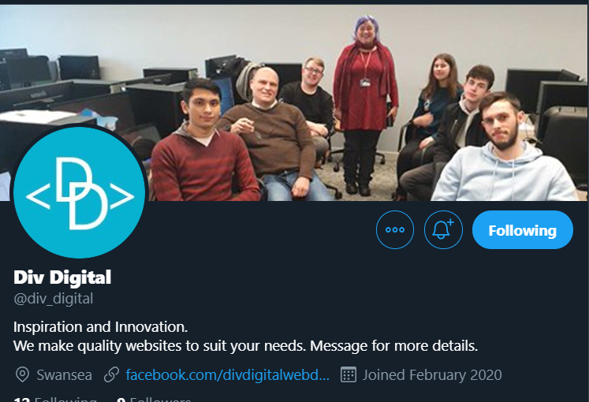
This is our Facebook page.
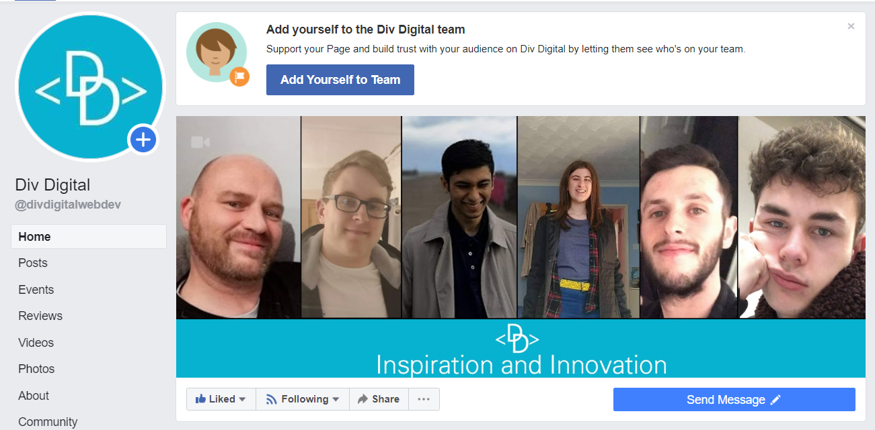
SEO
We will also purchase ad spaces that will be shown on other sites. Many users search for things they are looking for on a search engine. We can also do an SEO for our website to increase the chances of people finding us. Div Digital will be using relevant key words to increase the chances of us coming up.

Website
We are also making a website to help with the marketing for Div Digital. It will be used so potential customers can find out more about us as well as showing them what we are capable of. It will include a portfolio that shows our previous work. It will show viewers the services we provide and our contact info. The website will also be responsive so it is accessible to mobile users.

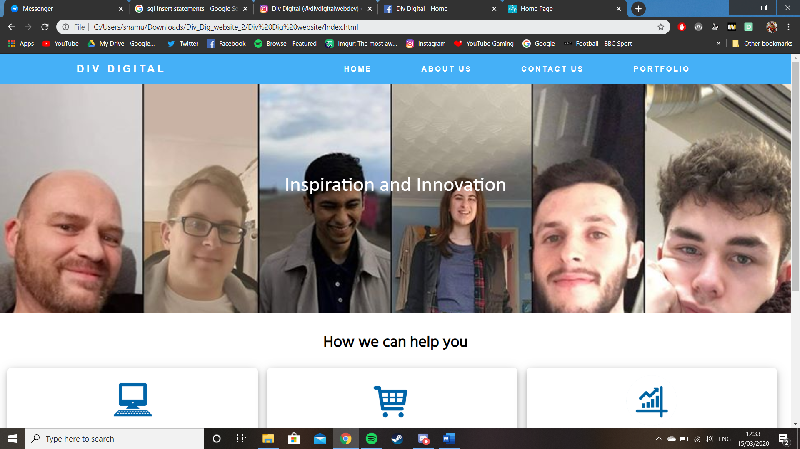 #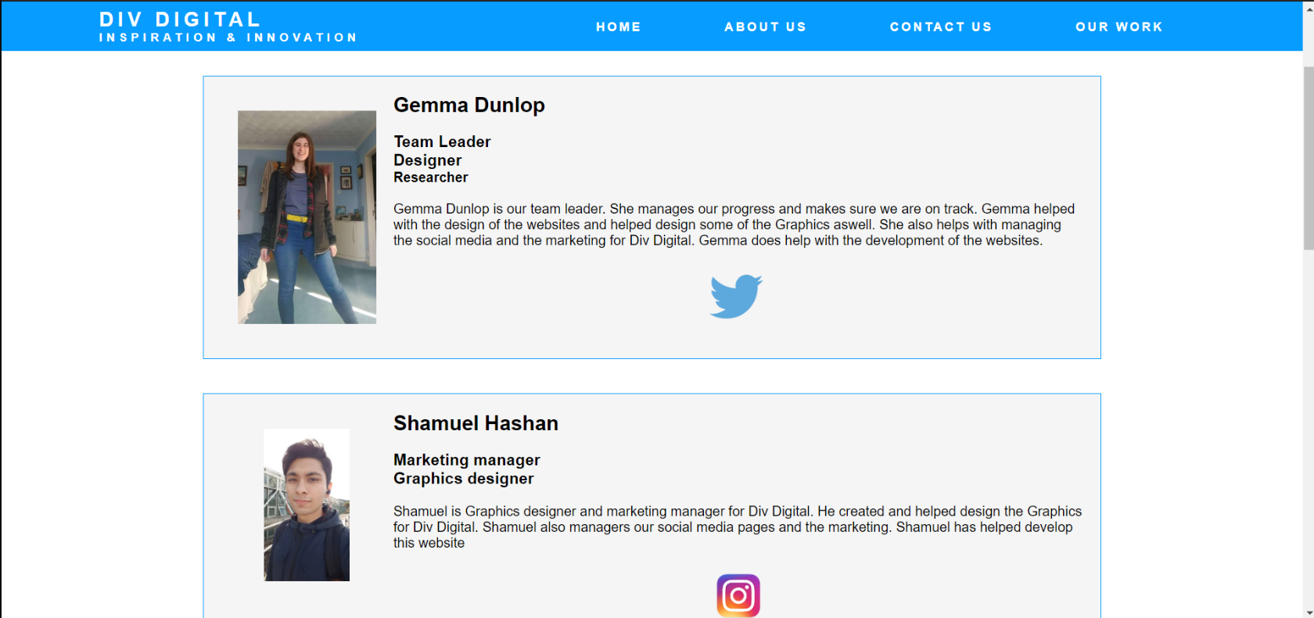 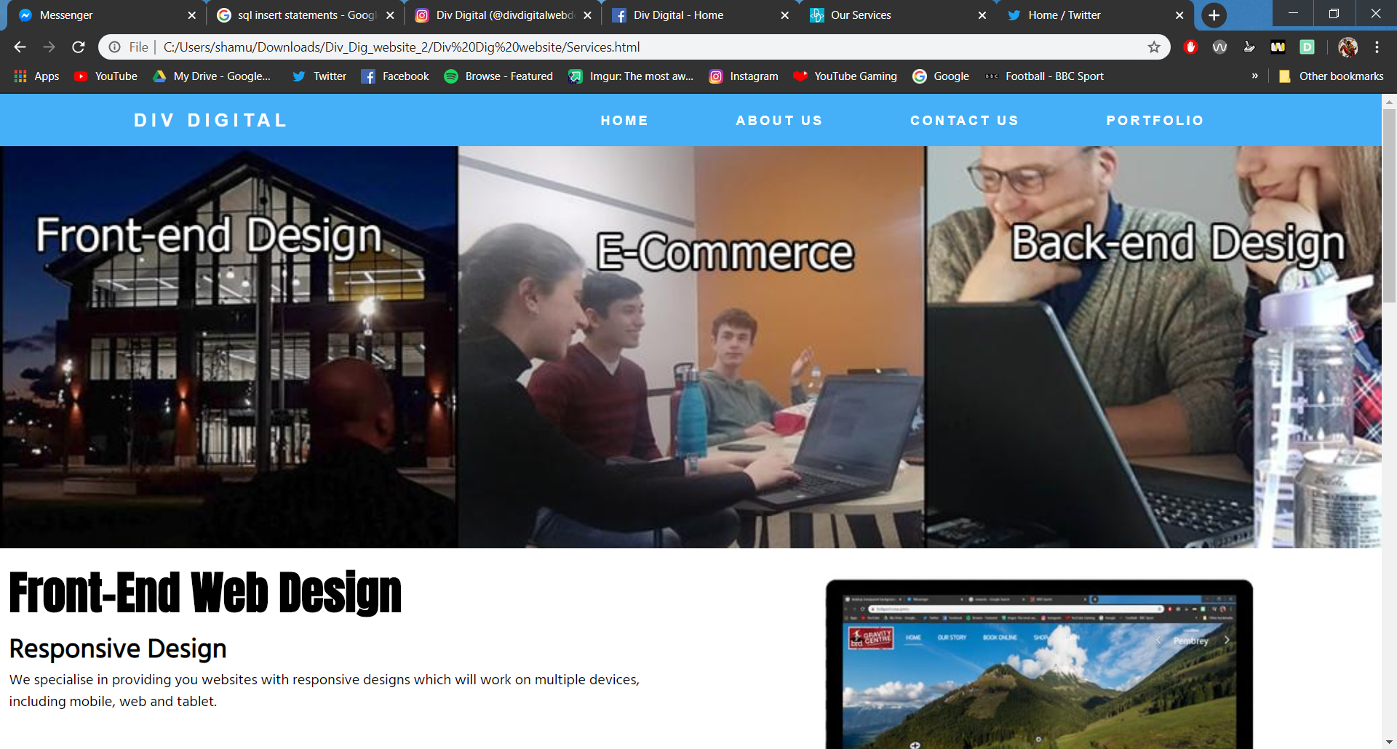
Poster
This is one of the posters for Div Digital. It is advertising our brand and social medias. This poster shows who we are and where the viewer can find us. It is kept quiute neat and tidy and doesn’t look to cluttered which helps make the poster look more apealing.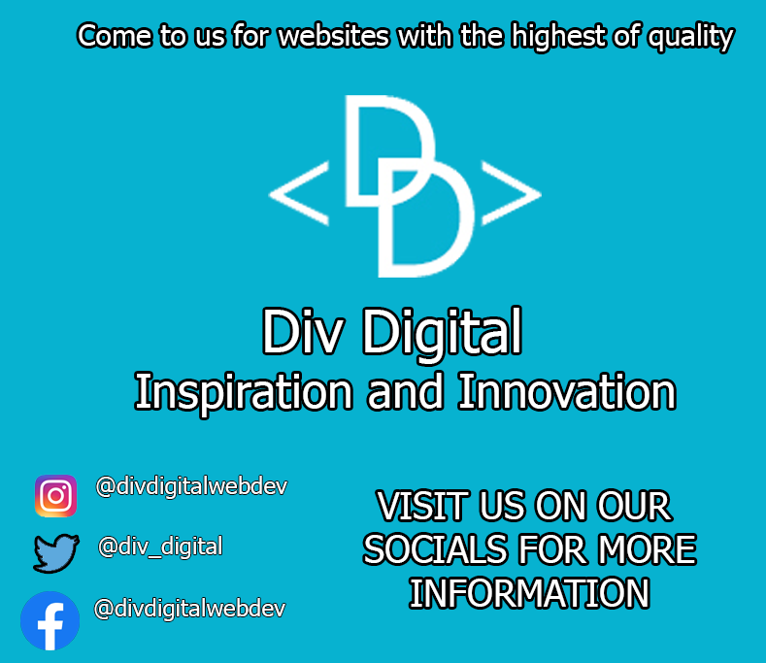

Conclusion

In this report we have looked at the marketing plan for the company. This report looked at who the target audience for the company is. The author discussed how Div Digital will go about with the marketing for the company. For example, We talked about how we would promote Div Digital and the branding of the company. This report also discussed the use of social media in helping the business with promoting the product. The author also discussed his own personal development during this project. The author also talked about how the author improved his own skills in coding websites, graphics, working in team and running a business.

Appendix

Team progress sheets

------------------- TEAM PROGRESS SHEET -------------------------
Team Name: Diverse Digital
Team Member Names & Roles:
GD: Gemma Dunlop
MH: Mark Huntly
RD: Rhys Davies
IJ: Iwan Jones
CE: Connor Ellement
SH: Shamuel Hashan
------------ ---------- ----------- ------------- ------------- ------------ ----------- ------------
Weekly Progress report 1:
Date: 13/11/19
In-Attendance: GD, CE, SH. Apologies: MH, RD. Absent: IJ
Team Goals:
To create a innovative website for the company BRD Sports, meeting specifications and requirements stated by the CEO Ben Room.
> Individual Updates:
GD Update: Researching innovative web technologies to include in our website.x
CE Update: Has been studying other websites, similar to what Ben has asked of us, for ideas and design tips.
SH Update: Began on a rough mark-up on how the website will look.
> Team discussion:
We are very early into our project development and with various absences over previous weeks, we are a little behind where we should be. However, in the forthcoming weeks, we intend on making time to organise meetings at Uni to work on the bulk of the project.
> Individual Actions:
GD Actions: To find and choose a specific innovative web tech to implement
CE Actions: To have a list of features that we can include in the website along with who is best to implement them.
SH Actions: To have a completed mock-up of the website.

------------------- TEAM PROGRESS SHEET -------------------------
Team Name: Diverse Digital
Team Member Names & Roles:
GD: Gemma Dunlop
MH: Mark Huntly
RD: Rhys Davies
IJ: Iwan Jones
CE: Connor Ellement
SH: Shamuel Hashan
------------ ---------- ----------- ------------- ------------- ------------ ----------- ------------
Weekly Progress report 2:
Date: 20/11/19
In-Attendance: GD, CE, SH, MH, IJ, RD
Team Goals:
To create an innovative website for the company BRD Sports, meeting specifications and requirements stated by the CEO Ben Room.
> Individual Updates:
GD Update: Collected photos Ben wants on his website.
MH Update: Deciding on what the legal clarification of start-up our team wants to set up.
CE Update: Has been researching website applications and web development trends for ideas and design tips.
SH Update: Finished PEST analysis.
IJ Update: Thought up any design ideas for the website.
> Team discussion:
We have made sure everyone is clear about what Ben wants for his website, making sure everyone understands the task at hand and knows what they are doing for it.
> Individual Actions:
GD Actions: Organise the team and make sure our planning is complete.
CE Actions: Continue researching web development trends and finding ideas from other website applications.
SH Actions: To have a completed mock-up of the website

------------------- TEAM PROGRESS SHEET -------------------------
Team Name: Diverse Digital
Team Member Names & Roles:
GD: Gemma Dunlop
MH: Mark Huntly
RD: Rhys Davies
IJ: Iwan Jones
CE: Connor Ellement
SH: Shamuel Hashan
------------ ---------- ----------- ------------- ------------- ------------ ----------- ------------
Weekly Progress report 3:
Date: 27/11/19
In-Attendance: GD, CE, SH, MH, IJ, RDC
Team Goals:
To create an innovative website for the company BRD Sports, meeting specifications and requirements stated by the CEO Ben Room.
> Individual Updates:
GD Update: Created a clear view of the design and content of the website.
MH Update: Researched into competitor mountain boarding companies.
CE Update: Researched other competitor website developers in our area, made initial template for the website.
SH Update: Created a few different versions of logos, documented in photos previous work.
RD Update: Began creating slogan, added design features to the website.
IJ Update: Contributed to design discussions.
> Team discussion:
We have created a main idea of the design for the website that we want to follow. We have worked as a group to create the presentation.
> Individual Actions:
GD Actions: Organise the team and make sure our planning is complete.
ALL- To complete specifically delegated slides for presentation

------------------- TEAM PROGRESS SHEET -------------------------
Team Name: Diverse Digital
Team Member Names & Roles:
GD: Gemma Dunlop
MH: Mark Huntly
RD: Rhys Davies
IJ: Iwan Jones
CE: Connor Ellement
SH: Shamuel Hashan
------------ ---------- ----------- ------------- ------------- ------------ ----------- ------------
Weekly Progress report 4:
Date: 11/12/19
In-Attendance: GD, CE, SH, MH, IJ, RDC
Team Goals:
To create an innovative website for the company BRD Sports, meeting specifications and requirements stated by the CEO Ben Room.
> Individual Updates:
GD Update: Started to look at design plan of the website.
MH Update: Started researching PHP and scroll functionality.
CE Update: Started creating design of prototype.
SH Update: Helped with the design of the prototype.
RD Update: Started researching 3js.
IJ Update: Started researching backend.
> Team discussion:
We mostly discussed the prototype and how we are going to design it, each giving our own individual input on ideas.
> Individual Actions:
GD Actions: Organise the team and make sure the planning is complete.
ALL- Work on the prototype

------------------- TEAM PROGRESS SHEET -------------------------
Team Name: Diverse Digital
Team Member Names & Roles:
GD: Gemma Dunlop
MH: Mark Huntly
RD: Rhys Davies
IJ: Iwan Jones
CE: Connor Ellement
SH: Shamuel Hashan
------------ ---------- ----------- ------------- ------------- ------------ ----------- ------------
Weekly Progress report 5:
Date: 18/12/19
In-Attendance: GD, CE, SH, MH, IJ, RDC
Team Goals:
To create an innovative website for the company BRD Sports, meeting specifications and requirements stated by the CEO Ben Room.
> Individual Updates:
GD Update: Discussed new ideas decided by Ben and how we are going to implement them.
MH Update: Organised a meeting with Ben to discuss updates on website. Explained meeting with Ben with rest of the group.
CE Update: Met with Ben to discuss the website.
SH Update: Wrote down new objectives of our website.
RD Update: Met with Ben to discuss the website.
IJ Update: Met with Ben to discuss the website.
> Team discussion:
We discussed Ben’s update on the website, including his approval of a 360-degree design and additional features he would like on the website.
> Individual Actions:
GD Actions: Organise the team and make sure the planning is complete.
ALL- Work on prototype.

------------------- TEAM PROGRESS SHEET -------------------------
Team Name: Diverse Digital
Team Member Names & Roles:
GD: Gemma Dunlop
MH: Mark Huntly
RD: Rhys Davies
IJ: Iwan Jones
CE: Connor Ellement
SH: Shamuel Hashan
------------ ---------- ----------- ------------- ------------- ------------ ----------- ------------
Weekly Progress report 6:
Date: 08/01/20
In-Attendance: GD, CE, SH, MH, IJ, RDC
Team Goals:
To create an innovative website for the company BRD Sports, meeting specifications and requirements stated by the CEO Ben Room.
> Individual Updates:
GD Update: Helped decide the features we need to include in the website.
MH Update: Started research on backend development and organising how to implement it.
CE Update: Discussed features we need to include in the website, including those which aren’t clearly shown on the prototype.
SH Update: Took notes during the meeting by recording features we want to use for the website.
RD Update: Started researching backend.
IJ Update: Started researching front end.
> Team discussion:
Discussed the features needed to be included on the website that have been approved by Ben.
> Individual Actions:
GD Actions: Organise the team and make sure the planning is complete.
ALL- Work on prototype.

------------------- TEAM PROGRESS SHEET -------------------------
Team Name: Diverse Digital
Team Member Names & Roles:
GD: Gemma Dunlop
MH: Mark Huntly
RD: Rhys Davies
IJ: Iwan Jones
CE: Connor Ellement
SH: Shamuel Hashan
------------ ---------- ----------- ------------- ------------- ------------ ----------- ------------
Weekly Progress report 7:
Date: 12/02/20
In-Attendance: GD, CE, SH, RD
Apologies: MH, IJ
Team Goals:
To create an innovative website for the company BRD Sports, meeting specifications and requirements stated by the CEO Ben Room.
> Individual Updates:
GD Update: Helped decide the features we need to include in the website.
MH Update: Started research on backend development and organising how to implement it.
CE Update: Discussed features we need to include in the website, including those which aren’t clearly shown on the prototype.
SH Update: Took notes during the meeting by recording features we want to use for the website.
RD Update: Started researching backend.
IJ Update: Started researching front end.
> Team discussion:
Discussed the features needed to be included on the website that have been approved by Ben.
> Individual Actions:
GD Actions: Organise the team and make sure the planning is complete.
ALL- Work on prototype.

------------------- TEAM PROGRESS SHEET -------------------------
Team Name: Diverse Digital
Team Member Names & Roles:
GD: Gemma Dunlop – Project manager
MH: Mark Huntly – Communications Liaison
RD: Rhys Davies – Full stack developer
IJ: Iwan Jones – Front end developer
CE: Connor Ellement – Back end developer
SH: Shamuel Hashan – Graphics designer
------------ ---------- ----------- ------------- ------------- ------------ ----------- ------------
Weekly Progress report 8:
Date: 26/02/20
In-Attendance: GD, MH, SH, RD
Apologies: CE, IJ
Team Goals:
To create an innovative website for the company BRD Sports, meeting specifications and requirements stated by the CEO Ben Room.
> Individual Updates:
GD Update: Created and runs the social media for the company. Started developing C#.
MH Update: Organised meetings with client. Started working on the database
CE Update: Started working on the database.
SH Update: Took notes during the meeting with client. Finished logo. Created some graphics for website. Helps run the social media
RD Update: Continued developing the front end. Started developing c# for the website. Created a discord server that allows us to work together and talk to each other.
IJ Update: Continued to develop the front end.
> Team discussion:
We had another meeting with Ben where we presented the 360 feature of the website and discussed the possibility for him to send more photos and some extra features he would like added to the website.
We also had a team meeting where discussed how the website will be developed and what all the members will need to do.
> Individual Actions:
GD Actions: Work on the C# for the website and work on the social media as well as managing the group.
SH Actions – Continue to produce graphics and post on the social media
IJ Actions – Continue to develop the about and login page
RD Actions – Continue to develop the website.
CE Actions – Develop the database
MH Actions - Develop the database
------------------- TEAM PROGRESS SHEET -------------------------
Team Name: Diverse Digital
Team Member Names & Roles:
GD: Gemma Dunlop – Project manager
MH: Mark Huntly – Communications Liaison
RD: Rhys Davies – Full stack developer
IJ: Iwan Jones – Front end developer
CE: Connor Ellement – Back end developer
SH: Shamuel Hashan – Graphics designer
------------ ---------- ----------- ------------- ------------- ------------ ----------- ------------
Weekly Progress report 9:
Date: 26/02/20
In-Attendance: GD, MH, SH, RD, CE
Apologies: IJ
Team Goals:
To create an innovative website for the company BRD Sports, meeting specifications and requirements stated by the CEO Ben Room.
> Individual Updates:
GD Update: Managing everything. Starting on div digital website.
MH Update: Doing backend of the website. Working on websites php. Working on Login Page. Helped sort out a sever for the webpage. Helped create the databases for the BRDsports website.
CE Update: Doing backend of the website. Working on the php and the log in page. Created the databases for the BRDsports website.
SH Update: Created some graphics for div digital. Interacting with potential customers. Managing marketing and social media.
RD Update: Continued developing the front end. Finished the home page, Working on shop page. Sorted out a server for the webpage.
IJ Update: Continued to develop the front end. Finished the about page.
> Team discussion:
We held a team meeting to look at everyone’s progress. We discussed the design of the BRDsports website.
> Individual Actions:
GD Actions: Work on the C# for the website and work on the social media as well as managing the group. Will continue to develop the div digital website.
SH Actions – Continue to produce graphics and post on the social media and work on marketing.
IJ Actions – Continue to develop the front end of the website
RD Actions – Continue to develop the website.
CE Actions – Continue to develop the database
MH Actions - Continue to develop the database

  - References

Bibliography
Ara, D. (2017, June 19). 7 Simple Marketing Strategies for Tech Companies on a Budget. Retrieved from totalproductmarketing: https://totalproductmarketing.com/marketing-strategies-for-tech-companies-budget/
Canva. (n.d.). How to choose the right colors for your brand. Retrieved from canva: https://www.canva.com/learn/choose-right-colors-brand/
Marris, M. (2019, August). 10 techniques to help your marketing strategy for technology products. Retrieved from Fifty Five and Five: https://www.fiftyfiveandfive.com/marketing-strategy-for-technology-products/
Morin, A. (2014, February 4). How To Use Color Psychology To Give Your Business An Edge. Retrieved from Forbes: https://www.forbes.com/sites/amymorin/2014/02/04/how-to-use-color-psychology-to-give-your-business-an-edge/#41872041170a
Sands, M. (2018, September 20). A Killer Marketing Plan for Startup Entrepreneurs. Retrieved from Business.com: https://www.business.com/articles/startup-killer-marketing-plan/
What is Brand Advertising, How is it Unique & Why Should You Use it? (2020, January 6). Retrieved from instapage: https://instapage.com/blog/brand-advertising-examples

