TECHNOLOGY
THE USE OF TECHNOLOGY IN THE MODREN HEALTHCARE:

BY: MANPREET KAUR
TO: KOUSHIK MOUDAK
MODULE: LHS4002

CONTENT
Introduction……………………………………………………………………………1
Different technologies…………………………………………………………….2
HIT issue in St Thomas hospital……………………………………………….5
Factors to slow progress in hospital…………………………………………7
Methodology…………………………………………………………………………...9
Sources………………………………………………………………………………….11
Conclusion………………………………………………………………………………13
Reference……………………………………………………………………………….15

introduction
Healthcare is an important crossroads in that current models of care are increasingly seen by politicians and policymakers a unsustainable. Many innovations leaps in health technology have been made in centuries people have been practicing medicine as early as the 1960s, cpmputers were initially too expensive and unreliable for medical practices to rely on. As technology improved costs came down, policies nad data standards were created to encourage healthcare organizations to adopt new technology not just for medical equipment, like diagnostic imaging machines, but also for everyday record keeping. Paper medical records were digitized and mostly replaced with HER i.e. electronic health record it make it easier for health data like test results or diagnosing to be accessed efficiently and securely. As healthcare industry faces new challenges, technology solutions are helping leaders to improve performances, increase collaboration across system and manage costs. As demands on organization increase, healthcare technology can steamline processes, automate tasks and improve workflow at scale that’s not possible for human alone. As providers at hospitals and health systems embarance value- based health reimbursement models, these solutions are helping healthcare proffessionals to improve patient care, create better experiences and reduce burden.

DIFFERENT TECHNOLOGIES USED IN GUY’S AND st thomas hospital.
Probelem statement: It’s difficult enough to survive in the competitive healthcare marketplace, but if hospitals doesn’t use the most cutting edge practices and latests healthcare technology, it can be especially challenging.
A hospitals willingness to embarance innovation Influences not only the decision of a patient seeking care but also the decision of a physician purusing a new position. Using technologically advanced clinical processes and medical devices are an effective way to improve the patient experience, attract high- caliber staff and ensure compliances with regultions.
Here are the technologies that used in hospital thrive.
- Electronic health records technology
Eectronic health care records(EHR) support sharing of patient data, test results and other information between healthcare providers and across departements. Today its nearly impossible to run a hospital effectively without an HER system. EHRs allow a patient entire care team to have a compelete picture of his or her treatment plan, ensuring the patient receives appropriate and consistent care during every stop of his or her hospital stay.
Easy- to use HER platforms also can be selling point when recuirting new staff members. Because nurses and physicians use EHRs every day, the expect a hospital to have an HER system that has a good balance between user friendliness and innovation. Aditionally, not only can EHRs reduce the time providers spend charting and improve consistency across medical records, but they also can increase reimbursement through Medicare and Medicaid.
- ROBOTICS TECHNOLOGY
Medical robots have been used by clinicans (particularly surgeons) for over a decade. one of the best known examples of this technology is the da vinci surgical system, which enables surgeon to perform surgeries via small incision, rather than having to make larger openings in the tissue. Because the system robotic arm can reach spaces too small for a surgeon’s hands it’s possible to perform more operations laparoscopically, thereby making procedures minimally invasive.
In addition to surgical robots, the healthcare industry recently has seen may other impressive new healthcare technologies, such as:
- Exoskeletons, which help paralyzed patients walk.
- Disinfection robots, which use ultravoilet light to quickly clean surfaces.
- Nanobots, which, when developed, can be injected or swallowed to remove foreign objects.
A handful of hospitals in canada have also been using a walking, talking MEDi robot (Medicine and engineering designing intelligence) to help ease anxinety in pediatric patients.
- DIAGNOSTIC TECHNOLOGIES:
Time is of the essence in treating many serious disease, and sometimes traditional diagnostic equipment can miss symptoms if they fall below the measurement threshold.
Wearable medical devices are becoming an increasingly popular way to diagnose chronic health conditions, such as a congestive heat failure and chronic obstructive pulmonary disease (COPD). Wearables can provide nurses and physicians with comprehensive data on a patient’s heart rate, breathing patterns and muscle movements, allowing them to more easily detect warning signs and develop an appropriate care plan. The more quickly a patient’s condition is diagnosed and treatment begins, the higher the likelihood of a positive outcome.
The mela find optical scanner offers clinicians additional information to help them determine whether are not to order a biopsy. The device uses 10 different wavelengths to scan moles and can reach up to 2.5mm under the skin surface. If the pattern-recognition algorithm spots a problem, then a biosphy scheduled to confirm the dignosis. The FDA- approved scanner offers almost instantaneous results and reduces the amount of unecessary biopsies.

Although new healthcare technology can be costly ,it offers benefits you can’t afford to ignore. To be attractive to patients and providers, consider incorporating the use of one of these technologies at your hospitals.
- AUTOMATED IV PUMPS:
Automated IV pumps control the dosages and drip given to patients. Software and medical tech allows nurses to change the drip amounts and medication does so patients aren’t waiting for changes. There IV pumps for nutrition that give needed meals at the righ times. Additionally, there are self pumps allow patients to increase a controlled amount of pain medication for themselves.
Automated IV pumps help speed up nursing processes and can be crucial if there is need for immediate adjustement. Changing medication through an automated process also removes elements of human errer that could present issues for clinical patients and hospital
- PORTABLE MONITORS:
Portable monitor equioment allows nursing proffessional to check on patients, even if they’re on the move or busy helping someone else. Portable devices monitor vital signs like ECG respirtaory rates, and oxygen saturation while transmitting the information back to central monitor. this means that nurses will get an alarm notification if there’s an emergency.
Most hospitals have nurses check levels hourly. Portable monitoring technology allows nurses to track and stats notes at right time, even if there are lot of other things going on. This helps them constantly monitor patients from anywhere in the hospital. The alerts alarms sent to nurses through the portable monitoring can be lives.
- SMART BEDS:
In hospitals smart bed can help nurses track movement, weight and even vitals. Smart beds also play a major role in keeping patient injuries inside hospitals, smart beds are very important for patient safety
Smart beds technology givve nurses a constant in room monitor that provides them with regular updates and communications on a patient’s activities. It can also help them identify patterns which can lead to a new diagnosis or a differen understanding of a condition
Doctors also spend less time coming ina nd adjusting supplies and medical equipment for comfort or safet because they can help control that with their smart beds. It allows providers to get back to other important work that only can do.
HEALTH INFORMATION TECHNOLOGY ISSUES IN guy and st thomas hospitals.
The number of preventable deaths in hospital globally is alarrming. In english hospital alone, an estimated 12,000 patient die every year because of entirely avoidable errors, costing of National Health Service(NHS) up to £2.5 billion a year. Overall costs of care also increasing, with a £30 billion shortfall predicted for the NHS england by 2020.
Healthcare information technology(HIT) has been hailed as a way to reduce these figures be enhancing tehb quality and safety of care and, through so doing, improving outcomes. Significant national and local investements have been made on the basis of this assumption. It has, as a result, been predicted that the HIT industry will generate global revenues of US$185 billion by 2018.
Previous work has identified that the key uses of the current generation of HIT offerings include: decision suuport tools, storage, management and transmission of data; and faciliating care from a distance. Indeed the underlying empirical evidence base is promising, albiet lacking transferbality between setting and evidence.
Example of different application of hit used in st thomas hospitals.
Storage, managemnet and transmission of data.
- Including electronic and personal health record system that contain patient specific data.
- Data can be accessed by patients and proffessional for clinical, adminstrative and/ or personal purpose decision support.
- For patient, this might include providing personal decision support through the use of, for example, the internet and mobile apps.
- The use of internet and/ or telephone to faciliate communication between healthcare professionals and patient (eg remote consultation through telecare application)
- Telemedicine which involve communication between healthcare providers.

FACTORS CONTRIBUTING TO SLOW HIT IMPLEMENTATION PROGRESS IN this HOSPITAL.
PROBLEM STATEMENT: Major benefits can be achieved through implementing HIT. This is particularly true for organisations that have extensively customised system ti suit their need (ie ‘home-grown’ system) and have overcome the difficult early implementation phase. However, the in house conceptualising, building and maintianing of HIT system is a complex, costly and time consuming process and therefore, commercial off- theshelf (COTS) products. Nevethless, these package little, if any, scope for local customisation, which can result in major challenges to the software integrating with, and supporting, clinical workflows. Other issues related to limited experience with procurement, and the cosiderable start up costs of system.
Nonethless, there are important lessons that the difficult journey of in these implementing hospitals towards electronic enviorments can demonstrate. These relate to strategic context, organisational apporoaches, technical characterstics and social consequences.
Strategic context: hospital are large organisations that are part of even large system that is governed centrally. This NHS, which is furthermore divided into NHS wales, NHS england, NHS scotland and NHS ireland. Although aims are similar. HIT implementation strategies and the associate involvement of governments vary. This can be disastrous consequences for not only the acceptbality of systems among users (they are more likely to reject system that they feel has been forced upon them), but also the strategies used by managers to intiate and sustain organisational transformation(they might not support the implementation and,therefore, behaved in a way that conveys doubt to users).
Oppertunities and challenges facing this hospital:
As it stands, HIT applications in this hospital are still inadequately conceptualised tools that do not be considered during implementation and beyond. Notwithstanding the significant amount of work required, a vision of the future aims of technlogical change is important.
METHODLOGY:
The term methodology is associated with a common usage, it refers either to method, to the field of inquiry studying methods, or to philosophical discussions of background assumptions involved in these processes. Some researches distinguish methods from methodlogies are more general research strategies that determine how to conduct a research project. In this sense, methodologies include various theoretical commitements about the intended outcomes of investigation.
THERE ARE TWO TYPES:
QUANTITATIVE, QUALITATIVE and mixed method based METHODOLOGY:
Quantitave research is closely associated with the natural sciences. It is based on precise numerical measurements, it utilized data numeric and statistical data. It measures variables and verifies existing theories or hyptheses.
Qualitative research utilized data cannot be qualified numerically. In words qualitative research focuses on words, description, ideas, and other such intangibles.
MIXED METHODS BASED: attempts to bring both qualitative and quanitative research it uses qualitative research to explore a situation and developed a potential model of understanding. Which is also called a conceptual framework, and then uses quantitaive methods to test that model empirically.
I must use quantitative research methodology for my research because:
- It uses a deductive approach and objective approach.
- Quantitative astudies are often fast, focused, scientific, and relatable.
- The speed and efficiency of the quantitave method as attractive to many researchers.
- Data computing equipment makes It possible to process and analyze data quickly, even with large sample sizes.

Sources:

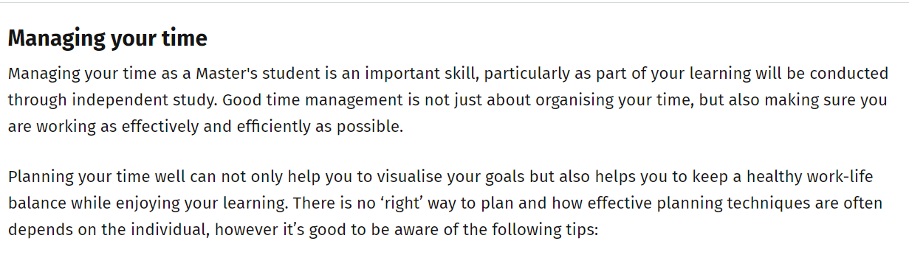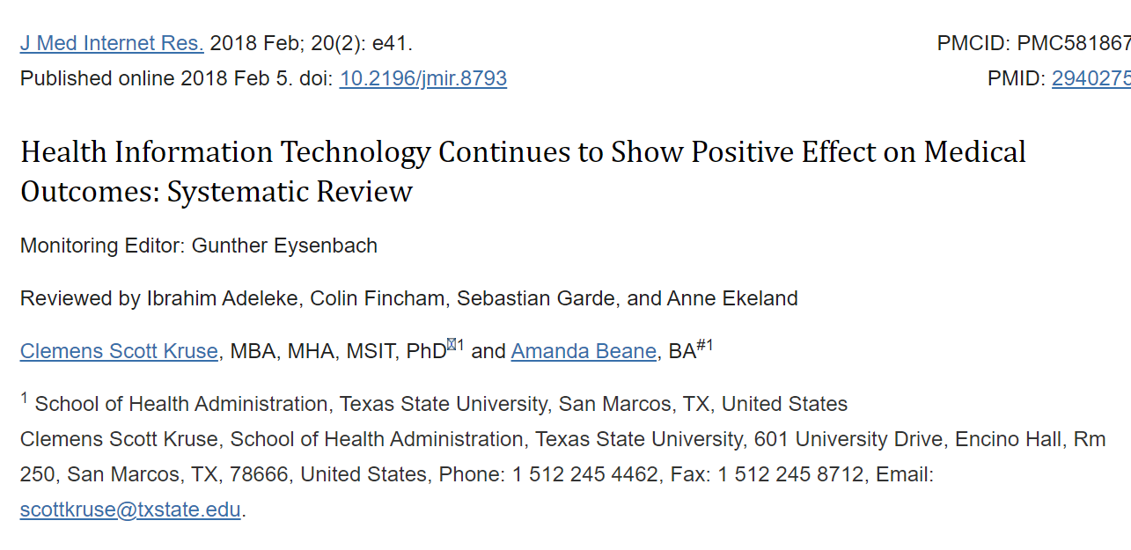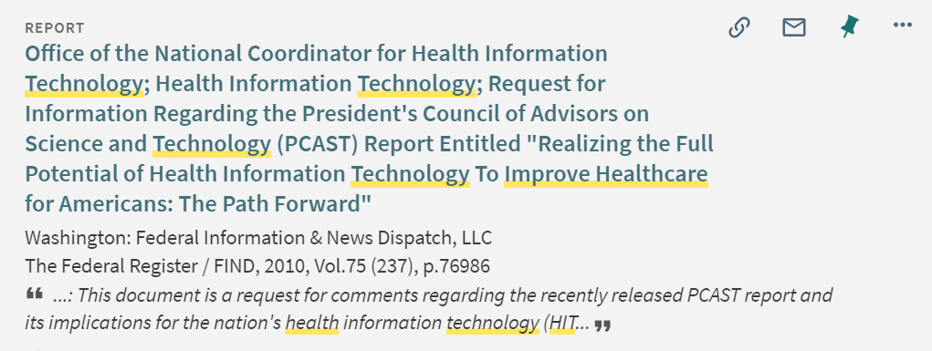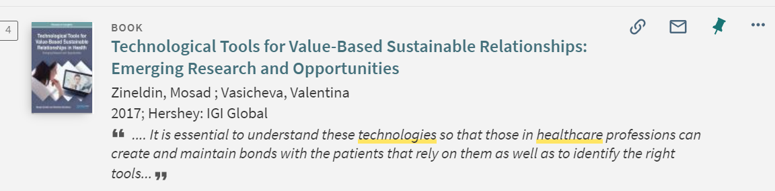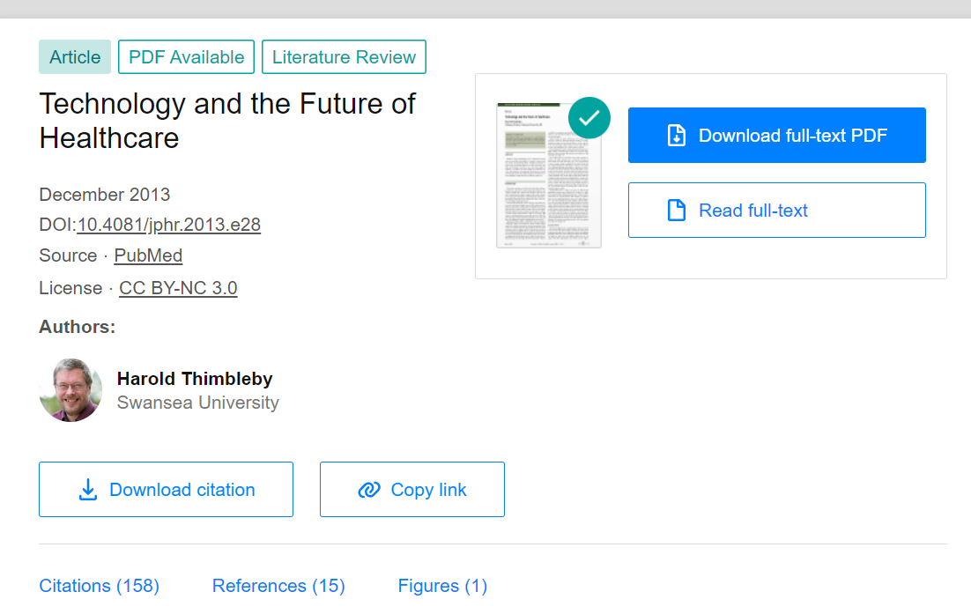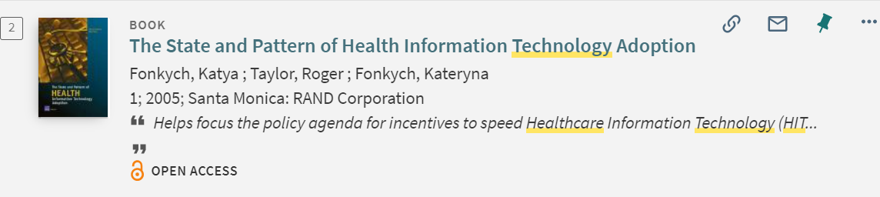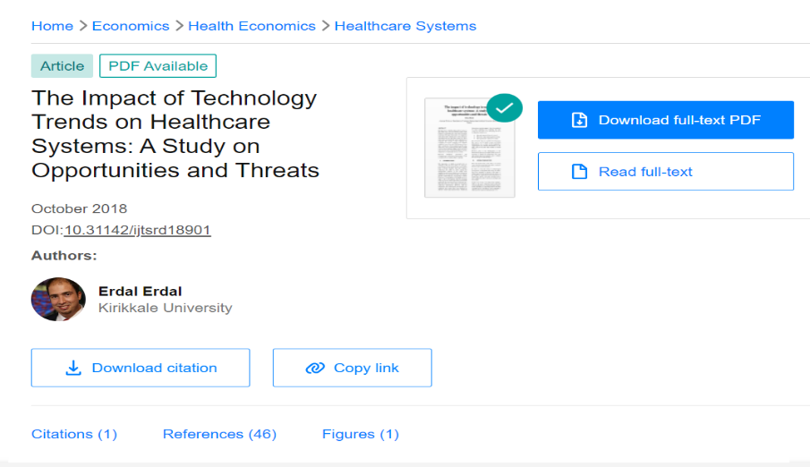

Conclusion
Medicine and in particular hospital in the UK have lagged behind in relation to HIT implementation and adoption. a significant contribution factor has hitherto been short-term thinking relating to strategic environment, technologies and organisational strategies, often resulting in various unintended social consequences. Therefore, there is need for longer term perspective that sees HIT not as an end but as a continuous journey towards a future data-rich environmental that supports the provision of safe, high quality and sufficient care, and the creation of learning health system. The use of electronic data for quality and safety improvements are currently the closest way to envisage this future. However, it is also important to recognize that new technical solution will become available, working practices will continue to change and guidelines will be updated. Therefore implementation of HIT is always a work in progress with constantly new emerging challenges. To deal with these challenges, hospitals will have to transform the way they function as HIT takes on new roles that have to be accommodated by healthcare workers.
REFRENCE
- James J. A new, evidence-based estimate of patient harms associated with hospital care. J Patient Saf 2013;9:122–8.
- Hogan H, Healy F, Neale G et al. Preventable deaths due to problems in care in English acute hospitals: a retrospective case record review study. BMJ Qual Saf 2012;21:737–45.
- BBC, 2014. NHS errors costing billions a year – Jeremy Hunt. Available online at www.bbc.com/news/uk-29639383 [Accessed 30 November 2014].
- BBC, 2014. NHS needs extra cash and overhaul, say health bosses. Available online at www.bbc.co.uk/news/health-29726934 [Accessed 30 November 2014].
- Institute for Healthcare Improvement, 2012. Across the chasm: six aims for changing the health care system. Available online at www. ihi.org/resources/Pages/ImprovementStories/AcrosstheChasmSix AimsforChangingtheHealthCareSystem.aspx [Accessed 01/11 2014]
Morrison Z, Robertson A, Cresswell K et al. Understanding contrasting approaches to nationwide implementations of electronic.
- Jha A, Doolan B, Grand D et al. The use of health information technology in seven nations. Int J Med Inform 2008;77:848–54.
- Bates DW, Gawande AA. Improving safety with information technology. N Engl J Med 2003;348:2526–34.
- Building Better Healthcare, 2014. Major opportunity for healthcare ICT vendors as tech spending gathers pace. Available online at www. buildingbetterhealthcare.co.uk/news/article_page/Major_opportunity_for_healthcare_ICT_vendors_as_tech_spending_gathers_ pace/95503#sthash.aBb3cIvl.RLVh22NU.dpuf [Accessed 15/10 2014].
- Black A, Car J, Pagliari C et al. The impact of eHealth on the quality and safety of health care: a systematic overview. PLoS Med 2011;8:e71238.
- Schade C, Sullivan F, de Lusignan S et al. e-Prescribing, efficiency, quality: lessons from the computerization of UK family practice.
J Am Med Inform Assoc 2006;13:470–5.
- Sheikh A, Jha A, Cresswell K et al. Adoption of electronic health records in UK hospitals: lessons from the USA. Lancet 2014;384:8–9.

